Harrison Stone (1904085)
Date : 14/01/2020
Information Engineering examination

Contents
DFD 1 2
DFD 2 3
DFD 3 4
ERD 5

DFD 1
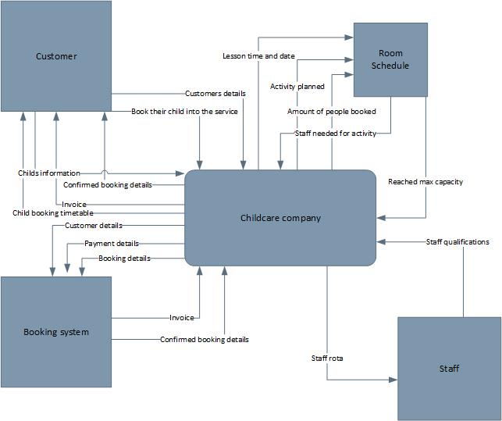

DFD 2
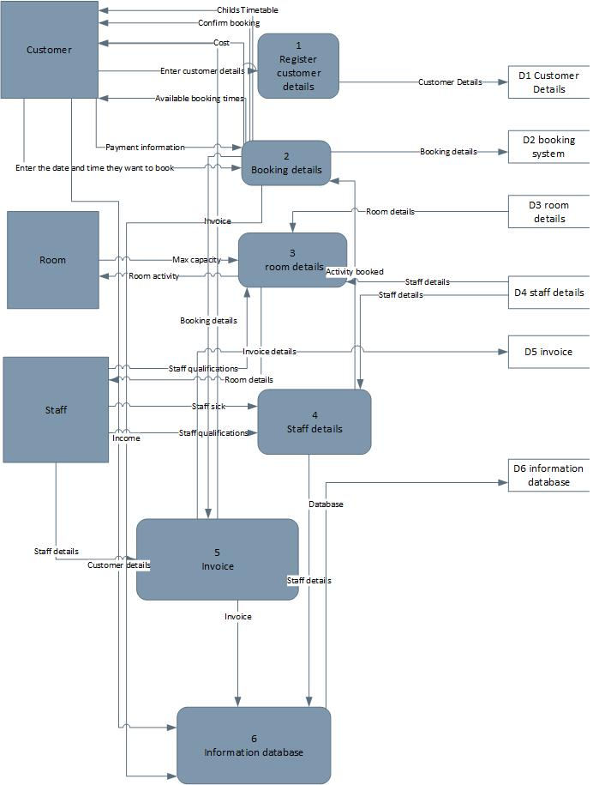

DFD 3
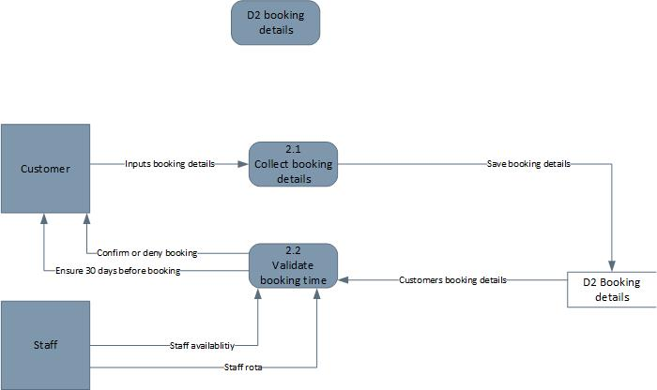

ERD


