PESTLE Analysis on Amazon word:626 (include table and figure)
Definition of PESTLE
Under the complex and VUCA environment(Bennett and Lemoine, 2014), no single organisations can escape the ‘laws of the jungles’ under fierce competition. The survival of an organisation depends on multiple elements including internal factors like labours, capitals and resources (Anderson, 2013; Barney, 2014; Boxall, 2016). While it is noteworthy that external factors (see Table 1.) are exerting game-changing impact on the organisations’ performance(Kew, 2016). PESTLE is a model that helps the organization to see the ‘bigger picture’, understand the external environment and get prepared for the challenges(CIPD, 2018). Usually being implemented before the decision-making process, PESTLE analysis is conducive to planning on strategies and key factors of SWOT analysis in the next stages(Johnson, 2017). According to Oxford(2016), it is not a once and for all practice and should be conducted with a regular interval to give its function into full play(Plummer and Armitage, 2007). Though the importance of PESTLE is self-evident for almost all organisations, the prominent developing trend of HR from outside-in pushes it to a higher poise(Ulrich and Dulebohn, 2015).
Why organizations need to consider PESTLE for talent attraction?
In the E-V-R congruence model developed by Thompson(2014), the ideally competitive position can be reached when the environment, resources and values of the organisation are mutually reinforced (see Figure 1.). Except that, according to McKinsey(2017), there is a huge efficiency gap between the higher performers and those ordinary ones(see Figure 2.), particularly for organizations involve higher degrees of complexity in their product, service and customer relationship. Therefore, for giant multinational corporations (Edwards, 2017) under higher uncertainty and complexity at global scale(Garner, 2018), it is more urgent to consider the external factors influencing on resourcing talent(Taylor, 2019; Eker, 2019) in order to enhance organisational competitive advantages and add value to the organisation(Bethke-Langenegger, Mahler and Staffelbach, 2011).

Figure 1. E-V-R model adapted from Thompson,2014

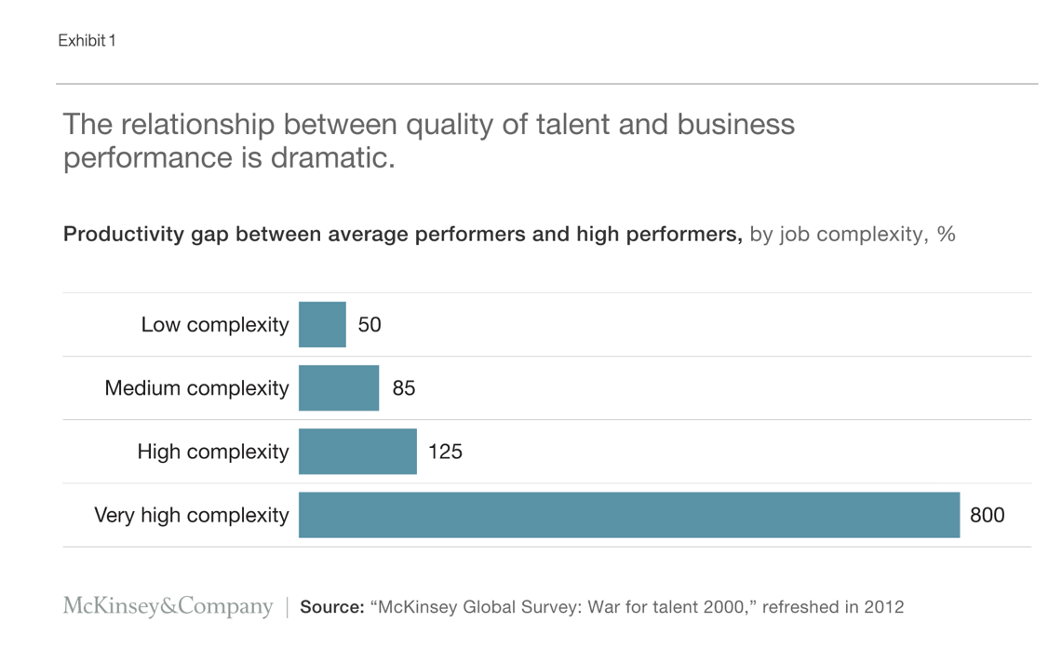

Figure 2. McKinsey Global Survey 2012

External factors influencing Amazon’s talent attraction strategies
The “Environmental” in PESTLE (see Table 1.) is targeted here, partly because some other elements will be discussed in the following part of this portfolio. But more importantly, environmental responsibility is a part of the corporate social responsibility(Kew, 2016) that has been regarded as a critical factor that affecting the employer image to the public (Puncheva-Michelotti, Hudson and Jin, 2018). Taking environment into consideration in organisational mission and value proposition helps to build up a positive employer brand especially during recruitment because the new generation of talents - well educated - have a higher sense of social responsibility and value more about the meaning of choosing a career(Coughlin, 2019). Besides, environmentally ethical culture contributes to becoming an employer of choice in the long run, which attracts more talent and thus forming a sustainable and virtuous cycle(Carlini et al., 2019; Higgs, Rees and McBain, 2004).
In response to climate change, Amazon revealed its strategic policies on environmental protection, including initiatives such as “Shipment Zero” , “Ship in Own Container”, and have designed reusable packaging and established solar-powered roof fulfilment centres in U.S.A to cap footprint, aiming at net-zero carbon emission 10 years earlier than that of Paris Agreement(Amazon, 2019; Regan, 2019).
On the other hand, not revealing enough data on its environmental impact has been criticized(Chasan, 2019). People worried about the counter-effect brought by e-commerce that its fast delivery has been indulging shorter-term buying habit while yielding longer logistics driving distance and higher carbon footprint to the earth(Nguye, 2018). As a result, they consider sustainability when choosing the HQ1 and in operation outside U.S.A like India, by abandoning non-recyclable packages to show their determination(Iyengar, 2019). However, it should be realized that all the external factors are interlinked to each other and should not be analysed in a silo. No matter it is the intrinsically driven motivation to protect the environment or for the sake of positive brand image, it is possible to reach a win-win result as long as the organisation take external factors seriously and put into real practice.
Table 1. Adapted from CIPD, 2019
External factors affecting talent attraction
(list to be continued)
Political  (CNBC, 2019) | Government policy  Political stability  Tax and tariff (Sino-US trade war)  Industry regulations  Global trade agreements / restrictions
Economic  (Bergvall‐Kåreborn, 2014) | Globalisation  Economic growth / decline  Exchange rates / currency  Cost of living  Labour costs  Consumer spending habits
Social  (Pyöriä et al., 2017) | Population and demographics (Aging society)  Labour market (College graduates)  Career attitudes  Work-life balance  Psychological contract  Skill gap
Technological  (BBC, 2018) | Automation / Robotics  Disruptive technologies  Social networking Upgrades  Artificial Intelligence  Cyber Security
Legal  (Sainato, 2018) | Employment law  Common law  Local labour law  Health and safety regulations  Union
Environmental  (Gunther, 2016) | Environmental restrictions imposed by government  Sustainable resources  CSR (Corporate social responsibility)  Ethical sourcing  Transportation Procurement  Supply chain management

Reference:
Amazon (2019) The Climate Pledge. Available at: https://blog.aboutamazon.com/sustainability/the-climate-pledge (Accessed: 25th, October 2019).
Anderson, V. (2013) Research methods in human resource management. 3rd edition. edn.: London : Chartered Institute of Personnel and Development.
Barney, J. B. (2014) Gaining and sustaining competitive advantage. Pearson higher ed.
BBC (2018) Amazon scrapped 'sexist AI' tool 23rd, September. Available at: https://www.bbc.co.uk/news/technology-45809919 (Accessed: 2019.
Bennett, N. and Lemoine, G. J. (2014) 'What a difference a word makes: Understanding threats to performance in a VUCA world', Business Horizons, 57(3), pp. 311-317.
Bergvall‐Kåreborn, B. (2014) 'Amazon Mechanical Turk and the commodification of labour', New Technology, Work & Employment, 29(3), pp. 213-224.
Bethke-Langenegger, P., Mahler, P. and Staffelbach, B. (2011) 'Effectiveness of talent management strategies', European Journal of International Management, 5(5), pp. 524-539.
Boxall, P. F. (2016) Strategy and human resource management. Fourth edition. edn.: London ; New York : Palgrave Macmillan.
Carlini, J., Grace, D., France, C. and Lo Iacono, J. (2019) 'The corporate social responsibility (CSR) employer brand process: integrative review and comprehensive model', Journal of Marketing Management, 35(1-2), pp. 182-205.
Chasan, E. (2019) Amazon’s New Environmental Report Will Show How Bad Two-Day Shipping Is. Available at: https://www.bloomberg.com/news/articles/2019-02-20/amazon-amzn-agrees-to-reveal-carbon-footprint-in-2019 (Accessed: 25th, October 2019).
CIPD (2018) PESTLE analysis. Available at: https://www.cipd.co.uk/knowledge/strategy/organisational-development/pestle-analysis-factsheet (Accessed: 16th September 2019).
CNBC (2019) How Amazon Paid $0 Federal Income Tax in 2018 [Video]. Available at: https://www.youtube.com/watch?v=qNg55JDMDHM (Accessed: 22nd, September 2019).
Coughlin, J. (2019) Greener Than You: Boomers, Gen X & Millennials Score Themselves On The Environment. Available at: https://www.forbes.com/sites/josephcoughlin/2018/05/05/greener-than-you-boomers-gen-x-millennials-score-themselves-on-the-environment/#ec30d214d8b4 (Accessed: 25th, October 2019).
Edwards, T. (2017) International human resource management : globalization, national systems and multinational companies. Third edition. edn.: Harlow, England : Pearson.
Eker, M. (2019) 'Exploring the Relationships between Environmental Uncertainty, Business Strategy and Management Control System on Firm Performance', Business & Economics Research Journal, 10(1), pp. 115-130.
Garner, B. A. (2018) 'Amazon in the Global Market', Journal of Marketing & Management, 9(2), pp. 63-74.
Gunther, M. (2016) Can Amazon's new 'dream team' fix the company's sustainability reputation? Available at: https://www.theguardian.com/sustainable-business/2016/feb/02/amazon-sustainability-edf-epa-best-buy-walmart-apple-microsoft-csr-child-labor (Accessed: 20th, October 2019).
Higgs, M., Rees, D. and McBain, R. (2004) People management: challenges and opportunities. Palgrave Macmillan.
Iyengar, R. (2019) Amazon and Walmart are now racing to reduce plastic pollution in India. Available at: https://edition.cnn.com/2019/09/04/business/amazon-india-single-use-plastic/index.html (Accessed: 26th, October 2019).
Johnson, G. (2017) Exploring strategy : text and cases. Eleventh edition. edn.: Harlow : Pearson Education Limited.
Kew, J. (2016) Human resource management in a business context. 3rd edition. edn.: London : Chartered Institute of Personnel and Development.
McKinsey (2017) Attracting and retaining the right talent. Available at: https://www.mckinsey.com/business-functions/organization/our-insights/attracting-and-retaining-the-right-talent (Accessed: 17th September 2019).
Nguye, N. (2018) The Hidden Environmental Cost of Amazon Prime’s Free, Fast Shipping. Available at: https://depts.washington.edu/sctlctr/news-events/in-the-news/hidden-environmental-cost-amazon-prime%E2%80%99s-free-fast-shipping (Accessed: 26th, October 2019).
OXFORD (2016) What is a PESTEL analysis? Available at: https://blog.oxfordcollegeofmarketing.com/2016/06/30/pestel-analysis/ (Accessed: 17th September 2019).
Plummer, R. and Armitage, D. (2007) 'A resilience-based framework for evaluating adaptive co-management: linking ecology, economics and society in a complex world', Ecological economics, 61(1), pp. 62-74.
Puncheva-Michelotti, P., Hudson, S. and Jin, G. (2018) 'Employer branding and CSR communication in online recruitment advertising', Business Horizons, 61(4), pp. 643-651.
Pyöriä, P., Ojala, S., Saari, T. and Järvinen, K.-M. (2017) 'The Millennial Generation:A New Breed of Labour?', SAGE Open, 7(1), pp. 2158244017697158.
Regan, P. (2019) INSIGHT: Did Amazon Consider Climate Risk for Its New Headquarters? Available at: https://news.bloombergenvironment.com/environment-and-energy/insight-did-amazon-consider-climate-risk-for-its-new-headquarters (Accessed: 25th, October 2019).
Sainato, M. (2018) Exploited Amazon workers need a union. When will they get one? Available at: https://www.theguardian.com/commentisfree/2018/jul/08/amazon-jeff-bezos-unionize-working-conditions (Accessed: 23rd, October 2019).
Taylor, S. (2019) Resourcing and talent management. Seventh edition. edn.: London, United Kingdom ; New York, NY : Kogan Page Limited.
Thompson, J. L. (2014) Strategic management : awareness and change. Seventh edition / John Thompson, Jonathan M. Scott, Frank Martin. edn.: Australia : Cengage Learning.
Ulrich, D. and Dulebohn, J. H. (2015) 'Are we there yet? What's next for HR?', Human Resource Management Review, 25(2), pp. 188-204.

Labour market trends affecting Amazon in different countries word:610
Global trends in the labour market
To understand the labour market, a preview on the macro-economic environment should be considered in the first place(CIPD, 2019c). The global demographic trend shows new momentum towards “aged while younger” workforce as a result of lower birth rate and an ageing population that generation Y and Z entering the workplace(PwC, 2017). In the business world, Future of Jobs 2018 report(WEF, 2018b) suggests global organisations should be highly alert to the workforce challenges that automation replacement on full-time employees may happen early in 2022. Besides, it is anticipated by organisations including CIPD(2019b) and Deloitte(2019) that the megatrends may trigger a bunch of new super-jobs(Deloitte, 2019) and behaviours, such as crowdsourcing and Internet of things as well as Super-consumers(Flynn and Goldsmith, 2016) that is a game of survival for multinational corporation like Amazon.
Modern connotation of Labour market
Labour markets also find different manifestation at the national and local level, for employment markets in specific industries and sectors. According to Taylor(2019), labour market refers to the place where organisations compete to acquire employees for organisational development, which is usually categorised by the relationship between labour supply and demand(Clegg, 2016). However, it should be recognised that neither the tight nor loose status is permanent, because it changes contingently according to the economic situation (CIPD, 2019c) and different industrial connection to technologies(EY, 2019), educational levels, as well as to the number of people with expected knowledge and skills --- the labour of talent(Beechler and Woodward, 2009).
Currently, America has been experiencing a relatively tight market(see Figure 3.), hitting its lowest unemployment rate since the past five decades(BBC, 2019). Despite its stable economic growth, the labour participation declined with the aged re-entering the workplace. One of the non-demographic contributors might be the gig economy that 42 million self-employees are predicted by 2020, which poses a challenge to the employer in talent attraction(Monahan, Schwartz and Schleeter, 2018; Wang, 2018). Besides, a paradoxical phenomenon reveals a lift in STEM graduates (with 60 per cent from China)(Herman, 2018) but at the same time an increasing number of job vacancies, which might be a result of skill gap caused by the rapid technological demand in the workplace and the lack of supply in skilled graduates(News, 2018). Also, it is accompanied by the larger gap between tertiary industries and non-tertiary sectors, low-skilled employee and their higher-skilled counterparts, which may aggregate to further payroll inequality(McCarthy, 2019).
Though more people welcomed the second-baby policy, data in the Chinese labour market (see Figure 4.) displays similar ageing trends (Moss, 2018; Xiaodong, 2019) and tightening workforce especially in STEM-related areas, with drastic transformation from the primary and the second industry to the tertiary industry(Mohrss.gov.cn, 2018). According to the World Economic Forum(2018a), migrant workers are anticipated to heat urbanization in the next decade, which poses bigger challenge to foreign employers like Amazon to train low-skilled workers while growing higher-skilled talents(Cyrill, 2019). With the transformation to short-distance migration (NBSC, 2018) and a high number of overseas returnees coming back to China(ChinaDaily, 2017), the employer also needs to consider the localization of employees and both the hygiene factors and motivators(Armstrong, 2017) in terms of talent management.

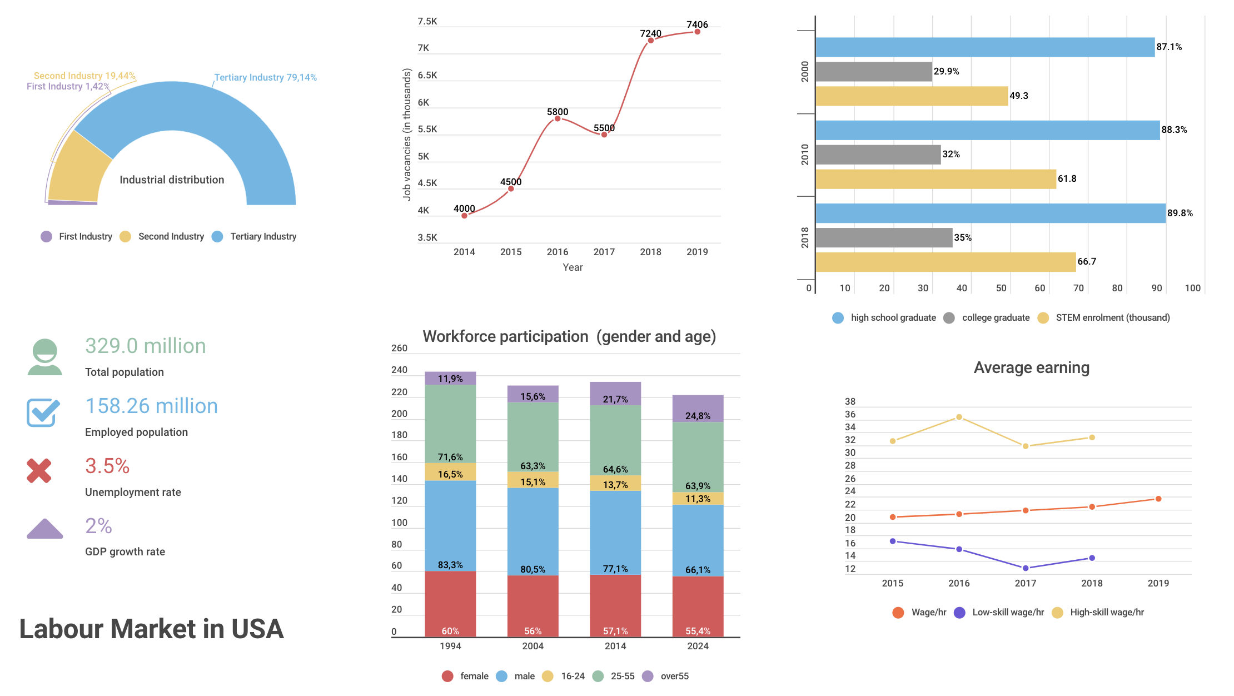
(2019; 2015; 2019)
Figure 3. Source: World Bank (2019), UNESCO (2015), Census.gov (2019)
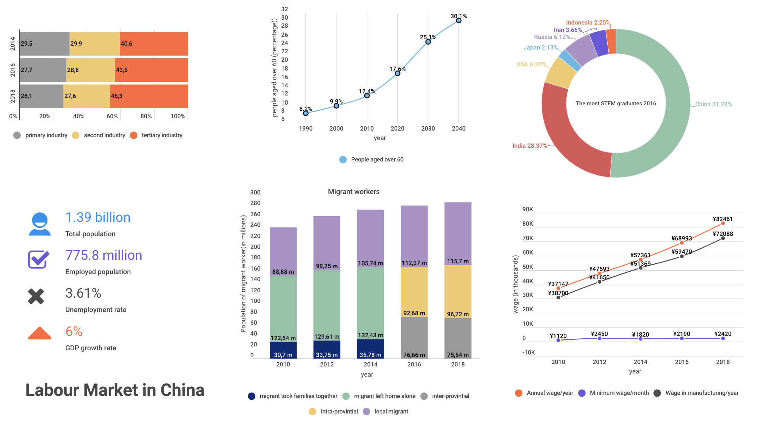
Figure 4. Source: World Bank (2019); NBSC (2019); Trading economics (2019)

It can be seen that although some features vary through countries, some labour market trends coincide: less loyalty to one job, increasing demand for high-skilled talent and anxiety on future skill gap(Frey and Osborne, 2017). Of course, Information above is collected from current reports and presented within limited range(CIPD, 2019a) on those highly relevant elements links to modern labour market changes, and there are other factors like diversity of talent(Frost and Kalman, 2016), inbound and outbound immigration, environment and trade relationship(Dicken, 2011) that impacting talent management in different countries. Labour market largely decides the human capacity of the organisation, but it is always necessary to cultivate a growth mindset in the progress of globalisation and less brick-and-mortar dependent talent resourcing environment(Edwards and Rees, 2016; Shorrocks, 2008).

Reference:
Armstrong, M. (2017) Armstrong's handbook of human resource management practice. Handbook of human resource management practice 14th edition. edn.: London ; New York, NY : Kogan Page.
BBC (2019) US unemployment rate falls to 50-year low of 3.5%. Available at: https://www.bbc.co.uk/news/business-49934309 (Accessed: 22nd, October 2019).
Beechler, S. and Woodward, I. C. (2009) 'The global “war for talent”', Journal of international management, 15(3), pp. 273-285.
ChinaDaily (2017) Better career opportunities back in China trigger a wave of overseas returnees. Available at: http://www.chinadaily.com.cn/weekend/2017-03/11/content_28517284.htm (Accessed: May 10 2019).
CIPD (2019a) Atypical Working-A guide to successfully implementing atypical work in your organisation. Available at: https://www.cipd.co.uk/Images/7904-atypical-working-guide-web_tcm18-61555.pdf (Accessed: 17th, October 2019).
CIPD (2019b) Megatrends report: flexible working. Available at: https://www.cipd.co.uk/knowledge/work/trends/megatrends/flexible-working (Accessed: 24th, September 2019).
CIPD (2019c) Understanding the economy and labour market. Available at: https://www.cipd.co.uk/knowledge/work/trends/economy-labour-market-factsheet (Accessed: 17th, September 2019).
Clegg, S. (2016) Managing & organizations : an introduction to theory and practice. Managing and organizations Fourth edition. edn.: London : SAGE.
Cyrill, M. (2019) China Labor Market: Hiring Costs, Job Preferences, Talent Acquisition. Available at: https://www.china-briefing.com/news/china-labor-market-hiring-costs-job-preferences-talent-acquisition/ (Accessed: 7th, October 2019).
Deloitte (2019) Leading the social enterprise: Reinvent with a human focus-2019 Deloitte Global Human Capital Trends. Available at: https://www2.deloitte.com/us/en/insights/focus/human-capital-trends.html (Accessed: Sep 6, 2019).
Dicken, P. (2011) Global shift mapping the changing contours of the world economy. 6th ed. edn. New York: New York : Guilford Press.
Economics, T. (2019) United States Job Vacancies. Available at: https://tradingeconomics.com/united-states/job-vacancies (Accessed: 27th, October 2019).
Edwards, T. and Rees, C. (2016) International human resource management : globalization, national systems and multinational companies. Third Edition. edn.: Harlow : Pearson.
EY (2019) How do we plan for the now, the next and what lies beyond? Available at: https://www.ey.com/en_gl/innovation-realized/how-do-we-plan-for-the-now-the-next-and-what-lies-beyond (Accessed: 27th, September 2019).
Flynn, L. and Goldsmith, R. (2016) 'Introducing the super consumer', Journal of Consumer Behaviour, 15(3), pp. 201.
Frey, C. B. and Osborne, M. A. (2017) 'The future of employment: How susceptible are jobs to computerisation?', Technological forecasting and social change, 114, pp. 254-280.
Frost, S. and Kalman, D. (2016) Inclusive talent management: How business can thrive in an age of diversity. Kogan Page Publishers.
Herman, A. (2018) America's High-Tech STEM Crisis. Available at: https://www.forbes.com/sites/arthurherman/2018/09/10/americas-high-tech-stem-crisis/#2a33242af0a2 (Accessed: 28th, September 2019).
McCarthy, N. (2019) The Countries With The Most Millionaires. Available at: https://www.forbes.com/sites/niallmccarthy/2019/10/22/the-countries-with-the-most-millionaires-infographic/#1d5f61d765fa (Accessed: 20th, October 2019).
Mohrss.gov.cn (2018) MHRSS Statistical Release of 2018. Available at: http://www.mohrss.gov.cn/SYrlzyhshbzb/dongtaixinwen/buneiyaowen/201906/P020190610566694719241.pdf (Accessed: 30th, September 2019).
Monahan, K., Schwartz, J. and Schleeter, D. T. (2018) Decoding millennials in the gig economy 26th, October. Available at: https://www2.deloitte.com/us/en/insights/focus/technology-and-the-future-of-work/millennials-in-the-gig-economy.html (Accessed: 2019.
Moss, D. (2018) China Must Grow Its Shrinking Workforce to Keep Up. Available at: https://www.bloomberg.com/opinion/articles/2018-05-21/china-must-grow-its-shrinking-workforce-to-keep-up (Accessed: 20th, September 2019).
NBSC (2018) China Statistical Yearbook 2018. Available at: http://www.stats.gov.cn/english/statisticaldata/annualdata/ (Accessed: 11th, September 2019).
News, N. (2018) Are U.S. Students Ready For A Changing Job Market? Available at: https://www.youtube.com/watch?v=u6PNnWnZq2s (Accessed: Sep 3, 2019).
PwC (2017) Megatrends: 5 global shifts changing the way we live and do business [Video]. Available at: https://www.youtube.com/watch?v=V6sEDtTOzW8 (Accessed: 25th, September 2019).
Shorrocks, A. (2008) The international mobility of talent: Types, causes, and development impact. Oxford University Press on Demand.
Taylor, S. (2019) Resourcing and talent management. Seventh edition. edn.: London, United Kingdom ; New York, NY : Kogan Page Limited.
UNESCO (2015) UNESCO science report: towards 2030. Available at: https://unesdoc.unesco.org/ark:/48223/pf0000235406 (Accessed: 27th, October 2019).
Wang, A. X. (2018) The number of Americans working for themselves could triple by 2020. Available at: https://qz.com/work/1211533/the-number-of-americans-working-for-themselves-could-triple-by-2020/ (Accessed: 27th, October 2019).
WEF (2018a) Future of Consumption in Fast-Growth Consumer Markets: China. Available at: http://www3.weforum.org/docs/WEF_Future_of_Consumption_in_Fast_Growth_Consumer_Markets_China.pdf (Accessed: 15th, October 2019).
WEF (2018b) The Future of Jobs Report 2018. Available at: https://www.weforum.org/reports/the-future-of-jobs-report-2018 (Accessed: 15th, September 2019).
Wordbank (2019) The Little Data Book on Gender. Available at: https://openknowledge.worldbank.org/bitstream/handle/10986/31689/LDB-Gender-2019.pdf?sequence=2&isAllowed=y (Accessed: 25th, October 2019).
Xiaodong, W. (2019) Birth rate fall on horizon. Available at: https://www.telegraph.co.uk/china-watch/society/china-birth-rate-fall/ (Accessed: 21st, October 2019).
Executive Review: HR adjustment in Liberal economy and coordinated economy
Statistics show that the lifespan of S&P 500 companies shortens from 60 years to under 20 years because of new and disruptive factors(CNBC, 2017). And the ushering of globalisation in the 21st century has made the world flatter than ever that individuals and firms from different countries all share the tickets into the global arena(Nolan, 2008). However, among all the uncertainty and complexity, globalisation does not lead to homogeneity but rather brings integration challenges to multinational corporations in their operated countries(D'aunno, Succi and Alexander, 2000).
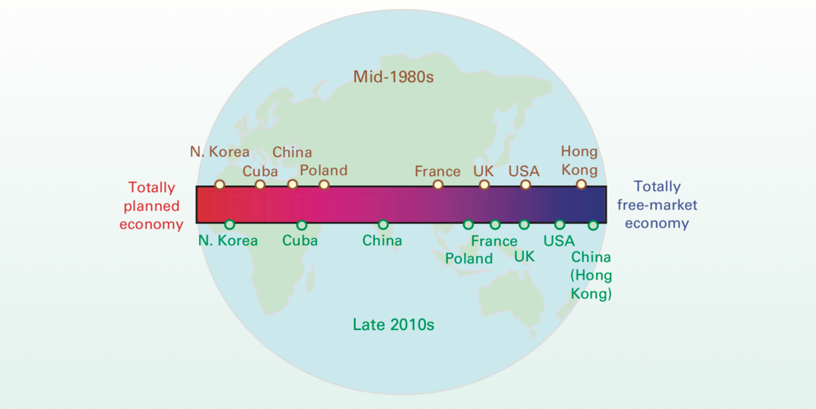
It is argued that in the 21st century, both U.S.A and China are in the mixed economics that neither planned nor free (see Figure 5.)(Sloman, Garratt and Guest, 2018). These two countries have been long in economic comparison (see Figure 6 &7 &8.) and are analysed here as a liberal market economy and a coordinated market economy based on this mixed-economy premise (Soskice, 2001). Evaluated by the World Bank(2019), China has been transformed from a central controlled economy into a more market-based economy during the past 40 decades with its own characteristics, but still remain relatively higher degree in terms of intervention from non-market factors, therefore regarded as the coordinated economy(Karnia, 2016; Peck and Zhang, 2013).
Figure 5. Classifying economic system. Source: Economics, Sloman 2018

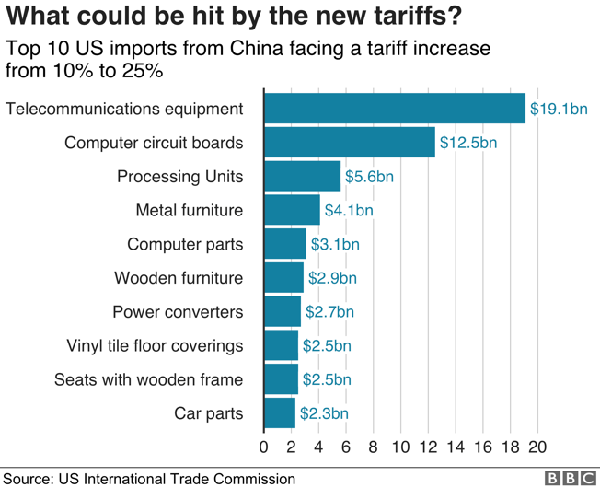
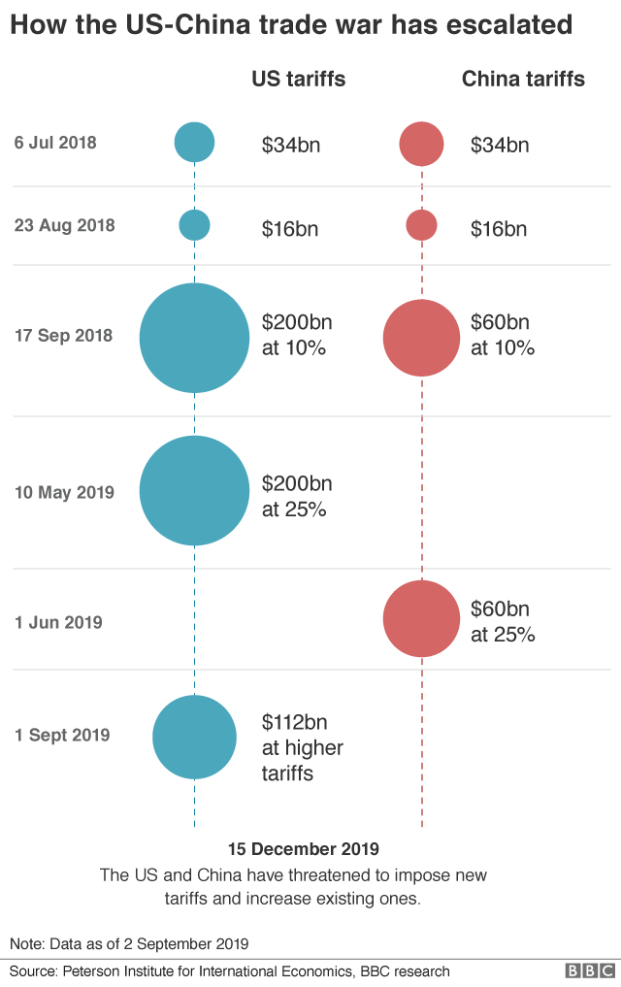
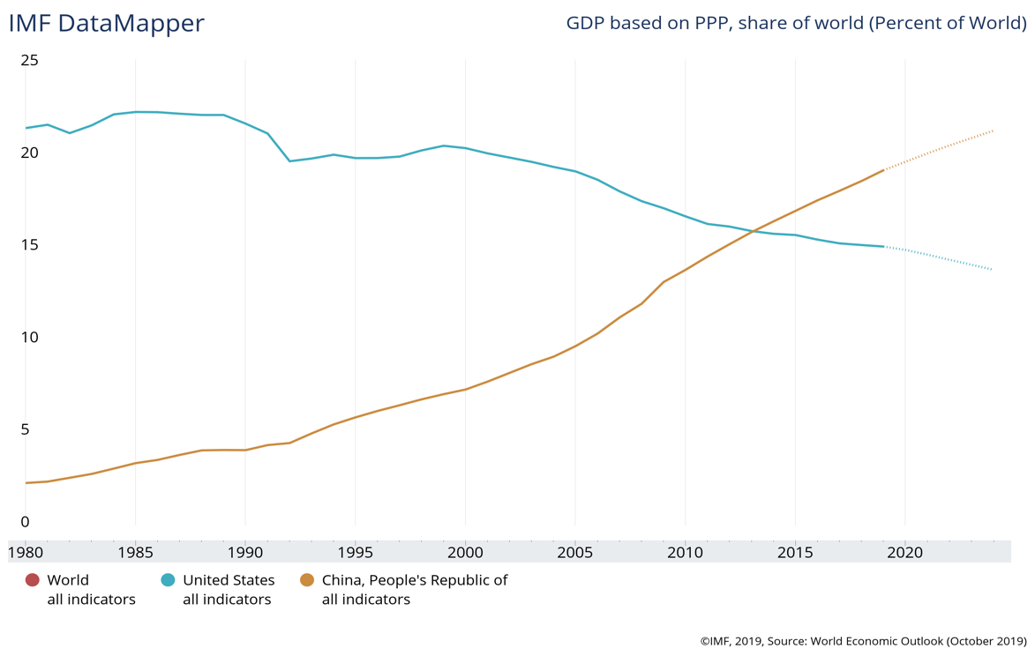
Figure 6.(IMF, 2019)
Figure 7: (BBC, 2019)
Figure 8. (Palumbo and Costa, 2019)
Generally speaking, the major difference between liberal and coordinated markets can be analysed through the flow model of economics(see figure 9.)(Knight, 1933), which reflects the degree of government intervention from laws and legislation, reallocation of resources, relationship between the market and business, i.e. the employer-employee relationship(Kew, 2016; Sloman, Garratt and Guest, 2018).
Revenue
Goods & service
Goods & service
Labour/land/capital
Labour/land/capital
Cost
Income

Consumption

Figure 9. Economic circular flow Adapted from (Knight, 1933)
Besides, according to Hofstede(1984), cultural conducts may also influence human management practice in different countries of operation(see figure 10). However, it should be kept a critical eye on equating the economic environment to cultural philosophies, that codes of conducts at the national level could not be perceived the same to individuals and organisational performance (ecological fallacy) and reversely, specific HRM practice is not compatible according to different industries and companies (Baskerville, 2003; Hofstede, 2001).
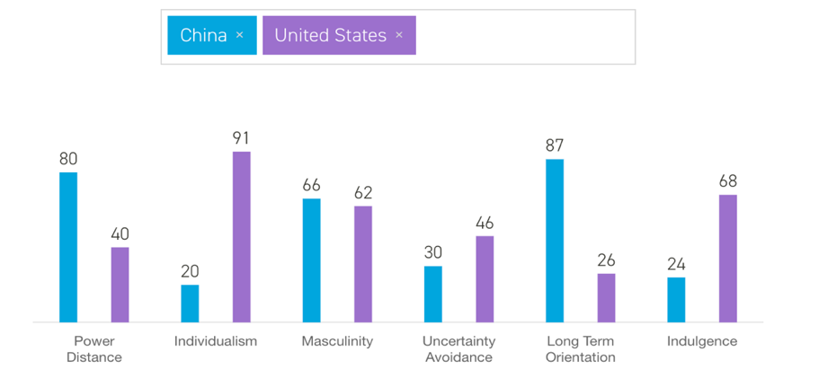

Figure 10: Hofstede cultural dimension(HofstedeInsights, 2019)
In a liberal economy like America (see Table 2.), organisations are affected more by the competition and the invisible hand in the market(Smith, 1963). Amazon’s “customer-obsessed” value-orientation just illustrates its vital reliance on the decisive market share. Though its current HRM practices(see Figure 11.) have been criticized for being over profit-driven and less employee-concerned, especially burnout pressure on low-skilled employees in fulfilment centres(Chamberlain, 2018), Amazon continues to lead the game because of its advantageous production in human, natural and capital resources(Sloman, Garratt and Guest, 2018). However, despite its aggregated profit and employer brand(Raw, 2015; Anders, 2018), tight and fierce competition in the labour market requires more proactive HRM practices(bsi, 2018), especially on tapping the motivation of talent, by giving higher trust and autonomy, training and cultivating a learning culture inside(Armstrong, 2017).

Table 2. Main component of liberal economy. Source: (Harari, 2018)
 | National level | International level
Political field | Free election, rule of law, minority rights; multiple political party | Multilateral cooperation, international laws and organisation
Economic field | Free markets, privatization, low tax | Free trade, global integration, low tariffs
Personal field | Free choice, individualism, diversity, gender equality | Ease of personal movement and immigration

Figure 11. HR practice in Amazon (Amazon, 2019)
In a coordinated economy, it supposed to be low-cost in labour and competition(Akkermans, Castaldi and Los, 2009). However, the situation in China shows, on the one hand, fast economic development leads to a skill shortage in senior managerial talents(Rees and Smith, 2017; Parry, Dickmann and Morley, 2008). On the other hand, multinational organisations suffer from high employee turnover, lack of understanding on local policies and regulations and less power in leveraging employee-employer relationship(Ferner, 1997; Farndale, Brewster and Poutsma, 2014). Amazon announced quitting online shipping business in China because of deficit in competition against local e-commerce like JD and Alibaba(Weise, 2019; Cooke, 2009). Therefore, except HRM practices suggested to America, it is the changing cultures should be considered (see Table 3.).
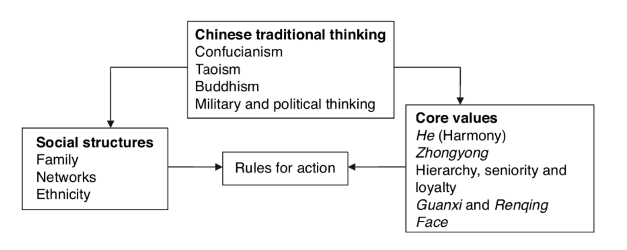
Table 3. Cultural determinants of Chinese individuals source: (Yuan, 2013; Redding and Hsiao, 1990)

Generally speaking, when considering entry to different economies, there is a paradox between best-fit or best-practice HRM(Sparrow, 2013; Paauwe and Boselie, 2005) for multinational corporations. Universal practices crossing the borders might be beneficial to organisational alignment but causes conflicts in the local culture and business context. The “best fit” practices require critical reassessment about the external economic norms as a precondition of adding value, maximizing profit of shareholders through methods that aligned with the business strategies at large(Purcell, 1999). Just like there is no one size fits for all scheme, neither there exists chameleon magic that fit into different economic market but throws away all the core values and business strategies in the long run(Ulrich and Dulebohn, 2015; Boxall, 2016).

Reference:
Akkermans, D., Castaldi, C. and Los, B. (2009) 'Do ‘liberal market economies’ really innovate more radically than ‘coordinated market economies’?: Hall and Soskice reconsidered', Research Policy, 38(1), pp. 181-191.
Amazon (2019) Working at Amazon. Available at: https://www.aboutamazon.com/working-at-amazon (Accessed: 11th, October 2019).
Anders, G. (2018) Amazon is the most sought-after employer in the U.S. We went inside to find out why. LinkedIn. Available at: https://www.linkedin.com/pulse/amazon-most-sought-after-employer-us-we-went-inside-find-anders/ (Accessed: 26th, September 2019).
Armstrong, M. (2017) Armstrong's handbook of human resource management practice. Handbook of human resource management practice 14th edition. edn.: London ; New York, NY : Kogan Page.
Baskerville, R. F. (2003) 'Hofstede never studied culture', Accounting, organizations and society, 28(1), pp. 1-14.
BBC (2019) Trade war: US hits China with new wave of tariffs. Available at: https://www.bbc.co.uk/news/business-49505781 (Accessed: 24th, October 2019).
Boxall, P. F. (2016) Strategy and human resource management. Fourth edition. edn.: London ; New York : Palgrave Macmillan.
bsi (2018) Organizational Resilience Index Report 2018. Available at: https://www.bsigroup.com/en-GB/our-services/Organizational-Resilience/ (Accessed: Sep 8, 2019).
Chamberlain, G. (2018) Underpaid and exhausted: the human cost of your Kindle. Available at: https://www.theguardian.com/technology/2018/jun/09/human-cost-kindle-amazon-china-foxconn-jeff-bezos (Accessed: 25th, September 2019).
CNBC (2017) Technology killing off corporate America: Average life span of companies under 20 years. Available at: https://www.cnbc.com/2017/08/24/technology-killing-off-corporations-average-lifespan-of-company-under-20-years.html (Accessed: 28th, September 2019).
Cooke, F. L. (2009) 'A decade of transformation of HRM in China: A review of literature and suggestions for future studies', Asia Pacific Journal of Human Resources, 47(1), pp. 6-40.
D'aunno, T., Succi, M. and Alexander, J. A. (2000) 'The role of institutional and market forces in divergent organizational change', Administrative Science Quarterly, 45(4), pp. 679-703.
Farndale, E., Brewster, C. and Poutsma, E. (2014) 'Coordinated vs. liberal market HRM: the impact of institutionalization on multinational ﬁrms', International human resource management: Routledge, pp. 20-39.
Ferner, A. (1997) 'Country of origin effects and HRM in multinational companies', Human resource management journal, 7(1), pp. 19-37.
Harari, Y. N. (2018) 21 Lessons for the 21st Century. Random House.
Hofstede, G. (1984) Culture's consequences: International differences in work-related values. sage.
Hofstede, G. (2001) Culture's consequences: Comparing values, behaviors, institutions and organizations across nations. Sage publications.
HofstedeInsights (2019) Compare United States and China. Available at: https://www.hofstede-insights.com/product/compare-countries/ (Accessed: 3rd, October 2019).
IMF (2019) World Economic Outlook, October 2019. Available at: https://www.imf.org/en/Publications/WEO/Issues/2019/10/01/world-economic-outlook-october-2019 (Accessed: 30th, October 2019).
Karnia, K. (2016) 'Is China’s capitalism sustainable?', “Economy Today. An Interdisciplinary Approach to Contemporary Economic Challenges”, ed. P. Urbanek, Ser.“Economy”, Wydawnictwo Uniwersytetu Łódzkiego, Łódź 2016;: Wydawnictwo Uniwersytetu Łódzkiego.
Kew, J. (2016) Human resource management in a business context. 3rd edition. edn.: London : Chartered Institute of Personnel and Development.
Knight, F. H. (1933) Capitalistic production, time and the rate of return.
Nolan, P. (2008) Integrating China: towards the coordinated market economy. Anthem Press.
Paauwe, J. and Boselie, P. (2005) 'HRM and performance: what next?', Human Resource Management Journal, 15(4), pp. 68-83.
Palumbo, D. and Costa, A. N. d. (2019) Trade war: US-China trade battle in charts. Available at: https://www.bbc.co.uk/news/business-48196495 (Accessed: 22nd, October 2019).
Parry, E., Dickmann, M. and Morley, M. (2008) 'North American MNCs and their HR policies in liberal and coordinated market economies', The International Journal of Human Resource Management, 19(11), pp. 2024-2040.
Peck, J. and Zhang, J. (2013) 'A variety of capitalism… with Chinese characteristics?', Journal of Economic Geography, 13(3), pp. 357-396.
Purcell, J. (1999) 'Best practice and best fit: chimera or cul‐de‐sac?', Human resource management journal, 9(3), pp. 26-41.
Raw, L. 2015. The Everything Store: Jeff Bezos and the Age of Amazon. Malden: Blackwell Publishing Ltd.
Redding, S. G. and Hsiao, M. (1990) 'An empirical study of overseas Chinese managerial ideology', International Journal of Psychology, 25(3-6), pp. 629-641.
Rees, G. and Smith, P. (2017) Strategic human resource management: An international perspective. Sage.
Sloman, J., Garratt, D. and Guest, J. (2018) Economics. Tenth edition. edn.: Pearson Education.
Smith, A. (1963) An Inquiry into the Nature and Causes of the Wealth of Nations. Wiley Online Library.
Soskice, P. A. H. D. W. (2001) Varieties of capitalism: The institutional foundations of comparative advantage. Oxford University Press.
Sparrow, P. (2013) 'Strategic HRM and employee engagement', Employee engagement in theory and practice: Routledge, pp. 113-129.
Ulrich, D. and Dulebohn, J. H. (2015) 'Are we there yet? What's next for HR?', Human Resource Management Review, 25(2), pp. 188-204.
Weise, K. (2019) Amazon Gives Up on Chinese Domestic Shopping Business. Available at: https://www.nytimes.com/2019/04/18/technology/amazon-china.html (Accessed: 30th, October 2019).
worldbank (2019) The World Bank in China. Available at: https://www.worldbank.org/en/country/china/overview (Accessed: 30th, October 2019).
Yuan, L. (2013) Traditional Chinese thinking on HRM practices: Heritage and Transformation in China. Springer.

Atkinson’s flexible firm from the perspective of open talent economy
The emergent call for flexible organisations appeared against the backdrop of the 1980s economic recession in Japan(Atkinson, 1984) primarily in the manufacturing sector. Since then, Atkinson’s Flexible Firm Model(see Figure 12.) became an influential guide for modern organisations to enhance business resilience by resourcing talent in the VUCA environment(Taylor, 2019; Christidis, 2018). Owing to globalisation, demographic change and technological development, new behaviours emerged in accompany with higher mobility in the workplace and people no longer have to commute to brick-and-mortar offices and tend to change jobs more frequently than the previous generations(Johns and Gratton, 2013; PwC, 2017).
Secondary peripheral group
Numerical flexibility
Agency worker
Outsourcing
Sub-contracting

Figure 12. adapted from Atkinson’s Flexible Firm

In the wake of that, the open-talent economy came into being, prioritizing talents in today’s competition, whereas challenging the traditional perception of “being flexible”(Kraaijenbrink, Spender and Groen, 2010). In the Atkinson’s model, employees in the “core group” are “owned” by the organization with full-time permanent contract (functionally flexible), while the “peripheral group” and the “third group” consists of smaller proportion of people both in the organisational balance-sheet but not central, and external labour that “bought” or “borrowed” on short-term demand (functional and numerical flexibility)(CIPD, 2019c). However, with the technological impact on human resource management discussed previously, the shape, size and skills of organisations may witness enormous shift: core group shrinks and the out-layers expand (Wyman, 2017)(see Figure 13.).
Agency worker
Sub-contracting
Outsourcing
The third group

Figure 13. Shrinking core group (adapted from Wyman, 2017)

It can be seen at the open talent economy framework and talent lifecycle(Figure 14.) that it is the economic environment allowing unrestricted flow between resources and atypical work-form(see Figure 15.)(CIPD, 2019a), which forms a new employment ecosystem that the relationship became more of a reciprocal choice between employee and employers(Deloitte, 2013; Ahmad, 2015).
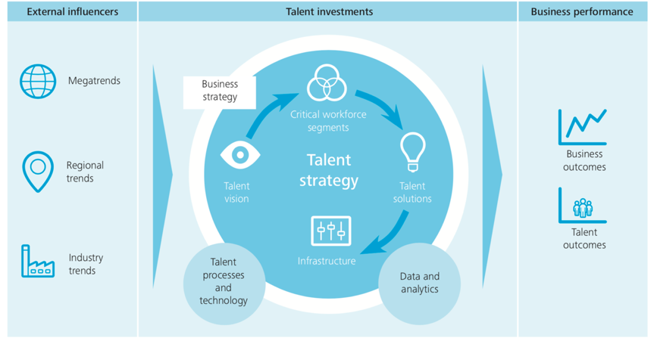
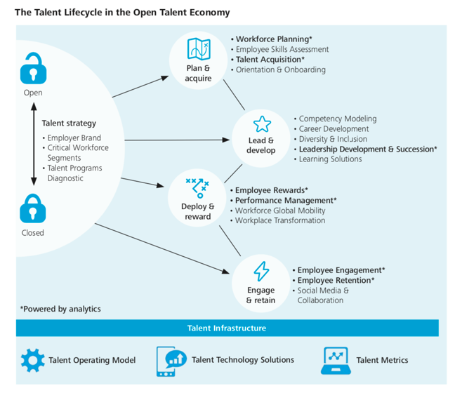
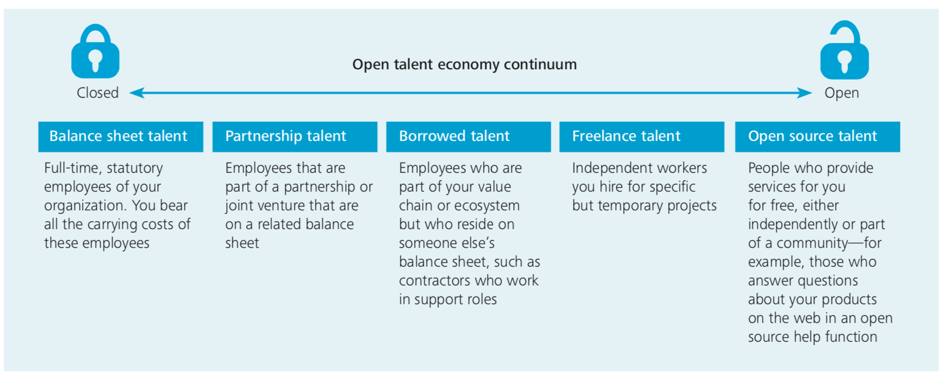
Figure 14. Open Talent Economy Continuum & Talent lifecycle &Framework (Deloitte, 2013)

Figure 15: Atypical form of work. Adapted from (CIPD, 2019b)
In terms of benefits, though there are still lots of companies stick to the “core group” employees, it is undeniable that structural flexibility(Taylor, 2019) helps to extend the border of the talent pool and reduce redundancy for resource reallocation in people management(Boxall, 2016). Meanwhile, cultural flexibility encourages cultivates flexible mindset inside the company, triggers a mutually-trusted psychological contract for a positive brand image (Cannon, 2017; Guest and Conway, 2002). On the other hand, for employees, taking flexible working largely reduces burnout stress by improving work-life balance, especially for those who have family-caring concerns(CIPD, 2016; Clark, 2000). Besides, the ongoing external trends of mutually flexible working are conducive to keep people on a learning trajectory while enhancing employability(Griffiths et al., 2018; Reilly, 2001).

However, the other side of the coin raises concerns and criticism. Firstly, job insecurity forges a conflict between flexibility of peripheral employees and higher expectation of commitment(Taylor, 2019). Engagement in the 21st century doesn’t come as a result of financial rewards, but more empowerment, mastery, purpose and autonomy are pursued by the higher-skilled talents, which is hard to realize among the short-term employees(Pink, 2011; Sachau, 2007). Moreover, flexibility may cause income instability for the “gig workers”(such as Amazons Flex in Figure 16 .)(CIPD, 2017), inequality and protection for traditional full-time employment relationships(Clarke and Holdsworth, 2017), and taxation and health insurance issues at the societal level (Worldbank, 2019).
Figure 16: source: Flex Amazon (2019a)

In Amazon, they have flexible working hours for core employees who are in the core group, but as automation keeps thriving, the peripheral short-term workers are easy to be lost which should be taken seriously(Amazon, 2019b). Therefore, to be prepared with higher resilience, Amazon should adjust HR practices to deal with the complex business environment. Here Atkinson’s Flexible Firm Model is endowed with new connotations and will continue to be upgraded. On the one hand, organisations can utilize to improve profitability by attracting and retaining talent from outside(Ulrich, 2016), but on the other hand, investment should be made on smart workforce planning, segmentation and talent career development as well as leadership development (Storey, Ulrich and Wright, 2019; Kew, 2016). Just as the senior leader of PwC Donovan(2019) said, organisations should not rely too much on the programming of “flexible” policy while ignoring the importance of cultivating a culture of learning, agility and diversity in the first place(Morgan, 2014; Dweck, 2015).

Reference:
Ahmad, H. (2015) 'A critical examination of the advantages and disadvantages of adopting flexible working practices in relation to the employer and employee'.
Amazon (2019a) Flex Amazon. Available at: https://flex.amazon.com/ (Accessed: 1st, November 2019).
Amazon (2019b) Working at Amazon. Available at: https://www.aboutamazon.com/working-at-amazon (Accessed: 11th, October 2019).
Atkinson, J. (1984) 'Manpower strategies for flexible organisations', Personnel management, 16(8), pp. 28-31.
Boxall, P. F. (2016) Strategy and human resource management. Fourth edition. edn.: London ; New York : Palgrave Macmillan.
Cannon, F. (2017) The Agility Mindset: How reframing flexible working delivers competitive advantage. Springer.
Christidis, A. (2018) Building a Talent Ecosystem. Available at: https://www.mercer.com/our-thinking/building-a-talent-ecosystem.html (Accessed: 29th, October 2019).
CIPD (2016) Commuting and flexible working. Available at: https://www.cipd.co.uk/Images/employee-outlook-focus-on-commuting-and-flexible-working_tcm18-10886.pdf (Accessed: 4th, October 2019).
CIPD (2017) To gig or not to gig?Stories from the modern economy. Available at: https://www.cipd.co.uk/Images/to-gig-or-not-to-gig_2017-stories-from-the-modern-economy_tcm18-18955.pdf (Accessed: 28th, September 2019).
CIPD (2019a) Atypical Working-A guide to successfully implementing atypical work in your organisation. Available at: https://www.cipd.co.uk/Images/7904-atypical-working-guide-web_tcm18-61555.pdf (Accessed: 17th, October 2019).
CIPD (2019b) Fact sheet: Zero-hours contracts. Available at: https://www.cipd.co.uk/knowledge/fundamentals/emp-law/terms-conditions/zero-hours-factsheet (Accessed: 14th September 2019).
CIPD (2019c) Megatrends report: flexible working. Available at: https://www.cipd.co.uk/knowledge/work/trends/megatrends/flexible-working (Accessed: 24th, September 2019).
Clark, S. C. (2000) 'Work/family border theory: A new theory of work/family balance', Human relations, 53(6), pp. 747-770.
Clarke, S. and Holdsworth, L. (2017) Flexibility in the Workplace:Implications of flexible work arrangements for individuals, teams and organisations. Available at: https://m.acas.org.uk/media/4901/Flexibility-in-the-Workplace-Implications-of-flexible-work-arrangements-for-individuals-teams-and-organisations/pdf/Flexibility-in-the-Workplace.pdf (Accessed: 11th, October 2019).
Deloitte (2013) The open talent economy-People and work in a borderless workplace. Available at: https://www2.deloitte.com/global/en/pages/human-capital/articles/open-talent-economy1.html (Accessed: 10th, October 2019).
Donovan, A. (2019) What PwC Learned from Its Policy of Flexible Work for Everyone. Available at: https://hbr.org/2019/01/what-pwc-learned-from-its-policy-of-flexible-work-for-everyone (Accessed: 15th September 2019).
Dweck, C. (2015) 'Carol Dweck revisits the growth mindset', Education Week, 35(5), pp. 20-24.
Griffiths, D. A., Inman, M., Rojas, H. and Williams, K. (2018) 'Transitioning student identity and sense of place: future possibilities for assessment and development of student employability skills', Studies in Higher Education, 43(5), pp. 891-913.
Guest, D. E. and Conway, N. (2002) 'Communicating the psychological contract: an employer perspective', Human resource management journal, 12(2), pp. 22-38.
Johns, T. and Gratton, L. (2013) The Third Wave of Virtual Work. Available at: https://hbr.org/2013/01/the-third-wave-of-virtual-work (Accessed: 29th, September 2019).
Kew, J. (2016) Human resource management in a business context. 3rd edition. edn.: London : Chartered Institute of Personnel and Development.
Kraaijenbrink, J., Spender, J.-C. and Groen, A. J. (2010) 'The resource-based view: a review and assessment of its critiques', Journal of management, 36(1), pp. 349-372.
Morgan, J. (2014) The future of work: Attract new talent, build better leaders, and create a competitive organization. John Wiley & Sons.
Pink, D. H. (2011) Drive: The surprising truth about what motivates us. Penguin.
PwC (2017) Megatrends: 5 global shifts changing the way we live and do business [Video]. Available at: https://www.youtube.com/watch?v=V6sEDtTOzW8 (Accessed: 25th, September 2019).
Reilly, P. A. (2001) Flexibility at work: Balancing the interests of employer and employee. Gower Publishing, Ltd.
Sachau, D. A. (2007) 'Resurrecting the Motivation-Hygiene Theory: Herzberg and the Positive Psychology Movement', Human Resource Development Review, 6(4), pp. 377-393.
Storey, J., Ulrich, D. and Wright, P. M. (2019) Strategic Human Resource Management: A Research Overview. Routledge.
Taylor, S. (2019) Resourcing and talent management. Seventh edition. edn.: London, United Kingdom ; New York, NY : Kogan Page Limited.
Ulrich, D. (2016) The Future of HR [Video]. Available at: https://www.youtube.com/watch?v=57PmDk73u7I (Accessed: 23rd, September 2019).
Worldbank (2019) The Changing Nature of Work. Available at: http://documents.worldbank.org/curated/en/816281518818814423/2019-WDR-Report.pdf (Accessed: 25th, October 2019).
Wyman, O. (2017) Delivering the Workforce for the Future. Available at: https://www.oliverwyman.com/our-expertise/insights/2017/oct/delivering-the-workforce-for-the-future.html (Accessed: 19th, October 2019).
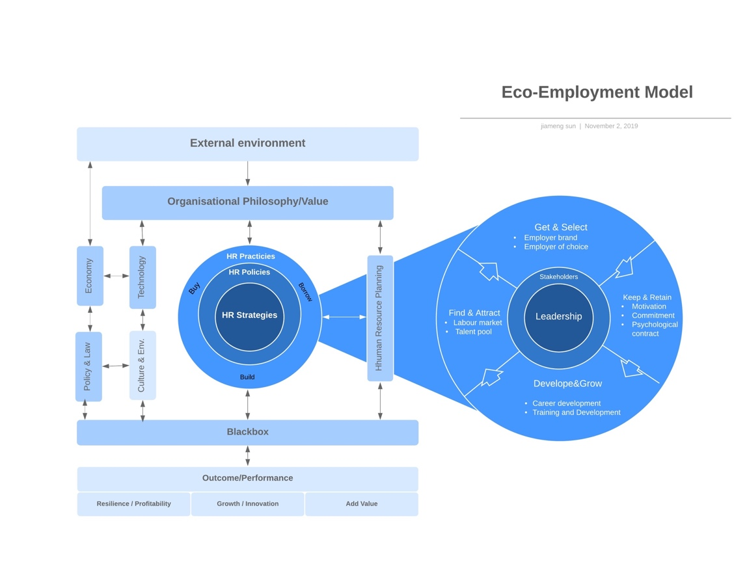

Albrecht, S. L., Bakker, A. B., Gruman, J. A., Macey, W. H. and Saks, A. M. (2015) 'Employee engagement, human resource management practices and competitive advantage: An integrated approach', Journal of Organizational Effectiveness: People and Performance, 2(1), pp. 7-35.
Allen, P., Maguire, S. and McKelvey, B. (2011) The SAGE handbook of complexity and management. Handbook of complexity and management London: London : SAGE.
Armstrong, M. (2017) Armstrong's handbook of human resource management practice. Handbook of human resource management practice 14th edition. edn.: London ; New York, NY : Kogan Page.
Armstrong, M., Brown, D. and Reilly, P. (2010) Evidence-based reward management: Creating measurable business impact from your pay and reward practices. Kogan Page Publishers.
Boxall, P. F. (2016) Strategy and human resource management. Fourth edition. edn.: London ; New York : Palgrave Macmillan.
bsi (2018) Organizational Resilience Index Report 2018. Available at: https://www.bsigroup.com/en-GB/our-services/Organizational-Resilience/ (Accessed: Sep 8, 2019).
Coopey, J. and Hartley, J. (1991) 'Reconsidering the case for organisational commitment', Human resource management journal, 1(3), pp. 18-32.
Hakanen, J. and Schaufeli, W. (2006) 'Burnout and Work Engagement Among Teachers', Journal of School Psychology, 43, pp. 495-513.
Maslach, C. (2017) 'Burnout: A multidimensional perspective', Professional burnout: Routledge, pp. 19-32.
McDaniel Jr., R. R. (2007) 'Management Strategies for Complex Adaptive Systems Sensemaking, Learning, and Improvisation', Performance Improvement Quarterly, 20(2), pp. 21-41.
O'Reilly III, C. A. and Tushman, M. L. (2013) 'Organizational ambidexterity: Past, present, and future', Academy of management Perspectives, 27(4), pp. 324-338.
Richard, O. C. (2000) 'Racial diversity, business strategy, and firm performance: A resource-based view', Academy of management journal, 43(2), pp. 164-177.
Schuler, R. S. and Jackson, S. E. (2007) Strategic human resource management. 2nd ed. edn. Malden, Mass. ; Oxford: Malden, Mass. ; Oxford : Blackwell.
Soane, E., Truss, C., Alfes, K., Shantz, A., Rees, C. and Gatenby, M. (2012) 'Development and application of a new measure of employee engagement: the ISA Engagement Scale', Human resource development international, 15(5), pp. 529-547.
Sparrow, P. (2013) 'Strategic HRM and employee engagement', Employee engagement in theory and practice: Routledge, pp. 113-129.
Storey, J., Ulrich, D. and Wright, P. M. (2019) Strategic Human Resource Management: A Research Overview. Routledge.
Ulrich, D. (2016) The Future of HR [Video]. Available at: https://www.youtube.com/watch?v=57PmDk73u7I (Accessed: 23rd, September 2019).
Ulrich, D. and Dulebohn, J. H. (2015) 'Are we there yet? What's next for HR?', Human Resource Management Review, 25(2), pp. 188-204.
Walton, R. E. (1985) From Control to Commitment in the Workplace. Available at: https://hbr.org/1985/03/from-control-to-commitment-in-the-workplace (Accessed: 24th, September 2019).

