University of Wales Trinity Saint David
School of Engineering
Title of the Coursework
Christopher Hopkins
149588
27/01/2020
Optimisation of a high speed 3 cylinder using the Ricardo WAVE engine development software M6X00408
Owen Williams
Contents
1 Introduction 1
1.1 Aims 1
2 Background 2
3 Methodology 3
3.1 Excel Section 3
3.2 Ricardo WAVE section 5
4 Results 12
5 Discussion & Conclusion 17
5.1 Discussions 17
5.2 Conclusions 18

Figure 3.1 Pressure/Volume graph 4
Figure 3.2 WAVE Triumph 675cc Triple 5
Figure 3.3 Complex Y-junction calculation 6
Figure 3.4 Cylinder Panel Liner 6
Figure 3.5 Cylinder Panel Piston 7
Figure 3.6 Cylinder Panel Valves 7
Figure 3.7 Valves editor 8
Figure 3.8 Valve profile 8
Figure 3.9 Engine General Panel Operating Parameters 9
Figure 3.10 Wiebe Model 9
Figure 3.11 Ambient Panel 10
Figure 3.12 Injector Panel 10
Figure 3.13 Constants Table 11
Figure 4.1 10250RPM Wiebe 12
Figure 4.2 13000RPM Wiebe 12
Figure 4.3 14400RPM Wiebe 13
Figure 4.4 Pressure/Crank Angle 10250RPM 13
Figure 4.5 Pressure/Crank Angle 13000RPM 14
Figure 4.6 Pressure/Crank Angle 14400RPM 14
Figure 4.7 Volume/Clearance Volume 10250RPM 15
Figure 4.8 Volume/Clearance Volume 13000RPM 15
Figure 4.9 Volume/Clearance Volume 14400RPM 16
Figure 4.10 LOGPV 10250RPM 16
Figure 4.11 LOGPV 13000RPM 17
Figure 4.12 LOGPV 14400RPM 17

Introduction
This report will outline the steps taken when investigating engine simulation software Ricardo WAVE. The software will be used to model a Triumph 675cc triple of which a general engine file has already been created. Using a technical data sheet combined with dyno data an excel sheet will be made to identify extra characteristics about the engine that will be required to accurately model the engine within WAVE. With these extra properties the engine file will be modified to match and then from there different aspects of the software will be further modified with the end goal of creating a simulation that matches the real dyno data. This report will include the process taken on both Excel and WAVE analysis and comparison of the results as well as a section on how each parameter effected the results obtained.

Aims
- To accurately develop a model of a Triumph 675cc Triple using Ricardo WAVE across 3 RPM values.
- Compare the results of the simulation with the real data provided in order to judge the validity of the model as well as the software in general.

Background
Ricardo WAVE is a 1D computation fluid dynamic used throughout the engine development industry. It allows for characterizing engine operation without the use of high-end computers and lengthy calculation times (Cordon, et al., 2007). Furthermore, this software allows for accurate prediction of performance without the need to build a physical model (Algahtani, et al., 2015). (Algahtani, et al., 2015) also states that Ricardo wave is an industry standard engine thermodynamic and gas dynamic simulation software used for gas simulation on intake, combustion and exhaust system configurations.

Methodology
In order to model the engine on WAVE, excel will be used to plot dyno data combined with a technical data sheet to convert it into usable information to set parameters within the Ricardo wave model to simulate the engine.

Excel Section
To begin The Triumph data needs to be analysed to acquire technical information that can be input into WAVE. The Triumph dyno data was broken down into crank angle, cylinder pressure, burned rate and volume %. Additionally, the technical data sheet stated the following parameters about the engine:
- Sweep Volume 225.008cc
- Clearance Volume 1.92315e-5m³
Clearance volume can then be converted to cc. $1.92315e-5*1000000=19.23cc$ clearance volume and sweep volume are then combined to calculate total volume within the cylinder.
- Total Cylinder Volume 244.24cc
The volume per degree of crank rotation is then calculated.
$V=Vt-\left(1-\left(\frac{V\%}{100}\right)\right)*Vs$ (1)
Where
- Vt = Total Cylinder Volume
- V% = Volume %
- Vs = Sweep Volume
Following this $\frac{V}{Vs}$ Is calculated as well as $\log{\frac{V}{Vs}}$.

Cylinder pressure is given 1bar below absolute pressure and so 1 needs to be added to the cylinder pressure column. When plotting a pressure/$\frac{V}{Vs}$ a compression ratio of roughly 12.7 can be identified. This is also confirmed on the technical data sheet
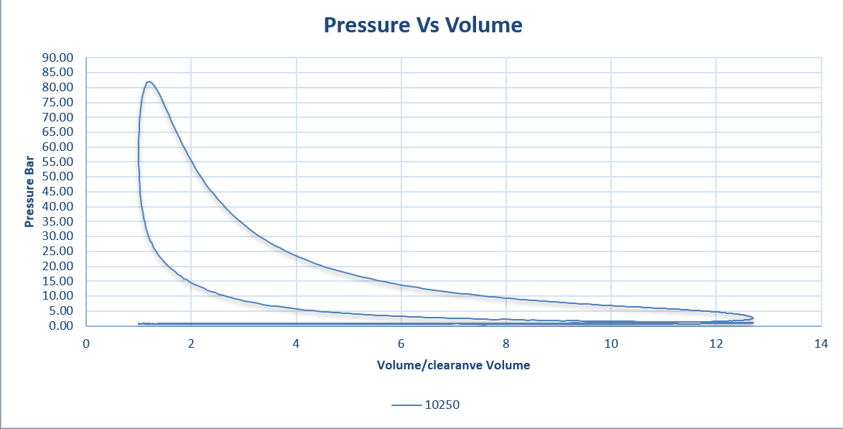
Figure 3.1 Pressure/Volume graph
Finally, the burn rate can be used to find the crank angle for 10%, 50% and 90% MFB. This process is repeated on all 3 RPM’s provided. The angle was calculated using
$$CA=\left(\left(\frac{MFB-L\%}{H\%-L\%}\right)*\left(HCA-LCA\right)\right)+LCA$$
Where
- CA = Crank Angle
- MFB = MFB% required
- L% = Lower % of MFB found from dyno data
- H% = Higher %
- HCA = Higher Crank Angle from dyno data
- LCA = Lower Crank Angle
From the Excel section the following technical parameters have been acquired.
- Total Cylinder Volume
- Volume per degree of crank rotation
- Absolute Pressure
- Compression Ratio
- Crank angle for 10%, 50% and 100% MFB

Ricardo WAVE section
This section required the following parameters from the Excel section:
- Compression Ratio 12.7
- Crank angle for 10%, 50% and 100% MFB
- Clearance Volume 19.23cc
This section also requires the following information from the technical data sheet @10250RPM:
- Bore 0.076m
- Stroke 0.0496m
- Conrod Length 0.1046m
- Air Temp 20ºC
- Air/Fuel Ratio 12

Using the preconstructed WAVE model of the Triumph 675cc Triple shown in figure 3.2 which will use 3 cases with varied engine speeds
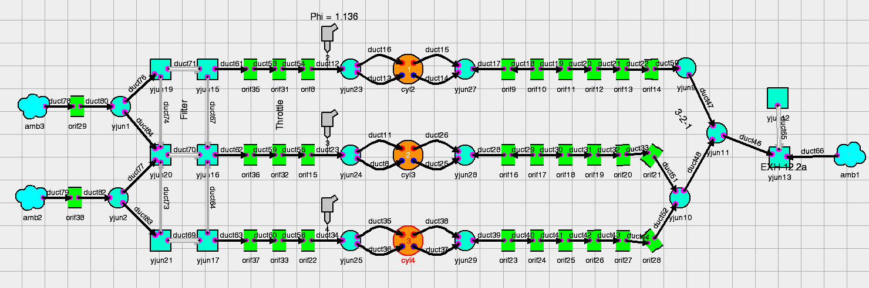
Figure 3.2 WAVE Triumph 675cc Triple
Starting by checking through each complex y junction and calculating the “Volume” and “Heat Transfer/Skin Friction Area” as shown in figure 3.3
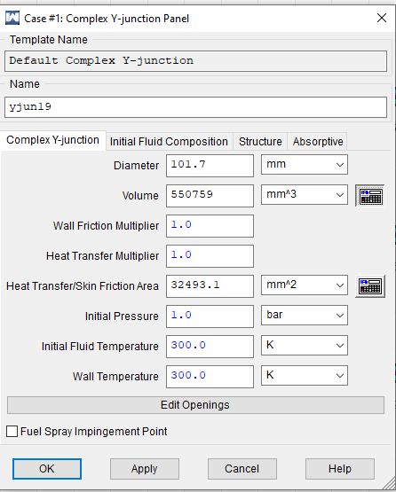
Figure 3.3 Complex Y-junction calculation
Then using the cylinder panel. Parameters were modified in multiple section. Starting with the GeometryLiner tab. Clearance height, the clearance height was calculated by $h=\frac{Vc}{πr^{2}}$ where Vc is clearance volume and r is half the bore making h = 0.0424m. Bore and Stroke are already set to the correct values according to the data sheet.
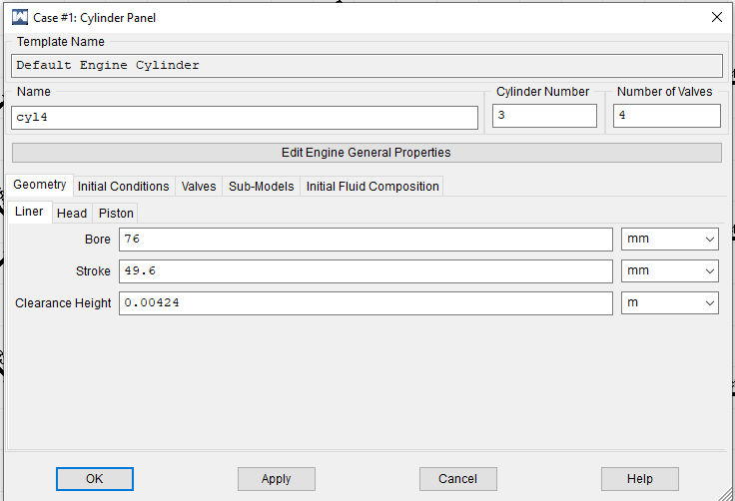
Figure 3.4 Cylinder Panel Liner
Next the GeometryPiston tab. Is where the conrod length was set to 0.1046 as the data sheet states and the compression ratio was set to 12.7 as discovered in Excel and backed up by the data sheet.
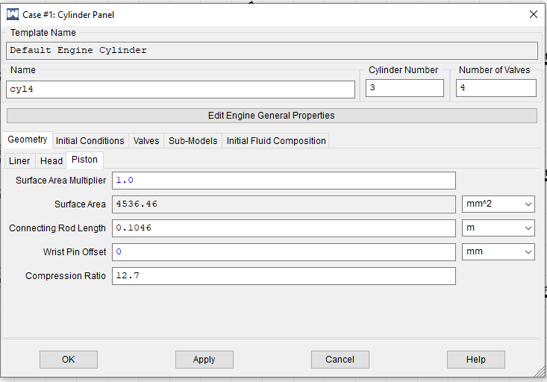
Figure 3.5 Cylinder Panel Piston
In the initial conditions tab constants were set for piston top temperature, cylinder liner temperature and cylinder head temperature however, these values were left as they were.
Finally, in the piston section the valve lift and flow coefficient profiles are set in the valves tab by selecting either an inlet valve or exhaust valve.
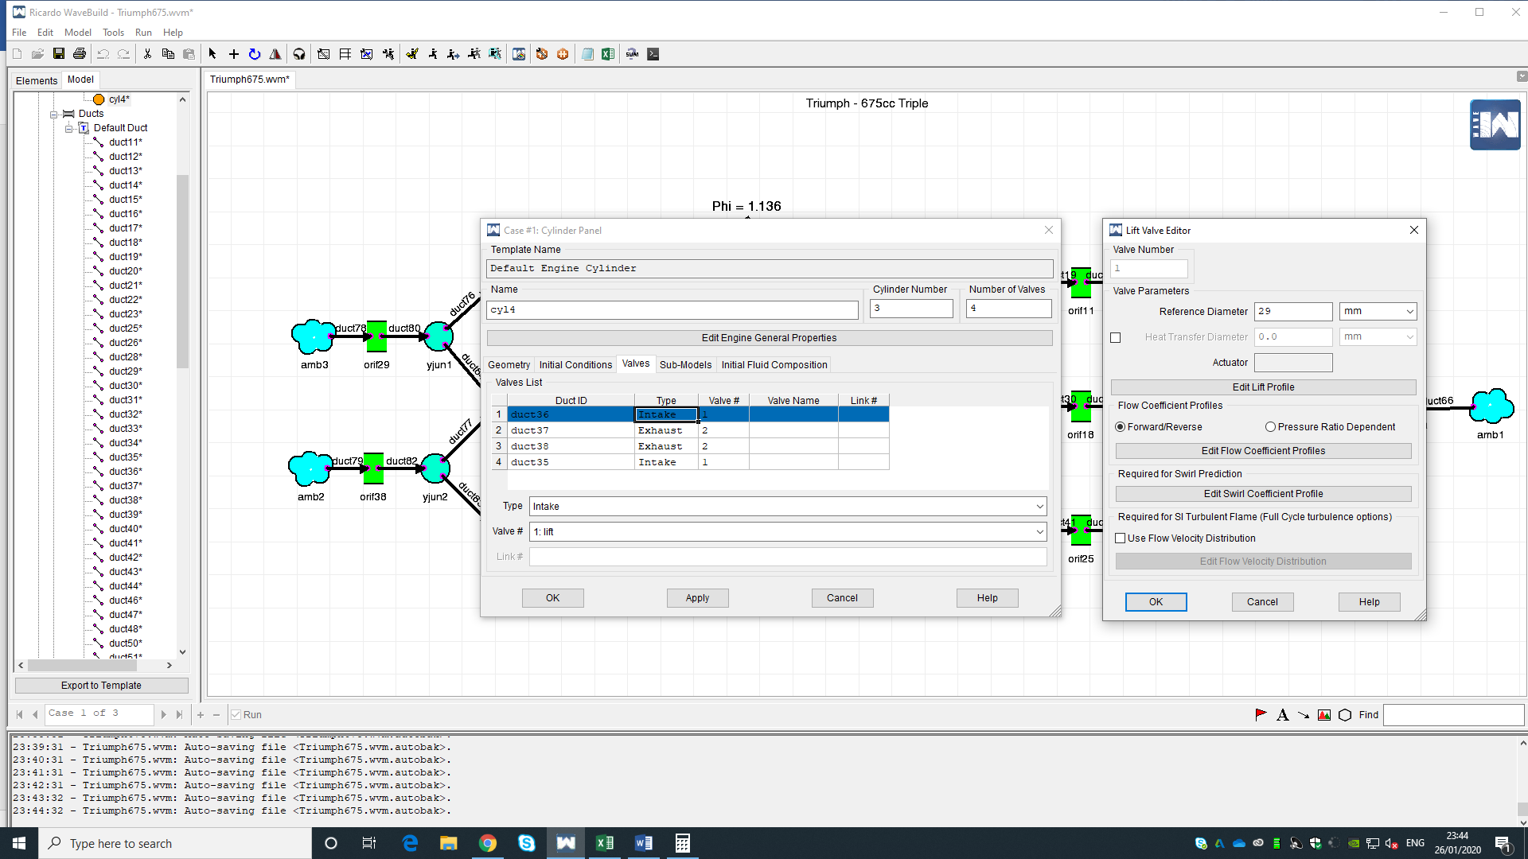
Figure 3.6 Cylinder Panel Valves
Figure 3.7 Valves editor
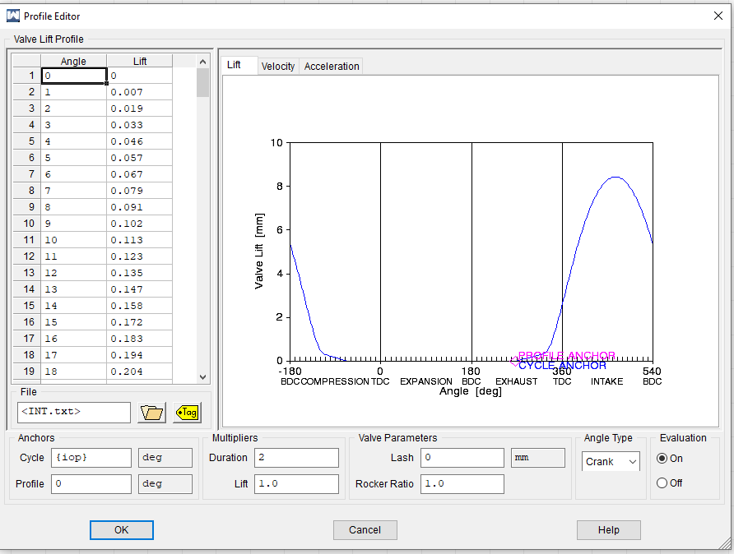
Figure 3.8 Valve profile
Files were provided for lift and flow coefficient profiles.
- Lift (Inlet) INT
- Flow Coefficient (Inlet) FLOWINT
- Lift (Exhaust) EXH
- Flow Coefficient (Exhaust) FLOWEXH
Following this, on the operating parameters tab of the engine general parameters panel had constants assigned to the engine speed, reference pressure and reference temperature. This allowed for the value to be changed depending on the case.
- Speed 14400 13000 10250
Both reference pressure and temperature were left at the default values as modifying them had no impact on the final result other than the stated volumetric efficiency of the engine.
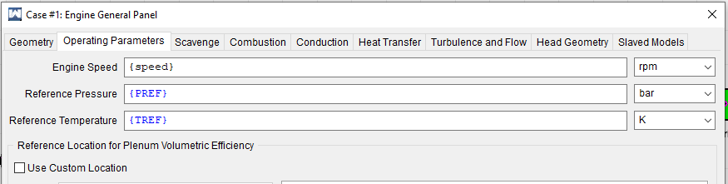
Figure 3.9 Engine General Panel Operating Parameters
On Combustion tab Siweibe1 location of 50% burn and combustion duration had constants applied.
- THB50 7 11 9.8
- BDUR 28.5 28.5 26.5
These values were selected from the Excel section for 50% MFB for THB50 and the difference between 10% and 90% MFB for BDUR. These values were slightly lowered or increased from the Excel values to fine tune the peak pressures. However, this was only done in small amounts
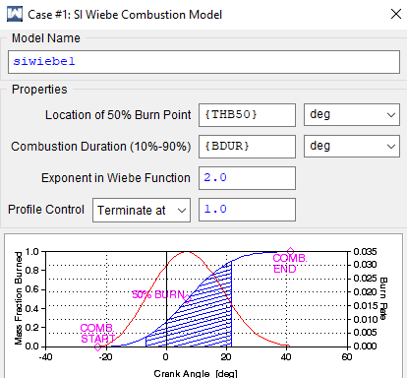
Figure 3.10 Wiebe Model
The temperature in the ambient panel was set to 20ºC as it was stated in the data sheet. This boosted the pressure slightly as the air molecules are more tightly packed together
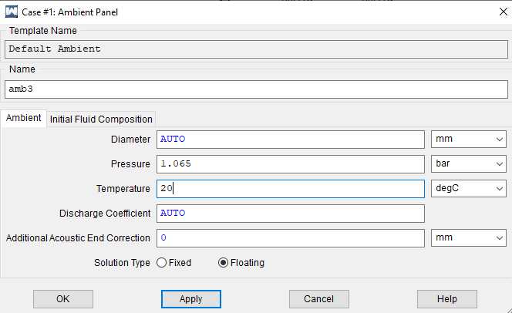
Figure 3.11 Ambient Panel
The final constant was set in the proportional injection panel to allow for varied fuel injection.
- FARD 0.071 0.081 0.083
FARD was the final constant that was chosen. It was used to modify the peak pressure of the cylinder. The data sheet also stated that the air/fuel ratio at 10250RPM was 12 or roughly 0.83$ϕ$. setting FARD to 0.071 at engine speed 14400 produced the highest peak pressure.
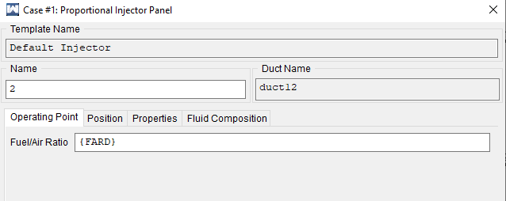
Figure 3.12 Injector Panel
Figure 3.13 shows the constants table used by WAVE. The final parameter adjusted was IOP which dictates when the inlet opens. The IOP was set at 267 across all 3 cases as the Triumph doesn’t have variable valve timing. The choice to move the IOP from 250 degrees to 267 was made when comparing to the exhaust lift profile when connected to EOP. As it was, there was a major overlap between the exhaust closing and the inlet opening. By setting the IOP to 267 the overlap was reduced reducing the risk of fuel rushing out the exhaust and resulted in values being closer to the dyno testing results. In addition to this the temperature of the piston, liner and head were modified but eventually reset back to their default value. When tweaking these values, it became apparent that reducing the initial temperature within the engine parts gave a slight boost to the peak pressure within the cylinder.
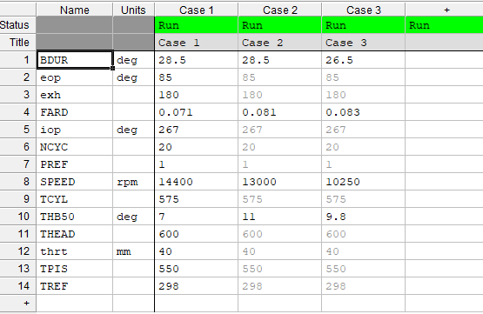
Figure 3.13 Constants Table

Results

Figure 4.1 10250RPM Wiebe

Figure 4.2 13000RPM Wiebe

Figure 4.3 14400RPM Wiebe
All 3 Wiebe graphs show close data between the dyno data and WAVE data figure 4.1 appears to have the largest error as the burn appears to happen over a longer duration. However, in general the data seems accurate to the dyno data especially figure 4.3 which practically identical other than the first few degrees. This suggests that the results depending on Wiebe should be accurate and that any issues with the simulation are likely not because of the Wiebe.

Figure 4.4 Pressure/Crank Angle 10250RPM

Figure 4.5 Pressure/Crank Angle 13000RPM

Figure 4.6 Pressure/Crank Angle 14400RPM
The pressure/Crank angle graphs produced by WAVE are very similar to the real-world data suggesting that the Engine has been accurately modelled. Figure 4.4 matches peak pressure with a 0.03% error as WAVE produced a peak pressure of 81.953bar whereas the dyno data peaked at 81.93bar the shape of the graph also appears to be almost identical suggesting accurate pressure results throughout the whole cycle. Figure 4.5 shows very similar accuracy with a 0.07% peak pressure error as WAVE produced 80.3016. Finally, Figure 4.6 is the least accurate looking graph, with an error of 2.1% and a slightly less matching graph shape it can be concluded that at this engine speed the WAVE model was less accurate then at previous speeds suggesting something might not be calculated correctly.

Figure 4.7 Volume/Clearance Volume 10250RPM

Figure 4.8 Volume/Clearance Volume 13000RPM

Figure 4.9 Volume/Clearance Volume 14400RPM
Pressure/Volume/ clearance volume graphs show again close results with some discrepancies within them. All WAVE produced graphs match correlate to the 12.7 compression ratio however, do not match the exact shape of the dyno data counterparts. As shown in the previous graphs section the peak pressure almost matches in figures 4.7 and 4.8. however, 4.9 doesn’t quite reach this standard but does match the Pressure/Volume/volume shape on expansion whereas the dyno side of figures 4.8 and 4.7 tend to both increase in pressure faster during compression and expansion. This again suggests possible errors when setting up the WAVE simulation.

Figure 4.10 LOGPV 10250RPM

Figure 4.11 LOGPV 13000RPM

Figure 4.12 LOGPV 14400RPM
The last set of graphs further support the previous set of graphs however, they also show the flaw in WAVE as WAVE is predicting its data under ideal (perfect) conditions. This is evident within figures 4.10 – 4.12 because although WAVE gets the general trend in shape correct the dyno data produces less smooth, noise interference data as the conditions are not ideal in real testing. However, with the general trends of the graphs matching up well it can be assumed that the WAVE setup is fairly accurate to the dyno data.

Discussion & Conclusion

Discussions
From testing this software and the various different inputs available to the user it was found that each variable seemed to affect the model in vastly different was or amounts. Burn duration and 50% burn constants had one of the largest effects on the peak pressure of the cylinder as a quicker combustion generally produced a higher peak pressure when within the realistic ranges obtained from the real data. Even slight changes of 0.1º of the 50% constant.
When modifying the IOP and EOP the its affects tended to vary. Some cylinders in general cylinders tended to lost pressure as IOP was increased however, more pressure was lost at lower RPM’s whereas EOP tended to be more unpredictable. Some modifications increased pressure at certain RPM’s but reduced it at others.
Finally, Fuel/Air Ratio in general began to reduce pressure the higher the number and increase the pressure when lower. However, there tended to be a limit on how low the ratio could be before the pressure started to plummet. The ratio tended to depend on the ambient pressure, higher ambient pressures tended to result in higher ratios whereas lower pressure tended to bring the minimum ratio down.
In general Ricardo WAVE looks like an accurate modelling software for users that have all information about an engine. As there are a lot of potential variables within WAVE it would be very difficult to model an engine without sufficient information on the engine. However, with all of the key information about the engine WAVE would make it very easy to make little changes quickly to simulate the result suggesting WAVE is a very useful model if all parameters are set correctly.

Conclusions
To conclude Ricardo provided mostly accurate results from the inputs provided. However, the results weren’t always identical to the real-world data. But some data like the pressure/crank angle data was modelled very accurately. In addition, the software looks to be very accurate when all parameters of the engine are correct set allowing for easy testing of new features.
Aim 1
The simulation model appeared to plot somewhat accurate data with one cylinder having a 0.03% peak pressure error, another having 0.07% and the final having a 2.1% error. With very small errors in terms of peak pressure the data can be seen as accurate. In general, the higher RPM had the lowest accuracy.
Aim 2
The software tended to plot nearly fully accurate data despite some input values not being confirmed as correct. With the software still predicting fairly close results even without the ideal values that the engine actually runs on it can be concluded that the software is capable of plotting accurate and reliable results as long as the user is equipped with all the relevant information about the engine being modelled.

