Using lesson study to identify if setting challenges in the continuous provision promotes creativity and critical thinking.

Student 1302734

6372 words excluding references and appendices.

Contents Page
Abstract and Aims and purpose 3
Research context 3
Overview of literature 4
Explanation of lesson study method 7
Ethical considerations 9
Lesson 1 and analysis 10
Lesson 2 and analysis 13
Lesson 3 and analysis 14
Discussion of research findings related to literature and research 16
Conclusions 17
Recommendations 18
References 20
Appendices A Leuven scale 23
B Gibbs’ reflective cycle 24
C Interview questions 25
D Child friendly assent form 26
E Lesson 1 planning 27
F Lesson 1 observation before the challenge was given 29
G Lesson 1 observation during the challenge 30
H Interview from lesson 1 31
I Lesson 2 planning 32
J Lesson 2 observation before the challenge was given 34
K Lesson 2 observation during the challenge 35
L Interview from lesson 2 36
M Cards from lesson 2 37
N Lesson 3 planning 38
O Lesson 3 observation before the challenge was given 41
P Lesson 3 observation during the challenge 42
Q Letter from the Easter bunny 43
R Resources for lesson 3 44
S Cards from lesson 3 45
T Interview from lesson 3 46
Using lesson study to identify if setting challenges in the continuous provision promotes creativity and critical thinking?

Abstract
This research project aims to identify how setting children challenges in the continuous provision enhances children’s creativity and critical thinking.
Two nursery classes and a reception class were used to conduct three lesson studies. The researchers planned and delivered three lessons and collected qualitative data. The data was analysed to enable the researches to improve their teaching to enhance children’s learning.

Aim, focus and purpose of the research
My second classroom experience teaching was in a local Nursery school. During my teaching experience, I observed that the children spent most of their school day playing in the continuous provision; the children play independently without input from an adult. I was interested to observe the learning that takes place within the continuous provision, how much creativity the children are using and if as a teacher, I can extend their learning while they are playing. As Csikszentmihalyi (1996:11, cited in Arthur et al, 2016) reinforces, if too few opportunities for curiosity are available, if too many obstacles are put in the way of risk and exploration, the motivation to engage in creative behaviour is easily extinguished. Furthermore, Flutter and Rudduck (2004, cited in Drake, 2009) point out that by the time that children go to secondary school, if not well before, they are hungry for real learning, when they can get stuck into tasks and problems that have meaning and relevance, rather than go over the same old exercises, time and time again. With relevance to this research the continuous provision being the same activities day in day out. With this in mind I was curious to explore more in depth how children learn best.
Research context
The school with regards to my part of the research project has 272 pupils coming from a variety of backgrounds; ranging from relatively prosperous to economically disadvantaged, although around 35% live in the 20% most deprived areas of Wales. Approximately 27% of pupils receive free school meals, which is above the local authority and national averages.
The Nursery school is in a separate building to the rest of the school. It is an old infant school, benefitting from having four spacious classrooms and a large outdoor area. The children are split into four groups of 13 children, the groups rotate during the school day experiencing the different classrooms throughout the day. There is a numeracy room, lets create room, literacy room and construction. An adult focused activity is undertaken daily, with the children having free-play in the continuous provision the rest of the time. With the new curriculum coming into effect in 2022 it is important to keep adult focused activities to a minimum as too much tightly directed activity deprives children the opportunity to explore their own ideas depriving them of being creative and independent (Donaldson, 2015).
As the children are playing in the same areas and doing the same activities every day I was curious to see what experiences the children were getting and if I could improve them.
I discussed my feelings with my research triad who also felt based on their experience, that the children were on occasions doing the same activity, in the areas which they felt comfortable in, without any challenge or creativity. The children do not necessarily think creatively and critically for themselves; everything is organised for them by the teacher for focused activities with a fixed outcome. Furthermore, during free-play the children are not given any challenge or observed to see how to move their learning on.
Therefore, the question we developed for our research was ‘Does setting challenges in the continuous provision promote creativity and critical thinking?’

Overview of literature
It is widely recognised that children learn through play, but it can be unclear how deep the learning is. Looking at research one of the first theorists to recognise the importance of play as an effective means to learning was Plato (Hanson, 2016). He believed that teachers need to create an environment that stimulates creativity for play, which can be done by challenging them to use their curiosity. Vygotsky (1978, cited in Moyles, 1990) researched further that children with support achieve above their level of ability through play. He believed that children need to be supported by a more able peer or by a teacher to push their learning into the zone of proximal development. Vygotsky (Aubrey and Riley, 2016) expands on this further by advocating that learning through experimental, challenging play scaffolded by a more able peer can develop vital thinking. Researcher Rogoff (1990, cited in Woodhead, 2016) built on the work of Piaget and Vygotsky stating that a child’s world is key to their development and that children need shared challenges with both adults and children, she concluded that it is important for children to participate in shared thinking and guided participation to enable creativity during play (Arthur et al, 2010).
In addition to this, Leavers (2000, cited in Robson, 2006) researched that children are more likely to be deeper involved in an activity if they are doing an activity of their choice participating with others, compared to an adult led activity.
With the changing curriculum coming into force in Wales, Donaldson (2015) promotes that play should be exciting, stimulating and challenging. One of the purposes of the new curriculum is to create individuals who are ambitious, seeking and enjoying challenges and enjoy problem solving using creativity. The process of being creative involves asking questions, making connections, exploring ideas, imagining what might be, and reflecting critically on the outcome. Donaldson (2015) emphasises that when play is well planned, it enhances children’s creative and problem-solving skills. This is a continuum from the Rumbold report (1990) which promoted the importance of play allowing children to be curious and creative to motivate them to want to learn more.
Casserley (2004, cited in Grigg, 2015) used research to indicate that creativity brings benefits in terms of pupil motivation, enthusiasm, independence and enjoyment. Furthermore, Grigg (2015) expands on this by explaining that teachers should set high expectations and be clear about anticipated outcomes. He continues that promoting creativity in the classroom does not mean providing pupils with a free rein but by supporting children, and that higher levels of creativity usually result when children have a willingness to experiment. In correlation to Grigg, Hattie (2015) indicates that to promote creative critical thinking, lessons should include a challenge. He expands on this reinforcing that teachers should act as mediators posing questions but that this isn’t widely adopted in schools because it does not fit into what many people think as being a good lesson. To instil children to have the confidence to critically think, activities should build on children’s prior knowledge and skills. His research found that by teachers challenging children to think critically it enhances their learning by 25%. This would indicate during a school year of nine months the learning would be extended by just over two months.
The National strategies for Early years (2010) develops this thinking further by advocating that by giving children a challenge within play is crucial to improving the quality of learning. However, there are ways in which it should be implemented to ensure that children feel comfortable and understand that there are many ways in which to undertake the activity and not feel anxious to try.
Research undertaken by Sylva et al (1976, cited in Broadhead et al, 2010) exemplifies this. A group of children were given free choice of play and another group were given a problem-solving exercise, it concluded that the children who were given free play were more inventive with devising strategies to solve the problem. The children who were in the adult led group either succeeded or gave up as it was too hard to use materials with which they were given. If children are steered towards a singular outcome which they are unable to complete it can provide the child with a negative mindset. More recent research is being undertaken at present by McIntyre (2016) he explains that play should connect experiences of vulnerability and surprise to curiosity and wonder, rather than to crippling anxiety. He is in the process of researching that little attention is given to play regarding critical and creative thinking.
However, the question remains whether children need an adult lead to begin to explore before they can be creative themselves. Michael Gove (Robinson, 2013) argues that before children can express themselves creatively they need to acquire basic skills and knowledge. Therefore, children need to understand the provision before they can be creative. This may mean that a challenge could be problematic unless they have had experience of using every piece of provision.
In contrast to theories supporting play, others believe that it is not as important. Brennan (1979, cited in Moyles, 1990) suggested that children achieve at a much lower level of ability during play. He suggested that if there is too much free choice the children get complacent with the provision which they play with every day. This would mean that the children would not be stretching their ability. More recently theorist Freud (2001, cited in Grigg, 2015) found that children begin life as passionate, curious and powerful learners and that their school experiences should enhance, rather than obstruct this journey. He continued that unstructured play can be described as chaotic, repetitive activity, ‘hands on brains off’. Similarly, Knapton (2017) conducted research into the benefits of play and found that if children have too much choice with provision it can be harmful for their learning. He found that children were more distracted and did not engage as they did when in a more focused activity with as little as four toys. His research showed that when choosing provision, it interfered with the duration and depth of play.
Despite barriers it is clear from research that challenging play is an important means for creativity, there are limitations with regards to the confidence of the child and the provision on offer. By doing the lesson study it will help to see this more in depth.

Explanation of lesson study design
The methodology used was lesson study research which consists of a detailed study of the practice of teaching. Peter Dudley introduced lesson study to the UK, conducting his first lesson study in 2001, although lesson study has been in use in Japan since the 1970s.
It is built on the hypothesis by Fernandes and Yoshida (2004) that the best way to improve education is to get teachers to study the processes of teaching and learning in the classroom and create ways to improve them. Dudley (2014) explains how Lesson study is classroom action research which focuses highly on the development of teacher practice knowledge. Lesson study has been used successfully to improve teaching techniques to develop pupil progress. In support of lesson study Sir Peter Williams (2008, cited in DfES, 2009) identified that it is a key professional model for improving Maths.
According to Dudley (2014) lesson study methodology consists of teachers collaboratively planning, teaching, observing and analysing learning and teaching. During a lesson study a small group of teachers use data to agree a focus to research. A lesson is planned jointly and taught by one of the teachers to address the focus, children are observed; typically, three case pupils. The lesson is reflected upon and children are interviewed to gather pupil voice to gain their insights into the research lesson. The data is shared during a post-lesson colloquium (Lewis et al, 2006), the information is reflected on and another lesson is planned, and the process starts again. Although lesson study has been around for many years albeit only 17 years in the UK, some (Lewis, 2006) believe that due to how little is known about lesson study it could be a fad in experimental research. Saito et al (2008, cited in Coe et al, 2014), have also reported that it can be bias as the researchers are going into a lesson with preconceptions of what they believe will happen. Lesson study has been proven to be effective which aids to dismiss these beliefs.
The methods of data commonly used for lesson study are non-participant and participant observations. By undertaking lesson study, it allows different perspectives regarding observations to ensure that results are not biased. Susan Isaacs (1937, cited in Grigg, 2015) emphasised the importance of observations as a tool to understanding young children stating that observations are powerful tools involving a process of watching and listening to children. Critics (Devereaux and Miller, 2003) believe there are constraints with observations as they can be difficult to manage due to time, that important information can be forgotten and that they should be undertaken by a highly skilled practitioner. In the same way Meadows et al (1998) believe observing and assessing play can be a difficult task to undertake and interpret. Although observation can be difficult and complex, it is identified as one of the most versatile ways of gathering information (Simpson et al, 2003).
Although it is recognised that observations are not regularly undertaken within early years classrooms, Frost (1992, cited in Papatheodorou, et al) highlighted the importance of observations. He believed that they should be undertaken daily to ensure that play is providing children with creativity and critical thinking amongst other areas of development.
The method used was the Leuven scale (Laevers, 1994) (APPENDIX A). The Leuven scale was developed under the supervision of Dr Ferre Laevers, having two central indicators to observe, the well-being and involvement of a child during the activity. Leuven researched that if a child has high levels of well-being and involvement during an activity, deep learning is taking place. Leuven links with Vygotsky’s (1978, cited in Robson, 2006) idea that to learn children need to stay involved with the activity in which they are doing. The Leuven scale identifies many signs to observe including: concentration, posture, persistence, precision, language and satisfaction.
The activity consisted of two parts: the first part where the children were playing in the continuous provision independently, observing their engagement, creativity and critical thinking. The second half of the lesson consisted of giving the children an independent ‘challenge’. The children were observed again to identify if their engagement was higher, and if they used creativity and critical thinking, or if they found it too difficult. Two observation records were produced; one filled in during the first part of the lesson and one during the second for comparison. The observation record contained the children’s names, the level on the Leuven scale and any additional notes. The researchers participating in the lesson study observed as non-participant observers. All the researchers were non-participant observers due to the observations needing to capture how the children used their creativity and critical thinking rather than the children being told what to do. The observation data was qualitative as no participant in the study had a preconceived idea as to what the outcome of the lesson study would be. The observation notes were taken into consideration alongside the interviews with the children for their insight into the study. Qualitative research can be construed as being bias, but due to the researchers working in a triad it extinguishes accusations of it being bias increasing its validity and reliability (Cowie et al, 2014).
The observations and interviews were used to reflect on the practice, reflective practice aims to improve the quality of learning and teaching. Furthermore, it is important to be open-minded with being reflective as Dewey (1933, cited in Pollard et al, 2014) points out it is important to listen to more than one side, to listen to facts from whatever source they come from and to give attention to all possibilities accepting error.
The reflections were captured using Gibbs’ (1998) reflective cycle (APPENDIX B). Gibbs’ reflective cycle emphasises that learning happens from experience and considers feelings surrounding the experience. The advantages of this method are that it gave a good structure to follow and it allowed all levels of the process to be assessed. The disadvantages of using Gibbs’ cycle were that the questions can be construed as being very narrow and can be difficult to interpret.
Three focus children were chosen; a child from the higher attainment group, middle attainment and lower attainment. This was to identify if the ability of a child made a difference. Due to a challenge being given and not differentiated, the children could choose how they decided to undertake the activity and if they wanted to do it. As the group was small all the children were observed throughout the activity, this was in the event of a child withdrawing from the research to ensure that there were other children in which their observations could be used. The children were interviewed as a group using semi structured interviews and by using open ended questions, which eliminate the risk of bias results (Pollard, 2014) (APPENDIX C). The aim was for the children to lead the interview, eliminating the risk of it being bias, as due to the age of the children they could have easily been led into saying what the researchers wanted them to. As the children were particularly young it was important that they felt comfortable to give their views.
Ethical considerations
There are ethical considerations linked with doing research. BERA (2011) guidelines were followed which recognise and support educational researchers conducting educational research to promote respect for all who are part of a research project. Prior to completing the lesson study, an ethics form was submitted explaining how ethical guidelines would be considered. The university mentor and the deputy head teacher signed to agree to the research being undertaken and the class teacher agreed to lesson study being undertaken in her class.
To eliminate any risks to participants all the children were treated equally. The children always had more than one adult present and were in a small group of children and at no point during the study was any child left alone. Children, schools and parents were asked for acceptance to use any information that may be deemed as personal for the research.
It is essential that children are willing to participate prior and during the research, so assent was gained from the children to provide them with opportunity to stop being part of the research at any time if they wished. The children were given a sticker with their name on, the children could either put their name on the smiley face if they were happy or the sad face if they wanted to stop taking part in the activity. The children were informed that they could move their name to the sad face at any time (APPENDIX D). This follows the UNCRC article 12 (1989) which emphasises that every child’s view was respected, considered and taken seriously and also that children should have a say in the matters which affect them.
In addition, Article 16 (UNCRC, 1989) was considered to protect the children’s privacy. To provide confidentiality and anonymity the names of the participants and the school remained anonymous. Any data transferred from one partner to another remained confidential and stored on a password encrypted memory stick.
All adults present for the research had previously received a Disclosure and Barring Service Certificate to allow them to work with children.

Lesson 1 (APPENDIX E)– Using the Gibbs reflective cycle
The children were all playing in the continuous provision on offer which consisted of Lego, painting, jigsaw, the home corner and the slide. The classroom contained all the continuous provision, so the children were used to the resources and how to play with them. Referring to the Leuven scale (APPENDIX F) the children were mainly all happy, engaged in playing but moving from provision to provision. Their expressions changed from being satisfied to happy, there was never any intense moments. The children were all fairly involved in continuous activity but were easily distracted. The children were not using creativity as they were doing activities which they normally do using the provision which was already out. The children were happy to play with their peers and without the support from an adult.
Half way through the lesson the teacher explained to the children about Easter and that they would be making Easter cards to take home for their families. The children were told that they could play in the continuous provision and make cards using any resources that they wanted to. No resources were put out and it was up to the children to get what they needed, to make the cards. The children were not provided with any other information, pictures or ideas.
No children participated in the activity, within this lesson there were no resources and no cards to look at for guidance or as a scaffold. The researchers felt that the children were confused and not confident in knowing how to make a card and what to use. It was obvious from the observations (APPENDIX G) that the children were comfortable in the continuous provision which was evident from their well-being on the Leuven scales. Using the Leuven scale the children scored the same as they did before the challenge as they did not participate and stayed within the continuous provision.
The researchers found that it was difficult to watch the children looking curious to participate but not knowing what to do. They also felt that they wanted to give them guidance so that they would participate. One of the children said to her friend ‘Miss Lewis said we must make cards’, but the girls carried on playing.
On observation it was good to see the children playing in the continuous provision, enhancing their language and social skills. Unfortunately, they were not using creativity or critical thinking as they were in an area in which they were comfortable and where they spent every day. There were not any signs of intense involvement or the children feeling proud of what they were achieving.

The researchers discovered that without any visual clues or scaffolding the children struggle to be creative and stay within their comfort zone, which using Vygotsky’s (197 8) theory of the zone of proximal development is not extending the children’s learning.
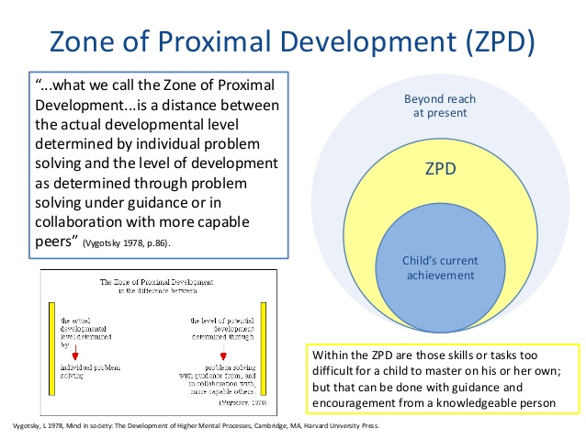Vygotsky (1998)
Where the child is comfortable.
As the children didn’t participate, the researchers were unable to determine whether the children’s involvement and wellbeing changed when a challenge was given. The children carried on doing what they had been doing previously, so it was difficult to interpret their creativity and critical thinking.
During the interview with the children (APPENDIX H) none of them mentioned that one of the activities were to make cards. They spoke about what they had been doing confidently but with little enthusiasm. When asked if they could explain what they had made, two of the focused children said that they didn’t know what to do, the third child talked about that they had made food in the house. When the children were asked if they would like to participate in a challenge next time the children were forthcoming in telling the researchers that they didn’t know, as they didn’t know what to do.
The researchers felt that giving the children an activity that they were unable to undertake would have given them a negative mindset. As previously mentioned Hattie (2015) re-emphasises this as he believed that if children are unable to participate in an activity which is too difficult for them or in this instance too complicated it will give them a negative mindset.
In the next lesson the researchers decided that to scaffold the children they would give them pictures and pre-made cards to give the children ideas. The children would be told not to copy the designs but that they needed to make their own cards with their ideas. The children would be expected to find their own resources to use but could use whatever they wanted to.

Analysis of lesson 2 – (APPENDIX I)

The register was taken, and the children were told that they could choose where they wanted to play within the continuous provision. Four children are allowed in each area at a time to allow the children to make full use of the provision to enhance their learning. Referring to the Leuven scale (APPENDIX J) the children were comfortable, happy but without any intense moments of wellbeing or involvement. The children moved from one area to another when they decided to and if there was space for them. The children used the provision on offer for them and did not choose any resources which were in the cupboard or drawers, they were complacent and did not stretch their ability. As Brennan (1979, cited in Moyles, 1990) states this is a common problem with children playing without a challenge.
Half way through the lesson the children were informed of their challenge. They were told that they needed to make an Easter card. The teacher showed the children a selection of cards that he had made but told the class that he wanted them to use their thinking hats to make their own cards. Bono (1999, cited in Arthur et al, 2007) claims that by using thinking hats encourages children to think creatively. The children were also informed that they would have to find their own resources using anything that they wanted to.
The children went back to the areas in which they had been playing in with only two children deciding to undertake the activity. The children found the card and what they wanted to use by themselves independently. The other children continued to play oblivious to the other children making the cards.
Referring to the Leuven scale (APPENDIX K) the children’s level of involvement was mid-range as they were unsure what to do, so they stayed within their comfort zone. When interviewed (APPENDIX L) the children were anxious as they were unsure what they were doing, some of the children wanted to participate but they were unsure how to and did not understand what they needed to get out. As Gove (Robinson, 2013) argued children need the basic skills and knowledge before they can undertake an activity independently to express their creativity.
The researchers wished that they had told the children which resources they could use, as this would have given the children the confidence to go and get them and they would have participated.
It was good that two of the children were willing to participate, they used their creativity to make their own card and did not copy the pre-made cards or photos. Their creativity was evident as they both made different cards as shown in (APPENDIX M).
It was disappointing that four of the children which were observed did not participate as they did not know which resources to use and they chose to stay within their comfort zone of continuous provision.
Through observations and interviews the researchers discovered that at this young age children need more scaffolding despite their attainment. When discussing the lesson, the researchers referred to when they are teaching in an everyday situation, when a new resource is placed in the classroom as enhanced provision it is shown to the children and role-modelled first, for them to understand how to use it.
From undertaking this lesson, the researchers found that by having a scaffold the children were more confident and more likely to participate in a challenge and use their creativity. Based on this lesson the researchers decided that in the next lesson they would give the children pictures of cards but also a selection of resources for them to choose.

Analysis of lesson 3 – Lesson plan (APPENDIX N)
The children were taken into the creative classroom and told that they had free choice. The children went straight into the different continuous provision choices on offer. The children were told that they could make anything that they wanted to. Some of the children chose to paint, while others chose to go in the role play and small world area. On observation using the Leuven scale (APPENDIX O) the children were satisfied but were not fully engaged in any activity in which they were doing. They were being creative but in a way that they were not challenged as they were doing activities that they do every day and which they are comfortable with. With reference to Flutter and Rudduck (2004, cited in Drake, 2009) as children get older they are hungry for more than just doing the same exercises over and over and again. Half way through the lesson the researcher stopped the children and told them that a letter (APPENDIX Q) had come from the Easter Bunny asking the children to make Easter cards for the Easter bunny’s friends. The researcher showed the children a selection of cards and put a wide selection of resources on the table (APPENDIX R). The children were told that they could use anything they wanted to make their own cards.
All the children took part in this lesson immediately and independently, analysing the observations using the Leven scale (APPENDIX P) the children were lively, energised and motivated. The children were all confident with the activity and showed creativity and critical thinking as all the cards were different and the children were independent (APPENDIX S).
The researchers were pleased that they could see the children all engaged, independent and being creative. The children shared resources and helped each other, it was nice to see that they did not need any adult input. If they needed a resource the children scaffolded each other. When interviewed (APPENDIX T) all the children spoke about making the cards and that they would like to participate in another challenge, which is largely different from the first lesson which the researchers planned.
The good aspects of the lesson were that all the children participated and were creative, unfortunately there were negative aspects as the children were not totally independent as they did not get the resources for themselves. This is not to say that with time and confidence to get the resources that they need it would not happen in the future.
The children were independent being creative but needed the scaffold of a visual aid and the resources available to them to allow them to undertake the activity. This links in with Vygotsky’s (1978, cited in Moyles, 1990) theory that with a scaffold children are emerged into their zone of proximal development which enhances their learning.
Using all the observations and interviews if the researchers were to undertake the lesson study again they decided that they would role model a card and see if by it being visual to children whether they would be creative and independent to think critically for themselves. They would also ensure that the children were independent in using the resources and that they know where they are.

Discussion of research findings to related literature and research
The researchers found that setting a challenge did enable children to be creative and think critically. But, firstly to be creative and undertake challenges the children did need a scaffold to feel comfortable.
Furthermore, the observations found that as Freud (2001, cited in Grigg, 2015) stated, when the children were playing in the continuous provision they were not being creative as they were never fully engaged as they were going between the repetitive activities.
During the challenges the researches became aware of the impact of setting a challenge which was too difficult. The children felt anxious to try and did not even begin, this as Grigg (2015) argues is a barrier when children are given a ‘free-reign’ rather than supported to use their creativity. When the researchers were discussing the first lesson they discussed that some children may not see many cards especially Easter cards. The children were only four years of age and may not remember having an Easter card previously, Michael Gove (Robinson, 2013) emphasised that a challenge will not work if a child does not have prior knowledge.
The children who participated in the activity were more comfortable, happy and engaged using their creativity when they knew the resources which they could use, Hattie (2015) reinforced this by stating that for children to be creative they need to have prior knowledge and skills of the resources available to them.
In addition to this the children’s mindset was considered during all the lessons. According to Donaldson (2015) it is important for children to be ambitious, confident individuals who have a positive mindset, During the observation in the third lesson it was evident that when the play was more well-planned and resourced the children were happier and used their creative, critical thinking and problem-solving skills. The children were more anxious in lesson one which would have encompassed a more negative mindset.
Furthermore, although the activity was adult focused but with more of a challenge the children could be creative. The researchers found that when they had been in previous schools and a special occasion was celebrated and the children were asked to make cards all the cards would look the same. The children wouldn’t use creativity and would be scaffolded by an adult to provide a single outcome which would be thirty cards looking the same. The research showed that by allowing the children to be challenged with a focus but without a definite outcome the children were deeper involved in the activity which focuses on research by Donaldson (2015). The children within the research were pushed into their zone of proximal development but as Vygotsky (1978) advocates it must be at a safe level scaffolded by a more able peer or adult to allow the child to undertake the activity.
From undertaking the lesson study, the researchers established that to ensure that children have a stimulating experience they need to be scaffolded and as with Knaptons (2017) research proved that children are more distracted and not as engaged when they have the choice of too much provision. The children in the research participated which in turn showed creativity when placed with several resources rather than getting their own and a complete free choice.

Conclusion
None of the researchers had ever participated in a lesson study. As Yoshida and Fernandes (2004) point out it did provide the researchers with ways of analysing and reflecting on a lesson to improve children’s education. The researchers found it interesting to have an insight into other teachers views on a lesson, as Dewey (1933, cited in Pollard et al, 2014) iterates it is important to listen to more than one side to ensure that bias views are avoided. The children were at the heart of the lesson study always and the researchers were clear to gain assent regularly. The children felt comfortable with extra adults in the class as Meyer et al (2010) states when children are presented with a few extra adults in their class it can be daunting especially when it is adults that the children do not know.
The data collection methods were proven to be effective, they were simple to use and enabled the researchers to analyse the findings easily. There is a limitation when doing lesson study that anomalies can be found within results of data. The researchers had decided on different results using the Leuven scale, even though this was the case it did not affect the overall results as the anomalies were minor discrepancies.
Three very different primary schools were used for this lesson study. Generally speaking all children have a selection of continuous provision within their classrooms and have used resources within their classrooms. Saying that the researchers were aware that due to the different nature of the schools and the vast range of attainment and independence of the children that could be a limitation with regards to the data. Unless the data is collected from the same type of school with the same academic attainments of children it is impossible to make a true comparison. Some critics (Pollard, 2014) may believe that due to these differences between the schools and children it could make the data less valid. To ensure that in the future the data from a lesson study is more valid the lessons could be undertaken in the same class with the same children, this would ensure a more accurate result in data.
As previously stated within the essay many researchers believe that children need to have previous knowledge before they can be creative to undertake an activity. The researchers were unsure if any of the children had previously made Easter cards and what resources they had used. This could be a limitation as if children had made them before they would more likely know what to do again.
Furthermore, the researchers concentrated on how much creativity children used when they were challenged but they may have missed any creativity that was happening in the other areas in the classroom.
The Gibbs’ reflective cycle proved to be an efficient way to reflect on the lesson, although the questions are narrow, the researchers found them easy to interpret and an effective way to analyse the effectiveness of a lesson and ways forward.
The lesson study gave the researches the data to enable them to answer the research question and give them ideas on how to improve their future teaching practices. It showed that in the future children should be given the opportunities to explore provision and resources before a challenge is set. By having this prior knowledge and a scaffold the children’s learning will be enhanced and by having a challenge it would promote critical thinking and creativity.

Recommendations
In the future I would participate in another lesson study as it improves teaching to enhance children’s learning. Instead of using three totally different schools I would chose to do the lesson study using the same children for all the lessons, this will give more accurate data.
I would like to develop the idea of setting challenges further by researching into cognitive acceleration and to develop children’s metacognition which will give children the skills to problem solve (Arthur et all, 2007). The children would be provided with a variety of challenges and steps would be taken to achieve the challenge. The steps classified by Adey (2002, cited in Arthur et al, 2007) work through strategies to enhance the cognitive acceleration process. This introduces children to more than just a challenge but ways to tackle a challenge, thinking about it, talking about it, tackling it and how children can use the skills for future activities.

6372 words excluding references and appendices.

References
Arthur J, Grainger T, Wray D. 2006. Learning to teach in the primary school. London: Routledge.
Aubrey, K. Riley, A. (2016) Understanding and using Educational theories. London: Sage Publications.
British Educational Research Association (2011) Ethical guidelines for educational research. London. BERA
Broadhead, Howard, J. Wood, E. (2010) Play and learning in the early years. Sage: London
Coe, R., Aloisi, C., Higgins, S., and Major, L.E. (2014) What makes great teaching? Review of the underpinning research. Sutton Trust.
Cowie, H. Huser, C. Myers, C. (2014) The use of participatory Methods in researching the experiences of children and young people. [Online] https://hrcak.hr/file/185021 cited on [24th March 2018].
DCFS (2010) Challenging practice to further improve learning, playing and interacting in the Early Years Foundation Stage [Available online]https://www.foundationyears.org.uk/wp-content/uploads/2011/10/Challening_Practice_to_Further_Improve_Learning_Playing_and_Interacting_in_the_EYFS.pdf. [Accessed on 29th March 2018].
Devereaux, J and Miller, L, (2003) Working with Children in the Early Years. Oxon: David Fulton Publishers.
Donaldson, G. (2015) Successful futures. Independent Review of the Curriculum and Assessment Arrangements in Wales.
Drake, J. (2009) 3rd ed. Planning for childrens play and learning. Meeting childrens needs in the later stages of the EYFS. Routledge: London.
Dudley, P. (2014) Lesson study, Professional learning for our time. Routledge London.
Fernandez, C. Yoshida, M. (2004). Lesson study: A Japanese approach to improving mathematics teaching and learning. MLEA, publishers US.
Gibbs, G. (1998) Learning by doing A guide to teaching and training methods. FEU: London University
Grigg, R. (2015) 2nd Edition. Becoming an Outstanding Primary School Teacher. Oxon: Routledge Taylor and Frances Group.
Hanson, K. (2017) Accessing the Curricular Play of Critical and Creative Thinking [online] Available at www.journals.sfu.ca/cje/index.php/cje. [Accessed on 5th March 2018].
Hattie, J. (2009) Visible learning for teachers, Maximizing impact on learning. Oxon: Routledge.
Hattie, J. (2015) Hattie ranking: 195 influences and effect sizes related to student achievement. [Online]. Available at: https//visible-learning.org/hattie-ranking-influences-effect-sizes-learning-achievement. [Accessed on 25th October 2017].

Knapton, S. (2017) Too many toys are bad for children study suggests [online] Available at www.telegraph.co.uk/science/2017/12/05/many-toys-bad-children-study-suggests/amp
Laevers, F. (1994) The Leuven scale for young children. Centre for experimental education. Belgium: Laevers.
Leuvers, F. (1994) Involvement scales [Online] https://www.google.co.uk/search?q=leuvers+involvement+scale&source=lnms&tbm=isch&sa=X&ved=0ahUKEwjwwabXpZHaAhVBD8AKHWZsBwMQ_AUICigB&biw=1518&bih=723#imgrc=iC0FWxVy1p5PmM: [Accessed on 14th March 2018]
Lewis, S. (2006) A Randomized Trial of Lesson Study with Mathematical Resource Kits: Analysis of Impact on Teachers’ Beliefs and Learning Community. [Online] https://link.springer.com/chapter/10.1007/978-3-319-07716-1_7 [Accessed on 30th March 2018].
Meadows, S. & Cashdan, A. (1988) Helping children learn: contributions to a cognitive curriculum. London: David Fulton.
Moyles, J. (1990) Just playing. Milton Keynes: Oxford University Press.
Papatheodorou, T. and Luff, P. (2011) Child observation for learning and research. London: Routledge.
Pollard, A. (2014) 4th Ed. Reflective teaching in schools. Bloomsbury: London
Robson, S. (2006) Developing thinking and understanding n young children: an introduction for students. London: Routledge.
Robinson A. (2013) Early schooling damaging children wellbeing [online] https://www.theguardian.com/education/2013/sep/12/early-years-schooling-damaging-wellbeing. [Accessed on 28th March 2018].
Rumbold, A. (1990) Starting with quality: the report of the committee of inquiry into the quality of the educational experience offered to 3 and 4-year old. London: H.M.S.O. Simpson, M. Tuson, J. (2003) Using observations in small scale research. SRCE: Glasgow.
Turner, J. Meyer, D. (2010) Studying and Understanding the Instructional Contexts of Classrooms: Using our Past to Forge our Future [Online]. Available at https://www.tandfonline.com/doi/abs/. [Accessed on March 28th, 2018].
United Nations Convention on the Rights of the child. (1989) [Online] Available at htps://downloads.unicef.org.uk/wp-content/uploads/2010/05/UNCRC_summary-1.pdf [Accessed on 5th March 2018].
Vygotsky, L. (1978) [Online] Available at http://image.slidesharecdn.com/week7socio-culturaldevelopment2012-130228002852-phpapp02/95/sociocultural-development-vygotsky-14-638.jpg?cb=1362011474. [Accessed on 29th March 2018].
Woodhead, M. (2016) Changing perspectives on early childhood: theory, research and policy. [Online] Available at http://oro.open.ac.uk/6778/1/Woodhead_paper_for_UNESCO_EFA_2007.pdf. [Accessed on 29th March 2018].
Williams, P. (2008) Independent Review of Mathematics Teaching in Early Years Settings and Primary School. [Online] http://www.childrensmathematics.net/williams_maths_review.pdf [Accessed on 28th March 2018].

APPENDIX A – Leuven scales for wellbeing and involvement.
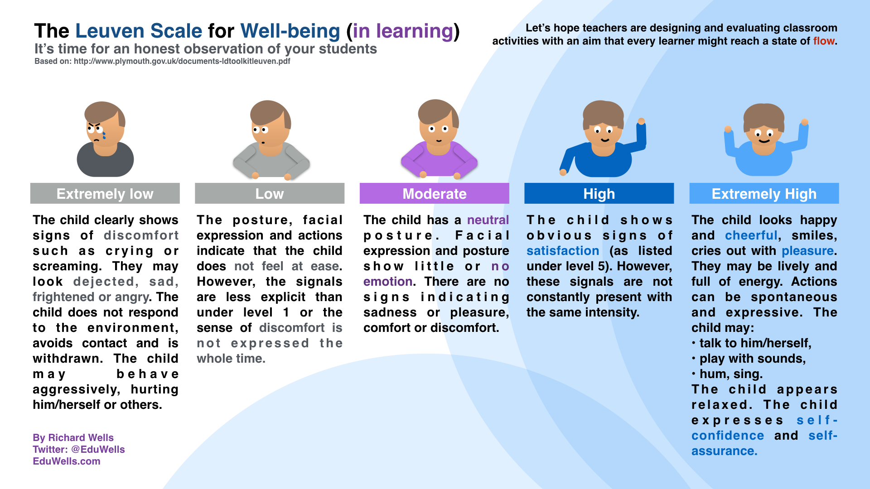

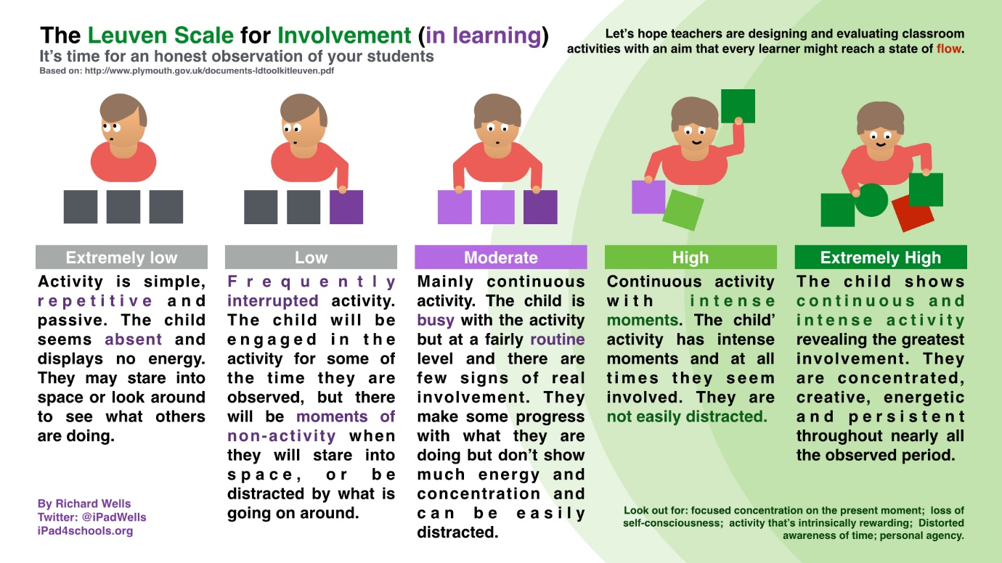

APPENDIX B - Gibbs’ reflective cycle



APPENDIX C – Interview questions

- What activities did you do in today’s lesson?
- What did you like doing best?
- What didn’t you like doing?
- What would you like to do next time?
- Would you like to do another challenge?
- Can you explain to us what you made?
- How did you feel when you were playing?

If a child doesn’t complete the activity we will ask:
- Why didn’t you want to do the challenge?
- What would you prefer to do next time?

APPENDIX D – Child friendly assent form




APPENDIX E - Lesson one plan
Name of Trainee: | Emily Lewis |  |  | Session ref: |  | TET – Lesson 1 |  | Date: |  |  |  |  | Class: | Nursery – Williams |  |  | Cynllun Ffocws y Cyfnod Sylfaen  2d
Targed(au) Hyfforddi Personol |  |  |  |  |  |  |  | Number of learners: |  |  |  | 6 | Age: | 3 – 4 Years |  |  | Cynllun Ffocws y Cyfnod Sylfaen  2d
Learning objectives/intentions: |  | Design and make simple products |  |  |  |  | Success Criteria |  | - Use appropriate materials to make an Easter card |  |  |  |  | Meeting learners’ needs:
Introduction/plenary tasks |  |  |  |  | Main activities |  |  |  |  |  | Resources/  Key Vocabulary |  |  |  | Assessment for Learning (strategies and opportunities)
Introduction  Explain to children that they will be taking part in a research study  Show children their smiley face consent poster and explain  Explain to children that they will have free choice activities for 10 minutes.  (While children are taking part in this we will observe their involvement using the Leuven Scale) |  |  |  |  | Trainee focused task (purpose, outline of trainee’s role and children’s learning):  After children have participated in free choice for 10 minutes we will ask the children to make an Easter card.  The children will not be directed in this activity and will have free choice in what material and design they wish to use.  (While children are completing this task, we will observe their involvement using the Leuven Scale) |  |  |  |  |  | A4 card  Leuven Scale  Observation record sheet  Glue  Glitter  Paint  Crayons  Felts  Pencils  Rubbers  Paint brushes  Happy/Sad poster  Childrens names |  |  |  | Formative feedback  Self Assessment  Peer Assessment  Traffic Light
Additional adult tasks (purpose, outline of additional adults’ role and children’s learning):

Observing using the Leuven Scale.
Plenary  Children will show each other their designs and say what they like and improvements. (two stars and a wish)  Children who have taken part in the research will then be asked to participate in an interview. |  |  |  |  | Independent learning opportunities:  Making the Easter Card using creative and critical thinking.
Curriculum coverage (range and skills)
Use a wide range of resources and stimuli
Be involved in activities that allow them to buld as individuals
Experience celebrations and traditions of different cultures
Literacy (LNF)  Experiment with a range of mark making instruments and materials |  |  |  |  |  |  |  |  |  |  | Numeracy (LNF)  Identify steps to complete the task or reach a solution
DCF |  |  |  |  | Thinking  - Learners know how to improve  - Develop greater self-assessment and autonomy of learning  - Active engagement  - Application of ideas |  |  |  |  |  | ESDGC  Recyclable materials |  |  |  | YCC

APPENDIX F – Observation before the challenge

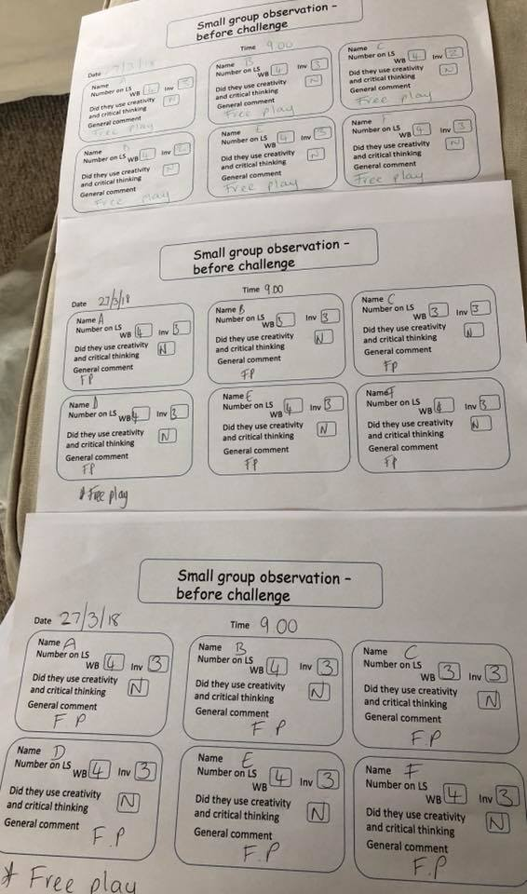
APPENDIX G – Observation record during the challenge
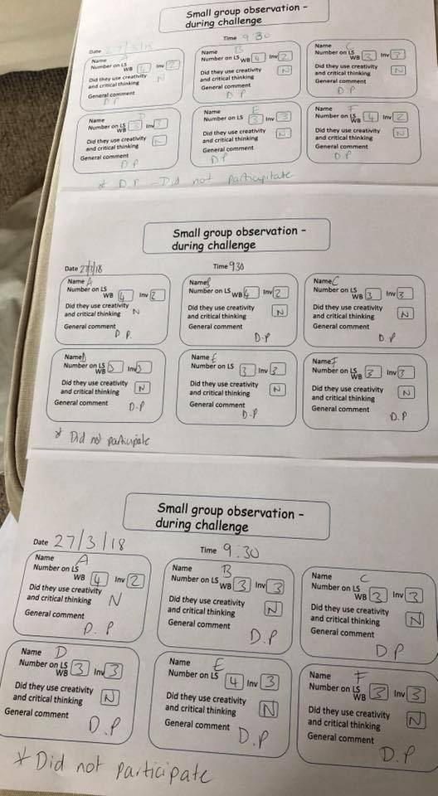

APPENDIX H – Interview from lesson 1
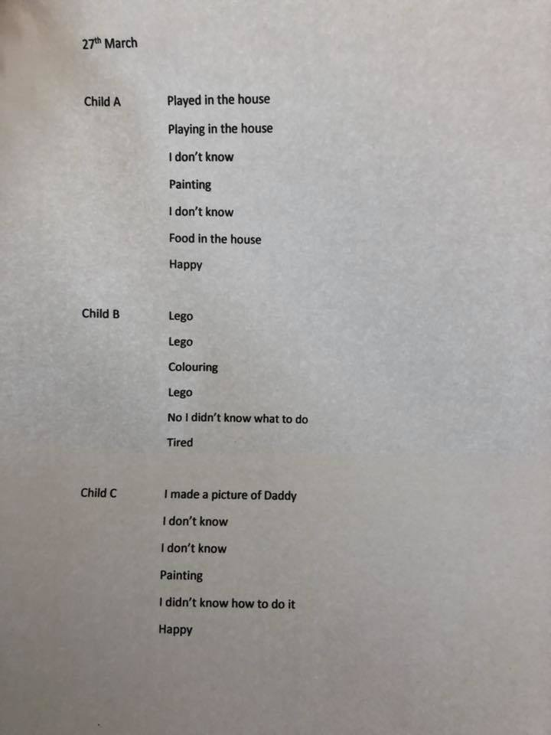

APPENDIX I – Lesson plan for 2nd lesson
Name of Trainee: | Darren |  |  | Session ref: |  | TET |  | Date: |  | 28th March 2018 |  |  | Class: | Reception |  |  | Cynllun Ffocws y Cyfnod Sylfaen  2d
Targed(au) Hyfforddi Personol |  |  |  |  |  |  |  | Number of learners: |  |  |  |  | Age: | 4 – 5 year old’s |  |  | Cynllun Ffocws y Cyfnod Sylfaen  2d
Learning objectives/intentions: |  | Design and make simple products |  |  |  |  | Success Criteria |  | Use appropriate materials to make an Easter card |  |  |  |  | Meeting learners’ needs:
Introduction/plenary tasks |  |  |  |  | Main activities |  |  |  |  |  | Resources/  Key Vocabulary |  |  |  | Assessment for Learning (strategies and opportunities)
Introduction  Explain to children that they will be taking part in a research study  Show children their smiley face consent poster and explain  Explain to children that they will have free choice activities for 10 minutes.  (While children are taking part in this we will observe their involvement using the Leuven Scale) |  |  |  |  | Trainee focused task (purpose, outline of trainee’s role and children’s learning):  Children will be shown a selection of Easter cards. They will be asked to create their own, using whatever resources they would like.  Take photos throughout the activity. |  |  |  |  |  | Leuven Scale  Observation record sheet  Glue  Glitter  Paint  Crayons  Felts  Pencils  Rubbers  Paint brushes  Happy/Sad poster  Childrens names |  |  |  | Formative feedback  Self Assessment  Peer Assessment  Traffic Light
Additional adult tasks (purpose, outline of additional adults’ role and children’s learning):

Observe children using the Leuven Scale
Plenary  Once the children have completed their card they will be brought onto the carpet to look at the photos taken throughout the activity. Children will be asked about the process of making the cards and what they liked and disliked.  Children who have taken part in the research will need to take part in the interview questions. |  |  |  |  | Independent learning opportunities:  Making the Easter Card using creative and critical thinking.
Curriculum coverage (range and skills)

Use a wide range of resources and stimuli
Be involved in activities that allow them to buld as individuals
Experience celebrations and traditions of different cultures
Literacy (LNF)  Experiment with a range of mark making instruments and materials |  |  |  |  |  |  |  |  |  |  | Numeracy (LNF)  Identify steps to complete the task or reach a solution
DCF  Recognizing people in a photo |  |  |  |  | Thinking  - Learners know how to improve  - Develop greater self-assessment and autonomy of learning  - Active engagement  - Application of ideas |  |  |  |  |  | ESDGC  Recyclable materials |  |  |  | YCC

APPENDIX J – Observation record from before the challenge

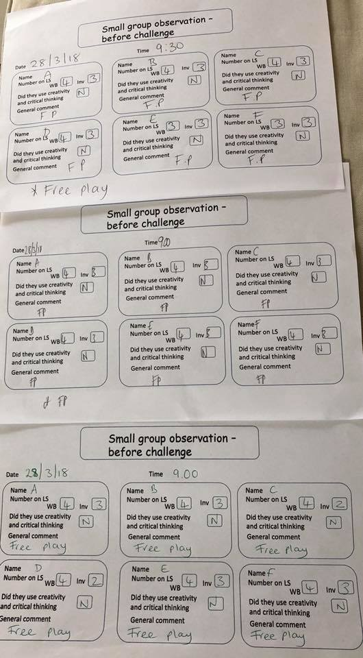

APPENDIX K – Observation sheet from during the challenge
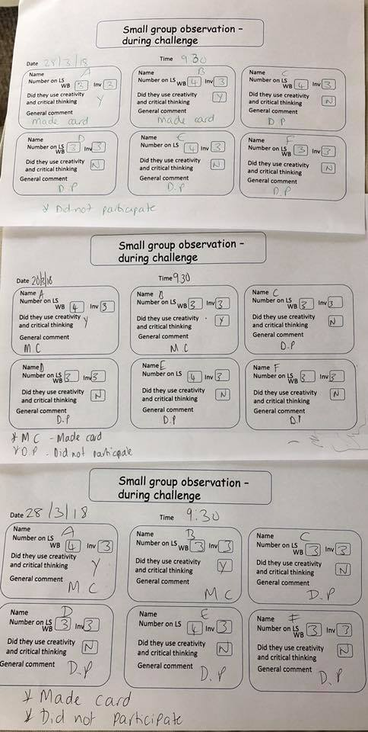

APPENDIX L – Interview from the second lesson
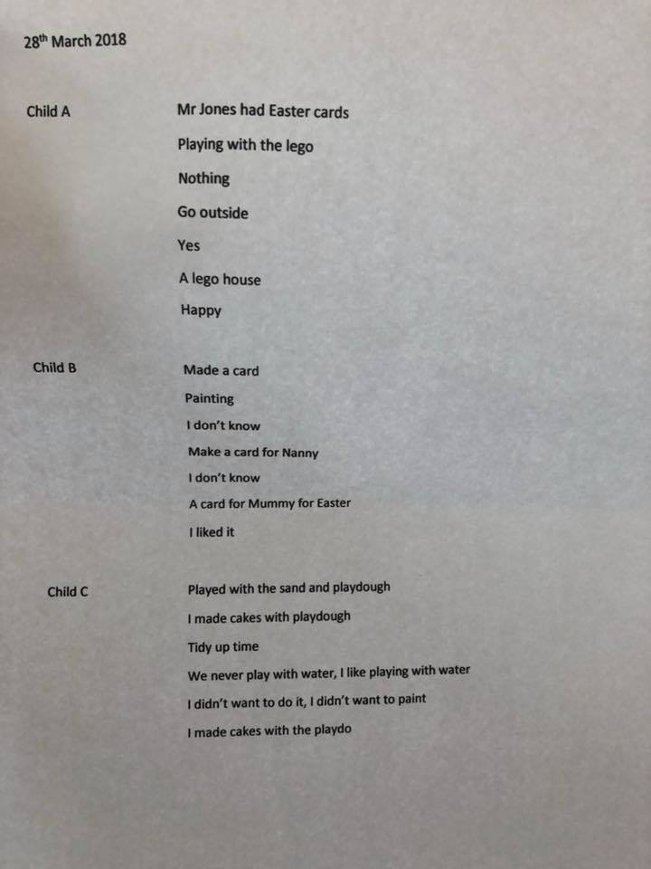

APPENDIX M – Cards from the second lesson
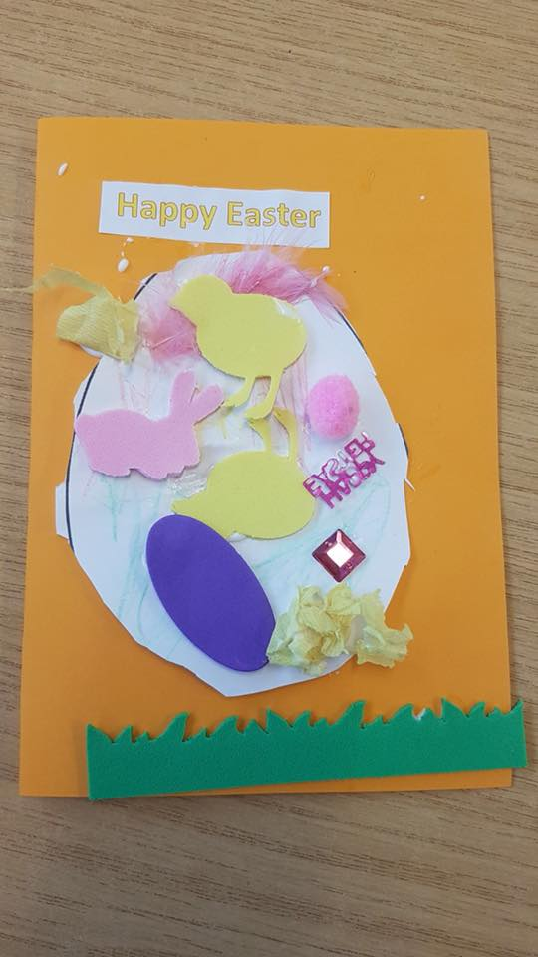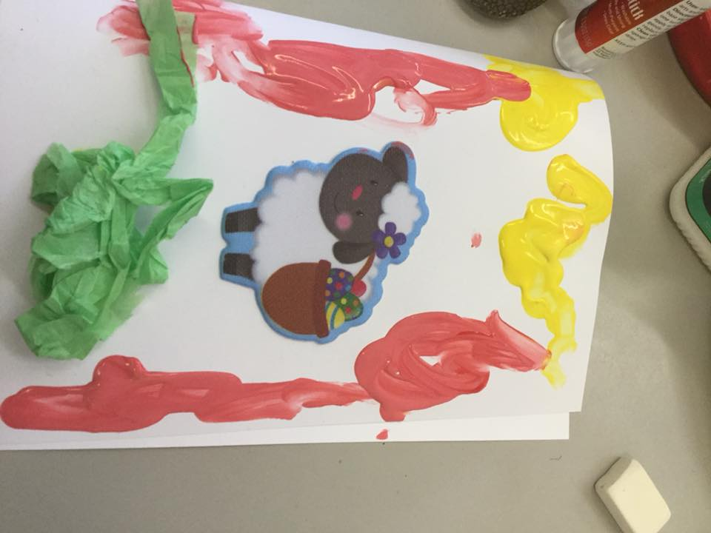

APPENDIX N – Plan for lesson 3
Name of Trainee: | Melissa Preece |  |  | Session ref: |  | TET – Lesson 3 |  | Date: |  | 29th March 2018 |  |  | Class: | Nursery – Richards |  |  | Cynllun Ffocws y Cyfnod Sylfaen  2d
Targed(au) Hyfforddi Personol |  |  |  |  |  |  |  | Number of learners: |  |  |  | 13 | Age: | 3 – 4 years old |  |  | Cynllun Ffocws y Cyfnod Sylfaen  2d
Learning objectives/intentions: |  | Design and make simple products |  |  |  |  | Success Criteria |  | Use appropriate materials to make an Easter card |  |  |  |  | Meeting learners’ needs:
Introduction/plenary tasks |  |  |  |  | Main activities |  |  |  |  |  | Resources/  Key Vocabulary |  |  |  | Assessment for Learning (strategies and opportunities)
Introduction  Explain to children that they will be taking part in a research study  Show children their smiley face consent poster and explain  Explain to children that they will have free choice activities for 10 minutes.  (While children are taking part in this we will observe their involvement using the Leuven Scale) |  |  |  |  | Trainee focused task (purpose, outline of trainee’s role and children’s learning):  After children have participated in free choice for ten minutes they will be gathered together to show them Easter cards. The children will be told that they are going to create an Easter card, using the template that is given.  (Throughout the activity the children will have pitstops, that are designed for them to share their work with each other) |  |  |  |  |  | Easter card template  Leuven Scale  Observation record sheet  Glue  Glitter  Paint  Crayons  Felts  Pencils  Rubbers  Paint brushes  Happy/Sad poster  Childrens names |  |  |  | Formative feedback  Self Assessment  Peer Assessment  Traffic Light
Additional adult tasks (purpose, outline of additional adults’ role and children’s learning):

Other adults will observe the childrens involvement in the activity by using the Leuven Scale.
Plenary  Children will share their work with the rest of the group and discuss what they like, dislike and would do differently next time.  Children who have taken part in the research will then be asked to participate in an interview. |  |  |  |  | Independent learning opportunities:  Making the Easter Card using creative and critical thinking.
Curriculum coverage (range and skills)
Use a wide range of resources and stimuli
Be involved in activities that allow them to buld as individuals
Experience celebrations and traditions of different cultures
Literacy (LNF)  Experiment with a range of mark making instruments and materials |  |  |  |  |  |  |  |  |  |  | Numeracy (LNF)  Identify steps to complete the task or reach a solution
DCF  Recognizing people in a photo |  |  |  |  | Thinking  - Learners know how to improve  - Develop greater self-assessment and autonomy of learning  - Active engagement  - Application of ideas |  |  |  |  |  | ESDGC  Recyclable materials |  |  |  | YCC

APPENDIX O – Observation record from before the challenge
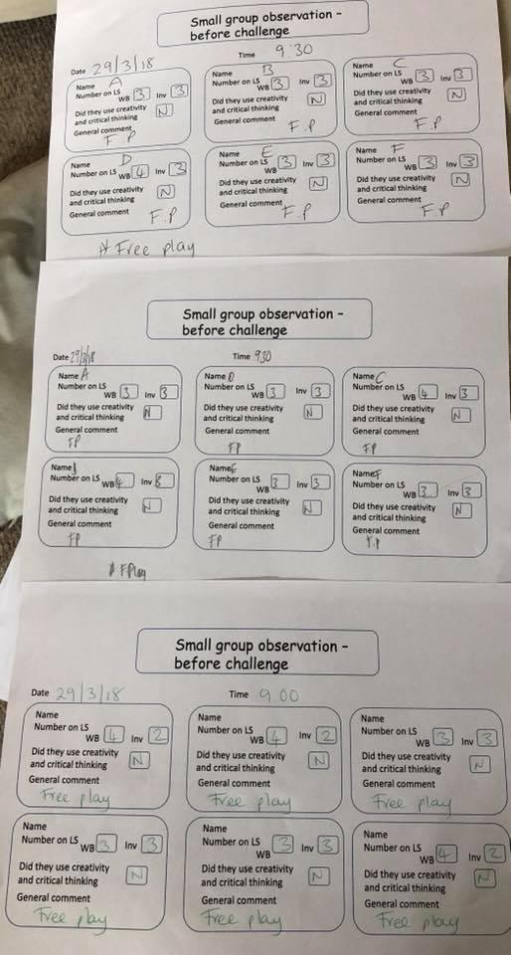

APPENDIX P – Observation record from during the challenge
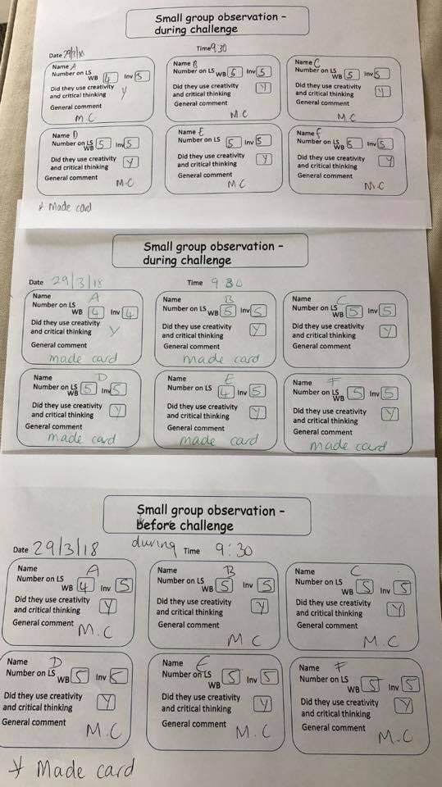

APPENDIX Q- Letter from Easter bunny

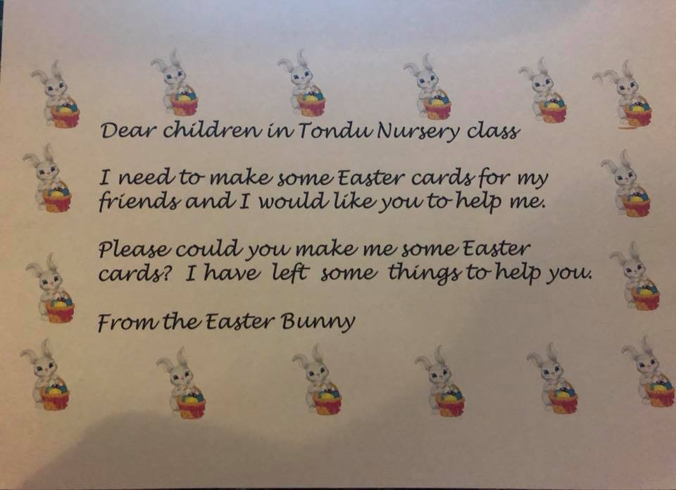

APPENDIX R - Resources
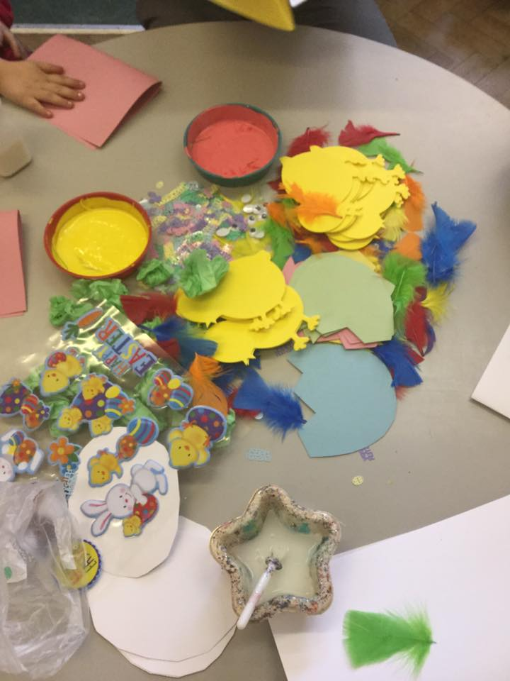

APPENDIX S- CARDS
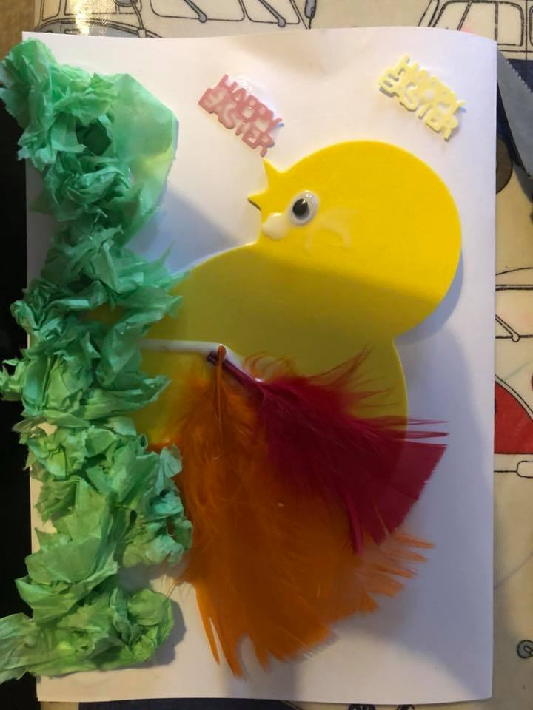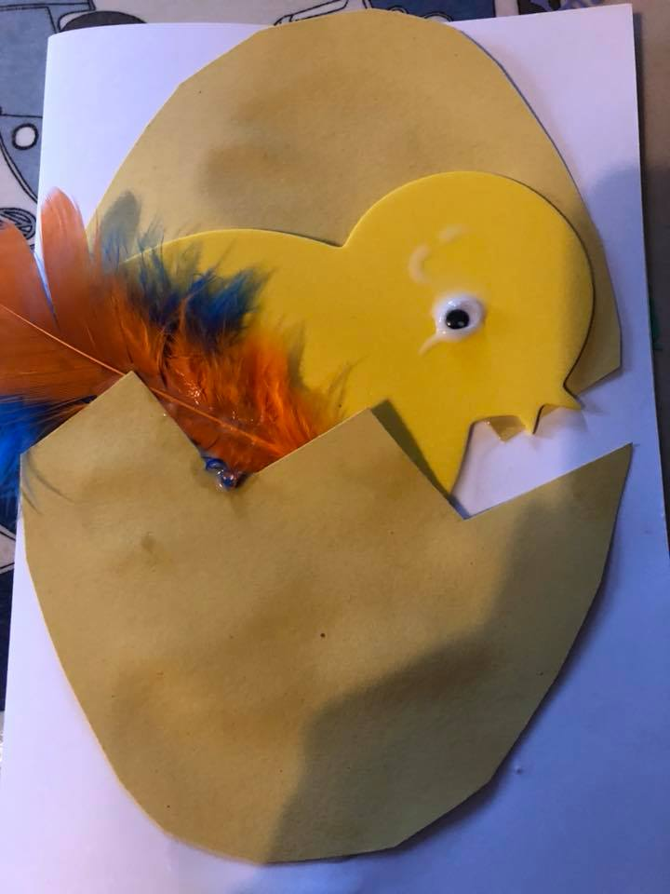

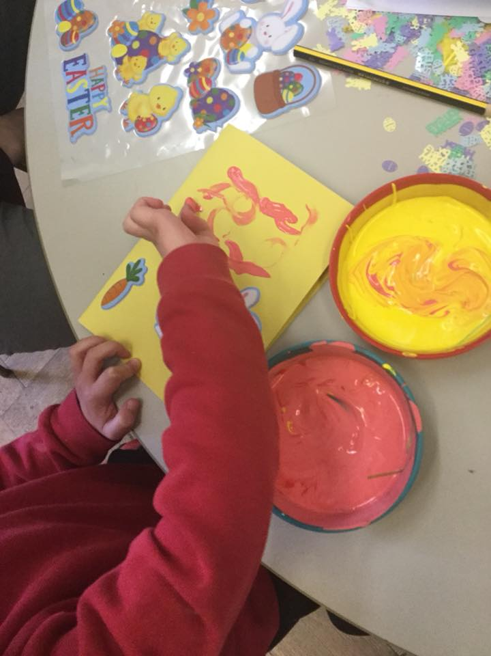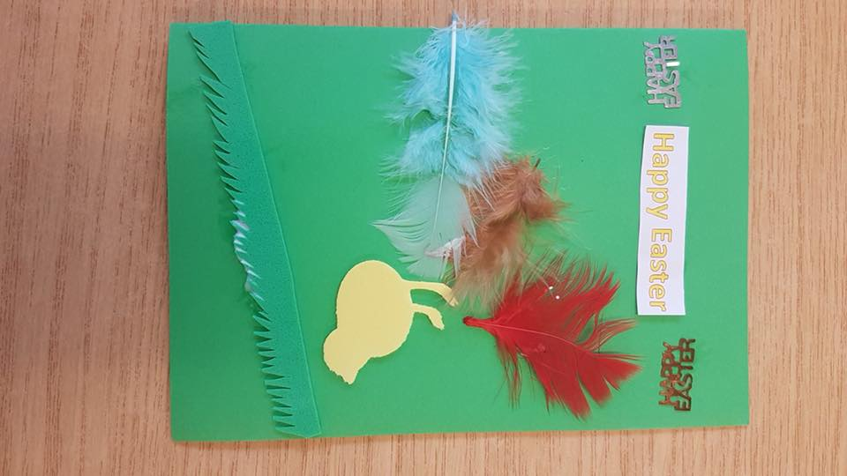

APPENDIX T – Interview from lesson 3


