Desiccating Organic Material

By Olivia Hunt (2403821)
Dr Katharina Zinn and Dr Ros Coard
10/04/2026
BA Ancient History

Table of Contents
Abstract 2
Introduction 2
Method 3
Materials 3
Results, Findings and Data 4
Discussion 6
Conclusion 7
References 7
Appendices 8

Abstract
This study investigated the effectiveness of different salts in promoting desiccation as a model for mummification practices in ancient Egypt. Pear tissue was used instead of biological material due to high water content and structural similarities to soft tissue. Four specimens were prepared, including a control, and treated with magnesium sulphate, sodium chloride and sodium bicarbonate. Changes in mass and physical characteristics were recorded over a three-week period.
Key Words:
- Desiccation
- Mummification
- Salt
- Natron
- Pear
- Ancient Egypt

Introduction
Mummification, most notably associated with ancient Egypt and practiced as far back as 6,000 years ago, is a preservation process that relies on desiccation – the removal of moisture from biological tissues to inhibit bacterial activity and delay decomposition. Since water is essential for these things, its removal significantly slows the breakdown of organic material.
Historically, the Egyptians used natron, as first described by Herodotus, a naturally occurring mixture primarily composed of sodium carbonate decahydrate, sodium bicarbonate and smaller quantities of sodium chloride and sodium sulphate, in order to dehydrate corpses. The effectiveness of this process is largely attributed to the absorbent nature of these salts, which draw moisture out of tissues via osmosis. Experimental and chemical analysis of mummification materials have demonstrated that slat mixtures similar to natron facilitate dehydration and preservation through water removal and ionic interactions with biological tissue.
This experiment uses pears as tissue as an equivalent for biological material to investigate the desiccating effects of different salts: magnesium sulphate (Epsom salt), sodium chloride and sodium bicarbonate. Pear tissue is suitable due to its high-water content and structural similarity to soft biological tissue. The aim of this experiment is to compare the effectiveness of these salts in advancing desiccation, measured primarily through loss of mass over time, and to evaluate the relevance of salt to the historical practice of mummification. Modern experimental studies have replicated mummification processes, demonstrating that salt-based desiccation is effective in reducing tissue moisture and inhibiting decomposition, therefore supporting historical accounts of Egyptian embalming techniques.

Method
For week 1, the uncut pear was first examined and its qualities noted. It was then divided using a sharp knife into the four specimens with each segment weighed and measured (for data see Table 1 in Results). Next, all of the specimens were put into sealable plastic bags and – expect for Specimen A, the control – were fully covered in 150g of different salts. B was put in magnesium sulphate heptahydrate, known as Epsom salt; C was put in sodium chloride, known as table salt; and D was put in sodium bicarbonate. All bags were properly sealed and stored away to be re-examined in Week 2.
After one week of the experiment, the specimens were unsealed and removed with the qualities noted. Each specimen was thoroughly cleaned of all salt with metal dental tools, weighed and compared to the previous week to determine progress (for data see Table 1 in Results). Additionally, their height and width were recorded using digital callipers for accuracy. Finally, they were then put back into their original bags and resealed for another week. All steps of Week 2 were repeated in Week 3.
  - Materials
- A pear
- Knife or scalpel
- Four airtight sealable bags
- 150g magnesium sulphate (Epsom salt)
- 150g sodium chloride (table salt)
- 150g sodium bicarbonate
- Electronic weighing scales
- Metal dental tools (e.g. toothpicks)
- Digital callipers
- Safety Equipment
  - Gloves
  - Chopping board
- Cleaning Equipment
  - Antibacterial wipes/spray
  - Tissues

Results, Findings and Data
All of the specimens lost overall weight from Week 1 to Week 3, especially the treated specimens, as can be seen in Table 1, indicating progressive moisture loss. In contrast, the control specimen showed minimal change in mass. An anomaly was observed in Specimen C, because from Week 2 to 3, it gained 0.24g, it is possible this is the result of incomplete removal of salt. Although this did not occur in any other specimen.
Within a short amount of time after cutting the specimens, it was noted that the inside had begun to brown. This was the start of decay and may be comparable to the changes the human body undergoes shortly after death. The browning continued to varying degrees for each of the specimens across the experiment, as will be discussed below.

Table 1 – Change of Mass in Grams over Three Weeks
Specimen | Week 1 | Week 2 | Week 3
A | 24.91g | 34.66g | 34.2g
B | 22.17g | 12.09g | 9.1g
C | 25.73g | 12.06g | 12.3g
D | 21.2g | 15.15g | 14.4g

Table 2 – Percentage Change of Mass
Specimen | Week 1 – Start Weight | Week 2 | Week 3 | Overall
A | 34.91g | 0.716% decrease | 1.327% decrease | 2.034% decrease
B | 22.17g | 45.467% decrease | 24.731% decrease | 58.953% decrease
C | 25.73g | 53.129% decrease | 1.99% increase | 52.196% decrease
D | 21.20g | 28.538% decrease | 4.951% decrease | 32.076% decrease

  - Specimen A
Specimen A, the control, showed some signs of browning with small, brown dots appearing predominantly on the flesh by Week 2, with this response continuing into Week 3. Additionally, a patch of mould was identified in a small ear of the pear, this must have developed between the second and third week of the experiment as it was not noted earlier. The skin of Specimen A became paler over the course of the experiment. The texture of A remained firm but did begin to soften by the end of the experiment. When measurements for Specimen A were taken there was a 2.987% decrease in height (69.98mm to 67.89mm) and a 7.034% decrease in width (from 53.88mm to 50.09mm).
  - Specimen B
Specimen B showed strong darker areas in Week 2, particularly in the lower portion of the sample as well as mould being identified on the surface of the flesh. By Week 3, these properties had continued to develop until the large majority of B was a dark colour. The skin which began – as all of the other specimens did – as a light green colour with minimal bruising to the smooth skin and a pale flesh changed too; by Week 2 the skin started to wrinkle, notably at the edges where the skin met the flesh. Likewise, this was noted as having progressed in Week 3. Specimen B also became soft and spongy to the touch. Beyond its mass, its other measurements also decreased. Over the period of a week, Specimen B decreased in height from 54.3mm to 50.66mm and in width from 22.93mm to 16.04mm, which is a 6.706% decrease and a 30.048% decrease respectively.
Specimen C
Specimen C was perhaps the best preserved of all. In Week 2, the specimen’s flesh remained a pale colour with only light browning at the bottom of it; this behaviour persisted into Week 3 with the specimen remaining largely unchanged in colour. The outside of Specimen C became shrivelled and wrinkly across the experiment as the moisture was removed from it. The measurements of Specimen C show a decrease in height by 5.917% (from 60.84mm to 57.24mm) and in width by 10.526% (from 18.81mm to 16.83mm).
  - Specimen D
In regard to Specimen D, its colour changed the most as by Week 2 the flesh had darkened, and the skin as become a very dark brown/black colour with a firm to solid texture. By Week 3, these changes continued. Additionally, the height of D decreased by 9.914% (from 62.84mm to 56.61mm) and the width decreased by 2.866% (from 24.77mm to 25.48mm).

Discussion
The results demonstrate a clear overall reduction in mass across all specimens, thus indicating successful desiccation. This is consistent with the expected behaviour of hygroscopic salts, which create osmotic gradients that draw water out of plant cells, leading to dehydration and structural collapse of the tissue. As water is removed, cells lose turgor pressure – the force that is exerted by the fluid against the cell wall – leading to dehydration and eventual structural collapse of the tissue. This is consistent with other experimental reconstructions of mummification, which show that dehydration through the application of salt significantly limits microbial activity and tissue degradation.
Quantitively, Specimen B exhibited the greatest overall loss of mass loss (58.953%), followed by Specimen C at 52.196%; while Specimen D showed a comparatively lower reduction (32.076%). The control, Specimen A, showed minimal mass loss (2.034%), confirming that the observed changes were primarily due to salt-induced desiccation rather than something else, such as natural evaporation.
In contrast, sodium chloride (C) demonstrated both substantial mass loss and comparatively better structural preservation. The specimen retained a lighter colour and more intact shape over time, indicating that sodium chloride not only promotes desiccation, but it may also inhibit enzymatic and bacterial activity more effectively. This aligns with its widespread use in food preservation and supports its relevance as a component of natron in ancient Egyptian mummification practices.
Sodium bicarbonate (D) was less effective in general, as reflected by its lower percentage mass loss. This may be due to its weaker hygroscopic properties and limited capacity to sustain prolonged moisture absorption. Additionally, its chemical instability under certain conditions may reduce its effectiveness as a desiccant.
The anomalous increase in mass observed in Specimen C between Week 2 and Week 3 is most likely attributed to an experimental error, particularly the incomplete removal of salt residues prior to weighing. Sodium chloride crystals may have adhered strongly to the tissue surface, artificially increasing the recorded mass. This highlights a clear limitation in measurement accuracy and suggests that the cleaning method may not have been sufficient enough to eliminate all adhered material, although no other specimen was noted as having experienced a mass increase.
The browning observed shortly after cutting is indicative of enzymatic oxidation of phenolic compounds by polyphenol oxidase, the reaction that occurs to food, such as vegetables and fruit, resulting in it turning brown when exposed to oxygen. This could be considered analogous to early post-mortem biochemical changes in animal tissue. However, as desiccation progressed, further enzymatic and bacterial degradation would have been inhibited, reinforcing the role and importance of moisture removal in preservation processes.
Several limitations should be considered. Environmental conditions – such as temperature and humidity – were not controlled, potentially affecting the rate of evaporation and desiccation, as well as not being similar to the hot and humid conditions of ancient Egypt. Variations in specimen size and surface area may also have influenced the rate of water loss. Additionally, the use of plant tissue introduces obvious differences in cellular structure and composition compared to animal tissue, thus limiting direct comparison to human mummification.
In order to improve this study, future experiments could improve reliability by incorporating controlled environmental conditions, replicating trials, standardising specimen dimensions and implementing more rigorous cleaning protocols (e.g. rinsing and drying protocols prior to weighing).

Conclusion
This investigation confirms that salts are effective desiccating agents capable of reducing the water content of biological matter. All treated specimens exhibited mass loss over time, demonstrating the removal of water.
Magnesium sulphate resulted in the greatest overall mass loss (13.07g) among those tested, indicating strong desiccating ability. However, sodium chloride demonstrated the most effective balance between dehydration and structural preservation. Sodium bicarbonate was less effective overall.
Overall, these findings support the role of salts in mummification and provide insight into the mechanisms by which desiccation inhibits decomposition, although limitation of the experimental model and the differences between plant and soft tissue should be considered when interpreting the results and findings.

References
Biology Online, Turgor Pressure (2023) https://www.biologyonline.com/dictionary/turgor-pressure#References [accessed 3rd March 2026]
Davison, Ehlana, Specimen Photographs Week 1, 5th March 2026, Figures 1.1, 1.2, 1.3, 2
Davison, Ehlana, Specimen Photographs Week 2, 12th March 2026, Figures 3.1, 3.2, 4, 5, 6.1, 6.2, 7.1, 7.2
Davison, Ehlana, Specimen Photographs Week 3, 19th March 2026, Figures 8.1, 8.2, 9.1, 9.2, 10.1, 10.2, 11
Institute of Food Science and Technology, Fruit and Vegetables: Enzymic Browning, https://www.ifst.org/lovefoodlovescience/resources/fruit-and-vegetables-enzymic-browning [accessed 3rd March 2026]
Livius.org, Herodotus on Mummification (2020) https://www.livius.org/sources/content/herodotus/mummification/ [accessed 24th March 2026]
Macheix, J., Sapis, J., Fleuriet, A., ‘Phenolic Compounds and Polyphenolxidase in Relation to Browning in Grapes and Wine’, Critical Reviews in Food Science and Nutrition, 30.4 (1991), 441—486 <DOI: https://doi.org/10.1080/10408399109527552>
Öhrström, Lena and others, ‘Experimental Mummification—In the Tracks of the Ancient Egyptians’, Clinical Anatomy, 33.6 (2020) 860—871 <DOI: https://doi.org/10.1002/ca.23568 >
Weisberger, Mindy, The Ancient Mummy is Older than the Pharaohs (2018) https://www.livescience.com/63351-mummy-older-than-pharaohs.html [accessed 24th March 2026]

Appendices
Appendix I
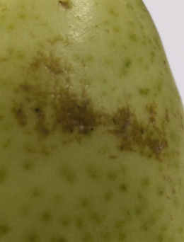 Figure 1.1 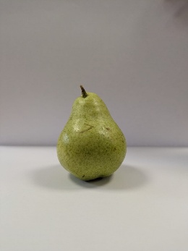 Figure 1.2 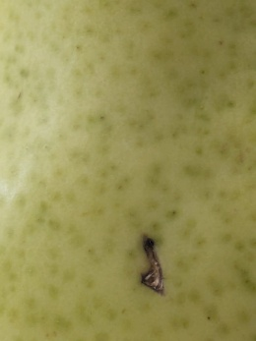 Figure 1.3
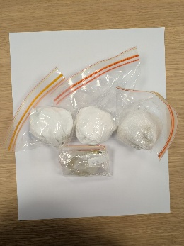 Figure 2
Appendix II
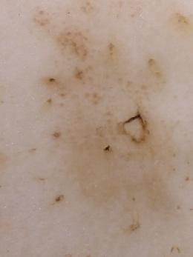 Figure 3.1 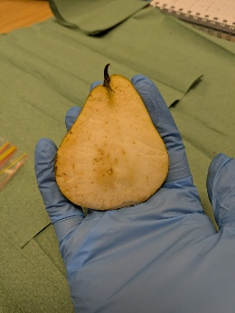 Figure 3.2
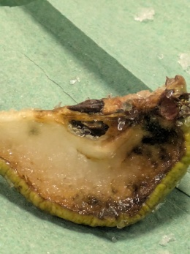 Figure 4
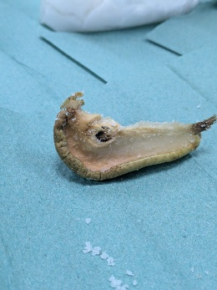 Figure 5
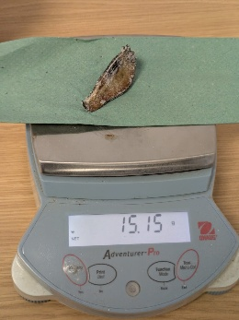 Figure 6.1 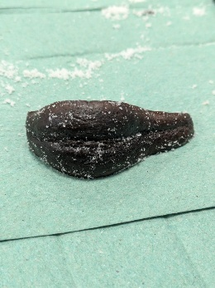 Figure 6.2

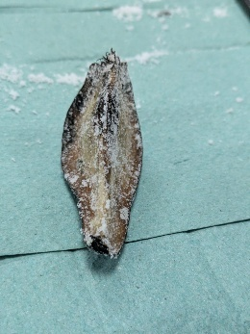 Figure 7.1 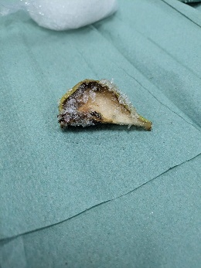 Figure 7.2

Appendix III
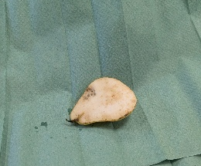 Figure 8.1 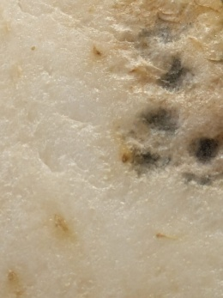 Figure 8.2

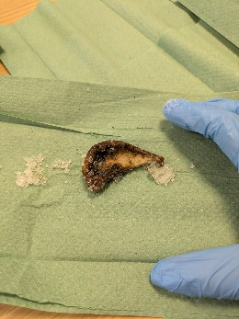 Figure 9.1 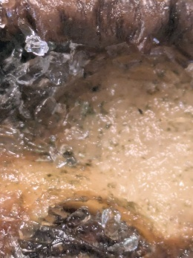 Figure 9.2
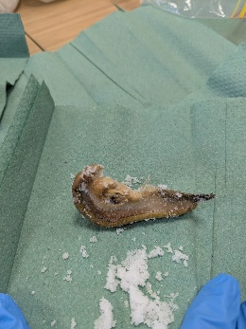 Figure 10.1 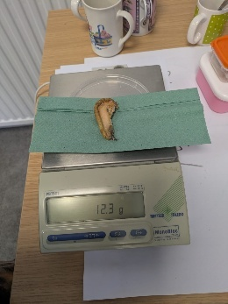 Figure 10.2

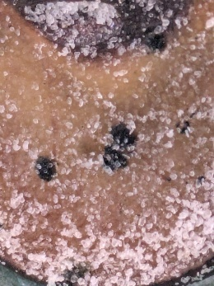 Figure 11

Mindy Weisberger, The Ancient Mummy is Older than the Pharaohs (2018) https://www.livescience.com/63351-mummy-older-than-pharaohs.html [accessed 24th March 2026].
Livius.org, Herodotus on Mummification (2020) https://www.livius.org/sources/content/herodotus/mummification/ [accessed 24th March 2026].
Lena Öhrström and others, ‘Experimental Mummification—In the Tracks of the Ancient Egyptians’, Clinical Anatomy, 33.6 (2020) 860—871 <DOI: https://doi.org/10.1002/ca.23568 >.
For images see Appendix I Ehlana Davison, Specimen Photographs Week 1, 5th March 2026.
For images see Fig 3.1 and Fig 3.2 in Appendix II. Ehlana Davison, Specimen A Week 2, 12th March 2026, Photograph.
For images see Fig 8.1 and Fig 8.2 in Appendix III Ehlana Davison, Specimen A Week 3, 19th March 2026, Photograph.
See Fig 4 in Appendix II Ehlana Davison, Specimen B Week 2, 12th March 2026, Photograph.
See Fig 6.1 and Fig 6.2 in Appendix II. Ehlana Davison, Specimen D Week 2, 12th March 2026, Photograph.
Biology Online, Turgor Pressure (2023) https://www.biologyonline.com/dictionary/turgor-pressure#References [accessed 3rd March 2026]
Öhrström and others, ‘Experimental Mummification—In the Tracks of the Ancient Egyptians’ p. 869.
Jean-Jacques Macheix, Jean-Claude Sapis, and Annie Fleuriet, ‘Phenolic Compounds and Polyphenolxidase in Relation to Browning in Grapes and Wine’, Critical Reviews in Food Science and Nutrition, 30.4 (1991), 441—486 <DOI: https://doi.org/10.1080/10408399109527552>
Institute of Food Science and Technology, Fruit and Vegetables: Enzymic Browning, https://www.ifst.org/lovefoodlovescience/resources/fruit-and-vegetables-enzymic-browning [accessed 3rd March 2026]

