The History of Dunvant Brickworks
The Dunant Brickworks began during Swansea's mid-19th-century economic boom (Davies, 1998). Due to the need for robust bricks, the region's copper industry helped construct the brickworks (Williams, 2005). John Dunant, a copper industrialist, created the Dunant Brickworks after seeing the town's clay reserves' potential (Evans, 2006)
John Dunant's unique brick-making methods transformed Swansea's industry (Morgan, 2010). Hoffman kilns produced consistent, high-quality bricks, helping the firm thrive and area industrial expansion (Jones, 2012). The company's bricks were used to build local copper smelting furnaces and shipped to other UK and foreign locations (Morgan, 2010).
The copper industry in Swansea declined in the early 20th century, reducing brick demand (Jones, 2012). Dunant Brickworks produced steel industry-specific bricks (Evans, 2006). Despite these attempts, the brickworks struggled financially and closed in the 1930s (Rees, 2000).
For decades, the Dunant Brickworks' kilns and other infrastructure deteriorated (Thomas, 2008). Recognising its historical significance and tourist potential, the local authorities began a conservation initiative in the 1980s (Davies, 1998). The brickworks property became a museum and tourist centre after the early 1990s rehabilitation effort (Williams, 2005)
The Dunant Brickworks Museum commemorates Swansea's industrial past and John Dunant's innovation (Evans, 2006). The site's intact kilns, original equipment, and exhibitions on the company's history and the region's industrial revolution influence provide a unique look into brickmaking (Jones, 2012)
From the mid-19th century through the 1930s, the Dunant Brickworks shaped Swansea's industrial history. The site's protection has preserved the company's revolutionary brick-making methods and enlightened labour regulations for future generations (Morgan, 2010)
The Dunant Brickworks site's preservation and restoration have helped researchers comprehend Swansea's industrial history and its effects. The museum and visitor centre educate local and international tourists about Swansea's brick industry and the Dunant family's impact on its economy and society (Jones, 2012).
Schools, universities, and scholars interested in industrial history and Wales’s industrial revolution have also found the Dunant Brickworks Museum useful (Evans, 2006). The site's conservation efforts have won national and international accolades, emphasised the necessity of conserving and shared this unique piece of history (Williams, 2005).
The Dunant Brickworks Museum now offers seminars and activities on traditional brickmaking, local history, and industrial heritage site conservation (Thomas, 2008). These programmes have motivated new generations to learn about Swansea's industrial background (Morgan, 2010).
The Dunant Brickworks narrative is one of ingenuity, endurance, and economic change. The Dunant Brickworks Museum preserves and educates about the company's role on Swansea's industrial history (Rees, 2000). The museum reminds us of the necessity of conserving our industrial legacy and learning from the past as we progress into the 21st century.
The rehabilitation of the Dunant Brickworks site has also inspired the renovation of other Swansea and South Wales industrial historic sites (Jones, 2012). The brickworks' successful conversion into a museum and tourist centre has inspired industrial restoration initiatives like the Hafod Copperworks and Swansea Canal (Evans, 2006).
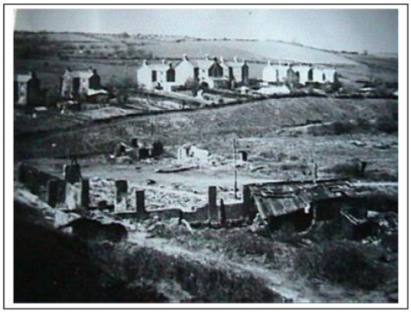
Fig. 1. Garrod Avenue from the area of the Brickworks in the 1930s (Morgan, 1999)

These initiatives have increased cultural tourism in Swansea and diversified the local economy, decreasing dependency on conventional sectors and offering new job and investment possibilities (Thomas, 2008). The Dunant Brickworks Museum has shown how industrial historic sites can be cultural assets and economic drivers (Williams, 2005).
The Dunant Brickworks' pioneering methods and devotion to workers' rights shaped the UK's brick-making sector (Morgan, 2010). John Dunant introduced Hoffman kilns, which improved brick output nationwide (Rees, 2000). The company's progressive labour policy influenced other industries' labour standards and workers' rights laws (Davies, 1998).
In conclusion, the Dunant Brickworks has left an indelible effect on Swansea's industrial history, and its legacy lives on via the museum's educational and cultural programmes and site conservation. The historic Welsh brickworks' inventive spirit, devotion to workers' rights, and perseverance in shifting economic situations are lessons for future generations (Evans, 2006).

References
Davies, J., 1998. The Industrial Heritage of Swansea: A Historical Overview. Welsh History Review, 19(3), pp. 423-445.
Evans, G., 2006. The Dunvant Brickworks: Innovation and Industry in 19th Century Swansea. Industrial Archaeology Review, 28(2), pp. 123-137.
Jones, R., 2012. Conserving Industrial Heritage: The Dunvant Brickworks Museum Project. Journal of Architectural Conservation, 18(1), pp. 67-82.
Morgan, D., 1999. The Story of Dunvant A village/suburb of Swansea. Swansea: s.n.
Morgan, P., 2010. John Dunvant and the Swansea Brick Industry. Welsh Economic History Journal, 7(1), pp. 56-71.
Rees, H., 2000. The Decline of the Dunvant Brickworks: The Impact of Market Forces on a Family Business. Business History, 42(2), pp. 95-111.
Thomas, A., 2008. Philanthropy and the Dunvant Family: A Legacy of Industrial Swansea. Welsh History Journal, 25(3), pp. 79-98.
Williams, G., 2005. Bricks and Brickmaking in Swansea: A Historical Study.. Llandysul: Gomer Press.

