Trinity Saint David University.
Design for Industry 4.0



ACPA7001

Carl Jones Student 2134125.
Cohort 07/22
Lecturer Dr. Fred Cooper

Assignment 2 – Essay

Use of Hydrogen to replace fossil fuels in transport and other sectors – how Industry 4.0 and Design for X aid in this paradigm shift in Hydrogen production.

Contents
Introduction. 4
Concepts and methodology. 5
Industry 4.0. 5
Design for X. 5
Design for Manufacture. 5
Design for Assembly. 6
Design for Manufacture and Assembly. 6
Design for Reliability. 6
Design for Quality (DfQ). 6
Design for Maintenance (DfM). 7
Design for Testing. 7
Design for Supply Chain. 7
Design for Cost. 7
Design for Sustainability. 7
Hydrogen as a vehicle power source. 8
Hydrogen production using electrolysis of water. 8
Green Hydrogen. 8
Blue Hydrogen. 8
Grey Hydrogen. 8
Electrolysis of water. 9
Issues that reduce Electrolysis efficiency. 9
Ohmic Voltage drop. 9
Bubble effect. 9
Hydrogen production from Electrolysis using “Imaginary” Catalytic Electrolyte. 10
Vehicle Hydrogen Storage Cell improvements. 10
Issues to be resolved before widespread adoption of Hydrogen by the Transport Sector. 11
Safety 11
Infrastructure. 11
Powertrain developments required to use Hydrogen. 11
Effect of cheap Green Hydrogen adoption. 12
Additional uses of Hydrogen fuel. 12
Steel production. 12
Aviation Fuel. 12
Energy store. 12
Electricity generation and Heating 12
Socio-economic effect of world-wide adoption of Green Hydrogen. 13
Bibliography 14

Figure 1 Design for X Principles of Design and Manufacturing 5
Figure 2 Electrolysis in action. 9
Figure 3 Bubble effect 9
Figure 4 Hydrogen Fuel Cell Schematic 11

Introduction.
The transport sector is responsible for nearly a quarter of all global greenhouse gas emissions. Globally, there are close to one billion light duty Internal Combustion Engine Vehicles (ICEV), and this is expected to double in the next few decades. These vehicles consume 25% of global primary oil. (Ellingsen, et al., 2016). Many used vehicles exported from developed countries to undeveloped contribute significantly to the effects of climate change. (Rukikaire, 2020). However, even the most efficient fossil fuel ICEVs will still have significant greenhouse gas emissions (more than three times the CO² compared to Electrically powered Vehicles (EVs)) and carbon footprint hence the recent adoption of EVs. Many governments with targets in minimising greenhouse gases have produced favourable policies to promote market uptake of EVs, however the impact of EVs on climate change depend on the sources of the electrical generation. Fossil fuel generation has a large carbon footprint whilst renewable energy such as solar, wind and wave generated electrical power has a greatly reduced carbon footprint (Ellingsen, et al., 2016).
Batteries used in EVs have negative environmental impact. Lithium, Cobalt, and Nickel used in battery production are mined using water-intensive methods and traces of these toxic elements can then migrate into surrounding water tables (Lakshmi, 2023). The end-of-life strategy of these batteries is still not clear as lithium for example retains 80% of its storage properties making it unsuitable to be reused in new EV batteries but could be re-used in electric scooters and the like (Li, et al., 2020).
A main drawback of EVs is the range of travel between battery charges, recent battery developments have increased this to an average 212 miles (fossil fuel cars average range close to double this), but this is dependent on speed, how the EV is driven and weather conditions (Yurday, 2022). This perception of reduced range has led to a condition known as user anxiety. Infrastructure, availability, and kW capacity of charging points are also constraints on EV adoption.
Another green alternative to ICEV is the Hydrogen Fuel Cell Vehicle (HFCV). Hydrogen is recognised as a viable green fuel source when compared to fossil fuels as it has nearly three times the energy with no carbon emission at point of use (Ebiad, et al., 2015). The biggest obstacle in adoption of HFCV is the high purchase cost compared to EVs, the cost of Hydrogen production, storage and transport are other financial and technological bottlenecks (Zhang, et al., 2023).
An advantage of HFCV is the range of travel between cell change requirements. Dependant on number of cells the range could be more than 1,000 miles.
The following report will gauge the effect of a new fictional catalyst development that fundamentally changes the ease and cost of electrolysis of water-based production of Hydrogen. The design of the production process with particular emphasis of digitising all process aspects using Industry 4.0 (I4.0) and Design for X (DFX) will be the focus of the report.

Concepts and methodology.

Industry 4.0.
Breaking manufacturing systems down to an abstract level reveals the core constituent resource parts of a manufacturing system. The introduction of Industry 4.0 (I4.0) Cyber Physical Systems (CPS) has allowed all areas of the manufacturing system to become digitised, allowing potentially vast amounts of Big Data (BD) to be collected by the Industrial Internet of Things (IIoT). This BD allows real-time analysis by Artificial Intelligence (AI) Data Sciences (DS) to give instant feedback of customer requirements, where and what state raw material is at, effectively schedule production, gauge how processes are performing, ensure product quality is maintained and continuously improved, and scheduling delivery of final finished product (Rauch & Matt, 2021).
This real time data feedback allows manufacturing sites to be utilised productively, increasing share-holder wealth, and maintaining the competitiveness of businesses, and ensuring customer delight with their purchases.

Design for X.
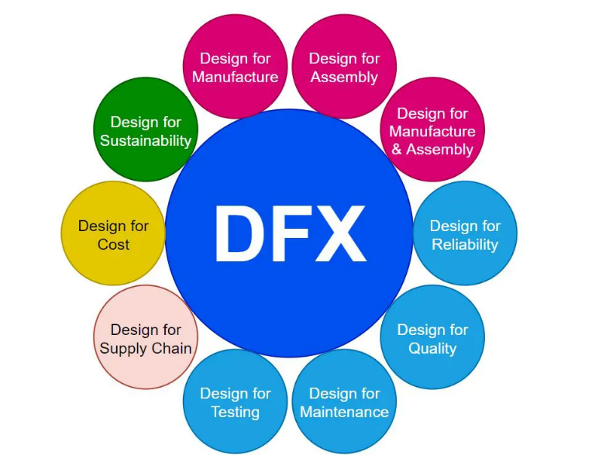
Design for X (DfX) is a holistic approach in supporting sustainable development of new products and supports a better decision-making process whenever a new complex product is being developed (Baptista, et al., 2018).
Figure 1 Design for X Principles of Design and Manufacturing

Design for Manufacture.
Ensures the ease of manufacturing the product is considered during development and design. Ensures that final product development iterations are minimised, speeding up development time and reducing cost.

Design for Assembly.
Ensures final finished product of minimised modular parts is easy, and difficult to build incorrectly. Disassembly should also be straight forward, so the modular design concept is utilised to easily change worn or non-functioning parts.

Design for Manufacture and Assembly.
Redirects the design engineer’s focus so both aspects are re-examined, so they complement and interlock to form solid and simple designs.

Design for Reliability.
A definition of reliability “The ability of a component or system to perform its required functions under stated conditions for a specified period of time” (Velling, 2021). Each stage of DfX should ensure that reliability is not affected as each stage of is completed and re-evaluated and end of life expectations are achieved. Tools such as Failure Mode Effect Analysis (FMEA) are used highlight potential modes of failure, so design solutions account for them reducing design iterations and prototyping costs.

Design for Quality (DfQ).
Product quality should be designed into fabric of design as product quality has a dramatic effect on product sales and has several main metrics driven by customer requirements and market competition:

Performance.
Performance of product must meet customer requirements as a minimum, with design engineers aiming to delight customers with new performance enhancements.

Features.
Design engineers must satisfy customer expectations whilst meeting cost, quality, and sustainability requirements.

Reliability.
Product End Of Life performance must be attained to meet customer expectation and retain customer loyalty.

Conformance.
Product must pass quality test criteria and be easy to test so customer specific specifications can be checked without ambiguity. Capability of significant characteristics should conform to 6σ.

Durability.
Product must pass durability testing so End Of Life performance is attained.

Serviceability.
Products should be modular in design so worn parts of an assembly can easily be changed.

Aesthetics.
Part of brand loyalty can be attributed to the aesthetic appeal of a company’s product, so it is easily distinguished with competitors’ goods.

Perceived quality.
Brand loyalty is a vital aspect of a successful business and the Voice Of The Customer has become an important aspect of exceeding customer expectation and causing customer delight.
(Velling, 2021).

Design for Maintenance (DfM).
Ensuring that products and systems are easy to maintain, and if possible, aid in predictive maintenance by incorporating field level sensors that digitise product performance and highlight changes in the Cyber Physical Systems (CPS) of the sensor network to prevent breakdowns of the product and systems.

Design for Testing.
Linked to DfQ and DfM and highlights the need for the design engineer to think about how testing can be quickly and accurately carried out on the products they design.

Design for Supply Chain.
Making parts that are modular in nature simplify supply chains by reducing the amounts of different parts required to make finished goods. Incorporating devices such as Radio Frequency Identification (RFID) tags with blockchain protection to enable automatic identification of products, their build states, date of manufacture etc… so supply chains can be interrogated in real time increasing vertical and horizontal integration along the entire supply chain (Vrchota, et al., 2019).

Design for Cost.
An important factor in product design is cost, as it directly impacts the profitability of a business. Incorporating all DfX principles to minimise redesigns, prototyping, release to market, whilst increasing quality, modularity, reliability, and ease of assembly will all minimise cost.

Design for Sustainability.
Businesses are increasingly using the circular economy and sustainable materials due to legislative, and consumer led pressure due to global warming and its devastating impact on climate change. Reducing the carbon footprint of products is essential going forward and it is vital that design engineers participate in reducing the effects of climate change (Gupta, et al., 2021).

Hydrogen as a vehicle power source.
Hydrogen has a very high specific energy density due to its chemical reactivity and has nearly three times the energy of petrol based on mass. Volumetrically Hydrogen has low energy density and needs to be compressed to use as a viable vehicle fuel source so extended range of travel between refuelling is achieved.
HFCV store the Hydrogen at 5,000 to 10,000 psi pressure ranges so the integrity of the cells to withstand these high pressures is crucial. Typical refuelling times to store 5kgs of compressed Hydrogen takes 3 to 5 minutes (U.S. Department of Energy, 2023).

Hydrogen production using electrolysis of water.

Green Hydrogen.
Hydrogen production from electrolysis of water is considered a sustainable method due to its inherent simplicity and green credentials if produced using renewable sources of energy such as Solar Photo Voltaic (PV) and Wind Powered (WP) electricity.

Blue Hydrogen.
Produced using natural gas fossil fuel with the carbon emissions captured and stored.

Grey Hydrogen.
Constitutes most Hydrogen production where natural gas is used with the resulting carbon emissions allowed into the atmosphere contributing to global warming greenhouse gases.

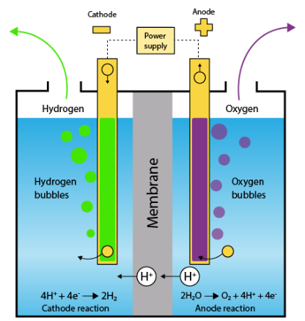
Electrolysis of water.
Figure 2 Electrolysis in action.
High amounts of electrical energy (Overpotential) are required to “force” open activation barriers of clean water (Type IV ASTM D1193 with less than 5µS / cm conductivity @ 25°C) which is mainly due to its low conductivity. Additives introduced to pure water reduce this resistance to electrical flow and are called Electrolytes. Acids, Bases, and salt Electrolytes can be used but these can have long term use issues and over time reduce efficiency of the Electrolysis reaction (Wang, et al., 2013).

Issues that reduce Electrolysis efficiency.

Ohmic Voltage drop.
A key contributor to high energy consumption, and the total resistance is an accumulation of all the resistances of the system and include Electrolyte, Membrane, Bubble and Circuit resistances.

Bubble effect.
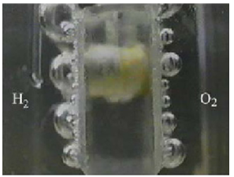
Caused by the accumulation of Hydrogen bubbles at the Cathode and Oxygen bubbles at the Anode. These bubble accumulations cause high electrical resistance increasing Overpotential. Free-form gas bubbles that have become too large detach from the electrodes also increase the electrical Ohmic resistance (Wang, et al., 2013).

Figure 3 Bubble effect

Hydrogen production from Electrolysis using “Imaginary” Catalytic Electrolyte.
The new Imaginary Catalytic Electrolyte has greatly improved the issue of Ohmic Voltage drop by adding conducting ions without the issue of contamination causing impurities in the Hydrogen and Oxygen produced during Electrolysis. This paradigm improvement in Electrolysis of clean type IV water has brought about the possibility of emission free transport in the next 10 years.
New Cathode and Anode materials, form and coatings also have the potential to greatly reduce the formation of bubbles and the subsequent Ohmic resistance increase and increase Hydrogen production to unprecedented levels.
Applying positive pressure to the process would also reduce the formation of bubbles at the Cathode and Anode and could be a further improvement.
Cost of Hydrogen using PV and Wind powered electrolysis using the new Imaginary Catalytic Electrolyte is £5 / kg of Hydrogen. Current cost of Petrol is £5.90 / gallon which weighs 3.3kgs. However, the energy potential of Hydrogen is close to 3 tines the potential of petrol so when compared to the amount of work or miles of travel Hydrogen works out slightly cheaper with no greenhouse emissions.

Vehicle Hydrogen Storage Cell improvements.
Recent improvements in Hydrogen Fuel cell designs and materials have resulted in storage devices that can withstand 20,000psi and pass collision testing without risk to Hydrogen leakage. These new storage vessels have imbedded field level sensing devices that will alert the vehicle user and seal the potentially suspect vessel automatically using an expanding foam to act as a protective seal. However, more needs to be done to ensure public safety before widespread deployment.

Issues to be resolved before widespread adoption of Hydrogen by the Transport Sector.

Safety
Hydrogens high reactivity makes it an ideal fuel but also has inherent dangers. Leak detection and control, automatic fire suppression of fuel cells and filling stations must be developed so the entire production, storage and fill of fuel cells is safe and ready before use by the public (Cui, et al., 2023).
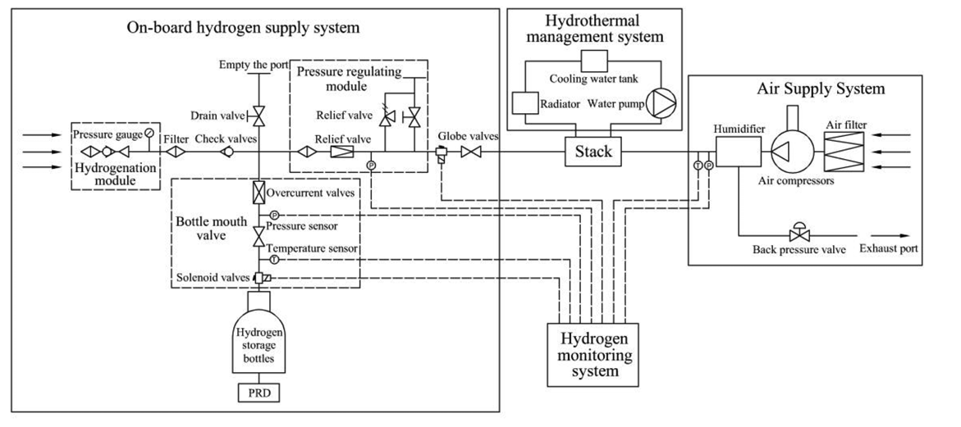
Figure 4 Hydrogen Fuel Cell Schematic
The schematic in Figure 4 shows some of the autonomous real-time system data acquisition using field level sensing (Pressure, Vibration and Temperature), to digitise the process into CPS. The Hydrogen Monitoring System would react to changes in feedback based on algorithms generated by Artificial Intelligence (AI) and deploy countermeasures to mitigate risk.

Infrastructure.
Currently, the number of refuelling stations for HFCV is very small, and an industry wide common design to ensure safety, ease of use and vehicle compatibility should be adopted.
Demand for these HFCV fuel station will be driven by government pressure to hit greenhouse gas reduction targets and by consumers given the cheap, clean fuel that would quickly displace fossil-based transport fuels.

Powertrain developments required to use Hydrogen.
Engine design would be very similar to fossil fuel ones, differences would be in the fuel to air ratios, fuel diffusion and operating temperatures but would not prove to be difficult to adapt current fossil fuel designs to Hydrogen.

Effect of cheap Green Hydrogen adoption.
The development of the “imaginary” catalyst has changed the green fuel landscape forever. Industrial designers now have access to a carbon footprint free fuel and all the inherent potential advantages.

Additional uses of Hydrogen fuel.

Steel production.
New fields of use could be leveraged such as fuel in the steel industry where projected reduction in CO² emissions is 95% compared to fossil fuels (Shell Global, 2023). A new facility in North Sweden is being constructed that is close to a supply of renewable electrical energy and is due to produce “Green Iron” in 2025.The steel and Hydrogen production plants will be co-located so production and storage of the fuel is close to point of use to reduce the issues of transporting high pressure Hydrogen. 8% of all global greenhouse gases are produced in the manufacture of steel.

Aviation Fuel.
The aviation sector accounts for 2 – 3% of all global greenhouse gas emissions, and Hydrogen could become the solution to remove this pollution.

Energy store.
Renewable energies PV and Wind have periods of low and high production activity. High activity can have surplus dependant on customer demand and this excess power could be used to produce Hydrogen using Electrolysis. The Hydrogen could then be stored and used to produce electricity when customer demand surpasses renewable energy supply. (U.S. Energy Information Administration, 2023).

Electricity generation and Heating
Hydrogen can be a direct replacement of power stations that use natural gas as a fuel. Currently electricity and heating contribute 31% of all global greenhouse gas emission.
Small scale Hydrogen fuel cell or integrated Hydrogen production could be used for heating streets or individual properties.
Main electrical generation could be supplied using renewable energy sources such as PV and wind, and excess generation could be diverted to Hydrogen Electrolysis production to help supplement periods where renewable energy production falls due to reduced sun and wind availability.

Socio-economic effect of world-wide adoption of Green Hydrogen.
Energy is an essential pillar in economic and societal development and an increasing world population is stressing current systems. Add to this the global warming threat and it is clear current methods for generating energy must evolve and change. Renewable energy sources must be rapidly adopted to reduce and ultimately stop use of fossil fuels. Renewable Energy currently supplies less than 10% of word-wide energy demand and a “six-fold increase is required to comply with the Paris agreement by 2050” (Sharma, et al., 2023) which targets world-wide carbon neutrality.
Green energy adoption requires massive, large-scale investment and inter-nation co-operation is essential to overcome the generation and transport issues that will arise with green power adoption Countries will have to pool resources and share intellectual property to overcome the difficulties in moving away from large-scale dependency on fossil fuels.
Developing countries with access to hot sunny climates could become energy rich using untapped PV generated energy resources. Access to water could also make them producers of Hydrogen to export to other countries. Wastewater and sea water can be treated using Reverse Osmosis technology to realise Type IV water purity for Hydrogen production. Partnerships with cash-rich developed countries could then pay for the infrastructure and production facilities and a symbiotic partnership formed. Scale of the production plants could be designed with use in mind, so small scale versions for smaller communities with no scope for export could be deployed without the need for massive infrastructure projects.
Design will play a crucial role in developing green energy strategies that will shape our passage into a future with carbon neutrality as the goal. Using Design for X principles to leverage safe energy production system design, incorporating Industry 4.0 principles to digitise the real world into CPS that can be monitored in real-time to keep production facilities running safely, efficiently and with correct quality of product. Reliability of the designs could be ensured by using modular principles with easy maintenance assembly and disassembly.as a key principle.

Bibliography
Baptista, A. J., Peixoto, D., Ferreira, A. D. & Pereira, J. P., 2018. Lean Design-for-X methodology: Integrating Modular Design, Structural Optimization and Ecodesign in a machine tool case study. Porto, Elsevier.
Cui, S. et al., 2023. Analysis of the fire hazard and leakage explosion simulation of hydrogen fuel cell vehicles. Thermal Science and Engineering Progress , 41(1), pp. 1 - 13.
Ebiad, M. S., Hammad, M. & Alghamdi, T., 2015. THERMO economic analysis OF PV and hydrogen gas turbine hybrid power plant of 100MW power output. IIternational Journal Of Hydrogen Energy, 40(1), pp. 12120 - 12143.
Ellingsen, L. A., Singh, B. & Stromman, A. H., 2016. The size and range effect: lifecycle greenhouse gas emmisions of electric vehicles.. Environmental Research Papaers, 11(1), pp. 1 - 9.
Gupta, H., Ashwani, K. & Wasan, P., 2021. Industry 4.0, cleaner production and circular economy: An integrative framework for evaluating ethical and sustainable business. Journal of Cleaner Production, 295(1), pp. 1 - 18.
Lakshmi, R. B., 2023. EARTH.ORG. [Online]
Available at: https://earth.org/environmental-impact-of-battery-production/
[Accessed 1 October 2023].
Li, J. et al., 2020. An activity theory-based analysis for end-of-life management of electric vehicle batteries.. Resources, Conservatio and Recycling, 162(1), pp. 1 - 10.
Rauch, E. & Matt, D. T., 2021. Status of the Implementation of Industry 4.0 in SMEs and Framework for Smart Manufacturing.. In: D. T. Matt, H. Zsifovits & V. Modrak, eds. Implementing Industry 4.0 in SMEs. Concepts, Examples and Applications.. Cham: Open Access, pp. 3 - 26.
Rukikaire, K., 2020. UN Environment Programme. [Online]
Available at: https://www.unep.org/news-and-stories/press-release/new-un-report-details-environmental-impacts-export-used-vehicles
[Accessed 1 October 2023].
Sharma, G. D. et al., 2023. Socio-economic aspects of hydrogen energy: An integrative review. Technological Forecasting & Social Change, 192(1), pp. 1 - 19.
Shell Global, 2023. Shell Global. [Online]
Available at: https://www.shell.com/energy-and-innovation/new-energies/hydrogen/rethinking-the-value-chain.html
[Accessed 4 October 2023].
U.S. Department of Energy, 2023. U.S. Department of Energy. [Online]
Available at: https://afdc.energy.gov/fuels/hydrogen_basics.html#:~:text=Hydrogen%20can%20also%20serve%20as,%2C%202.8%20kilograms)%20of%20gasoline.
[Accessed 4 October 2023].
U.S. Energy Information Administration, 2023. Hydrogen explained. [Online]
Available at: https://www.eia.gov/energyexplained/hydrogen/use-of-hydrogen.php
[Accessed 4 October 2023].
Velling, A., 2021. Factory. [Online]
Available at: https://fractory.com/design-for-x-dfx/
[Accessed 2 Octocber 2023].
Vrchota, J., Volek, T. & Novotná, M., 2019. Factors Introducing Industry 4.0 to SMES. Social Sciences, 130(8), pp. 1 - 10.
Wang, M., Wang, Z., Gong, X. & Zhancheng, G., 2013. The intensification technologies to water electrolysis for hydrogen production – Areview. Renewable and Sustainable Energy Reviews, 29(1), pp. 573 - 588.
Yurday, E., 2022. Nimblefins. [Online]
Available at: https://www.nimblefins.co.uk/average-electric-car-range
[Accessed 1 October 2923].
Zhang, W., Fang, X. & Sun, C., 2023. The alternative path for fossil oil: Electric vehicles or hydrogen fuel cell vehicles?. Journal of Environmental Management , 341(1), pp. 1 - 11.

