Breathing Corpses PWB-
Our group presentation is on the play Breathing corpses by Laura Wade. Breathing corpses is a play about how people are affected by death whether they were the ones to see it or have a loved one who has seen it and share their grief and how three strangers are somehow connected by the deaths.
As a group we decided that the DPs would have a scene each to focus on. So, Kate had scene 1 and 5 because they are both the hotel room, scene 2 was Eirys, scene 3 was Sophie and scene 4 was me. The actors decided to preform after we (DPs) showcased how we would do the scene to get a feel for the scene. We decided on a revolving circular stage to showcase our performance because of how the story circles back to the beginning and it all makes sense. We then looked at how other theatres put on the script such as Coal Mine theatre, 2016; Australian Theatre for young people; Pranksters theatre company; Steep theatre.
Scene 4 is where we are in Jim and Elaines house and we are in the garage where Jim has taken all the doors of the door frames. Elaine has arrived home and Jim is unscrewing door handles, and she hands him his sleeping medicine where Jim needs help opening it but then decides he is not ready to sleep yet. Jims answers to Elaine are short and cold. Elaine has brought Ray home and ray asks if Jim is coming back to work and Elaine and Ray try to convince Jim to come back into work. Elaine talks about how she makes excuses for Jim for him having glandular fever and that he hasn’t seen his son for Christmas and maybe a few days in Easter.
For scene 4 I first looked at costumes, and I started with Jim and I wanted to keep his outfit the same as scene 2 where “He is wearing a checked shirt and khaki trousers – the boss, but not a suit” this implies that he wants to look like a boss without the responsibility of dressing up and wearing a suit; also that he might think he is above wearing the companies uniform. For his shirt I wanted it to be ripped and have oil stains from taking off the doors and dirt because I imagine his self-hygiene hasn’t been great because he has been so disturbed by what he saw. For Elaines costume I wanted it to be the same as scene 2 because she has just come home from work and hasn’t been affected by the body in the box the same way as Jim. “She is wearing Green Door self-storage dungarees underneath her outdoor coat” is Elaines costume description. I envisioned her wearing a long brown waxed coat because it’s a smart casual coat and was popular in the 2000s and it was on top of the Green door self-storage dungarees. She appears still well put together because she isn’t as disturbed as Jim is and can still put herself together despite feeling the coldness and disturbance from Jim. Also, for Elaine she has a handbag for this scene because she has been out and has picked up Jims sleeping medicine for him and I went for a neutral 2000s handbag that would have gone with everything. For Rays costume it would be the same as scene 2 because he has not changed as much and is still appearing in his work uniform. “Green Door Self-storage uniform – green dungarees and a baseball cap” the same uniform as Elaine a bright green dungaree with a black T-Shirt underneath and a cap that is backwards as it’s a bit more casual and its after work and he doesn’t have to look that presentable.
For the set of the Garage, I wanted to go for your typical garage filled with bits and bobs like paint brushes, WD40, oil etc. The interior being still not decorated with exposed concrete breeze blocks and a concrete floor. The concrete breeze blocks would be made out of foam and not actual concrete because they are very heavy and might fall over and hurt someone. There would be a pile of nine doors because they are mentioned as part of what the set would look like and they are important to this scene as Jim hasn’t taken them off their frame. There would be a camping ground sheet as mentioned in the script to hide the doors under, that is then later pulled off to reveal all nine of the doors. I would make sure there was a place to hang up coats on the wall because Elaine hangs up her coat as she enters the scene and the hooks where on the wall it wouldn’t be a stood-up coat hanger. There would also be a pile of brass door handles on the floor as Jim is taking them off the doors and later on in the scene Ray helps Jim take the screws off the door handles with a screwdriver. There would be a hanging light from the top of the set where the ceiling would be that would be attached with two metal rods. There would be two doors either side on each wall because that is how we want the stage to be laid out like. The problem I faced with the doors is that Jim has taken the doors of the frames and we have the doors to separate each scene, so I thought of laminating a hallway onto the door but Elaine walks through the door frame so then we thought of having the doors completely swing open into the other sets to hide the doors.
For lighting they say it’s a “Tuesday evening, mid- January, dark already and getting cold” so I thought of having the set slightly misty because its cold and it adds to the eeriness of the scene. I would have the lighting like hospital lighting because it reflects how disturbed Jim is and it is uncomfortable lighting because it’s so bright and cool toned. For sound I would have cars going past every so often along with talking as if people are walking past. I would also have unscrewing noises like a wind-up toy when they are unscrewing the screws from the handles and maybe some household noises like a kettle as Elaine juts got home and maybe wants a cup of tea.
For props I would have the medicine bottle with the safety catch and a pharmacy bag that it comes in. I would also have a screwdriver to unscrew the screws and the brass door handles with the screws and also a toolbox where the screwdriver might be stored.
Evaluation-
Overall, I think that our presentation went well and we worked well together as a group. I really enjoyed designing the set for scene 4 because it’s a bit different to your typical scene where it would be in a bedroom or kitchen for example. Next time I would do more research into more set ideas and dive deeper into the story. I would also practice presenting and making better script for when I talk to the audience. But despite being unwell I think it went as well as I could do.

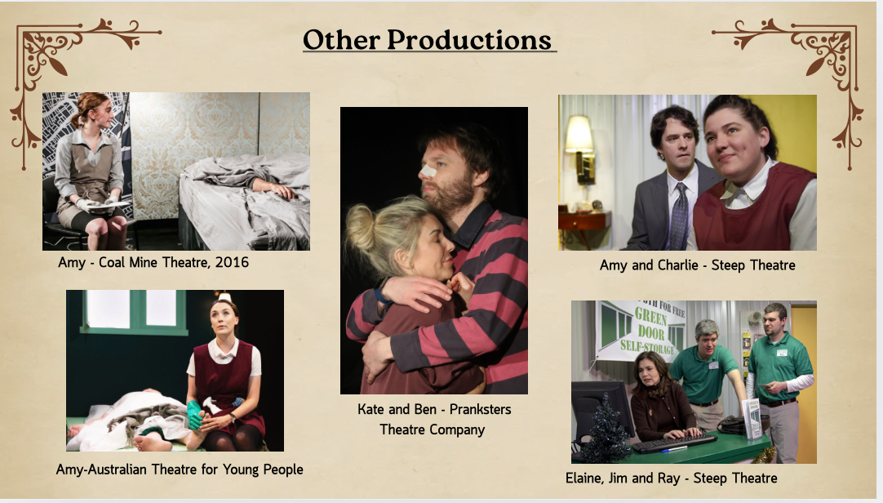
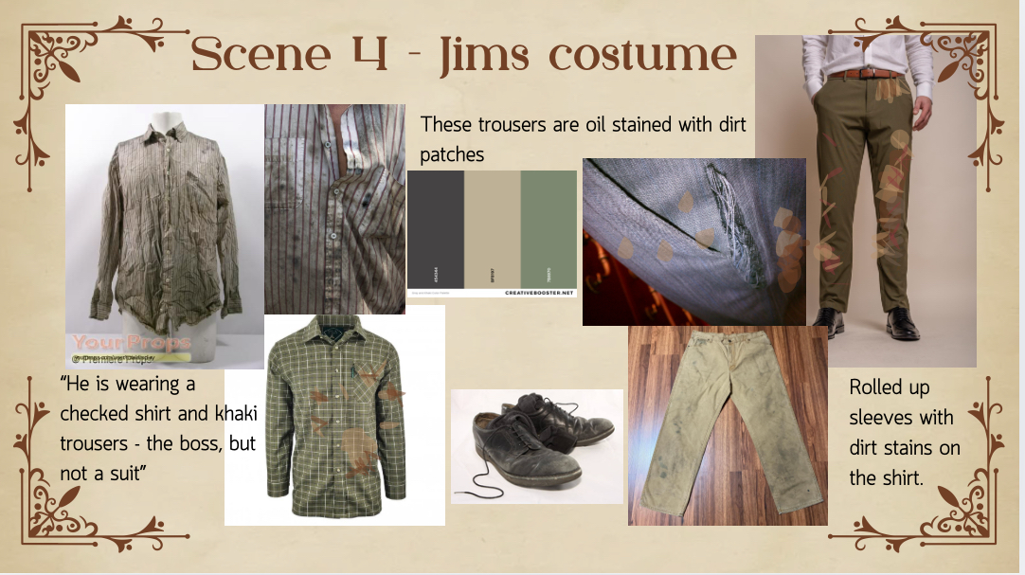
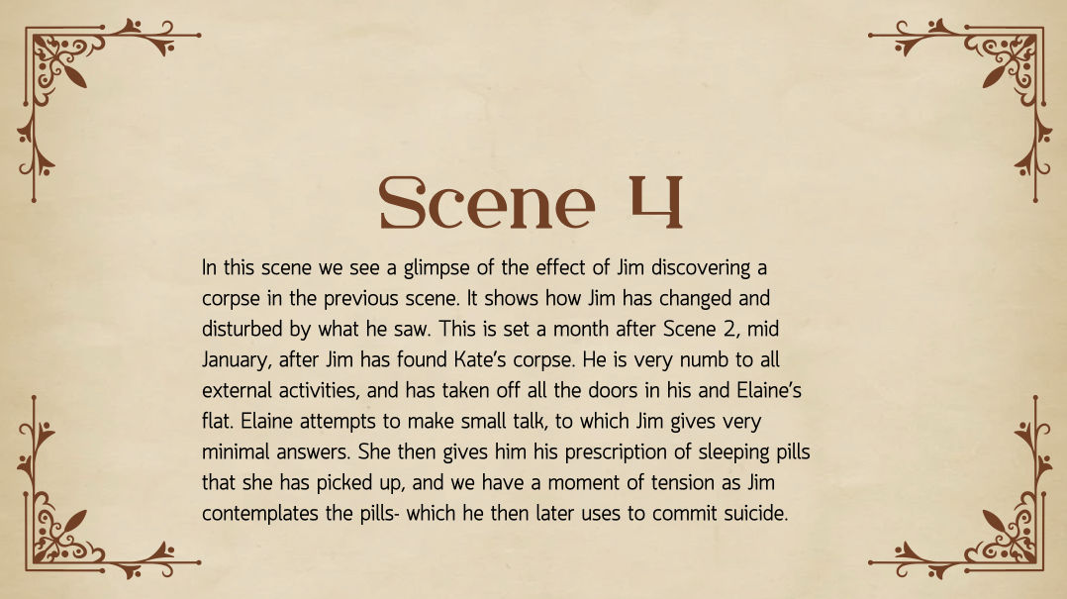
Appendix-
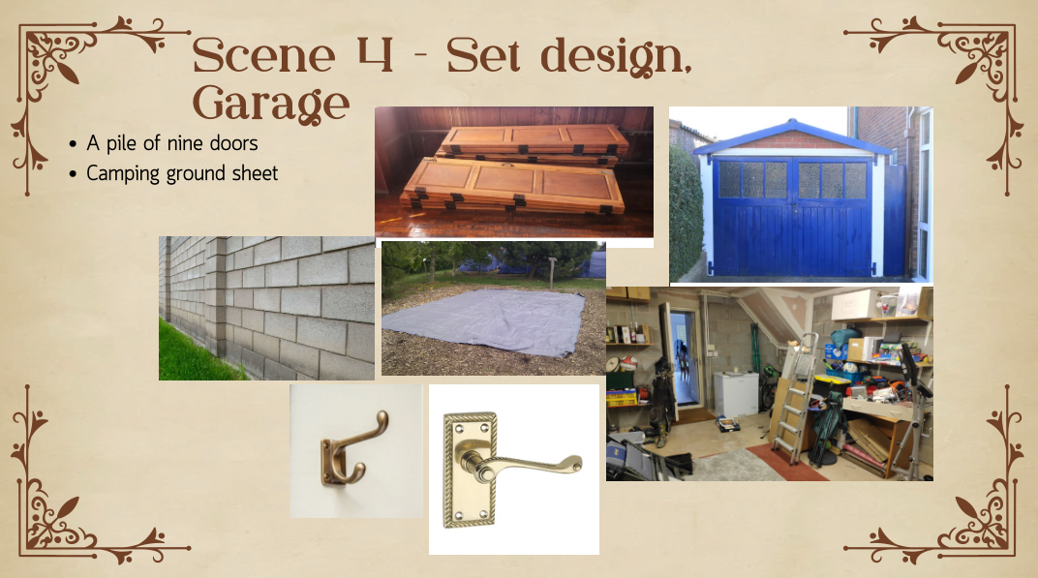
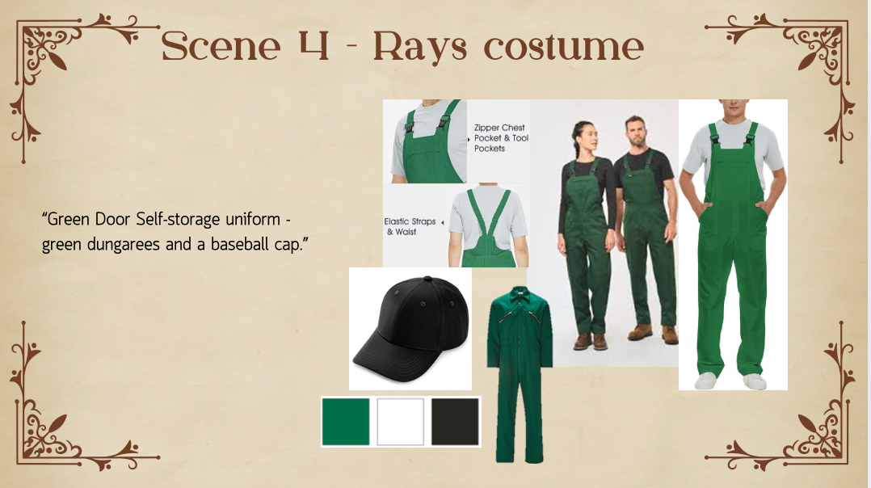
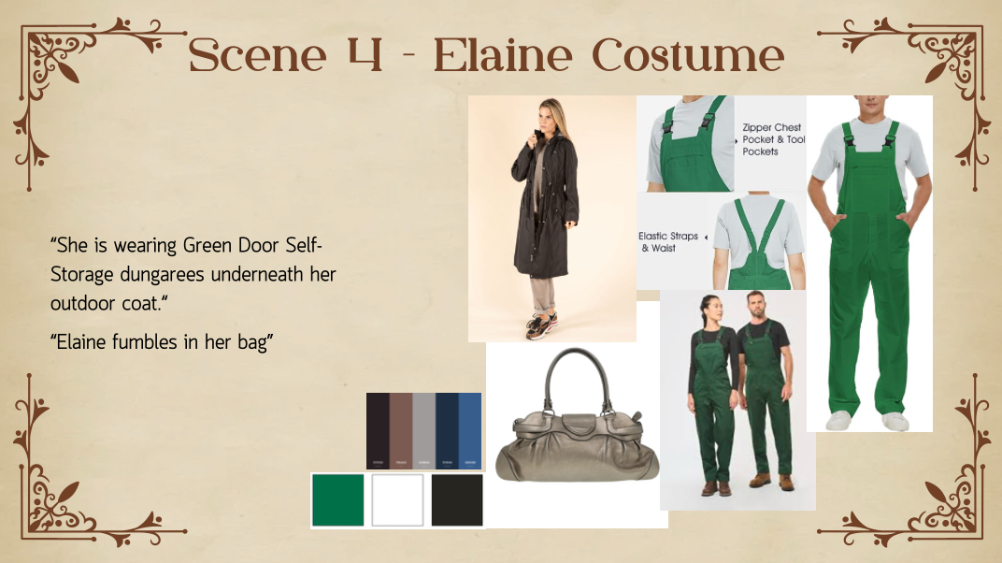

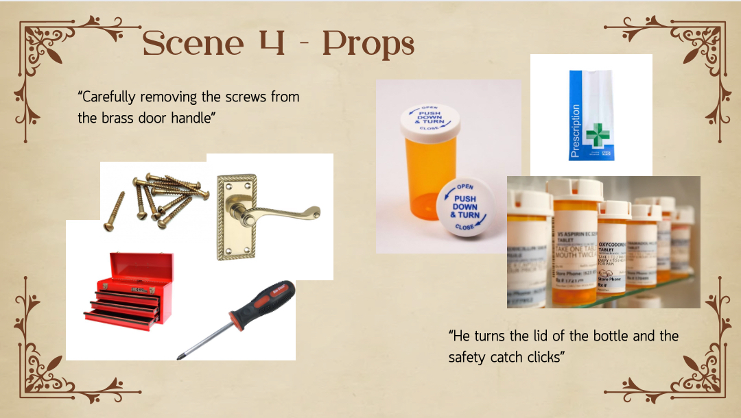
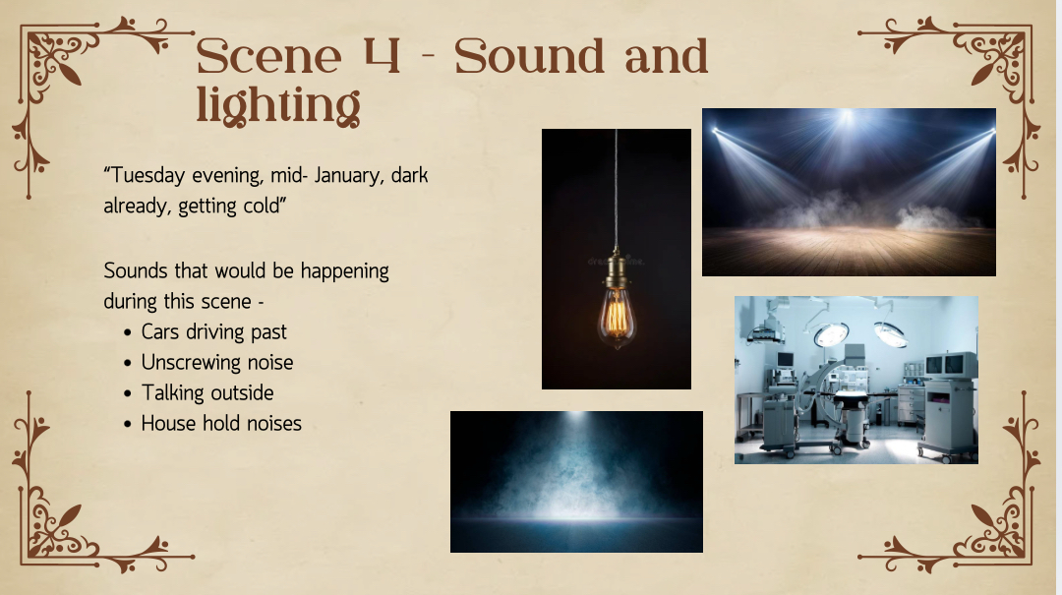
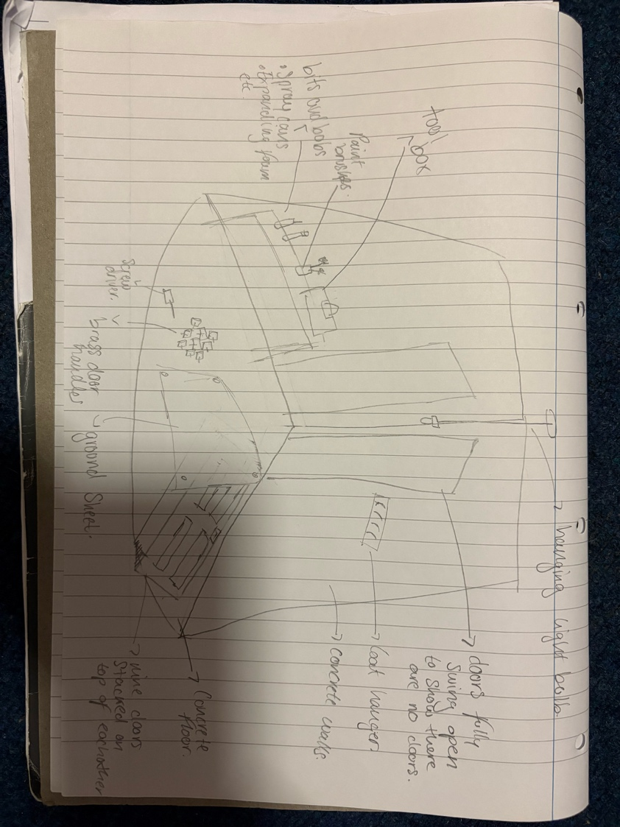
Reference list
Hannon, V. (2022). Theatre Now Review: Breathing Corpses. [online] theatrenow.com.au -. Available at: https://theatrenow.com.au/theatre-now-review-breathing-corpses/ [Accessed 5 Dec. 2025].
Hoile, C. (2016). Review - Breathing Corpses - Coal Mine Theatre, Toronto - Christopher Hoile. [online] Stage-door.com. Available at: http://www.stage-door.com/Theatre/2016/Entries/2016/10/27_Breathing_Corpses.html [Accessed 5 Dec. 2025].
Pranksterstheatre.org.uk. (2025). Review: Breathing Corpses – Pranksters Theatre Company. [online] Available at: https://pranksterstheatre.org.uk/reviews/review-breathing-corpses/.
Steep (2019). Steep Theatre. [online] Steep Theatre. Available at: https://steeptheatre.com/breathing-corpses [Accessed 5 Dec. 2025].

