
ASSIGNMENT TITLE: DATA HANDLING AND BUSINESS INTELLIGENCE
STUDENT ID:
WORDS: 1257

Table of Contents
Introduction 2
Current Trends in Business Intelligence 2
Cloud Analytics 2
Unified Data Management and Analytics 2
Augmented Analytics 3
360° Business Analytics 4
Embedded Business Intelligence 4
Data Storytelling 4
Business Activity Monitoring 5
Conclusion 6
References 7

Introduction
Business Intelligence refers to the process of extended data and digital technologies used to manage daily business functions. Multiple trends are evolving in the market with rising software engineering. The report will aim to deliver information on more than five trending business intelligence tools in the market.

Current Trends in Business Intelligence

Cloud Analytics
Cloud analytics is the most common and elongated business intelligence process that is rising in usage and utilities. Since 2020 and 2021, almost all companies have been transforming their internal and external operations in cloud space (Onyshchenko et al., 2022). The idea is built from the need to store data in safer and larger spaces. Manual records are, however, errored and often mismanaged with depreciation stakes. However, cloud analytics comes with the added software features of automatic archiving and retrieving information in big data analysis. Companies are planning to harness cloud analytics in the future to make a budget-friendly, secure, and legally and ethically compliant system that keeps the data load from hardware. It also comes with the opportunity for customising public, private, hybrid, or multiple community clouds using connective technologies (Onyshchenko et al., 2022). The process is made easier with microservice options that enable companies to invest in easy processing, adding and computing services.

Unified Data Management and Analytics
In addition to cloud analytics and transformation, a recent trend coming to the fore in business intelligence is the unification of BI stacks. Thus, a visualisation of modern BI applications and analytics has been platformed with the consolidation of data preparation layers. It means that in the next few years, data will likely become a native flow of BI operations with integration, management and insights on business decisions (Ruzgas and Dabulytė-Bagdonavičienė, 2017). The BI full stack approach using self-service analytics is considered a bigger trend in handling heavy volumes of data analysis. Thus, automatic technologies are included in the software to ease market and internal assessments (Ruzgas and Dabulytė-Bagdonavičienė, 2017). Businesses would soon invest in automatic piloting of data to use decisions in systems and devices for regular functions. It would enable the creation of a high-power programme for companies wherein agencies would only feed inputs and programmes to run data assessment and generate final reports and advice.

Augmented Analytics
Critics have noted a rapid digital technology evolution in the last few years. There is no doubt in expecting further increments in digital evolutions, as noted in the figure below for augmented systems. For instance, natural language query (NLQ) capabilities have enabled programmers and technological consumers to use immersive conversations in BI approaches using automatic and augmented systems (Analytics insight. 2022). The augmented system is already being applied in various bulk product and order handling systems (warehousing). Companies have begun applying augmented trends in real-time planning and management of warehouses and inventories. The main advantage here is the ease of operations and decisions, which augmented features add to regular warehouse functions. The systems have the scope to decide on new inventory layouts, plan work, and efficiently manage orders and stores. However, it would also require manual control to supervise the necessary functioning and upgrades.
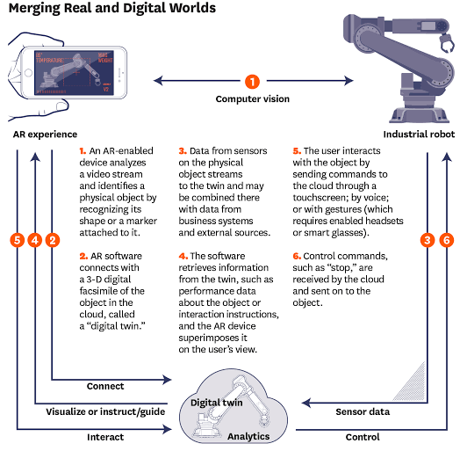
Figure 1: Augmented Business System
(Source: Harvard Business Review. 2022)

360° Business Analytics
Data agnostic evolution is a common expectancy that would affect businesses in the next decades. The reason is the diverse and enlarged adoption of business applications and software systems which are error-free in delivering needs (Brambilla et al., 2017). Not only that, each business application being included comes with the scope for data and software integration which is expected to ease the operations of companies in future. Domain-specific data models that are trending are expected to evolve into a generic dataset in the cloud from which all business software can collect necessary information (Brambilla et al., 2017). So, BI approaches would expect a complete transformation of business analytics into the digital and software space in the next few years. A benefit of this system is that new software models come with facilities to trace business specifications for moderating services.

Embedded Business Intelligence
Along with independent software vendors in companies, independent business consultancies need a monitored BI integration. The BI vendors used in companies also exist in the features of business consultants with some additional user-focused asset applications (Munawar et al., 2020). The consultancies can use these systems to harness low or no code applications from asset information. The BI vendors embedded in consultancies come with continuous API stacks that will help business-to-business services build natural workflow analytics (Munawar et al., 2020). Critics have researched that this system would help consultants retain their demands in the automated world with special asset allocations that companies cannot locate.
In most cases, such software and hardware integrate prebuilt components of businesses that enable advanced applications. Thus, using minimal hand coding, a consultant can offer an all-in-one experience to the companies they work for. The feature is trending among global business giants needing support from host locations.

Data Storytelling
It is vital to opine that business intelligence also comes with complications and stakes in the digital environment. The most noted problem is the attack on utility dashboards and investment returns from cyber policies (Analytics insight. 2022). So far, businesses have issued a primitive structure to issue data insights without biases. The software systems need an information report that is legible to all business teams for more standardised decisions. Keeping these in mind, data storytelling comes with the feature of BI's key performance indicators for assessing data interactions (Analytics insight. 2022). Consumerised insight deliveries are aimed to build just experiences on good and bad events to follow. Automated documentation and the portal channel are vital, created using specific software. The total system is based on creating a link with artificial intelligence.

Business Activity Monitoring
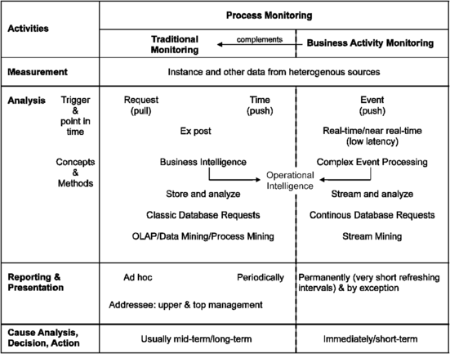
Figure 2: Business Intelligence in Activities Monitoring
(Source: Springer: Business Activity Monitoring. 2022)
The above figure shows activity monitoring done using a business intelligence software. The trend comes from the modern self-service BI approaches, along with up-close KPIs monitoring. The intelligence invested in the BI activity supervision is used to speculate data, monitor performance recordings in different departments, and spot outlines for proactive contributions (Dwivedi et al., 2021). Programmers have been able to create software that is individually capable of assessing the data on individual work. However, most of this service is based on self-accounted reports that must be uploaded regularly. An advantage of this mechanism is that no team member can manipulate their contributions using false data (Dwivedi et al., 2021). Special data alerts in the system for tallying records would secure the process.

Conclusion
It is clear from the assessment that each of the chosen processes in BI is important to trigger welfare in the overall system. However, applying these technologies needs valuable assessment before actuating the Intelligence systems in business functions. The report gives a detailed list of vital aspects of delivering ideal services. Further, it helps to reconsider many business intelligence trends.

References
Analytics insight. 2022. [online] Available at: <https://www.analyticsinsight.net/7-business-intelligence-trends-to-watch-out-for-in-2022/> [Accessed 25 July 2022].
Brambilla, M., Cabot, J. and Wimmer, M., 2017. Model-driven software engineering in practice. Synthesis lectures on software engineering, 3(1), pp.1-207.
Dwivedi, Y.K., Hughes, L., Ismagilova, E., Aarts, G., Coombs, C., Crick, T., Duan, Y., Dwivedi, R., Edwards, J., Eirug, A. and Galanos, V., 2021. Artificial Intelligence (AI): Multidisciplinary perspectives on emerging challenges, opportunities, and plan for research, practice and policy. International Journal of Information Management, 57, p.101994.
Harvard Business Review. 2022. [online] Available at: <https://hbr.org/2017/11/how-does-augmented-reality-work> [Accessed 25 July 2022].
Munawar, H.S., Qayyum, S., Ullah, F. and Sepasgozar, S., 2020. Big data and its applications in smart real estate and the disaster management life cycle: A systematic analysis. Big Data and Cognitive Computing, 4(2), p.4.
Onyshchenko, O., Shevchuk, K., Shara, Y., Koval, N. and Demchuk, O., 2022. Industry 4.0 and accounting: directions, challenges, opportunities. Independent Journal of Management & Production, 13(3), pp.s161-s195.
Ruzgas, T. and Dabulytė-Bagdonavičienė, J., 2017. Business Intelligence for Big Data Analytics. International Journal of Computer Applications Technology and Research, 6(1), pp.001-008.
Springer: Business Activity Monitoring. 2022. [online] Available at: <https://link.springer.com/chapter/10.1007/978-1-4471-4866-1_15> [Accessed 25 July 2022].

