Title: Programmes in C and Documentation
Part C: (Implementation-Function Based)
C Programme of a Card Game

Module: Software Development
ACCA4017

Course: HND Electronics and Electrical Engineering

University of Wales Trinity St David

By: Nick Regan
Student No: 1803871
Date: 2.5.19
Part C
1.1 Identify the problem: (break down into smaller problems, write individual stages)
- Ask user to enter position of first card between 0-11 and store in card1
- Ask user to enter position of second card and store in card2
- Print on screen the position of first card and the number of first pair ad store in card1 and pairs[card1]
- Print on screen the position of the second card and the number of second pair and store in card2 and pairs[card2]
- If the pair matches print on screen it’s a match
- Print on screen pairs found and the number of pairs found and store in found
- Loop back to the beginning and count turn
- If pairs don’t match then print sorry no match
- Loop back to beginning and count turn
- If either card has already been picked print on screen sorry the position of this card has been removed
- Once all pairs have been found the loop will stop
- Print on screen you’ve found all the pairs
- Print on screen the total number of turns taken is …… and store in turns

1.2 Annotated code
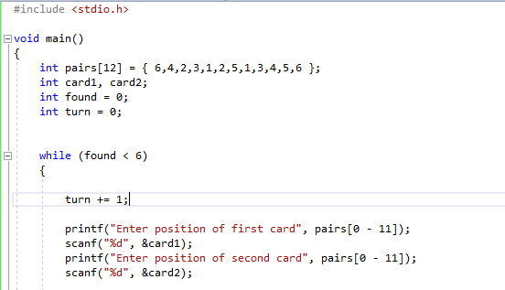

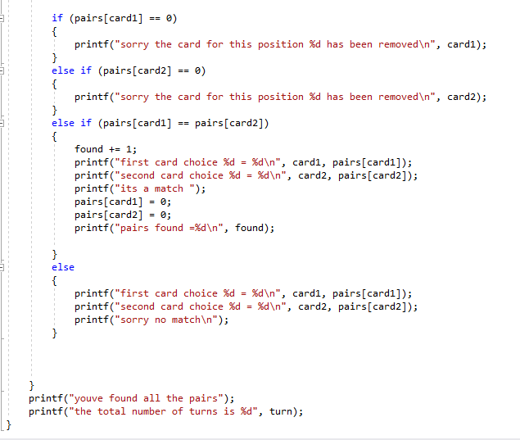

1.3 Testing
1.3.1 Normal values
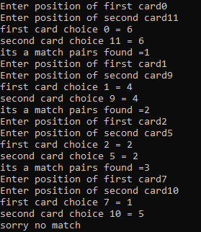
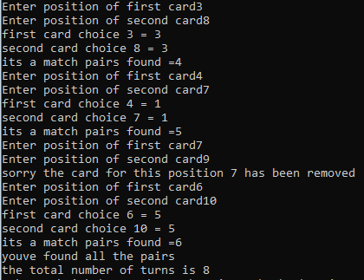
Result: program ran as expected and was successful. When the pairs were the same it printed it’s a match, when the pairs were different it printed sorry no match, if a pair had already been picked it printed sorry the card for this position has already been moved, once all pairs were found it printed you’ve found all the pairs and it calculated the amount of turns correctly and printed the total number of turns. Unfortunately the positions of the cards aren’t randomised so they will be the same every game.

1.3.2 normal and negative values
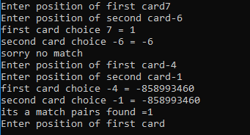
Result: as shown above a problem was encounter when using negative value. When a negative value was used as just a second choice the negative value was used as the pair resulting in no match as it was different to the first choice. When 2 negative values were used for the position choices the pairs came back the same but the values were completely different to pairs used in the game this however resulted in a match.
1.3.3 values higher than 11 and the same
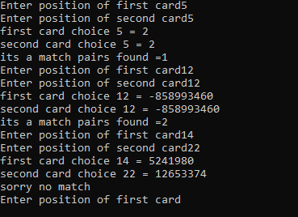
Result: As shown above there was a problem when using the same value for each card choice and a value higher than the value of positions in the game. When using the same value the pairs were the same as the card has not yet been removed resulting in a match. When using the same value but higher than the value of positions the pairs were the same but the value of the pair was different to the pairs used still resulting in a match. And when using to different values higher than the value of the positions the pairs were different and the values were different to the pairs used in the game resulting in no match.

1.3.4 letters
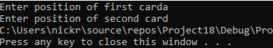
Result: as shown above when using letters the program would not run as it wouldn’t let the user enter anything for the second choice.



