

Strategic Management and Sustainability

LCBB6004
ASSESMENT 1

STUDENT NAME: VALENTINA STEFANOVSKA
STUDENT ID: 2123930
LECTURER: Dr. JAYA GOPALKRISHNAN
TERM: JUNE 2024
SUBMISSION DATE: 26.08.2024

TABLE OF CONTENTS
Introduction 3
The key business and corporate strategies of the company 3
Reasons for choosing the strategies 4
PEST Analysis 4
Porter’s 5 Forces 5
The resources and capabilities of the selected company 6
Alignment of resources and capabilities to its current business/corporate strategies 7
The success of the company in implementing selected business and corporate strategies 8
The ‘Click and Collect program’ 8
Technology and innovation 9
The competitive approach of the company considering sustainability and the environment 10
The choices available for the company’s strategic direction in the future 10
Better digital transformation 10
Adding more private-label products 10
Initiatives for sustainability 11
Geographic and Market Growth 11
Recommendations on further sustainability practices 11
Conclusion 12
References 13
Appendices 15
Appendix 1: PEST Analysis 15
Appendix 2: Porter’s 5 forces 16
Appendix 3: VRIO analysis 17

Introduction
Food, apparel, general items, and services are the main focusses of ASDA, the third-largest supermarket chain in the UK. Supported by sustainability goals to lessen environmental effect, the company's objectives include delivering high-quality goods, meeting customer wants, and reducing costs. As a result of competition from cheaper alternatives like Aldi and Lidl, ASDA is responding to market share decline caused by post-Brexit uncertainties and rising inflation by investing in store upgrades and enhancing its online presence.

The key business and corporate strategies of the company
With a 13.4% share of the UK market in April 2024, ASDA is the third-largest UK grocery chain, after Tesco and Sainsbury's (Bedford, 2024). Food, clothing, general items, and service retailing are its core competencies. Achieving cost savings while maintaining product quality is one of ASDA's primary strategic goals (Bedford, 2024). In order to lessen its effect on the environment and its operational expenses at the same time, it has a supplementary set of sustainability goals. Figure 1 shows that in the wake of Brexit-related uncertainty and rising prices, consumer attitudes have shifted, leading to a decline in ASDA's market share (Bedford, 2024). Cheaper alternatives, like Aldi and Lidl, are becoming more popular, according to Statista's study. These rivals' continual expansion worries ASDA (Hardy, 2024), as shown in Figure 2.
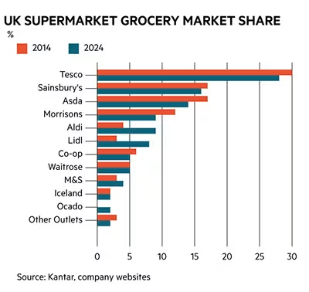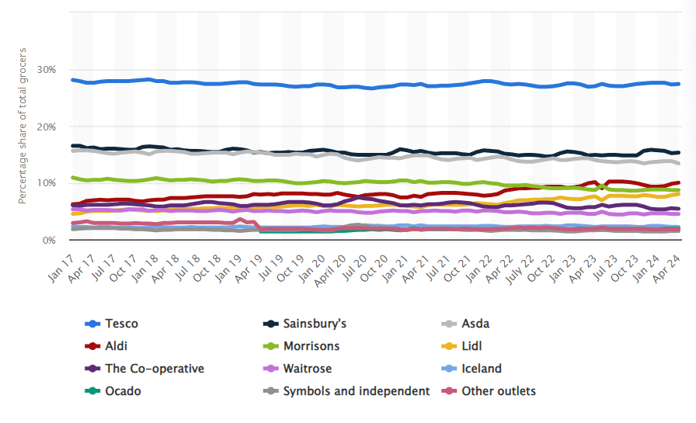
Figure 1 & 2: UK Supermarket Grocery Market Share
(Source: Hardy, 2024; Bedford, 2024)
Walmart, the parent company of ASDA, is concentrating on the prospects presented by the e-commerce sector as a result of this competitive pressure. With that in mind, ASDA offers a variety of services, including online shopping, delivery, and a "Click and Collect" program that lets consumers buy online and pick them up at a nearby ASDA store. Asda's expansion plans include a heavy emphasis on online shopping (Hardy, 2024). After separating from Walmart in early 2023, the grocery store began working with digital transformation firm Publicis Sapient to completely revamp its online grocery operation.
On the other hand, ASDA has come up with a growth plan that involves cutting expenses across the board while simultaneously increasing its online and physical presence. Innovation and branching out into new product lines are also priorities for them as they work to broaden their brand's reach. They gain from the R&D efforts of other Walmart companies since they are a member of the Walmart group. By the end of November 2024, for instance, 170 of Asda's shops would have been upgraded as part of the retailer's £50 million investment program (Retail Week, 2024). The grocery store chain will be able to use the funds to upgrade existing locations and provide new services.

Reasons for choosing the strategies

PEST Analysis
Political - The uncertainty resulting from post-Brexit regulatory reforms has affected consumer confidence and purchasing habits. Brexit-related changes to trade laws may have an impact on import pricing would be around 11% (Cepr, 2023). ASDA's cost-cutting and competitive pricing strategy is a reaction to the demand for affordability in an uncertain situation.
Economical - Inflation has been on the rise in the UK, which has an impact on consumer buying power. June 2024 saw no change in the UK's inflation rate from the previous month, when it dropped to its lowest level since July 2021 (Statista, 2024). The UK had seven months of double-digit inflation between September 2022 and March 2023, with a high of 11.1% in October 2022 (Statista, 2024). ASDA's strategy to cut expenses and provide value-for-money items is in line with the reality of the market.
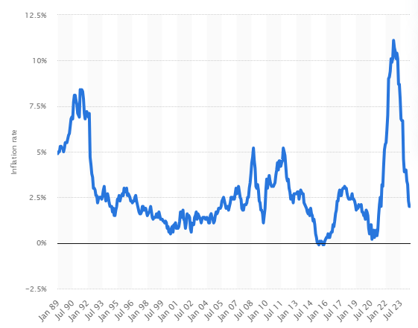
Figure 3: CPI in the United Kingdom
(Source: Statista, 2024)
Social - Over 80 % of people in the United Kingdom engage in online shopping, which in another sense means that over four out of five customers in the United Kingdom are converting digitally (Statista, 2021). As for the younger generation and day-to-day shopping, the trend of convenience and internet buying is also on the rise. The “Click and Collect” program and needs for e-commerce investment also correspond with these shifts in customer behaviour.
Technological - About 45 % of the retail businesses in the UK stated that they employed technological tools of visual search frequently in the course of the survey. Voice search came in next, with 27% of the shops employing this technology (Statista, 2024). To stay ahead in the market, the company must adhere to the digital transformation trends by employing smart technology.

Porter’s 5 Forces
Competitive Rivalry: Retail competition in the UK is relatively high because of the high number of participants involved in the market hence it affects both young and old firms. In this case, the company will experience high force since there are similar firms like “Tesco, Morrison, and Sainsbury” that challenge Asda (Jones and Comfort 2021).
Threat of New Entrants: This factor leads to the introduction of low force for the company. It is indeed challenging to venture into the retail business due to barriers to entry that include; the initial costs are always very high and the need for popular brands. However, ASDA has not ceased advancing and funding shops enhance TOR to maintain its edge and prevent new rivals from entering the market.
Bargain power of consumers: Many grocery shops experience high force while buying items from several supermarkets, on the other hand, consumers or buyers in the retail segment leverage their e-commerce buying strength to decide on which supermarket would offer them the best services and maximum pleasure (Sarisa 2021).
Bargain power of suppliers: As a result, the company face low force since over 50% of suppliers are working with ASDA such as Food procedures and manufacturers, home goods suppliers, clothing and textile companies etc, by adapting digital transformation to provide different kinds of products so that it can fulfil the consumer’s demands at its retailer store.
Threat of Substitute Products: the company faces medium force in threats of substitutes. There is more competition since there are alternatives, such as bargain stores like Aldi and Lidl, online grocery choices like Amazon Fresh and Ocado, and other handy options including meal kit delivery services like HelloFresh and Gousto. To lessen the impact of potential replacements, ASDA has taken the strategic decision to expand its online presence and provide customers with more convenient shopping choices.

The resources and capabilities of the selected company
VRIO analysis is a suitable framework to analyse the resources and capabilities of ASDA. This analysis will help in understanding how the company is developing its competitive advantage through its optimisation of resources. As observed in Appendix 3, the cost leadership strategy of ASDA is valuable; however, not rare. It has been mentioned before in the report that consumers are preferring cheaper alternatives such as ALDI (Sarisa, 2021). On the other hand, being the third-largest brand and a subsidiary of Walmart provides the company with sufficient brand recognition. In terms of supply chain, every week, over 18 million people shop at Asda via its many channels, including its e-commerce site, local grocery shops, Asda Living stores, and supercenters. Asda depends on Blue Yonder's Luminate Platform for labour management, omnichannel fulfilment, end-to-end supply chain visibility, and artificial intelligence-powered forecasting to guarantee it can deliver the right items to the right consumer in the right location at the right time.
Regarding its resources of employee training and development, the company website is flourished with details of various training programs provided to the employees. However, there have been repeated allegations, as illustrated in Figure 4, of a lack of training, guidance and leadership (LinkedIn, 2024). On the contrary, the company emphasises research and development strongly to get ahead in the competition. For example, in 2022, the company partnered with Salesforce to redevelop its CRM strategy. To transform the grocery shopping experience for consumers, Asda would use Salesforce technology to get a comprehensive understanding of its clients (Salesforce, 2022). This would allow the company to provide individualised and customised services. Thus, overall, ASDA has excelled in some aspects of its internal resources. However, there is still room for improvement in some of the other aspects.
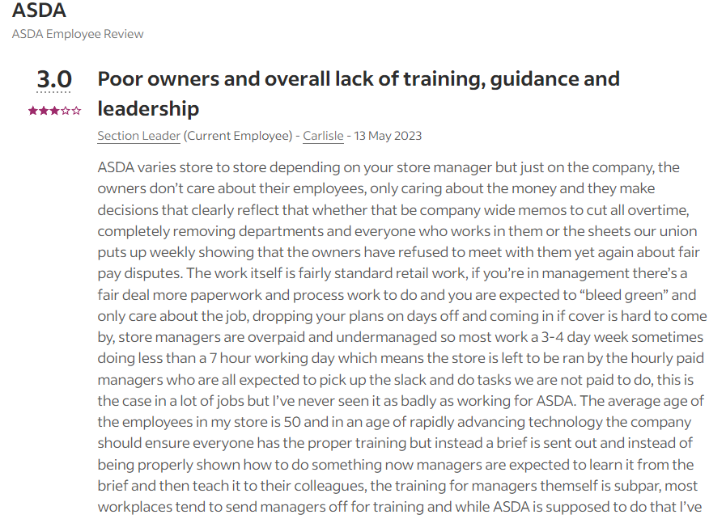
Figure 4: Employee grievance against ASDA
(Source: LinkedIn, 2024)

Alignment of resources and capabilities to its current business/corporate strategies
To do well in the very competitive UK food business, ASDA needs to plan how to best use its resources and skills. Walmart stays ahead of the competition by keeping prices low by using its huge supply chain network. This is called "cost leadership." In line with its goal to cut costs and attract price-conscious customers, ASDA is taking this method. Because Lidl and Aldi are cheaper, ASDA may not be able to fight on price alone. It will need to find other ways to stand out. As the third-biggest grocery company in the UK, ASDA gets a lot of name recognition from being in the market. Its strategy goals include expanding the range of goods it sells and improving the in-store experience by spending a lot of money on things like the £50 million shop improvement project (Retail Week, 2024). Its brand strength helps it reach all of these goals. By making in-store deals better, ASDA is moving towards its goal of going above and beyond what customers want and building brand recognition. In order to stand out, the business wants to be known as a place to get both cheap and good items easily.
The "Click and Collect" service and ASDA's focus on online shopping are both in line with the company's plan to grow digitally. The company's choice to work with Publicis Sapient to update its online shopping business shows that it is now putting more emphasis on digital platforms for growth. ASDA is making the switch to digital by putting money into research and development, especially in customer relationship management (CRM), which aims to make the customer experience better and increase customer trust. ASDA does not put enough money into training and developing its employees, as shown by reports of not enough training. However, the fact that the company is focused on new ideas and using Walmart's research and development skills shows that it wants to improve its business powers. By aligning its resources and skills with its strategic goals, ASDA deals with market problems and stays competitive by looking at the big picture.

The success of the company in implementing selected business and corporate strategies

The ‘Click and Collect program’
Asda's "click and collect" program has been able to develop a competitive advantage for the company as, on average, 60% of internet-bought items are picked up in-store. In some places, this number is even higher for clothes, at 70% (Retail Technology, 2024). Asda started the program in 2011 for food and now has 650 sites, with 614 shops and 46 spots that are farther away (Retail Technology, 2024). Every year, more than 15 million orders are made through the service, and 30% of those orders are picked up on the same day (Retail Technology, 2024). Asda also does other things, like letting customers pick up their orders at train stops and having sellers complete their orders directly. However, as per Figure 5, the Trustpilot rating for the company is abysmal, with 1.3 stars along with expressed dissatisfaction from customers over this service (Trustpilot, 2024).
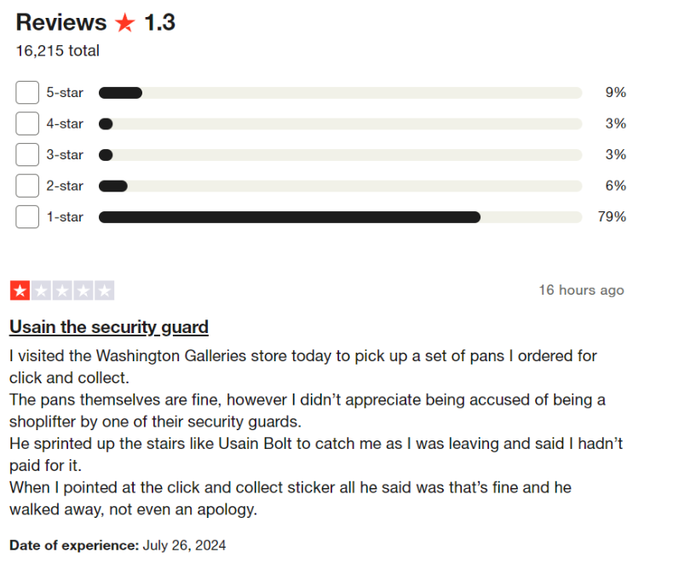
Figure 5: Trustpilot rating and customer feedback on the Click and Collect program
(Source: Trustpilot, 2024)

Technology and innovation
Asda put in place next-generation LP technology to help fight shrink in today's tough market because they knew the importance of data and being able to see their whole shrink-control ecosystem. With this smart approach, Asda can see what is going on in all of their stores at once. With these new insights, Asda doesn't have to rely on guesses to make decisions about their shrink. Instead, they can rely on what the data tells them. By planning ahead, Asda can start to streamline operations and protect their investments for the future. They can do this by focussing on centralised management, optimising store labour, addressing possible training needs, and making the shopping experience better inside the stores. Asda can see if alarms go off less often in shops with better security by tracking the highs and lows of crime activity in each one and trying the efficiency of different loss prevention methods.

The competitive approach of the company considering sustainability and the environment
ASDA has noted the increasing role of sustainable and sound environmental practices in influencing customers’ prescribing habits and legislation. These have been incorporated into the competitive strategy of the firm to improve its market standing as well as the brand image. In this respect, it should be noted that an important strategy of ASDA has been its environmental efficiency, that is, addressing the issues of environmental conservation and working on ways to minimize an organization’s impact on the environment alongside working on ways to decrease the organizational costs and expenses. This dual benefit strategy enables ASDA to enhance its generic competitive and sustainable advantages since it is in an era where consumers are very sensitive in their reach (Achterberg, 2024). Their short-term, science-based goal is to reduce carbon emissions from direct and indirect operations by 2030, along with emissions related to the use of forests, land, and agriculture (FLAG) in the production of their goods. Their emissions also reduced in 2022 to 8% less than in 2021 as they Continued to implement more measures to reduce the emission rates (ASDA ESG Report 2022). The firm has probably established clear goals and objectives for cutting the level of greenhouse gases and waste from its operations. Such energy efficiency solutions as enhancing fridge control solutions to reduce power consumption as well as including doors on our fridges to affect the energy that it uses (affecting the store temperature) are currently being implemented among their business chain.

The choices available for the company’s strategic direction in the future

Better digital transformation
ASDA could put more money into its digital change and e-commerce. It could improve its online footprint by adding more features to its online shopping platform, making the user experience better, and incorporating cutting-edge technologies like AI for more personalised buying. Building on its new relationship with Publicis Sapient, ASDA could look into using machine learning and more advanced data analytics to better handle its supplies and learn more about its customers.

Adding more private-label products
ASDA can set itself apart from rivals by expanding its private name line. ASDA could boost the value of its brand and keep customers coming back by putting out new, high-quality, private-label goods in more categories. Putting an emphasis on unique goods that meet new market trends could help you get and keep more customers.

Initiatives for sustainability
The ASDA's goals for sustainability open up a big opportunity. Consumers who care about the environment might be interested in expanding efforts to lessen environmental impact, such as making shops more energy efficient, better-managing trash, and using more sustainable materials. These projects also fit with bigger goals for business social duty and could save money in the long run.

Geographic and Market Growth
ASDA can look into new regional areas or add more types of products to its collection. While focussing on growing in current markets, it could look for chances in areas that are not well covered or in related industries, like health and fitness goods.

Recommendations on further sustainability practices
Expand renewable energy
Technologies like solar and wind can be applied at the ASDA to power the facility or even make a recommendation to adopt them (Huang et al. 2021). Some of these companies like ASDA can make use of smart meters, IoT sensors, and data analytic tools to capture data on the generation and utilization of energy in real time. This sort of data may therefore be used in making particular suggestions to the customers concerning energy saving, a time that might be taken to accomplish certain energy-demanding activities depending on available renewable resources.
Sustainable supply chain
It would be possible for organisations such as ASDA to use sustainable supply chain management to promote products and services, and recommendations that are ethical and environmentally friendly. Therefore, through establishing track and trace solutions and cooperating with environmentally friendly suppliers, ASDA can provide suggestions regarding the products with correct certified sources, ethical employment of workers, and fewer detrimental effects on the environment (Jones and Comfort 2021). They may include locally grown food products, products made from recycled material or products that are packaged least elaborately.
Food waste reduction
The excess fresh foods should be contributed to a nearby non-profit organization like a charity or a food bank. Include the application of Artificial Intelligence in such a manner that its implementation will help eradicate unnecessary stocking, and therefore, wastage.

Conclusion
In conclusion, the strategic decisions made by ASDA show how the company has adapted to the changing and competitive retail landscape is identified in this report. To tackle market problems and evolving customer preferences, ASDA is concentrating on cost leadership, digital transformation, and sustainability. This report mentioned about the company's dedication to improving customer experience and operational efficiency is seen via its collaborations, investments in technology, and retail enhancements. Using its brand power and innovative skills, ASDA plans to weather the economic storms caused by Brexit and inflation, as well as the competitive challenges from bargain retailers, so it can continue to thrive in the ever-changing UK grocery industry.

References
Achterberg, E., 2024. Towards Meaningful Human Rights Impact Assessments: From supermarket commitments to best practice action.
Adelakun, A., 2020. Should Porter's Five Forces have value in businesses today. Computing for Business (BSC).
ASDA ESG Report (2022) Bing. Available at: https://asdagroceries.scene7.com/is/content/asdagroceries/Asda.com/7.%20Sites/Creating%20Change%20for%20Better/Asda%2DESG%2DReport%2D2022%2D240319.pdf (Accessed: 27 July 2024).
Bedford, E. (2024) Great Britain: Grocery market share 2024, Statista. Available at: https://www.statista.com/statistics/280208/grocery-market-share-in-the-united-kingdom-uk/ (Accessed: 27 July 2024).
Cepr (2023) Brexit inflation: The role of trade policy uncertainty in increasing UK import prices | CEPR. Available at: https://cepr.org/voxeu/columns/brexit-inflation-role-trade-policy-uncertainty-increasing-uk-import-prices (Accessed: 27 July 2024).
Hardy, R. (2024) Has a strong Christmas made supermarkets investible?, Investors’ Chronicle. Available at: https://www.investorschronicle.co.uk/content/55da74ca-d821-51ce-b3e0-77669762a123 (Accessed: 27 July 2024).
Huang, I.Y., Manning, L., James, K.L., Grigoriadis, V., Millington, A., Wood, V. and Ward, S., 2021. Food waste management: A review of retailers’ business practices and their implications for sustainable value. Journal of Cleaner Production, 285, p.125484.
Jones, P. and Comfort, D., 2021. Animal welfare and UK food retailers. International Journal of Sales, Retailing and Marketing, 10(1), pp.14-22.
Jones, P. and Comfort, D., 2021. Leading Retailers in the UK and Modern Slavery Statements. International Journal of Sales, Retailing and Marketing, 10(2), pp.18-26.
Retail Technology (2024) Retail technology: Study: ASDA builds up e-commerce success, Retail Technology News. Available at: https://www.retailtechnology.co.uk/news/5018/study:-asda-builds-up-e-commerce-success/#:~:text=Asda%20has%20also%20been%20able,orders%20are%20collected%20in%20store. (Accessed: 27 July 2024).
Retail Week (2024) Asda (strategy), Retail Week. Available at: https://www.retail-week.com/retail-navigator/asda/asda-strategy/7038426.supplierarticle#:~:text=Ecommerce%20is%20one%20of%20Asda’s,business%20following%20separation%20from%20Walmart. (Accessed: 27 July 2024).
Salesforce (2022) Asda redefines the consumer grocery experience with Salesforce, Salesforce. Available at: https://www.salesforce.com/news/press-releases/2022/06/09/salesforce-asda-grocery-news/ (Accessed: 27 July 2024).
Sarisa, L., 2021. Business strategies in the retail supermarkets industry: A comparative case study analysis of Costco and Aldi.
Sarisa, L., 2021. Business strategies in the retail supermarkets industry: A comparative case study analysis of Costco and Aldi.
Statista (2021) Topic: Online shopping behavior in the UK, Statista. Available at: https://www.statista.com/topics/7887/online-shopping-behavior-in-the-uk/#topicOverview (Accessed: 27 July 2024).
Statista (2023) Leading 10 retailers in the UK 2023, Statista. Available at: https://www.statista.com/statistics/462863/leading-ten-retailers-by-sales-uk/ (Accessed: 27 July 2024).
Statista (2024) UK inflation rate 2024, Statista. Available at: https://www.statista.com/statistics/306648/inflation-rate-consumer-price-index-cpi-united-kingdom-uk/#:~:text=The%20UK%20inflation%20rate%20was,11.1%20percent%20in%20October%202022 (Accessed: 27 July 2024).
Statista (2024) UK retailers technology use 2019, Statista. Available at: https://www.statista.com/statistics/1014970/retail-technology-use-uk-retailers/#:~:text=The%20most%20widely%20used%20technology,by%2027%20percent%20of%20retailers (Accessed: 27 July 2024).
Trustpilot (2024) Asda is rated ‘bad’ with 1.3 / 5 on Trustpilot, Trustpilot. Available at: https://www.trustpilot.com/review/www.asda.com (Accessed: 27 July 2024).

Appendices

Appendix 1: PEST Analysis
Key components | Analysis
Political | Brexit-related changes to trade laws may have an impact on import pricing would be around 11% (Cepr, 2023)
Economical | The UK had seven months of double-digit inflation between September 2022 and March 2023, with a high of 11.1% in October 2022 (Statista, 2024)
Social | Over 80 % of people in the United Kingdom engage in online shopping, which in another sense means that over four out of five customers in the United Kingdom are converting digitally (Statista, 2021)
Technological | Voice search came in next, with 27% of the shops employing this technology (Statista, 2024)

Appendix 2: Porter’s 5 forces
Key component | Impact | Force
Competitive Rivalry | In this case, the company will experience high force since there are similar firms like “Tesco, Morrison, and Sainsbury” that challenge Asda (Jones and Comfort 2021). | High
Threat of New Entrants | ASDA has not ceased advancing and funding shops enhance TOR to maintain its edge and prevent new rivals from entering the market. | low
Bargain power of consumers | Consumers or buyers in the retail segment leverage their e-commerce buying strength to decide on which supermarket would offer them the best services and maximum pleasure (Sarisa 2021). | high
Bargain power of suppliers | As a result, the company face low force since over 50% of suppliers are working with ASDA such as Food procedures and manufacturers, home goods suppliers, clothing and textile companies etc. | low
Threat of Substitute Products | To lessen the impact of potential replacements, ASDA has taken the strategic decision to expand its online presence and provide customers with more convenient shopping choices. | medium

Appendix 3: VRIO analysis
Resources | Value | Rare | Inimitable | Organised | Competitive advantage
Cost leadership | YES | NO | NO | Well-organised with Walmart's support | Competitive parity
Brand recognition | YES | YES | YES | Strong brand loyalty and marketing strategies | Sustained Advantage
Supply chain efficiency | YES | YES | MEDIUM | Leveraged through Walmart’s global network | Competitive Advantage
Private label products | YES | YES | MEDIUM | Well-integrated into product offerings | Competitive Advantage
Employee training and development | NO | NO | MEDIUM | Ongoing investment in employee development | Temporary Advantage
Research and development | YES | YES | MEDIUM | Walmart’s support for R&D | Competitive Advantage

