CONCEPT AND STORYBOARDING

We want our VFX piece to represent the reality of wildlife fires, and how endangering they can be to animals and people. Following recent events in countries like the United States (specifically the LA fires), we think that it’s a very recent and relevant topic. Many people have lost their homes to this, as it is primarily caused by human negligence (over 90% of forest fires in the US alone are manmade ^{[1]}) and it will continue to affect nature until we proactively fight against it.

For my part of the project, I want to use real footage, while keying and tracking effects in. My partner expressed that he wished to use 3D footage of an environment he will create to effectively show our topic.

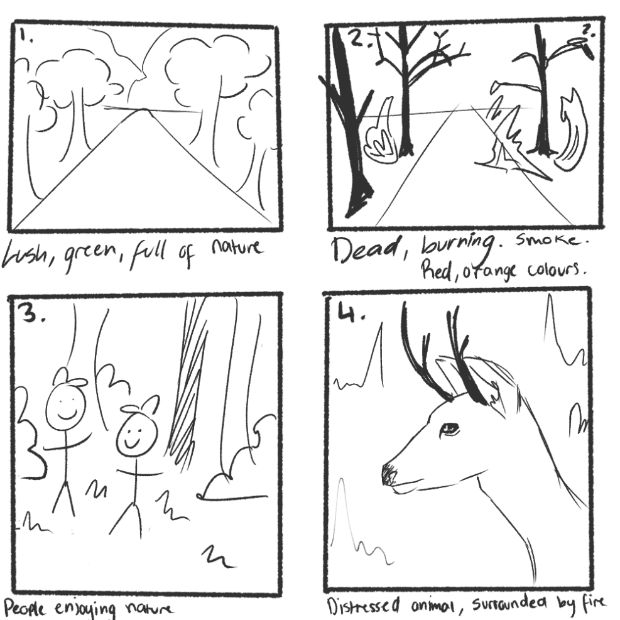
STORYBOARD 1:

Our first idea for the shot is to show contrast, within a forest, by visualising the serene aspect of nature and then our distressing, aflame forest. We hope this will have a little bit of a shock factor, and represent how quickly forest fires affect the lives and habitats of animals—and even the lives of people.
STORYBOARD 2:
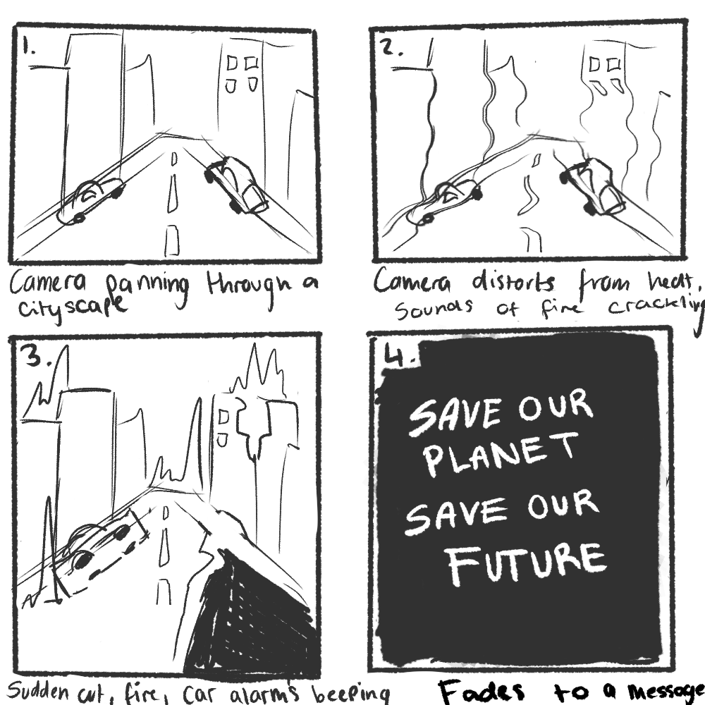
For our second shot, we want to exaggerate how quickly fires and climate change can affect our way of life, and the future of it.

STORYBOARD 3:
After some back and forth between emails, my partner and I decided that it would be too unrealistic to showcase our topic through a big city being ruined so drastically, and may come across too far-fetched for the viewer to take it seriously.

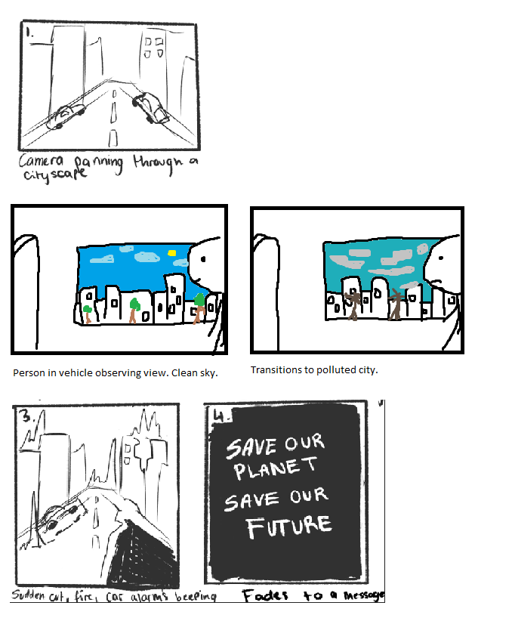
My partner sent this storyboard, providing a new perspective of someone sat in a vehicle, watching the city slowly deteoriate.

We decided that it would be too difficult to find footage, so we settled on our first idea.

STORYBOARD 4, FINAL:

For our last storyboard, I created 5 clips by using shots from our first. I want to show how drastically different it is between how peaceful it is without the threat and danger, and hopefully allow the viewer to pity the animals involved by showing them.
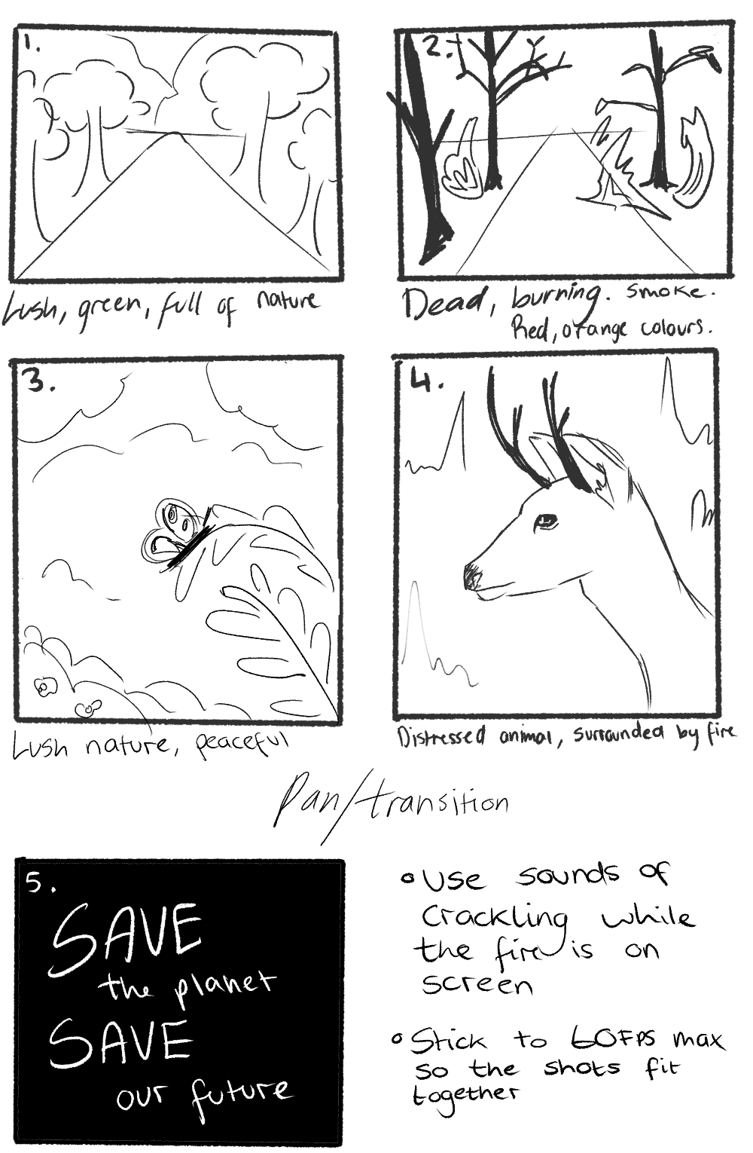
I want to composite a serene, vibrant shot of a butterfly on a leaf—or something alike it if I cannot find the correct footage/assets—as it is pretty and may be relaxing to look at. I then want to use reds and ambers for the shot of the deer, to set a tone and visual shift, and imply that the stag is surrounded by a burning forest.
For the last shot, I want to create a simple black screen with animated text; a saying or phrase to impact the viewer.
[1] WFCA, “What Causes Wildfires?,” WFCA, Jul. 06, 2022. https://wfca.com/wildfire-articles/what-causes-wildfires/

