     | Business Expansion of the Jewelry Group into the Asian Market  In a perspective of international business communication  [DAQIAN LI 1805441]  [WEI HE 1900504]  [YOU LI 1803783]  [ZIXIANG AO 1804416]  Course: M3X9089  <International Business Communication>  Date: 2020-05-01

Introduction
Jewelry industry is highly localized in terms of that less than 15% of the global revenue is generated by ten top leading companies (McKinsey, 2019). However, as the diamond industry shows, the jewelry industry is also becoming more globalized than ever(ELLIOTT, 2019).The Global Trade Center is shifting from Western Europe to the Middle East and Southeast Asia. The Asian market not only provides consumers with high purchasing power, but also provides one of the most unique manufacturing centers in the world (OEC, 2019). This has made huge senses, that is, it will make British jewelry companies face tremendous competition, whether in terms of price, quantity or transportation cost, all are also facing a huge threat. It is possible that the market share in the world will shrink rapidly and the turnover will go down significantly.

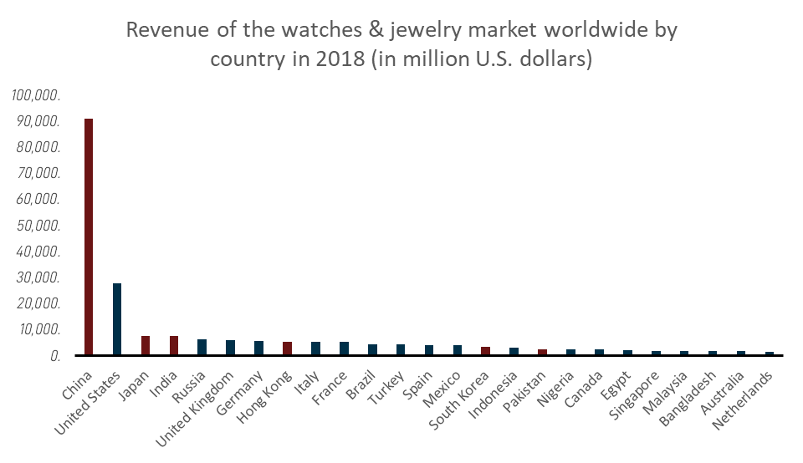
Figure 1. Revenue of watches & jewelry market worldwide by country in 2018 (in million USD). Source: (Statista, 2019)
From the Figure 1, we can clearly see that in the global sales of jewelry, there is no doubt that China is the first, $90,000 million and much higher than other countries, followed by the United States, Japan and India. So we can figure out that if any company occupies the Asian market, the jewelry industry will definitely increase revenue and profits. In addition, we can see that UK jewelry revenue is about $5000 million, which is ranking 5. So apart from its domestic market, if British jewelry companies want to open the door to the Asian market and effectively achieve the potential benefits of entering the Asian market, it will be quite beneficial to the profitability of UK jewelry companies. Therefore, UK company must formulate a feasible and effective international business communication strategy. Otherwise, the company can only be limited to the jewelry needs of the domestic country, and cannot expand overseas markets.

Cultural comparisons between markets
The distinctive characteristics of Asian culture can make the articulation of effective international business communication highly challenging. From the Hofstede’s model, the Asian countries are not only different from western countries, they also show distinct characteristic within the region (Hofstede, 2011). In east Asia, many cultures were shaped or influenced by the Han dynasty culture, because in ancient times, jewelry such as jadeware was a precious symbol of the status of a emperor. Also, they show distinct preferences especially when it comes to communication with western culture as argued by (Zhang et al., 2005). When it comes to jewelry products, the Asians show clear different preferences compared with western consumers. For example, the iconic Olympic game medal in 2008 made by China consists a jade ring. Inside Asia the taste on jewelry is also diverse(Kim, 2014). Indians prefer gold and conventional gemstones such as ruby. Chinese people prefer green jade, especially on some special occasions, such as giving elders gifts, green jade is a good choice. Therefore. In order to better understand the local market as well as to more effectively cooperate local partners, it is thus important to implement effective international business communication in the group.

Figure 3. Cultural differences based on Hofstede cultural dimensions (own creation based on Hofstede' theories (2011))
According to Figure 3, we can easily see that Hofstede model reveals the cultural characteristics of various countries and helps people understand the culture of other countries from a deeper level. As a kind of objective existence, cultural differences affect all aspects of international business exchanges. Using this model, we can profoundly analyze the differences in cultural values between the United Kingdom and Asian countries such as China, and propose corresponding countermeasures to increase UK jewelry companies' awareness of cross-cultural communication in international business activities, reduce cultural conflicts, and more Promote economic and cultural exchanges and development.
But in fact Hofstede's point of view also has certain limitations, such as not taking into account the host country's policy regulations on multinational companies. Many countries have formulated various legal provisions on multinational companies or joint ventures for various purposes. Second, multinational companies cannot simply set out the company's articles of association, remuneration, etc. based on their own laws or practices.

Countermeasures to bridge cultural differences

Why developing a relationship with Asian Partners matters?

Importance of effective international business communication
Multinational corporations are culturally diverse in their workforce and in the process of handling various business activities. In the same cultural context, there are few differences in communication when people live together; but in the same way, when dealing with people of another cultural background, misunderstandings and conflicts often occur (Okoro, 2012). Thus, it will be a significant disadvantage for the group if it is not well-versed in effectively communicating with its local partners from Asian markets. Moreover, successful navigation of relationships with global partners based on an in-depth understanding of the Asian culture will bring the group with significant development prospects in Asian Markets. Applying a set of well-developed approaches in relationship development can also ensure the group to make the full use of the host markets to widen the group’s portfolio by promoting localized services and products. Thus, the group could successfully penetrate into the Asian market and even develop a competitive business edge.

Benefits of effective international business communication
The primary benefits of developing good relations with the local partners can benefit the group in the following ways. A well-developed relationship with global partners in the Asian market can effectively help the group to reduce any communication misunderstanding, and inadvertent conflicts in business operation resulted from cultural differences. For instance, problems will be commonplace between the expatriate employees and local partners due to their preferences of different communication styles. Meanwhile, the process of developing great relationships with local partners can facilitate the group to gain more knowledge and insights into the Asian markets, which can be leveraged to target local customers and tailor the regional strategies. Apart from above, the extensive experience resulted from group’s successful operation, and its embrace of local cultures may give the possibility of a synergy effect when diverse talents with different cultures are working together. The cross-cultural relationship encourages individuals to collaborate internationally instead of sticking to the previous styles of working. The smooth sharing of knowledge and experience without any communication barriers has been widely proved beneficial for driving innovation and inspiring creativity that synergies the cultures of the home country and the host countries (Beamer and Varner, 2001; Schmidt et al., 2007; Pikhart, 2014).

What if the group fails to develop a relationship with its Asian partners?

Possible impact of ineffective international business Communication
Each employee working for the group hopes to get respect and be recognized for their contributions. And firms with more energized employees always deliver more superior productivity and higher creativity. However, in some previous business expansion cases, the failure to develop a great relationship with the local partners result in various issues including the feeling of disrespect, the occurs of misunderstanding, the happens of conflicts, etc.(Thomas and Peterson, 2016) Over time, a negative work atmosphere will be nurtured within the organization with employees being less energized.
Also, it is challenging for the group, with no experience of operating in Asian markets, to successfully realize their ambition of business expansion in the Asian market without any facilitation of local partners. As discussed above, local partners can be helpful to help the group to gain knowledge and insights into the Asian market, so that it can reach out to the targeted customer in a more concise way. Meanwhile, with less time spending on solving communication problems due to excellent relationships with business partners, the group can harvest synergy effect if all employees are collaborating towards same goal. Thus, dealing with Asian partners with different cultural backgrounds is imperative, and the inability of the group to conduct business in a way that accommodates its local partners will significantly hinder the group from its business expansion in Asian markets.

Possible causes of ineffective international business communication
Indicated by Brislin (1990), values and beliefs, which are ingrained deeply in the cultures, have a significant impact on the recognition of other’s respect and trustworthiness. As people from very different cultures working together, different values and beliefs are integrated into their way of communicating and collaborating. Conflicts often arise from employees who are stubborn with their own values and beliefs.
Apart from the differences in values and beliefs, ethnocentrism is also observed as the primary culprit behind most intercultural communication failures. Ethnocentrism is defined by Hammond and Axelrod (2006) as the sense of superiority on values, races, religions, cultures, etc. over other groups of people. An essential prerequisite of effective intercultural communication is to understand and respect cultural differences. However, ethnocentric individuals are not capable of appreciating cultural diversity, but will sometimes involve judgmental behavior in the workplace. Especially when leaders demonstrate certain ethnocentrism, a low level of team cohesion can be frequently observed.
Stereotyping denotes the inertial assumption that all members of a specific group share some particular traits, such as Asian people are always labeled as introverts (Oakes, Haslam and Turner, 1994). However, culture can only be genuinely observed until employees engage in culture-specific communications. employees may fail to understand and respect people from different cultures, and the frail of great relationships with local partners occurs as a consequence of stereotyping.

Concluding Remarks
The report shows the significance, methods and potential issues of the jewelry group's international expansion to the Asian market. There are significant cultural differences of attitudes and preferences of the jewelries between the UK market and the Asian market. Therefore, before entering the Asian market, UK jewelry companies have to carefully consider the applicable methods of providing effective international business communication and possible problems, which will help them make full preparations when entering the Asian market.

Reference List

Babcock, D. & Bertha, D. (2001), Language-based communication zones in international business communication. The Journal of Business Communication, 38: 4, pp. 372-412

Beamer, L. & Varner, I. (2001), Intercultural communication in the global workplace. McGraw-Hill/Irwin New York, NY

Brislin, R. W. (1990), Applied cross-cultural psychology. Sage Publications

Casson, M. (2001), Economics Business Culture，Game Theory，Transaction Costs and Economic Performance [M].Oxford:Clarendon Press，31:2, pp. 261-271

Dunning, J.(1997), The cultural sensitivity of the eclectic paradigm [J].Multinational Business Review,3: 2, pp. 348−370

ELLIOTT,A. (2019), We Are the World: The Globalization of the Jewelry Industry.r, 29:2, pp. 142-158

Hammond, R. A. & Axelrod, R. (2006), The evolution of ethnocentrism’, Journal of conflict resolution. Sage Publications Sage CA: Thousand Oaks, CA, 50:6, pp. 926–936

Hevoinick, L. (1980), Transnational corporations: analysis of UN experts [J]. Foreign economy and management, 13:1, pp. 56-58

Hofstede, G. (2011), Dimensionalizing cultures: The Hofstede model in context, Online readings in psychology and culture. International Association for Cross-Cultural Psychology, 2:1, pp. 8-10

Kim, J. (2014), Asian jewellery at the Museum of Applied Arts and Sciences. The Journal of Product Innovation, 18:5, pp. 219-230

Le,S.(2015), Intercultural business communication: research status and development path [J]. Journal of Guangdong University of foreign studies

McKinsey,K. (2019), A multifaceted future: The jewelry industry in 2020

Oakes, P. J., Haslam, S. A. & Turner, J. C. (1994), Stereotyping and social reality. Blackwell Publishing

OEC (2019) OEC - China (CHN) Exports, Imports, and Trade Partners

Okoro, E. (2012), Cross-cultural etiquette and communication in global business: Toward a strategic framework for managing corporate expansion, International Journal of Business and Management. Canadian Center of Science and Education, 7:16, pp. 130-132

Pikhart, M. (2014), Implementing new global business trends to intercultural business communication, Procedia-Social and Behavioral Sciences. Elsevier, 152, pp. 950–953

Schmidt, W. V et al. (2007), Communicating globally: Intercultural communication and international business. Sage Publications

Statista,J. (2019), Revenue of the watches & jewelry market worldwide by country 2018

Thomas, D. C. & Peterson, M. F. (2016), Cross-cultural management: Essential concepts. Sage Publications

World Bank (2019), Final consumption expenditure (2010 US$) - East Asia & Pacific | Data

Xie, S.(2008), Study on cross-cultural conflicts and Strategies of transnational corporations [J]. Economic theory and economic management, October 2008

Zhang, Y. B. et al. (2005), Harmony, hierarchy and conservatism: A cross-cultural comparison of Confucian values in China, Korea, Japan, and Taiwan, Communication research reports. Taylor & Francis, 22:2, pp. 107–115

