
Applied Leadership and Management in the Workplace
Module Assignment Submission
Student Name: | Alexandra Williams
Student Number: | 2126654
Module No: | BMSK4014
Module Title: | Problem Solving and Decision Making

Statement of Confirmation of Authenticity
By the act of making this submission, the student declares that this is the work of the student named above. The work has not, in whole or in part, been knowingly presented elsewhere for assessment, or where assessment has been built on a previous assessment, this has been identified. Where materials have been used from other sources it has been properly acknowledged. If this statement is untrue, the student acknowledges that an assessment offence has been committed.
Attention is drawn to the plagiarism and unfair practice policies of both the University and of ILM.
I acknowledge the use of Chat GPT during the time completing this assessment.
I would ask Chat GPT to explain some of the topics I needed clarity on. I also asked it if my paragraphs made sense as I struggle with knowing what I need and want to say but it gets a little muddled up. It would suggest changes, which I would adapt / change into my own work.
I confirm that I have not presented any AI generated text as my own work. I confirm I have most (due to not realising I needed to keep all copies) I did however keep some back-ups of my own work, copies of my drafts, notes, and other resources I used before, and after the use of AI tools which I may be asked to provide in evidence.
I acknowledge the use of Grammarly (https://www.grammarly.com/) on during this assignment to check my work using the prompts, which were the basic suggestions / typos.
​​

Table of Contents
Introduction 3
Workplace Problem 3
Scope 4
Impact 4
Analysis 5
Brainstorming 5
Brainstorming for Casa Cwtch Play 6
Mind Map of brainstorming ideas 6
5 Whys – Helping find the Root Cause of the Problem 7
Ishikawa – Fish Bone Theory – Problem Factors 8
Possible Solutions 8
Evaluation 10
Grid analysis 10
Cost benefit analysis and ratio 11
SWOT Analysis 13
Action Plan Implementation 14
Fallback Plan 15
Communication Plan 15
Combined Stakeholder Communication Grid Plan and Power-Interest Analysis 17
Executive Summary / Conclusion 18
References 19

Introduction
Indoor play centres are a growing market in the UK as families look for safe and fun places for children to play. According to Allied Market Research (2020) this sector is set to grow at a rate of 12.6% from 2022 – 2031.
Businesses need to manage many different tasks at the same time, such as session times, party bookings, capacity limits, and staffing levels. Many play centres still rely on manual booking methods phone calls, walk-ins, or paper diaries. This can create problems such as double bookings, long waiting times, over-crowding, loss of business, loss of reputation and extra pressure on staff.
This report will focus on how bookings are currently managed at the play centre, and whether introducing a computerised or online booking system would improve the situation. An online booking system would allow parents/carers to book sessions and parties themselves at any time. It would also help the centre keep track of visitor numbers more easily, prevent overcrowding, and make staff planning more efficient.
This report will analyse this problem using problem-solving tools such as brainstorming and the 5 Whys method to explore the causes of the current difficulties. It will then generate possible solutions and compare them. To make a fair and well-reasoned decision, the report will use Grid Analysis to compare each solution against set criteria, and Cost-Benefit Analysis to weigh up the financial and practical impacts.
Choosing the right booking system has the potential to reduce staff workload, improve customer experience and satisfaction, minimise mistakes, and support the play centre’s long-term growth. This report will show how structured problem-solving and decision-making techniques can help find a clear and effective solution.

Workplace Problem
Casa Cwtch Play Centre, which is an indoor play centre, is facing the challenge of developing an efficient booking system that can meet the needs of both the business and its customers. Currently, bookings are taken through phone calls, social media messages, or in-person enquiries, which can lead to confusion, delays, and errors. The business offers a variety of activities such as open play sessions, various timed events catering for older children/teens, birthday parties, group bookings, and potentially membership options. Each of these activities has different time slots, capacity limits, and pricing structures. Without a clear and consistent booking system, it becomes difficult to monitor visitor numbers, ensure safety, manage staffing levels, and provide a reliable service to customers. The option of monitoring reports will also be beneficial to see increases and decreases of different sessions to enable adaptation for recovery or growth i.e. changing of session times, events etc.
The problem is made more complex because the play centre needs to manage several pieces of information at the same time. For example, the centre must be able to track how many children and adults are attending each session, which party rooms are available, what pricing applies, and whether any membership discounts need to be applied. If this is done manually, mistakes such as double bookings, incorrect pricing, or overcrowding can occur. This not only affects day-to-day operations but can also lead to dissatisfaction among customers, possible negative reviews and increased stress for staff.

Scope
The scope for the new booking system at Casa Cwtch Play is to avoid confusion with staff, customers and bookings, use resources effectively and wisely, and ensure the new booking system improves the business in the most beneficial way. For example:
- Customers / Parents / Carers rely on clear session availability and easy booking. If the process is slow or confusing, they may become frustrated or choose to go elsewhere.
- Business Owner / Management - Need accurate information to plan staffing, ensure safety rules are followed, manage revenue, and keep the business running smoothly.
- Staff Members - When bookings are unclear or incorrect, staff may have to spend extra time sorting out issues, which takes time away from customer service.
- Booking Channels (Online / Phone / In-Person) - Without a centralised system, information may be inconsistent across different booking channels, leading to misunderstandings.

Impact
The impact of the current problem could be:
- Customers may not be able to easily check session availability, see clear pricing, or understand what is included in their booking. This can cause confusion and dissatisfaction.
- The business may experience problems such as overcrowding, lost income from missed bookings, difficulty planning staffing levels, and increased administrative workload.
- Staff stress may increase as they spend more time manually managing bookings, handling complaints, or correcting errors.
- Safety and experience could be compromised if too many people attend a session or if activities overlap without proper planning.

Analysis
Using established models and tools to explore the causes of complex problems helps businesses and teams identify issues and potential solutions with greater clarity and consistency. By following a six-step approach (see figure 1.), groups are better able to make informed decisions, minimise bias, and work collaboratively towards effective solutions (Vy, 2023).
Figure 1. A Six Step Problem Solving Process (Vy, 2023).
Using a clear method as above to identify and analyse the problem helps teams solve issues more effectively. It encourages the use of facts, teamwork, and strong reasoning, making decisions and changes easier to understand and support. This report will follow this structure using established models to identify the causes of the problem and offer workable solutions.

Brainstorming
The first step after identifying a problem is to identify all possible solutions, and the main purpose of brainstorming is to come up with and record as many ideas as possible, even if the ideas seem unusual. This type of open thinking encourages creativity and can lead to new solutions. By allowing everyone to share their thoughts, people can build on each other’s ideas to find the best way to solve a problem. It is said to be best done in groups, working together to think of ideas and solve problems and encourages staff to be more involved, sharing their ideas with no judgment. It can also be done alone. A person can sit down and write down any ideas or answers they can think of to explore different ways of solving a problem (Eaton Business School, 2018).
University of Derby (2017) suggests that brainstorming is best carried out by having some structure, for example, using mind maps and then identifying the causes using the 5 Whys and Ishikawa’s Fishbone cause and effect diagram, which are shown below.

Brainstorming for Casa Cwtch Play
Ideas:
- Buy an app with support services Yes
- Commission a programmer to develop a bespoke booking system for the business Yes
- Design own booking system W
- No booking system – pay on arrival with no booking option W
- Booking by telephone only No
- Use a calendar or google spreadsheet No

Mind Map of brainstorming ideas
Mind mapping is a good visual way to get ideas down when you are not sure where to start. It is suggested to start by identifying the main problem/topic in the centre, then add any related points around it. This helps see connections and gives a clear overview of the key points. (The Open University, 2025).

The following mind map (see figure 2.) helps show the different booking system options for the business. By laying the ideas out visually, it becomes easier to see what each option involves and compare the advantages and disadvantages.

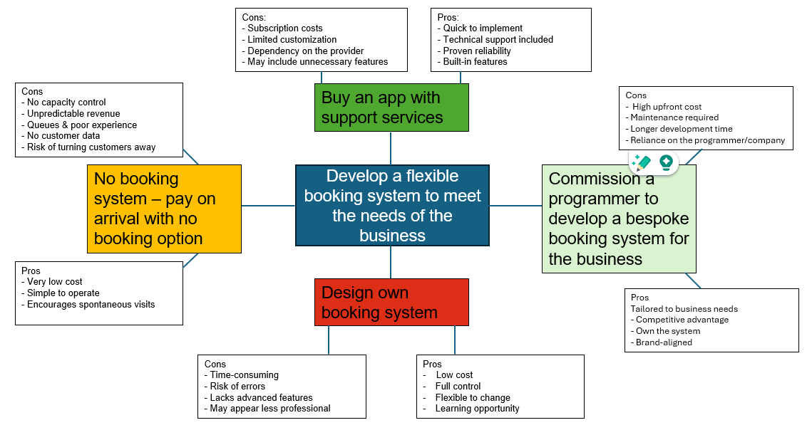Figure 2. Mind map of brainstorm ideas for Casa Cwtch Play

Looking at the options side-by-side helps see which system would work best for the business. The mind map helps to make the decision clearer and supports choosing the most suitable and practical solution. The chart above shows that the top two ideas from mind mapping for identifying the best solution for the Casa Cwtch Play booking problem are that the darker green code is possibly the best suggestion, and the light green is a second.

5 Whys – Helping find the Root Cause of the Problem
The 5 Whys is a simple problem-solving technique that can help find the root cause of an issue by asking “why?” up to five times and digging deeper each time. Serrat (2017) suggests that this technique/process encourages honest reflection, clear problem statements, and a determination to identify the real cause.
The above technique was used to personalise the problem for Casa Cwtch Play (see figure 3.).
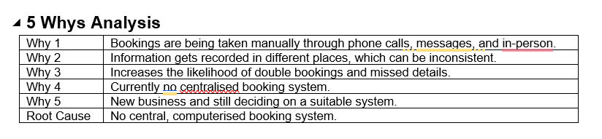Figure 3. 5 Whys analysis

By asking “why?” repeatedly and working as a team, can uncover the underlying issue and agree on actions to prevent the problem from happening again. In the above scenario, it identifies that the ‘root cause’ is that there is no computerised system in place, which also shows the current process and problems it can cause, for example, double bookings, inaccurate information recording, which could lead to overbooking/crowding.

Ishikawa – Fish Bone Theory – Problem Factors
The Fishbone Diagram (see figure 4.) which is also known as the Ishikawa Diagram, is used to identify and organise the possible causes of a problem. By breaking the issue down into key categories, it allows us to look deeper and visually at what factors may be contributing to the problem.
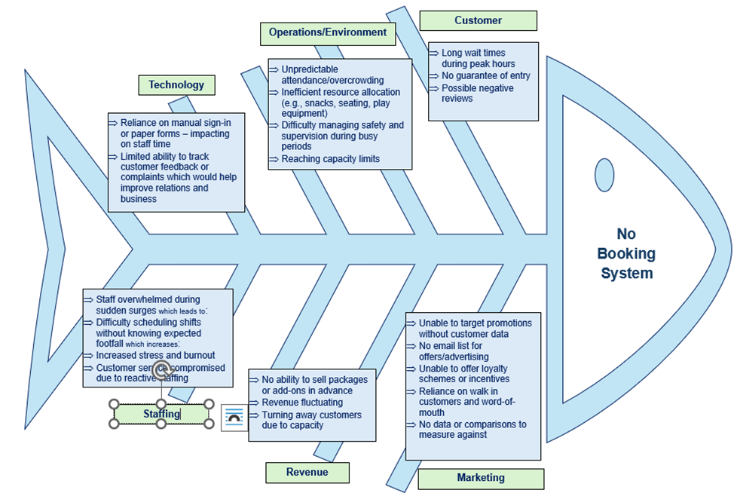
Figure 4. Fishbone Analysis Diagram

By examining the problem from multiple angles, the Fishbone Diagram helps to highlight the root causes that need to be addressed for Casa Cwtch Play as detailed in the above figure/diagram. This helps support a clearer decision-making and allows appropriate actions to be planned to prevent the issue from continuing and by using the completed Fish Bone leads on to identifying possible solutions.

Possible Solutions
Through the application of brainstorming methods, some potential solutions have been identified, including the use of the mind mapping process (figure 2.) to address the problem of Casa Cwtch Play operating without a booking system, which could be:
- Buy a ready made booking app.
- Pay a developer to create a custom booking system.
- Create a simple in-house booking system (e.g., forms/spreadsheet).
- Use an online third-party booking platform (e.g., Bookwhen).
- Employ a staff member to manage bookings manually (phone/in-person).
Figure 5. below outlines possible solutions for addressing Casa Cwtch Play’s lack of a booking system. These ideas were developed through brainstorming and were considered in terms of practicality, benefits, and potential barriers.
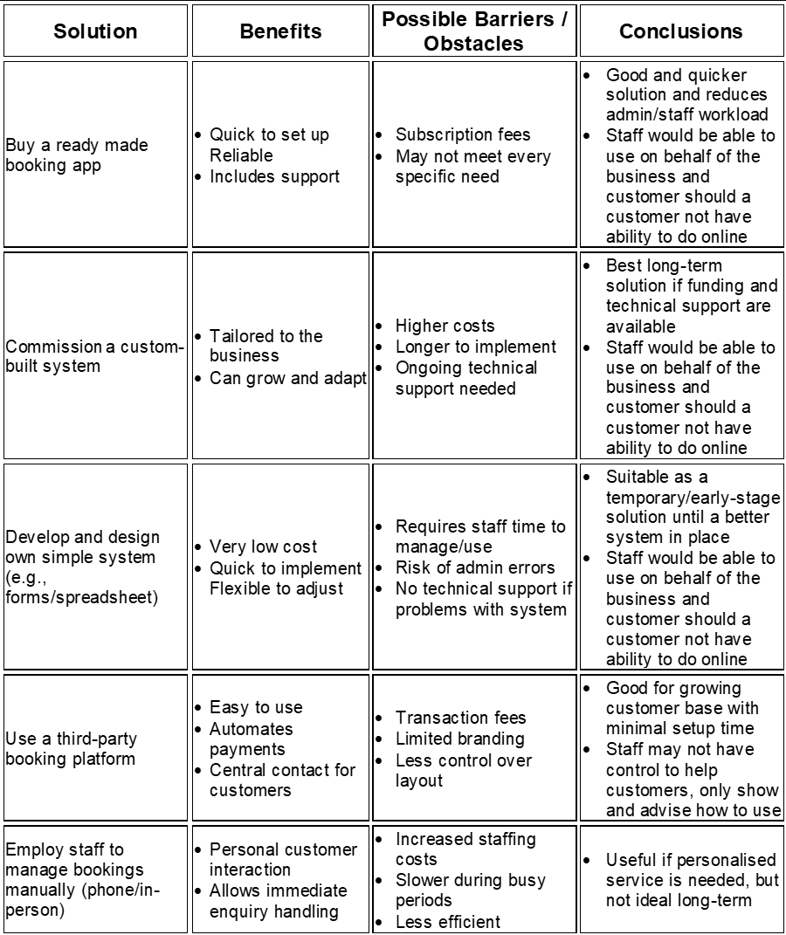
Figure 5. Solutions Barrers and Obstacles
This helps compare the solutions and shows which option may work best based on cost, time and ease of use, supporting the final decision.
Each solution helps compare the possible solutions and shows how each option may work best based on different benefits depending on cost, time, practicality etc. In the short term, using a simple in-house system or an online third-party platform is practical and affordable. For long-term growth, buying a supported booking system or having one custom-made would be more sustainable and reduce manual work. Hiring extra staff may help with customer service, but it is costly and may not be efficient as the business gets busier.
Some examples of the platforms that are available out there are:
- Bookwhen https://bookwhen.com/
- Bookaby generic booking and management app https://bookaby.co.uk/
- Booked it – for soft play centres https://booked.it/
- ROLLER Software – Playground Booking Systems https://www.roller.software/industries/playground-software
- Beyonk – Soft Play Booking System https://beyonk.com/activity-booking-system/soft-play/
All the above have a cost and vary in the services they offer.

Evaluation

Grid analysis
A grid analysis is a structured decision-making tool used to compare multiple options against a consistent set of criteria. Each criteria is assigned a weight based on its importance, and each option is scored according to how well it meets these criteria. The weighted scores are then calculated to produce a total score for each option, allowing decision-makers to identify the most suitable choice based on objective, data-driven comparisons. A grid analysis has been created below to help make a decision for Casa Cwtch Play problem solving by implementing a booking system.
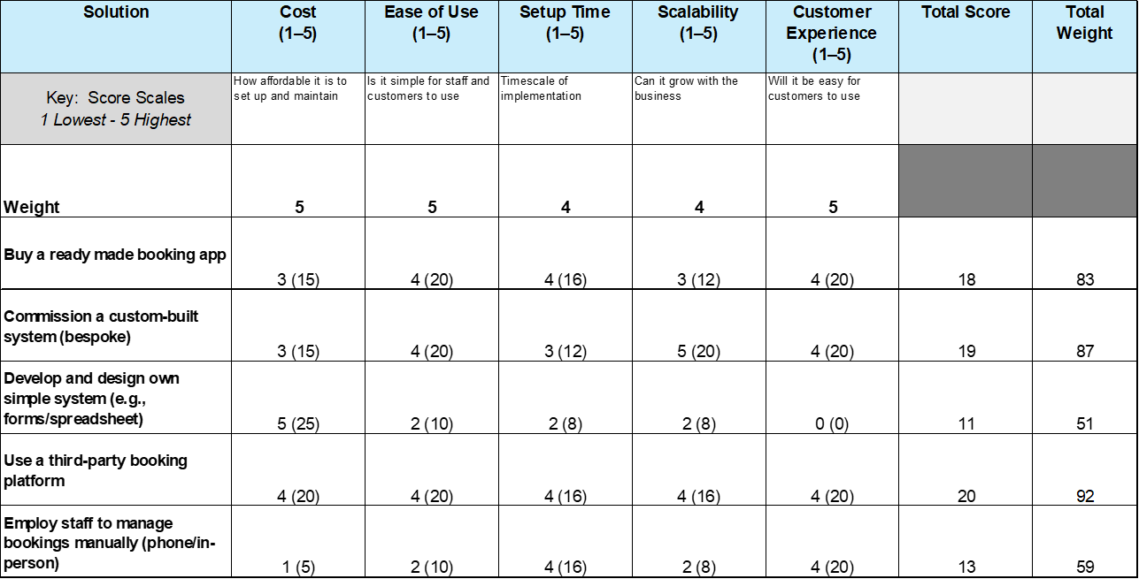Figure 6. Grid analysis for Casa Cwtch Play
The grid analysis (figure 6.) compared the booking system options by evaluating their strengths and weaknesses. It showed that the best solution is not always the cheapest when overall performance and business needs are considered. The analysis identified a third-party booking platform as the most practical choice, with a bespoke system ranking closely behind for its potential to offer a more tailored experience.
As Casa Cwtch Play is a new business introducing its first online system, the third-party platform is the preferred option due to its usability, affordability, and built-in support. This aligns with best practice, as grid analysis helps compare alternatives systematically and improve decision quality (Scott, 2025).

Cost benefit analysis and ratio
Tim Stobierski (Stobierski, 2019) sums up that a cost-benefit analysis a process which can identify the best solution by comparing the projected or estimated costs and benefits associated with the suggested project decision determining whether it makes sense from a business perspective.
A cost benefit analysis is used to help solve a problem and make a decision based on comparing the possible costs and benefits of different options as shown in figures 7. and 8. It provides a break down and shows what each option would score in terms of costs, benefits. The total costs are then compared to the total expected benefits to help see which option offers the most value. Sometimes this can also be shown as a ratio. If the benefits are greater than the costs, the option is likely to be a good decision. If the costs are higher than the benefits, then the business may need to change or rethink the idea. Doing this analysis helps the business make informed and confident decisions, rather than guessing.
It is also important to remember that the best option is not always the cheapest. A low-cost choice may not always work well or meet the needs of the business. Sometimes the most effective decision may be a combination of two solutions, to provide a balance of cost, quality, speed, and customer experience. The best option should be the one that offers the best overall solution, not just the lowest price.

ROLLER Software – Playground Booking Systems https://www.roller.software/industries/playground-software has been chosen as the most cost effective, practical and well reviewed company of choice. The following is based on the company's costings:
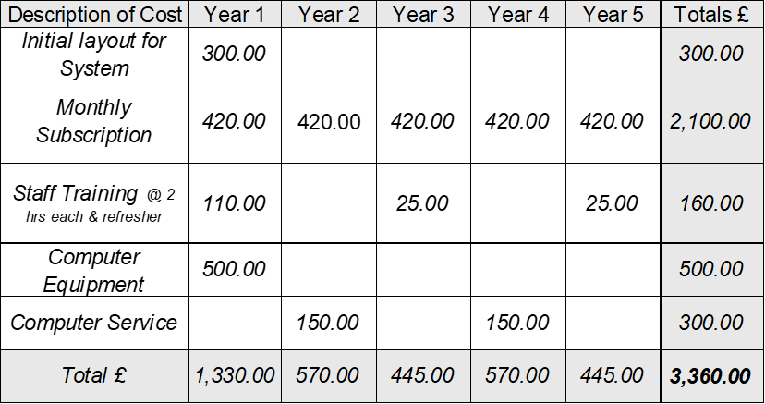Figure 7. Costs of the new booking system

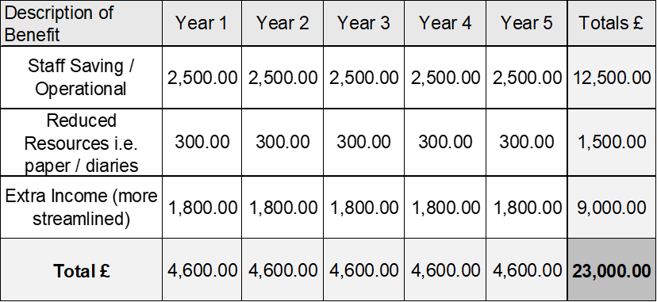Figure 8. Benefits of the new booking system

Financial Performance Indicators / Ratios
Benefit to Cost Ratio = Total Benefits £23,000
Total Costs £3,360
= 6.84

Net Annual Benefit = Total Benefits £4,600
(First Year) Minus
Total Costs £1,330
= £3,270

Total Annual Benefit = Total Benefits £23,000
Minus
Total Costs £3,360
= £19,640
divided by 5 years
= £3,928

The above Financial Performance Indicators and the cost and benefit tables in figures 7. and 8. show that the online booking system is a worthwhile investment for Casa Cwtch Play. With costs of only £3,360 and projected benefits of £23,000 over five years, it offers a strong financial return. Alongside the savings, the system will improve efficiency, reduce staff and admin time, and make bookings easier for customers. The system will deliver ongoing efficiency and cost savings/growth making it a sustainable investment for future growth.

SWOT Analysis
By using the SWOT analysis (see figure 9.) in addition to the Cost and Benefit Analysis can also be a useful tool, as the cost and benefit is more to assess and analysis the cost effectiveness whereas the SWOT will also help identify strengths and weaknesses within the discriptive side. Therefore, a SWOT analysis has been completed to support the decision making process for the choice and implementation of a booking system.
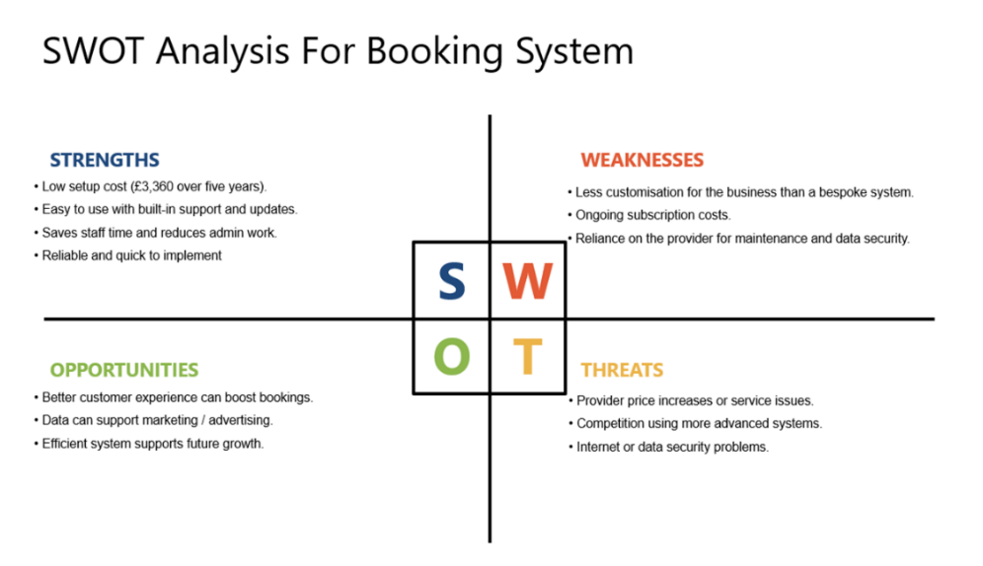
Figure 9. SWOT analysis

The above SWOT analysis shows that althougth there is a cost, the strengths and opportunities are a strong factor which help to mitigate the risks of implementing an online hybrid system opposed to not having one. The main risks would be increase of fees and data security but ensuring they have a good reputation and all equipment is secure with passwords and anti virus usage the risk can be reduced.

Action Plan Implementation
To implement the plan effectively, priorities will be based on the cost–benefit analysis, focusing on the cost and practicality of using a third-party online booking system. A Gantt chart will be used to outline key stages and timelines, helping to plan and monitor progress clearly. This structured approach supports good organisation and communication, ensuring stakeholders stay informed throughout the process. Following the Gantt Chart (figure 10.) an Action Plan (figure 11.) will be developed to further explore the Gannt chart in more detail to provide desired outcomes.

Figure 10. Gannt Chart
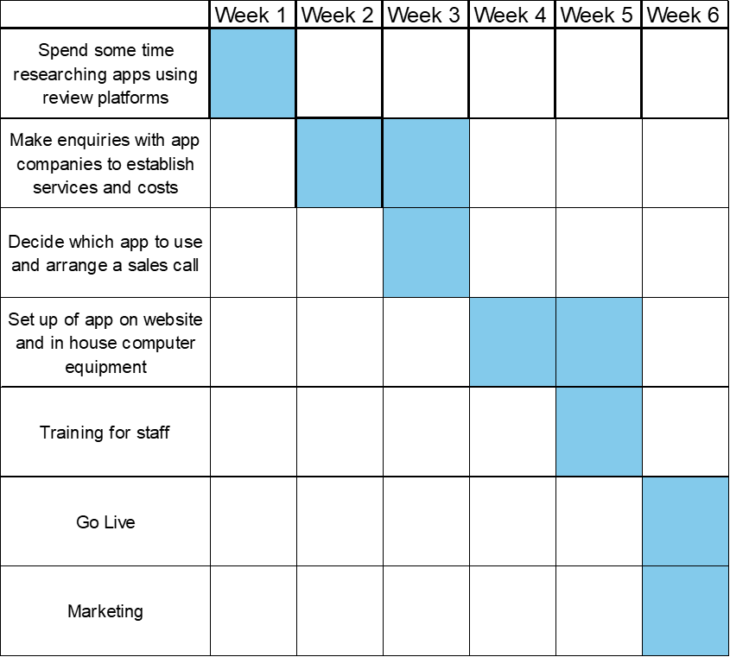
Figure 11. Action Plan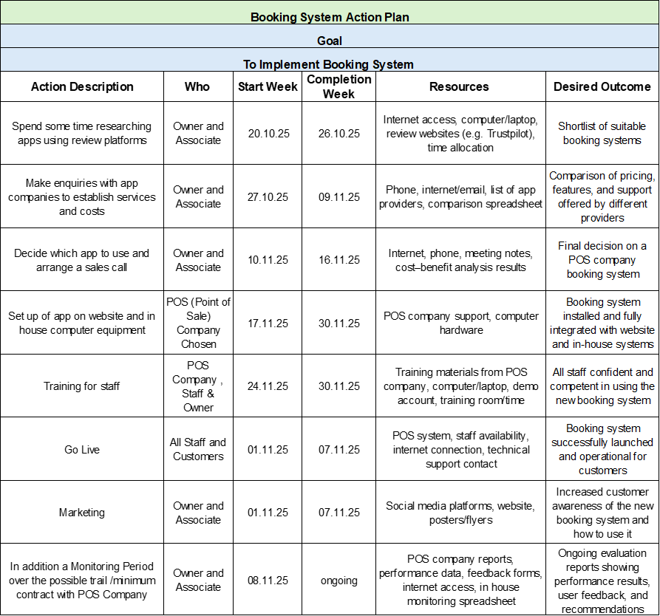
The Gantt Chart (figure 10.) and the Action Plan (figure 11.) with timelines together present a well-organised strategy to enhance business efficiency, customer experience, and operational control through the implementation of an effective booking system using the chosen provider. These visual tools help to organise and track progress, ensuring a structured approach to managing resources and supporting the business in staying on schedule and meeting key targets.

Fallback Plan
In the event that the third party app via the supplier or venue technical equipment was to fail due to various reasons i.e. software problem, networks, technical failure then a fallback plan will be in place. This will be by keeping a back up spreadsheet, visible price lists, receipt book, food order pads, visitor list etc which will monitor payments and details of walk in customers along with ensuring staff are trained and confident in resorting back to basics as a temporary back up.

Communication Plan
Clear communication is vital for implementation of a business change, such as implementing a new booking system which will have costs to the business because it ensures understanding and collaboration. Freeman (1984) highlights the need to consider all stakeholders, such as staff and customers, through open and transparent communication. The Shannon-Weaver Communication Model (1949) explains how information flows from sender to receiver through a chosen channel, with feedback reducing misunderstandings caused by noise. In the Casa Cwtch Play communication plan, management acts as the sender, delivering messages about the new booking system via channels such as meetings, emails, and social media. Staff and customers are the receivers, and feedback is collected through surveys and polls to ensure clarity and engagement. This structured approach helps minimise confusion and supports successful implementation.

Figure.13 The Shannon and Weaver Model of Communication
Diagram below: Shannon and Weaver Model of Communication. (2011). ‌



Combined Stakeholder Communication Grid Plan and Power-Interest Analysis

This combined table below (figure.14) integrates the Stakeholder Communication Plan with the Power-Interest Grid. It includes examples for additional stakeholders such as the POS Booking App Supplier and Owner. By adding Power, Interest, and Strategy columns, the table helps prioritise communication and engagement efforts based on influence and involvement (Oguz, 2022).

Figure. 14 Stakeholder Communication Plan

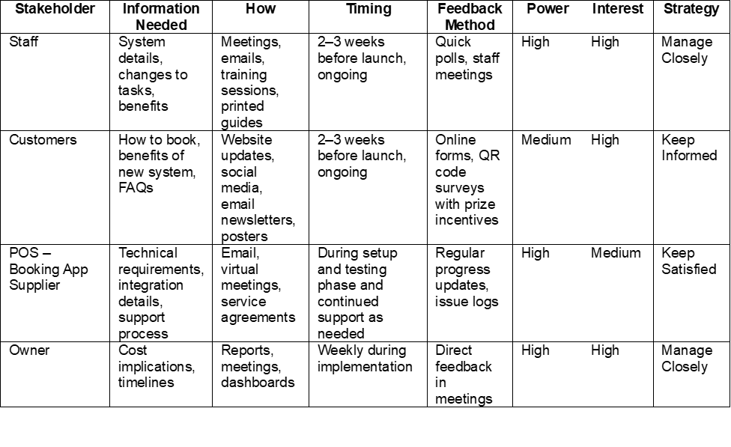
Roles (power and interest) were assigned based on their influence and involvement: Staff and Owner have high power and interest. Customers have high interest but less influence, so they should be kept informed. The POS (point of sale) Supplier has high power due to technical control but medium interest, so keeping them satisfied ensures smooth integration.

Conclusion
This report addresses the operational challenge at Casa Cwtch Play Centre which is the absence of an efficient booking system, which currently leads to errors, customer dissatisfaction, and increased staff workload. Using structured problem-solving techniques—including brainstorming, 5 Whys, Ishikawa analysis, Grid Analysis, Cost-Benefit Analysis, and SWOT—the report evaluates multiple solutions.
The analysis’ concludes that implementing a third-party online booking platform is the most practical and cost-effective option. It offers strong usability, affordability, and built-in support, with a quantitative benefit-to-cost ratio of 6.84 and an estimated net annual benefit of £3,928, demonstrating long-term financial sustainability. Alongside these measurable outcomes, qualitative benefits such as improved customer experience, reduced staff stress, and enhanced operational control strengthen the case for adoption.
An action plan, fallback strategy, and communication framework have been developed to ensure smooth implementation. Performance will be monitored through quantitative metrics (usage rates, revenue changes) and qualitative feedback (customer and staff satisfaction surveys) to maintain alignment with business objectives. Overall, this approach provides a sustainable solution that enhances efficiency and positions the play centre for future success.

References

Allied Market Research. (2020). UK Family/Indoor Entertainment Centers Market Statistics | 2031. Allied Market Research. https://www.alliedmarketresearch.com/uk-family-indoor-entertainment-centers-market-A06725#:~:text=Depending%20on%20the%20type%2C%20the,also%20increase%20in%20investments%20in
Bhimani, T. (2024). Communication Strategies for Stakeholder Management in Project Management. International Journal of Applied Business and Management Studies, 9(2). https://www.ijabms.com/wp-content/uploads/2024/12/02_Bhimani_PB.pdf
Eaton Business School (2018). Brainstorming In Business- Tips & Ideas. https://ebsedu.org/blog/brainstorming-in-business#:~:text=Brainstorming%20is%20a%20powerful%20tool,a%20specific%20topic%20or%20challenge.
Oguz, A. (2022). 5.2 Stakeholder Analysis. https://pressbooks.ulib.csuohio.edu/project-management-navigating-the-complexity/chapter/5-2-stakeholder-analysis/
Scott, C. (2025). How To Use Grid Analysis for Complex Decisions https://expertbeacon.com/how-to-use-grid-analysis-for-complex-decisions-while-minimizing-bias/
Serrat, O. (2017). The Five Whys Technique https://doi.org/10.1007/978-981-10-0983-9_32
Shannon and Weaver Model of Communication. (2011). Communication Theory. https://www.communicationtheory.org/shannon-and-weaver-model-of-communication/
Stobierski, T. (2019). What Is Cost-Benefit Analysis? 4 Step Process https://online.hbs.edu/blog/post/cost-benefit-analysis
The Open University. (2025). Mind Mapping https://help.open.ac.uk/notetaking-techniques/mind-maps
University of Derby (2017). Creative Problem Solving: Mind Mapping. https://libguides.derby.ac.uk/develop-at-derby/creative-problem-solving/mind_mapping#:~:text=Mind%20mapping%2C%20also%20known%20as%20spider%20diagrams%2C,helps%20to%20clarify%20and%20deepen%20your%20understanding.
Vy, N. (2023). PS Model: An In-Depth Guide to the 6 Step Problem Solving Process. https://www.studocu.vn/vn/document/truong-dai-hoc-van-lang/ki-nang-mem/6-step-problem-solving-process/45433131
What Is Cost-Benefit Analysis? 4 Step Process. (2019, September 5). Business Insights Blog. https://online.hbs.edu/blog/post/cost-benefit-analysis

‌

