Dissertation Proposal

Analyzing effective e-commerce strategies to increase sales and organizational performance: A case of the retail industry of the UK

Name :- Himanshu Patidar
Student Number :- 2128672
Supervisor :- Gladius David Kulothungan
Submission Date :- 17/03/2023

Table of Contents
Introduction 3
Background 3
Rationale 3
Main Body 4
Methodology 4
Aims and Objectives 5
Research Question 6
Literature Review 6
Research Limitations 9
Ethical Consideration 10
Timeframe 10
Conclusion 11
References 12

Introduction

Background
The economic climate has developed progressively more intricate over the years, and corporations are now required to change accordingly and comply with novel advancements. E-commerce has arisen as a key and essential facet of a number of commercial frameworks and strategies that have gradually evolved over the years (Tolstoy et al. 2022). Nowadays, a diverse range of corporations across the globe embraces e-commerce, which has transformed into a hugely significant and feasible corporate strategy. Through the implementation of the world wide web, companies, as well as consumers, might purchase and sell commodities through e-commerce. The necessity of maintaining a footprint on the web has increased dramatically in the contemporary era, and corporations have opted to adopt using the world wide web for both internal as well as external commercial gain (Rita and Ramos, 2022). E-commerce allows companies to gain the possibility of offering their offerings and solutions “online 24/7” to a huge community of clients in addition to the ability to publicize their products and services globally.
In concerns of e-commerce, there have been three primary categories that are prevalent in the modern-day world such as "business-to-business", "consumer-to-business", and "business-to-consumer". Corporations have benefitted immensely from the advent and expansion of e-commerce, which has additionally had a multitude of consequences. In these tumultuous situations, establishing a digital footprint will enhance a company's competitiveness, minimize promotional expenditures, turn it from a retail company to a global provider, and shield it from significant advancement disruptions (Scutariu et al. 2022). Online shoppers have much more versatility over the content they want to look up compared to their experiences with more standard forms of consumer interaction.

Rationale
The primary objective of this investigation will be to assess effective e-commerce approaches for enhancing institutional efficiency and revenue growth, with an emphasis on the UK retail sector.
Currently, people belong to a period of advances in technology or digital transformation that stimulates the cognitive advancement of the people who have become a component of it (Tolstoy et al. 2022). Consumers are "digitalizing" in increasing numbers, consequently, corporations need to alter and enhance their technological prowess to be creative and equipped for the digital realm, in a coordinated attempt at attracting quite as many potential consumers as possible.
In the modern era, having an online presence has become imperative, and businesses have chosen to use the internet for both internal and external economic gain. Establishing a digital footprint will boost a company's competitiveness in these turbulent times, reduce promotional costs, transform it from a retail business to a worldwide provider, and protect it against substantial advancement disruptions (Fedushko and Ustyianovych, 2022). Compared to their experiences with more traditional kinds of consumer contact, online buyers have a lot more flexibility over the stuff they wish to search for.

Main Body

Methodology
Research Philosophy
The investigation is considered to be developed by the suitable framework of the philosophical structure. As acclaimed by Cabral and Dhar (2020), the development of the suitable assumptions associated with the research work will be considered to be progressed by the implementation of the “interpretivism research philosophy” as it will help the demands of the investigator in an efficient way.
Research Approach
The selection of the suitable approach of the research considerably will help to frame the work while avoiding the delays as well as discrepancies pertaining to the investigation of the subject matter (Purup and Peterson, 2020). With the help of the “inductive and deductive” approach of the research, the study is considered to be developed on a significant scale. The study will be developed by the incorporation of the “deductive approach” as it is considered to be a cost-effective and time-oriented process.
Research Design
The investigation work is considered to be advanced with the help of the efficient technique required for conducting the research work (Yang et al. 2020). Through the "explanatory, descriptive, and exploratory" designs, the research work is considered to be conducted on a significant scale. However, the "descriptive design" will be considered to be involved with the investigation pertaining to the effective arrangement made on the basis of the availability of the information and data sets.
Research Method
An appropriate method of the collection of the data is considered to be advanced pertaining to the implications of the genuine and valid sets of data as well as information (Daly et al. 2020). The research work will be developed to be by the implementation of the "primary method" of the data collection approach as it is considered to aid the investigation pertaining to the classification of the information through the utilization of the data sets in an unbiased way.
Research Strategy
The efficient strategies incorporated with the investigation work are perceived to be involved with the categorization of the tactics based on the "qualitative as well as quantitative" tools (Hediger et al. 2019). The "quantitative strategy" will be considered to help in the formulation of the suitable elaboration of the prime factors of the research in a suitable way.
Data analysis
The suitable implication of the information and data sets associated with the study are considered to develop the major factors in a significant manner pertaining to the work (Hamdam et al. 2022). The investigation will be considered to be developed with the help of the “thematic analysis.
Ethics
The investigation will be developed by incorporating the major guidelines involved with the proper citations of the sources (Yang and Meng, 2020). The researcher will conduct the investigation by the removal of the plagiarism factors to manage the authenticity of the investigation.

Aims and Objectives
Aim
The aim of this research is to evaluate and determine the different kinds of e-commerce strategies incorporated by retail industries and correspondingly how the overall sales and effectiveness of corporations are affected by e-commerce. The investigation will presumably look at the potential offered to corporations by e-commerce and ways in which they can reap the benefits of these prospects to enhance their entire productivity and sales volume. In addition to determining the constraints it encounters and interpreting the underlying trajectories, the aim is to additionally ascertain the importance of e-commerce as well as its consequences in the given context.
Objectives
- To examine the various types of e-commerce strategies adopted by retail industries to enhance the sales volume and the performance of the organization
- To understand the relationship between effective e-commerce strategies and overall sales and performance of the retail sector of the UK.
- To examine the benefits and challenges associated with the incorporation of e-commerce strategies within the organizational performance of the retail industries.

Research Question
- What are the different types of e-commerce strategies embraced by retail industries to accelerate the sales volume and the performance of the business organization?
- What is the link between effective e-commerce strategies and organizational productivity and sales in the UK retail sector?
- What are the perks and flaws of integrating e-commerce strategies within the business operations of the retail industry?

Literature Review
Different e-commerce strategies are taken by retail industries to boost sales and organisation performance
In the interest of keeping up with evolving consumer tastes, several traditional retailers that emerged as “traditional storefront (B&M)” establishments in the fashion, office supply, and electronic goods sectors have revised their marketing strategies. In comparison, Gao et al. (2023), states that e-commerce prevalence continues to remain lesser in plenty of other sectors, including retail pharmacy chains, sporting equipment and outdoor areas, and construction and household equipment. More than 90% of the revenue earned by retailers in these professions still happens in-store. These retailers might be required to promptly reassess their e-commerce activities in the post-COVID-19 scenario. For instance, Fuller et al. (2022), demonstrate that the retail corporation's "SEO strategy" facilitates the fact that its content appears on "search engine results pages (SERPs)" for suitable requests and benefits to an outstanding “client experience (CX)” when consumers get the data they're searching for, which in response, assist the firm in enhancing their organizational effectiveness and also to gain more sales margins in its entirety.
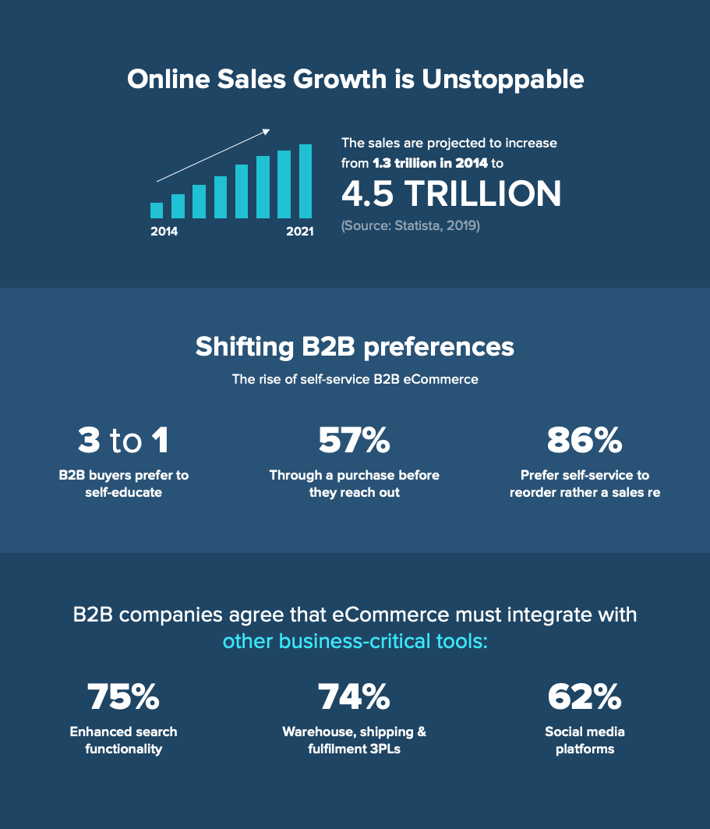
Figure 1: Effective E-commerce Strategies Boosting Sales Volume and Organizational Performance
(Source: revechat, 2023)
On the other hand, nowadays, each month, social networking sites are accessed by billions of individuals worldwide, and it has the potential to aid corporations in developing strong relationships with the people they appeal to. Qin and Liu, (2022), highlight that marketing professionals can, however, communicate with consumers through online social networking sites by answering their opinions, presenting appropriate information, and broadening product details. Further, these days, “order surveillance” is thought of as an important tool by online consumers. Consumers envision being capable of monitoring and keeping tabs on their orders during each phase of the delivery transaction. For “direct-to-consumer” online firms, neglecting to enable “track and trace” places client contentment and retention at stake.
As a preponderance of retail companies, Scutariu et al. (2022), asserts that especially in the UK market, have addressed drastically fewer concerns, track and trace effectively lessened consumer service expenditures. As a consequence, it boosts productivity because the corporation has effective performance over accomplishment and also can promptly take care of any issues or discrepancies which may emerge. In light of this, their e-commerce approach not just to reduces issues but also broadens the lifetime worth of their clients' and facilitates improving their company's performance.
Advantages and disadvantages of e-commerce strategies within the retail industry
In 2020 and far beyond, the COVID-19 pandemic outbreak triggered an increase in digital shopping. Online purchases have now progressed considerably, together with adversaries and clients' evolving requirements. Businesses may acquire, expand, and sustain their target markets by spending both resources and time on e-commerce marketing practices. According to Chen et al. (2022), marketing a commodity or service is a paramount component of e-commerce marketing tricks. An appealing online store along with effective promotional strategies can draw consumers, transform them into legitimate clients, sustain them around, and enhance a corporation's "customer lifetime value (CLV)". Kumar and Prasad, (2022), claim that the corporation can approach and engage potential clients if the sales department is kept informed concerning the most emerging advancements. In spite of being discovered that e-commerce approaches offer a good number of advantages, corporations must however conquer a variety of obstacles in order to implement them adequately.
One of the biggest benefits of e-commerce for retail businesses has been acknowledged as "cost-saving". Pursuant to the paradigm and also its execution, the preponderance of e-commerce operations are executed at cheaper rates. Krasnyuk et al. (2022), states that corporations have been striving to develop a deeper grasp of the way these opportunities could have been drastically increased as the business practices in e-commerce have fundamentally revolutionized. A significant variety of retail companies in E-commerce have simplified their operational practices. Companies routinely transport their goods directly from the wholesaler, which lessens the requirement to construct a storefront. As a byproduct of the cost savings, corporations are therefore equipped to cut down on a substantial amount of effort and time on storage, distribution and transportation of commodities.
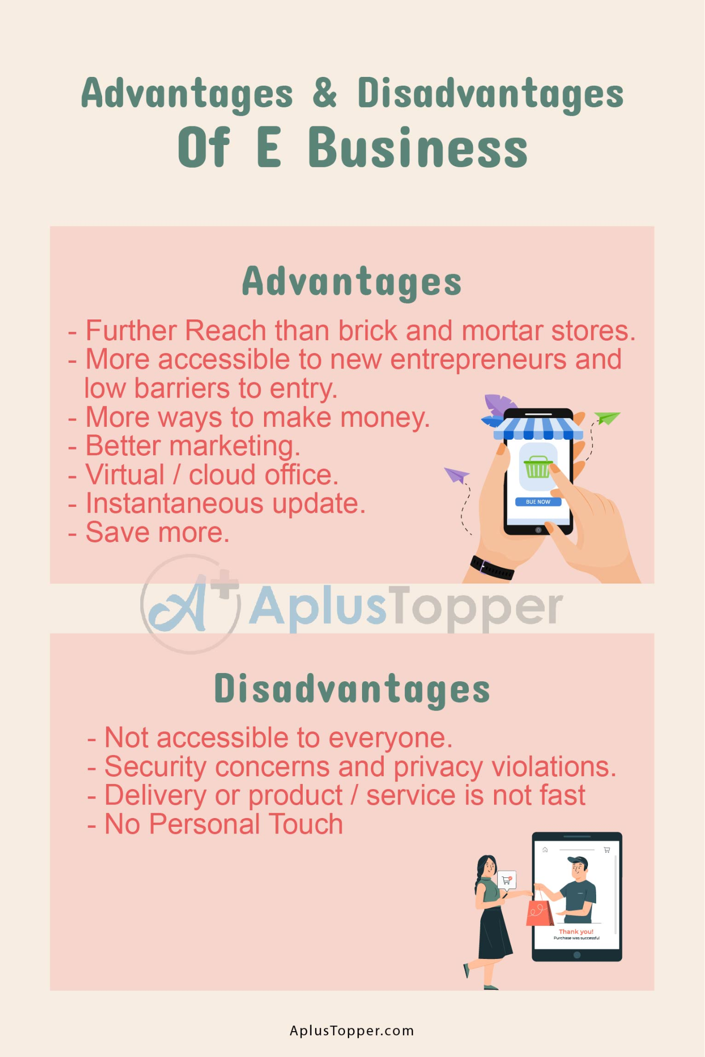
Figure 2: E-commerce Strategies' Benefits and Drawbacks for the Retail Sector
(Source: aplustopper, 2023)
On the contrary end, Yang, (2022), contends that “cybersecurity” may constitute one of the most obvious difficulties in e-commerce. The threat of cyber-security issues looms for retail businesses that advance a digital following. For a broad spectrum of objectives, various hazardous entities and individuals get entangled in the hacking of e-commerce platforms. Lots of other people hack for sensitive data and records, even though some perform this act in accordance to blackmail requests. For online stores, cyber-attacks have evolved to pose a big problem, which also has hindered their overall efficacy and productivity.

Research Limitations
This analysis will be significantly hampered by the limitations in gaining permission to consult an array of materials and journals that might have potentially shed light on important concerns. Due to the preponderance of the accessible research publications' inaccuracy, lack of a comprehensive document, or incomplete information on the records, the investigation will concentrate merely on a lesser subset of these journals (Stahl et al. 2022). Also, the time limit will hinder efforts to accomplish a more detailed analysis and incorporate views and knowledge on adjacent parts of the subject at hand.
Additionally, the proposed study subject will offer relevant data solely about successful e-commerce strategies for boosting organizational effectiveness and revenue growth, with a focus on the UK retail industry. Besides that, the investigation will not account for the connections between successful e-commerce tactics and overall corporate sales and performance. Moreover, no advice will be given to the UK's retail organisations regarding how they can effectively embrace e-commerce approaches and alleviate the current impediments.

Ethical Consideration
The ethical concerns of the study indicate devotion to being "responsible" for sustaining the investigation's well-coordinated completion. In order to uphold the accuracy of the findings and coherence, vigilant supervision is needed to track and prevent any contradictions that develop during the course of the study. This ought to be in addition to the strict standards of ethics and ideologies embraced. Preventing partiality or concentrating on baseless claims is fundamental while examining the data given in order to make sure that the evaluation of the provided content is reliable (McLennan et al. 2022). In conformity with the “Data Protection Act, 2018”, applicable references will be employed as well. The study typically requires the avoidance of consolidating confidential info or even using them improperly for self-gain, despite the reality that privacy is an influential concern that needs to be paid close attention to during the methodological approach.

Timeframe
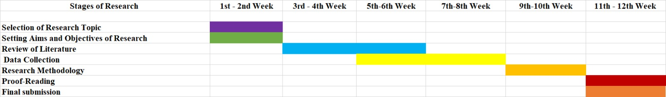
Figure 3: Gantt Chart
(Source: Self-created)
Over the course of the first two weeks, the study subject and the proposal's objectives and goals will be determined. Subsequently, the "literature review" and also the acquisition of pertinent data will be accomplished between the sixth and eighth weeks, respectively. The research method will be accomplished within the 10th week, followed by proofreading in the 11th–12th week and the submission of the finalized research report in the 12th week.

Conclusion
The proposed area of study is an evaluation of effective e-commerce techniques for increasing organisational effectiveness and sales growth, with a focus on the UK retail industry, and the proposed research incorporates a background exposition of the study's theme. It also acknowledges the reality that, in the long run, this aids companies in retaining a distinct and powerful presence in this competitive industry, thereby boosting their overall sales volume and organisational success. Therefore, the reason for conducting the investigation and the methodology of the study are addressed, followed by the determination of the research questions and the research objectives. The research approach also considers ethical concerns and the constraints of the investigation.

References
Aplustopper.com, (2023). Advantages-And-Disadvantages-Of-E-Business. Available at: https://www.aplustopper.com/wp-content/uploads/2022/03/Advantages-And-Disadvantages-Of-E-Business-2.jpg. [Accessed on: 25.02.2023].
Cabral, C. and Dhar, R.L., (2020). Ecotourism research in India: From an integrative literature review to a future research framework. Journal of ecotourism, 19(1), pp.23-49.
Chen, S., Wu, Y., Wu, Y. and Li, Z., (2022). Strategy analysis of e-commerce enterprises under the COVID-19 pandemic:--A case study of PDD. Highlights in Business, Economics and Management, 4, pp.320-327.
Daly, J., McDonald, I. and Willis, E., (2020). Why don’t you ask them?: A qualitative research framework for investigating the diagnosis of cardiac normality. In Researching health care (pp. 189-206). Routledge.
Fedushko, S. and Ustyianovych, T., (2022). E-commerce customers behavior research using cohort analysis: A case study of COVID-19. Journal of Open Innovation: Technology, Market, and Complexity, 8(1), p.12.
Fuller, R.M., Harding, M.K., Luna, L. and Summers, J.D., (2022). The impact of E-commerce capabilities on online retailer performance: Examining the role of timing of adoption. Information & Management, 59(2), p.103584.
Gao, J., Siddik, A.B., Khawar Abbas, S., Hamayun, M., Masukujjaman, M. and Alam, S.S., (2023). Impact of E-Commerce and Digital Marketing Adoption on the Financial and Sustainability Performance of MSMEs during the COVID-19 Pandemic: An Empirical Study. Sustainability, 15(2), p.1594.
Hamdam, A., Jusoh, R., Yahya, Y., Abdul Jalil, A. and Zainal Abidin, N.H., (2022). Auditor judgment and decision-making in big data environment: a proposed research framework. Accounting Research Journal, 35(1), pp.55-70.
Krasnyuk, M., Kulynych, Y., Tuhaienko, V. and Krasniuk, S., 2022. E-business and e-commerce technologies as an important factor for economic efficiency and stability in the modern conditions of the digital economy (on the example of oil and gas company). Grail of Science, (17), pp.69-81.
Kumar, V.V. and Prasad, N.C., (2022). E-Commerce: Problems and Prospects. Specialusis Ugdymas, 1(43), pp.1621-1628.
McLennan, S., Fiske, A., Tigard, D., Müller, R., Haddadin, S. and Buyx, A., (2022). Embedded ethics: a proposal for integrating ethics into the development of medical AI. BMC Medical Ethics, 23(1), p.6.
Purup, P.B. and Petersen, S., (2020). Research framework for development of building performance simulation tools for early design stages. Automation in Construction, 109, p.102966.
Qin, Y. and Liu, H., (2022). Application of Value Stream Mapping in E-Commerce: A Case Study on an Amazon Retailer. Sustainability, 14(2), p.713.
revechat.com, (2023). importance-of-digital-marketing-startegy. Available at: https://www.revechat.com/wp-content/uploads/2021/01/importance-of-digital-marketing-startegy.png. [Accessed on: 25.02.2023].
Rita, P. and Ramos, R.F., (2022). Global research trends in consumer behavior and sustainability in E-Commerce: A bibliometric analysis of the knowledge structure. Sustainability, 14(15), p.9455.
Scutariu, A.L., Șuşu, Ș., Huidumac-Petrescu, C.E. and Gogonea, R.M., (2022). A cluster analysis concerning the behavior of enterprises with e-commerce activity in the context of the COVID-19 pandemic. Journal of Theoretical and Applied Electronic Commerce Research, 17(1), pp.47-68.
Stahl, B.C., Antoniou, J., Ryan, M., Macnish, K. and Jiya, T., (2022). Organisational responses to the ethical issues of artificial intelligence. AI & SOCIETY, 37(1), pp.23-37.
Tolstoy, D., Melén Hånell, S. and Özbek, N., (2022). Effectual market creation in the cross-border e-commerce of small-and medium-sized enterprises. International Small Business Journal, p.02662426211072999.
Tolstoy, D., Nordman, E.R. and Vu, U., (2022). The indirect effect of online marketing capabilities on the international performance of e-commerce SMEs. International Business Review, 31(3), p.101946.
Yang, C., Huang, C. and Su, J., (2020). A bibliometrics-based research framework for exploring policy evolution: A case study of China's information technology policies. Technological Forecasting and Social Change, 157, p.120116.
Yang, Y. and Meng, G., (2020). The evolution and research framework of carbon footprint: based on the perspective of knowledge mapping. Ecological Indicators, 112, p.106125.
Yang, Y., (2022). Selection method of cross-border e-commerce export logistics mode based on collaborative filtering algorithm. Journal of Mathematics, 2022, pp.1-11.

