Cloud Engineering Principles and Practice

ACCA7027 Assignment Report

Module Code: ACCA7027
Module Title: Cloud Engineering Principles and Practice
Programme: MSc Cybersecurity and Digital Forensics

Student Name: Dhaval Rami
Student ID: 2528086
Lecturer: Renuga Jayakumar

Submission Date: 17 August 2026

Table of Contents
1. Introduction 1
2. Virtualisation in Cloud Computing 1
2.1 Principles of Virtualisation 1
2.2 Virtualisation of Shared Hardware 2
2.3 Virtualisation and Cloud Infrastructure 3
3. Docker and Containerisation 5
3.1 Principles of Containerisation 5
3.2 Benefits of Containerisation in Cloud Computing 5
3.3 Dockerfile and Image Construction 6
3.4 Building and running a Docker Container 7
3.5 Publishing Docker Images to DockerHub 10
3.6 Docker Volumes 12
3.7 Docker Networking 14
3.8 Evaluation of Docker for Cloud Deployment 17
4. Load Balancing, Scalability and Application Gateways 18
4.1 Selected Cloud Application Scenario 18
4.2 Load Balancing 20
4.3 Scalability 20
4.4 Application Gateways 20
4.5 Why Load Balancing and Scaling Work Together 21
4.6 Benefits of Combining These Technologies 21
5. Main Driving Forces Behind Cloud Computing Expansion 22
5.1 Cost Efficiency 22
5.2 Flexibility, Scalability and Global Availability 22
5.3 Serverless Functions 23
5.4 Serverless Functions Compared with Containerisation 24
6. Conclusion 25
7. References 27

Introduction
Cloud computing is one of the main components of today's digital services and helps organisations to use computing power and storage, network and application platforms without having to own all the physical equipment [1]. Organisations can now deploy services more flexibly, scale resources as needed, and reduce the time needed to deploy an application without having to rely on only fixed on-premises servers.
The degree of cloud adoption clearly demonstrates the importance of cloud engineering being a technical and business priority. Gartner projects that global public cloud end-user spending will surpass $595.7 billion in 2024 to exceed $723.4 billion in 2025 and that 90% of organisations will follow a hybrid cloud strategy by 2027 [2]. The results of Flexera's 2025 research reveal that 84% of participants agreed that cloud spend management is the primary cloud challenge, and 17% are spending more than they should on cloud. Cloud engineering needs to be about more than just deployment and scalability; however, it also needs to look at cost control, governance, security and operational efficiency.
This report concentrates on Docker containerisation and its role in cloud engineering. Containerisation bundles an app and its requirements into a portable image that can be executed in a steady manner on various environments. The hands-on examples are for creating a Dockerfile, building an image, running a container, publishing an image to DockerHub, Docker volumes, and Docker networking.
The report also covers more comprehensive cloud concepts, such as load balancing or scalability and application gateways. Lastly, the primary factors driving the growth of cloud are covered: cost efficiency, flexibility, scalability, and serverless functions; and how serverless computing relates to containerisation.

1.Virtualisation in Cloud Computing

Principles of Virtualisation
Virtualisation is one of the key technologies behind cloud computing, as it enables physical computing resources to be split up into multiple distinct virtual computing environments. Virtualisation enables multiple virtual machines to run on a single physical server rather than one OS being installed on one server, and one application on another. Each virtual machine is like a real one with its own operating system, storage, applications and network setup.
This process is made possible by a key part of software: the hypervisor. It coordinates with the physical CPU, memory, storage and network resources and uses them to allocate them to various virtual machines. The cloud provider can optimise the use of hardware resources and keep customer workloads separated from each other. It is crucial in public cloud systems as many organisations can be sharing the same provider infrastructure at the same time.
Virtualisation also facilitates the concept of the cloud - resource pooling. The cloud providers can have huge amounts of physical infrastructure, and present it to customers as a stretchy virtual product. Customers can provision virtual machines, storage and networks without having to manage the physical data centre.
It additionally establishes management duties. Cloud providers need to provide protection for the hypervisor, ensure tenant isolation and tenant performance monitoring. Virtual machines also need to be managed carefully by customers, as excessive or unused resources can translate to higher costs. Thus, whilst flexible, virtualisation does need governance, monitoring and security controls.

Virtualisation of Shared Hardware
Cloud providers can maximize the utilization of their physical resources through virtualisation of shared hardware. With a traditional data centre, one might be able to run servers with less than their optimum capacity since each server can be assigned to a specific task [3]. Multiple virtual machines can be hosted on one physical machine, thereby making better use of the resources and decreasing the waste.
It is not a requirement that customers purchase full physical servers before deploying an application. Instead, they may hire virtual machines as needed, and increase the resources as demand fluctuates. This reduces initial capital cost, and helps to accelerate deployment.
Resilience and recovery are also provided by virtualisation. Copying, snapshotting, migrating and restoring virtual machines are easier than doing so with physical servers. This assists organisations to recover services following a failure and aids availability planning. A poorly configured virtual environment can still suffer from performance issues, high cost or security weaknesses.

Virtualisation and Cloud Infrastructure
Virtualisation is a critical part of cloud infrastructure because it allows separating the physical infrastructure that is owned by the cloud provider from the virtual infrastructure that is controlled by the cloud customer [4]. This enables users to build servers, mount storage, set up networks and deploy applications without having to deal with the physical hardware itself.
But virtualisation is not containerisation. Virtual machines virtualise hardware and typically have their own guest OS, whereas containers virtualise an OS level and share the host OS kernel. This can result in containers being lighter and quicker to boot, whereas virtual machines offer better operating system separation and continue to be beneficial for legacy systems and workloads that need to run different operating systems.
The key differences between virtual machines and cloud containers in a cloud engineering environment are summarised in Table 1.
Table 1: Comparison between virtual machines and containers.
Area | Virtual Machines | Containers
Virtualisation level | Hardware-level virtualisation | Operating system-level virtualisation
Operating system | Each VM usually has its own guest operating system | Containers share the host OS kernel
Startup time | Usually slower because a full OS must boot | Usually faster because containers run as isolated processes
Resource overhead | Higher because each VM includes a full OS | Lower because containers are lightweight
Best suited for | Legacy systems, strong OS isolation, different OS requirements | Cloud-native apps, microservices, repeatable deployment
Scalability | Can scale, but usually with heavier resource use | Well suited to rapid horizontal scaling
Main risk | VM sprawl and high resource consumption | Image vulnerabilities and weak isolation if misconfigured

The comparison reveals that virtual machines and containers don't replace each other in all situations. Virtual machines can be helpful if more isolation or control over the operating systems are desired. Cloud-based applications, microservices and repeatable deployment is more suitable for containers. In reality both technologies are often combined [5]. This multi-layered model sees virtualisation as the infrastructure layer and containerisation as the application packaging layer.
Overall, virtualisation is important to cloud computing as it allows for the pooling of resources, flexibility in provisioning, multi-tenancy and increased utilisation of infrastructure. It's also essential to manage carefully as it is critical that it is configured properly and monitored for performance and security.

Docker and Containerisation

Principles of Containerisation
Containerisation is a technique for the application deployment which packs the application into a container with all files, runtime components, libraries, and configuration required to run the application. A container image is a packaged unit that is run as a running container when executed.
The fundamental technology concept is running at the operating system level. A container typically does not have a full guest operating system and its own kernel, unlike a virtual machine. Rather, containers provide the same operating system kernel for use, but execute as independent processes [6]. This results in faster and lighter container start-up times than many virtual machines, while the security still relies on proper image selection, runtime configuration and host security.
Docker images are typically regarded as static build products. The image should never be edited manually in production after it has been created. In case of an application update, the Dockerfile or source file should be modified, and a new image version should be created. This practical work involved creating the image acca7027-cloud-webapp:v1 and after enhancing the web interface of the page, it was rebuilt into v2.

Benefits of Containerisation in Cloud Computing
Portability, repeatability, fast deployment and scalability are the key advantages of the container-based approach. A container image comprises the application (and necessary runtime environment) to be deployed between development, testing, and deployment environments more consistently.
Repeatability is also enhanced by Dockerfile as well, as it documents the build process. For the practical part of this report the base image in the Dockerfile was nginx:alpine, while the custom index.html was copied into the web directory of the Nginx web server and port 80 was exposed [7].
Containers are also able to be scaled horizontally. In the event of high application demand, multiple identical application instances can be started using the same image. In a cloud environment, these instances can be load balanced with several containers instead of relying on one server.
But containers do not necessarily make for a secure or economical choice. Risk can be posed by untrusted base images, vulnerable packages, exposed ports, secrets handling that is not as secure, and excessive privileges. Likewise, unutilized containers and oversized images will consume resources. Thus, containerisation enables the portability and efficiency of the cloud, but still needs governance, monitoring and security measures.

Dockerfile and Image Construction
A Dockerfile was written to describe how to build the containerized web application. This is key to cloud engineering, as deployment should be repeatable, not reliant on manual server configuration [8]. The practical took the form of a static HTML page and Nginx-based Docker image demonstrating packaging application content into a Docker image.
The project folder contains the HTML file that will be used in the Docker web application as shown in Figure 1.
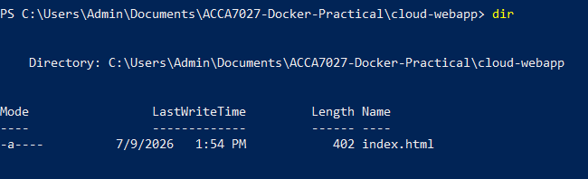
Figure 1: Project folder containing the HTML file for the Docker web application.
The custom ACCA7027 web page served by Nginx inside the container was included in the index.html file.
The Dockerfile used to create the container image is shown in figure 2.
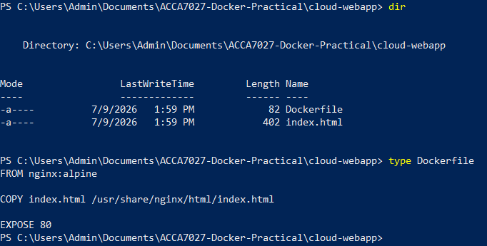
Figure 2: Dockerfile created for building the Nginx-based container image.
nginx:alpine was the base image of the Dockerfile. This image already contains the Nginx web server on a light weight Alpine Linux environment. The COPY instruction placed index.html into the default Nginx web directory, while EXPOSE 80 documented that the container uses port 80 internally for HTTP traffic.
This illustrates an important principle of Docker: A custom image can be built from a base image by adding application-specific files and instructions. In this case, the final image contained both the Nginx runtime environment and the custom HTML page needed to run the web application.

Building and running a Docker Container
After creating the Dockerfile, the image was built using the docker build command. That resulted in a re-usable Docker image called acca7027-cloud-webapp:v1 and converted the project files and Dockerfile instructions.
Figure 3 shows the Docker image being successfully built from the Dockerfile.
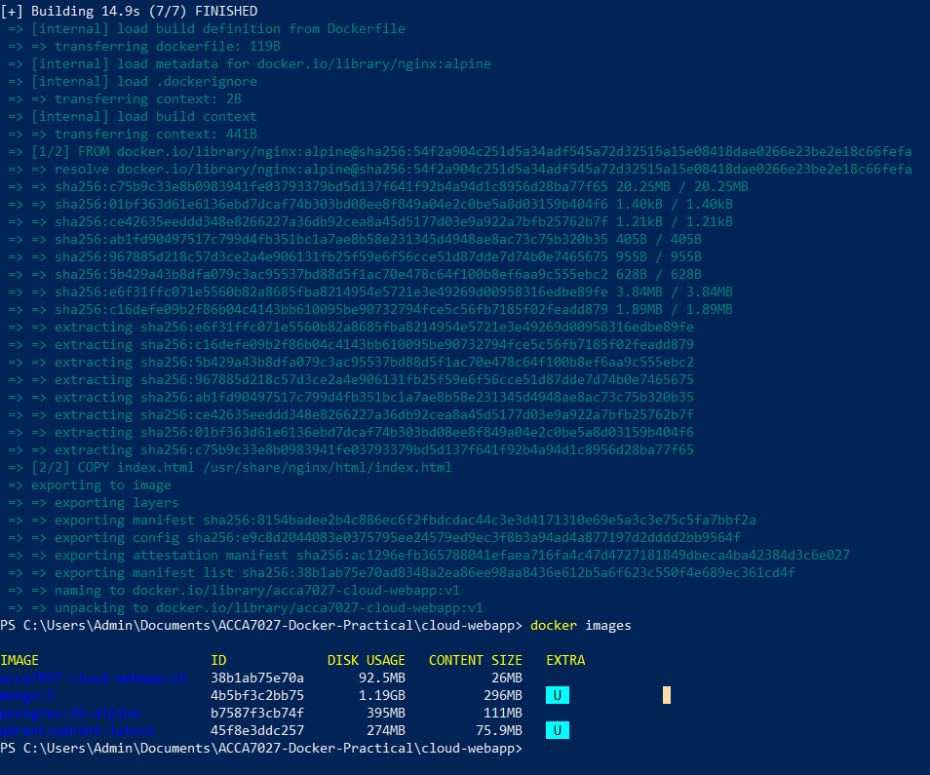
Figure 3: Docker image successfully built from the Dockerfile.
The build process produced a read-only image that could be reused to create containers. This is important because the image acts as a portable application package rather than a manually configured web server.
Figure 4 shows the Docker container running with host port 8080 mapped to container port 80.
Figure 4: Docker container running with port mapping from localhost port 8080 to container port 80.
This was achieved by using port mapping to enable access of the Nginx service within the container via http://localhost:8080 on the host machine. This shows how the port in the container has been separated from the port exposed on the local machine.
The custom ACCA7027 web page is successfully served by the Docker container as shown in figure 5.
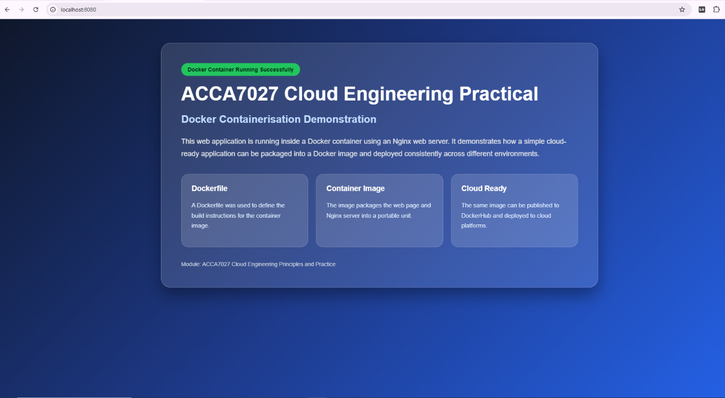
Figure 5: Custom ACCA7027 web page running from inside the Docker container.
This validates the Docker processes that were used: the Dockerfile was created, an image was built, a container was launched from that image, and the app was accessed from the browser.
The web page interface was enhanced and the Docker image rebuilt, as shown in figure 6.
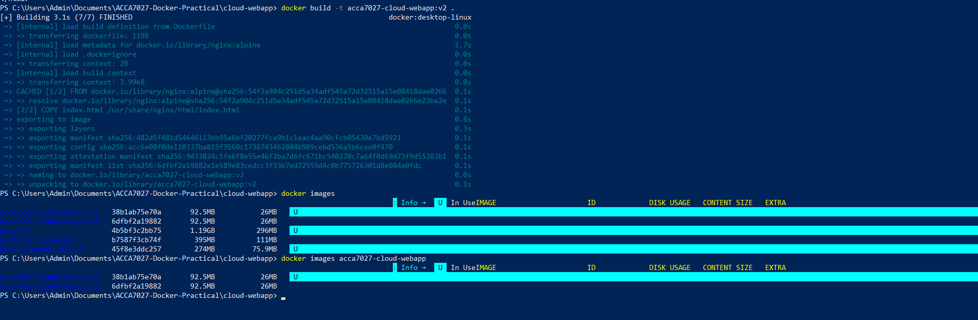
Figure 6: Docker image rebuilt after updating the web page interface.
Following the first test, the web page was enhanced with internal CSS and the image was re-built as acca7027-cloud-webapp:v2. This shows image versioning because changes were made in the source file and packaged into a new image version rather than editing the running container.
The rebuilt image is now used to run the container as illustrated in Figure 7.
Figure 7: Updated Docker container running from the rebuilt Docker image.
This practical step demonstrates that containers should be treated as replaceable running instances of images.

Publishing Docker Images to DockerHub
After local testing, the image was published to DockerHub. A container registry is important in cloud engineering because it stores Docker images in a central location where they can be pulled by other machines, team members or cloud deployment platforms [9].
Figure 8 shows successful DockerHub login from the command line before publishing the image.

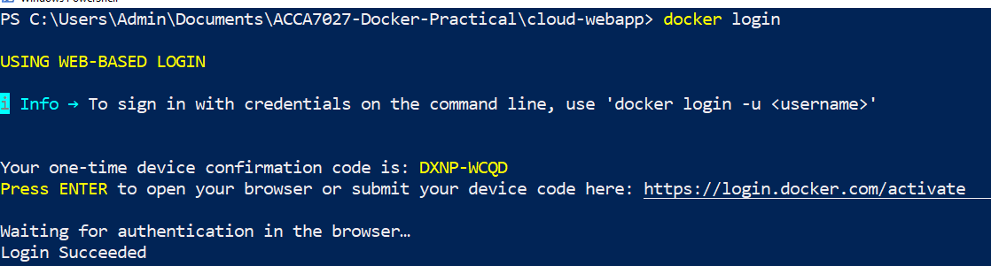
Figure 8: Successful DockerHub login before publishing the Docker image.
The image is labelled with the name of the docker hub repository, as can be seen in figure 9.
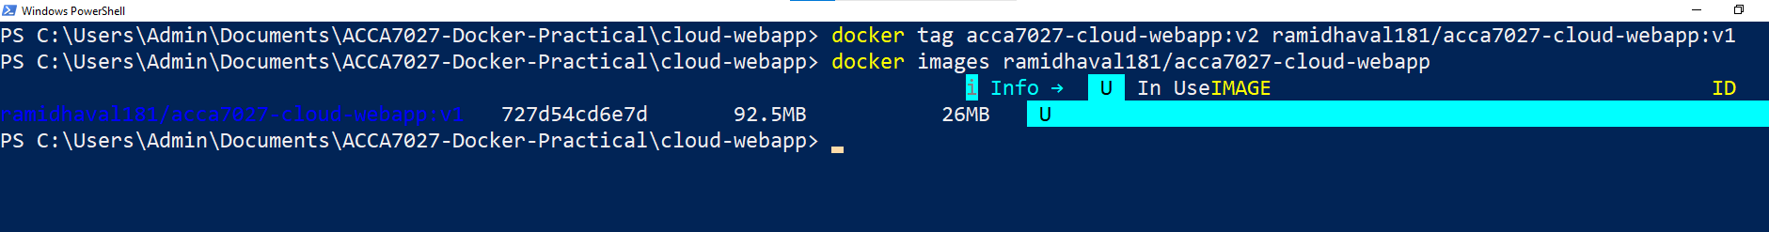
Figure 9: Docker image tagged for publishing to DockerHub.
The image was tagged using the DockerHub format username/repository:tag. In this practical, the image was prepared as ramidhaval181/acca7027-cloud-webapp:v1.
Figure 10 shows the Docker image being pushed to DockerHub.
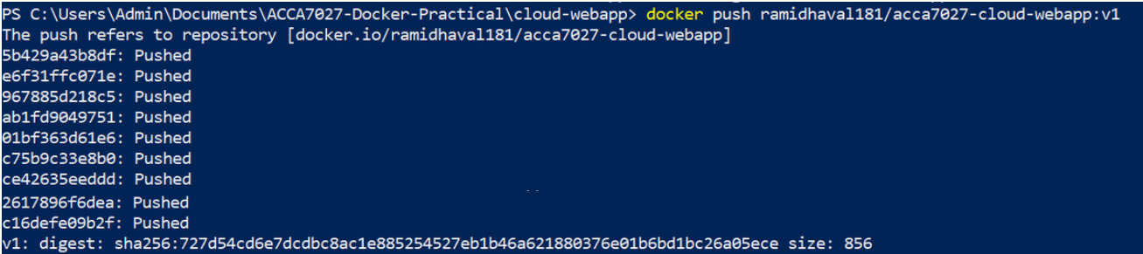
Figure 10: Docker image pushed to DockerHub.
The push command uploaded the image layers to DockerHub. Docker images are created in layers and layers that are not changed need not be uploaded again and again.
As can be seen in Figure 11, the published image is present in the DockerHub repository.
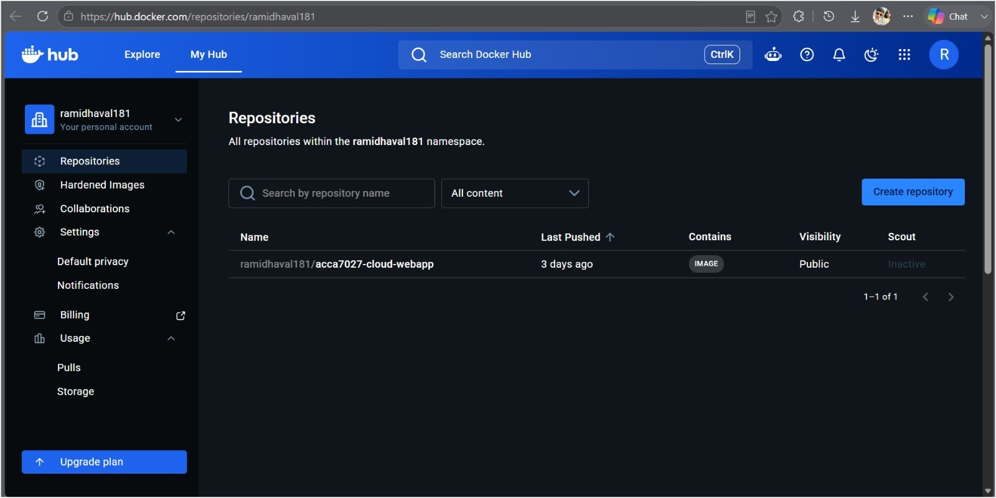
Figure 11: DockerHub repository showing the published Docker image.
Publishing the image allows another machine to pull ramidhaval181/acca7027-cloud-webapp:v1 and run it without needing the original project folder or Dockerfile. This is one of the reasons that registries are vital to cloud deployment: tested images can be distributed and re-used consistently. But secrets, passwords, API keys or sensitive configuration files are not permitted in public repositories.

Docker Volumes
Docker Volumes: Persistent Storage beyond the lifecycle of the container. This is essential as containers are temporary and replaceable. When data is only stored in the container's writable layer, it can be lost if the container is removed from its location.
In Figure 12, the Docker volume has been created and inspected to illustrate the persistence of the volume beyond the lifetime of the container.
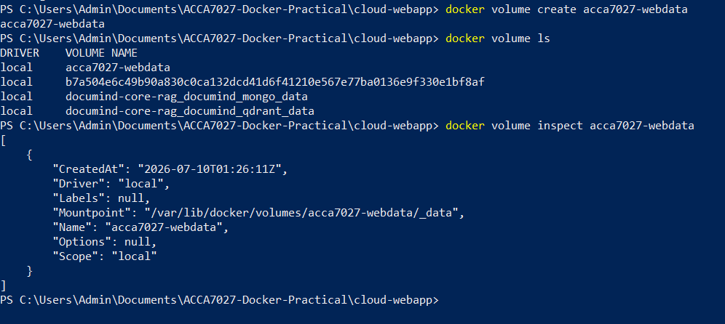
Figure 12: Docker volume created and inspected for persistent container storage.
A Docker volume with the name of acca7027-webdata was created and examined in this practical.
The image in figure 13 displays that the Nginx container is running with the Docker volume mounted within the web server directory.
Figure 13: Container running with a Docker volume mounted for web content.
The volume was mounted to the Nginx web directory, allowing the container to serve the content in the volume. This illustrates the difference between an image and persistent data: the image is used to supply the application environment, the data on the volume can be preserved even if the container is stopped or replaced.
Figure 14 proves that the browser can be used to view the web page contained in the Docker volume.
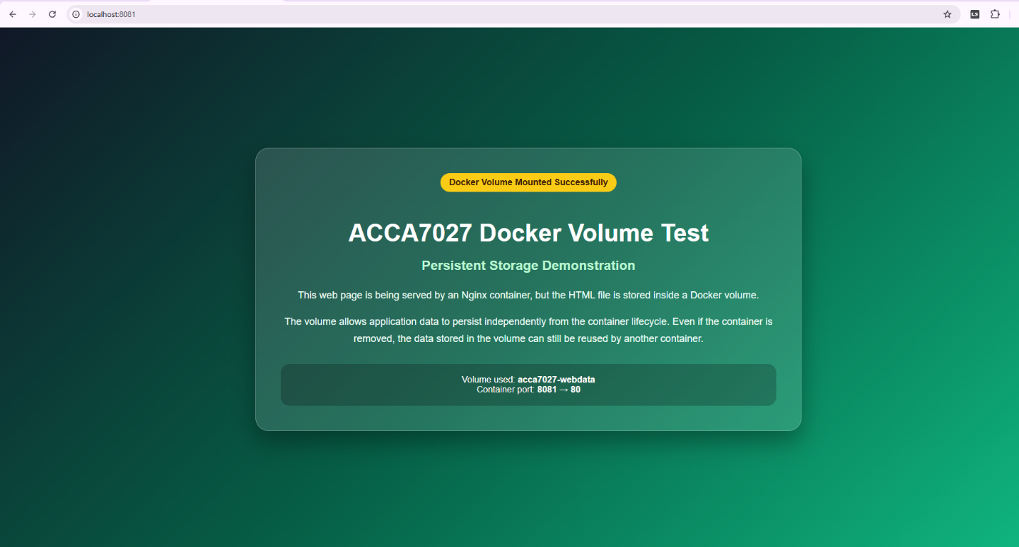
Figure 14: Nginx container displaying an HTML page stored inside a Docker volume.
Persistent storage still needs to be backed up and accessed, monitored and encrypted when applicable in production cloud environments. Thus, Docker volumes are persistent, but do not eliminate the need for good storage governance.

Docker Networking
Docker networking allows containers to communicate with each other and with external systems. This is crucial as real cloud apps typically have a number of services, including a frontend, backend API, database, cache, and monitoring portion [10].
Figure 15 shows the custom Docker network created and inspected for container communication.
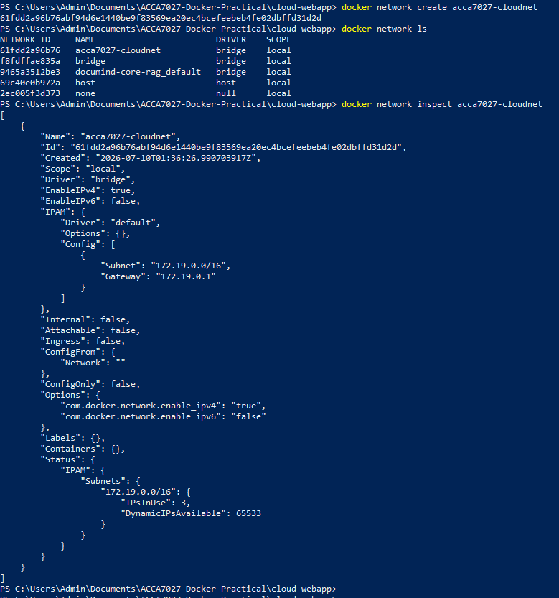
Figure 15: Custom Docker network created and inspected for container communication.
In this practical, a custom Docker network named acca7027-cloudnet was created. Containers attached to the same custom network can communicate using container names, which is more reliable than depending on changing container IP addresses.
Figure 16 shows a successful ping test between containers using the custom Docker network.
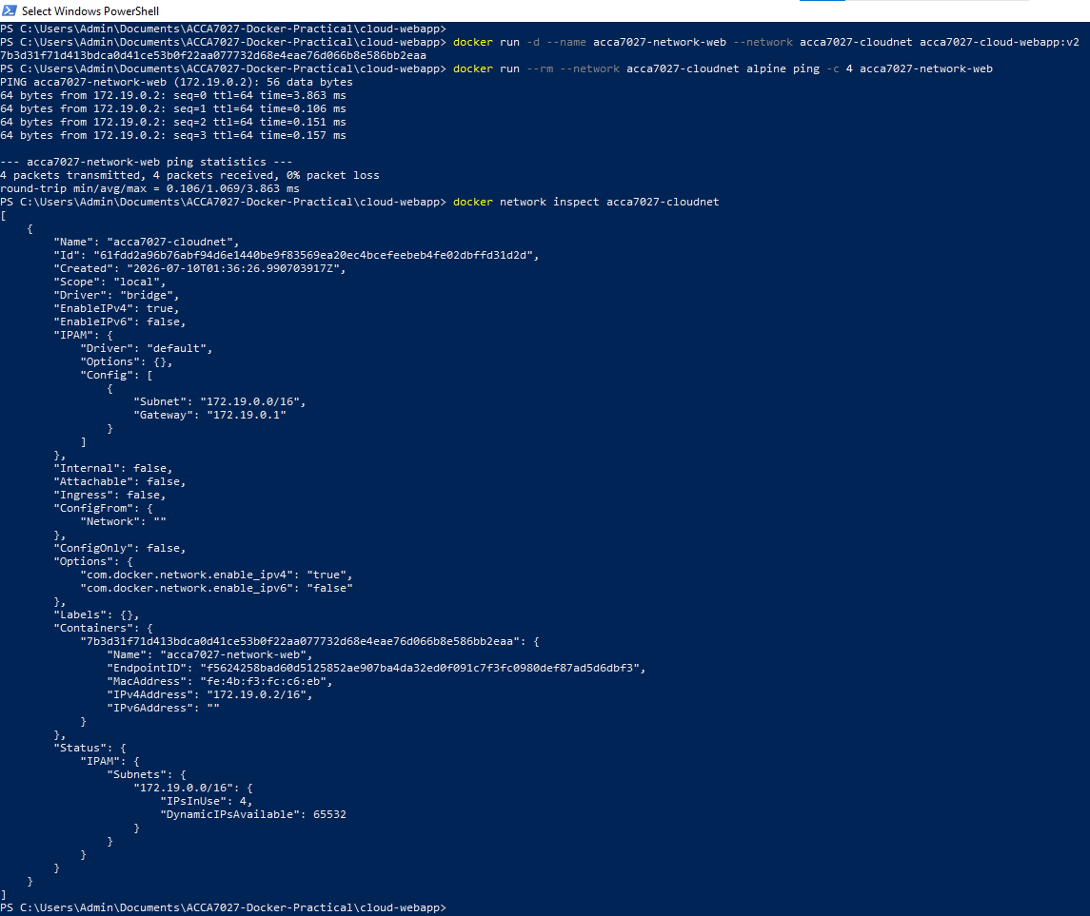
Figure 16: Successful container-to-container communication through the custom Docker network.
The successful ping test confirmed that one container could reach another container through the custom Docker network. This proves that the practical work demonstrated controlled container-to-container communication, not only isolated container execution.
In cloud engineering, networking must also be designed securely. For services to communicate with each other, there must be a good operational need and containers should not have unnecessary ports exposed. For production systems, network segmentation, firewall rules, service discovery and secure communications are key in minimizing risk and enhancing reliability.

Evaluation of Docker for Cloud Deployment
Docker is beneficial for cloud deployments because it bundles up an application and all of its requirements in a consistent and repeatable image. In this practical, the ACCA7027 web application was developed as a local HTML-file, put in Nginx-based Docker image, executed as a container, and posted to DockerHub, linked to persistent storage using a Docker volume, and tested using a custom Docker network [11].
The image was pushed to DockerHub and another machine could pull and run ramidhaval181/acca7027-cloud-webapp:v1 without having to install Nginx and transfer the project folder. Repeatability is also available in Docker: The Dockerfile contains the command to build the image and image tags are used to name different versions. In case of change in the application, a new image version can be created, tested and deployed - without having to change a running server.
Docker also supports scalability. When needed, several containers can be created from a single image and placed behind a load balancer. The separation of concerns was also demonstrated in the practical work; the image contained the application package, the volume contained the persistent storage, and the communications occurred in the network between the containers.
Docker isn't a single solution to a complete production cloud, however. Monitoring, logging, vulnerability scanning, access control, backup policies, automated deployment via a managed container service or orchestration via Kubernetes are also part of a production deployment. Images should be built from trusted base images, scanned for vulnerabilities and kept free from secrets. Unnecessary privileges and exposed ports should also not be present in containers.
All in all, Docker enables portability, consistency, repeatability and scalability; a trait that makes it pertinent to cloud engineering. Meanwhile, it needs to be integrated with security, monitoring, storage governance, network control and cost management to enable delivery of production grade cloud services.

Load Balancing, Scalability and Application Gateways

Selected Cloud Application Scenario
The selected scenario is a containerised web application based on the Docker practical completed in this report. In the practical work, the application was packaged as an Nginx-based Docker image and accessed locally through a browser. In a real cloud environment, the same type of application could be deployed as a customer-facing service such as a student portal, booking page, e-commerce landing page or public information website.
A single local container is suitable for demonstration, but it is not enough for production use. If all users depend on one container or one virtual machine, the application may become slow during high traffic or unavailable if that instance fails. A stronger cloud design should therefore use multiple application instances, distribute traffic across them and scale resources when demand changes.
The figure below shows an extension of the containerised Web application to a cloud-based architecture that involves an application gateway, load balancer, and container instances that are scaled up.
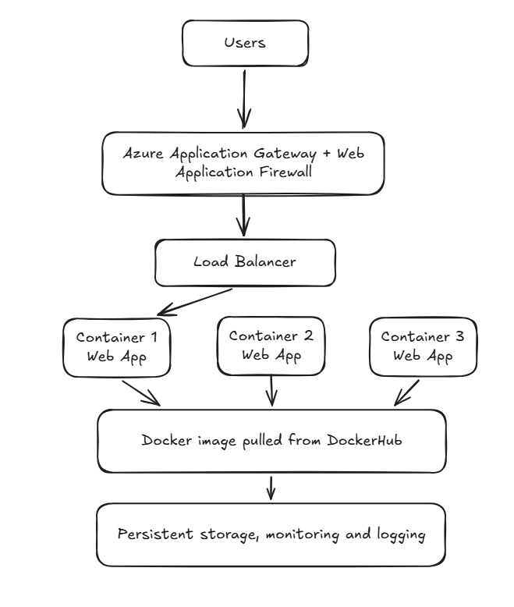
Figure 17: Proposed cloud architecture combining application gateway, load balancing and scalable container instances.

Load Balancing
Load balancing distributes incoming traffic to multiple backend resources. Instead, traffic would be shared across several running instances of the same application. It enhances performance as one instance is not responsible for all the traffic, and it enhances availability as traffic is rerouted if one of the backends is unhealthy.
In Azure, Azure Load Balancer can distribute traffic across backend resources such as virtual machines and application instances. For this web application, several backend instances could run the same Docker image while the load balancer spreads traffic across them. However, load balancing alone does not create extra capacity. If all backend instances are overloaded, the application can still slow down. This is why load balancing must work together with scalability.

Scalability
Scalability is the ability of a system to increase or decrease capacity according to demand. Cloud traffic is rarely constant.
There are two main types of scaling. Vertical scaling increases the size of one resource, such as adding more CPU or memory. Horizontal scaling adds more application instances. For cloud-native systems, horizontal scaling is often more useful because several instances can share traffic and the failure of one instance does not stop the whole service.
For the selected application, scalability would mean running more containers when demand increases and reducing them when demand falls. This supports performance during busy periods and cost control during quiet periods. However, scaling rules must be configured carefully because poor autoscaling can create unnecessary cost, slow response to demand changes or unstable scaling behaviour.

Application Gateways
An application gateway manages web traffic at the application layer. Unlike a basic network load balancer that mainly works with IP addresses and ports, an application gateway can make routing decisions using HTTP information such as host names, URL paths and request rules.
In this case, users could use an application gateway as the public interface to the system. It could serve normal requests from websites to the frontend service, and API requests to the backend service. It can also be used in conjunction with Web Application Firewall features to provide security in public facing applications that are subject to Internet traffic.
But application gateways need to be set up appropriately. If the routing rules are not set well, the TLS setting is weak or the monitoring or the backend pool is not in place or is not configured appropriately, the availability or security of the application may be affected.

Why Load Balancing and Scaling Work Together
Load balancing and scaling are two problems that are connected but different. Scaling changes the quantity of capacity, load balancing distributes load over the capacity. If autoscaling adds more containers or virtual machines, the load balancer is needed to route traffic to those new instances. Without load balancing, there can be additional instances, but they might not be utilized effectively.
As well, load balancing without scaling is constrained. A load balancer can distribute traffic between existing instances, but if there are not enough instances, then all instances can be overloaded. Scaling provides additional capacity; load balancing puts that capacity to work. Together, they offer elasticity - the capacity to remain flexible in response to fluctuations in demand, and to keep costs under control.

Benefits of Combining These Technologies
Load balancing and scalability with application gateways makes a more powerful cloud service than either alone. Application gateway offers public entry point and/or application-level routing. The load balancer distributes traffic among instances in the back. Scalability, sufficient capacity is available when demand changes.
The primary advantages are:
- increased availability,
- enhanced performance, and
- increased traffic control and cost efficiency.
In the event of backend failure, traffic can be redirected to other healthy backends. More instances can be added in case the demand grows and the traffic can be distributed among these instances.
However, this design also increases architectural complexity. Unexpected cost and outages can occur due to misconfigured routing rules, bad health checks, weak scaling thresholds or insufficient monitoring. Thus, it is imperative that cloud engineers test for failures, review performance and scaling rules periodically.
In general, these technologies demonstrate the potential of the Docker-based web application to transition from a lab example to a more production-ready cloud-based application.

Main Driving Forces Behind Cloud Computing Expansion

Cost Efficiency
One of the key reasons for an organisation to embark on cloud computing is cost efficiency. When launching a service, organisations are typically forced to buy servers, storage, networking devices, software licensing and data centre space before they can launch. Cloud computing revolutionizes this model by enabling provisioning of resources as needed and billable as operational expenditure.
Larger companies also get an advantage due to cloud platforms that help accelerate experimentation without lengthy hardware purchase cycles. This shift towards cloud-based IT delivery is enormous, as Gartner predicts that global public cloud spending will reach $723.4 billion by 2025.
But cost efficiency of cloud is not free. According to Flexera's 2025 report, 84% of respondents cited cloud spend management as the highest priority for cloud, with 17% of cloud budgets over budget. Any virtual machines that are not being used, databases that are too large, containers that are sitting idle, storage that is not being used, or misconfigured autoscaling rules can all drive up costs. So, monitoring, budget alerts, rightsizing, lifecycle policies and governance are the keys to cost efficiency.

Flexibility, Scalability and Global Availability
Another important factor for the growth of the cloud is flexibility. Access to cloud platforms enables organisations to rapidly deploy and remove resources, helping to accelerate business change and development. Teams can provision virtual machines, databases, containers and serverless functions far more rapidly than getting physical hardware, rather than waiting.
This flexibility supports business agility. An organisation can establish a new web application, test customer reactions to it and expand the service as it becomes more popular. This minimises waste of infrastructure in the long-term and enables organisations to meet customers, competitors and regulations more rapidly.
Horizontal scaling is particularly important for the cloud-based systems. Organisations can have several instances of an application on several servers and load-balance between the instances. This enhances the service's performance and resilience because one instance fails does not mean that the entire service fails. In the context of the Docker web application shown in this report, scalability would be to run multiple instances of the same image that has been published to DockerHub.
Cloud computing also has the benefit of global availability as the major cloud providers have data centres in various regions. Services can be deployed near user to reduce latency, can be replicated across regions for disaster recovery. But if it is deployed globally, care must be taken to prevent data residency, compliance, replication cost and network complexity.

Serverless Functions
Another important factor of cloud growth is serverless computing, particularly Function as a Service. However, servers are not going away with Serverless. It is when the cloud service provider takes care of the servers, runtime, scaling and infrastructure operations, and developers write small pieces of code known as functions.
AWS Lambda and Azure Functions are common examples of serverless function platforms. AWS Lambda allows code to execute in response to events without provisioning or managing servers. It can be triggered by services like API Gateway, S3, DynamoDB and scheduled events. Similarly, Azure Functions offers an event-driven approach for Microsoft Azure, and it can react to web requests, timers, queues, storage events and other Azure resources.
Serverless functions are great for scenarios that don't need a server running all day. In the case of a web application, a serverless function could validate a contact form, resize a photo that has been uploaded, send a notification e-mail or write a short record in the database.
But serverless isn't right for all workloads. It may cause cold start delays, time limit during execution, vendor lock-in and less control over execution environment. For this reason, serverless is more suited for short-lived event-driven workloads, but might not be the best approach for long-running applications, custom runtimes or systems that require predictable low-latency performance.

Serverless Functions Compared with Containerisation
Cloud computing can be provided by serverless functions and/or containerisation, each of which addresses a distinct problem. In the context of containerisation, a package contains an application and its associated dependencies and is wrapped up in a portable image [12]. This allows the developers to have more control over the run time, dependencies and deployment environment. In the Docker practical of this report, the web server (Nginx) and the custom HTML file were bundled into a reusable image that can be deployed locally and uploaded to other systems, such as DockerHub, where it can be used for other deployment instances.
With serverless functions, the burden of operation is lighter. The function code is uploaded by the developer, and the cloud provider takes care of the run time infrastructure, scaling and server maintenance.
Table 2 shows the similarities and differences between serverless functions and cloud containerisation when it comes to cloud expansion drivers.
Table 2: Comparison between serverless functions and containerisation.
Area | Serverless Functions | Containerisation
Main idea | Runs small functions in response to events | Packages applications and dependencies into images
Infrastructure control | Lower control; provider manages runtime infrastructure | Higher control over runtime, dependencies and image
Best suited for | Event-driven tasks, automation, short jobs | Long-running services, APIs, web servers, microservices
Cost pattern | Efficient for irregular workloads because functions run on demand | Efficient for steady workloads where services run continuously
Scaling | Provider handles scaling automatically | Scaling usually managed through container platforms or orchestration
Portability | More provider-dependent | More portable across environments using the same image
Main limitation | Cold starts, execution limits, vendor lock-in | Requires image management, security scanning, orchestration and monitoring

Both approaches support cloud growth, but they are suited to different workload patterns. Serverless functions are often better for irregular, event-driven tasks because they reduce infrastructure management and avoid paying for idle servers. Containers are often better for long-running services such as web servers, APIs and microservices because they provide more runtime control and can handle continuous traffic without repeated cold starts.
Overall, cloud expansion is driven by cost efficiency, flexibility, scalability, global availability and faster innovation. Gartner’s cloud spending forecast shows the scale of adoption, while Flexera’s findings show that adoption must be controlled through cost management and governance. A strong cloud engineering strategy should not treat serverless or containers as universally better; it should choose the deployment model that best matches the workload.

Conclusion
This report covered the general aspects of cloud engineering, including virtualisation, deployment of the cloud, traffic management, and serverless architecture, and how these technologies fit into Docker containerisation.
The practical Docker work demonstrated how a simple web application can be packaged and deployed as a containerised service. A Dockerfile was created using Nginx Alpine base image, a custom HTML page was copied into the web server directory, and the image was built and run as a container. The application was then accessed via localhost port mapping and tagged and published to DockerHub. Additional evidence showed that persistent storage was possible via Docker volumes and communicating between containers via a custom Docker network.
Load balancing, scalability and application gateways were also taken into account. These technologies are important because ensuring the reliability, responsiveness and safety of a production cloud service is a must. Load balancing spread the traffic, scalability increase the capacity as needed, application gateways enable intelligent web routing and security support.
Finally, the report explored some of the main enablers of the cloud's rise, including cost efficiency, flexibility, scalability and serverless computing and global availability. Both the serverless and container architectures were compared to illustrate that they are also useful and suitable for different workloads. To conclude, Docker provides the portability, repeatability and scalability but the development for production use in cloud still needs to be carefully monitored, secured, governed, stored and architected.

References
[1] T. R. Merlo, F. Fard, and S. Hawamdeh, “Cloud Computing’s Impact on the Digital Transformation of the Enterprise: A Mixed-Methods Approach,” Sustain. 2025, Vol. 17, Page 5755, vol. 17, no. 13, p. 5755, Jun. 2025, Accessed: Aug. 04, 2026. [Online]. Available: https://www.mdpi.com/2071-1050/17/13/5755
[2] O. Kushchov, “GLOBAL TRENDS IN THE DEVELOPMENT OF CLOUD SOLUTIONS AND TECHNOLOGIES,” European Scientific Platform (Publications), Dec. 2023. Accessed: Aug. 04, 2026. [Online]. Available: https://www.researchgate.net/publication/377273883_GLOBAL_TRENDS_IN_THE_DEVELOPMENT_OF_CLOUD_SOLUTIONS_AND_TECHNOLOGIES
[3] L. Helali and M. N. Omri, “A survey of data center consolidation in cloud computing systems,” Comput. Sci. Rev., vol. 39, no. 0, p. 100366, Feb. 2021, Accessed: Aug. 04, 2026. [Online]. Available: https://www.sciencedirect.com/science/article/abs/pii/S157401372100006X
[4] O. R. Arogundade, “Virtualization Revolution: Transforming Cloud Computing with Scalability and Agility,” 2023. Accessed: Aug. 04, 2026. [Online]. Available: https://www.researchgate.net/publication/372311743_Virtualization_Revolution_Transforming_Cloud_Computing_with_Scalability_and_Agility
[5] H. Sturley, A. Fournier, A. Salcedo-Navarro, M. Garcia-Pineda, and J. Segura-Garcia, “Virtualization vs. Containerization, a Comparative Approach for Application Deployment in the Computing Continuum Focused on the Edge,” Futur. Internet 2024, Vol. 16, Page 427, vol. 16, no. 11, p. 427, Nov. 2024, Accessed: Aug. 04, 2026. [Online]. Available: https://www.mdpi.com/1999-5903/16/11/427
[6] S. Soltesz, H. Pötzl, M. E. Fiuczynski, A. Bavier, and L. Peterson, “Container-based operating system virtualization: A scalable, high-performance alternative to hypervisors,” Association for Computing Machinery, Mar. 2007. Accessed: Aug. 04, 2026. [Online]. Available: https://www.researchgate.net/publication/269193525_Container-based_operating_system_virtualization
[7] D. Patel, “Using Docker and Nginx to host a custom webpage locally | by Dimple Patel | Towards AWS.” Accessed: Aug. 04, 2026. [Online]. Available: https://towardsaws.com/using-docker-and-nginx-to-host-a-custom-webpage-locally-163a61c86dd2
[8] B. S. Kim, S. H. Lee, Y. R. Lee, Y. H. Park, and J. Jeong, “Design and Implementation of Cloud Docker Application Architecture Based on Machine Learning in Container Management for Smart Manufacturing,” Appl. Sci. 2022, Vol. 12, Page 6737, vol. 12, no. 13, p. 6737, Jul. 2022, Accessed: Aug. 04, 2026. [Online]. Available: https://www.mdpi.com/2076-3417/12/13/6737
[9] J. Zhang, B. Liu, and X. Wang, “A Container Deployment Optimization Method for Edge Computing,” J. Phys. Conf. Ser., vol. 1927, no. 1, May 2021, Accessed: Aug. 04, 2026. [Online]. Available: https://www.researchgate.net/publication/351998052_A_Container_Deployment_Optimization_Method_for_Edge_Computing
[10] L. Huawei Technologies Co., “Container Technology,” Springer, Singapore, 2023. Accessed: Aug. 04, 2026. [Online]. Available: https://link.springer.com/chapter/10.1007/978-981-19-3026-3_7
[11] A. Ayyagar, “LEVERAGING DOCKER CONTAINERS FOR SCALABLE WEB APPLICATION DEPLOYMENT,” vol. 11, no. 1, 2026, Accessed: Aug. 04, 2026. [Online]. Available: https://www.researchgate.net/publication/401133780_LEVERAGING_DOCKER_CONTAINERS_FOR_SCALABLE_WEB_APPLICATION_DEPLOYMENT
[12] J. Yang and A. Abraham, “Analyzing the Features, Usability, and Performance of Deploying a Containerized Mobile Web Application on Serverless Cloud Platforms,” Futur. Internet 2024, Vol. 16, Page 475, vol. 16, no. 12, p. 475, Dec. 2024, Accessed: Aug. 04, 2026. [Online]. Available: https://www.mdpi.com/1999-5903/16/12/475

