‘Present Past’ Pitch Presentation: Process and Evaluation
This module has taught me how to take a play and extract and analyse information in order to form my own ideas of how the text may be brought to life. Throughout the weeks we have used performance tasks to cement our understanding and begin to realise playwrights’ intentions, while still applying our own takes on the story to our work. Each lesson has ended with a presentation that have gradually increased in length and standard to prepare us for assessment. These presentations have not only helped with my confidence and ability to share my ideas but also to work collaboratively and recognise who I work well with.
For our assignment we were given the task of forming a company and convincing a mock panel (in this case The Royal Court Theatre, London) to let us produce a previously performed play. My group was allocated the 2009 play Jerusalem by Jez Butterworth. Our first course of action was to read and meet the following week to share our initial thoughts and ideas. Just like previous weeks, I used CAST AND CREW GO to analyse the text and begin to think how our production could look. We also dispensed different research tasks amongst ourselves dependant on believed strengths. For example, one member of the group was in charge of researching other plays by Butterworth to see what kinds of worlds he is typical of creating and if there may be any influences on Jerusalem. We found common themes of the supernatural and dilapidation, Butterworth often discussing delicate topics.
My biggest takeaway from Jerusalem was a sense of freedom or lack thereof, such as the repeated drug use suggesting addiction, Dawn’s unbreakable attachment to Johnny, Phaedra’s potential abuse, and the pressure on Johnny to live a society-respected life. However, as a group we chose to focus on the mythical elements to really maximise our creative capacity. For example, this allowed me to over emphasise my expression and gesture during scene displays as I performed in a more energised, whimsical way to reflect the world we were aiming to create. In Act One we are immediately introduced into this reality warp where Ginger, the main character Johnny’s best mate, is upset at having missed Johnny’s party. Rather than apologising, Johnny spins a tale about Girls Aloud visiting meaning he couldn’t contact Ginger. Playing Ginger in this scene, I chose to be dramatic in my movement, turning on my heel and crossing my arms when upset and pacing across the ‘clearing’ when angry. I also varied my pace extensively, stopping and starting with no warning to establish an unpredictable atmosphere most likely fuelled by illicit substances. In our production I would love for this manner to be echoed by other similar characters. In comparison, I would want the rest of the village population to be slower and more subtle in movement and quieter in voice to show how they may be existing in different ‘dimensions’ to the main partiers. I also carried this variation in my voice. On the line “Who said… (Stops.) Fucking… (Stops.) Sex and the City, mate.” (p. 17) I split up each syllable to show my shock and anger at Johnny as Ginger struggles to get his words out in disbelief.
A main focus of ours was character analysis because we knew this would enable us to make accurate choices not only in performance but also in design. Other modules have taught me how much costume can affect acting (e.g. stance, gait) so it was important the actors of my group collaborated with the costume focused designer. We shared our thoughts about the personalities, intentions, and mannerisms of characters to ensure there was cohesion of ideas throughout our presentation. Usually I find group work hard and it was at first. Before we began adding to our slides, it was hard to visualise others’ ideas and organise my own work but by then laying out a clear plan and delegating tasks respectfully, I found the process smoother and less stressful than I have done previously.
In order to aid my understanding and acting style I watched a video (The New York Times, 2011) from Butterworth that showed an insight into some of his choices such as the setting’s location and the myths included. This prompted me to view photos of the location Flintock to immerse myself in the mind of the characters I would be playing and walk in my local area (See Appendix 1) to observe the natural elements that these characters would be familiar with. I expected the walk might, for example, change the way I placed my feet in my performance but unfortunately I didn’t find it to be noticeably useful. Therefore this won’t be my first choice of research task in the future. However, watching the trailer (WhatsOnStage, 2011) from a previous production helped build the world for me and suggest ideas to the design students. It also let me see snippets of the actors different styles to take inspiration from. The reviews included in the trailer led me to search for other reviews to include in our presentation, to help persuade the panel in favour of the play, which I found on London Theatre’s website (2016).
In order to help the panel visualise our plans, we brought some props along to share. I made bags of cocaine out of cornflour and clingfilm and another group member bought candy sticks to mimic cigarettes and spliffs. (See Appendix 2) We also used different party-style sunglasses to link to the rave and fair aspects of the play. Following feedback from our rehearsal, we chose to pass these amongst the audience to make the presentation more immersive. Building on this, I also addressed the audience when speaking certain lines. When Ginger is trying to deny Johnny has seen a giant, stating “It’s at the very least going to be on BBC Points West. At the very least.” (p. 61) (See Appendix 3) I gestured my head in the audience’s direction, splaying my hands in a way that promoted agreement. I also widened my eyes briefly and stressed “least” in a persuasive tone to support this. However, I believe I could have worked better on pacing myself as I tend to speak faster when I’m focused on getting through a scene. This is something I have been advised on in other modules too, so moving forward it will be an important focus of mine. I have also learnt I want to be more confident in voicing my thoughts in the future. For example, noticing Padstow May Song (See Appendix 4) was sang in Jerusalem, I suggested we play it during transitions in our pitch. While this was received respectfully by my group, it was later pushed to the side and forgotten. I believe this would have made a good addition so I plan to be more insistent in my opinions moving forwards.
Overall I think our presentation went very well and we acted on rehearsal feedback effectively. This process has really highlighted for me the importance of using the whole play to see a character’s journey, not just focusing on a singular scene, and how to work beneficially with both actors and designers to bring a story to life.
Bibliography
Jez Butterworth (2009) Jerusalem. London: Nick Hern Books.
London Theatre (2016) Jerusalem Review 2009. Available at: https://www.londontheatre.co.uk/reviews/jerusalem-review-2009 (Accessed: 27 November 2025).
The New York Times, (2011) Mythology and ‘Jerusalem’. Available at: https://www.bing.com/videos/riverview/relatedvideo?&q=past+productions+of+jerusalem+by+jez+butterworth&&mid=98838F7D8B72B0CAD5F998838F7D8B72B0CAD5F9&&FORM=VRDGAR (Accessed: 25 November 2025).
WhatsOnStage (2011) Jerusalem - Show Trailer - Apollo Theatre. Available at: https://www.bing.com/videos/riverview/relatedvideo?q=past%20productions%20of%20jerusalem20by%20jez%20butterworth&mid=A49FCE9D5*D49FC23B172A49FCE9D5D49FC23B172&ajaxhist=0 (Accessed: 27 November 2025).

Appendix
Appendix 1
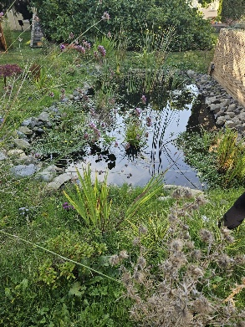
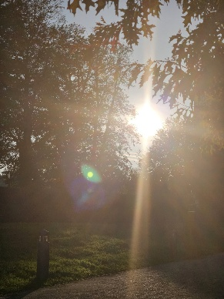

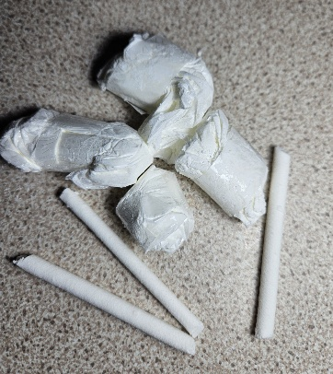
Appendix 2

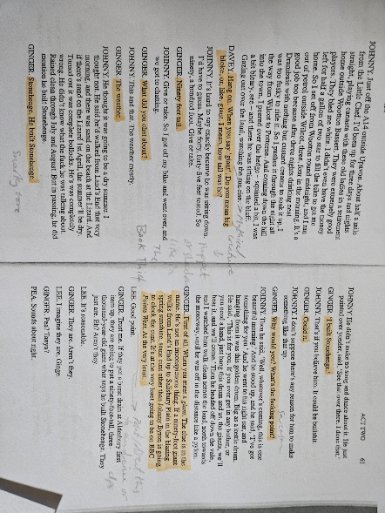
Appendix 3

Appendix 4


