Research Practices

Keywords: Paper, Culture, Symbolism

Cerys Angharad Davies
1706603
Surface Pattern Design
Word Count 2,358
Julia Lockheart
The three keywords which I will be researching into for my dissertation are paper, culture and symbolism. During this process I will be gaining a better understand of each word individually, and to mainly focus on my current course work which represents paper cutting. The purpose for choosing these keywords is to comprehend the production of paper, how did paper cutting first begin, when is paper cutting used within China, how important is paper cutting to the Chinese culture, and what do the motifs and characters represent to the natives of china. Once I have acquired this knowledge, I will be refining my research and developing a question to continue into my dissertation.

“Material manufactured in thin sheets from the pulp of wood or other fibrous substances, used for writing, drawing, or printing on, or as wrapping material. ‘a sheet of paper’” (OED) by initially looking at the definition of paper I wanted to explore the processes of how it is made, as well as an old tradition classed as paper cutting. When looking into the production of paper, I primarily want to consider having a comparison of past, present and future to see how we have made it, how we have developed, and where we are heading, as resources diminish it will be intriguing to see how individuals have tasked themselves to solve this problem. Additionally, as paper is a much-needed resource not only for artists and design, as everyone at some point requires paper, when that point comes, we don’t question how the material is manufactured. Although looking into the Most wonderful machine mechanization and social change in Berkshire paper making I discovered, “Paper making involves breaking down vegetable matter into cellulose fibre; forming it into a thin, wet sheet; drying it; and when it is destined for writing or printing, giving it a suitable surface.” (McGaw, J.A. & American Council of Learned Societies, 1987, p.39). Although this process has developed overtime, it is remarkable how we are able to manufacture a natural product and intern recycle it constantly to produce paper and alternative paper-based products. In addition, the imagery below represents how the paper production industry manufactures paper in twenty-first century, in comparison to the reference used above.

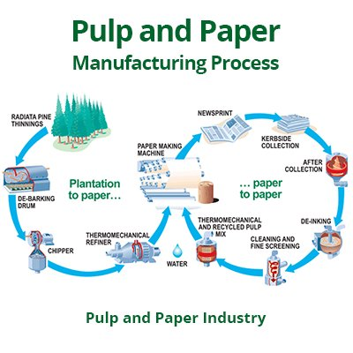
Pulp and Paper Manufacturing, 2019

Continuing, the tradition of paper cutting is quite remarkable as families have managed to maintain the craft over generations of teaching and learning. What I found to be quite notable was the craft initially started off as embroidery pattern samples, which I sourced from an article as it mentions, “Its early development was associated with embroidery, because in the beginning, paper cuts were used as pattern samples for embroidery works. By the end of the Qing Dynasty, Nanking-style paper cutting had become a unique expression of folk art popular in southeast China.” (Wang, 2012). As paper cutting dates back to the Dynasties, I was not surprised to learn that the beginning was to embellish and embroider textiles, as the Nanking style was very delicate and exquisite with their patterns. However, if you were to have a comparison of the craft between Eastern and Western there would notable be differences, such as the spiritual meaning since paper cuttings are used for multiple scenarios such as wedding, events and ceremonies within the Chinese culture as they are used as blessings and hold meaning for individuals within the surroundings. Alternatively, the motifs and patterns used would hold different connotations as the Chinese culture alternates their designs to suit the zodiac, season and scenario, whilst perhaps western culture does not follow such designs and can substitute with a wide variety of motifs and patterns. Furthermore, paper cutting is a unique talent which is taught through generations of households who obtained this gift. However, looking into an article Wang (2012) mentions that there are two major styles of Chinese paper cutting, which are the north and south Chinese styles. As the Norths primarily more energetic with their line work and consists of more bold imagery, whilst the South puts more emphasis on details with more delicate and intricate line work and images. Although they are both different, they both link with the culture as paper cutting is not only for design it is for cultural purposes, which brings these paper pieces meaning within events and ceremonies.

Culture, although we all have a common understanding of what the word means and represents it can sometimes be forgotten over the duration of time, henceforth the definition within the Oxford English Dictionary references ‘the beliefs and attitudes about something that people in a particular group or organization share the political cultures of the United States and Europe are very different. A culture of failure exists in some schools. company culture We are living in a consumer culture’ (OED). Within this section I will be looking into my keyword Culture, my initial idea is to focus on the Chinese traditions of paper cutting as I want to gain a better understanding of why they are used within ceremonies, events and to even decorate certain natives’ households. In addition, I will be looking into how the culture links with certain colours such as red, since it is a prominent colour within the craft of paper cutting. However, I will be exploring the symbolism of the colours within the Chinese culture to see how they affect the image and meaning behind the craft afterward. When exploring ancient Chinese ceremonies, I discovered that at Birth there would be three different types of ceremonies which would be held. Initially there is the Sanzhao, which is held three days after birth whilst Bari, is held a whole month since birth, lastly Zhuazhou which is arranged a full year since birth. Although these ceremonies seem unusual for western culture, during ancient china these were executed as they were and still are rather spiritual and religious. Furthermore, another two major ceremonies which are held stand the ‘coming of age’ and the ‘wedding’. Wang the author of Ancient China website was a useful source of information which guided me with my work, however I wish to look more in depth about which ceremonies held more meaning as well as which ones included ancient paper cutting.

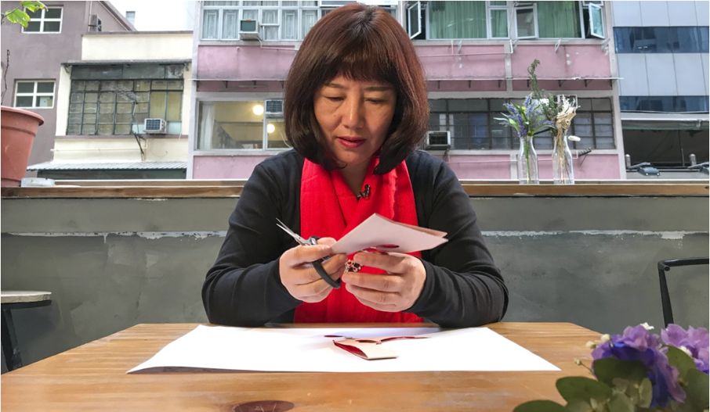
Moreover, an individual who appears in the South China Morning Post (Chan, 2018) is Li Yunxia. She has become known for her talents of the ancient craft of Chinese paper cutting, which was taught to her through her mother and grandmother since the age of six. Within the article she mentions how red is an important colour for the Chinese culture as it represents luck and happiness, but it is rather important during the Lunar New Year especially since you will see designs with phrases and good fortunes and especially the conforming year of the zodiac. Another comment which Li Yunxia (Chan, 2018) mentions “The hardest thing to master in paper cutting is handling the scissors. You use the scissors as if you were using a pencil to draw something, but you can’t make a mistake”. However, although Yunxia uses scissors that isn’t the only method which can be used as there is also another technique which is involves cutting with craft knives or scalpels, yet the traditional technique would involve sharp scissors, allocated time and lots of patience. Finally, Yunxia (Chan, 2018) discusses how within the Chinese tradition there are qualities a ‘good’ woman should possess, these are paper cutting, embroidery and keeping appearance. If the individual doesn’t develop these techniques, they have no standing within the Chinese community, I found this to be quite eye opening as I never truly understood how important the ancient style of paper cutting was to families looking for brides. Although Yunxia does state “Paper cutting represents wisdom; if you know how to make paper cuts, it means your children will be smarter” (Chan, 2018). Thinking about what I have roughly learnt from the culture and their principles, it makes sense how they value these skills, as they date back to around the Han Dynasty. Even so, the fact the ancient Chinese paper cutting technique is still around shows how people value the importance of these delicate pieces, as they not only decorate natives’ homes but are used to ward off evil spirits within ceremonies and events and in turn bring luck and happiness.

Li Yunxia paper cutting (Chan, 2018)

Symbolism, a word which is ever changing and gaining new meaning, the definition of symbolism within the Oxford English Dictionary mentions “The use of symbols to represent ideas or qualities” (OED). Within this subdivision I will be exploring the symbolic significance behind the motifs and key words used inside the ancient Chinese paper cuttings. Initially, to gain a better understanding of the importance of symbolism within the Chinese culture I saw that The British Museum mentions:
Symbolic meaning has played a significant role in the lives of the Chinese. The nature of their written and spoken language has contributed to the rich vocabulary of symbolism. The large numbers of homophones in the Chinese language means that words with different meanings become associated with each other due to a similarity of sound when spoken. As well as linguistic symbolism, there are symbols which originated from ancient cosmological and mythical beliefs. Symbolic meanings form an intrinsic part of culture and are readily understood by Chinese people (The British Museum, 2008-09).
Although I am primarily looking into the symbolic meanings behind the imagery, characters or words used within ancient Chinese paper cutting, it intrigues me to known that the culture has multiple symbolic references to a wide variety of articles or words. Continuing, China has many symbols which they use throughout the year depending on the season, event or ceremony. Looking through Chinese symbolism (The British Museum, 2008-09) there are six classifications which are prominent such as Plants, Animals, People, Eight Auspicious Symbols of Buddhism, Written Characters, and numbers. Within my dissertation I will be gaining knowledge and looking in depth as to why they use these specific motifs or characters within the Chinese background. Also, I will be expanding upon the importance of each segment within the Chinese culture, as to what they represent, when they are used either in ceremonies, events or as decorations, and why they are used within ancient Chinese paper cutting. Out of the six symbolic sections currently I will be focusing mainly on Plants, Animals, and numbers.
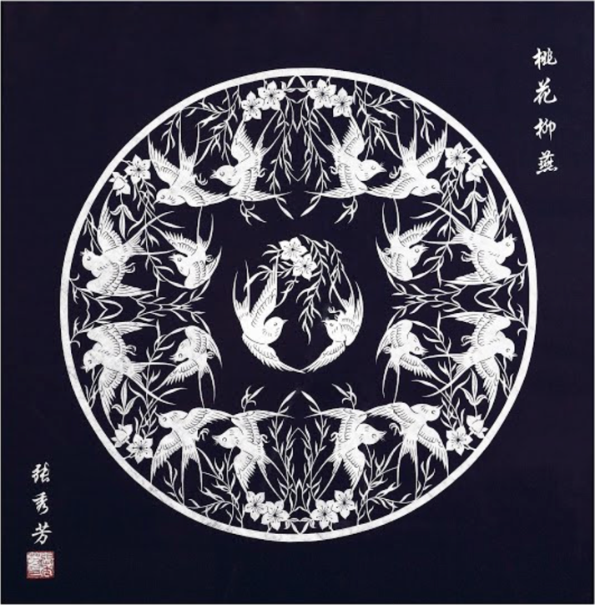
Plants

Additionally, the plants which are symbolic to the Chinese are Pine, Bamboo and Plum Blossom, when these three are presented together they are classed as ‘The Three Friends of Winter’ (The British Museum, 2008-09). Also, within the plant symbolism they have Chrysanthemum, Lotus, Peach and Peony. Even though the Chinese have firm combinations for certain seasons, the majority of the plants mentioned have an uplifting meaning behind them ranging from royalty, immortality, longevity, purity, vitality and nobility. The image beside

Swallows, Willows and Peach Blossoms (Xiufang 2007)
Animals

Furthermore, the animals which are listed within The British Museum (The British Museum, 2008-09) do not relate to the Chinese zodiac apart from the Dragon, as it is a symbol of energy, good fortune and even embellished onto robes of important figures. As well, there is the Bat which symbolises happiness, joy, and if five are spotted together are called the ‘Five Blessings’. Also, the Crane is a symbolic figure for longevity due to their live spams, whilst a flying crane represents hope. Additionally, the Phoenix symbolises good fortune due to their peace and prosperity, and it is a symbol for the empress but once paired with the dragon represents the perfect marriage. Lastly, the Fish which represent wealth and can also symbolise marriage and birth due to the fishes reproducing.

Numbers

Lastly, within the Chinese culture there are a few key numbers which are most prominent such as number four, five, eight and nine. Each individual number has a corresponding meaning such as four as it is unlucky, due to the pronunciation of it as its corresponding word meaning death, five is their auspicious number since it links with the elements, eight is related to good fortune as the pronunciation is similar to expand, and lastly nine which is not lonely linked with the emperor it is also a blessing long lasting such as weddings. All of these meanings were from The British Museum ((The British Museum, 2008-09).

Throughout my research through my keywords, I have gained a better understand of them individually and collectively with the main link being ancient Chinese paper cutting. From learning about the production of paper and how paper cutting first began, it has made me question how the ancient craft has developed both with materiality and methods over the decades. However, on the other hand culture has made me aware of how important religion and tradition is within China but moving forward into the dissertation, it has made me want to question the traditions with Western and Eastern Culture with comparisons of the ancient paper cutting. Lastly, with symbolism it has made me mindful of how the Chinese link certain words and phrases with plants, animals or numbers, now having gained this knowledge I will be looking into the importance of symbolism within the Chinese culture and how it influences events and ceremonies.

Question

Since the beginning of paper cutting, how have the Chinese developed their ways with technique, material and symbolic meaning?

Sub-Questions

How the Ancient craft has been developed, how modern paper cutting compares to the ancient tradition?

How culture between the Eastern and Western compare and contrast with traditions and modern day?

The Importance of symbolism within the Chinese culture? How it affects events and ceremonies throughout the years?

Bibliography

Carr, K.E. Who invented paper? Ancient China and the history of paper. Quatr.us Study Guides, July 27, 2017. Web. May 2, 2019.
Available at: https://quatr.us/china/invented-paper-ancient-china.htm (Accessed: 1st May 2019)

Chan, B. (2018) ‘Chinese New Year paper cutting explained by a Hong Kong master of the craft’, South China Morning Post, 14th February. Available at: https://www.scmp.com/culture/arts-entertainment/article/2133180/chinese-new-year-paper-cutting-tips-master-craft (Accessed: 1st May 2019)

McGaw, J.A. & American Council of Learned Societies, 1987. Most wonderful machine mechanization and social change in Berkshire paper making, 1801-1885, Princeton, N.J.: Princeton University Press.

Oxford English Dictionary

Thackeray, B., 1998. Paper: making, decorating, designing., New York: Watson-Guptill Publications.

The British Museum (2008-09) China Journey to The East. Available at: https://www.britishmuseum.org/pdf/Chinese_symbols_1109.pdf (Accessed: 4th May)

Turner, S., 1998. The book of fine paper, London: Thames and Hudson.

Wang, E (unknown) Ancient China. Available at: https://elainewang-ancientchina.weebly.com/ceremonies.html (Accessed: 1st May 2019)

Wang, F., 2012. Nanjing-style Paper Cutting. China & the World Cultural Exchange, pp. China & the World Cultural Exchange, Jan 1, 2012. Available at: https://search-proquest-com.ezproxy.uwtsd.ac.uk/docview/1223493963/fulltext/F3D0704C90D84436PQ/1?accountid=130472#center (Accessed 4th May 2019)

Watson, D., 1991. Creative handmade paper: how to make paper from recycled and natural materials, Tunbridge Wells: Search Press.

Imagery

Pulp and Paper Manufacturing, 2019 available at: https://www.pulpandpaper-technology.com/articles/pulp-and-paper-manufacturing-process-in-the-paper-industry (Accessed: 2nd May 2019)

Chan, B. (2018) Li Yunxia. Available at: https://www.scmp.com/culture/arts-entertainment/article/2133180/chinese-new-year-paper-cutting-tips-master-craft (Accessed: 2nd May 2019)

Xiufang, Z (2007) Swallow, Willows and Peach Blossoms [Paper] Available at: https://artsandculture.google.com/asset/swallows-willows-and-peach-blossoms/KAENUbtz6Y_XYw (Assessed: 6th May)

