Kristian Cole (1810705)
University of Wales Trinity Saint David
Hyper fort network solution

Table of Contents
1 Abstract 2
2 Introduction 2
3 Related work 2
4 Problem formulation 3
4.1 Single Tier Network Topology 3
4.2 System User Devices 3
4.3 BYOT 4
4.4 Viruses and Malware 4
4.5 System User Devices 4
4.6 Hackers Methods 5
4.6.1 Reconnaissance 5
4.6.2 Scanning and Enumeration 5
4.6.3 Gaining Access 6
4.6.4 Escalation of Privilege 6
4.6.5 Cover Tracks 6
4.7 Wireless Router Configuration 6
5 Implementation 8
5.1 Network Hierarchy Model 8
5.1.1 Access Layer 9
5.1.2 Distribution Layer 9
5.1.3 Core Layer 9
5.1.4 DMZ 10
5.1.5 Mobile Device Management 10
6 Results/Findings & discussions 11
References 12
Appendices 14
Appendix A Netcraft Output 14
Appendix B NMAP Output 14
Appendix C Telnet Command Prompt 15
Appendix D Example Security Policy 16

1 Abstract
This report will outline a solution to the Hyper Fort network hierarchy problem that requires a secure network hierarchy model, to reduce risk of intrusion by hackers, provide high availability and quality of service for organisation employees.

2 Introduction
Hyper Fort is an energy sector consultancy organisation, with a worldwide employee and customer base and intellectual property data worth billions. Hyper Fort’s expansion requires staff and customers access to the organisations on-site network and resources. As Hyper Fort is a consultancy firm for the energy sector, are at a higher risk of network intrusion and industrial espionage than an average organisation. As the organisations data is worth billions a secure infrastructure to protect that data is required. This report covers the proposed network hierarchy model, the intrusion threats and current methods employed by the hacking community on your current model and finally the habits of the Hyper-Fort employees, which needs to be modified to prevent data breaches.

3 Related work
The report will primarily focus on covering the need for a standardized network model and how this setup is challenged by the advances in technology that are continually evolving. The network hierarchy recommended by this report is currently in use across a higher percentage of public organisations and still data breaches and hacked systems still occur. The aim of this report is to highlight the current cutting-edge threats on the most modern network setup and the recommendations for future technological use within an organisation.

4 Problem formulation

4.1 Single Tier Network Topology
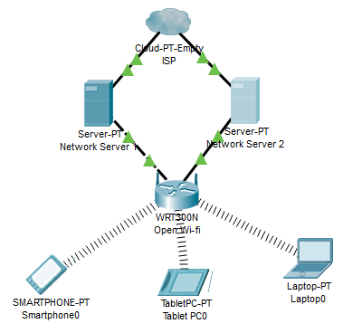
Figure 1.1. Unsecure network, open Wi-Fi with multiple devices attached.
A single tier network, see Figure 1.1, can pose major security risks. The network setup laid out in figure 1.1 shows multiple, multi operating system devices attached to an open wi-fi wireless router that has the basic username “user” and password “password1”. Mobile device employees are logging into the wireless network and accessing the internet via two internal organisation servers, both internet facing.
An open Wi-Fi access point for Hyper Fort employees and guest employees would open various issues for the organisation and employees.

4.2 System User Devices

System user personal mobile phones, tablets and laptops will not have the level of security configured than on an organisation provided device. BYOT allows this security risk into an organisation but can also aid in productivity:

4.3 BYOT

BYOT Advantages
- Employees can work from any organisation site without accessing site hardware but using their own and accessing the shared network.
- Organisation saves on the cost of providing hardware and internet costs be halved as employees use their own internet service providers as well as the organisations.
- One device for organisation/ personal use.
BYOT Disadvantages
- Employees can access any websites/software on organisation time during working hours.
- Data loss if device is stolen, misplaced or broken
- Different devices run at different speeds for the applications provided by the organisation.
- Different devices need different coded applications, Objective-C for Apple and Java for Android.
The single tier network, see Figure 1.1, does not have the capability to expand and route more than a limited amount of device connections. The more devices accessing the network takes a larger amount of the network availability is distributed, lessening performance and lowering quality of service.

4.4 Viruses and Malware

System User devices contain no antivirus software, be infected with viruses and malware. As the device then logs onto the organisation network the servers can become infected and this is installed on other system user devices to propagate the infection further.

4.5 System User Devices

Organisational data is available at a click from the desktop (Word, Excel, etc.), to system folders and internal websites. As data transfer rates rose from the minimal to the maximal there is little need for USB/DVD/CD storage as Cloud companies offer storage and means to transfer data between sites. In the above network there is an ability for Employees to copy files from system folders to mobile device folders or cloud storage and walk out of the site with that data in their hands. Another access point would be to send the data directly out of the officer via an internet mail service (AOL, Yahoo Mail!, Gmail). Employees own password strength on personal devices will more than likely comply to their own standards rather than an enforced one. Employees own lifestyle habits, where mobile device is used and accessed from is another issue, if lost anyone could have access to the data.

4.6 Hackers Methods

Hackers methods as stated by CEH(Certified Ethical Hacker) concepts [1] for weak and strongly secure networks remain the same:

4.6.1 Reconnaissance

From the internet to server and using a free online tool like Netcraft [2] a hacker can perform a small information gathering exercise on the Hyper Fort website and return valuable information. Netcraft can list what Operating System the site is running, the language it is written in (PHP, ASPX, Html, etc), what code runs on the page (JavaScript, C#, SQL, etc) (Example results in Appendix A). If the Hyper Fort website works from the same server as Employee data sources and SQL databases, then they have access to all Hyper Fort data.
With the knowledge of what the code is running on the website a hacker could create a query string in the web browser address bar and perhaps access the back end of the website procuring System Usernames and Passwords. This process is call SQL Injection and primarily involves writing an SQL query in a query string in the Internet Browser address bar (e.g. http://HyperFort.com/userdetails.aspx?userId=user'; UPDATE employees set password=’password’ where userid = ‘admin’) The example given has reset the password of a known user to ‘password’, so now hackers can use that account with a reset password.
From the wireless router side, a hacker could set up a router that acts as a path between System User Device and Hyper Fort wireless router. A piece of hardware called the pineapple router can perform this task. As the System User automatically logs onto open Wi-Fi networks that are free, the Pineapple router [3] collects the username and password from the System User and then routes the user to the wireless router. This method is described as a Man in the Middle Attack [4].

4.6.2 Scanning and Enumeration

From Netcraft results, the hacker has enough websites associated with the original site. Using the application NMAP, a port scanning application, the scan returns a wealth of information (see Appendix B).
NMAP (Network Map) is a network mapper and security scanner [5] and is primarily for penetration testing what ports are open on your servers and how you can configure them for safetya. An IP address will have been procured from website hosting server or a website address that has returned an actual server name.

Once NMAP has been run on the websites provided by Netcraft and a list of open server ports has been obtained, there is enough to start attempting access via various ports.

4.6.3 Gaining Access

The username and passwords found in the Wi-Fi PineApple honeypot scan can be combined with an IP address or server name to access the system remotely. “192.168.0.1\Username” or “HyperFortWebServer\Username”. An application called Telnet can be used to access the above via the port that was returned as open in the NMAP scan.
Port 23 is now open, see Appendix C, Telnet can access that port and have full access to files and folders on the server [6]. Telnet is an application now disabled on Windows due to its ability to communicate and access the port. [7]

4.6.4 Escalation of Privilege

From the previous 'gaining access’ process, especially if an SQL access has been obtained, a range of security settings can be configured via the SQL management studio command line to levels of System Admins for various applications. By the command line via Telnet the following code can be executed (telnet> sql -u admin –p password), escalation of privilege is achieved as hackers now have admin access to the SQL server databases.

4.6.5 Cover Tracks

Hackers generally sit behind a VPN (Virtual Private Network) situated in another country for anonymity or on the TOR (The Onion Router) network, another anonymous browser based node VPN.

4.7 Wireless Router Configuration

As mentioned in the previous section Wireless technology can be almost easily compromised by unwanted Employees.
Wireless Security Protocols – an access point with no credential requirements or weak encryption such as the network above can be easily accessed by non-Employees. The example network has the username “User” and password “password1”. WEP (Wired Equivalent Privacy) is the weakest and currently abandoned wireless network security protocol available to wireless routers. It has the standard encryption available to wired network routers and is easily accessed with the right tools.
Wireless Router Coverage Area – an access point with a higher range of access allows multiple non-employees the abilities to see and connect to the organisational network. A 2.5gz router can reach up to 46 metres indoors and 92 metres outside, but this distance can be affected but which 802.11 protocol has been applied to the wireless router. The 802.11 Protocol [8] has been produced in various wireless standards an example of which is the 802.11n - a high speed wireless protocol, seven times faster than 802.11g and can the range extend to 300 feet or more. Imagine the range and speed available to a non-system user with elevated rights.

5 Implementation

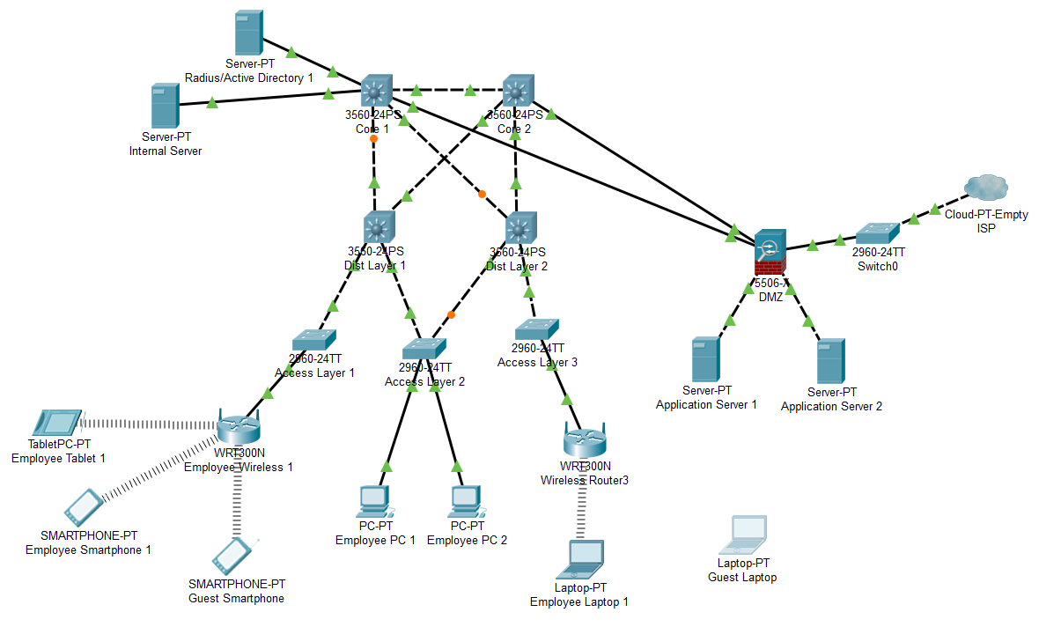
1.2 Hyper Fort Three Tier Network Recommendation

The three-tier network specified in image 1.2 offers a security model that is scalable in terms of availability, speed and lessens risk of intrusion from non-employees of Hyper Fort.

5.1 Network Hierarchy Model

System user devices such as Apple products (Ipad, Iphone, etc) and the many Android models will need a secure route to the internal systems. The operating system of the devices is not the issue, it is how the employees will connect to the internal systems. This applies to both employees and guest employees that require access. The initial access must be handled by an authentication server and process.
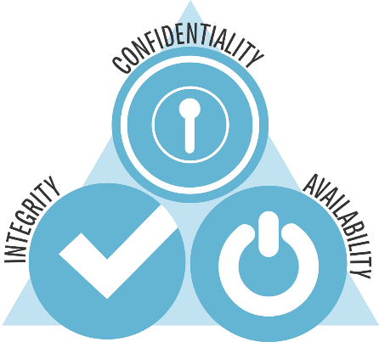
Figure 1.3 CIA Triad [9]
The CIA Triad is a concept whereby the System User is bound by C (Confidentiality), I (Integrity) and A (Accountability) [10]. Confidentiality due to the nature of the Intellectual property, integrity whereby the information of the organisation is guarded against misuse and finally accountability towards the accessibility and usage of the organisational data [11]. The use of Bring Your Own Technology security needs to centre around that concept. Starting with the user’s technology there must be the following stages as the wireless access point is accessed. All Hyper Fort employees must sign a security policy, for example see Appendix D, to ensure they are aware of the guidelines and restrictions placed on them as Employees and how compliance must be achieved with their adherence of organisation guidelines.

5.1.1 Access Layer

The wireless access point must have the standard WP2/AES password encryption. WPA2/AES encryption is a higher level of encryption than other wireless encryption standards such as WEP [12]. The wireless access points must be configured to have a range that only covers the Hyper Fort site. The authorization credentials for the employee wireless access point are open for employees. The wireless access points are networked to switches providing a high availability for employees and guest employees. The access point switches also provide port security, only certain types of traffic are allowed in and out of the network as all unused ports are closed by the firewall configuration on the switch. The switch also provides a virtual access control configuration whereby only devices, recognised by IP Address or MAC Address, on an access list authorized by an internal Radius Server can access the network [13].

5.1.2 Distribution Layer

The distribution layer provides another layer of secure access between the Access layer switches and the Core network. Only switches configured to access this distribution layer, which can be another set of multilayer switches or routers are allowed access to Hyper Fort network services [14].

5.1.3 Core Layer

User access is authorized by a Radius or Active Directory authentication security level at the core, whereby the System User logs into the core network using a strong password. A Radius/Active Directory server placed at the core network as outlined in the three-tier network provides an AAA (Authorization, Accessibility, Accounting) security level [15].
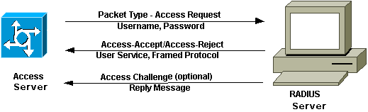
Figure 1.4 Radius Server Process [15]
The password can be configured in Microsoft Group Policy to be a certain length, to contain a number and special characters [16]. All Hyper Fort employees and Guest employees must have a network account to access the core servers’ documents and applications. The Guest wireless access point will have a weekly expiring password, this will also apply to the network password. The Core layer provides the speed needed to handle data transfers from multiple Employees, this layer is connected by fast ethernet connections and is not configured to expand [17]. If more user devices were to use this network then more routers and switches would need be added to the distribution layer to route the data packets and negate bottlenecks in the network.

5.1.4 DMZ

A DMZ (Demilitarized Zone) needs to lie between the internal LAN and the external WLAN where access to the internet is obtained by the Employees. A webserver sits in the DMZ and is connected through the DMZ firewall to the internal network [18].

5.1.5 Mobile Device Management

All employee devices must have a mobile device management strategy in place to protect email, documents and employees personal ability to access the organisation wireless access points. Citrix Xenpoint is a mobile device management software solution [19]. Hyper Fort employees should have this software on their devices. Citrix Xenpoint can:
- Install to any of the major operating systems (Apple, Windows, Android).
- Hyper Fort can deploy system applications to any devices.
- Citrix Xenpoint software can wipe the drive of a missing or stolen device.
- Hyper Fort can manage all devices from a central point.
- Access to Hyper Fort documentation is encrypted by Citrix Xenpoint.

6 Results/Findings & discussions

A three-tier network hierarchy model provides:
- Availability, high network speeds and is scalable for expansion of organisational services.
- Security lessens risks of successful intrusions by non-Hyper Fore employees by employing authentication techniques and port management by configured firewalls in each of the network layers (Access, Distribution and Core).

System user accountability
- Fair use and security policies signed as a contract between organisation and employee ensure culpability for Hyper Fort intellectual property usage.

Future work includes:
- Emerging network intrusion threats of cryptographic nature from Quantum Computing [20] and hacking methods.
- New technologies and how they will additional aid and expand the network hierarchy model.

References

[1] | M. Gregg, "Chapter 4: Enumeration and System Hacking," in Certified Ethical Hacker Verson 9, Pearson IT Certification, 2017, p. 185.
[2] | "https://www.netcraft.com/," Netcraft Ltd, [Online]. Available: https://www.netcraft.com/. [Accessed 06 12 2018].
[3] | H. LLC, “Wi-fi Pineapple - Home,” Hak5 LLC , [Online]. Available: https://www.wifipineapple.com/. [Accessed 10 December 2018].
[4] | D. C. Campell, "Lecture 3 - Malware and Malcious Code," University Of Wales - School Of Computing, Swansea, 2018.
[5] | G. Lyon, "NMAP The Network Mapper - Free Security Scanner," Insecure Org, [Online]. Available: https://nmap.org/. [Accessed 10 December 2018].
[6] | D. C. Campell, "Lecture 7 - Fortifying The Kingdom," University Of Wales - School Of Computing, Swansea, 2018.
[7] | A. I. GmbH, "Using telnet to Test Open Ports | The Complete How-To," Acronis International GmbH, [Online]. Available: https://www.acronis.com/en-us/articles/telnet/. [Accessed 10 December 2018].
[8] | "Network+ Exam Cram: Wireless Networking," Pearson, [Online]. Available: http://www.pearsonitcertification.com/articles/article.aspx?p=1329709&seqNum=4. [Accessed 10 December 2018].
[9] | M. CBRM, "CIA Triad - Computer and Information Security," 08 May 2018. [Online]. Available: https://security6132.wordpress.com/2018/05/08/cia-triad/. [Accessed 13 December 2018].
[10] | W. Stallings, "Computer Security Concepts," in Cryptography and Network Security - Principles and Practice, Essex, Pearson Education Limited 2017, 2017, pp. 22-23.
[11] | D. C. Campell, "Lecture 2 - The CyberSecurity Sorcery Cube," University Of Wales - School Of Applied Computing, Swansea, 2018.
[12] | Cisco, "Cisco Wireless Controller Configuration Guide, Release 8.2 - Configuring a WLAN," Cisco, 16 September 2016. [Online]. Available: https://www.cisco.com/c/en/us/td/docs/wireless/controller/8-2/config-guide/b_cg82/b_cg82_chapter_01010011.html. [Accessed 15 December 2018].
[13] | Cisco, "Security Configuration Guide: Access Control Lists, Cisco IOS Release 12.4T - Controlling Access to a Virtual Terminal Line [Support]," Cisco, 21 July 2017. [Online]. Available: https://www.cisco.com/c/en/us/td/docs/ios-xml/ios/sec_data_acl/configuration/12-4t/sec-data-acl-12-4t-book/sec-cntrl-acc-vtl.html. [Accessed 15 December 2018].
[14] | Cisco, "Hierarchical Network Design Overview (1.1) > Cisco Networking Academy Connecting Networks Companion Guide: Hierarchical Network Design," Pearson, 2014. [Online]. Available: http://www.ciscopress.com/articles/article.asp?p=2202410&seqNum=4. [Accessed 15 December 2018].
[15] | Cisco, "How Does RADIUS Work? - Cisco," Cisco, [Online]. Available: https://www.cisco.com/c/en/us/support/docs/security-vpn/remote-authentication-dial-user-service-radius/12433-32.html. [Accessed 15 December 2018].
[16] | "Password Policy Windows 10," Microsoft, 2018. [Online]. Available: https://docs.microsoft.com/en-us/windows/security/threat-protection/security-policy-settings/password-policy. [Accessed 13 December 2018].
[17] | T. Faq, "Understanding The Cisco three Layer Heirarchial Model," Tech Faq, 2018. [Online]. Available: http://www.tech-faq.com/understanding-the-cisco-three-layer-hierarchical-model.html. [Accessed 17 December 2018].
[18] | Cisco, "Configuring DMZ," Cisco, [Online]. Available: https://www.cisco.com/assets/sol/sb/isa500_emulator/help/guide/ad1681599.html. [Accessed 17 December 2018].
[19] | C. S. Inc, "Citrix Endpoint Management - Device Management for Every Major Mobile Platform - Citrix," Citrix Systems Inc, 2018. [Online]. Available: https://www.citrix.com/products/citrix-endpoint-management/get-started.html. [Accessed 17 December 2018].

Appendices

Appendix A Netcraft Output
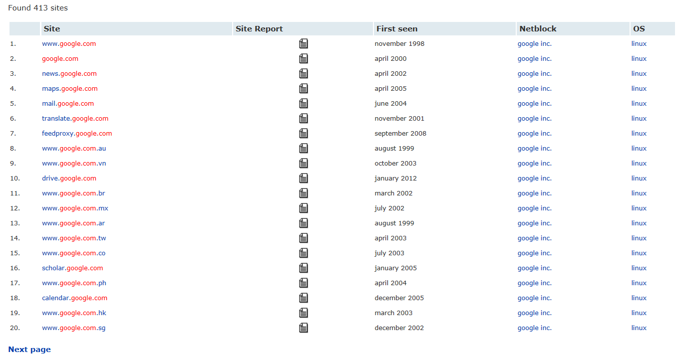

Appendix B NMAP Output

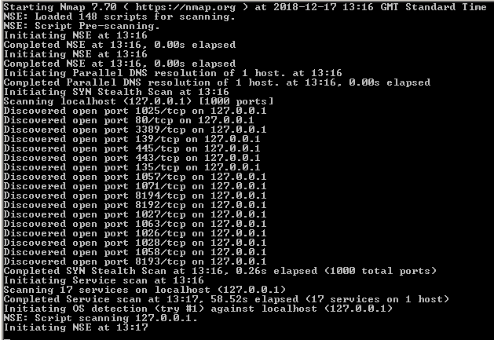

Appendix C Telnet Command Prompt

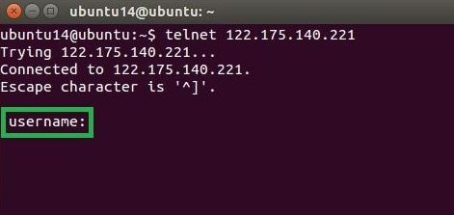

Appendix D Example Security Policy


