

PROGRAMME: MASTER OF BUSINESS ADMINISTRATION
MODULE: MARKETING MANAGEMENT
MODULE CODE: LCMB7024

Title: Marketing Environment Analysis of BHP

Student Name: KRISH SNEHALKUMAR PATEL
Student ID: 2543699
Table of Contents
Introduction 4
Task 1: Marketing Environment Analysis 4
1.1 Importance of the External Marketing Environment 4
1.2 Natural Environment 5
Climate Change and Operational Sustainability 5
Market Opportunities 6
Environmental Challenges 7
1.3 Political Environment 8
Government Regulation and Climate Policy 8
Stakeholder Confidence and Competitive Advantage 8
1.4 Critical Evaluation 10
Interaction Between Marketing Environmental Actors 10
Task 2: Strategic Growth and Competitive Positioning 10
2.1 Strategic Growth Using the Ansoff Matrix 10
(a) Market Penetration 11
(b) Product Development Strategy 11
(c) Market Development 12
(d) Diversification 12
2.2 Competitive Advantage 12
Achieving Differentiation 12
Innovation and Technology 13
2.3 Recommendation 13
Sustainable Competitive Growth 13
Task 3: Critical Reflection on AI Usage 14
3.1 Tool Disclosure 14
AI Applications 14
3.2 Critical Evaluation of AI Output 14
Verification and Error Identification 14
3.3 Contribution Analysis 14
Original Contribution 14
Ethical and Professional Reflection 15
Conclusion 15
References 16

Introduction
Global mining industry is accelerating its transition towards lower-carbon production because environmental expectations, regulatory requirements, and investor pressure increasingly influence long-term competitiveness. Among the largest mining companies globally, BHP is investing in renewable energy and operational decarbonisation, as well as sustainable resource development (BHP, 2025). Demonstrating the increasing strategic significance of sustainability, the company targets to reduce greenhouse gas emissions, which are associated with its operational activities.

Task 1: Marketing Environment Analysis

1.1 Importance of the External Marketing Environment
External marketing environment actors significantly influence how mining companies formulate sustainability strategies and maintain competitive advantage (Amoah and Eweje, 2023). In the case of BHP, the Natural Environment is the most dominant actor since climate change has a direct impact on operational continuity, stakeholder expectations, and availability of resources. The Political Environment is also a significant complementary factor, with a significant impact on environmental regulations and decarbonisation policies.
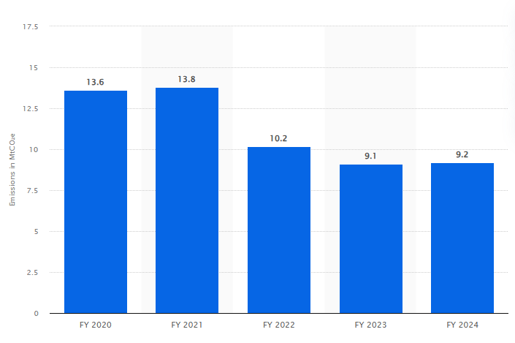
Figure 1: BHP’s greenhouse gas emissions
Source: (Statista, 2025)
The company’s mining activities play a significant role in greenhouse gases, as they contribute 9.2 million metric tons of carbon dioxide once operations and downstream activities are involved (Statista, 2025). All these marketing actors, collectively, guide BHP's shift to lower-carbon products and responsible mining.

1.2 Natural Environment

Climate Change and Operational Sustainability
The Natural Environment has risen to become the dominant influence on the marketing and operations decisions of BHP. Rising temperatures, unpredictable weather conditions, water shortages, and depletion of biodiversity pose a direct challenge to the productivity of mining. Mainly as they are also raising pressure on sustainable operations. Global clean energy investment more than doubled, reaching $2.155 trillion in 2025 being shown in Figure 2 (Stille, 2026). Thus, implying that mining companies have to trade off the growth in production and environmental protection.
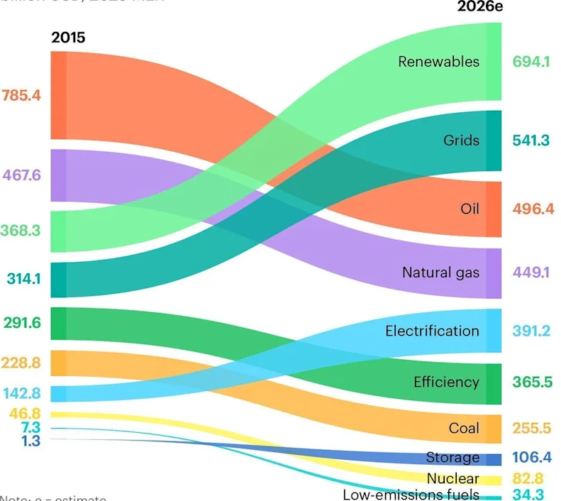
Figure 2: Global energy investment
Source: (Stille, 2026)
BHP has reacted through significant investments in renewable power, electrification of its fleets, water recycling and carbon-cutting technologies in its processes. The company invested $41.5 billion of funds as invested over the past years in climate-related efforts and sustainable activities (BHP, 2024). This has boosted its standing among greener investors and industrial customers. These projects decrease emissions in operations but promote brand positioning as a responsible supplier of necessary transition minerals.

Market Opportunities
The Natural Environment has brought great market opportunities by creating more demand for commodities, which underpin renewable energy technologies. Indispensable products in electric vehicles, battery storage systems and sustainable agriculture are copper, nickel and potash. Clean energy technologies may cover over 40% of the prospective advancements in copper demand by 2040 (IEA, 2025). The graph in Figure 3 below shows that copper demand remains showing only modest index variations. This will provide BHP with favourable market circumstances in the long term.
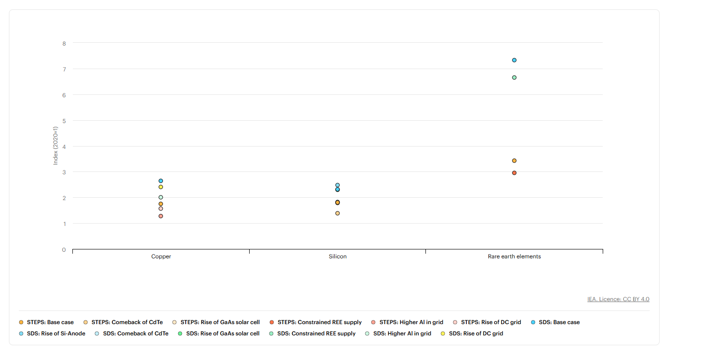
Figure 3: Copper Demand
Source: (IEA, 2025)
This increasing demand allows BHP to enhance relations with customers who want responsibly sourced minerals with lower carbon bases. Sustainability investments enhance corporate reputation, as well as the value to customers in the long run (Ardiansyah and Alnoor, 2024). The environmentally sustainable production is increasingly acting as a marketing advantage since industrial buyers are introducing environmental performance in their purchasing decisions.

Environmental Challenges
Irrespective of all such opportunities, environmental risks are still high. Australian government put pressure on mining companies to lower their impacts on the environment. As well as making their processes more efficient and resource-saving.
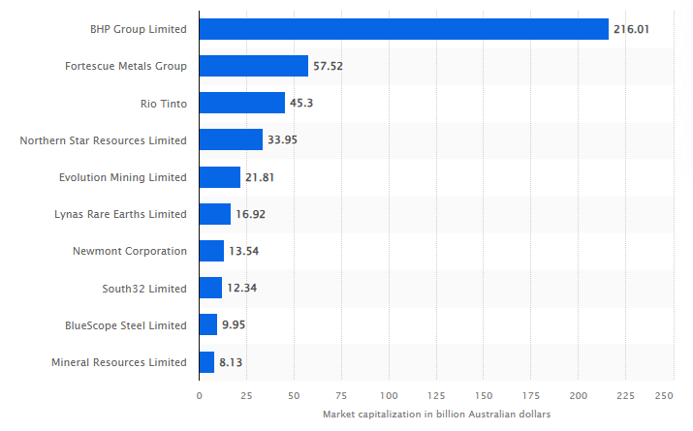
Figure 4: Australia mining companies capitalisation
Source: (Sasu, 2025)
BHP Group is valued at over AUD 216 billion (Sasu, 2025). Hence lack of fulfilling the demands of stakeholders in terms of environmental management may affect the company image negatively and decrease investor trust of investors (Khalid et al., 2023). Moreover, all the physical climate risks like flooding, droughts and heatwaves can interfere with the production schedules and make the operations more expensive. As such, environmental management has now taken shape as a sustainability factor as well as a strategic marketing need.
Environmental factor | Marketing implication
Renewable energy transition | Supports promotion of responsibly sourced minerals
Operational emissions | Enhances sustainability positioning and investor confidence
Resource efficiency | Encourages investment in cleaner production technologies
Table 1: Influence of the Natural Environment on BHP

1.3 Political Environment

Government Regulation and Climate Policy
Political Environment plays an excellent role and has power in establishing the transition of BHP by enacting environmental laws, carbon pricing policies and international climate treaties. Governments are also placing growing demands on mining companies to report on emissions, enhance environmental performance and aid the national decarbonisation goals (Noor, 2026).
Adherence to environmental laws builds the credibility of BHP with governments, investors and industrial customers. At the same time, when the regulation is stricter, it becomes more expensive to operate since a company has to invest in cleaner technologies (Long et al., 2022). However, compliance with regulations provides a chance to make BHP stand out from the competitors who have poorer sustainability results.

Stakeholder Confidence and Competitive Advantage
Infrastructure support for renewable energy by the government also adds to the demand for the minerals extracted by BHP. Electric cars, renewable electricity and battery production are stimulated by public investment programmes and will demand large amounts of copper and nickel. The estimated energy transition global investment is about more than $2.3 trillion in 2025 (Statista, 2026). This is supporting the market forces' long-term need to produce economic products of low-carbon mining.
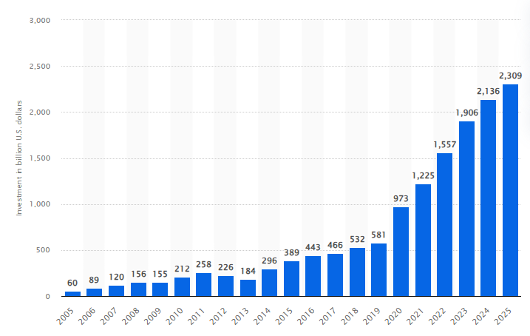
Figure 5: Investments in energy transition
Source: (Statista, 2026)
By adjusting corporate strategy in line with changing government priorities, BHP can reinforce corporate relations with policymakers and minimise regulatory risk. Transparent reporting also enhances trust among stakeholders and improves brand reputation (Sari and Muslim, 2024). Mainly among institutional investors who are integrating more environmental, social and governance parameters in their investment choices.
Political factor | Marketing implication
Net-zero policies | Increases demand for sustainable mining practices
Energy transition investment | Expands markets for copper and nickel
Environmental regulation | Encourages continuous sustainability innovation
Table 2: Influence of the Political Environment on BHP
Source: (Self-developed)

1.4 Critical Evaluation

Interaction Between Marketing Environmental Actors
Natural and Political environments reinforce each other in accelerating BHP's sustainability transformation. Climate change becomes the subject of increasing societal concern about the performance of society in terms of the environment, with increasing regulations and climate policies (Sarfraz et al., 2023). Therefore, environmental responsibility is a law and an asset of competitive marketing. Thus, aim to detail the regulatory compliance aspects and improve relations with customers and corporate image in BHP. This places the firm in a position to tap into future growth opportunities in the fast-growing global low-carbon economy.

Task 2: Strategic Growth and Competitive Positioning

2.1 Strategic Growth Using the Ansoff Matrix
External marketing environment shows that increased demand for low-carbon minerals and strict environmental guidelines offer opportunities to enable BHP to seek sustainable growth. Ansoff Matrix presents a suitable model used to identify growth schemes, as it considers the opportunities in terms of the available current and new products in the current and new markets (Puyt et al., 2024). Based on the robust resource base and international business, Product Development can be discussed as the most appropriate strategy for BHP.
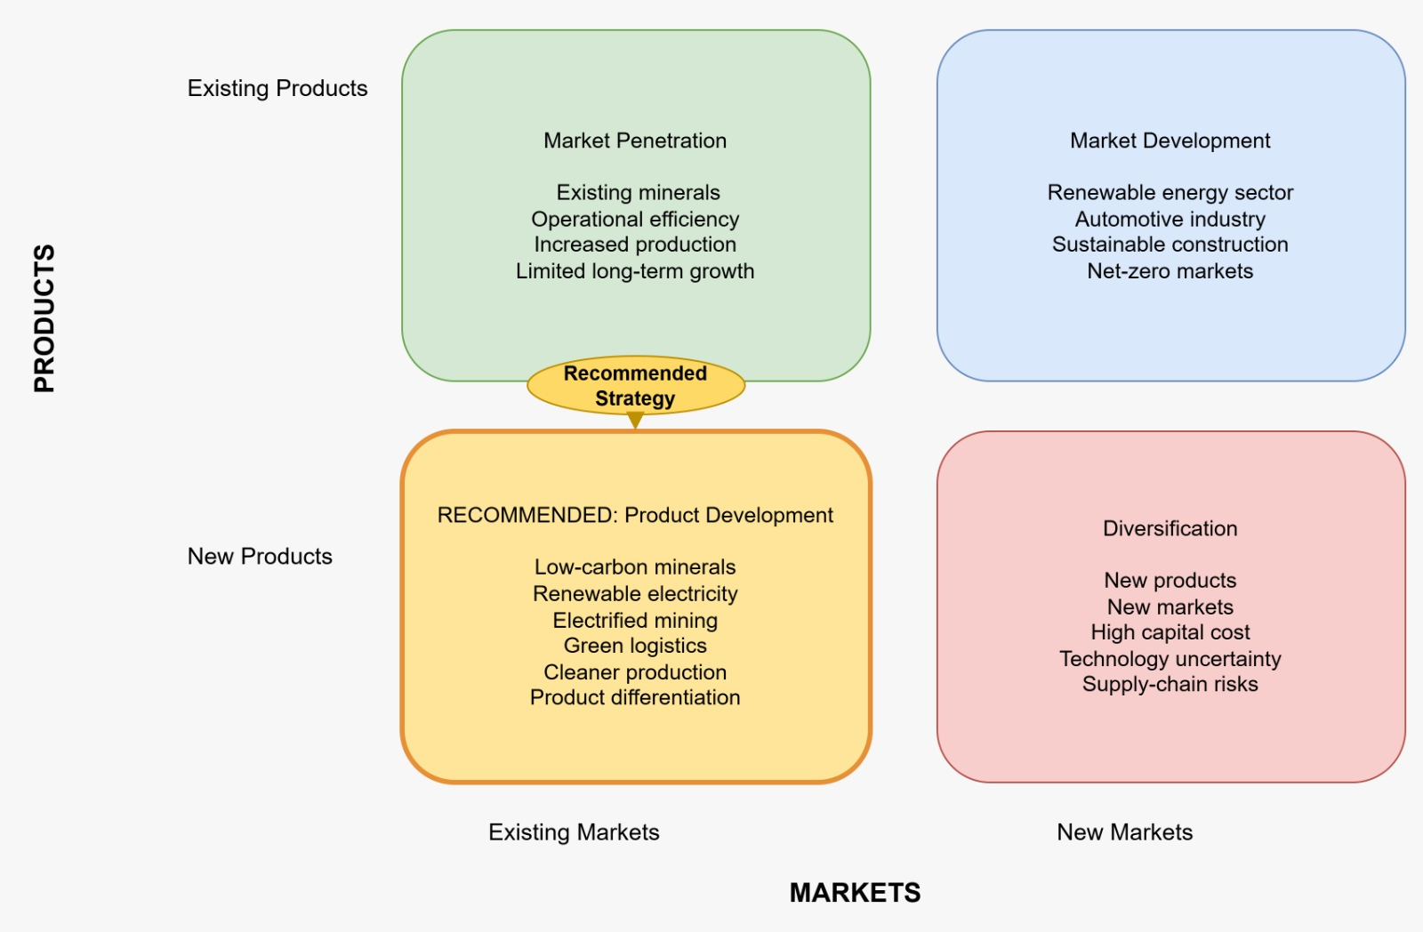
Figure 6: Ansoff Matrix
Source: (Self-created)

Market Penetration
Market Penetration focuses on increasing sales of existing products within existing markets; however, this strategy offers limited long-term opportunities for BHP. S&P (2026) estimates that demand for copper utilised in clean energy technologies will grow by about 50% by 2040. This helps the value of sustainable mineral production at the commercial level. Creating lower-carbon mining products and greener manufacturing processes can help BHP to empower its competitive advantages coupled with satisfying stakeholder expectations.

Product Development Strategy
Product Development is the process of offering new or enhanced products into the already existing markets (Chen and Chen, 2023). Instead of geographic expansion, BHP can develop the environmental performance of its current mineral portfolio by adopting cleaner technologies in production, renewable electricity and low-carbon logistics. At the same time, there is increasing demand among customers to get minerals sourced in a responsible manner that can help them decarbonise themselves. BHP has stated that its operational greenhouse gas emissions had decreased by 36% compared with FY2020 (Knaus and Morton, 2026). This is a tangible change that it is making towards sustainability goals. The company has already made massive investments in renewable energy agreements and electrification initiatives that decrease operational emissions and enhance product differentiation. Many nations have set net-zero goals, which have provided a more vigorous regulatory expectation throughout global mining activities.

Market Development
The creation of certified low-carbon blast furnace modification products allows BHP to react immediately to the modification of customer options (BHP, 2026). Manufacturing companies in the automotive sector, renewable energy and construction spheres have been progressively incorporating the concept of sustainability in the selection of suppliers. On this basis, environmentally differentiated products enable BHP to assert greater customer relations and generate greater long-term value amid greater production investment.

Diversification
Diversification involves introducing new products into new markets, but this strategy would expose BHP to higher financial and operational risks during its transition to a lower-carbon business model. Lower-carbon technologies are also hard to develop and necessitate a lot of capital expenditure before they can bear commercial profits (Mani et al., 2024). International inflation and disruption in supply chains only continue to raise the cost of equipment and capital expenditure in mining.
The acceptance of the material market also requires the customers to realise the extra value in favour of sustainability-produced minerals. Unless buyers are no longer price-sensitive, there might be no premium pricing opportunities. Moreover, there is uncertainty about technologies that will make the implementation process challenging, as some decarbonisation technologies are still being developed. BHP should thus invest in innovation projects and maintain financial discipline at the same time, ensuring that operations remain efficient.

2.2 Competitive Advantage

Achieving Differentiation
According to Porter’s Generic Strategies, differentiation generates competitive advantage by providing unique value in competition against price (Bhat et al., 2024). BHP need not stress price competition; instead, it must aim to differentiate itself by being environmentally friendly. It is more than suppliers showing lower emissions, clear reporting and responsible sourcing that customers are appreciating. Decarbonisation has become one of the key strategic priorities of 70% of mining executives (ABB, 2024). It is which means that the industry becomes more competitive in terms of sustainability.
Investment in digital technologies, renewable electricity and monitoring of emissions enhances the effectiveness of operations and environmental credibility. These abilities reinforce the brand image of BHP as well as promoting high-calibre business ties with large multinationals that are dedicated to environmental, social and governance goals. Sustainable differentiation also mitigates reputational risks about climate change and increases confidence of the investors in long-term corporate performance (Arhinful et al., 2025).

Innovation and Technology
Technological innovation enhances Product Development as it provides the continuity of raising efficiency and environmental performance of mining. Using artificial intelligence, automation, predictive maintenance and digital twins maximises the use of energy and minimises waste production (Abadi et al., 2025). BHP has increased the number of autonomous mining operations, which enhances productivity as well as consumes less fuel in several Australian locations. The use of autonomous haulage systems has shown productivity gains of more than 10% (Chen and Khan, 2025). This portrays the role of technology in creating sustainable competitiveness.
Novelty also helps in responsible management of resources by enhancing water recycling, biodiversity tracking and the accuracy in extraction mechanisms. Such programs diminish the environmental effects, besides showing leadership in the international mining markets (Hodge et al., 2022). Ongoing technological enhancement thus helps not only to enhance operational excellence but also to ensure efficient sustainability marketing. It can provide the organisation with competitive advantage.

2.3 Recommendation

Sustainable Competitive Growth
Product Development is the best strategic choice as it will build on the prior existing capability of BHP and respond to environmental and market changes found in Task 1. Production of low-carbon minerals, growth of renewable-powered activities, and technological innovation help increase competitive advantage and achieve long-term profitability (Faig et al., 2025). The plan is also complementary to rising world demand for transition minerals that are important in the renewable energy infrastructure. Considering sustainability in developing products, BHP creates value for its customers, improving its regulatory performance and corporate reputation at the same time. Product Development therefore allows the firm to gain sustainable competitive advantage in addition to contributing towards the world moving into a low-carbon economy, which has been adopted globally. This approach helps to build market resilience, facilitates future investments, boosts stakeholder confidence, fosters innovation, and promotes continued business expansion on a global scale.

Task 3: Critical Reflection on AI Usage
Artificial Intelligence (AI) supported the development of this report by improving research efficiency, organising ideas and refining academic writing. Nevertheless, the results of AI should be reviewed with scrutiny since generative AI systems can provide false information, unfounded assertions or false references. Thus, essential critical judgement was needed throughout the process of preparing the report to be academic and trustworthy marketing analysis.

3.1 Tool Disclosure

AI Applications
Initial definitions of marketing concepts and report structure suggestions were generated by generative AI tools, such as ChatGPT, to enhance academic language and summarisation of publicly available information on sustainability initiatives at BHP. AI was also used to help coherence and propose suitable headings. All these applications were reported by filling out the AI Use Acknowledgement in accordance with academic integrity standards at the university.

3.2 Critical Evaluation of AI Output

Verification and Error Identification
All AI-generated information was independently verified using authoritative sources, including BHP’s Reports and the International Energy Agency. Before inclusion, statistical evidence, strategic recommendations, and environmental information were cross-checked. Maximum of the AI-generated figures do not have any evidence to support them or contain outdated and wrong information during the verification. Such inaccuracies were eliminated, and new data were used instead based on credible corporate reports and internationally recognised organisations, so the final analysis would be evidence-based and academically sound.

3.3 Contribution Analysis

Original Contribution
The basic types of tasks that AI aided were language refinement, structural organisation and initial content generation. Criticism of the BHP external marketing environment, choosing the Product Development strategy as the one in the Ansoff Matrix, explanations of environmental impacts and the explanation of competitive advantage are my personal work. The ultimate choices made on report structure, choice of sources, statistical evidence and scholarly arguments were created and modified alone to meet assessment expectations.

Ethical and Professional Reflection
Use of AI has to be done responsibly through transparency, accountability and external validation (Bell, 2023). Even though AI enhances productivity and aids in marketing analysis, overuse can decrease the critical thinking process and introduce misinformation in academic work. Improving ethical practice means therefore considering AI help, verifying generated material and leaving original judgement at the heart of the decision-making process. Integrating AI functionality with human analysis generates a more accurate, skilled and morally sound marketing analysis without compromising academic integrity or intellectual honesty. This balanced approach promotes responsible innovation, strengthens research credibility, encourages continuous learning, supports informed decisions, and maintains professional ethical standards.

Conclusion
The changes in environmental and political forces which change customer expectations and competition are the main factors that impact the shift of BHP towards lower-carbon mining. Product Development would be the best strategy to use for growth, as it facilitates sustainable innovation and differentiation. The quality of the reports was improved through careful use of AI, and independent verification guaranteed the quality of analytical research, academic integrity and conclusions drawn in the research.

References
Abadi, A., Abadi, C. and Abadi, M. (2025). Sensors & Transducers Artificial Intelligence and Digital Twins for Sustainable Production Systems 1, *. Sensors & Transducers, [online] 270(3), pp.1–10. Available at: https://sensorsportal.com/html/st_journal/pdf_files/p_3371.pdf
ABB (2024). ABB study reveals 70 percent of mining leaders believe significant decarbonization can be achieved with existing technologies. [online] News. Available at: https://new.abb.com/news/detail/120586/abb-study-reveals-70-percent-of-mining-leaders-believe-significant-decarbonization-can-be-achieved-with-existing-technologies [Accessed 8 July 2026].
Amoah, P. and Eweje, G. (2023). Organisational drivers and sustainability implementation in the mining industry: A holistic theoretical framework. Business Strategy and the Environment. doi:https://onlinelibrary.wiley.com/doi/abs/10.1002/bse.3438.
Ardiansyah, M. and Alnoor, A. (2024). Integrating Corporate Social Responsibility into Business Strategy: Creating Sustainable Value. Involvement International Journal of Business, 1(1), pp.28–41. doi:https://ejournal.agungmediapublisher.com/index.php/iijb/article/download/5/5.
Arhinful, R., Mensah, L., Amin, M., Obeng, H.A. and Gyamfi, B.A. (2025). The Strategic Role of Sustainable Finance in Corporate Reputation: A Signaling Theory Perspective. Sustainability, [online] 17(11), pp.5002–5002. doi:https://www.mdpi.com/2071-1050/17/11/5002.
Bell, S. (2023). The write algorithm: Promoting responsible artificial intelligence usage and accountability in academic writing. BMC Medicine, 21(1). doi:https://link.springer.com/article/10.1186/s12916-023-03039-7.
Bhat, M., Agrawal, A. and Barmpas, M.V. (2024). Differentiation, Cost Leadership, or Ending Up in the Middle? . Athens Journal of Business & Economics, [online] 10(3), pp.217–238. Available at: https://www.athensjournals.gr/business/2024-10-3-3-Bhat.pdf
BHP (2024). Annual report 2024. [online] Available at: https://www.bhp.com/-/media/documents/investors/annual-reports/2024/240827_bhpannualreport2024.pdf [Accessed 7 July 2026].
BHP (2025). Future Resources | BHP. [online] Bhp.com. Available at: https://www.bhp.com/about/futureresources [Accessed 8 July 2026].
BHP (2026). Modifying the blast furnace route for lower carbon intensity steelmaking. [online] Bhp.com. Available at: https://www.bhp.com/news/bhp-insights/2026/06/modifying-the-blast-furnace-route-for-lower-carbon-intensity-steelmaking [Accessed 6 July 2026].
Chen, S.-L. and Chen, K.-L. (2023). Exploring the Impact of Technological Innovation on the Development of Electric Vehicles on the Bibliometric Perspective of Innovation Types. World Electric Vehicle Journal, [online] 14(7), pp.191–191. doi:https://www.mdpi.com/2032-6653/14/7/191.
Chen, X. and Khan, M.R. (2025). A Juxtaposition of Autonomous Haulage Systems in China and Australia: Technological, Economic, and Social Perspectives. Mining, Metallurgy &amp; Exploration, 4(1). doi:10.1007/s42461-025-01394-y.
Faig Gasimov, Williams, R.A. and Krishanan, M.G. (2025). Key pathways towards sustainable processing of critical minerals. Minerals Engineering, 233(3), pp.109644–109644. doi:https://www.sciencedirect.com/science/article/pii/S0892687525004728.
Hodge, R.A., Ericsson, M., Löf, O., Löf, A. and Semkowich, P. (2022). The global mining industry: Corporate profile, complexity, and change. Mineral Economics, 35. doi:https://link.springer.com/article/10.1007/s13563-022-00343-1.
IEA (2025). Mineral requirements for clean energy transitions – The Role of Critical Minerals in Clean Energy Transitions. [online] IEA. Available at: https://www.iea.org/reports/the-role-of-critical-minerals-in-clean-energy-transitions/mineral-requirements-for-clean-energy-transitions [Accessed 7 July 2026].
Khalid, F., Sun, J., Guo, J. and Srivastava, M. (2023). Green corporate image: Assessing the effects of climate change management practices on corporate reputation. Corporate Social Responsibility and Environmental Management. doi:https://www.researchgate.net/profile/Fahad-Khalid-5/publication/375025034_Green_corporate_image_Assessing_the_effects_of_climate_change_management_practices_on_corporate_reputation/links/6551d5e93fa26f66f4fbf312/Green-corporate-image-Assessing-the-effects-of-climate-change-management-practices-on-corporate-reputation.pdf
Knaus, C. and Morton, A. (2026). Revealed: The internal BHP memo that slammed the brakes on world’s biggest miner’s climate push. [online] The Guardian. Available at: https://www.theguardian.com/world/ng-interactive/2026/may/25/bhp-files-internal-memo-revealed [Accessed 6 July 2026].
Long, W., Luo, Le, Sun, H. and Zhong, Q. (2022). Does going abroad lead to going green? Firm outward foreign direct investment and domestic environmental performance. Business Strategy and the Environment. doi:https://onlinelibrary.wiley.com/doi/pdf/10.1002/bse.3156.
Mani, A., Budd, T. and Maine, E. (2024). Emissions-Intensive and Trade-Exposed Industries: Technological Innovation and Climate Policy Solutions to Achieve Net-Zero Emissions by 2050. RSC Sustainability, 3. doi:https://pubs.rsc.org/en/content/articlehtml/2024/su/d3su00335c.
Noor, R. (2026). Decarbonization Performance of the Australian Extractive Industry: A Cross-State Comparative Analysis. The Extractive Industries and Society, 26, p.101883. doi:https://www.sciencedirect.com/science/article/pii/S2214790X26000341.
Puyt, R.W., Antoniou, P.H. and Caputo, A. (2024). The Ansoff archive: Revisiting Ansoff’s legacy and the holistic approach to strategic management. Strategic Change, [online] 33(6), pp.513–518. doi:https://onlinelibrary.wiley.com/doi/abs/10.1002/jsc.2600.
S&P (2026). Copper in the Age of AI | S&P Global. [online] S&P Global. Available at: https://www.spglobal.com/en/research-insights/special-reports/copper-in-the-age-of-ai [Accessed 6 July 2026].
Sarfraz, M., Ozturk, I., Yoo, S., Raza, M.A. and Han, H. (2023). Toward a new understanding of environmental and financial performance through corporate social responsibility, green innovation, and sustainable development. Humanities and Social Sciences Communications, [online] 10(1), pp.1–17. doi:https://www.nature.com/articles/s41599-023-01799-4.
Sari, R. and Muslim, M. (2024). Corporate Transparency and Environmental Reporting: Trends and Benefits. Amkop Management Accounting Review (AMAR), 4(1), pp.1–18. doi:https://ojs.stieamkop.ac.id/index.php/amar/article/download/1448/1024.
Sasu (2025). Australia: Largest metals and mining company by market cap . [online] Statista. Available at: https://www.statista.com/statistics/1241687/australia-largest-metal-mining-companies-by-market-capitalization/ [Accessed 10 July 2026].
Statista (2025). BHP operational greenhouse gas emissions . [online] Statista. Available at: https://www.statista.com/statistics/1407581/bhp-operational-emissions-of-greenhouse-gases/ [Accessed 7 July 2026].
Statista (2026). Global energy transition investments . [online] Statista. Available at: https://www.statista.com/statistics/1201435/global-investment-in-energy-transition/ [Accessed 8 July 2026].
Stille, L. (2026). The World’s Biggest Energy Bet Is No Longer on Fossil Fuels. [online] Yahoo Finance. Available at: https://finance.yahoo.com/energy/articles/worlds-biggest-energy-bet-no-210000953.html [Accessed 10 July 2026].

