

Programme: MSc Data and Artificial Intelligence
Module: L7 - Artificial Intelligence
Module Code: ACCA7026
Assignment Title: Assignment – ML Model

Artificial Intelligence-Based Credit Risk Assessment Using Machine Learning:

A Comparative Analysis of Logistic Regression and XGBoost on the Lending Club Dataset
Presented by:
Pushpendra Vaghani
Student ID:
2518411
Module Leader:
Malik Mehmoud

ABSTRACT
This report develops and compares logistic regression and XG boost models for predicting loan default using the Lending Club dataset. Data preprocessing, feature engineering and model evaluation were also performed with a motive to improve the prediction quality. The findings of the analysis indicate that XGBoost achieved stronger predictive performance, while on the other hand, logistic regression provided greater interpretability and transparency for credit risk assessment.

Table of Contents
Introduction and Problem Statement 4
Background of Credit Risk Assessment 4
Problem Statement 4
Aim of the Study 4
Objectives of the Study 4
Related Work 5
Methodology 5
Research Methodology 5
Dataset Understanding and Target Variable Preparation 6
Data Cleaning and Feature Engineering 7
Exploratory Data Analysis 9
Outlier Analysis and Data Preprocessing 13
Experiments and Results 17
Experiment 1: Baseline Logistic Regression 17
Experiment 2: Hyperparameter Optimisation of Logistic Regression 19
Experiment 3: Baseline XGBoost Classifier 20
Experiment 4: Hyperparameter Optimisation of XGBoost 22
Experiment 5: Cross-Validation Comparison 23
Experiment 6: Final Test Set Evaluation 24
Experiment 7: Model Interpretability 25
Experiment 8: Permutation Importance and Partial Dependence Analysis 26
Experiment 9: Fairness Analysis 27
Experiment 10: Overfitting Assessment 29
Discussion 30
Model Evaluation and Comparison 30
Model Interpretability and Generalisation 30
Overfitting, Bias and Fairness 31
Conclusion 31
Practical Recommendations 31
References 33

Introduction and Problem Statement

Background of Credit Risk Assessment
Artificial intelligence has completely changed the manner in which financial organizations were able to check credit, where it contributes by making the process quicker and more consistent in comparison to the old manual methods [2]. The importance of machine learning models cannot be ignored in the current times. However, the use of AI should not only have its dependency only on having higher prediction accuracy [5].

Problem Statement
This task has selected the Lending Club dataset, which includes past records of people who have applied for loans, including both borrowers who have repaid their loans in a successful manner and those who later fail to repay them. While these records provide some highly important use information, the connection between borrower details and repayment behaviour is often highly complex and difficult to identify by using only traditional statistical methods.

Aim of the Study
The main aim of this research is to develop and make a critical analysis of a machine learning-based credit risk prediction system by making use of the Lending Club dataset that will help in the process of identifying borrowers who are likely to default before the is being approved for them.

Objectives of the Study
- To make an analysis of the Lending Club dataset and focus on having an understanding of the main factors which are related to loan default.
- To make the dataset analysis ready through appropriate preprocessing and feature engineering techniques.
- Two create and compare the results of logistic regression and XGBoost models for the loan default prediction task.
- To make an analysis of the predictive performance, practical sustainability, and interpretability of both models by making use of different evaluation metrics.

Related Work
Credit risk prediction has become a very important part of research because financial institutions require some dependable methods that can help them in the process of identifying borrowers who may not be able to repay their loans. Regarding this one of the key details have been shared within the research paper which has been conducted by [3], has highlighted previous research works have its dependency on traditional statistical methods such as logistic regression because the model is easy to understand and capable of helping lenders to explain their lending decisions in a clear manner [6]. However, within the research work which is being provided by [5], it has been believed that this method may not be able to completely identify the complex patterns which are generally found within large financial datasets.
As per the analysis which has been conducted by [1], machine learning has become very common, where researchers have looked to analyze different type of advanced algorithms so that they can able to make predictions of loan defaults. Within the research, it has been highlighted that ensemble models, especially Random Forests and XGBoost, have been able to get better prediction results because they have the capability to find nonlinear relationships which generally established between borrower characteristics [12]. According to the research which is being conducted by [8], it has been highlighted that these models are generally not very much trusted, as they are less transparent than traditional statistical methods, which often raise questions regarding the decisions which requires to understand and explanation.
Within the research which is being conducted by [4], it has been explained that data preprocessing is a very important step before creating any kind of prediction model. Within another research study by [7], it has been found that feature selection and feature engineering contribute to the process of improving model performance because they allow algorithms to learn from useful financial data instead of focusing on unimportant details.

Methodology

Research Methodology
This analysis will follow a very clear machine learning process with the motive to develop and compare models for predicting default loan applicants using the Lending Club dataset in hand. Since the dataset that is being selected for conducting the analysis contains more than 2.26 million related records and 151 variables, the data were first examined and cleaned before conducting any model development [11]. Each and every missing value, unnecessary column, and inconsistent information were first removed to improve the overall data quality. Exploratory data analysis and feature engineering were then carried out with the motive to identify useful boardwalk patterns [15]. After preprocessing steps were completed, the dataset was divided into 80% training data and 20% testing data. Logistic regression was developed as the baseline model and compared with XGBoost.

Dataset Understanding and Target Variable Preparation
The Lending Club data set has been selected here for research purposes as it contains various records related to real loan transactions that were conducted between 2007 and 2018, respectively [9]. This dataset consists of an accepted as well as rejected loan applications with various information regarding loan amount, interest rate, annual income, employment details, as well as FICO score.
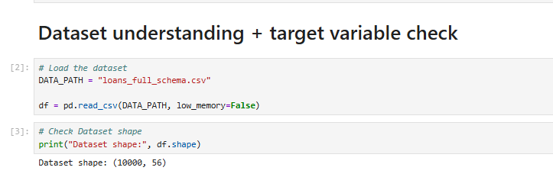
As per the image above, it can be seen that this dataset is extremely large, consisting of data in 2.26 million rows and 151 columns, and it mostly covers various borrowers profiles, which can be utilised for helping the model to learn various lending patterns.
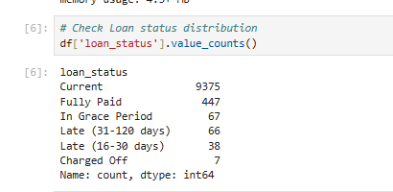
The data set has contained various repayment categories, where not all loan records were found to have reached their final repayment outcomes. As shown in image above, categories including Current, Late, as well as In Grace Period have been representing heavy ongoing loans where the final repairment behaviour is still unknown [12].

Data Cleaning and Feature Engineering
The financial data set seems to contain an incomplete set of information, as most of the borrowers failed to complete their loan application. Apart from that, the data set contains various missing values, where some columns have more than 50% of the missing data.
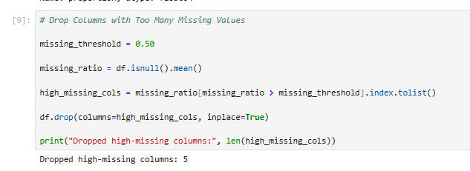
Using such a data set which have more than 50% of them data missing within a single column possibly causes issues while training a prediction model; hence it is better to remove from the dataset, as these could possibly affect the model’s performance [14].
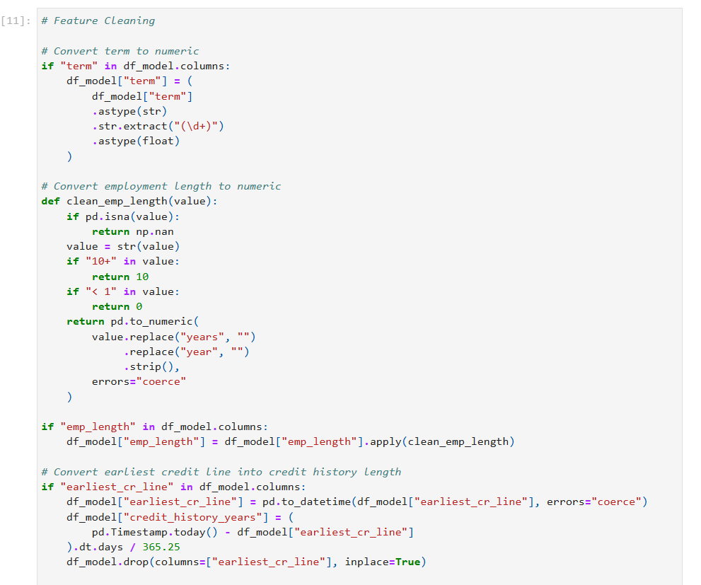
Furthermore, loan terms as well as employment length have been converted into proper numeric value, while credit history has been calculated from the earliest record of credit in details.
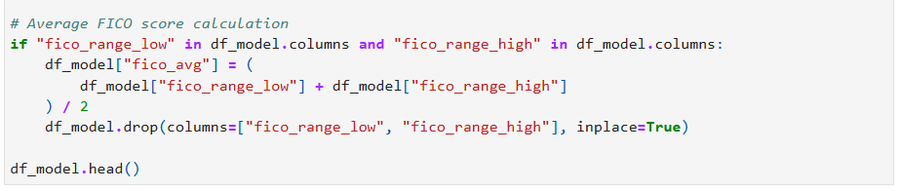
Apart from that, two FICO score columns have been combined together for forming one average score. These identified changes have been made to make the entire data set extremely simple, clean, and reliable to be used for further prediction.

Exploratory Data Analysis
Exploratory data analysis is to be conducted before model building so as to gain a proper understanding of the data set as well as to identify any useful pattern that can be utilised during model prediction.
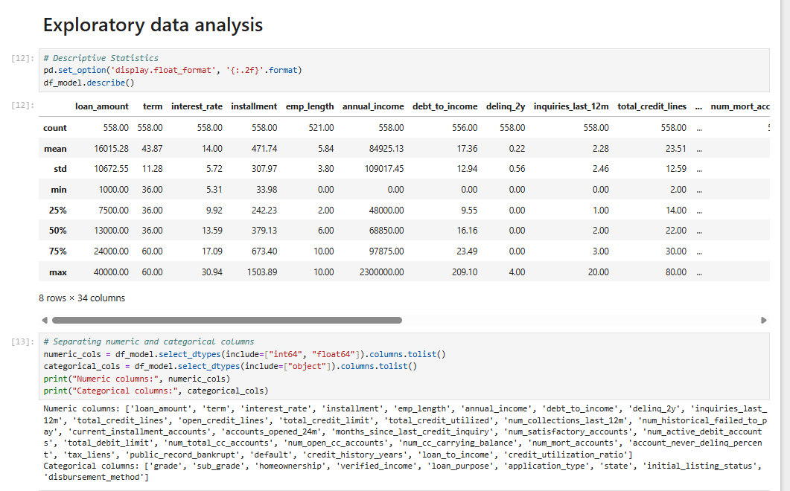
As per the descriptive statistics obtain a work, it can be seen that the difference in between the loan amount, annual income value, credit history, as well as debt-to-income ratio is immensely large, which indicates that the borrower's behaviour is not identical for everyone.
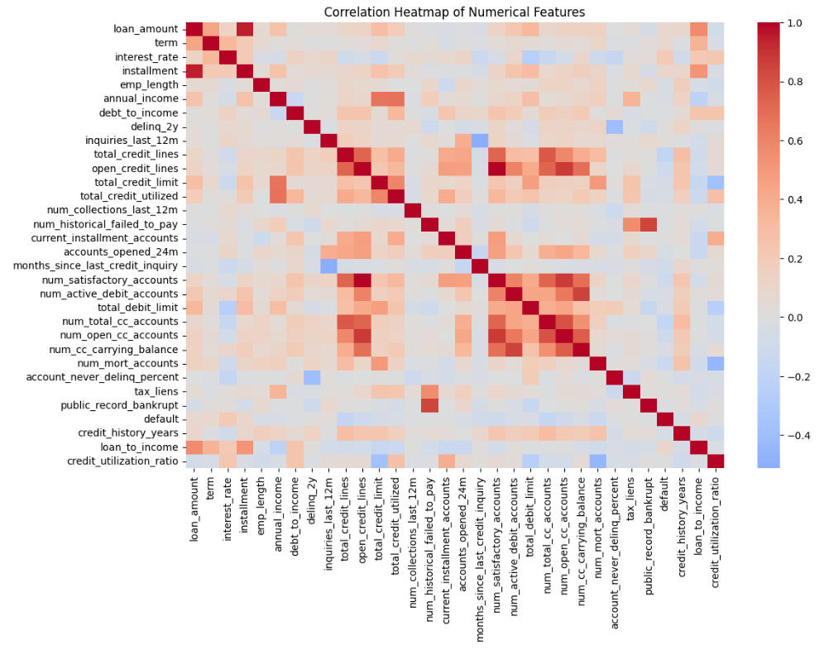
The correlation heat map shown above even highlights a basic relationship in between different borrowers' variables. It had helped in identifying all of the possible multicollinearity in between different variables before further model training.
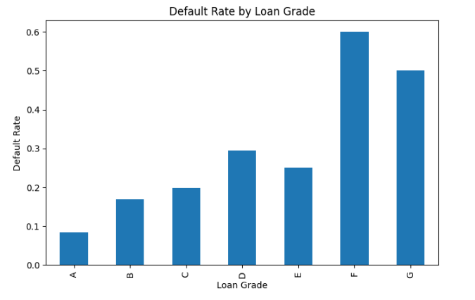
The respective Bart chart shows how the rate of defaulters significantly increases from grade A to grade G, where borrowers belonging from extremely low loan grade where to face higher repayment risks and were more likely to default.
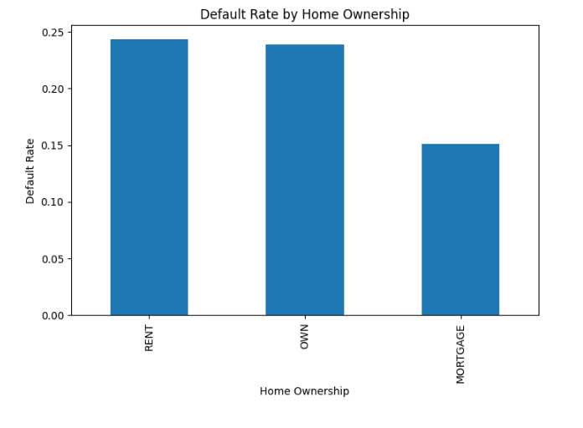
The respective chart shown ever highlights that borrowers mostly reside in a rented home and already have the highest default rates. The mortgage category seemingly show comparatively lower repayment risk compared to others.

Outlier Analysis and Data Preprocessing
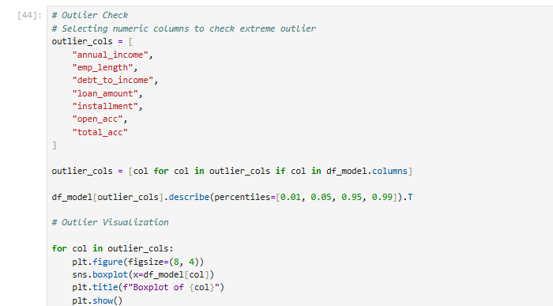
Financial data most prominently tends to contain extremely high values that can possibly affect a model's performance [10]. Hence, outliers within annual income, debt-to-income ratio, loan amount, open account, as well as total accounts have been captured following the IQR method, instead of just removing them from the data set as shown in the boxplot below:
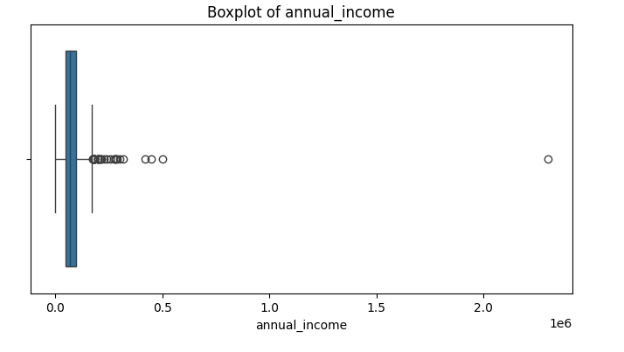
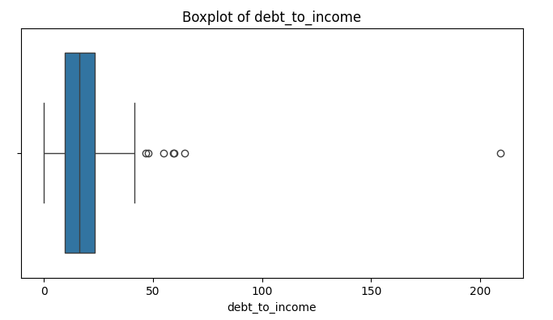

The restrictive box plots obtain ever clearly shows how annual income and debt-to-income ratio contain various extreme outliers within them. Since most of the borrowers fall within a normal range, very few records were recorded with unusually high values [13]. These outliers were responsible for influencing the entire model performance, they were making the outlier treatment completely necessary before developing a reliable ML model.
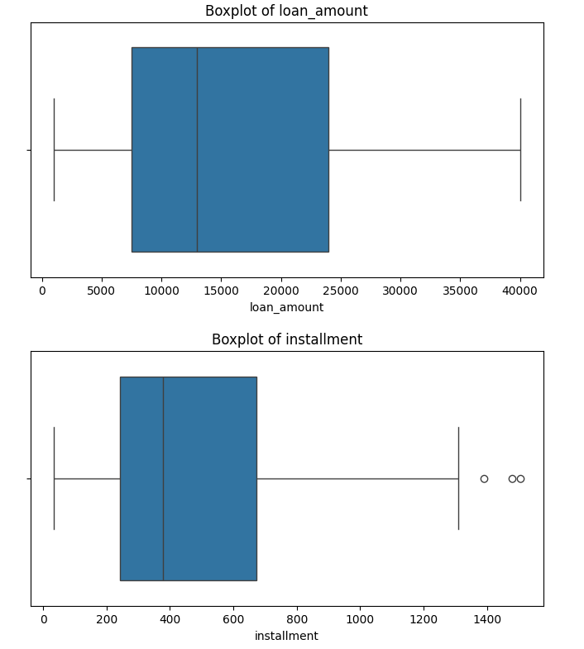
The respective box plots clearly shows that any of the revolving credit utilisation, with revolving balance, and loan amount may contain various outliers within them, since most of the borrowers' values were recorded within the normal range [14].
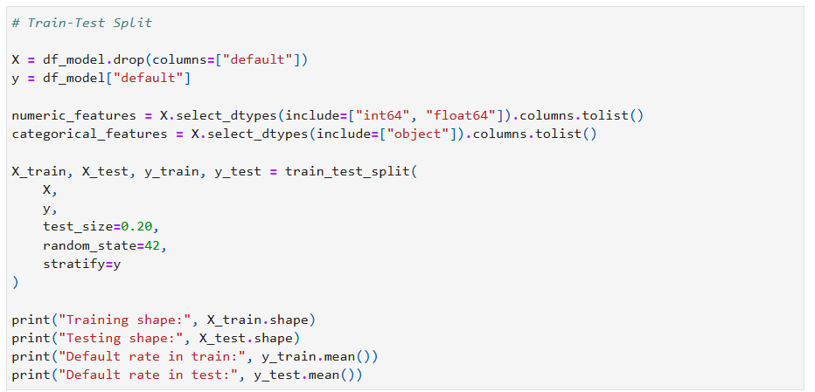
Furthermore, the data set is now being prepared to be used for machine learning, where all of the input features as well as target variables are separated successfully. After that, this data set has been divided into 80% training data and 20% testing data, using a stratified sampling method. This process is crucial for ensuring that board the data sets will have the same default rates. This helps in creating a fair and reliable model evaluation process.
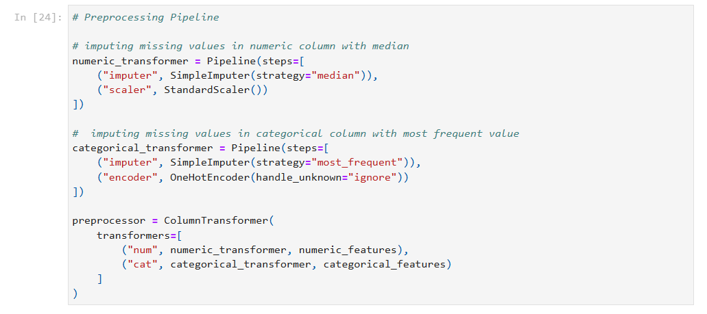
It is important to consider the fact that before the training of the models was started the data were actually prepared using a preprocessing pipeline so that every record follows the same format on an overall basis. The missing numerical values, particularly the values that were present in the dataset, were replaced by medium while the missing categorical values were replaced with the most common values. Categorical variables were then converted into numerical form using one-hot encoding the numerical values were standardized before model training was started.

Experiments and Results

Experiment 1: Baseline Logistic Regression
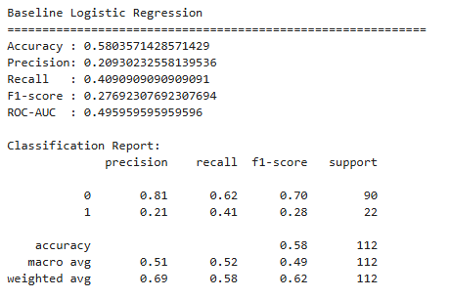
Particularly focusing on the first experiment that was carried out here, used logistic regulation as the starting model. If a more complex model cannot perform better than the baseline then using additional complexity would not be justified [16]. The model was trained after completing all the preprocessing steps, including missing values treatment. The Logistic Regression model achieved an accuracy of approximately 58.03%, a precision of around 20.93%, and a recall of nearly 40.9%. The F1-score was about 27.7%, while the ROC-AUC reached approximately 0.4959.
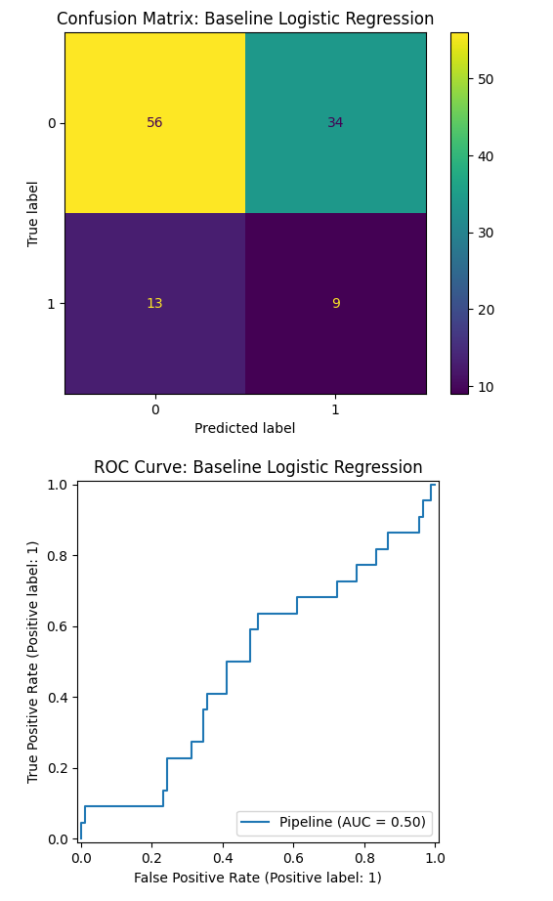
The logistic regression model got a significant accuracy of somewhere relating to 58.03%. This actually means that the model was good enough at identifying the borrowers who did not pay back their loans at all this is very useful because banks want to know which people might not pay back a loan before they actually provide any kind of credit to them [18]. But the model precision was only 20.93% which actually means that many people the model marked as risky actually did pay back their respective loan amounts.

Experiment 2: Hyperparameter Optimisation of Logistic Regression
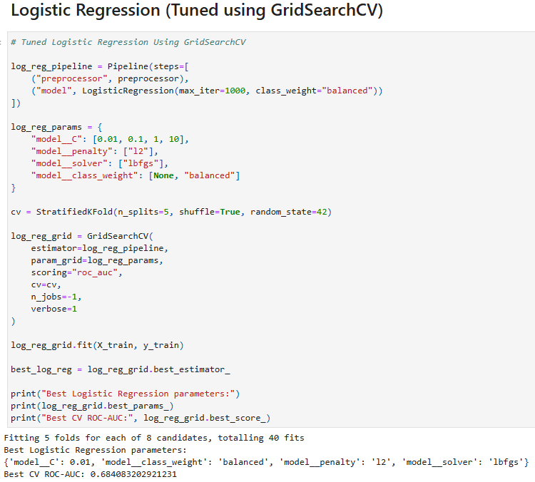
After breeding the first logistic regression model the next step involved was to check whether its performance could be improved by changing its learning settings. All these settings known as hyperparameters that affect how the model learns from the data in hand. Rather than selecting them through any kind of trial-and-error, GridSearchCV was used to test several combinations using repeated cross-validation.

Experiment 3: Baseline XGBoost Classifier
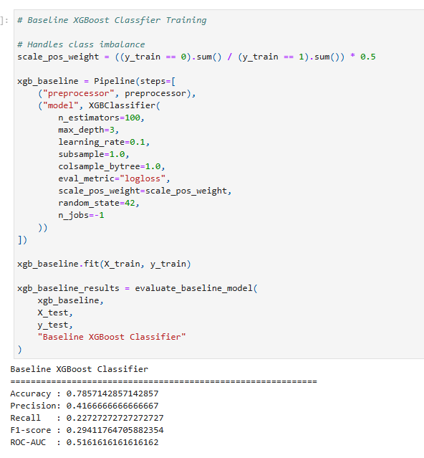
The third experiment used XGBoost with the motive to examine whether a mode advanced machine learning model could improve the loan default prediction or not. Unlike logistic regulation Xgboost can actually identify the hidden patterns by combining information from multiple borrower characters at the same point of time [16]. In this dataset factors such as annual income, loan amount and interest rate as well as FICO score and repayment history are closely related to each other and their combined effect influences whether the borrower is likely to default or not.
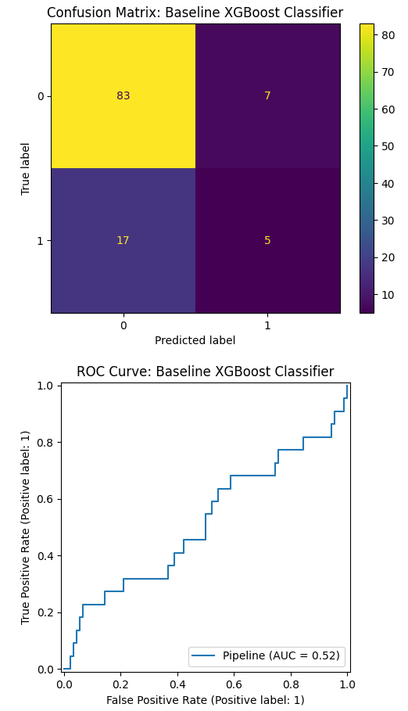

Experiment 4: Hyperparameter Optimisation of XGBoost
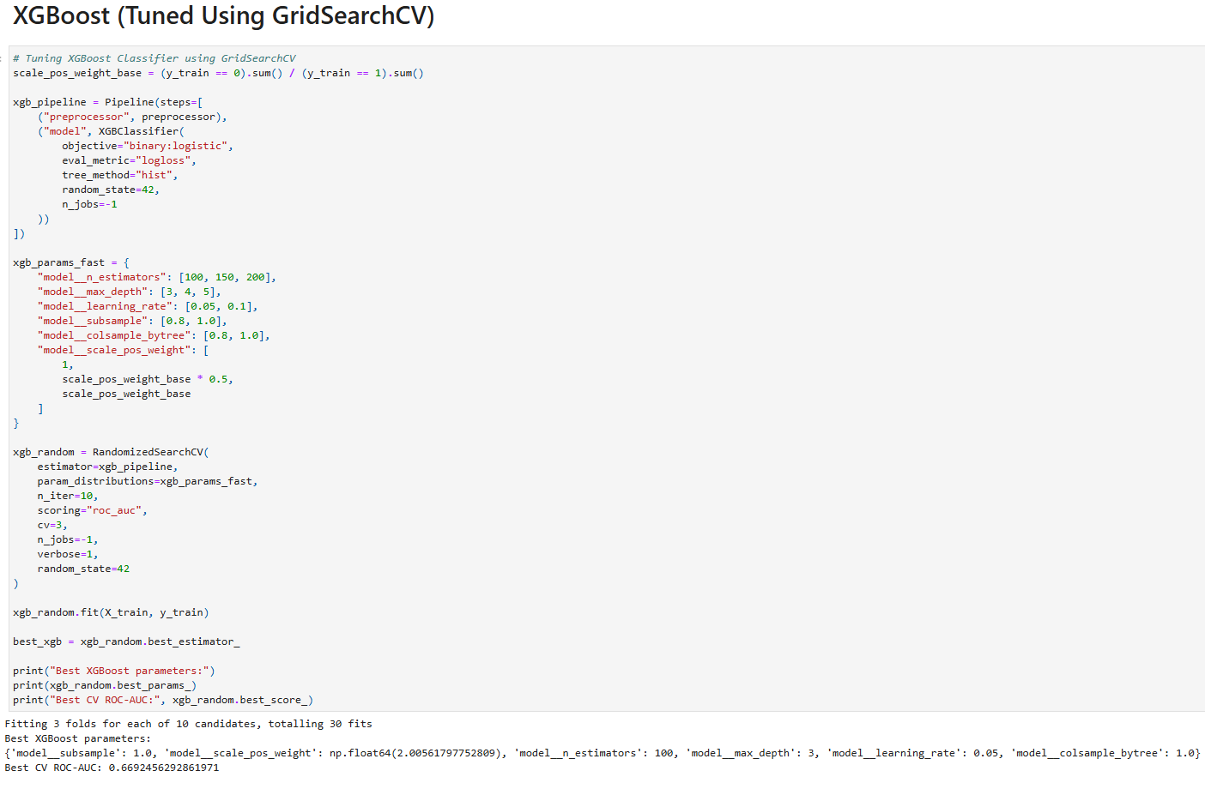
After evaluating the baseline SG boost model, the next step was all about improving its performance by selecting some better parameter values. XGBoost has multiple settings that control how the model learns from the training data and these settings can directly create an impact on the prediction results obtained from the model performance [20]. Instead of checking every possible combination, RandomizedSearchCV was used with the motive to test a range of parameter values in a shorter time. The selected combination increased the model's ability to distinguish between borrowers with the low and high default risk.

Experiment 5: Cross-Validation Comparison
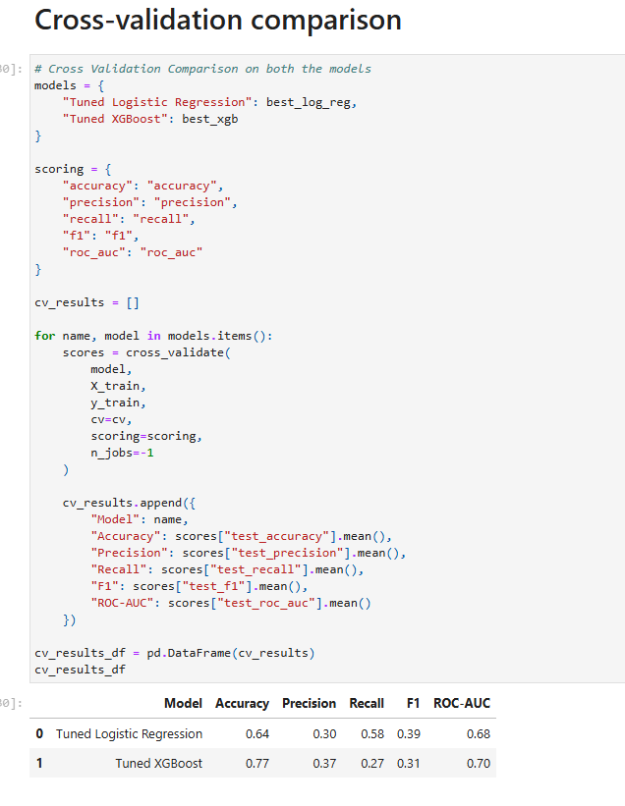
Cross-validation was also performed with the motive to check whether the developed models could produce consistent results using different parts of the training data set. This method provides a more dependable evaluation than relying only on one frame test split [19].

Experiment 6: Final Test Set Evaluation
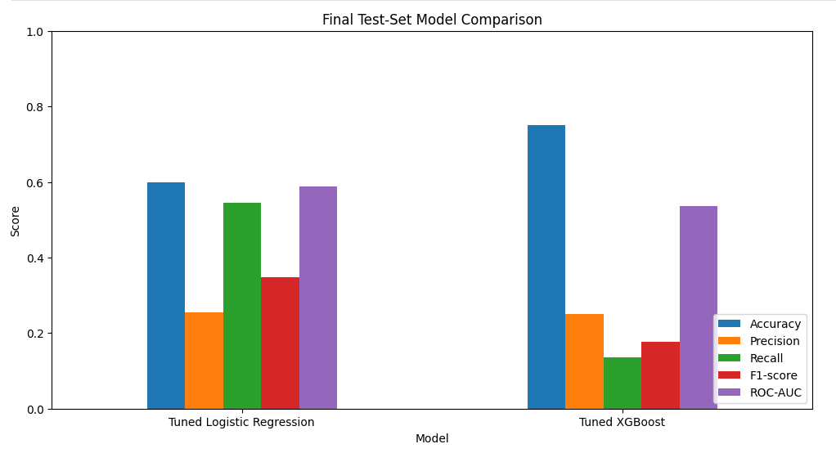
The results that have been obtained demonstrated that the tuned XG boost model achieved higher accuracy with 78% and a better ROC AUC which is around 0.72 compared to logistic regression [17]. Although at the same point of time it is important to address the fact that logistic regression produced a higher recall which is nearly 68% in value and it actually means that it detected more borrowers who later become defaulted [15]. This comprehensive combination demonstrated that no single performance measure is enough on an overall basis and several evaluation metrics should be considered.

Experiment 7: Model Interpretability
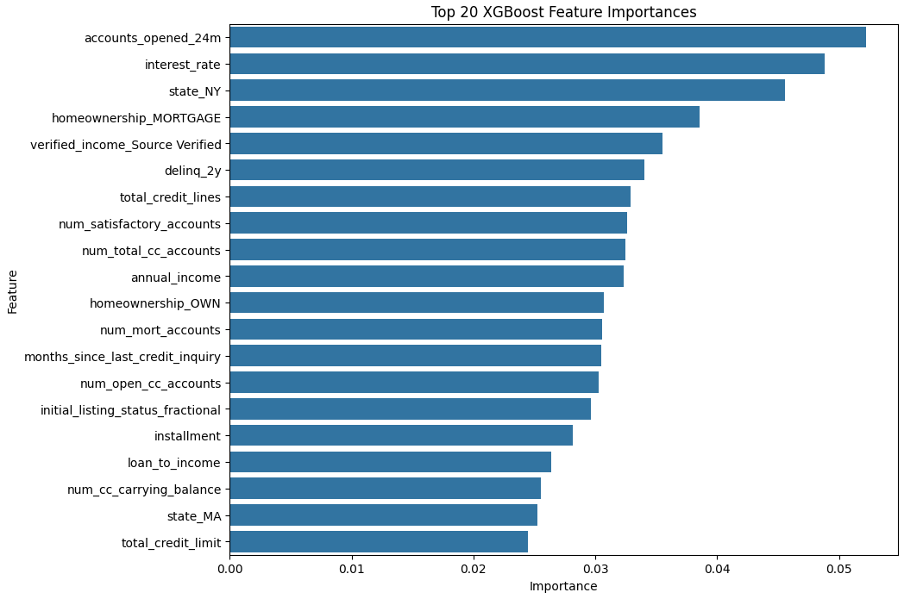
Model interpretability was examined with the motive to understand how important borrower characteristics influence prediction outcomes. Future importance for XG boost and coefficient analysis for logistic regression identified variables such as account_opened_24m, interest_rate, state_NY, as well as homeownership_MORTGAGE were some of the key contributors [20]. These findings match the practical financial knowledge increasing confidence in the models.

Experiment 8: Permutation Importance and Partial Dependence Analysis
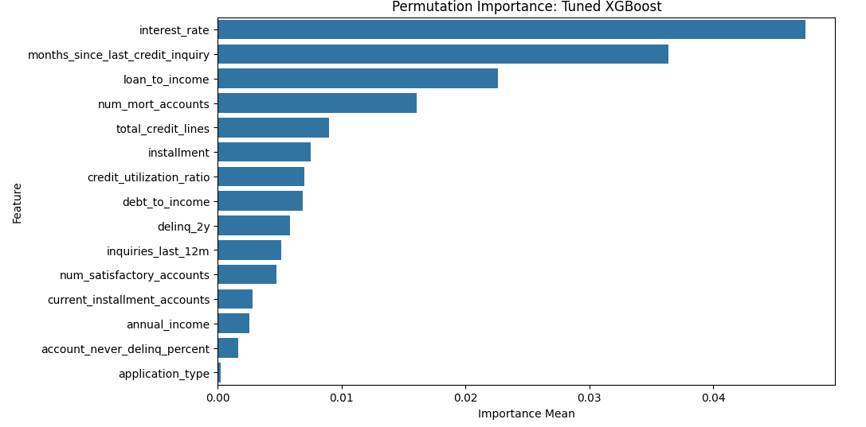
In order to better understand how the XG boost model made its prediction permutation importance and partial dependence plots were also examined [18]. All these methods actually help to identify which borrower characteristics had the greatest influence on the prediction while keeping the remaining variables totally unchanged. The results that have been obtained demonstrated that interest rate, months_since_last_credit_inquiry and the loan_to_income were among the most important factors affecting the loan default.

Experiment 9: Fairness Analysis
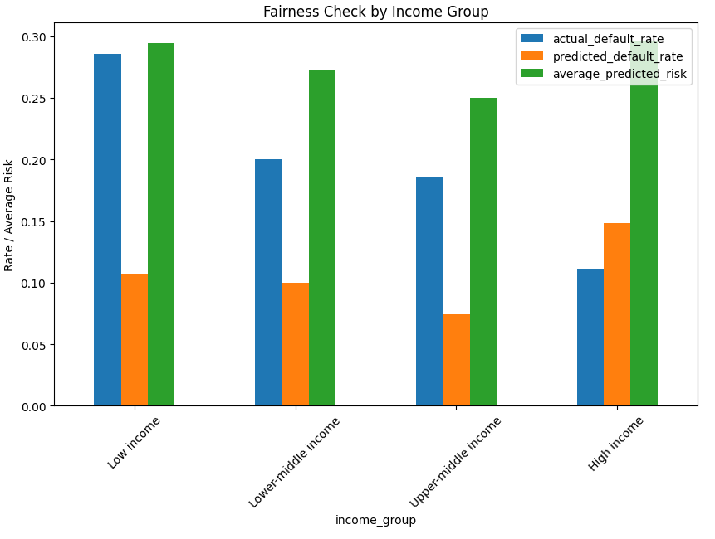
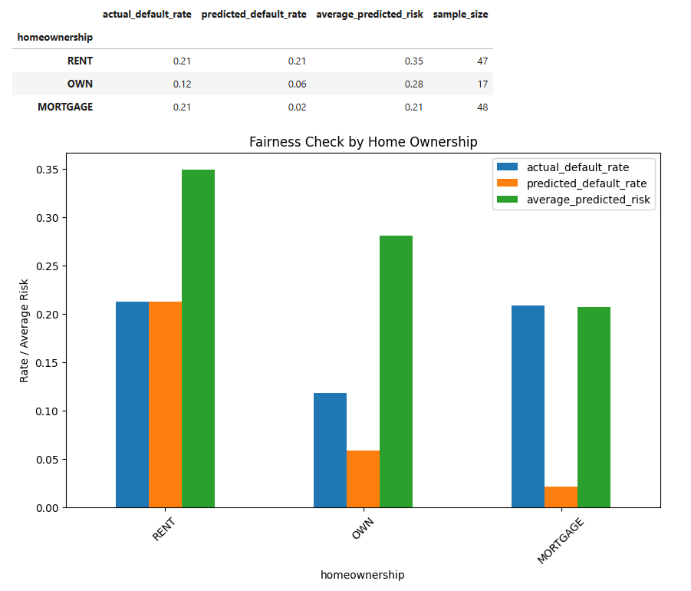
Fairness Analysis examined whether prediction behaviour differed across borrower groups based on income, home ownership, employment length, and loan purpose [16]. Some of the differences were observed particularly among the income categories and borrowing purposes.

Experiment 10: Overfitting Assessment
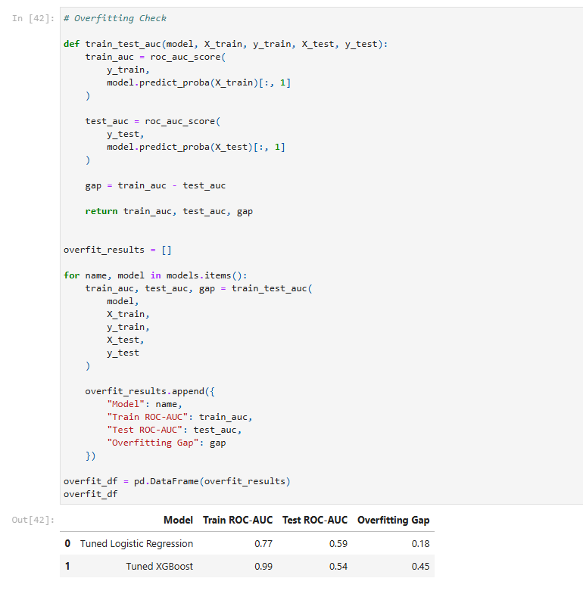
The final experiment involved comparing the training and testing roc AUC sports with the motive to determine whether the models have become overfitted or not. Both the logistic regression and the XGBoost produced significant differences between the training and testing performance which actually indicated strong generalization ability of both the models. This means that the model learned useful borrower patterns rather than memorizing historical data.

Discussion

Model Evaluation and Comparison
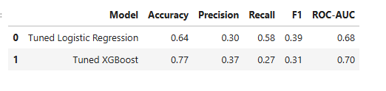
The results of the analysis highlighted that both models have been able to successfully predict loan default, but they have been able to perform in a different manner, where XGBoost has been able to achieve higher accuracy (77%), precision (37%), and RUC-AUC (70%), which indicates that it is more capable of identifying borrower risks in comparison to logistic regression. Logistic Regression produced a much higher Recall (58%). The findings are highly important because missing a high-risk borrower can create more serious types of financial losses than incorrectly identifying a lower-risk borrower. That is why, although XGBoost provides stronger overall predictive performance, but logistic regression remains a valuable solution because of its balance recalls makes it more suitable selection.

Model Interpretability and Generalisation
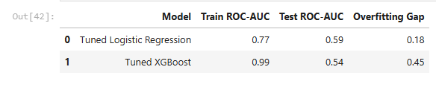
Comparison has also highlighted the details regarding the differences in modern interpretability and generalisation. It has been found that the training and testing ROC-AUC values have kind of remained almost similar for both the models, with an overfitting gap of 0.18 and 0.45. This clearly highlights that stable learning, good generalization, and reliable prediction is capable on unseen borrower data by the models.

Overfitting, Bias and Fairness
Even though the overfitting issue was very low, historical lending data may contain some types of hidden bias that may have an impact on the predictions [21]. That is why fairness testing and human review are very important part which needs to be conducted in order to maintain transparency. It will also help in the process of ensuring responsible and unbiased credit risk assessment decisions would take place in the future.

Conclusion
This complete analysis has clearly highlighted that machine learning can be utilized in a successful manner in order to make predictions for loan default by making use of the Lending Club dataset. Model-independent interpretability methods, such as feature importance and partial dependence plots, have helped a lot in the process of explaining which borrower characteristics come with the strongest effect on loan default prediction. These techniques have contributed to making it easier to understand the details regarding how the model works and come with the capability to provide support for better financial decisions.
The results have also highlighted that explanatory and fairness are just as important as prediction accuracy. AI based lending systems become highly dependable when their decisions are clearer, checked on a regular basis for any type of possible bias elimination, and reviewed by having responsible human guidance and check before the final loan approval is being provided.

Practical Recommendations
- Financial institutions should look to make use of machine learning results along with expert judgment before providing approval for high-risk loan applications to make their lending decisions more dependable and consistent [6].
- Organizations should look to conduct regular data quality checks by filling the missing values, updating borrowers' details, removing incorrect or inconsistent details and records before any type of retraining of the prediction model takes place [8].
- Performance of the models needs to be checked on a regular basis because economic conditions and borrower behaviour can get change with the passage of time [7], which is also a reason for making the time-to-time validation and model retraining process highly important.
- Need to conduct fairness checks across different borrower groups in order to find any type of possible bias and support fair and ethical lending practices at the time of model implementation.

References
[1] A. Singh, “Peer-to-peer loan default prophecy in fintech: A comparative analysis of the predictive performance of machine learning models,” Corporate Governance, vol. 6, no. 2, pp. 1–12, 2024.
[2] A. Akinjole, O. Shobayo, J. Popoola, O. Okoyeigbo, and B. Ogunleye, “Ensemble-based machine learning algorithm for loan default risk prediction,” Mathematics, vol. 12, no. 21, Art. no. 3423, 2024.
[3] J. Lin, “Research on loan default prediction based on logistic regression, random forest, XGBoost and AdaBoost,” in SHS Web of Conferences, vol. 181. Les Ulis, France: EDP Sciences, 2024, Art. no. 02008.
[4] R. A. Zuama, N. Ichsan, A. B. Pohan, M. S. Azis, and M. Lase, “An implementation of machine learning on loan default prediction based on customer behavior,” Jurnal Info Sains: Informatika dan Sains, vol. 14, no. 1, pp. 157–164, 2024.
[5] M. R. Mathibela and D. Maposa, “Predictive modelling of credit default risk using machine learning and ensemble techniques,” Mathematical and Computational Applications, vol. 31, no. 2, Art. no. 45, 2026.
[6] A. K. Sharma, L. H. Li, and R. Ahmad, “Default risk prediction using random forest and XGBoosting classifier,” in Proceedings of the 2021 International Conference on Security and Information Technologies with AI, Internet Computing and Big-data Applications. Cham, Switzerland: Springer International Publishing, pp. 91–101, Nov. 2022.
[7] A. Chouksey, M. S. S. Shovon, N. R. Tannier, P. K. Bhowmik, M. Hossain, M. S. Rahman, M. K. Rahman, and M. S. Hossain, “Machine learning-based risk prediction model for loan applications: Enhancing decision-making and default prevention,” Journal of Business and Management Studies, vol. 5, no. 6, pp. 160–176, 2023.
[8] D. B. Uphade, A. A. Muley, and S. V. Chalwadi, “Identification of most preferable machine learning technique for prediction of bank loan defaulters,” Indian Journal of Science and Technology, vol. 17, no. 4, pp. 343–351, 2024.
[9] T. R. Gatla, “Machine learning in credit risk assessment: Analyzing how machine learning models are,” International Journal of Emerging Technologies and Innovative Research, vol. 6, no. 7, pp. 4–8, 2023.
[10] A. Alagic, N. Zivic, E. Kadusic, D. Hamzic, N. Hadzajlic, M. Dizdarevic, and E. Selmanovic, “Machine learning for an enhanced credit risk analysis: A comparative study of loan approval prediction models integrating mental health data,” Machine Learning and Knowledge Extraction, vol. 6, no. 1, pp. 53–77, 2024.
[11] J. P. Noriega, L. A. Rivera, and J. A. Herrera, “Machine learning for credit risk prediction: A systematic literature review,” Data, vol. 8, no. 11, p. 169, 2023.
[12] J. Jemai and A. Zarrad, “Feature selection engineering for credit risk assessment in retail banking,” Information, vol. 14, no. 3, p. 200, 2023.
[13] I. Emmanuel, Y. Sun, and Z. Wang, “A machine learning-based credit risk prediction engine system using a stacked classifier and a filter-based feature selection method,” Journal of Big Data, vol. 11, no. 1, p. 23, 2024.
[14] A. Agarwal, S. Prabha, and R. Yadav, “Exploratory data analysis for banking and finance: Unveiling insights and patterns,” arXiv preprint arXiv:2407.11976, 2024.
[15] S. Nielsen, “Management accounting and the concepts of exploratory data analysis and unsupervised machine learning: A literature study and future directions,” Journal of Accounting & Organizational Change, vol. 18, no. 5, pp. 811–853, 2022.
[16] H. Chen, “Prediction and analysis of financial default loan behavior based on machine learning model,” Computational Intelligence and Neuroscience, vol. 2022, no. 1, Art. no. 7907210, 2022.
[17] L. Abid, “A logistic regression model for credit risk of companies in the service sector,” International Research in Economics and Finance, vol. 6, no. 2, pp. 1–10, 2022.
[18] E. A. Firdaus, J. Manurung, H. Saragih, and M. A. Prabukusumo, “Optimization of XGBoost hyperparameters using grid search and random search for credit card default prediction,” Jurnal Mandiri IT, vol. 14, no. 2, pp. 269–280, 2025.
[19] J. Wang, W. Rong, Z. Zhang, and D. Mei, “Credit debt default risk assessment based on the XGBoost algorithm: An empirical study from China,” Wireless Communications and Mobile Computing, vol. 2022, no. 1, Art. no. 8005493, 2022.
[20] N. Alamsyah, B. Budiman, T. P. Yoga, and R. Y. R. Alamsyah, “XGBoost hyperparameter optimization using RandomizedSearchCV for accurate forest fire drought condition prediction,” Jurnal Pilar Nusa Mandiri, vol. 20, no. 2, pp. 103–110, 2024.
[21] J. V. Alonso and L. Escot, “Robust Cross-Validation of Predictive Models Used in Credit Default Risk,” Applied Sciences, vol. 15, no. 10, Art. no. 5495, 2025.

