COURSEWORK PART 2

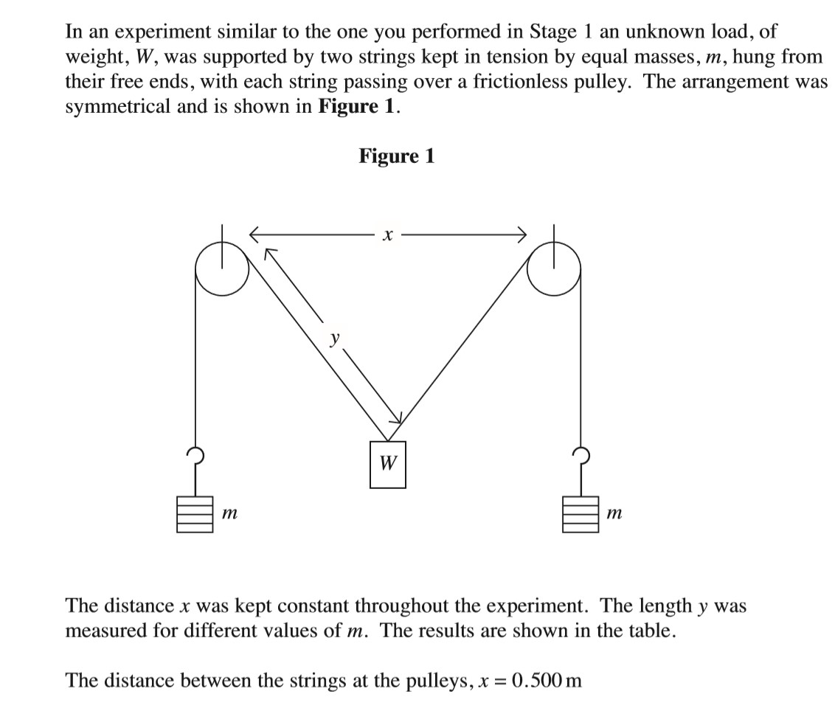
2.


This is just a rough table made in excel with the correct answers.
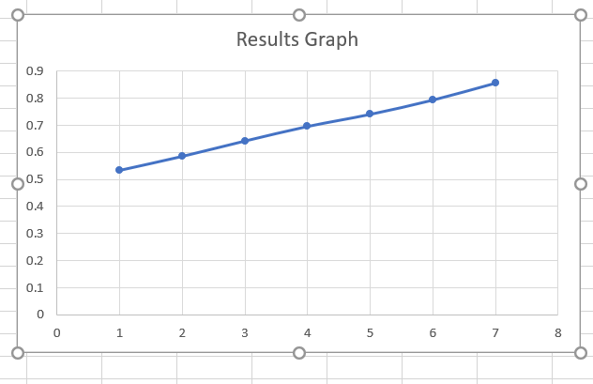
2.2.a.

The graph above is made in excel and I used the results from the table found above and doesn’t start at 0 since there isn’t a result in the table that is just 0 on its own. It is also not done very well as it is not showing the graph at the exact decimal place since there are whole numbers along the y axis.

2b.
The gradient of the graph above is straight but if I had done it by hand and not in excel I may have ended up with a different graph altogether. The graphs gradient is also not entirely accurate as it is not done in the best possible way.

2.1d.
The term systematic error can also be determined as “human error” but it is no longer defined as that and instead it is called systematic error due to things that can happen such as something being wrong with the equipment when performing an experiment and this can all fall back on the person doing the experiment but usually comes down to there being a fault with the equipment.

