Name: Chelsie Gallagher
Student Number: 2213739
Course: Design Craft
Lecturer: Dr Julia Lockheart

Manifesto Writing - 585
Observational Writing - 683
Practise-based Writing – 503

Total – 1,771

Manifesto Writing

Rules…

- Nothing is a mistake; you cannot win or lose but you can only learn from.

- Consider everything as an experiment.

- Be passionate about ALL your work, even if it does not seem like much right now. You never know when it might come in handy in the future.

- Experiment with a load of varied materials and techniques. Do not always go your usual route to things.

- Do not worry about feeling foolish when it comes to art. Art is not meant to be understood.

- Try and use more recycled or preloved items. It is amazing how to can transform someone’s waste into your own treasure.

- You can listen to the opinions of others but do not rely on it when it comes to your work, always trust your gut, and do the things that you want to do.

- Research continuously, gain new knowledge and enjoy all of life’s experiences.

- Statement 6.

Throughout our past people have been recycling and reusing past loved items for centuries. It is nothing new to us but nowadays it has become more popular to use recycled goods and shop in charity shops. “The charity shop has become one of Gen Z’s favourite ways to shop” (Wright, 2023). Therefore suggesting that thrifting is the trendier way to shop. Growing up in the late 90’s to early 00’s having the latest brands was the cool things to do but now with fast fashion, trends are constantly changing and all the latest brands from the 00’s have now ended up in the charity shops and labelled as vintage.

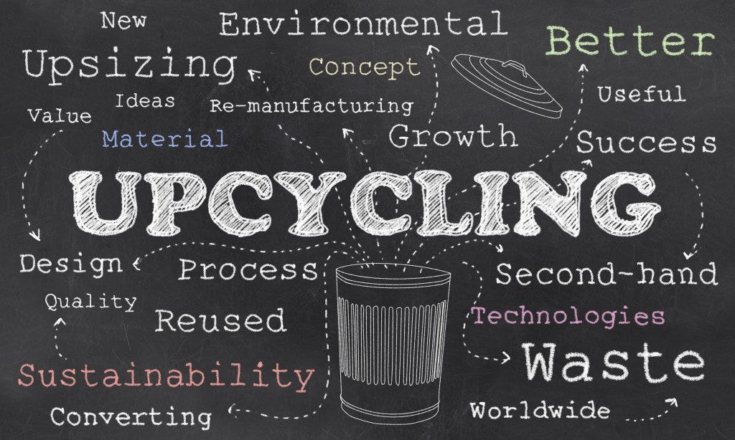
Figure 1 An upcycling mind map, Medium (19.12.2023)

Waste is a massive issue. “British household creates over 26m tonnes of waste each year.” (Recyclingbins.co.uk 2010) So by upcycling and downcycling it would really benefit everyone. Firstly, upcycling is “the act of taking something no longer use and giving it a second life” (Upcycle That, 2017). And downcycling is “turning discarded garments or materials into something lesser value. For instance, turning clothing into rags” (Benson, 2023). But upcycling items can not only help save materials from landfills and reduce waste but can also help save money and create a profit. A good example of this is the TV show ‘Money for Nothing’ where Sarah Moore finds people throwing out considerable worthless goods and transforms them to beyond recognition with help from different designers and sells them off for a much higher value and any profit made get returned to the original owner. So, with all this evidence upcycling helps solves the waste issue, helps you create a profit for yourself and that its now became popular to do so.


Figure 2 TV show 'Money for Nothing' BBC (19.12.2023)

- Statement 5

It worries me that there are more people concerned about the fear of looking stupid, especially in the art world. “The problem is most people are afraid of looking stupid. It is painful, embarrassing and people laugh. It is not nice but if you train yourself to become someone who is ok looking stupid. And to face your fears. Because what is on the other side of fear? Nothing” (Moore, 2021). By holding back from your full potential just because of the opinions of others. Art is not meant to be understood as it has no boundaries and can be anything.

In a book called Exploration in Art, Theology, and Imagination, there is a section on common sense commitments about art, particularly on understanding it. “Everybody wants to understand art. Why not try to understand the songs of a bird? Why does one love the night, flowers, everything around one, without trying to understand them?” (Picasso cited in Austin, 2016 p.16). Why do we need to understand art instead of just appreciate it?

- Statement 2.

Artists must experiment with materials and techniques. It is through experimenting that we learn how to get the most from our materials.

- “Explore and refine new/different/ extended concepts in my art practice.
- Explore colours, compositions and deepen understand of art theory.
- Develop technique and understanding of existing materials and tools
- Learn to use and incorporate new materials and tools” (Lee, 2023).
Malit B Lee talks about the 4 broad reasons for why artists should play around and get experimental. Being experimental allows artists to push boundaries, discover new techniques, and create unique and innovative work. It helps them grow creatively and keeps their art fresh and exciting.

References

Austin. M (2016) Exploration in Art, Theology and Imagination, London: Taylor & Francis

Benson. S (2023) Sustainable Wardrobes: Practical Advice and Projects for Eco-friendly Fashion, London: White Lion Publishing

Lee. M (2023) 4 Reasons for Creatives to be creative to Play and Experiment [online] available at www.maltiblee.com accessed on [19.12.2023]

Moore. A (2021) If You’re Willing to Look Stupid for Long Enough, You’ll Eventually Become a Millionaire [online] available at www.anthony-moore.medium.com

Money for Nothing (2015-2018) [BBC TV Show] available at www.bbc.co.uk/programmes/bo77nzdc [18.11.2023]

RecyclingBins.co.uk (2010) Recycling Facts [online] available at www.recyclingbins.co.uk accessed on [18.11.2023]

UpcycleThat (2017) Explore the Cape town Collection [online] available at www.upcyclethat.com accessed on [18.11.2023]

Wright. G (2023) How Charity Shops Became Cool [online] available at www.retailgazette.co.uk accessed on [19.12.2023]

Observational Writing

“Semiotics is the study of signs and symbols” (Yatsko & Suslow 2016, p. 25). It explores how we interpret and understand words, images, gestures, and sounds in daily life. By examining how we interpret and assign significance semiotics helps unravel the hidden layers in communication. Roland Barthes a philosopher and semiotician explored the ways in which signs and symbols shaped our understanding of culture, literature, and society. Barthes that “Language is a skin. I rub my language against the other. It is as if I had words instead of fingers… My language trembles with desire” (Barthes cited in Granger, 2004, p. 108). This captures the idea of language as a medium in that we interact with. It highlights the power and emotion of language within signs and symbols.

Advertisers use signs and symbols to display hidden messages by carefully choosing colours, images, words, and placements to invoke specific emotions to the advert’s viewers. Therefore, by understanding semiotics advertisers can strategically design their ads to effectively communicate with their target audience and create an impact.


Figure 3 J'adore Dior Perfume Ad, Charlotte Joy, 2014
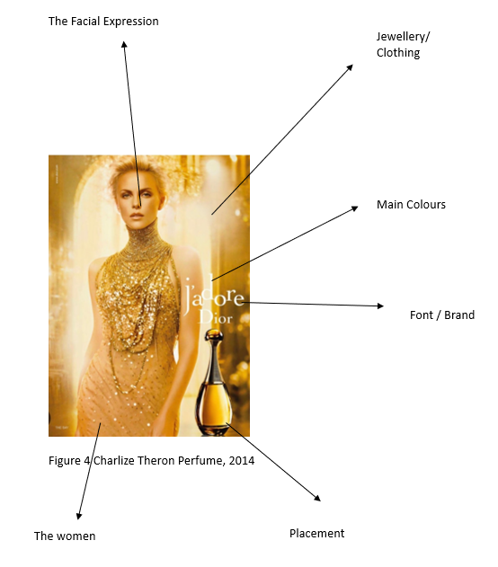
Figure 4 Charlize Theron Perfume, 2014

Main Colours.

“In semiotics, colour theory can impact us in three different ways cultural, emotions and socio economical” (Meulen, 2019). Advertisers often use specific colour palettes show different emotions or associations in their audience. Certain colours are commonly used to make a reaction. Blue is often used to convey calmness whilst green is commonly associated with nature.

This J’adore advert is filled with warm colours, hints of oranges but associating with gold. The warm colour in this advert gives the impression of luxury and wealth. Gold is an obvious example that is often seen as superior. HuddleCreative (2022) mentions that “Orange is an attention attraction colour” they also say, “its associations tend to be feelings of adventure, confidence, creativity, enthusiasm and success.”

J’adore advertisers created this advert for not only the symbolising the colour of the perfume itself but to give the viewer the impression that using this product will make them feel superior. This perfume is a luxury item.

The Model

The main feature of the advert is not the perfume bottle but the model Charlize Theron who fills the whole main frame whilst the actual product is in the corner. Theron is a tall, attractive blonde woman; stereotypically perfect. Advertisements will often use attractive people because they will grab attention of the viewers. Using celebrities is a marketing strategy, based on the idea that people are drawn to beauty and can be influenced by it. Kalturablog (2023) says “celebrity endorsement helps increase sales in the short term and brand awareness in the long term”. This is another reason on why companies use celebrities.

Theron faces the camera straight on which can come across as powerful or intense and has her mouth slightly opened gives the impression of seduction. Her makeup is nude, and her hair is pinned back, keeping her quite natural, whilst her outfit takes the full attention.
She wears a long nude floor length dress with golden sequin details that represents this repeating luxury theme. She also wears a golden choker styled necklace that mirrors the shape of the bottle’s neck.

The Brand/ Font

Dior was created in France and known for selling high quality products like fashion, accessories, fragrance, and beauty supplies. J’adore translates to ‘I adore’ which symbolizes romance. France has been associated with romance for centuries, partly because of its cities like Paris, which is known as the “City of Love” (Zimmer, 2022). Additionally, France has a long history of artistic expression, literature and film that often explores themes of love and passion. All these factors have contributed to the romantic image of France.

The font that J’adore Dior use is Serif. According to Grace Fussell (2023) “Serifs is trustworthy” [SIC] she also says, “psychological associations of Serif fonts is stability, tradition, intellect and formality.” A good typography enhances readability, it is important for creating an impactful and engaging visual. Dior has created a timeless brand font for themselves that will forever look pleasing to the eye.

References

Fussell, G. (2023) The Psychology of Fonts (Fonts that Evoke Emotions) [online] www.elements.envato.com [22.11.23]

Granger, C. (2004) Silence in Second Language, Multilingual Matters

Huddle creative (2022) Your Non-Scientific Guiled to Colour Semiotics [online] www.huddlecreative.com [22.11.23]

Kalturablog (2023) Celebrity Endorsement: How to use a Celebrity for your Campaigns and Event [online] www.corp.kaltura.com [22.11.23]

Meulen. M (2019) The Semiotics of Colour, [online] www.foolproof.co.uk [22.11.23]

Sebeok. T (2001). Signs: An Introduction to Semiotics

White. A (2015) Advertising Design and Typography

Yatsko. A and Suslow. W. (2016) Insight into Theoretical and Applied Informatics, Sciendo

Zimmer, L. (2022) Art Hiding in Paris: An Illustrated Guild to the Secret Masterpieces of the City of Light, Philadelphia: Running Press.

Object and Word

Word: Impact
Object: Stained glass windows

The definition of impact:

- The action of one object coming forcibly into contact with another. (collision, crash, smash)
- A marked effect or influence. (effect, impression)

“No one knows for certain how much impact they have on the lives of other people” (Asher, 2006).

Stained glass windows are made up with coloured and painted glass pieces that are held together by lead strips. Especially popular in Europe in the 1150 and 1550 and came to Britain in the 7th century, when they were a prominent feature of cathedrals and other churches (Rosewell, 2012). They could also be seen in city halls and homes but that was for the elite. They usually show a religious scene, the working life, or an intricate pattern.

Traditional stained-glass windows served multiple purposes. They were not only used for beauty but also had a practical and symbolic significance. They were used to tell stories and teach people who were illiterate, as the only people who could read were priests and royals (Gray, 2006). Therefore, every window would have to be made clear for them to understand. Additionally stained-glass windows also serve as a filter and control natural light entering the space (Brocket, 2018), creating an enchanting and ethereal atmosphere inside.

Winchester Cathedral
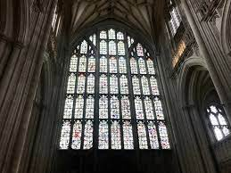
Figure 5 Winchester Cathedral Window, Lestz. M, 2020

The windows in Winchester cathedral which were destroyed by the Reformation illustrates how impactful stained-glass windows can be. The Reformation was a movement that aimed to reform the Roman Catholic Church to be changed to Protestantism. It was due to many factors, including religious disagreements, corruption within the church and a desire for a religious refoment and because of this many stained-glass windows and other Catholic iconography were destroyed or damaged (Ryrie, 2020). After being destroyed a lot of people kept broken pieces to reform the windows back together again. As they were not able to recreate the original painting, but they were able to make a more abstract piece. “Jumbles of coloured glass put together in a haphazard pattern. You might see partial faces or bits of scenes here and there, but mostly it is just random mosaic of colour”​ (Lestz, 2020)​. It does not represent the stories of the bible anymore, but it now tells a story about the war and the coming togetherness of the people who picked up and put it back together.

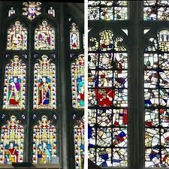
Figure 6 Before and after of Winchester Cathedral window, Lestz.M, 2020

Unfortunately, the art of stained-glass windows is dying out. Did it start after people were now able to read the bible? It could be argued that due the stained glass being used as pictorial way to tell bible stories, the need for stained glass might have been reduced once the bible was translated into other languages and people could read it for themselves. The need for stained glass as a way of telling a story is no longer necessary, so now it has changed its purpose to become more of a decorative item.

References

Asher, J. (2006) Thirteen Reasons Why, London: Penguin

Brocket, J. (2018) How to Look at Stained Glass: A Guide to the Church Windows of England, London: Bloomsbury Publishing

Gray, G.M. (2006) God's Story Through God's Light: Designing, Restoring, Protecting and Insulating Your Church-Stained Glass Heritage, Lincoln: iUniverse

Lestz, M. (2020) A Window, A War, and a Metaphor in Winchester Cathedral [online] available at: https://curiousrambler.com/a-window-a-war-and-a-metaphor-in-winchester-cathedral/ [Accessed 15.12.2023]

Rosewell, R. (2012) Stained Glass, London: Bloomsbury Publishing

Ryrie, A. (2020) The English Reformation: A Very Brief History, London: Society for Promoting Christian Knowledge

Finale references

Asher, J. (2006) Thirteen Reasons Why, London: Penguin

Austin. M quotes Picasso (2016) Exploration in Art, Theology and Imagination, P.16, England: Taylor & Francis

Benson. S (2023) Sustainable Wardrobes: Practical Advice and Projects for Eco-friendly Fashion, London: White Lion Publishing

Brocket, J. (2018) How to Look at Stained Glass: A Guide to the Church Windows of England, London: Bloomsbury Publishing

Fussell, G. (2023) The Psychology of Fonts (Fonts that Evoke Emotions) [online] www.elements.envato.com [22.11.23]

Granger, C. (2004) Silence in Second Language, Multilingual Matters

Gray, G.M. (2006) God's Story Through God's Light: Designing, Restoring, Protecting and Insulating Your Church-Stained Glass Heritage, Lincoln: iUniverse

Huddle creative (2022) Your Non-Scientific Guiled to Colour Semiotics [online] www.huddlecreative.com [22.11.23]
Kalturablog (2023) Celebrity Endorsement: How to use a Celebrity for your Campaigns and Event [online] www.corp.kaltura.com [22.11.23]

Lee. M (2023) 4 Reasons for Creatives to make time to Play and Experiment [online] available at www.maltiblee.com accessed on [19.12.2023]

Lestz, M. (2020) A Window, A War, and a Metaphor in Winchester Cathedral [online] available at: https://curiousrambler.com/a-window-a-war-and-a-metaphor-in-winchester-cathedral/ [Accessed 15.12.2023]

Meulen, M (2019) The Semiotics of Colour, [online] www.foolproof.co.uk [22.11.23]
Money for Nothing (2015-2018) [BBC TV Show] available at www.bbc.co.uk/programmes/bo77nzdc [18.11.2023]

Moore. A (2021) If You’re Willing to Look Stupid for Long Enough, You’ll Eventually Become a Millionaire [online] available at www.anthony-moore.medium.com

RecyclingBins.co.uk (2010) Recycling Facts [online] available at www.recyclingbins.co.uk accessed on [18.11.2023]

Rosewell, R. (2012) Stained Glass, London: Bloomsbury Publishing

Ryrie, A. (2020) The English Reformation: A Very Brief History, London: Society for Promoting Christian Knowledge

Sebeok, T. (2001). Signs: An Introduction to Semiotics

UpcycleThat (2017) Explore the Cape town Collection [online] available at www.upcyclethat.com accessed on [18.11.2023]

White, A. (2015) Advertising Design and Typography

Wright. G (2023) How Charity Shops Became Cool [online] available at www.retailgazette.co.uk accessed on [19.12.2023]

Yatsko, A and Suslow, W. (2016) Insight into Theoretical and Applied Informatics, Sciendo

Zimmer, L. (2022) Art Hiding in Paris: An Illustrated Guild to the Secret Masterpieces of the City of Light, Philadelphia: Running Press.

