

Skills for the Workplace
Module Assignment Submission
Student Name: | Mohammed M Rahman
Student Number: | 1714788
Module No: | BMSK4003
Module Title: | Digital Skills and Research Methods
Lecturer: | Balendran Kandasamy

Statement of Confirmation of Authenticity
By the act of making this submission, the student declares that this is the work of the student named above. The work has not, in whole or in part, been knowingly presented elsewhere for assessment, or where assessment has been built on a previous assessment, this has been identified. Where materials have been used from other sources it has been properly acknowledged. If this statement is untrue, the student acknowledges that an assessment offence has been committed.
Attention is drawn to the plagiarism and unfair practice policies of both the University and of ILM.

Contents
Introduction 2
Effectiveness of modern technologies 2
Web-conferencing 2
Cloud storage 3
Social media in the workplace 4
Facebook for marketing 4
Facebook for informational gathering 5
Facebook for communication 6
Conclusion 7
Evidence of my professional online presence 8
LinkedIn 8
Facebook 9
Twitter 9
References 10

Introduction
For a large part of things, technology forms the essence of growth for several industries and organizations within. Technology within organizations can be observed in numerous business functions. It is imperative for businesses to adapt to recent technology in order to sustain the competition and cater to new age customer needs. Technology is also essential for ensuring employee satisfaction and retention in the longer run (Guffey & Loewy, 2016). This report highlights upon the effectiveness of modern technologies that drive organizations today. Social media plays a significant role in marketing and communication of businesses today. Facebook as specifically gained immense traction over the last few years as an extensive tool that can be used for marketing, communicating and gathering information. The effectiveness and efficiency of these tools is also detailed within the report.

Effectiveness of modern technologies
Modern techniques that are used within organizations today have largely optimized several business processes (Cardon, 2014). These technologies have saved time and improved overall outputs by organization. The two prominent technologies used by a large number of organizations are web-conferencing and cloud storage.

Web-conferencing
Web conferencing is the process of real time sharing of computer screens, individual applications or any web based content among two or more computers located at different locations. Web conferencing is widely used to share information and communicate with people available at remote locations with the help of internet (Harris et. al., 2015). The advent of globalization has given rise to global working teams that are spread across the globe. Web conferencing makes it easy for such distantly located teams to communicate with each other and share information in real time. Web conferencing has the ability to connect several stakeholders of the firm which may or may not be present at the same physical location.
There are several leading providers of web conferencing. Cisco’s WebEx and Zoho Meeting are top players in the business. Both the providers can be used to host online events and connect with over various people across the globe. WebEx supports integration with dropbox and hence if an organization stores its data using dropbox then WebEx is the perfect Web conferencing provider for them. Zoho on the other hand is well integrated with its own software for CRM, chat and calendar. Both the providers are available on windows but Webex is supported by android devices making its reach wider.
Web conferencing also helps people in sharing information and file. It is a fast mode of transfer and hence is widely used by various people organizations throughout the world. It ensures faster file transfers, efficient information sharing and improved communication among stakeholders of the organization (O'sullivan et. al., 2017).

Cloud storage
Cloud storage is a model wherein data of any size can be stored in the form of digital data within logical pools. The physical storage of this data may span over multiple servers located in several different locations. Cloud storage is being used by several organizations across the globe in order to store data from different locations and make it accessible throughout their business (Chang et. al., 2016). Cloud storage is a much safer form of storage than any other digital or physical storage platforms available today. Cloud storage has made it possible for global teams to communicate with each other and share information at the click of a hand. Cloud storage keeps information safe and makes it possible for the organization’s management to make selective information available to desired stakeholders. This ensures that the right information is shared with the right people within the business.
It has also been noticed that cloud storage can make the world a greener place and reduce overall carbon footprints in the world (Avram, 2014). From the perspective of the provider, the biggest advantage continues to be the accessibility and the availability of large chunks of data coming from different organizations. iCloud and Google drive are two of the most leading storage providers. The biggest advantage of iCloud is that it lets users’ access data from iphone, ipod, Mac and other Apple Inc. devices. However, iCloud services are relatively more expensive. Google Drive on the other hand, provides 15GB of storage free to all its users. This the best place to store high resolution pictures because it does not charge additionally for resolution. Unfortunately, Google drive uploads are much slower than its competitors. However, there is an increasing competition among service providers of cloud computing. Therefore it will be difficult for any new provider to penetrate the market. Organizations need to trust the provider in order to use their software to store their data. Hence, branding and effective positioning plays a critical role for the establishment and success of any service provider.

Social media in the workplace
Social media has occupied several different aspects of our life. Today, social media is not just a tool to communicate and connect with friends but rather it is largely used by marketers to connect with their customers, understand their needs and target them in the most effective manner. Social media is one of the best platforms to understand consumer behaviour and enhance awareness about a product or a service to its respective target market (Chaganti et. al., 2017). This part of the report highlights upon the importance of Facebook as a marketing tool, communication tool and a platform for information sharing.
Facebook was found back in 2004 as a college project. Today the social media platform has over 2.2 Billion monthly active users. Facebook is now being used by various organizations across the globe. There are several advantages of using Facebook for business. These advantages are depicted as below:

Facebook for marketing
Facebook has been widely recognized as a marketing platform by leading organizations coming from several different industries. It is not at all uncommon to find even a small start up business to have its own Facebook page. Businesses invest heavily on their marketing and a large part of that marketing budget goes into social media marketing. Social media marketing refers to the process of marketing or promoting any product or service through social media platforms (Tuten & Solomon, 2017). These platforms include Facebook, Instagram, Snapchat or Twitter. Facebook has been one of the early platforms that has been used by marketers to market their offerings.
Organizations make their own pages on Facebook and target customers through that channel by creating and sharing content that would grab attention. Facebook as a marketing platform is also used as a tool to establish and maintain a positive positioning about the particular brand. Positioning refers to the image of the brand in the minds of its customers. Facebook ads, responses and posts are critically judged by customers and hence the platform can be used to enhance the brand’s likability (McDonald & Thompson, 2016).
A major advantage of a Facebook as a marketing platform is to give space for influencer marketing. Influencer marketing refers to the process of promoting a particular product or service by any brand with the help of influencers. These influencers can be singers, comedians, actors or any person with a large following who has the ability to influence consumer buying behaviour. These influencers are paid by organizations to promote the offerings of the business on their Facebook pages. For marketing purposes too, businesses ensure that their new products are unveiled on Facebook platforms. Facebook allows businesses to share information to customers regarding their new products and offers making it a perfect marketing tool that can be used by brands.

Facebook for informational gathering
Facebook is extensively used by customers as well as businesses to gain information about each other. Facebook allows brands to identify their customers, know their target market and study their behaviour on these social media platforms such as Facebook. There are dedicated employees in business who work towards identifying target customers and studying their needs and demands, their buying patterns, preferences and attitudes in order to serve them in an efficient manner. Consumer behaviour studies are largely facilitated by social media (Fusi & Feeney, 2018). Since these platforms have made customers a lot more transparent, it becomes easier to identify patterns in their buying decisions.
Facebook is also used by customers to critique and review their purchases making it all the way easier for brands to understand the fault as well as the advantages associated with their offerings. The fact that customers share reviews about products and services on social media platforms also makes it easy for brands to grab information about their own products and understand customer perception towards those products. Facebook helps businesses generate information that would otherwise be critical to obtain. Hence this platform is extensively used as a tool by brands to gather information about their customers’ needs, patters, behaviours, influences and decision making processes.
Social media has also made industries more transparent and information about competing brands has also become easier to gather. Businesses in competition find it easy to identify what the other players are offering as well as the customer reaction to the same. This allows businesses to use this information effectively and strategizing towards improved market positioning.

Facebook for communication
Communication forms a highly essential aspect of any business. This includes internal communication among business stakeholders as well as the communication of business with its customers. The importance of communication with customers and the efforts that are being put by several brands in order to establish and maintain communication by customers is now being largely recognized by brands. Facebook is also used as a platform to communicate with customers. Within traditional marketing, the communication between customers and the brand has been solely one sided. It is with the advent of social media that there has been a two way communication between brands and its customers. Customers share reviews and opinions about a brand on the brand’s Facebook pages. This has compelled brands as well as facilitated them to have a conversation with customers through these channels. Positive reviews help the brand in enhancing their positioning while negative reviews help brands in understanding their flaws and deepening their insight about the customer needs and demands.
Customer grievances are also handled effectively through Facebook. Various unsatisfied customers resort to Facebook in order to address their issues. Facebook in turn provides a platform for brands to acknowledge and rectify these issues in an efficient manner. Facebook is also largely involved as a tool to engage customer (Felix et. al., 2017). Customer engagement largely impacts the positioning of the brand in the minds of its customers. Businesses introduce Facebook contests and offers that are exclusively available on a particular page on Facebook. This garners customer attention as well as enhances the level of engagement that a customer has with the brand.
Facebook is the primary platform that brands use in order to make any announcement or share any information that needs to reach out to customers. The population of active members on Facebook continues to rise making it a perfect platform to connect with a large target group (Godey et. al., 2016). Therefore businesses ensure they have an active presence on Facebook to ensure customer retention, customer awareness as well as improve positioning.

Conclusion
Technology plays a significant role in organizations today. Not only does technology ensure efficient communication among business stakeholders but also ensures safer information keeping and improved operational efficiency. Businesses throughout the world are improving upon their technological expertise in order to ensure higher levels of effectiveness. Various technologies like cloud storage and web conferencing have enhance communication and information sharing among stakeholders.
Social media has also transformed business operations by allowing organizations to market their offerings in a competitive manner, gain a deeper insight about customer needs and preferences as well as ensure longer term customer relationships through communication and retention. Social media platforms like Facebook must be managed efficiently in order to reap maximum benefit and gain a competitive advantage over other players in the industry.

Evidence of my professional online presence

LinkedIn

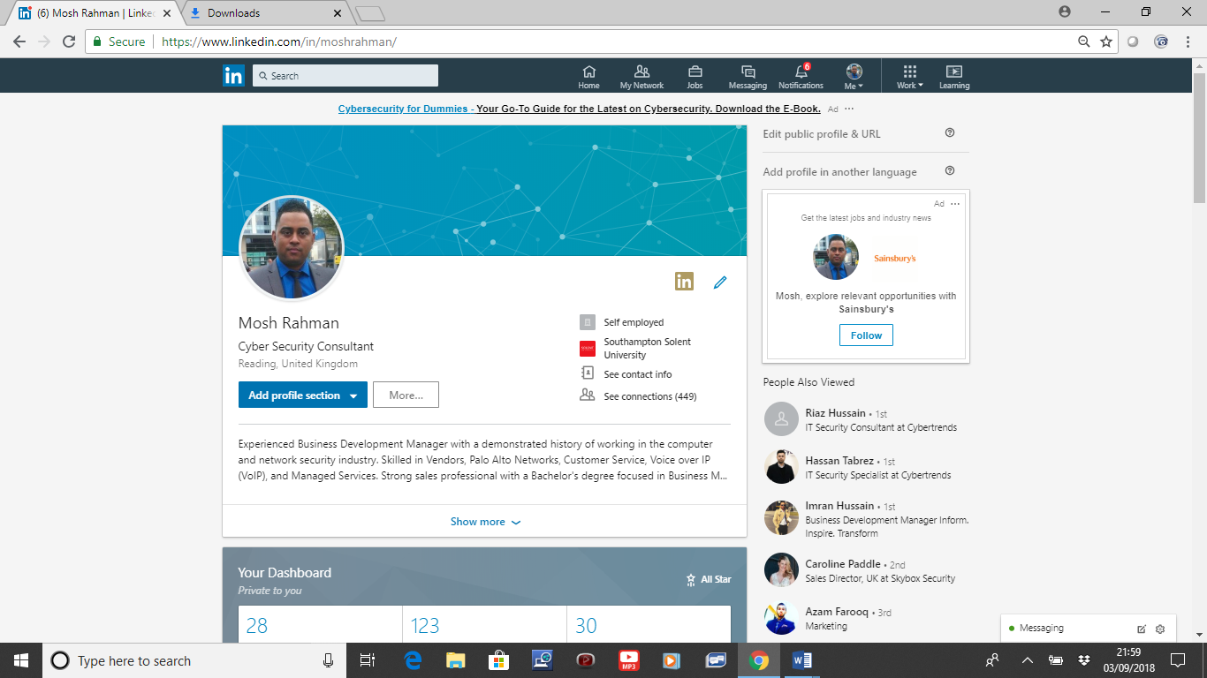

https://www.linkedin.com/in/moshrahman/

Facebook
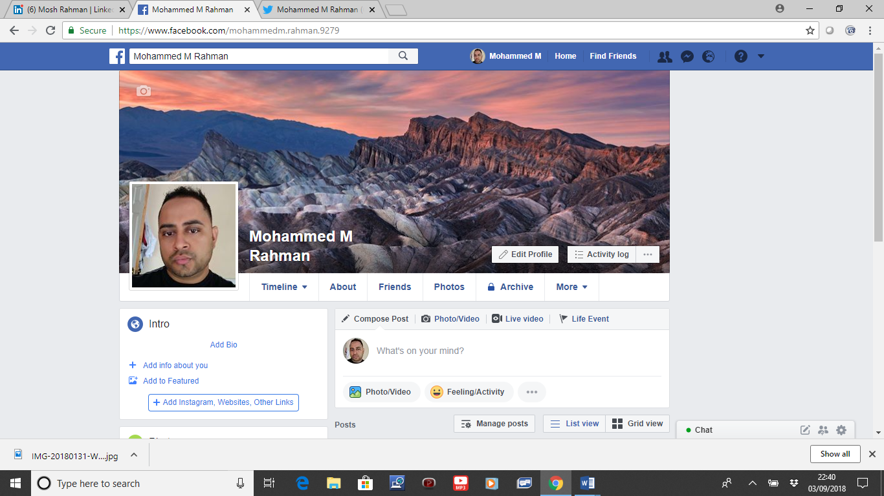
https://www.facebook.com/mohammedm.rahman.9279

Twitter
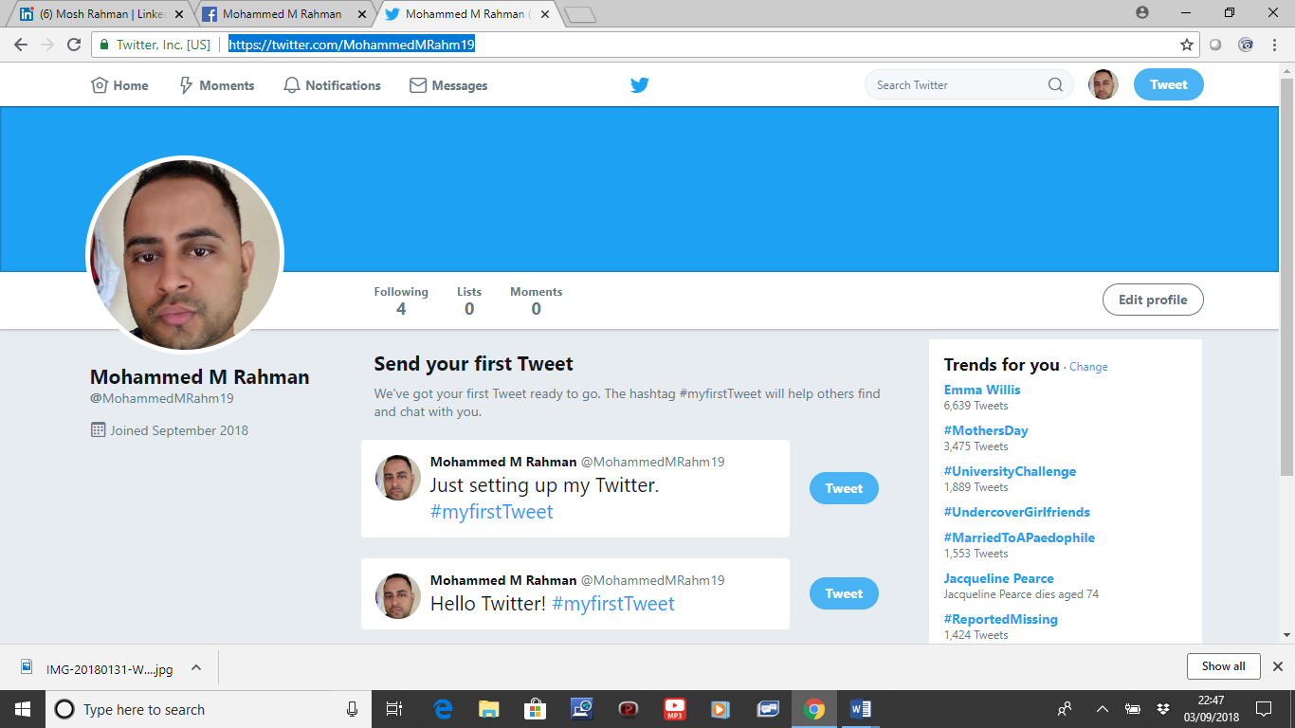
https://twitter.com/MohammedMRahm19

References
Avram, M.G., 2014. Advantages and challenges of adopting cloud computing from an enterprise perspective. Procedia Technology, 12, pp.529-534.
Cardon, P.W., 2014. Business Communication: Developing Leaders for a Networked World (3e). McGraw-Hill.
Chaganti, V., SV, S. and Tetali, S., 2017. Social Media Use at Workplace: An Analysis of the Agreement on Benefits, Risks and Risk Management Strategies.
Chang, V., Kuo, Y.H. and Ramachandran, M., 2016. Cloud computing adoption framework: A security framework for business clouds. Future Generation Computer Systems, 57, pp.24-41.
Felix, R., Rauschnabel, P.A. and Hinsch, C., 2017. Elements of strategic social media marketing: A holistic framework. Journal of Business Research, 70, pp.118-126.
Fusi, F. and Feeney, M.K., 2018. Social Media in the Workplace: Information Exchange, Productivity, or Waste?. The American Review of Public Administration, 48(5), pp.395-412.
Godey, B., Manthiou, A., Pederzoli, D., Rokka, J., Aiello, G., Donvito, R. and Singh, R., 2016. Social media marketing efforts of luxury brands: Influence on brand equity and consumer behavior. Journal of business research, 69(12), pp.5833-5841.
Guffey, M. and Loewy, D., 2016. Essentials of business communication. Language, p.610.
Harris, B., Cheng, K.F. and Gorley, C., 2015. Benefits and barriers: Case study of a government technology-mediated group mentoring program. Journal of Workplace Learning, 27(3), pp.193-206.
McDonald, P. and Thompson, P., 2016. Social media(tion) and the reshaping of public/private boundaries in employment relations. International Journal of Management Reviews, 18(1), pp.69-84.
O'sullivan, P.J., Raguillat, F., Stern, E.H. and Willner, B.E., International Business Machines Corp, 2017. Enhanced management of a web conferencing server. U.S. Patent 9,721,215.
Tuten, T.L. and Solomon, M.R., 2017. Social media marketing. Sage. United Kingdom.

