

STUDENT NAME: BASTIC SANDRIN VICENTIU

STUDENT NUMBER: 1817750

LECTURER NAME: GULNAR ALI

MODULE NAME: PROFESSIONAL CAREER DEVELOPMENT

MODULE CODE: BMSW4005_LON

Table of Contents

Introduction
- Personal development plan, SWOT Analysis
- Effective approaches, PDP cycle
- Gibbs reflective cycle
- VAK learning styles
- Johari window
- Recruitment process, self- motivation
- Conclusion
- References
- Appendix

In order to accomplish entrance and succeed in a new global society, graduate students and individuals are now commonly recognised as needing to improve employment prospects and career management skills. Employment management abilities in higher learning demonstrate how the active learners feel providing an important impulse in personal and job growth interactions. Career growth curriculum is about having students gain informations, ideas, abilities, skills and behaviours to navigate their jobs and their lifetime curriculum success.
Personal development planning (known as PDP) has been described as a method for monitoring progress, identifying and managing milestones and weak points, concentrating on objectives and establishing realistic targets, goals and action strategies. In comparison to SOAR, technical and higher education career development adrdresses PDP, a template of curriculum advancement that is used successfully to align professional and personal training with good academic success and workplace posiblities.
The aim of this paper is to enable students, leaners to improve the ability to connect education and accomplishments with the demands of both educators and workplaces and hopefully move on and incorporate those skills in the future teaching and learning professions. SWOT analysis is an instrument used by organisations for stragetic planning and management. The acronym SWOT represents ‘strengthts’, ‘weakness’, ‘opportunities’ and ‘threats’. Therefore SWOT Analysis is an effective method for scenario analysis that enable managers to recognise operational and environmental variables. There are two dimensions of SWOT analysis: internal and external. Strenghts and vulnerabilities are organisation’s internal influences and attributes. Opportunities and threats are situational external variables and attributes. SWOT Analysis is in this context a strategic technique used to determine an individual’s strengths, weakness, incentives and risks.

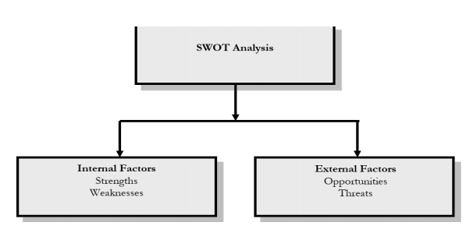
Fig 1. SWOT Analysis

SWOT analysis is a method that may include opportuniteies for administrators, healthcare professionals, nurses and personnel participating in the study of what is efficient and less successful in the healthcare process and practices, in the planning of a type of stragety (this may be an CQC (Care quality commisision), evaluations, assesments, quality controls etc).

In addition, a SWOT analysis could also be used for operation of making plans or research that could potentially have an impact on choices regarding financing, planning and management.

Fig 2. Example of a healthcare assistant SWOT Analysis

Strengths  - Getting a bachelor of science in Health and social care  - Over 5 years experience in health care industry as a mobile health care assistant  - Strong communication skills, well developed time management skills | Weaknesses  - As a healthcare assistant, workplace can be stresfull as long as long hours shift  - No significant hard assets  - Lack of IT support
Opportunities  - Many jobs opportunities available currently due to Covid-19 outbreak  - Health care industry well developed in the UK  - Head Nurse is willing flex clinic times to free up clinical staff time | Threats  - Poorly wages at the beginning of the career  - Economical changes could affect job availability  - Not enough funding and not prioritised by the government  - Brexit and Covid-19 could affect healthcare industry in future

Organisational strengths include of organisational skills which play a significant role in the achievement of organisational objectives. Each company must realise the ability it has and the factors that make it more competitive than the rivals, before moving into practice as it faces a challenge or opportunity. In fact, the organisation need to respond to potential environment challeneges by utilising its strengths. Weakness implies it is more undesirable attribute. Organisational weakness applies to circumstances in which an organisation’s actual structure and potential becomes lower than certain entities and competitive organisations. Threat is a circumstance or state that could influence an event’s achievement. It has a detrimental characteristic, it applies to an unfavourable condition and can be prevented.

Global opportunities and challenges refer to economic, financial, cultural, geographic, environmental, political, legal, technical and competitive patterns and activities that my substantially help or damage an individual or potential entity. Internal strengths and internal deficiencies are the controllable behaviours of an entity which are done particulatly well or poorly.
Goals can be set at the level of the entire organisation, or at divisional, departmental, team or individual levels. Workers and administrators need to get the target setting cycle correct, as insufficiently conceived, goals may create frustration or drive people, departments or the entire company in the negative direction. The SMART abbreviation is a method intended to help organisations and individuals set targets efficiently and productively. Clear and observable goals identify project or programme performance. Engage and inspire students, learners or individuals on measurable and safe targets. Timeline-bound milestones ensure that parties decide to time ranges for meeting objectives. A goal is a declaration explaining what a person, team or a company aims to accomplish. SMART i.e. specific, measurable, achievable, realistic and time-bound. Goals should be precise. They shall explain the intended effect that is comprehensive, understanding and well described. Using action-oriented words while developing targets, particularly for people, who explain what needs to be achieved to accomplish the goals. A target may define a result or consequence that is or may be linked to a percentage, duration, intensity or amount to be measurable.

‘Achievable’ indicates those it is delegated to are motivated and worthy of doing it. For this purpose, it is essential to identify and find consensus on the goals. ‘Realistic’ implies a good view of how the target might be achieved, that there are no conditions or variables that might cause the accomplishment of the objective difficult or doubtful, and that all future challenges and limitations are taken into consideration. ‘Relevant’ implies that the goals provided are suitable for the person and their position and task or organisational level as they fit with the association’s overall mission and vision. It should be important to establish a deadline or period by which the target will have been completed or achieved and this leads to the measurability of the goals. This is common practice to define targets or important measures for objectives that could take months or even years to reach entirely, and to establish timelines for them to help ensure advancement towards to the ultimate target on track. A timetable helps generate the pressure required, encourages change and focuses the attention of those who are responsible for the promises they have created in committing to the targets. Inability to set targets may decrease pressure and incentive rates, which can result in needless delays or failure to achieve the targets. There whenever practicable, priorities should be made transparent and expressed to superiors, staff, managers, even consumers or vendors, particulatly those at the operation level. Everything in the company should have a good view of the corporate priorities and a knowledge of their own role in their achievement. That will also include others who are not specifically accountable for meeting the targets, which will also warn citizens of improvements that could concern everyone.
(NA, 2020)

It is indeed apparent that learning doesn’t end upon graduation in the current knowledge society. Training for a career is just a beginning point of the trade for study. A professional Improvement Program or Personal Development Plan (PDP) becomes the method for developing performance in the career. While this method is quite common, no analysis study has been accessible to continue to educate scholars and specialists regarding results and circumstances that improve performance. In literature, various definitions apply to the term PDP: portfolio (technical or personal) growth plan, logbook, or specific technical profile. A personal development plan is a method used to obtain and record details regarding the skills the individual has focused on, and aims to improve accordingly. It can be described as an evaluation method in this regard. For analysis a research portfolio is used, whereas a documentation portfolio and a presentation portfolio are used for formative assesments. The main objective for a personal development plan is to develop participants ability to identify what and how they are doing, and to study, schedule and accept responsibility. The PDP cycle, as show below (see figure 2) is cyclical in nature and has 4 phases: Analysis, planning for intervention, intervention and result.

Fig.3 PDP cycle
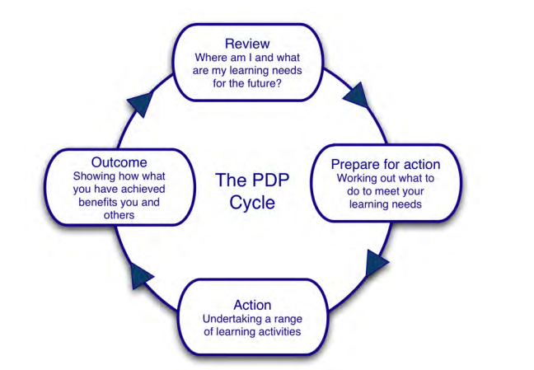

Review is the perfect starting point, as the review’s goal is not just to look back on what the individual has done so far in life, but also to look ahead in the future. And it’s all about where the participants are at the moment and where they hope they will be in the nearest future, as well a own job aspirations or ambitions in the future are also high recommend to be reviewed. Preparing for the action step is very important to make sense of the personal development plan. Sometimes could also be overlooked or ignored by the invidiual or group. In the analysis, the students or learners who take part of the personal plan need to find out where they sit at the moment and in which direction they are indenting to go, in clear words, also the learning needs are recommended to be clearly described and presented. A main feature of practice, therefore, is not only studying but the documenting and writing of these actions. Formal learning is perfect as a curriculum or research course typically has a framework to help the accredited learning while some need to be illustrated differently.

A famous reflective pattern is the reflective Gibbs series.The model consists of six plases which reflect. In 1988 Graham Gibbs Reflective Process was created to provide meaning to learning from experiences. It creates a structure for the analysis of interactions and, despite its cyclic existence, it relates itself especially well to recurring encounters, helping individuals to understand and prepare events that either went well or didn’t. The process includes 6 stages:
- Encounter definition
- Emotions and reflections on the event
- Assesment of the encounter, both positive and negative
- Interpretation to make sense of the scenario
- Conclusion of what it has been experienced and what individual might have accomplished better
- Action plan about how the person could cope with similar circumstances in the future, or general adjustments might be consider necessary. The reflective process of the Gibbs starts at definition and then shifts to emotions, evaluation, analysis, conclusion and finishes at course of action, returning gradually to description. It would be worth noticing the main details are not to be ignored. For examples, why some people got involved in the specific circumstance. The method of assessment is more about the feelings trigged by the incident, and also somebody’s emotions during the case, behaviour, or situation described. This model is a perfect way to make an interaction work. Gibbs first promoted their usage in repeated cases, but even with single interactions, the steps and concepts function as well. Helpful questions :
- What happened?
- When and where did it happen?
- Who was present?
- What did you and other people do?
- What was the outcome of the situation?
- Why where you there?
- What did you want to happen?
The aim is not to examine or reflect in detail on the sensation. Emotions don’t need to be calculated or judged. The process most important target is awareness. Helpful requests, can be used such as:
- What did you feel leading up to the event?
- What was it that you thought during this event?
- What did you feel following the event?
- How do you look at the case backwards?
The following questions are included in the next assessment phase to get what approach really performed good, and how? However what strageties didn’t work is recommended to be put in place. Therefore unpleasant encounters are an essential connexion, because the resulding behaviour in the retrospective phase of the Gibbs cycle allow individuals to learn about them. The phase of interpretation is where students learned from circumstances, events or behaviours. The activities and/or issues that people are facing will be transposed and analysed individually, both favourably and negatively. The appraisal more frequently correlates with the assessment phase. The knowledge previously gathered is, in general, quite beneficial at this point, and helps to contribuite to a fair and realistic decision. The problem is in this phase what was the great event that led to the situation, the circumstance or the interaction. In the final stage an action plan is proposed. The process may be a fantastic way to create an internal understanding of invidiual behaviour, particularly while doing internship tasks. Goals should be organisationally oriented and aligned with corporate plan, mission beliefs and priciples.

To assess the prevailing behavioural type, the VAK learning style uses the three primary sensory receivers: visual, auditory and kinesthetic (movement). This is focused on modalities – channels in which the human speech may take place, and it made of a mixture of memory and vision. VAK emerges from the rapid learning universe and, owing to its simplicity, seems to be perhaps the most common pattern today. Students and teachers are using these three approaches to acquire fresh ideas and interactions, then read them. However, one or two of those receiving forms are usually influential according to the VAK style. With one job, the learner can choose one learning style, and a mixture of others for another. Visual learners have two sub-channels: visual and linguistic. They are using maps, tables, photos or other visual communication tools. For reading and making notes involve diagrams, idea charts, goals, handouts etc. Kinesthetic learners perform their work whenever touching, running and feeling. There are also two sub-channels. Kinesthetic (motion) and tactile (touch). They seem to lose focus unless the perceived stimulus or activity is low or not present. Usually they might want to write everything down while responding to lessons, in order to shift their hands. Auditory learners sometimes talk to themselves. They can even lift their lips and read out loudly. Start new content with a brief description about what’s to follow. Auditory learners often require vocal games, such as brainstorming. This helps learners to interact about what they were relying on and how it relates to their case. (NA, 2020)

Recruitment and selection within a company has been an integral aspect of the overall cycle of human resource management and planning. Human resource planning aims to assess the accomplishment of organisational priorities by having the best mix of resources with the right number, efficiency and skills at the right time. The general recruiting process and a number of processes needs to be set up to maintain reasonable practices for the company before effective recruiting can occur. Moreover, the hiring and recruitment phase would include evaluating the position to be lined up, the candidate to be hired, writing a work description and personal qualifications, and reviewing the short, medium and long-term. In a limited company, a more valuable method might be for the employer to raise the plan to recruit and retain own staff. Optionally, a human resources director an jobs broker can even do the job. A career growth programme not just facilitates professional advancement but also aims to enhance the personal life. Improving qualities such as communication and management, emotional stability, helps a member of staff to develop and influence their job prospects. Career development provides the system of expertise, priorities, knowledge, appraisal and productivity that enables improve independently. Organizations are choosing to hire candidates with a wide range of perspectives and also the opportunity to consider the range of abilities they have gained through research, work experience and school programs.

Connection is the key to stake holders grip of the company. Communication is the secret to progress with every good enterprise and more so efficient communication has been one of the most critical metrics with determining organisational performance in the modern days. During this context, Josepth Luft and Harrington Ingham-JOHARI WINDOW’S communication model is ground-breaking concept that offers valuable guidance to enhance interpersonal contact through self-consciousness and awareness. This interpersonal communication method. Whenever implemented properly, not just to sensitises managers to the value of technical skills and moreover allows them to create a innovative and productive learning atmosphere. Although interpersonal contact includes oral, written and nonverbal modes of communication the word usually refers to spoken communication occurring between two persons or groups at a personal level it may be synchronous (for example face to face ) or asynchronous (instant messaging, phone, email)
(NA, 2020)

The Johari window is a easy and effective resource for training in self-awareness, growth of personality, interpersonal communication, team creation, community interaction and intergroup connections. It is also known as self-awareness exposure/input pattern. The theory behind the Johari window is that people have the enormous ability to follow four strategies to interpersonal interactions with regards to themselves: the capacity to share a lot of knowledge regarding themselves the ability to reveal certain details regarding themselves the ability to obtain input in a positive manner.

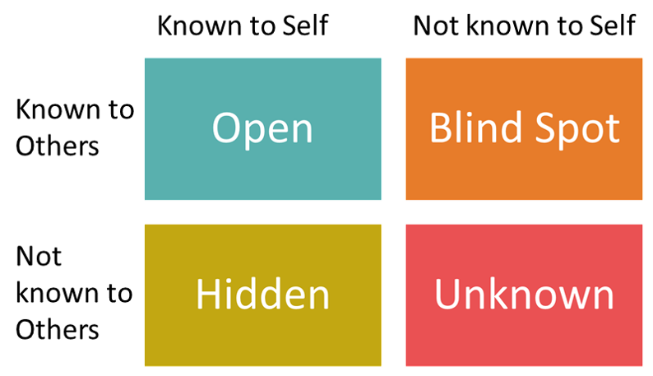
Fig 3. The Johari Window

The Johari window answers the following questions: what do other people think about them?
- What are they uncertain about?
- What many people don’t think about the person they do learn?
- What should they think about the person that should be revealed to the client?
Fig. 3 shows the Johari window diagrammatic representation.

It reflects the mindset, values, skills and perceptions of individual or group visa versa others from basically four viewpoints called windows or quadrants. The four viewpoints of this window may be referred to as regions or areas or quadrants.

Every field includes the details which reflects emotions which encouragement about whether the details is known to the individual or not and if the information is known or unknown to the those in the group. Open area process is ultimately of personal conscious an encompasses behaviour, inspiration, beliefs and habits that individual aware of and that others know of hidden is the region of what individuals don’t learn until they show it to others. Its also a cause of restraint or fear that is preventing a person from being available. It is often assumed that once one begins to expose thoughts, emotions, and reaction. Members of the community will evaluate negatively and respond inappropriately. Around the same time if any chances are not taken, then the ability to know vanishes.

Blind area is the step which deals with stuff people don’t recognise about themselves, so perhaps others can note with great clarity. For multiple causes, individual believe items are valid to themselves but some may interpret it differently. This knowledge may be in the context mannerism, facial signals the way people say things the style with which people compete with others.
Unknown area in the process in where usually people detect some misunderstanding of the dominant characterisitics in which neither participants nor their collegues may choose as thery reside in the unspecified corner. This reflects the indifference of each individual in understanding particiapnt’s actions or intentions. This field is an undefined region that contains experiences from early adolescence, residual potentialities, intra-personal complexities and unrecognised capital. Even though there is a chance that the internal boundaries will travel forward and backward or up and down as consequences of asking or providing feedback. (NA, 2020)

Other qualities and abilities that have historically been and remain relevant include written and oral communication skills, maturity, sound work ethics, extensive knowledge of exercise sciences. Exceptional leadership abilities, the willingness to function together with a number of people, and passion are all essential in the area of performance. Other considerations are often sometimes listed as very critical by workers in this modern era of rapid information. The capacity to perform an ordered, large amount of work is well known and demanded nowdays. Many people incorrectly refer to this attribute as multitasking or the act of continuously completing several activities.

Becoming part of a professional web such as LinkedIn, creating a great website, blog can help the invidiual career to be promoted and increase the chances of gaining employability. The world today is fast changing, and employees need to be able to change with it. This is more necessary than ever to remain agile and to be able to demonstrate a willingness to take on different roles.
Self motivation may be often. (Riebe, 2020)

Self motivation is a key element of the emotional intelligence, according to emotional intelligence expert Daniel Goleman. Goleman notes that motivation has four components: Achivement motivation or specific desire to accomplish, develop and fulfil those standards; dedication to own professional objectives; ambition or readiness to move on opportunities, hope or a willingness to look ahead and persevere in the expectation that individual reach objectives. Students appear especially well-suited to enjoy the rewards of self-motivation, although in the present school climate it may be challenging to be self-motivated. Also, there are range of approaches students should implement themselves. Altough self-discipline and self-motivation are two separate terms, self-discipline is essential if self-motivation is to proceed.. Simply becoming self-motivated is not enough to accomplish self objectives, balance self-motivation with self-discipline is needed to be in a place for the best results.
Professional career development provides important element approaches intended to improve student employability. It allows students to see clearly about the importance of these strategies, it also enhances the durability of their advantages.
Career growth research wasn’t quite as well reflected as it might have been in employability techniques. That being said, across higher education institutions, there has been a strong increase in professional advancement learning programmes. Unless professional preparation curriculum activities are to continue to expland and evolve, it is important to further redefine the essence of job opportunities in higher education and their partnerships with learning organisations.

Employability and workplace resource acquisition are increasingly playing a key position in enterprises as business understand the employee abilities and experise fuel their market growth (Guthridge et al., 2008). To improve these strenthgs and abilities, organisations are gradually making use of Personal development plans as an assessment method, presenting and recording reports about the expertise the individual has focused about, and aims to grow futher. In addition, adopting the organisation’s PDP appraisal can not be treated as getting in a Trojan horse, a method that is put along with high hopes but often seems to hold unexpected surprises.

Development planning in UK higher education implements idea creation through a variety of activities, grounded in capturing success, assessment, analysis and planning process. It discusses the different theoretical perspectives suggested for PDP and charts how the creation of evidence has become an increasing subject of concern for practitioners and policy makers.
A career growth programme not just facilitates professional advancement but also aims to enhance the personal life. Improving skills like communication and leadership, emotional attribute, enables a member of staff to improve and influence their job prospects. (Na, 2020)

References:

- NA, N., 2020. [online] Managers.org.uk. Available at: <https://www.managers.org.uk/~/media/Files/Checklists/CHK-231-Setting_Smart_Objectives.pdf> [Accessed 1 April 2020].
- NA, N., 2020. Visual, Auditory, And Kinesthetic Learning Styles (VAK). [online] Nwlink.com. Available at: <http://www.nwlink.com/~donclark/hrd/styles/vakt.html> [Accessed 2 April 2020].
- NA, N., 2020. [online] Ejsit.org. Available at: <http://www.ejsit.org/dec_15/journal13.pdf> [Accessed 8 April 2020].
- . NA, N., 2020. [online] Ejsit.org. Available at: <http://www.ejsit.org/dec_15/journal13.pdf> [Accessed 15 April 2020].
- Riebe, D., 2020. What Do Employers Want?.
- Na, N., 2020. [online] Core.ac.uk. Available at: <https://core.ac.uk/download/pdf/6339017.pdf> [Accessed 5 May 2020]
- Anon, (2020). [online] Available at: https://www.researchgate.net/profile/A_Watts2/publication/241130724_Career_development_learning_and_employability/links/542e6e360cf277d58e8eb526.pdf [Accessed 2 Jan. 2020]. (Anon, 2020)
- Google Books. (2020). Recruitment and Selection. [online] Available at: https://books.google.co.uk/books?id=937PxbuNcecC&lpg=PA1&ots=8yxSptcMaU&dq=recruitment%20and%20selection&lr&pg=PA1#v=onepage&q=recruitment%20and%20selection&f=false [Accessed 7 May. 2020].
- Managers.org.uk. (2020). [online] Available at: https://www.managers.org.uk/~/media/Files/Checklists/CHK-231-Setting_Smart_Objectives.pdf [Accessed 8 Jan. 2020].
- Practicelearning.info. (2020). [online] Available at: https://practicelearning.info/pluginfile.php/317/mod_data/content/2740/Extract%20-%20Lishman%20-%20chapter%2026.pdf [Accessed 10 April. 2020]. (Practicelearning.info, 2020)
- Sosyalarastirmalar.com. (2020). [online] Available at: http://sosyalarastirmalar.com/cilt10/sayi51_pdf/6iksisat_kamu_isletme/gurel_emet.pdf [Accessed 11 April. 2020]. (Sosyalarastirmalar.com, 2020)
- Anon, (2020). [online] Available at: https://www.researchgate.net/publication/318390296_Why_written_objectives_need_to_be_really_SMART [Accessed 12 April. 2020].
- he Balance Careers. (2020). What Is Career Development, and What Factors Influence Growth?. [online] Available at: https://www.thebalancecareers.com/what-is-career-development-525496 [Accessed 22 April. 2020].
- Kent.ac.uk. (2020). Employability Skills - Careers and Employability Service - University of Kent. [online] Available at: https://www.kent.ac.uk/ces/student/skills.html [Accessed 23 April. 2020].

Appendix:



