Emerging Trends – Individual Report
Ellis Christie (2203571)

Introduction
For the Emerging Trends module, our group (Ellis Christie, Daniel Thomas, Kai Probert, Che Morris, David Rapado, Faiz Khan) presented ‘Support Link’, a web-based charity service intended to make it easier to access community support resources such as mental health charities, food banks, council support etc. Our presentation included a demo of the website itself alongside our individual work contributions.
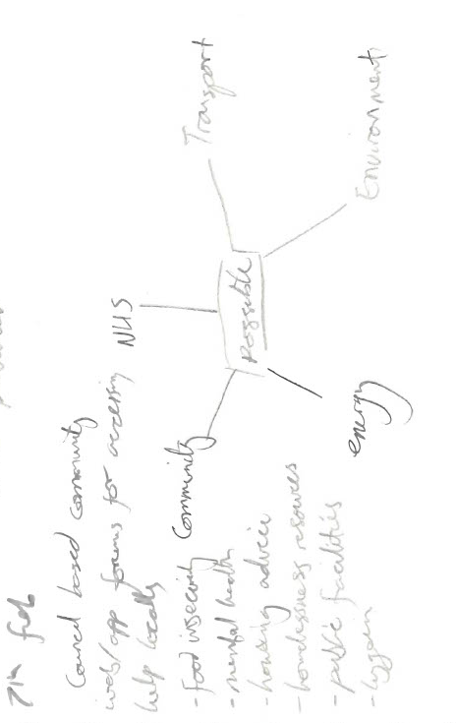
Idea generation

The idea itself was initially my own, and presented to the group during the initial idea generation. The idea came from thinking on personal experience, and what I would have wanted to see when in times of hardship and needing community support.

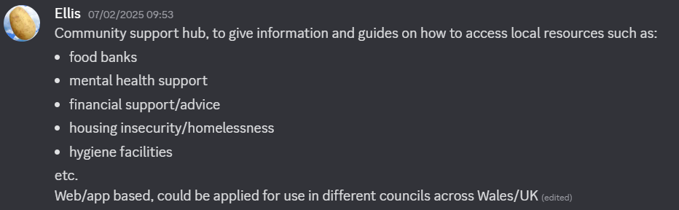
I had realised that, in my own experience, accessing things like food banks was not something I found on my own, but through a string of lucky coincidence. I had never used a food bank before, and did not know they required specific food vouchers to access or how to obtain these vouchers.
On looking into the matter further as a group, we found the sentiment of finding it difficult to know what is available and how to access it is a common sentiment across Wales, highlighting a very real and prominent issue, with many overlapping factors as to why the issue is so prevalent.
Using this knowledge, we developed the idea of Support Link to try and create a service that would remove those barriers to entry by making information widely available and easy to understand through the creation of a database of services with written guides on how to use them, such as guides on how to access food vouchers, counselling services or where to go to get help applying to benefits etc.
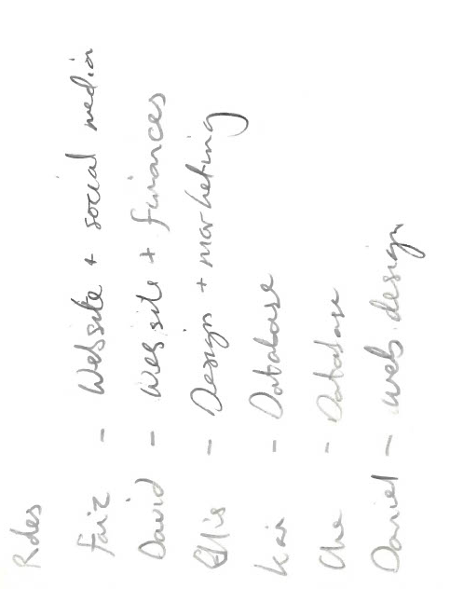
Project progression
Once our idea was established, we laid out a general plan of our team roles based on the individual strengths of the group, being made up of two Games and Animation students and four Cybersecurity students.
I was set to focus on the visual design, and originally intended to involve with marketing though ultimately
not much was done on the marketing aspect of the
project.

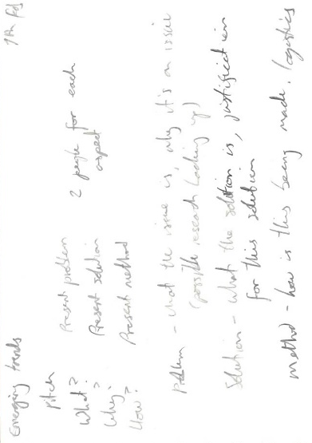
Along with design work, I also planned and structured all presentations across the module, as well as editing the slides completed by other members to ensure visual consistency.
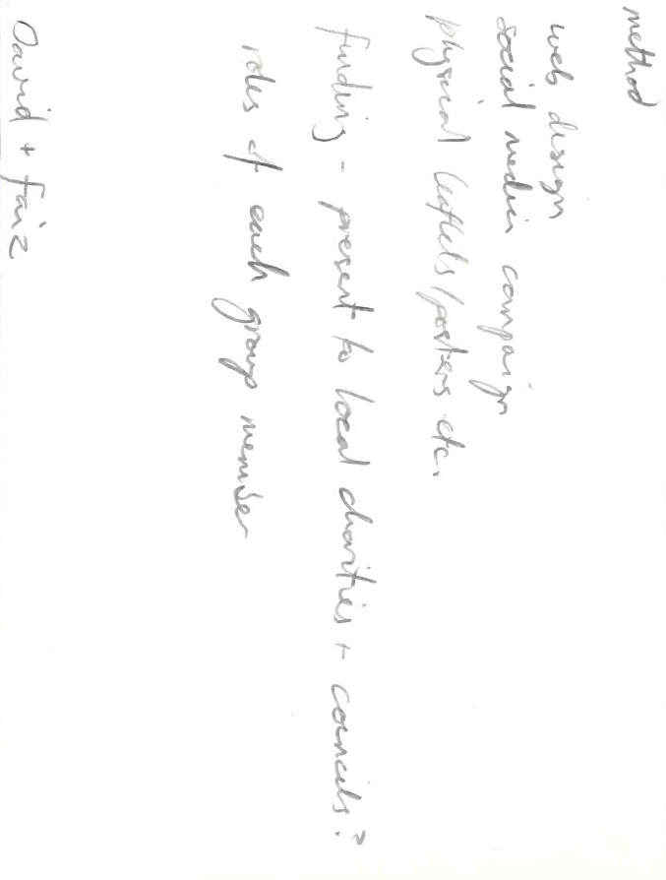
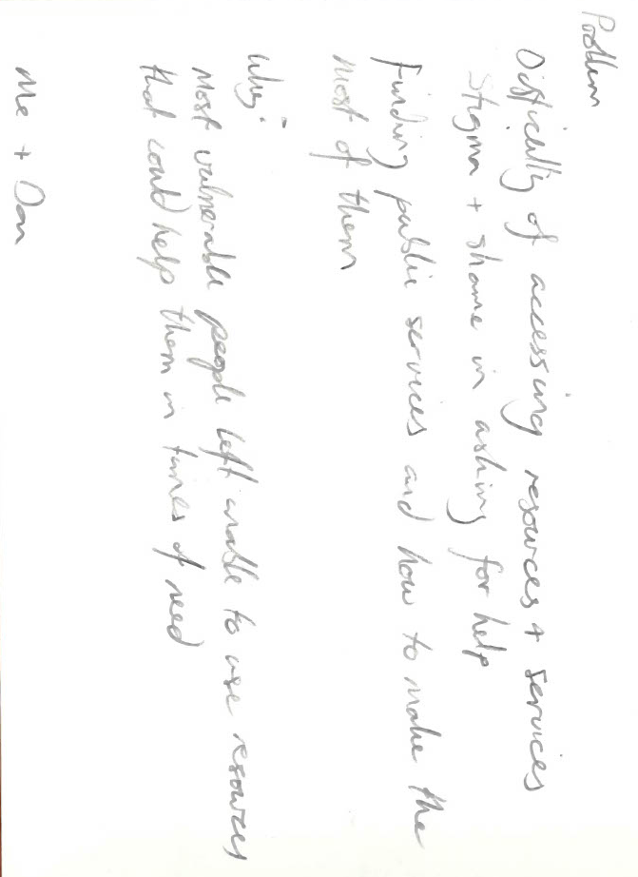
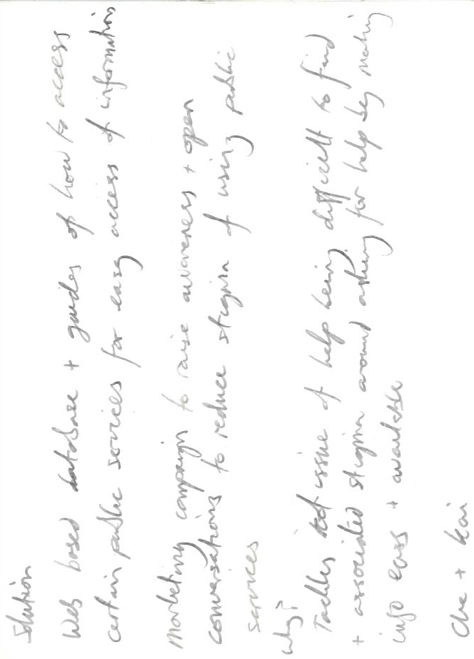

The above are notes for structuring the initial pitch presentation, broken down into three key sections with accompanying guidelines on content for the other team to use to produce their slides.
Between this and the next presentation, I moved on to design work, of which I will show the sketches and assets produced. All assets were created in Adobe Illustrator due to the effectiveness of vector assets for logos, since their scalability and clean appearance is particularly useful in ensuring a logo is clear and easy to use for material of any scale, such as a website banner vs social media profile.

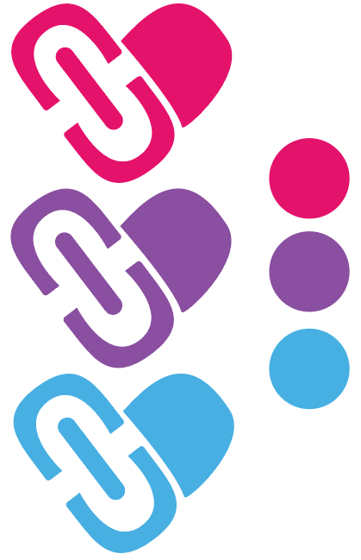
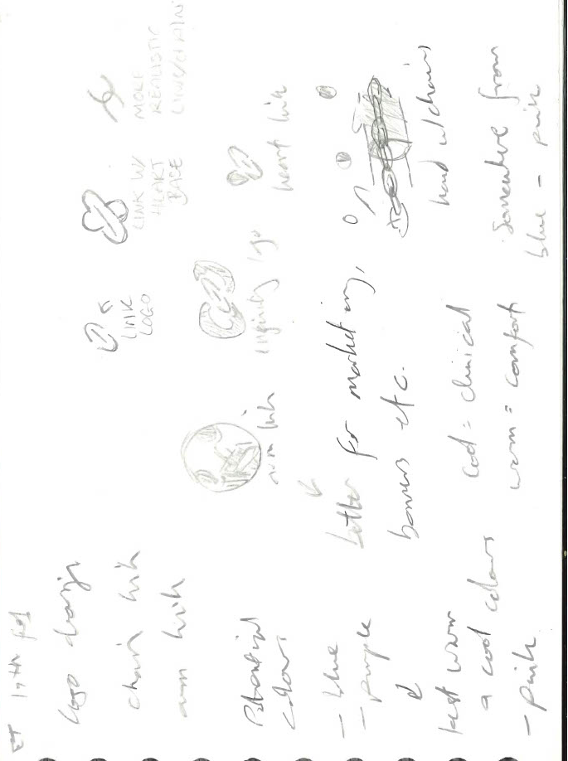

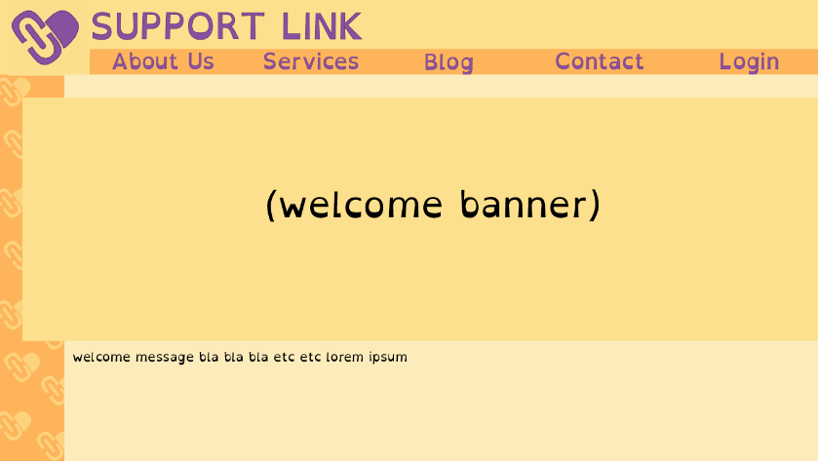

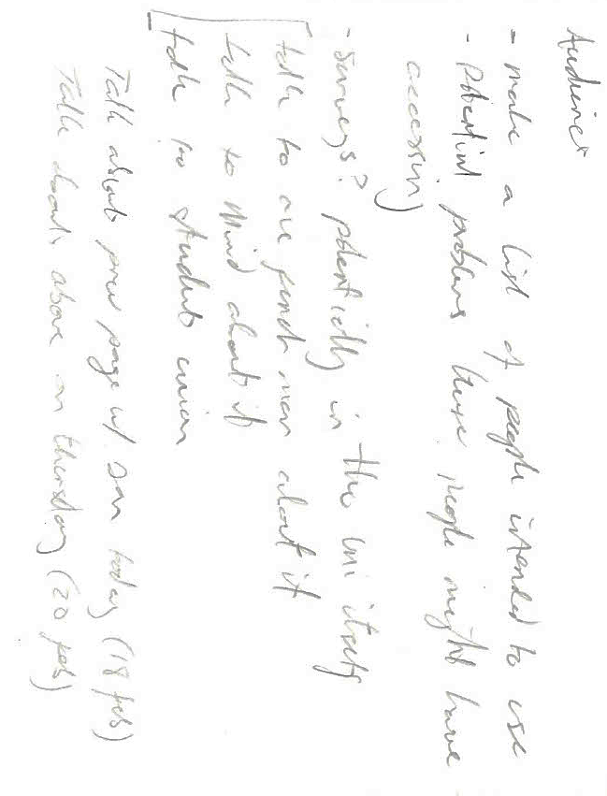

The font for the website is the free to use font ‘OpenDyslexic’ for the purpose of accessibility, as the website is designed to be usable for as many people as possible.
We considered accessibility throughout, with early on making a note to discuss the intended audiences and possible barriers to access within this audience.

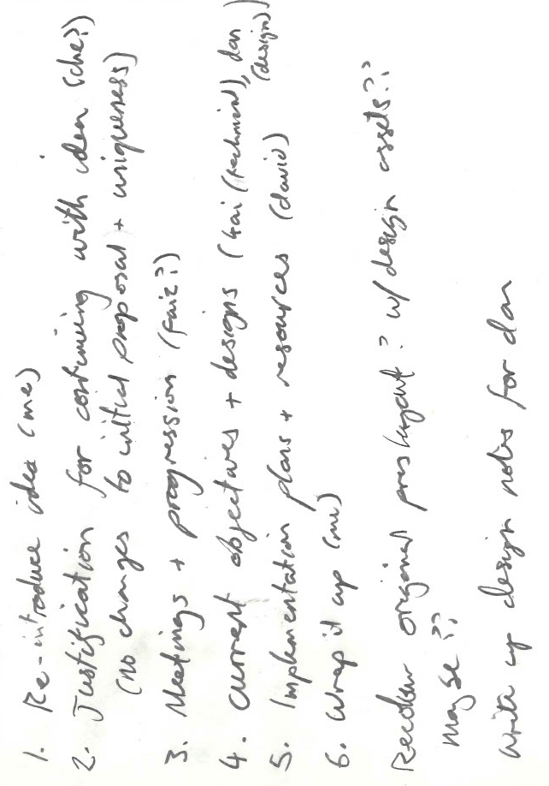
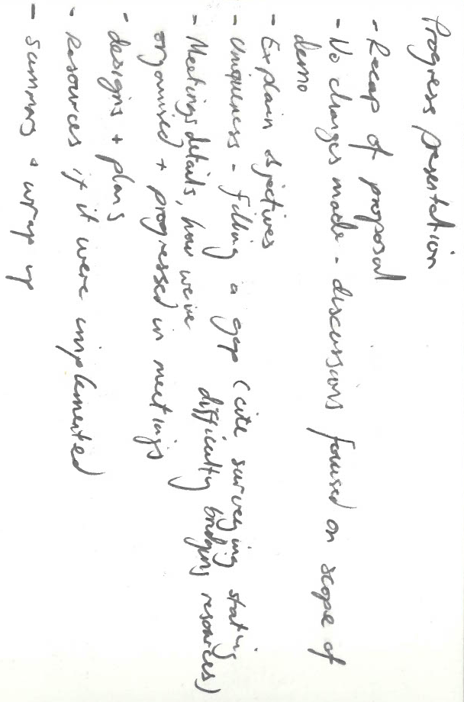
As with the first presentation, I created a series of planning notes and structured the presentation itself for the group.
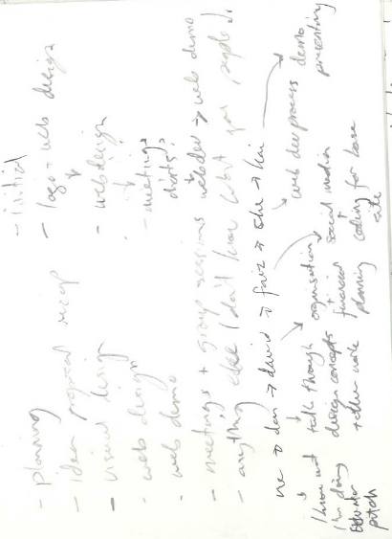
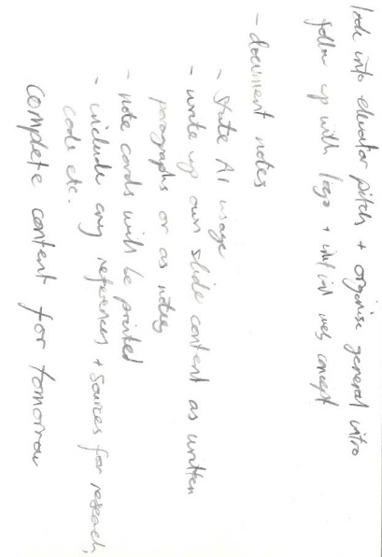
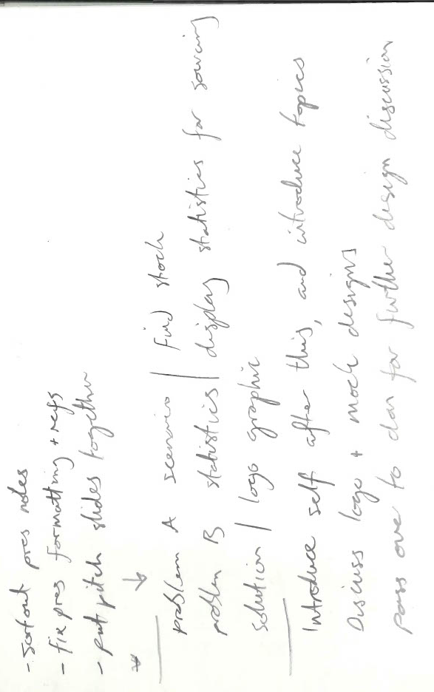
For the final presentation, I created notes as before, along with a word document outlining key aspects for not only content, but also certain things such as referencing guides and other notes.

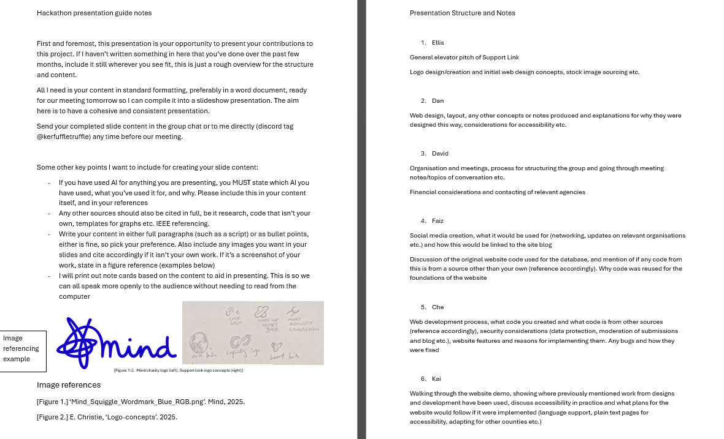


For my section of the final presentation, I wrote a script using techniques for an elevator pitch to introduce the topic in a concise manner before moving on to the development process. For this I also created a simple motion graphic of the logo using Adobe After Effects.

Team Ratings and Experience
David – 2/5
Organised and good with scheduling, though I found his over-reliance on AI difficult to work with, as he produced little to no original content including for business plans. This resulted in his presenting information that ultimately did not make sense for our project, and a lack of critical thinking when AI was unable to produce what he needed.
Faiz – 3/5
Reliable and punctual, though somewhat reluctant to bring new ideas to the table.
Che – 4/5
Enthusiastic and involved with the process throughout, and pleasant to work with as part of a team. Some issues with presentation formatting and referencing, but otherwise excellent in a team.
Kai – 4/5
Similar in work ethic and attitude to Che, easy to get along and work with, producing good results.
Daniel – 3/5
Suitably involved in group discussions and available for consulting on design matters, though often produced work very late/last minute and did not contribute much as a designer. Good in meetings, lacking in independent work.

Conclusion
Overall, I believe our concept was strong and has a great deal of potential, but due to the limited time and spread attention of the group due to the independent project running alongside this assignment, our outcome was unable to reach its full potential. The website itself was easy to use and intuitive as a design, but the usability of it was lacking as we ran out of time to add many of the features we wanted, having none of the features such as guides, the blog feature being removed etc. Our presentation was also somewhat disjointed in places, and though I did edit the formatting, there were still issues with the referencing.
The strength of the idea was somewhat lost in our execution, and much work would need to be done in order to create the Support Link idea to its fullest potential as we envisioned it.

[All references are available within the accompanying presentations]

