Q1. Evaluate the concept of evidence-based practice (EBP) and provide two examples of where Technivara could use it to ensure sound decision-making in people practice. (AC 1.1)
Evidence- based practice (EBP) is a planned approach to decision-making that includes carefully examining, collecting and merging different sources of evidence prior to decision-making (Barends & Rousseau, 2018, p. 3–6). Instead of fully relying on instinct or manager’s preferred choice, EBP depends on four key evidence domains: external research (externally sourced information), organisational data (data gathered and maintained internally), professional expertise (practitioners knowledge and experience within or connected to organisation), stakeholder views (views, concerns or feedback from groups or individuals impacted by or engaged in decision-making process) (Kearns, 2013). Bringing these sources together can benefit Technivara decision making and contribute towards more beneficial outcome.
A main strength of EBP is that it bases decisions on facts that can be checked (Kroon, 2022). It helps to limit bias while maintaining fairness and credibility in HR decisions. For instance, EBP helps HR professionals to notice patterns, recognise and solve issue accurately. However, EBP can be time- consuming, skills in analysing data, research review and stakeholder involvement (Kroon, 2022, Chapter 2: Navigating Evidence).
According to the CIPD (2024) Evidence-based practice in HR helps determine whether HR strategies are achieving their intended outcomes and ensures that these practices are being applied effectively. It involves using data, research, and analysis to guide decisions and improve results.
In order to explore and promote further development after their sixteen years of growth, Technivara could utilise such things as a” Workforce Planning Report”, to analyse resource levels in line with production needs. Because current people practice is paper-based, there is a possibility of losing the data, not having ready access to data or having incorrect data, which could lead to poor decision-making regarding future staffing and resource requirements. Technivara could use the data to predict future staffing requirements as the business grows.
Another example would be the implementation of a digital HR system designed to capture data across employee lifecycle. Technivara could collect and manage information through each stage of employment. Such a system could track headcount, skills gaps, turnover, absence and patterns. This data could also be used to compare performances with other organisation in the same area (Marr, 2018, p.45).
With traditional management style and outdated HR practices, Technivara could be experiencing high employees turnover. The introduction to modern practices could ensure that staff are kept engaged and continue to develop. Implementing regular staff feedback, surveys or conducting exit interviews, analysis of the reasons for leaving, could potentially help to understand the reason behind turnover. Access to this information can improve retention as well as keep them motivated and engaged (Armstrong, 2020, p. 215).
Q2. Evaluate one appropriate analysis tool and one appropriate analysis method that Technivara might apply to recognise and diagnose issues, challenges, and opportunities. (AC 1.2)
To understand organisational issues, challenges and opportunities, organisations need clear analysis methods that support good evidence -based decision-making (Hodgkinson and Starbuck, 2008, p.45).
SWOT analysis is a simple tool that helps a business understand what it does well or what external factors might harm it. It helps an organisation to see its strengths, weaknesses, opportunities and threats. Assessing the organisation’s current situation will help to show were knowledge, technology or procedures may be lacking. Involving staff from across the organisation can bring a range of viewpoints and a solid overall analysis (Fisher, Wisneski and Bakker, 2020).
"SWOT is commonly used in strategic planning but is also a versatile tool for understanding organisations, situations, and supporting decision-making across various contexts” according to CIPD (2025).
SWOT uses a simple 4-section matrix that makes it easier to explore opportunities and risks, promotes strategic thinking and help understand which external factors can help or cause problems. However, it also has downsides. The large amount of data can slow decision-making, quick changes can reduce accuracy, and the lack of structure can cause some details to be missed (CIPD, 2025).
By completing SWOT analysis, Technivara could have a better understanding of its current situation (Appendix 1). This would support decisions about strengths, weaknesses, opportunities and threats and guide decisions on how to address risks and pursue growth.
Technivara could also use a Business Scorecard (BSC) to have a better understanding and measurement of their performance across four main areas. Financial measures would help Technivara to gain a clearer view of the current financial performance and exploring options for further growth. Customer insights would show what clients think of Technivara and weather its system needs updating to remain competitive. Learning and development indicators would highlight existing employees skills and identify needs to support future capability. Internal process measures would help evaluate Technivara’s current operational practices and consider how these might evolve, especially as modern technology such as AI become more common.
The BSC offers Technivara a wide-ranging view on organisational performance, links daily activities to long-term aims and support strategic, evidence-based decisions (Niven, 2006).
However, its effectiveness depends on accurate data. Technivara’s reliance on paper-based system increases the risk of incomplete or misleading insights. Bill’s traditional approach can also slow change and influence others to resist new methods.
However, its effectiveness depends on accurate data. Technivara’s reliance on paper-based systems increases the risk of incomplete or misleading insights. Bill’s traditional approach may also slow change and influence others to resist new methods.
For the BSC to be successful, Bill needs to look ahead and link performance goals to strategy. Furthermore, the BSC does not assess employee morale and culture, which are essential during a period of change (Kotter, 2012).
Q3. Explain the main principles of critical thinking including how these might apply to your own and others’ ideas to assist objective and rational debate at Technivara (AC 1.3)
“Evidence-based practice enables better decision-making by relying on trustworthy, data-driven solutions rather than outdated habits, trends, or superficial fixes” states CIPD (2025).
Critical thinking is the ability to think carefully and logically without allowing personal assumptions and emotional influence. It is the process of systematic examination of available information like data and feedback to support decisions rather than following previous patterns (Fisher, 2001).
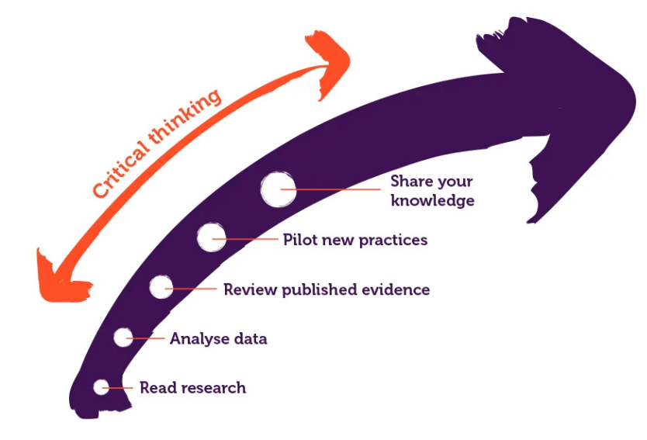 CIPD (2023)

Clarity is essential, it will make sure that arguments are presented in understandable way. Sue can demonstrate this by outlining risks linked to Technivara’s paper-based process, for example the potential for loss and compliance issues. By highlighting these risks, she clarifies the needs for change.
Another essential principle is accuracy, which requires the use of evidence-based information rather than assumptions. Sue can show accuracy by the use of verified HR system, compering Technivara’s performance with similar organisations and to show how modern tools improve reporting, compliance and workforce analysis (Catalyst One,2024). This helps challenge Bill’s traditional preferences by using facts rather than assumptions.
Relevance ensures that debate concentrate only on information directly connected to the issue. When introducing technologies such as AI, Sue should draw attention to their potential to improve efficiency, financial savings and keeping attention on organisational goals.
Logical reasoning requires that any conclusion reached are built by evidence and presented in a structured way. Sue can support her case by using SWOT analysis or cost-benefit review to highlights the strategic value of moving to digital system. Kotter’s (2012) change model contributes to logical thinking by providing a clear, stage process for managing resistant and motivating organisation for change.
Open-mindedness its crucial because it enables individuals to take different perspectives into account. By obtaining staff feedback prior to meeting Bill, Sue shows that is willing to consider concerns about skills, job security and workload pressure. This allows her to predict potential challenges and prepare measured, evidence- based responses.
Finally, fairness requires assessing all viewpoints without bias. Sue should recognise Bill’s concerns but still challenge outdated views with evidence (Adams, 2021)
Applying these principals allows Sue to promote rational discussion and helps Technivara adopt modern, evidence-driven approaches.
Q4. Explain two decision-making processes that Technivara could apply to ensure that effective outcomes are achieved. (AC 1.4)
Effective decision-making is essential for organisations to deliver successful results (Hodgkinson and Starbuck, 2008).
Two helpful decision- making models that Technivara could use are the Six Thinking Hats model (De Bono, 1999) and Lewin’s Force Field Analysis (Lewin, 1951). By adopting structured decision-making models, Technivara can improve accuracy, clarity and high-quality choices across strategic and operational areas. Both models help organisations to examine issues in depth, reduce the influence of personal bias and make choices that lead to stronger business results.
The Six Thinking Hats model introduces a structured approach that guides teams to examine situation from a range of different perspectives. For Technivara, this is especially useful when considering new initiatives, reacting to external market developments or reviewing internal progress. The White Hat supports evidence-based decision-making by directing attention towards factual information, including financial results, service-user feedback and organisational performance data. This will help Technivara base its decision on accurate, trustworthy data rather than assumptions. The Red Hat encourages reflection on stakeholder feelings which helps Technivara understand levels of employee engagement and customer reactions. The Black Hat helps Technivara examine potential risks, compliance gaps and operational difficulties at an early stage, lowering the chance of costly errors. The Yellow Hat draws attention to possible benefits such as improved efficiency or market position, ensuring opportunities are not overlooked. The Green Hat promotes creative thinking, supporting Technivara’s capacity to introduce new approaches and enhance current progress. Finally, the Blue Hat oversees the entire thinking process, helping to maintain structured and results in clear action plans. By separating thinking styles, the model prevents misunderstandings, promotes clear discussion and increases stakeholder commitment, which in turn leads to more effective business outcomes.
Lewin’s Force Field Analysis is especially useful for Technivara during of periods of organisational changes, such as implementing digital system or modifying work practices. Through this framework, Technivara can identify driving forces that support change, such as efficiency targets, customers expectations or new technology as well as the barriers that could obstruct it, such as employee resistance, skill gaps or financial challenges. By analysing how strong these factors are, Technivara can make evidence-based decisions about the viability of the change and what actions are needed to support successful implementation. Strengthening driving forces through development opportunities or rewards while addressing restraining forces with clear communication or support, can build greater readiness for change and decrease implementation risks (Cameron and Green, 2020).
In conclusion, both the Six Thinking Hats and Force Field Analysis provide structured, systematic approaches that help Technivara make balanced, evidence-based decisions. Applied appropriately, these models could help Technivara make better decisions, reduce risk and support successful implementation, ultimately contributing to stronger organisational performance.
Q5. Assess two different ethical perspectives including how these could be used at Technivara to inform and influence decision-making. (AC 1.5)
Ethical decision-making is vital for organisations facing change, managing employees and promoting fair, consistent practice (Armstrong, 2024). To support decision-making, Technivara could use two different ethical approaches- Contractarianism and Utilitarianism. Examining these theories show how ethical reasoning can enhance fairness, transparency and effective organisational decision-making.
Contractarianism suggests that ethical behaviour in the workplace is grounded in formal and informal commitments between employees and the organisation. These agreements provide a framework that outlines the responsibilities, behavioural standards and role expectations required of employees (Boatright and Smith, 2022). At Technivara, this viewpoint highlights the importance of clarity in contracts, policy guidance and consistent operational procedures. It also emphasises that trust and collaboration are crucial for successful teamwork and staff engagement. A key strength of Contractarianism is its focus on fair processes and procedures which supports open decision-making and helping employees understand how and why changes are introduced. This is especially relevant for Technivara, where traditional paper-based processes have created inconsistent outcomes and risks of unfair treatment. However, Contractarianism can be limited by unequal power dynamics between managers and employees. If agreements are dictated rather than mutually agreed, the level of trust between leaders and staff can be weakened. Therefore, Sue should introduce policy or system changes openly and engage employees, integrating Bill’s values while safeguarding fairness (Bingham, 2022).
In comparison, Utilitarianism evaluates ethical choices, consequences of actions, promoting decisions that maximise overall benefits for the larger number of people (Crane and Matten, 2019). This approach could help Technivara evaluate whether upgrading HR system will promote efficiency, data accuracy and overall compliance. A utilitarian view would endorse adopting digital process where they improve data reliability, reduce errors and improve overall experience for majority of employees. A key advantage of this approach comes from concentrating on decisions that supports the organisation’s long -term success. However, Utilitarianism can neglect the needs of smaller group, for example, employees who have difficulty adapting to new technology. It is important that the leaders balance majority benefits with focused support measures to avoid creating new inequalities (Beauchamp and Bowie, 2020).
“Serious risks can occur when an organisation’s culture is at odds with its stated ethical values” (CIPD2024).
When considered together, the two frameworks offer different yet compatible understandings. Contractarianism promotes fairness, transparency and mutually agreed decision-making, while Utilitarianism focus on ensuring decisions are effective, efficient and beneficial for the organisation. Together, the two approaches provide Technivara with a balanced decision-making, allowing Sue and Bill to make choices that respect employees’ rights while maintain organisational performance. Using both approaches would help Technivara modernise responsibly while reducing risks and promoting ethical decision-making through the business.
Q6. Appraise two different ways that Technivara could measure financial and non-financial performance, providing one example of each. (AC 3.1)
Non-financial performance at Technivara can be evaluated through various data sources, such as:
Employee engagement and satisfaction survey – would help Sue gather data on employee morale, levels of job satisfaction, issues with new processes and views on reward and recognition. If carried out regularly, these surveys would be enabling Sue to build a clearer picture on organisational performance rather than relying on occasional data.
Recruitment data- would provide Sue with information on recruitment timelines, effectiveness on new recruits and feedback from candidates. Using all the data together would help Sue understand recruitment effectiveness and where improvements are needed.
Headcount data- would allow Sue to monitor staff turnover and understand the factors driving employees to leave including gaps in career development.
Diversity and Inclusion date – would allow Sue to analyse Technivara’s workforce profile, helping assess inclusivity and attracting a broader range of candidates. Using this data with promotion and pay information would help Sue identify whether opportunities are being offered to employees from all demographic groups.
Using all this data will allow Sue to see whole workforce and identify any skills or recruitment gaps within Technivara. Understanding workforce patterns and behaviours will help Sue plan and implement future changes as well as strengthen her discussions with Bill (Marr, 2018).
“A range of stakeholders such as shareholders, employees and suppliers will take a great interest in the financial performance of a business.” BBC Bitesize. (n.d.).
To understand financial performance, Sue can refer to data such as:
Service level agreement (SLA’s) with external suppliers, helping Sue evaluate performance against agreed targets and clarify the service being provided to Technivara. This information would allow Sue to decide whether training the workforce would enable Technivara to lower future costs and transition the process back in-house as system improves.
Wage/ Training budget – this would help Sue to review the organisation skills base and where upskilling is needed. By understanding future workforce needs, Sue can establish the right grading framework and recruit the right candidates into right position at the correct pay levels. During the phase of Technivara’s change a well-resourced training budged would support workforce upskilling and ensure that the benefits of training are reflected in organisational performance.
Benchmarking – comparing Technivara with similar organisations allows Technivara to understand its performance levels, operational effectiveness and investment return.
Employees analysis - analysing Technivara’s financial implication of employee absences, legal disputes and turnover. It is important for Sue to explore and identify the underlying causes of these issues and take appropriate actions (Torrington et al.,2020).
For Technivara to expand effectively it must consider talent requirements, technology investments, supplier dependencies and recruitment needs to meet organisational demands. As new systems are introduced, it would be beneficial for Technivara to adopt technologies that monitor costs and predict future demands (Armstrong, 2020).
Q7. Explain how people practices could add value at Technivara and identify two methods that might be used to measure the impact of these people practices. (AC 3.2)
Effective people practices can provide Technivara with valuable information about organisational performance and identify emerging trends or potential shortages in workforce and resources. To gain Bill’s support, Sue should demonstrate how modern technology adds value and strengthens security. Effective people practice help ensure that recruitment, decision-making, learning opportunities and legal support are handled fairly and consistently. If these practices are not in place, Technivara can face a risk of making ineffective decisions that can put organisation’s stability at risk as well as demotivating the employees. (Torrington et al.,2020).
According to CIPD2024 “People practices refer to the structured processes and approaches used throughout the employee lifecycle. Activities such as learning needs, talent pool creation, policy development, data analysis, grievance management and recruitment. These practices help ensure consistency, fairness and strategic alignment in managing people effectively.”
Implementing an HR system would provide Sue and Bill with reliable, high-quality data, allowing them to monitor turnover, retention, talent availability and recruitment process. Such information will give Sue a clear picture the organisation’s capability, helping her to identify where additional skills or training is required. Replacing paper files with digital system could improve Technivara’s ability to meet compliance requirements and reassure both employees and third -party stakeholders about the security of their data (Kavanagh and Johnson, 2018).
Employee engagement tools - using regular surveys and feedback forums, enables staff to express their opinions through several channels. Examining both qualitative and quantitative feedback enables Sue to recognise potential concerns and take appropriate action. Ongoing feedback helps Sue and Bill to identify emerging issues in advance, allowing them to intervene before they lead to demotivation and underperformance.
Using Kirkpatrick’s evaluation models would allow Sue to assess the success and impact of the new training across the organisation (Kirkpatrick and Kirkpatrick, 2016). This model will allow Sue to see what training will be needed and implement it effectively:
Reaction – This stage requires Technivara to assess how positively employees responded to the training and whether it fulfilled their expectations.
Learning- Technivara could use post-training assessment or hold follow-up discussions with employees whether the training has resulted in the required level of knowledge and skills.
Behaviour- Technivara need to examine whether employees’ behaviours and performance have changed as a result of the training.
Results – Technivara should be able to notice improvements like new skills being used, higher productivity or organisational growth.
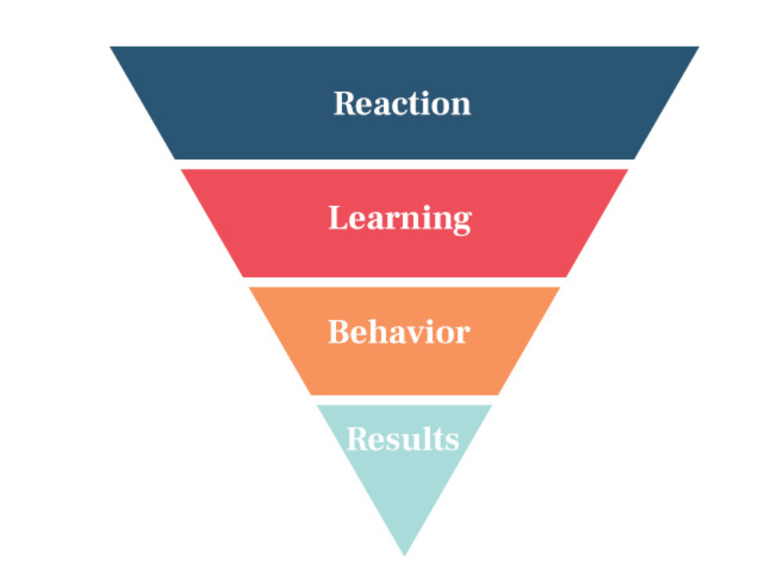 Deck, H. (2020).

Q8. Table 1 shows Technivara’s turnover and recruitment data for 2024. Sue has asked you to convert the data into percentage form, for each of the departments, to show:
- Leavers as a % of the total number of employees
- Vacancies as % of the total number of employees
- Positions filled as a % of the total number of employees (AC 2.1)

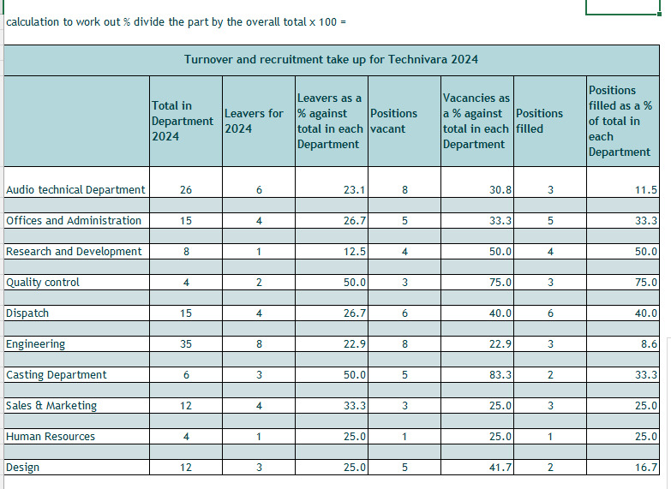
The 2024 turnover and recruitment data for Technivara shows workforce levels are least stable in Engineering, Audio Technical, Casting and Quality Control departments. High turnover, lots of vacancies and few successful hires shows that these teams are finding it hard to recruit and keep skilled people. This could be caused by skills shortages, gaps in the recruitment approach or problems linked to job design or working conditions. The impact includes a drop in productivity, increasing operational costs and lower morale. Further analysis to exit feedback, recruitment timelines and talent market is required.

Q9. When you completed Table 1, present your findings using a minimum of three different types of diagrammatical forms. (AC 2.2)

Q10. Table 2 contains evaluation feedback from 42 employees who attend a recent learning and development activity. Sue would like you to review the feedback and identify patterns, themes or trends that might be occurring and present recommendations based on your findings. (AC 2.3)
An examination of the feedback from 42 employees highlights several trends that indicate both positive aspects of learning and development activity as well as elements that require improvement. The survey suggest that the staff held different opinions on how the training was delivered and the overall effectiveness of the content. Although the facilitator received positive feedback, the data also points issues, including the need to improve course content to better meet learner expectations (Truelove, 2012).

Negative’s (CIPD, 2021):
- The data shows that employees preferred learning styles were largely overlooked during the session.
- Employees indicated that the training did not connect to their performance targets.
- Staff felt that the skills gained during the training were not easy applicable to their existing roles.
- Participants highlighted minimal interaction during the session, resulting in a lack of asking questions or engaging in discussion.
Positive’s (Armstrong, 2021):
- The facilitator was highly knowledgeable in the subject area.
- Clear, well-structured objectives were communicated from the beginning.
- The training resources were of the high quality which supported the facilitator’s knowledge and the clarity of the session.
Feedback indicated that the facilitators expertise the standard of the resources were the most positively rated features with clarity of explanation and effective materials. Even with the solid foundation in delivery, the overall learning experience did not achieve the desired level of effectiveness. Feedback suggests that participants expressed varied views on the structure of the session and pointed out their individual learning preferences were not considered, indicating a need for greater personalisation in the future design. It is possible that the staff held different levels of knowledge with the topic beforehand which could have affected how the material was received and understood (Jarvis,2010).

“Effective learning is supported by creating positive associations with existing knowledge and past success, and through engaging and creative activities.” CIPD. (n.d.).

The data indicates low levels of learner engagement as employees reporting restricted opportunities for meaningful questions or discussion. The absence of interaction could lead to reduced confidence in outcome achievement, as only a minority of participants felt that learning outcomes were met. The training did not demonstrate a strong link to job responsibilities or performance targets resulting in uncertainty among staff about how to use the knowledge, behaviours and skills in their day-to-day work (Knowles, Holton and Swanson, 2015).

To support Sue in planning and delivering suitable future training, below actions are recommended (Mankin, 2009):
- Strengthen alignment with PDPs: Sue could work closely with managers to review, update and monitor Personal Development Plan’s (PDS’s) to ensure that future staff training needs can be recognised and addressed. This will align staff objectives and ensure that Technivara’s requirements are fully considered. Relevant training it is far more likely to be applied effectively in the workplace.
- Conduct a learning needs assessment: Complete a learning needs assessment to give Sue a better understanding of training needs to reduce the skills gaps.
- Map training to job roles: Review training in relation to job roles to identify needs that match job profiles and future requirements.
- Understanding learning styles: Building a clear picture of the learning styles of Technivara’s staff. Sue could use a learning styles questionnaire, such as Honey and Mumford’s model. To understand the learning performance of her team. This would provide insights into the organisation’s preferred learning methods. Some staff may prefer in-person learning and others respond better to online or workplace-based training methods. Providing a range of training delivery will help improve engagement and retention across Technivara.
- Review the training budget: Assess the training budget to ensure it is used effectively. When the training is not relevant to staff development it can result in poor return on investment but also takes employees away from their roles without adding value.
- Rebuild confidence in training: Encourage employee’s confidence in attending training that supports their role.
Applying above recommendations could benefit Technivara in many ways (CIPD, 2021):
- Achievement of organisational objectives: Integrating training with PDPs and job roles ensures it supports organisational goals.
- Enhanced proactivity: Role-relevant training strengthens employee’s skills and improve operational efficiency.
- Improved customer engagement: Better-trained staff leads to higher standard of service and contributes to stronger levels of customer satisfaction.
- Stronger organisational culture: A clear and well-structured development progress supports perception of fairness, motivation and retention.
- Enhanced business metrics: Clearer goals and evaluation methods could increase Technivara’s ability to monitor development progress and make evidence-based decisions.
- Increased capability and future readiness: Targeted employee development strengthen internal talent and decreasing reliance on external recruitment.
- Perception of fairness and progression: Ongoing development opportunities helps build trust and supports higher level of employee engagement.
Technivara should also consider potential risks (Amstrong, 2021):
- Legal and compliance risks: Training that is not carefully design can lead to a company falling short of regulatory and compliance standards.
- Health and safety risks: Insufficient training can result in unsafe working practice.
- Financial risks: Investing in training that does not lead to demonstrate improvements can place unnecessary budget strain on Technivara.
- Impact on engagement: Irrelevant training can lead to deeper employee disengagement.
- Impact on customer experience: When training is ineffective it can often fail to improve service quality.
Adopting these recommendations will involve both direct and indirect costs (Kirkpatrick and Kirkpatrick, 2006):

- Direct costs: Can include investment in training materials, external training providers, learning-style assessment and digital learning system.
- Indirect costs: Can involve time away from duties, brief reduction in productivity and training internal facilitators.
- Cost-benefit considerations: Despite the initial spend, the long-term impact can be positive which can include reducing turnover, better performance and increase customer satisfaction.
- Budged feasibility – Technivara may need to prioritise the most impactful areas or adopt changes to stay within budget limits.
Although the training was well delivered, the programme did not fully engage learners or meet their needs. Improving these areas will help Sue create more effective training with long-term performance and customer satisfaction. Making the initial costs worthwhile (Armstrong, 2021).

Appendix

Appendix 1.

Strengths:
- Founded in 1970, Technivara is a long-standing organisation, with more than fifty years of experience.
- With sixteen years of continuous growth, Technivara demonstrates long-term stability and reliable performance.
- Operates across different sectors by supplying components for computer systems, electronic devices, medical technologies and automotive products.
- Bill Swankey maintains hands-on leadership style in the company operations, giving him extensive knowledge of the business.
Weaknesses:
- Operating in traditional management mindset could make it hesitant to adopt processes, potentially affecting Technivara ability to grow.
- Outdated People Practice means Technivara still rely on paper-based system which limits efficiency and data compliance. This increases the risk of decisions being made without reliable information.
- A lack of planned digital transformation may limit future effectiveness and competitiveness.
Opportunities:

- To bring HR practices up to date by investing in new technology and HR system that support better decisions and improve employee experience.
- Improving recruitment and retention by adopting HR practices could help Technivara secure the skills needed for future growth.
- Using new technology for data collection can improve planning, performance management and compliance.
Threats:
- Without updating its process, Technivara can fall behind better equipped competitors.
- Without secure digital storage, Technivara can face GDPR risks, as paper-based records are harder to secure.
- If Technivara does not update its practices, employee turnover could increase.
- Without modernisation, Technivara’s future growth might be at risk

References:
Adams, L. (2021) HR Disrupted: It’s Time for Something Different. 2nd edn. London: Practical Inspiration Publishing.
Armstrong, M. (2020) Armstrong’s Handbook of Human Resource Management Practice. 15th ed. London: Kogan Page.
Barends, E. and Rousseau, D.M., 2018. Evidence-Based Management: How to Use Evidence to Make Better Organizational Decisions. London: Kogan Page.
BBC Bitesize. (n.d.). Interpretation of data given on financial statements - Analysing the financial performance of a business - AQA - GCSE Business Revision - AQA. [online] Available at: https://www.bbc.co.uk/bitesize/guides/z6p892p/revision/4.
Beauchamp, T.L. and Bowie, N.E. (2020) Ethical Theory and Business. 10th edn. New York: Pearson.
Bingham, C. (2022) Employment Relations: Fairness and Trust in the Workplace. 2nd edn. London: SAGE.
Boatright, J.R. and Smith, J.D. (2022) Ethics and the Conduct of Business. 9th edn. Harlow: Pearson.
Cameron, E. and Green, M. (2020) Making Sense of Change Management. 6th edn. London: Kogan Page.
CatalystOne (2024) A Guide to HR Master Data. CatalystOne Solutions.
CIPD (2021) Learning and Development. London: Chartered Institute of Personnel and Development.
CIPD (2024) Evidence-based practice. Factsheet. London: Chartered Institute of Personnel and Development. Available at: https://www.cipd.org/uk/knowledge/factsheets/evidence-based-practice/
CIPD (2024). Ethical Practice and the role of people professionals. [online] CIPD. Available at: https://www.cipd.org/uk/knowledge/factsheets/ethics-role-hr-factsheet/#what-is-ethical-practice-in-organisations.
CIPD (2024). People Practice. [online] CIPD. Available at: https://www.cipd.org/uk/the-people-profession/the-profession-map/explore-the-profession-map/core-knowledge/people-practice/.
CIPD (2025) SWOT Analysis Factsheet. London: CIPD
CIPD (2025). CIPD | Evidence-based Practice for Effective decision-making | Factsheets. [online] CIPD. Available at: https://www.cipd.org/uk/knowledge/factsheets/evidence-based-practice-factsheet/.
CIPD (2025). SWOT Analysis. [online] CIPD. Available at: https://www.cipd.org/uk/knowledge/factsheets/swot-analysis-factsheet/#advantages-and-disadvantages-of-using-swot-analysis.
CIPD. (n.d.). CIPD | How are HR using their people data? [online] Available at: https://www.cipd.org/uk/knowledge/bitesize-research/hr-people-data/.
CIPD. (n.d.). CIPD | On this page. [online] Available at: https://www.cipd.org/uk/knowledge/factsheets/learning-theories/#changes-in-thinking-on-learning-styles.
Crane, A. and Matten, D. (2019) Business Ethics: Managing Corporate Citizenship and Sustainability in the Age of Globalization. 5th edn. Oxford: Oxford University Press.
De Bono, E. (1999) Six Thinking Hats. London: Penguin.
Deck, H. (2020). The New Kirkpatrick Model, or how to measure the effectiveness of training. [online] HCM Deck Blog. Available at: https://hcmdeck.com/en/blog/the-new-kirkpatrick-model/.
Fisher, A. (2001) Critical Thinking: An Introduction. Cambridge: Cambridge University Press.
Hodgkinson, G.P. and Starbuck, W.H. (eds.) (2008) The Oxford Handbook of Organizational Decision Making. Oxford: Oxford University Press.
Jarvis, P. (2010) Learning in Organisations: A Lifelong Perspective. Abingdon: Routledge.
Kavanagh, M.J. and Johnson, R.D. (2018) Human Resource Information Systems: Basics, Applications, and Future Directions. 4th ed. Thousand Oaks, CA: Sage.
Kearns, P. (2013) Professional HR: Evidence-Based People Management and Development. London: Routledge.
Kirkpatrick, D.L. and Kirkpatrick, J.D. (2006) Evaluating Training Programs: The Four Levels. 3rd edn. San Francisco: Berrett-Koehler.
Kirkpatrick, J.D. and Kirkpatrick, W.K. (2016) Kirkpatrick’s Four Levels of Training Evaluation. Alexandria, VA: ATD Press.
Knowles, M.S., Holton, E.F. and Swanson, R.A. (2015) The Adult Learner: The Definitive Classic in Adult Education and Human Resource Development. 8th edn. Abingdon: Routledge.
Kotter, J.P. (2012) Leading Change. Boston, MA: Harvard Business Review Press.
Kroon, B. (2022) Evidence-Based HRM. Tilburg: Open Press TiU.
Lewin, K. (1951) Field Theory in Social Science. New York: Harper & Row.
Mankin, D. (2009) Human Resource Development. Oxford: Oxford University Press.
Marr, B. (2018) Data-Driven HR: How to Use Analytics and Metrics to Drive Performance. London: Kogan Page.
Torrington, D., Hall, L., Taylor, S. and Atkinson, C. (2020) Human Resource Management. 11th ed. Harlow: Pearson.
Truelove, S. (2012) Training and Development: Theory and Practice. 2nd edn. London: Chartered Institute of Personnel and Development (CIPD).
Young, J. (2024). CIPD | Evidence-based practice for effective decision-making | Factsheets. [online] CIPD. Available at: https://www.cipd.org/uk/knowledge/factsheets/evidence-based-practice-factsheet/#what-is-evidencebased-practice.

Bibliography:
- BBC (2025). Strengths, Weaknesses, Opportunities, and Threats (SWOT) analysis - Decision making - Higher Business management Revision. [online] BBC Bitesize. Available at: https://www.bbc.co.uk/bitesize/guides/zkdc7nb/revision/5.
- BBC Bitesize. (n.d.). Interpretation of data given on financial statements - Analysing the financial performance of a business - AQA - GCSE Business Revision - AQA. [online] Available at: https://www.bbc.co.uk/bitesize/guides/z6p892p/revision/4.
- Bitesize (2024). How to Do a SWOT Analysis [with Examples & templates]. [online] BiteSize Learning. Available at: https://www.bitesizelearning.co.uk/resources/swot-analysis-explained-examples-templates.
- CIPD (2023). Building an evidence-based people profession. [online] CIPD. Available at: https://www.cipd.org/uk/views-and-insights/thought-leadership/insight/evidence-based-profession/.
- CIPD (2023). CIPD | The Profession Map / Core knowledge / Evidence-based practice. [online] CIPD. Available at: https://www.cipd.org/uk/the-people-profession/the-profession-map/explore-the-profession-map/core-knowledge/evidence-based-practice/.
- CIPD (2024). Ethical Practice and the role of people professionals. [online] CIPD. Available at: https://www.cipd.org/uk/knowledge/factsheets/ethics-role-hr-factsheet/#what-is-ethical-practice-in-organisations.
- CIPD (2024). People Practice. [online] CIPD. Available at: https://www.cipd.org/uk/the-people-profession/the-profession-map/explore-the-profession-map/core-knowledge/people-practice/.
- CIPD (2025). CIPD | Evidence-based Practice for Effective decision-making | Factsheets. [online] CIPD. Available at: https://www.cipd.org/uk/knowledge/factsheets/evidence-based-practice-factsheet/.
- CIPD. (n.d.). CIPD | On this page. [online] Available at: https://www.cipd.org/uk/knowledge/factsheets/learning-theories/#changes-in-thinking-on-learning-styles.
- Deck, H. (2020). The New Kirkpatrick Model, or how to measure the effectiveness of training. [online] HCM Deck Blog. Available at: https://hcmdeck.com/en/blog/the-new-kirkpatrick-model/.
- Houghton, E. (2020). CIPD | Making evidence-based decisions in an uncertain world. [online] CIPD. Available at: https://www.cipd.org/uk/knowledge/bitesize-research/evidence-based-decisions/.
- Howlett, W. and Coburn, T. (2019). CIPD | Critical thinking | Podcast. [online] CIPD. Available at: https://www.cipd.org/uk/knowledge/podcasts/critical-thinking/.
- Lothian Quality. (n.d.). PC Resource Force Field Analysis. [online] Available at: https://qilothian.scot.nhs.uk/pc-resource-force-field-analysis.
- Marenco, P. (2017). Evidence-Based Management: From the What and the Why, to the How To • ScienceForWork. [online] ScienceForWork. Available at: https://scienceforwork.com/blog/evidence-based-management-training/.
- McCombs School of Business (2025). Utilitarianism. [online] Ethics Unwrapped. Available at: https://ethicsunwrapped.utexas.edu/glossary/utilitarianism.
- Provitera, M. (2024). Developing an HR strategy in the digital age. [online] Peoplemanagement.co.uk. Available at: https://www.peoplemanagement.co.uk/article/1875203/developing-hr-strategy-digital-age.
- Strengths-based performance conversations: an organisational field trial Appendix 1: methodology. (2017). Available at: https://www.cipd.org/globalassets/media/knowledge/knowledge-hub/reports/performance-conversations-appendix1-methodology_tcm18-29746.pdf.
- www.linkedin.com. (n.d.). What matters the most? Value or Impact? [online] Available at: https://www.linkedin.com/pulse/20140703181118-450057-what-matters-the-most-value-or-impact.

