Marketing Fundamentals

Konstantina Malamova Student ID 2020492
University of Wales Trinity Saint David, London campus
BA Business Management
Term 3 Group 1

Contents
Introduction 3
Blog 1: Refillable product packaging, a new way of responsible shopping 3
Blog 2: Sustainable product mix is the key to success – Tesco refillable shopping 5
Blog 3: Sustainability with cost effectiveness - Cost benefits of Tesco refillable shopping for buyers 6
Blog 4: The trial run of refillable packaging process by Tesco in 10 East England stores 8
Blog 5: Do you want to reduce plastic waste generation from your supermarket shopping bag? Here is a solution 9
Blog 6: Is sustainability awareness is changing the shopping behaviour of supermarket customers? – A insight of modern generation customer perception 12
Blog 7: Tesco with a revolutionary sustainable shopping concept but at an affordable cost 13
Conclusion 14
Bibliography 15

Introduction
The following study consists of multiple blogs relating to customer interaction need of bigger brands as a part of their marketing communication activity. The following blogs focus on the case scenario of Tesco Plc and its marketing communication purpose for promoting sustainable shopping approach with reusable packaging. Tesco has recently launched refillable shopping system for 88 different product ranges in 10 stores across East England region. it is one of the latest sustainability initiative by the organisation to reduce waste generation from customer end. The following blogs addresses the marketing communication n needs of Tesco to promote the refillable shopping and product range among customers.

Blog 1: Refillable product packaging, a new way of responsible shopping
Sustainability has always been one of the biggest priorities for Tesco while doing business. Tesco always tries to advance our CSR initiatives for minimising environmental impacts of operation. The new refillable shopping facility of Tesco in collaboration with Loop has been launched with a bigger vision for minimising waste disposal and environmental pollution from customer end.
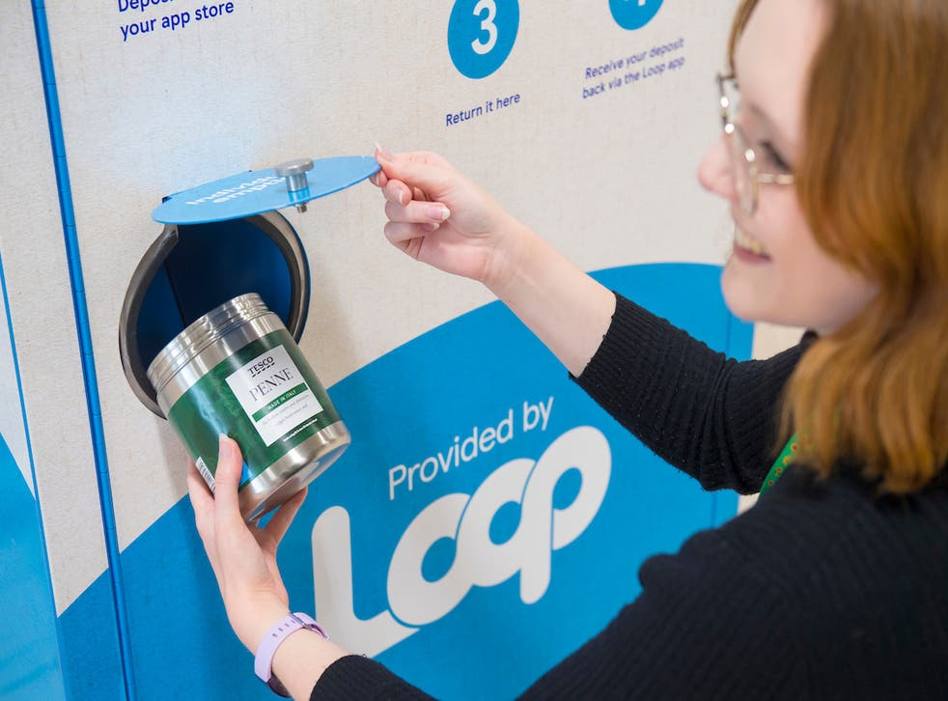
Source: independent.co.uk, 2021
Why it is important?
Disposal of plastic packaging waste from consumer end is one of the biggest sources of environmental pollution and Tesco is determined to provide customers with a sustainable alternative to change their shopping behaviour forever. Refillable usage of previously bought product packages could significantly limit waste generation volume from consumer need and even buyers at Tesco could feel more satisfied for contributing to environmental sustainability.
How it works?
Tesco is collaborating with Loop for installation of product refilling systems in 10 stores across East England. The refillable shopping experience is currently available for 88 different product ranges at Tesco. Customers can bring their used product containers to refill as per required volume through using these machines. Customers of Tesco can download the Loop deposit application to get products with Loop packaging and get their deposit back while returning the used package for reuse purposes. It is a great approach for empowering the buyers to reduce the burden of package waste every time they shop.
Why it is beneficial?
Refillable packaging is a revolutionary approach for enabling customers to avoid the burden of package waste every time they shop. It could also minimise the usage of single use plastic. Moreover, customers could enjoy more reasonable pricing of products due to eliminated requirement for packaging.

Blog 2: Sustainable product mix is the key to success – Tesco refillable shopping
The product mix strategy of Tesco for refillable shopping process currently covers 88 different product ranges including multiple third-party and company owned brands. BrewDog beers, Carex handwash, Fever-Tree drinks and mixers, etc are some of the most important products included in the product mix strategy of Tesco for Loop Refillable packaging process.
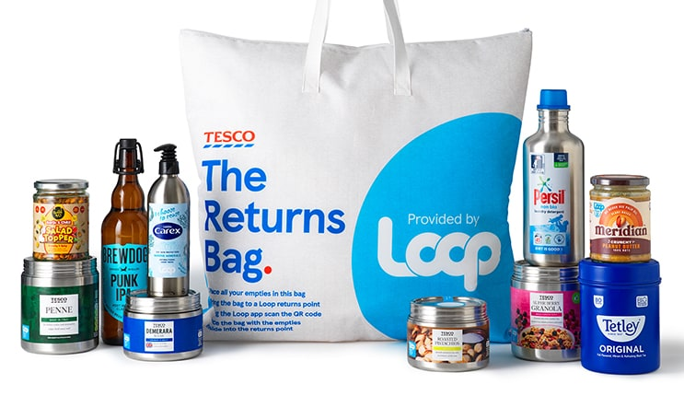
Source: Tesco, 2021
The selected product range of Tesco mainly targets refillable liquid and solid products that can fit in different size and forms of containers. The product mix strategy of Tesco mainly targets product categories which are commonly sold by other retailers with plastic or solid single use package materials.
Customers at the selected Tesco stores can either use these refillable containers for repurchasing of products or they can also submit these containers for getting their Loop Deposit within 6 working days. Tesco will further try to include more product categories under the Loop refillable packaging process so that sustainable shopping experience of customers can be enhanced with time.

Blog 3: Sustainability with cost effectiveness - Cost benefits of Tesco refillable shopping for buyers
Price mix strategy of Tesco has always prioritised reasonable pricing for buyers. Hence, it can be a matter of concern for buyers to lose their reasonable shopping experience in Tesco while trying refillable packaging. It is a very common perception among people that sustainable shopping comes with an extra cost but price mix strategy of Tesco for refillable packaging oriented products.
Why it is cost effective for us?
Cost of products does not only include the product itself but also includes different forms of additional costs and packaging is also a crucial cost area in this regard. The sustainability approach for offering customers with Loop refillable packaging system could effective help Tesco to minimise cost investment in product packaging. Elimination of packaging cost could help us to further minimise our overall product development and procurement cost and subsequently it could provide us with strong cost minimisation benefits.
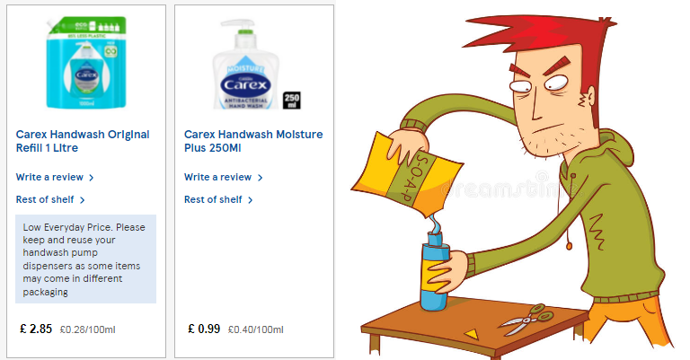
Source: Independent.co.uk, 2021
Why it is cost effective for you?
Refillable packaging not only about cost advantage of Tesco but it is also focused on more cost effective shopping experience of buyers as well. As a buyer, you must be thinking of the benefits of using refillable packaging apart form sustainability viewpoint. A small example of price difference with refillable packaging can clarify the whole scenario. A container of 250ml Carex hand-wash at Tesco costs around £0.99 which is equivalent to £0.40/100 ml.
When you decide to use the same container with refill handwash pouch, the price comes down to just £0.28/100 ml. Handwash refill pouch even comes with plastic packaging but Tesco Loop packaging system will further minimise the need for plastic packaging of refill packs. It will further reduce the price of Carex handwash for customers to just £0.24/100ml. Thus, the price mix strategy of Tesco for refillable products is capable of offering buyers with more cost effective buying experience and additional advantage of sustainable shopping behaviour.

Blog 4: The trial run of refillable packaging process by Tesco in 10 East England stores
Convenient availability and accessibility is always important for smoother adaptation of newer products and facilities by customers. The refillable packaging policy of Tesco is in its trial run phase. The place mix strategy of Tesco tries to focus on most of the popular UK stores having higher daily customer arrival rate.
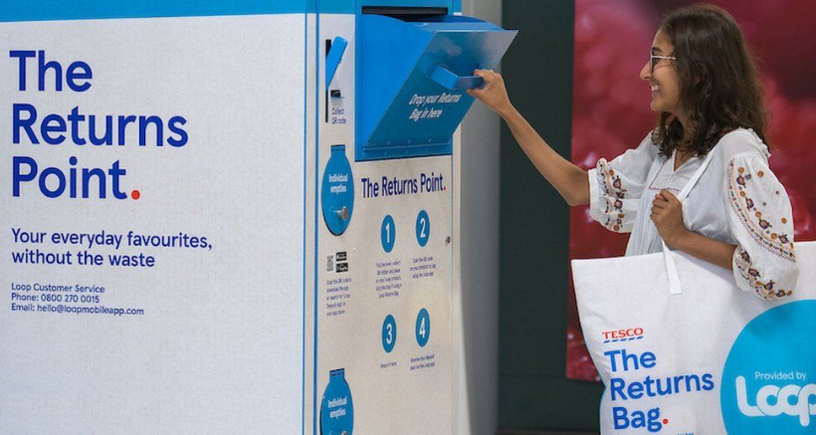
Source: BBC, 2021
Where you can see a Tesco store with refilling facility?
In the trial run phase, 10 Tesco stores in east England region will be offering customers with refill packaged products and facilities. Some of the most important store locations to be mentioned in this regard are Northampton South, Wellingborough, Milton Keynes Kingston, Leicester Hamilton, etc. Many customers might find this inconvenient for refill facility not being available at their respective locations and stores. However, it has to be mentioned that the project is being test marketed and its success depends on responsiveness of customers.
Way to globalisation of sustainable packaging?
A customer could be the key person to make this project success and foster its national and international level adaptation. Adaptability of this service among customers is our primary expectation because the overall refill packaging facility is focused to improve sustainable shopping behaviour of buyers. Through responding to this new shopping facility of Tesco a buyer can not only save some extra cost on household and grocery shopping but can also promote responsible shopping at larger global context.

Blog 5: Do you want to reduce plastic waste generation from your supermarket shopping bag? Here is a solution
Project like refillable package and shopping requires strong public exposure for popularity and better customer participation. Thus, success of Tesco with this new project also depends on its promotional excellence.
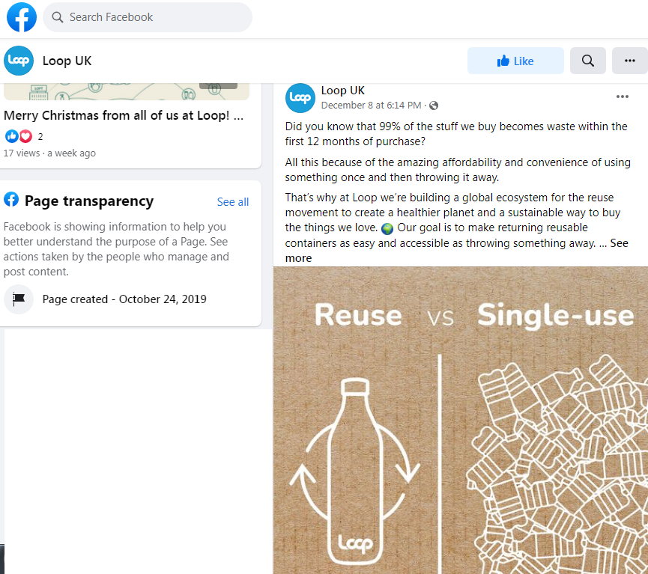
Source: Facebook, 2021
Loop UK has been trying to promote reusable product package and shopping at larger global context for multiple years. The social media promotional campaigns of Loop UK strongly reflects its efforts for complementing customer awareness about difference they could make for the environment by adopting reusable packaged products. Tesco is joining forces with Loop for promoting sustainable shopping behaviour to its huge consumer base across the UK.
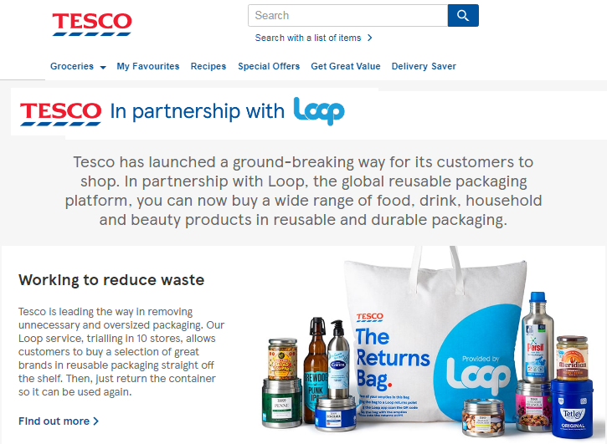
Source: Tesco, 2021
Want answers for your queries?
An interested buyer can visit Tesco’s official website or social media pages for adequate information about their queries regarding the new refillable packaging process. It could be your concern about getting untidy reused packages for your products from Tesco. However, Tesco is open to answer all your queries regarding the process. Tesco will use SEO initiatives with its website for promotion customer awareness oriented blogs regarding refillable packaging system and products.
Promotion at larger global context
Globally renowned advertisement agency Wieden + Kennedy has been recently hired for promotion and advertisement partner of Tesco. Based on the results from test marketing campaigns, Tesco is planning to promote the reusable packaging project at larger global context through mass media advertisement. Tesco is planning a global level mass media ad campaign in collaboration with the Wieden + Kennedy and it is expected to come live by the mid of 2022.

Blog 6: Is sustainability awareness is changing the shopping behaviour of supermarket customers? – A insight of modern generation customer perception
It is fact that modern generation customers in retail sector are lot more aware of their environmental responsibilities. It is a matter of concern how sustainability awareness of customers in supermarket industry could influence the way they shop. Even supermarkets like Tesco needs to realise the buyers’ segment willing to put extra efforts for minimising environmental impacts of their shopping behaviour.
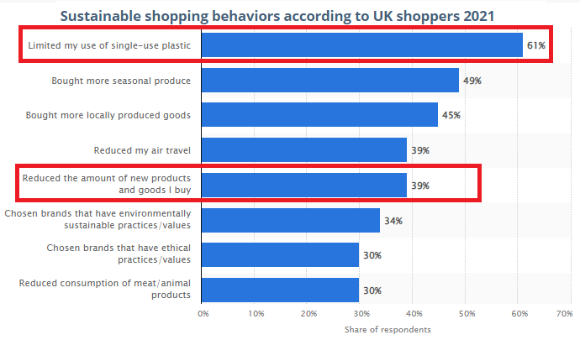
Source: Statista, 2021
A recent UK based market survey shows that limiting the usage of single use plastic is the first priority for 61% customers to adopt sustainable shopping behaviour. 39% customers have also mentioned to reduce purchase rate of new products for adopting sustainable shopping behaviour through limiting waste generation. It shows that larger proportion of buyers are considering package and waste generation form product purchases as the main issue for affecting their sustainable purchasing behaviour. Reusable packaging process of Tesco could be the best solution for sustainable shoppers to reduce single use plastic and packaging waste generation from new products.
Tesco is targeting certain segment of buyers to gladly adopt the reusable packaging policy. Psychographic buyers segment seeking for sustainable shopping behaviour is the primary consumer segment for Tesco in this regard. Behavioural segment of buyers limiting new product purchases to reduce waste generation is also a potential consumer segment for Tesco to offer reusable packaged products. Cooperation from demographic segment of younger generation buyers is also expected by Tesco due to their greater awareness about sustainable shopping behaviour. Geographic segment of buyers for reusable packaged products of Tesco is limited to East England region for the test marketing phase. Tesco is largely targeting the psychographic and behavioural buyers’ segments with its marketing campaign for reusable packaged products as they could get maximum benefits from this packaging system.

Blog 7: Tesco with a revolutionary sustainable shopping concept but at an affordable cost
Marketing success of an organisation largely depends on the ways in which it positions itself in consumer minds. It could be a concern for many customers about what price the reusable packaging might cost to them.
Will it be heavier for your pocket?
Positioning strategy of Tesco for reusable packaged products targets high quality – low cost quadrant in the positioning matrix. Reduced need for product packaging will enable Tesco to reduce production and procurement cost and subsequently products can be sold at more reasonable pricing. Tesco has strong customer reputation for selling quality goods over years. Thus, getting same quality products at more affordable pricing would be added advantage of reusable packaging to the customers.
What is the organisational viewpoint?
Tesco sees reusable packaging as an opportunity not only to enhance its sustainability management efficiency but also an opportunity to adopt more competitive pricing of products. It is unnecessary for you to carry disposable package garbage every time you shop and pay the extra cost for it as well. Tesco is minimising both these issues for enabling customers to get products at more affordable pricing with lesser hazards of plastic disposals in the environment.

Conclusion
The reusable packaging process is a newer concept towards sustainable shopping. It has the potential for bringing revolutionary change in sustainable shopping behaviour of customers in retail sector. Tesco is taking a revolutionary step for not only minimising waste generation from consumer need but also to minimise product purchasing cost for them as well. The above given marketing blogs are expected to give Tesco with adequate customer awareness about the new initiative.

Bibliography
Bran-Piedrahita, L., Valencia-Arias, A., & Palacios-Moya, L. (2020). Strategic marketing planning challenges for health sector organizations. Suma de Negocios, 11(25), 108-115.
Butler, S., 2021. Tesco moves to cut out plastic from range of own-brand products. [online] Available at: <https://www.theguardian.com/business/2019/nov/01/tesco-moves-to-cut-out-plastic-from-range-of-own-brand-products> [Accessed 31 December 2021].
Jolly, J., 2021. Tesco promises to ban brands that use excessive packaging. [online] Available at: <https://www.theguardian.com/business/2019/aug/22/tesco-promises-to-ban-brands-that-use-excessive-packaging> [Accessed 31 December 2021].
Mushketova, N. S., & Fedorova, S. V. (2019, March). Strategic marketing planning in the petrochemical market. In IOP Conference Series: Materials Science and Engineering (Vol. 483, No. 1, p. 012053). IOP Publishing.
Russon, M., 2021. Tesco zero-waste trial launches at 10 stores in England. [online] Available at: <https://www.bbc.com/news/business-58549651> [Accessed 31 December 2021].
Scialom, M., 2021. Tesco’s zero-waste trial with reusable Loop packaging begins in Cambridge. [online] Available at: <https://www.cambridgeindependent.co.uk/news/cambridge-tesco-trial-of-reusable-loop-packaging-starts-this-9216303/> [Accessed 31 December 2021].
Wadhera, C., 2021. Zero-waste shopping service to arrive in select Tesco stores. [online] Available at: <https://www.independent.co.uk/climate-change/tesco-zero-waste-store-uk-b1918981.html> [Accessed 31 December 2021].

