Q-Taxi Company
1.Entity Relationship Diagram
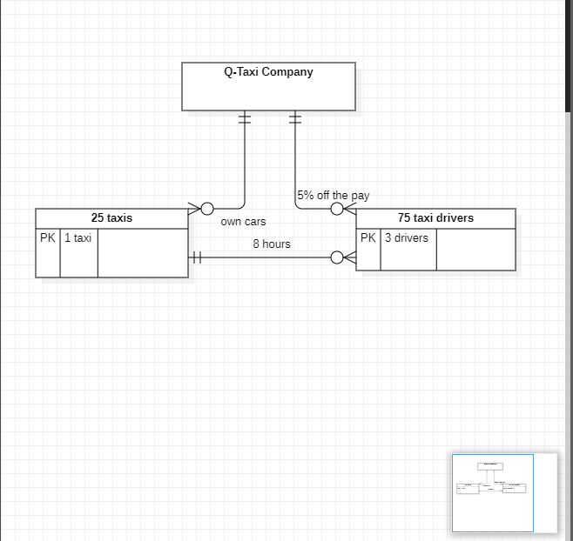
Q-Taxis company have 25 taxis for witch she got 75 drivers, each driver have taxi for 8 hours shift.
The company takes from the drivers front year rent for the car and from what they earn 5%.

2. Use Case diagram
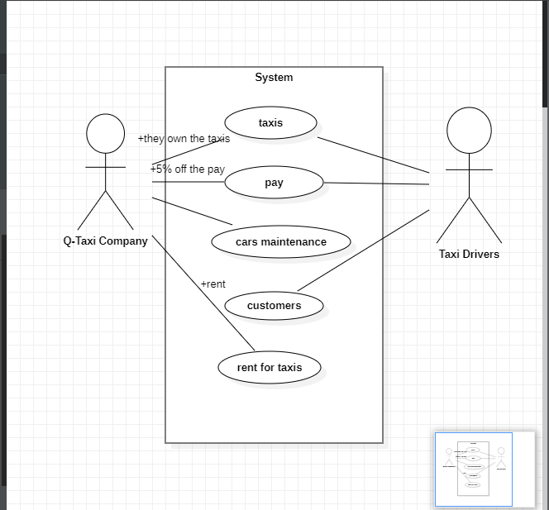
Only the taxis drivers have contact with there customers.
The company is doing the cars maintenances, the drivers just paid rent and give 5% off what they earn, everything else for the cars is paying from the company.

3. Data flow diagram
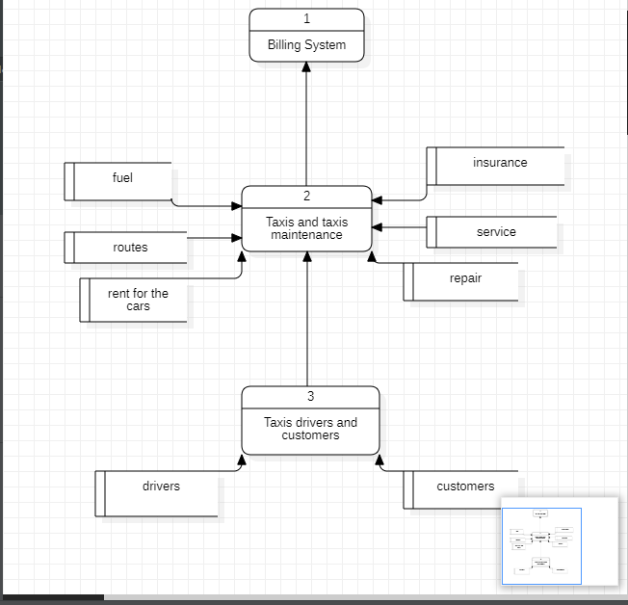
Q-Taxi have 25 taxis which they give for rent to drivers and take 5% off from what they earn. Each taxi is rented from 3 drivers and cover 8 hours shifts.So 75 drivers are working for the company.Every driver is paid year rent fee front and use the taxi for 8 hours every day.The company takes 5% of the money whitch driver earns every week. The company pays for tax, insurance, service and maintenance for the cars.If there is any problem with the car, the company is looking for mechanic to fixed and sorted out , and pay the cost for the service or repair.When drivers finish with they shift they give the money which they earn to the company and if they need to refill the fuel they tell to the company. In the end of every week the company counts the money and give the pay for the drivers when they take 5% off .

