Student information
Student number- 2311234
Student name- Maria Samis
Lecture-Jonathan Wyatt/ Kalee Thomas
Module- Contemporary challenges: making a difference
Module code- BMHP4018
Assignment tittle- E-portfolio (disease historical to present issues)
Word count- equivalent to 2000 words
Submission date- 13th March 2026 extend to 20th March 2026

Table of contents

Student information 1
Mind map 2
Cause and Effect Diagram 3
Evaluation 4
Defining and Contextualising the Issue 4
Evaluating Causes and Effects 5
Sustainable Development Goals and Communicable 6
Human Rights and Ethical Considerations 6
Wales and United Kingdom Responses 6
Potential Solutions and Recommendations 7
Policies 7
Conclusion 8
E-Learning Evidence 8
Topic 1 8
Topic 2 10
Topic 3 11
Reference List 12

Mind map
(Digital tools (AI-ChatGPT) were used to support the creation of the mind map which was allowed by lecture on the Assignment brief - CREATIVE, for this assessment, you can use Generative AI to create creative materials, such as images., Yes)

Cause and Effect Diagram
(Digital tools (AI-ChatGPT) were used to support the creation of the cause-and-effect diagram which was allowed by lecture on the Assignment brief - CREATIVE, for this assessment, you can use Generative AI to create creative materials, such as images., Yes)

Evaluation
Defining and Contextualising the Issue
Communicable disease is still one of the biggest problems for health and social care everywhere. In history, we see how the Black Death in 1300s killed so many peoples because they don’t have good medicine or clean water and the travels was not controlled. Later, in the nineteenth century, tuberculosis (TB) was everywhere because people lived too many in one room, poor food, and no money. Now, with COVID-19, we see that even when we have new technology, still we are not safe from infection. All these examples from past and now show us that communicable disease is not finished, it is still very hard problem, many times because of inequality. Besides TB and COVID-19, HIV/AIDS is also a good example for how diseases are made worse by social inequalities and stigma. HIV/AIDS was first found in the 1980s and it hurt mostly people who are already marginalised, like men who have sex with men, people who use drugs, and people from poorer countries (World Health Organization, 2023). Just like TB and COVID-19, HIV is spread more where there are poverty, not good healthcare, and people are left out from society. Even if now, there is better medicine, like antiretroviral therapy, not everyone can get treatment, and this is still a big problem everywhere. So, communicable diseases are not just about medicine, but also about justice and fairness, and this is why we say it is a wicked problem that is hard to solve.
Some people say communicable disease is what Rittel and Webber (1973) call wicked problem it is very complicated, made from many causes, and we cannot fix it easy. Things like bad house, bad jobs, no doctor, people traveling everywhere, and what politicians decide all these make the problem harder (Berridge, Gorsky and Mold, 2011). If you only fix one thing, like make hospitals better but people still live crowded, you don’t really solve it.
Today, numbers show the problem is very big. World Health Organization (2023) says TB is still one of the top killers, over 10 million new cases every year. COVID-19 killed many and made economy bad, and poor people had it even worse (World Health Organization, 2020; Office for National Statistics, 2021). Marmot (2020) says COVID-19 did not make new inequality, but showed what is already there. Also, resistance to antibiotics (AMR) is becoming danger now, it makes people sick with things we can’t treat so easy (UK Health Security Agency, 2023). And every year, flu makes hospitals full, especially for old people. So, communicable disease is always a problem, not just when there is pandemic.
Evaluating Causes and Effects
From my cause-and-effect diagram, I see that health inequality is very important for how diseases spread and who gets sicker. Bad houses and living too many in one room make people close together, so they get sick easier and can’t stay away from each other. This was true for plague, for TB in old factory towns, and even for COVID-19 when lockdowns were happening. It looks like we never really fix these social problems.
Maybe some will say today’s health systems should fix these things better. NHS started in 1948 from Beveridge Report (1942) to make sure people don’t pay for doctor. This helped many, but during COVID-19, we saw that even if everyone can go to hospital, not everyone gets same help. Some people had trouble because of not enough staff, or not knowing how to use online appointments (NHS England, 2020). Also, TB diagnosis was late in pandemic time (World Health Organization, 2021). So, health systems need to be ready not only for treatment, but also to stop problems before they start.
Jobs are also important. In COVID-19, if you had low paid job or worked in shop, you could not stay home, so you were more in risk. These people also have more health problems, so it’s double hard (Marmot, 2020). Before, in factories, many people got TB because work was not safe (Michael and Thompson, 2012).
Because people and goods move everywhere now, disease moves fast too. Globalisation makes money and jobs but also spreads infection. For example, COVID-19 moved so quick because planes and trains. Also, Antimicrobial resistance (AMR) shows how diseases are getting more difficult because antibiotics don’t work so good anymore (World Health Organization, 2022) and this is a big problem now, not just from poverty but also from how we use medicine and make rules. AMR needs everyone like doctors, governments, and companies to work together to solve it AMR is more because antibiotics is used too much in hospitals and farms (UK Health Security Agency, 2023). AMR is not a big boom like pandemic but goes slow and gets worse.
When people talk about effects, is not only about who dies. It is also about hospitals being full, lockdowns, job losses, mental health getting worse, and schools closing. Department of Health and Social Care (2021) says COVID-19 made NHS very busy and with long waiting lists. So, infection makes all society weaker, not just health service. TB and AMR show us this problem is not going away soon.

Sustainable Development Goals and Communicable
Disease Communicable disease is part of many UN Sustainable Development Goals (SDGs). SDG 3 is about health for everybody and stopping TB. But World Health Organization (2023) says we are not on track, especially after COVID-19 stopped many health services. This shows health progress can break very easy, and HIV is part of Sustainable Development Goal 3 as well, which wants to stop major diseases by 2030 (United Nations, 2015). To reach this, we need more education, support in communities, and fair access to medicine. If we don’t fix poverty and discrimination, the goal is hard to reach.
But as SDG 10 is about making less inequality, and with COVID-19, we see poor people died more (Office for National Statistics, 2021). Marmot (2020) says to fix this, we need better jobs, wages, and houses. Also, SDG 8 says people should have safe jobs, because if not, they go to work sick and spread infection. SDG 11 is about better cities and houses, because crowded homes help disease spread. So, we need all these goals together to stop infections, not just doctors and hospitals.
Human Rights and Ethical Considerations
It is also about rights. United Nations (1989) say every child should get best health possible, but during pandemic, poor children got worse help and could not go to school (Hall and Elliman, 2016). Ethics means we must think first about people who have more problems. Lockdown was difficult too, because it was hard for freedom, but also it protected everyone
Wales and United Kingdom Responses
In Wales, there is a law called Well-being of Future Generations (Wales) Act 2015. This says we must think long-term, prevent problems, and treat people fair. Public Health Wales does vaccines, TB checks, and helps people after COVID-19 to be stronger. In UK, NHS did a lot for vaccine and emergency care. Science worked fast, but there were not enough workers and now hospitals have long waits. UK Health Security Agency (2023) says AMR and TB are still big worries. also, people in the UK get free HIV tests and treatment from NHS helped people live longer, but some groups like migrants or ethnic minorities still don’t get same care (Public Health England, 2019). Wales is trying with early testing. It shows progress, but we still need to keep investing in prevention.
Potential Solutions and Recommendations
To solve communicable diseases, we must use design thinking, which means working together, having empathy, and thinking for the long term (Stickdorn and Schneider, 2011). Just giving medicine is not enough, we need creative and flexible solutions for complex problems and to stop disease, we need to do many things, not just medicine. Make better houses, less crowded, so people don’t get sick so easy (SDG 11). Make sure jobs are safe and pay sick leave, so people can stay home (SDG 8). Health and social care together, in the community, can help find infection early and help poor people more (SDGs 3 and 10). Stickdorn and Schneider (2011) say if we make policies with empathy and listen to people, it works better for everyone. Also, hospitals and farms must use less antibiotics to fight AMR (UK Health Security Agency, 2023). We must teach people about vaccines and good information, not believe rumours. If we don’t fix the big social problems, disease will always come back, and maybe even more strong.

Policies
International and national policies help with Sustainable Development Goals for reducing communicable diseases. The World Health Organization made the End TB Strategy, where the goal is to reduce TB deaths by 95% until 2035. This plan helps SDG 3 because it wants better diagnosis, prevention, and treatment in many countries. Also, there is International Health Regulations, which makes countries work together for stopping outbreaks like COVID-19.
In the UK, the government made the 5 Year Action Plan for Antimicrobial Resistance. This plan is to stop people using too many antibiotics and to slow down resistance. It helps SDG 3 too, by keeping medicines working and making health better. In Wales, the Well-being of Future Generations Act 2015 helps many SDGs because it wants prevention, equality, and better health for long time. All these policies show that governments and world organisations try to fight communicable diseases not just with hospitals, but also with social and environmental actions.

Conclusion
Communicable diseases are always a challenge, from history until now, because of inequality, global movement, and weak points in society. Black Death, TB, COVID-19 – all these show us that if poor people suffer, everyone is in danger. NHS and laws in Wales help, but not enough if we don’t stop inequality and prepare for future. If we follow SDGs 3, 8, 10, and 11, and work on social problems, maybe in future, disease will be less problem. But if not, this will be a wicked problem for many more years.

E-Learning Evidence
Screenshots showing completion of all required e-learning units

Topic 1
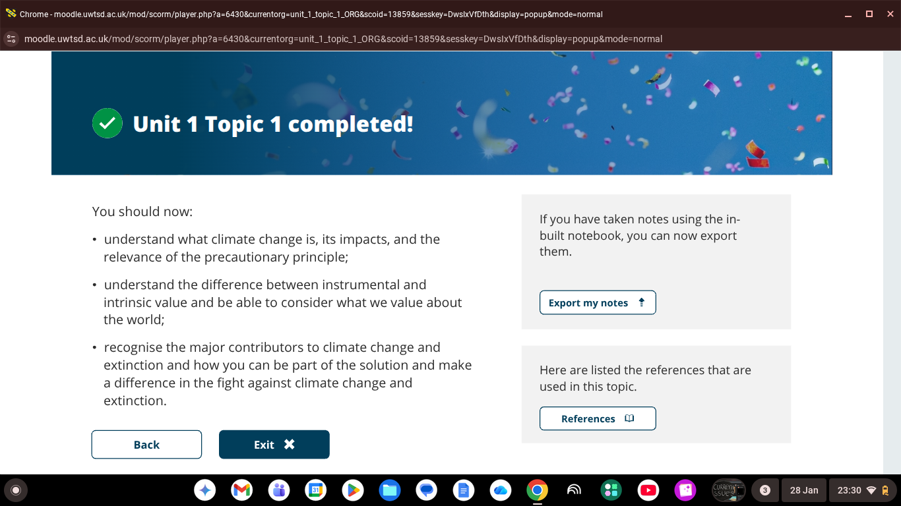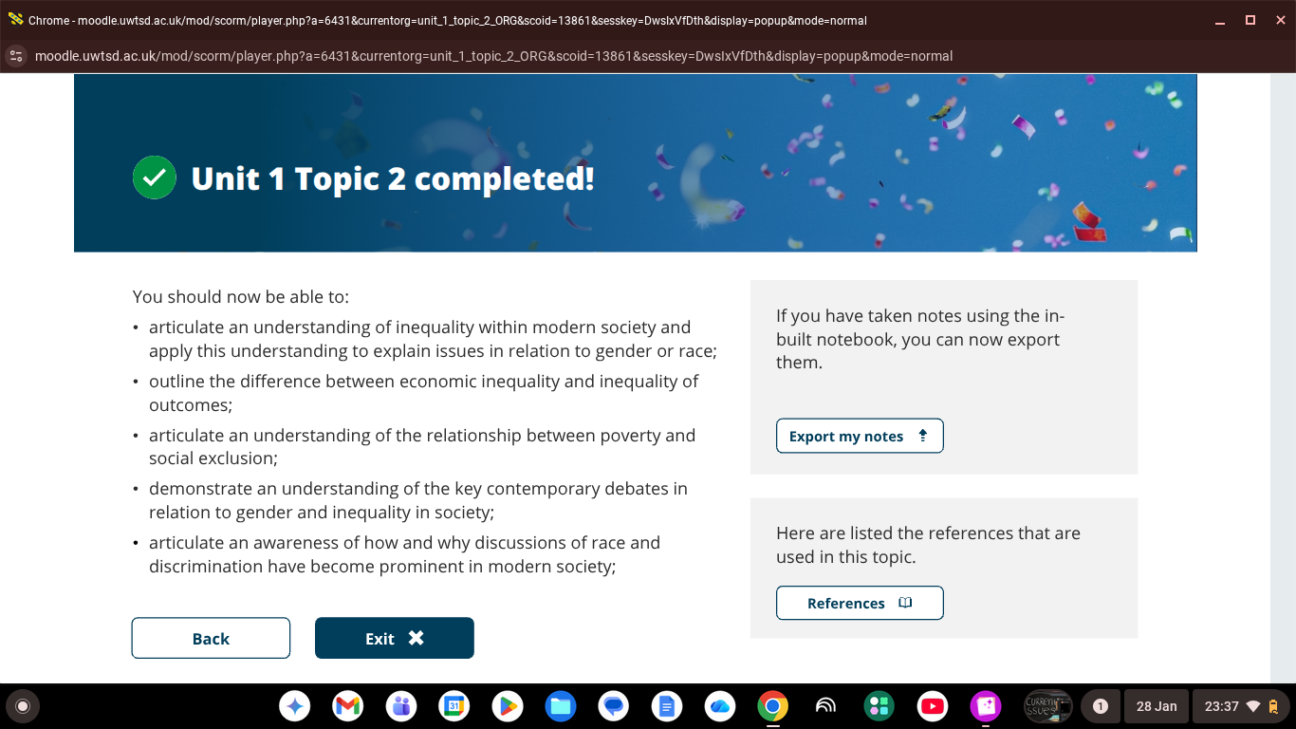
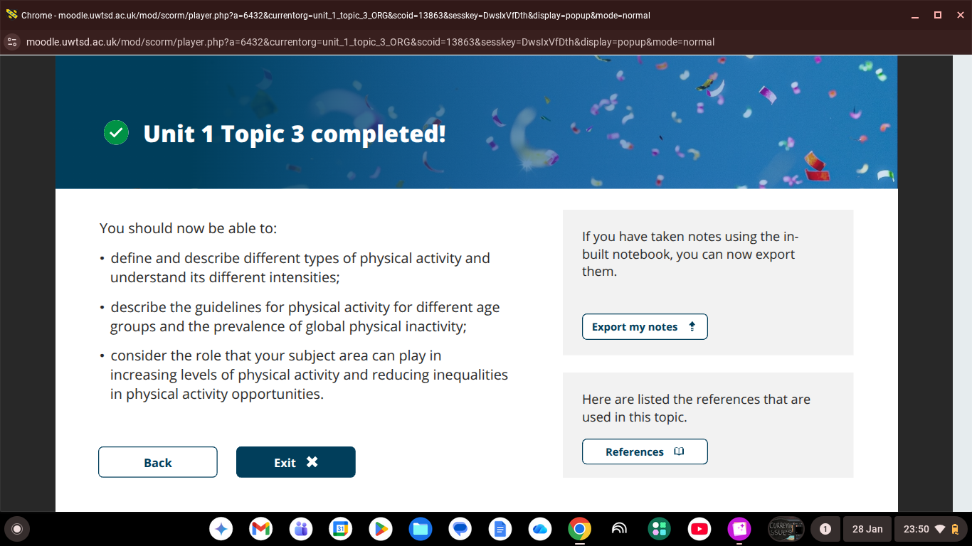
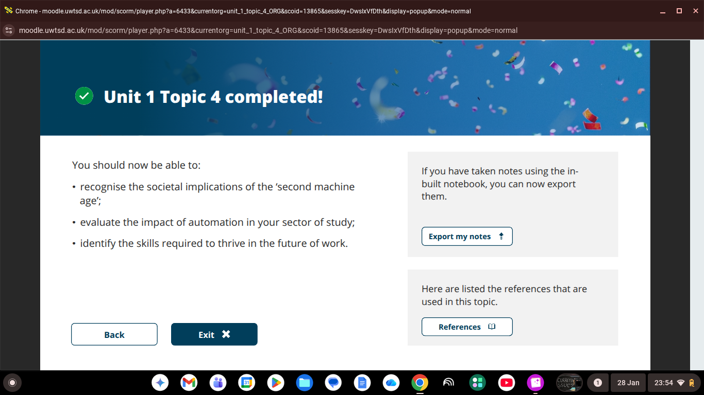

Topic 2
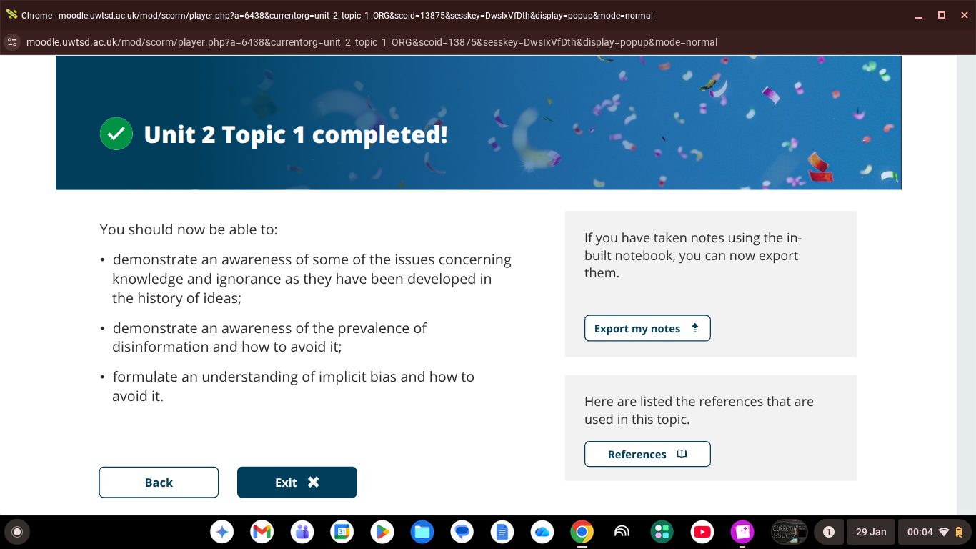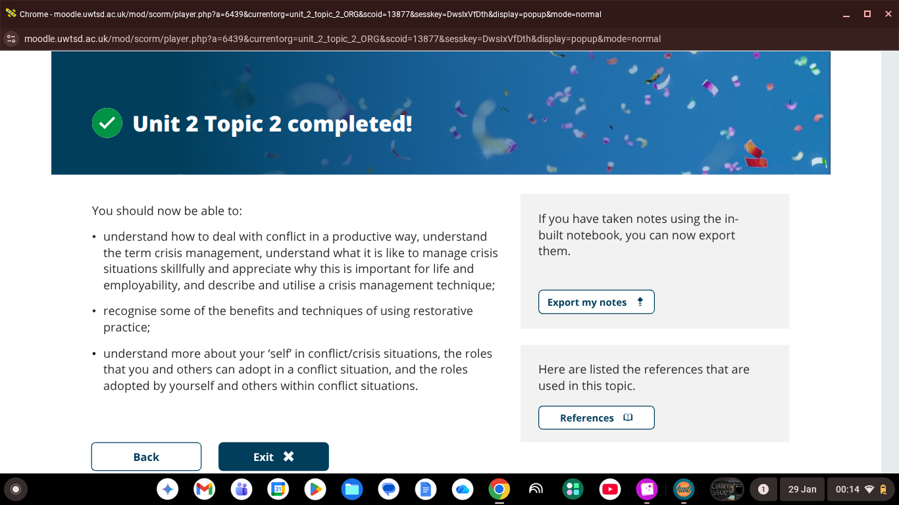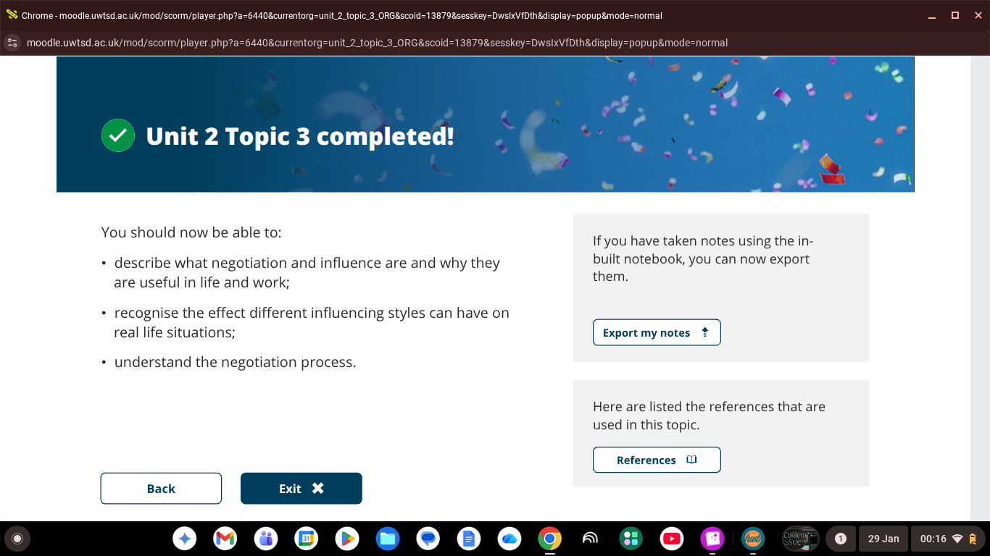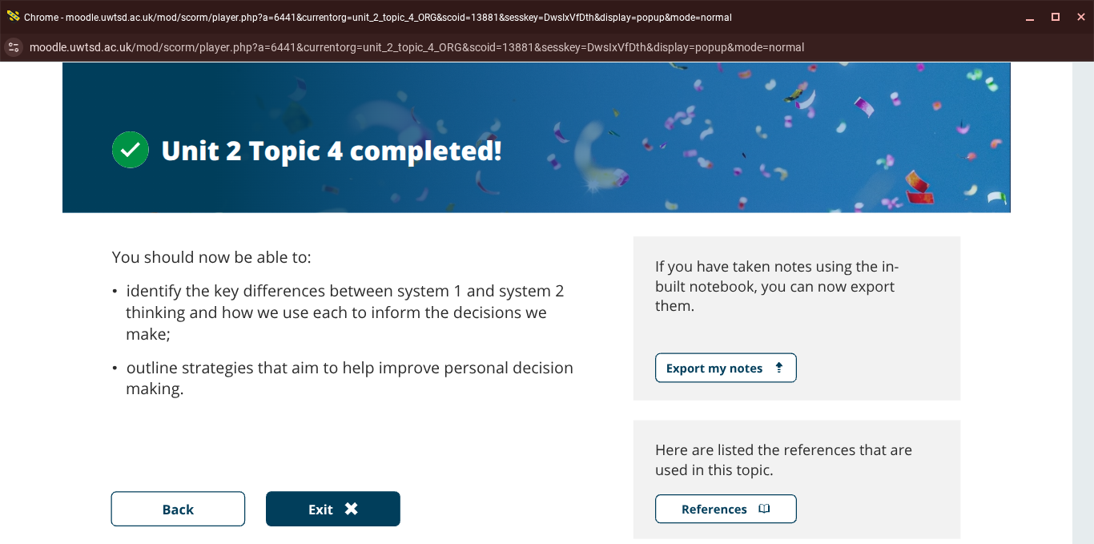

Topic 3


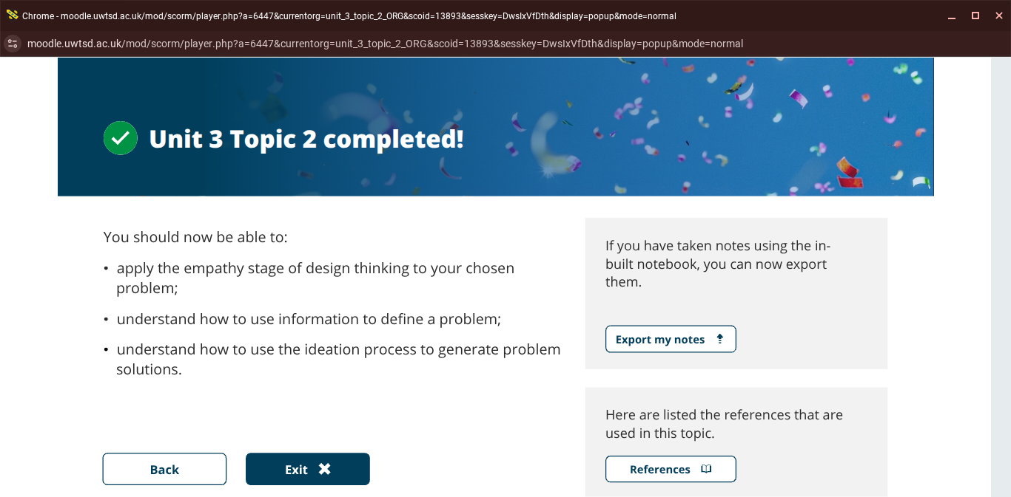

Reference List
Berridge, V. (1996) AIDS in the UK: the making of policy, 1981–1994. Oxford: Oxford University Press.
Berridge, V., Gorsky, M. and Mold, A. (2011) Public health in history. Maidenhead: Open University Press.
Beveridge, W. (1942) Social insurance and allied services. London: HMSO.
Brown, B., Crawford, P. and Hicks, C. (2013) Evidence-based research: dilemmas and debates in health care. London: Routledge.
Department of Health and Social Care (2021) COVID-19 response: lessons learned. London: DHSC.
Echavarria, M. (2015) Enabling collaboration. New York: LID Editorial.
Gostin, L.O. and Katz, R. (2016) ‘The International Health Regulations: the governing framework for global health security’, Milbank Quarterly, 94(2), pp. 264–313.
Hall, D.M.B. and Elliman, D. (2016) Health for all children. 4th edn. Oxford: Oxford University Press.
Hart, E. and Bond, M. (1995) Action research for health and social care. Buckingham: Open University Press.
Knapp, V.J. (1989) Disease and its impact on modern European history. New York: Edwin Mellen Press.
Meers, P., McPherson, M. and Sedgwick, J. (2012) Infection control in healthcare. 2nd edn. Oxford: Wiley-Blackwell.
Michael, P. and Thompson, S. (2012) Public health in Wales c.1800–2012. Cardiff: University of Wales Press.
NHS England (2020) COVID-19 prioritisation within health services. London: NHS England.
Office for National Statistics (2021) Deaths involving COVID-19 by socio-economic characteristics. London: ONS.
Orme, J., Powell, J., Taylor, P. and Grey, M. (2014) Public health for the 21st century. 2nd edn. Maidenhead: Open University Press.
Philpott-Howard, J. and Casewell, M. (2004) Hospital infection control. London: Saunders.
Public Health England (2019) HIV in the United Kingdom: Towards zero HIV transmissions by 2030. London: PHE.
Reid, N. (2018) Health care research. London: Sage.
Scriven, A. and Garman, S. (2007) Public health: social context and action. Maidenhead: Open University Press.
Siebel, T.M. (2019) Digital transformation: survive and thrive in an era of mass extinction. New York: Rosetta Books.
Stickdorn, M. and Schneider, J. (2011) This is service design thinking: basics, tools, cases. Amsterdam: BIS Publishers.
United Nations (1989) Convention on the Rights of the Child. New York: United Nations.
United Nations (2015) Transforming our world: the 2030 Agenda for Sustainable Development. New York: United Nations.
Welsh Government (2015) Well-being of Future Generations (Wales) Act 2015. Cardiff: Welsh Government.
World Health Organization (2005) International Health Regulations. 3rd edn. Geneva: World Health Organization.
World Health Organization (2015) The End TB Strategy. Geneva: World Health Organization. Available at: https://www.who.int/ Accessed: 9 March 2026).
World Health Organization (2020) COVID-19 and the social determinants of health. Geneva: WHO.
World Health Organization (2021) Global tuberculosis report. Geneva: WHO.
World Health Organization (2022) Antimicrobial resistance. Geneva: WHO.
World Health Organization (2023) Global HIV programme: key facts. Geneva: WHO.

