
Research on performance optimization management of Vanke real estate enterprises

STUDENT NAME: Zhenjiang Lin
STUDENT NUMBER:2216879

Abstract

From the perspective of performance management, this paper discusses how real estate group enterprises can jointly promote the transformation of enterprises to refinement through organizational performance management with the balanced scorecard as the core, personal performance management with KPI as the core, and amoeba management with partnership as the core. Through performance management, we can effectively bind organizational goals and personal goals to achieve win-win results for enterprises and employees.

Key words: real estate; Vanke; Employee performance; performance management

Contents

Abstract I
1 Introduction 1
2 Organisational overview 2
3 Main discussion 3
4 Conclusions 4
（1） Ambiguous management objectives 4
（2） Incomplete relevant systems 4
（3） Using the Balanced Scorecard Model 5
（4） There is a weak correlation between organizational goals and personal performance 5
5 Recommendations 6
（1） Smart Goals Model 6
（2） Build a multidimensional objective evaluation system 7
6 Reference list 9

1 Introduction
In recent years, policies related to China's real estate have been introduced in succession, and "no speculation in real estate" has become the guiding principle of the policy. With the development of purchase restriction, loan restriction, sales restriction and "real estate tax", the real estate market has fallen to the freezing point. In this context, real estate enterprises are faced with major strategic choices. How to adapt to market changes and survive the freezing period has become a difficult problem for current real estate enterprises to overcome. Based on this, staff performance improvement and refined management have become the main theme of real estate companies. Fine management is the process of decomposing, refining and implementing the strategy and objectives, and is the process of enabling the enterprise's strategic planning to be effectively implemented in each link and play a role. This requires enterprises to strengthen performance management, implement management responsibilities, specify and clarify management responsibilities, and timely correct deviations in the process of finding problems, so as to jointly achieve the goal(Hu.2014).

2 Organisational overview
Vanke Enterprise Co., Ltd., founded in May 1984, is currently one of the largest professional residential development enterprises in China. It has branches in more than 20 cities in China, with a total staff of more than 130000.
In 2011, the company completed a new construction area of 4.91 million square meters, a completed area of 5.364 million square meters, a sales amount of 63.42 billion yuan, operating income of 48.88 billion yuan, and net profit of 5.337 billion yuan.

Vanke Headquarters includes three business directions: a career development center, a management center, and a support center. Each center has an independent human resources management department. At the same time, this department has cross management for employees in various local branches, which results in an employee having two superior leaders, one for the business direction, and the other for the local leaders of the branch. This may lead to confusion in employee performance appraisal. This article uses the basic design of the balanced scorecard performance system to solve the problem of performance appraisal for Vanke employees.
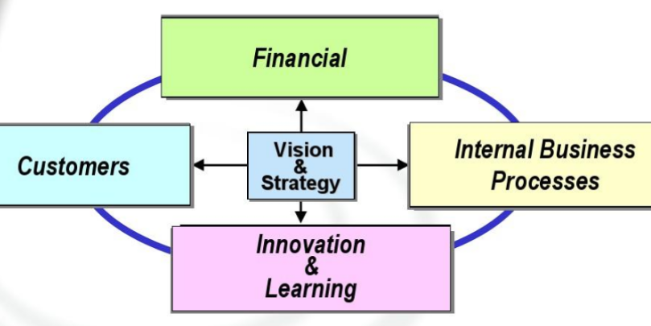

3 Main discussion

Vanke Group needs to improve its organizational performance and personal performance, because the group system is huge, the number of employees is large, and the performance completion standard is not clear enough, which greatly affects the work efficiency and is not conducive to the development of the entire enterprise. Performance management can organically combine the enterprise's strategy, resources, business and actions. First, performance management helps to ensure the consistency of enterprise objectives and employee behaviors. In the performance planning stage, through the hierarchical decomposition of objectives, the efforts of departments and employees are coordinated with the development of the enterprise, and the achievement of enterprise objectives is promoted. It is an important means to ensure the achievement of organizational objectives. Second, performance management is an important means to improve organizational management efficiency and work efficiency. Finally, performance management is an important way for employees to identify gaps, analyze reasons, improve work and seek development.

4 Conclusions
After the discussion above, we can find that Vanke Real Estate has problems in employee performance management:

（1） Ambiguous management objectives
The organizational management objectives are not clear. It can be seen that there is often departmentalism among various projects and departments of Vanke Group. The main reason for this phenomenon is that the objectives of the organization are not clear enough. For example, the sales department believes that the lower the price is, the better the profit is(Qiulin.2005). The cost department believes that the lower the cost is, the higher the profit is. The product department believes that the quality presentation can improve the core competitiveness, while the business managers take the maximum efficiency of human, financial, material and other resources as their business objectives (Tao&al.2021). The organizational management objectives must be understood and accepted by the members of the organization. Only when the understanding of the objectives by the members of the organization is not too different can they become the basis of the collaborative system.

（2） Incomplete relevant systems
The enterprise system is not perfect and lacks corresponding constraints and incentives, which is not conducive to refined management. Fine management is to replace general and vague management requirements with specific and clear quantitative standards, and transform abstract strategies and decisions into specific and clear development measures (Nicola & al. 2020). According to the current situation of the enterprise and the "fine" thinking, identify the key problems and weak links, improve and revise the relevant management system(Liu.2020), so that the enterprise can scientifically refine and reasonably optimize its business process and management process on the basis of standardization and standardization.
（3） Using the Balanced Scorecard Model
The evaluation of different dimensions is different for the same work result. Subordinates have a shallow experience value and generally agree with the work results, while peers pay more attention to whether it can bring direct benefits(Feng.2021), and superiors pay more attention to whether the value matches the contribution and the subsequent development potential, which makes the same work result different in different management levels.

Here, I find a performance appraisal form for Vanke Company, taking the marketing director as an example:
Indicator dimension | KPI indicators | weight | Performance target value | Assessment score
Finance | Return on Net Assets | 10% | The return on net assets during the assessment period is ____% above
Main business income | 10% | During the assessment period, the main business income reached____ 10000 yuan
sales revenue | 10% | Sales revenue reached during the assessment period____ 10000 yuan
selling expenses | 5% | Control the sales expenses within the budget during the evaluation period
Payment recovery rate | 5% | The recovery rate of payment for goods within the assessment period reaches ____%
Internal operations | Completion rate of annual corporate development strategic objectives | 10% | During the evaluation period, the completion rate of the annual enterprise development strategic goals reached ____%
Sales plan completion rate | 10% | The completion rate of the sales plan during the evaluation period reaches ____%
Contract performance rate | 5% | During the evaluation period, the contract performance rate reached ____%
Sales growth rate | 5% | Achieve ____% during the evaluation period
Completion rate of marketing plan | 5% | The completion rate of the marketing plan during the evaluation period reaches ____%
Customer category | Market share | 5% | Market share reached ____% during the evaluation period
Customer retention rate | 5% | During the evaluation period, the customer retention rate reached ____%
Customer satisfaction rate | 5% | During the evaluation period, the customer satisfaction rate was ____% above
Learning and Development | Training plan completion rate | 5% | The completion rate of the training plan during the assessment period reaches 100%
Core employee retention rate | 5% | During the evaluation period, the core employee retention rate reached ____%
Total score of this assessment
Appraisal Indicator Description | Sales growth rate
Appraisee | Assessor | Reviewed by
Signature: Date: | Signature: Date: | Signature: Date:

（4） There is a weak correlation between organizational goals and personal performance
There are certain differences between organizational objectives and employees' personal objectives. For an organization, in terms of resource matching, the first thing is to ensure the achievement of the organization's objectives. This requires that the individual employee is the leader in the relevant fields and has the successful experience of the project, and learn from each other to complement each other, so as to ensure the achievement rate of the organization's performance(Gan.2021). For employees, they want to undertake more important, high-growth and high-value work, and have a low willingness to work that they have mastered, such as being unable to improve in a short time and difficult to break the situation, or causing fatigue or even leaving the company.

5 Recommendations
（1） Formulate and clarify management objectives at all levels
A. Establishment of organizational management objectives. The organizational goal is the soul of the organization and the purpose of its activities(Wan.2022). When the goal is clear, the mind holds something, and the energy focuses on the value(Wang.2022). The action force can be stronger. Set organizational goals from top to bottom(He.2022). First of all, before taking the land, we should first establish the strategic goal, which is to make profits, to build brand reputation, or to try new product series and seize market share. Then, according to the strategic objectives, set the conceptual planning plan, (Zhang, 2022) further deduce the feasibility study and judgment, estimate how much investment, how much cost, when cash flow will be positive, and how much profit will be achieved, so as to reverse the cost of land and obtain land within the budget. Secondly, in the formulation stage of organizational objectives, further clarify the project positioning according to the strategic objectives and market research, and decompose and refine the management objectives at all levels, so that the members of the organization can understand and accept the management objectives of the panoramic, annual, quarterly and monthly departments.(Wei.2022) Finally, in order to further clarify and ensure the effective implementation of the organizational objectives, the group and the project will carry out hierarchical management and assessment on the core nodes, primary nodes, secondary nodes and tertiary nodes in the panoramic business plan and annual business plan, clarify the target value and challenge value of indicators(Wang.2022), clarify the completion deadline and assessment rules, monitor the completion of the work of each department through monthly planning tasks, and report through the reporting mechanism(Tao.2022), The online operation system monitors the progress of the work and also provides a basis for the evaluation of the target results(Lu.2022).

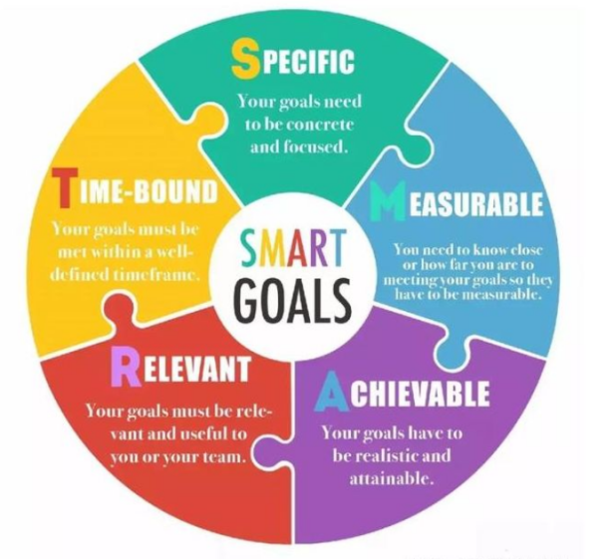
B. Optimize personal performance appraisal and encourage employees to grow(Li.2022). In order to fully mobilize and stimulate the enthusiasm and creativity of employees, both "achievement of results" and "ability development" should be considered in performance evaluation. On the one hand, strengthen the achievement of individual performance objectives established after the decomposition of organizational objectives(Jiao.2022), which are linked to the elimination mechanism, training resources, performance bonus, incentive distribution mechanism and salary adjustment; On the other hand, optimize the employee growth incentive plan, and link it with appraisal, job rotation, echelon talent training, and promotion opportunities, so as to promote the continuous optimization and promotion of enterprises and employees and achieve win-win results(Li.2022).
C. Establish the project inspection system and follow up and correct the deviation in time(Sun.2022). Patrol inspection is to record and report in time according to the target inspection. There are three purposes: first, strengthen the key objectives and achieve "early detection, early warning and timely correction"; The second is to learn from each other's strengths and make up for each other's weaknesses. The highlights of each project will be promoted to the whole group to learn and improve together. The shortcomings and improvement measures will be compiled into a volume and taught in a centralized manner to avoid similar situations in other projects; Third, process records. Provide objective basis for performance evaluation.
D. Improve the interview management mechanism and adjust cognitive differences. Improve the interview management mechanism, pay attention to the achievement of performance and employee growth, adjust cognitive differences through the interview, affirm the excellent performance and point out the next challenge goal(Qin.2022); Find out the gaps and clarify the improvement methods for the qualified employees, so as to make the employees more clear about the organizational goals and personal goals, and correct the deviations in time during the process, so as to effectively help the employees grow.
（2） Build a multidimensional objective evaluation system
A. Evaluation system of organizational performance. The core indicators of organizational performance evaluation are: progress and quality indicators, financial indicators, team management indicators and customer satisfaction(Zhang.2022), which are assigned by weight, and each dimension is composed of quantifiable indicators On this basis, the difference is dynamically adjusted according to the project difficulty value (the difficulty coefficient is evaluated from the land acquisition to the positioning stage) and the resource allocation value (the more resources are invested, the lower the value is assigned), so as to balance the evaluation difference caused by the imbalance of resources among various projects(Zhao.2022).
B. Personal performance evaluation system. On the one hand, it is based on the evaluation of performance results, mainly from the three dimensions of plan, process and results. First, evaluate the relevance of organizational goals and individual performance, and the achievement of planned and actual performance results; Secondly, the process evaluation is carried out through the key event recording method, case analysis, patrol scoring, third-party scoring, mutual inspection and mutual inspection score and spot check score(Gu.2022); Finally, employees at all levels will make management report and management review on performance results to effectively summarize and improve management. On the other hand, it is based on the evaluation of personal growth, mainly from the two dimensions of ability and potential(Xiao.2022). The specific evaluation methods include: interview, evaluation, examination, training clearance, competency evaluation, and comprehensive evaluation of the placement of the nine-house grid, personal reporting, job rotation, experience sharing, 360 evaluation, situation simulation, management case analysis, promotion clearance, etc. The direct supervisor will conduct a performance feedback interview with the employees for the evaluation results(Lin.2021).. Both parties will confirm the performance results, and simultaneously formulate and confirm the performance plan for the next cycle. In order to prevent the inconsistency of evaluation results, the controversial performance evaluation shall be reevaluated to effectively unify the understanding differences of all parties and ensure the objective and fair evaluation results.

6 Reference list
[1] Chun Xia Hu.(2014).Study on the Improvement Method of Employees' Performance Evaluation System.Li Juan Huang.Advanced Materials Research.
[2] Ke Qiulin.(2005).The corporate governance structure and corporate performance : empirical studies of China's listed real estate companies. University of Greenwich.
[3] Zou Tao;Bai Sijun;Tsai Sang-Bing.(2021).Enterprise Performance Optimization Management Decision-Making and Coordination Mechanism Based on Multiobjective Optimization. Mathematical Problems in Engineering.
[4] Breugst Nicola;Patzelt Holger;Shepherd Dean A.(2020).When is Effort Contagious in New Venture Management Teams.Understanding the Contingencies of Social Motivation Theory.Journal of Management Studies.
[5] Guangping Liu.(2020).Performance Monitoring of Project Earned Value considering Scope and Quality. KSCE Journal of Civil Engineering.
[6] Feng Yifei. (2021).Analysis on the current situation and countermeasures of performance management of real estate enterprises.Enterprise Reform and Management.
[7] Gan Yeqiang.(2021).Probing into the difficulties and countermeasures of performance management of real estate enterprises.economist.
[8] Wan Hongxing.(2022).Analysis on the current situation and countermeasures of performance management in manufacturing enterprises .China Market.
[9] Wang Fei.(2022).Explore the integration path of budget management and performance management .China Agricultural Accounting.
[10] He Yanyan. (2022).The positive impact of performance appraisal management in the work of real estate development enterprises.Modern Marketing (first ten-day issue).
[11] Zhang Guofu, Qu Wenchong&Song Zikang (2022). Research on Financial Performance under Vanke's Asset Light Operating Model National Circulation Economy (31), 81-84
[12] Wei Linhao (2022). Research on Vanke's Financial Performance Based on EVA Financial Management Research (09), 47-51
[13] Wang Yu (2022). A Case Study of the Impact of "The Battle of Wanbao" on the Operating Condition and Market Value of Vanke Company (Master's Thesis, Hebei University of Finance)
[14] Tao Lulu (2022). Research on the Impact of Introducing Professional Managers into Family Enterprises on Financial Performance (Master's Thesis, Nanjing University of Information Engineering)
[15] Lu Yin (2022). Research on Financial Performance Evaluation and Improvement of Poly Development under the Asset Light Operating Model (Master's Thesis, Anhui University of Finance and Economics)
[16] Li Lanqing (2022). Research on Financial Performance Evaluation of B Real Estate Company under the Asset Light Operating Model (Master's Thesis, Chongqing Business University)
[17] Jiao Li (2022). An Analysis of the Relationship between Working Capital Management and Enterprise Performance: Taking Vanke as an Example Journal of Shandong Vocational and Technical College of Commerce (01), 29-36
[18] Li Shuo (2021). Research on Financial Performance Evaluation of Vanke Group Based on Factor Cluster Analysis (Master's Thesis, Central South University of Forestry and Technology)
[19] Sun Lu (2021). Research on the Impact of Asset Light Model on Financial Performance of Real Estate Enterprises (Master's Thesis, Southeast University)
[20] Qiu Rongxin (2018). Research on the Implementation Effect of Vanke Group's Equity Incentive Plan (Master's Thesis, Guangzhou University)
[21] Zhang Huajian.(2022).Research on performance management optimization of state-owned enterprises in the context of deepening reform -- taking S state-owned enterprises as an example.Business Economics.
[22] Zhao Yansong.(2022).Incorporate the point system management mode to improve the enterprise performance management system -- take JFS as an example.economist.
[23] Gu Yifei.(2022).Research on the application of performance management in X Insurance Company .Quality and Market.
[24] Xiao Ze.(2022).Innovation path of enterprise human resource performance management in the era of big data.Human Resources Development.
[25] Lin Kexin.(2021).Analysis of performance management countermeasures for commercial real estate operation in the post-epidemic era.Business Exhibition Economy.

