Targets | How you have worked on this | An example can be found on
Target 1
Target 2
Target 3

ECAD6009-C

Part B – How a school develops one aspect of its SDP: a report that critically reflects on the actions, impact and evidence base.

Student Number: 1903950 CM Maudie Hughes

Word Count:

Assignment Title
How a school develops one aspect of its SDP: a report that critically reflects on the actions, impact and evidence base.

Table of Contents

Introduction
This report will examine one element of the School Improvement Plan (SIP) from a Welsh primary school. The school will be referred to as School X in order to protect the anonymity of its staff, learners and community in line with BERA guidance (BERA, 2018).

School X is a rural village primary school that currently has 234 pupils on roll (mylocalschool, 2022). Around 5.7% of learners in the school are eligible for Free School Meals, significantly lower than the national average of 21.3%, whilst around 22.3% of learners are considered to have an additional learning need (ALN), marginally above the national average of 20.6% (StatsWales, 2021). The school has developed a School Improvement Plan (SIP) covering the academic year from September 2021 to July 2022 that has four Priority Areas. In this report one area has been chosen as the focus, relating to the implementation of the curriculum for Wales (Welsh Government, 2022).

School Improvement Plans
School improvement plans (SIP), also known as school development plans (SDP) are strategic planning documents drawn up by every school to outline what and how over a three year period they will be focusing on in order to improve outcomes for learners (Welsh Government, 2014). Often containing targets linked to improving and maintaining standards in literacy and numeracy, the plans may also include targets relating to reducing the variation of attainment believed to be linked to poverty, and or other targets that have been influenced by local or national policy priorities (Reeves, McCall and MacGilchrist, 2001; Welsh Government, 2014). In the case of School X, there are 4 Priority Areas outlined on the plan with a number of targets detailed under each heading, with then a list of actions to be achieved to meet these targets. The plan also details which member or members of staff will lead on the plan, what costs may be associated with the action points, how the activity will be monitored and by when, and further details relating to the expected outcomes and success criteria. Finally there is a column allowing for ‘RAG’ rating (Law, 2016) where progress is shown using the colours of a traffic light. An example of the layout and typical content can be seen in the Appendix, Figure 1. It is worth noting that this particular plan has been drawn up to cover a single academic year, rather than a three year period which is considered to be a more typical length of time for a strategic plan (Davies and Ellison, 2003). As such the plan under review here could be considered to be a short term rather than medium term document, and this will be discussed further in due course.

The focus area under consideration here relates to priority area 1 of the plan, which is concerned with implementation of the curriculum for Wales (see Appendix, Figure 2). As can be seen on the document, there are two targets within this priority, each supported by a number of proposed actions and tasks. Of these targets, consideration is being given to the first, which aims to ‘further embed the Vision for the New Curriculum, ensuring that all stakeholders have a thorough and enhanced grasp of the future for our federation of schools’ (School X, 2022 – Appendix, Figure 2), looking specifically at action points relating to the four purposes of the curriculum (Welsh Government, 2022a).

Following the publication of the Successful Futures report (Donaldson, 2015) and subsequent consultations with stakeholders, the Welsh Government produced a new curriculum for use in Wales that will become statutory for maintained primary schools in September 2022 (Welsh Government, 2021). As such the inclusion of this particular target on the SIP will have been significantly influenced by this national policy. Nonetheless, along with many other schools, School X has already begun to adopt a significant majority of the curriculum and apply it in daily practice and activity (Deputy Head Teacher, School X, 2022) and so inclusion of this target area has also been determined through the school’s own self-evaluation process.

Self-evaluation is a process that schools are expected to undertake on a regular basis in order to inform and develop strategic plans such as the SIP, and also identify other areas beyond the plan where improvement is required (Welsh Government, 2021a). When done effectively it will involve the whole school community and draw on evidence and data supplied by a range of stakeholders, which in turn helps to promote effective engagement with the plan improvement plan that is then created. In this instance key stakeholders in the target area are predominantly staff, however the views of parents and learners will also have been considered, having been collected through consultations, general meetings and discussions and through monitoring of the learners’ work (Deputy Head Teacher, School X, 2022).

The four purposes have been placed firmly at the centre of the curriculum as the “starting point and aspiration for every child and young person in Wales” (Welsh Government, 2022b). Designed to develop “ambitious capable learners, ethical informed citizens, healthy confident individuals and enterprising and creative contributors” (Welsh Government, 2022a) the four purposes statements describe a range of skills and attitudes that schools are expected to develop in the learners as they progress through their education. This approach has been taken by the Welsh Government to promote the development of children and young people as responsible and active citizens who will become key in developing a better Wales, and therefore able to support the seven goals of the Well-being of Future Generations (Wales) Act 2015 (Welsh Government, 2022c). Many of the statements within the four purposes can be linked to these seven goals (Welsh Government, 2022a; Welsh Government, 2021a) which include aims such as “a healthier Wales, a prosperous Wales and a Wales of cohesive communities” (Welsh Government, 2021a).

School X
It is clear from the SIP that School X has created that the school leadership have noted the importance Welsh Government have placed on the four purposes (Welsh Government, 2022a). Furthermore there is evidence in the statement given for Priority Area 1 that the school are aware of and engaged with the wider education and policy communities that can influence their activity as they refer to the ‘our national mission’ document created by Welsh Government as part of the education transformation activity (2017) (see Appendix, Figure 2). Not clear from the document is how the school’s own self-evaluation activity influenced the inclusion of this priority area, however discussion with the Deputy Head Teacher did suggest that ongoing feedback from work scrutiny activity and staff meetings had been used to formulate the action points identified (Welsh Government, 2014; Deputy Head Teacher, School X, 2022).

Also clear from the document is the intention to involve a range of stakeholders, namely staff, learners, and the governing body (referred to as GB) (see Appendix, Figure 2), and again this is something considered to be good practice, if not essential, in creating and delivering the SIP successfully (Woods and Brighouse, 2013; Welsh Government, 2014). The monitoring and review column makes reference to the various parties that will be involved in and what form that involvement will take. Mention is also made of the proposed use of learning walks as a means by which monitoring will take place. Learning walks allow the observer to see a range of activity whilst it is happening in real time against a specific focus that will have been predetermined (Woods and Brighouse, 2013; Estyn, 2021).

Reference List

Mylocalschool (2022), Tavernspite CP School Available at: https://mylocalschool.gov.wales/School/6682266?lang=en#0 (Accessed: 16 May 2022)

BERA (2018) Ethical Guidelines for Educational Research 4th edn. Available at: https://www.bera.ac.uk/publication/ethical-guidelines-for-educational-research-2018 (Accessed: 16 May 2022)

StatsWales (2021), Pupil Level Annual School Census summary data by local authority (pupils aged 5 to 15 in primary, middle or secondary schools) Available at: https://statswales.gov.wales/Catalogue/Education-and-Skills/Schools-and-Teachers/Schools-Census/Pupil-Level-Annual-School-Census/pupillevelannualschoolcensussummarydata-by-localauthority (Accessed: 16 May 2022)

Welsh Government (2014), School Development Plans: Guidance Available at: https://gov.wales/sites/default/files/publications/2018-03/school-development-plans.pdf (Accessed: 16 May 2022)

Reeves, J., McCall, J. and MacGilchrist, B., (2001) ‘Change leadership: planning, conceptualization and perception’, in MacBeath, J., and Mortimore, P. (ed.) Improving Schoo Effectiveness Maidenhead: Open University Press

Law, J., (2016) A Dictionary of Accounting. 5th edn. Oxford: Oxford University Press

Welsh Government (2022a) Developing a vision for curriculum design Available at: https://hwb.gov.wales/curriculum-for-wales/designing-your-curriculum/developing-a-vision-for-curriculum-design/#curriculum-design-and-the-four-purposes (Accessed: 16 May 2022)

Donaldson, G., (2015) Successful Futures: Independent Review of Curriculum and Assessment Arrangements in Wales Available at: https://gov.wales/sites/default/files/publications/2018-03/successful-futures.pdf
(Accessed: 15 May 2022)

Welsh Government, (2021) Curriculum for Wales: the journey to curriculum roll-out Available at: https://hwb.gov.wales/curriculum-for-wales/curriculum-for-wales-the-journey-to-curriculum-roll-out#page-wrapper (Accessed: 19 May 2022)

Deputy Head Teacher, School X (2022) Conversation with CM Maudie Hughes during Professional Teaching Experience 3, 8 March.

Welsh Government, (2021a) School improvement guidance: framework for evaluation, improvement and accountability Available at: https://gov.wales/sites/default/files/consultations/2021-01/210126-school-improvement-guidance-framework-for-evaluation-improvement-accountability.pdf (Accessed: 19 May 2022)

Welsh Government, (2022) Curriculum for Wales Available at: https://hwb.gov.wales/curriculum-for-wales/ (Accessed: 16 May 2022)

Welsh Government, (2022b) Introduction to Curriculum for Wales guidance Available at: https://hwb.gov.wales/curriculum-for-wales/introduction/ (Accessed: 20 May 2022)

Davies, B., and Ellison, L., (2003) The New Strategic Direction and Development of the School: Key Frameworks for School Improvement Planning. 2nd edn. London: Routledge

Welsh Government, (2022c) Well-being of Future Generations (Wales) Act 2015 Available at: https://www.futuregenerations.wales/about-us/future-generations-act/ (Accessed: 22 May 2022)

Welsh Government, (2021a) Well-being of Future Generations (Wales) Act 2015: Essentials Guide Available at https://gov.wales/sites/default/files/publications/2021-10/well-being-future-generations-wales-act-2015-the-essentials-2021.pdf (Accessed: 22 May 2022)

Welsh Government, (2017) Education in Wales: Our national mission: Action plan 2017 – 2021 Avaialble at: https://gov.wales/sites/default/files/publications/2018-03/education-in-wales-our-national-mission.pdf (Accessed: 22 May 2022)

Estyn, (2021) Supplementary guidance: Lesson observation and learning walks – September 2021: Lesson observation: General principles Available at: https://www.estyn.gov.wales/document-page/20555/contents/guidance/lesson-observation-general-principles (Accessed: 22 May 2022)

Woods, D., and Brighouse, T., (2013) The A-Z of School Improvement: Principles and Practice London: Bloomsbury Education

Appendix
Figure 1 – Screen Shot of a page of the SIP from School X
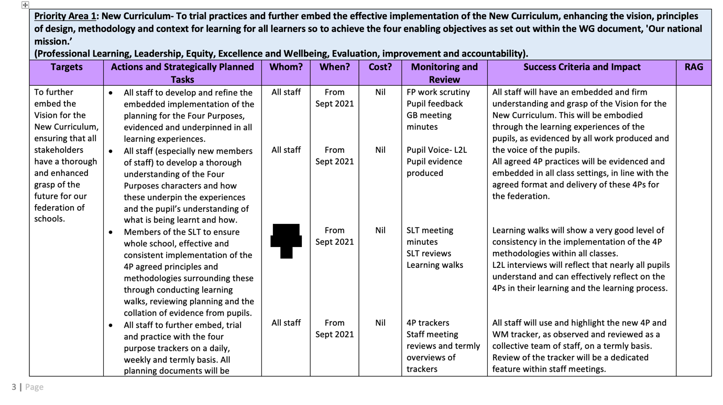

Figure 2 – School X SIP – Priority Area 1
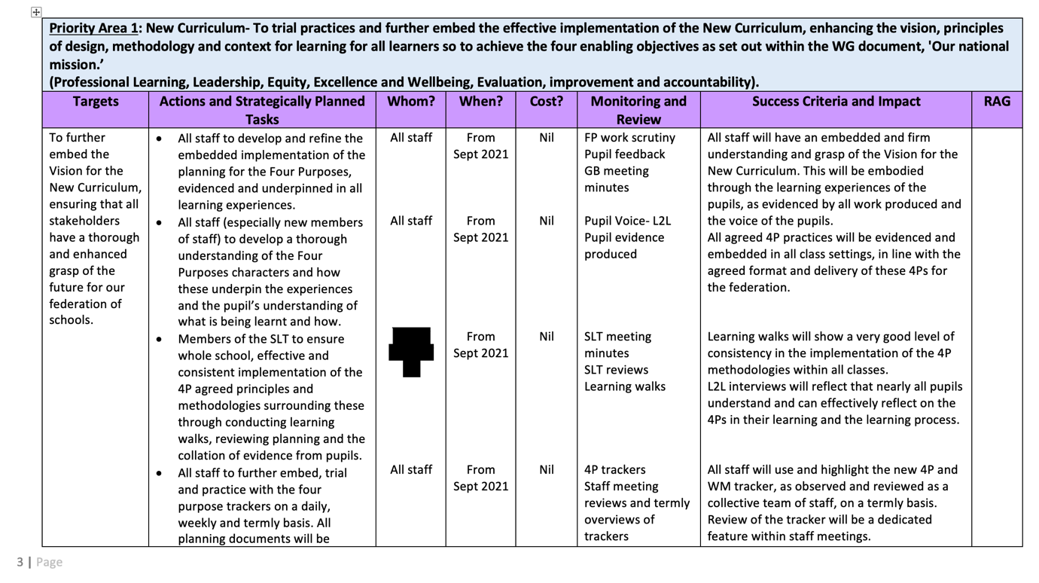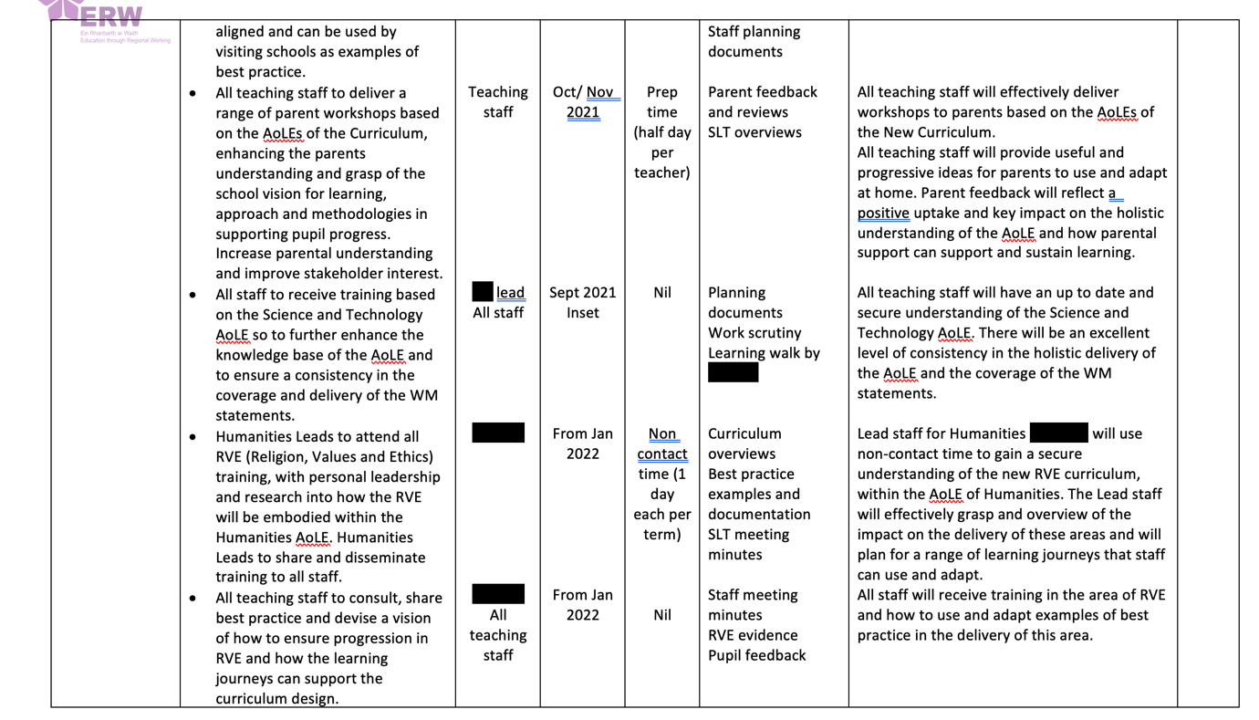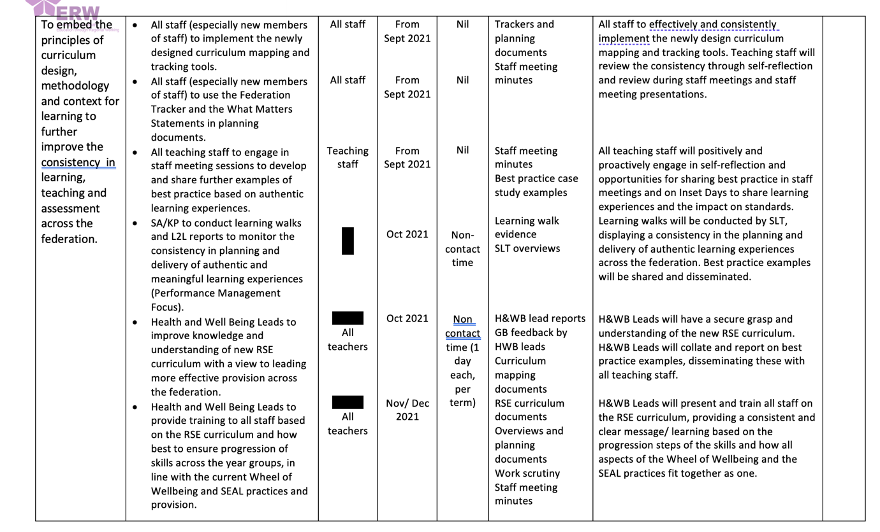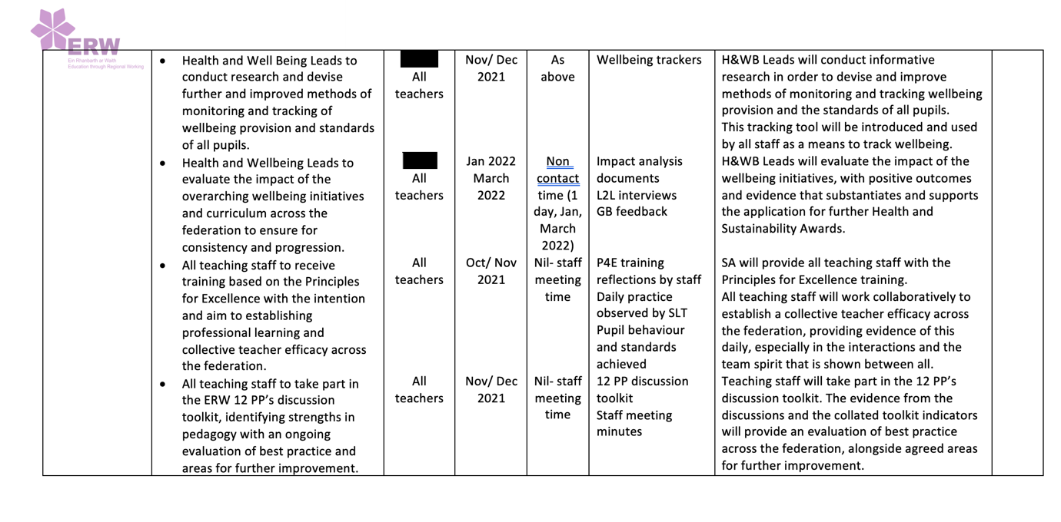

Figure 3 – School X Four Purposes Tracker


