

Assessment 1 – Reading Task Template
Upload your photo of your A3 in-class notes here:
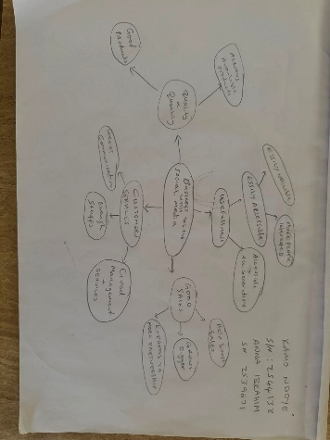

1. Answer these questions using the sentence starters below
a. What is the main idea of the text?
The main idea is that keeping the business in line with social media
b. What are two key points?
One key point is Tik tok used with 1.5 million UK business use tik tok
Another key point is Instagram is used. More 200 million business worldwide are using Instagram to reach customers.
c. What part of the text did you find most important? Why?
The most important part is the number of people that use the social media platform is very big.
d. Was anything unclear or difficult to understand?
I was not sure about the difference between the types of social media there is.
e. How did your group help you understand the text better?
My group helped me by explaining the use of both platforms.
2. One sentence reflection
Question: What did you find challenging about this task?
The hardest part was knowing the difference between the different platforms

