

Information Engineering
  - Harry Morris
  - 20/04/2020

Contents
Introduction 2
Initial Design 3
SQL 12
Conclusion 13
References 13

Introduction
The purpose of this document is to show the steps which I took when developing a database for information engineering unit. I have contently broken down this document int step which I took, from planning to creating forms and reports this document will contain it all. I will include screenshots of each of the tables both in design view and in datasheet view. I will also include the screenshots of the relationship, queries, forms and finally the reports.
Brief/Key Points
- Staff should be able to order new stock for the store from their suppliers. They will order books which they think customers might want to purchase.
- Customers should be able to order copies of books, both popular books and rare editions, for people who want to collect books.
- Customers can order from outside the Swansea area.
- They also currently have a small computer network with customer information on it, however this is not up to date.
From this I then decided on what tables that I should put into the database. The tables which I came up with was Customer, Staff, Department, Product, Supplier and Orders. Here is an example one of the tables (staff) that I have created. I then filled all of the tables with data in order to test them in the future. All of the table design came from my data dictionary which I create before developing my database.
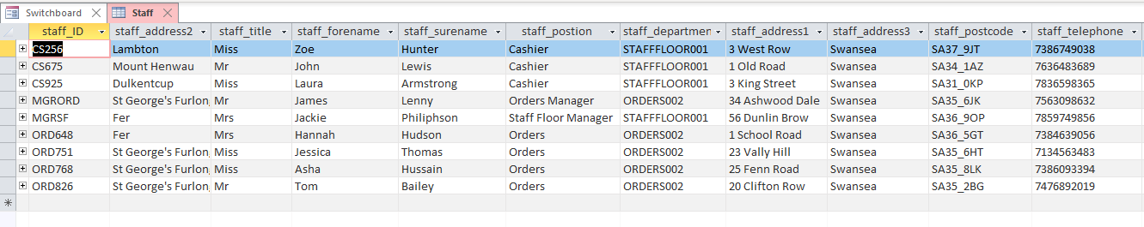
I used an image as a logo for the fictional book store. Below is the image which I used. [1]

Initial Design
  - External Documentation
This section of the document will contain all of the documentation which goes with this assignment. This includes, ERD diagram, the designs for my menu screen.
EDR
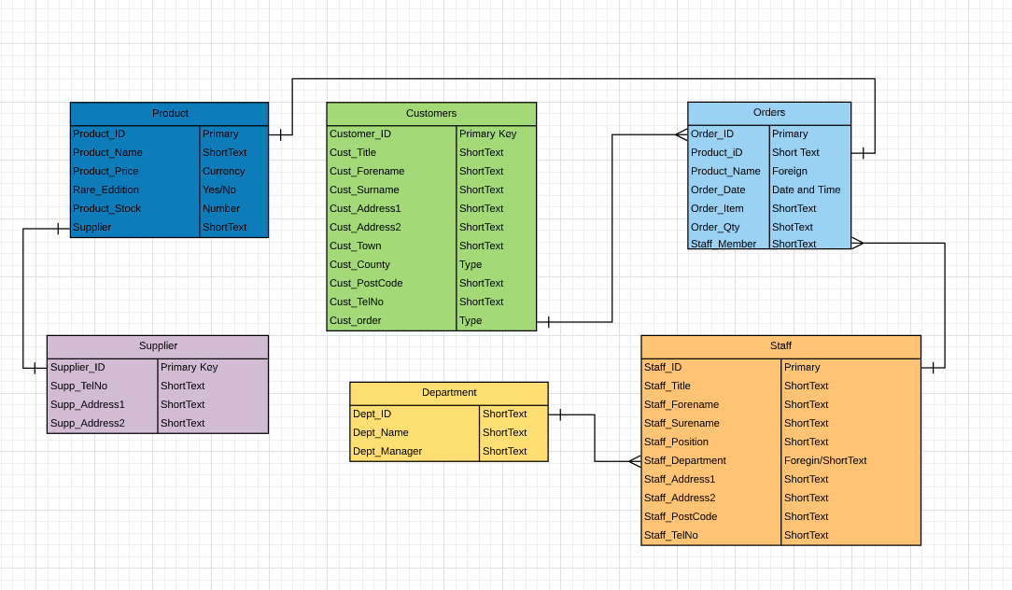
Menu Design
This is the design for my switchboard (menu). The purpose of this menu is to stop users from interacting with the tables, instead the user will then interact with the forms which I have created. There are a total 7 buttons, 6 of these buttons allows users to navigate through the different forms as while the other button closes the program.
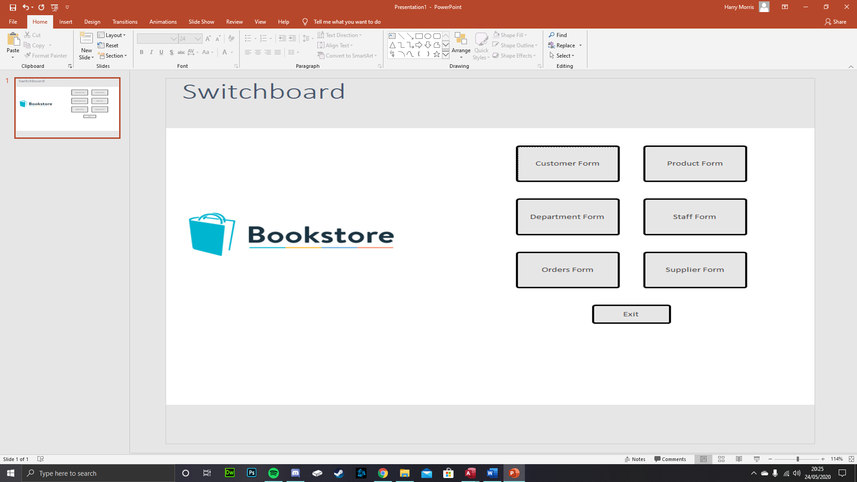
  - Relationship Between Tables
The relationship allows me connect all of the tables in my database together. This section of the document will explain why I have linked these tables together and what do they mean.
Department – this table has a one to many links with the staff table. The link is the dept_ID which is used to identify what department the staff work for. The one to many relationships means that a department can have many members of staff within that department.
Staff -the staff table has two links between tables, the department which was mention above and has a link to the orders table. This is done because a member of staff will be assigned an order when an order has been made. The one to many links means that one staff member could work on multiple orders.
Orders - the order table has two other links, one which links to the customer table and one which links to the products. The link to the customer is a one to many which allows a customer to order multiple orders but they link to one ID. While the product id links the product table to the order.
Supplier – this table only links to the product table, the link connects these tables together via the supplier’s name.
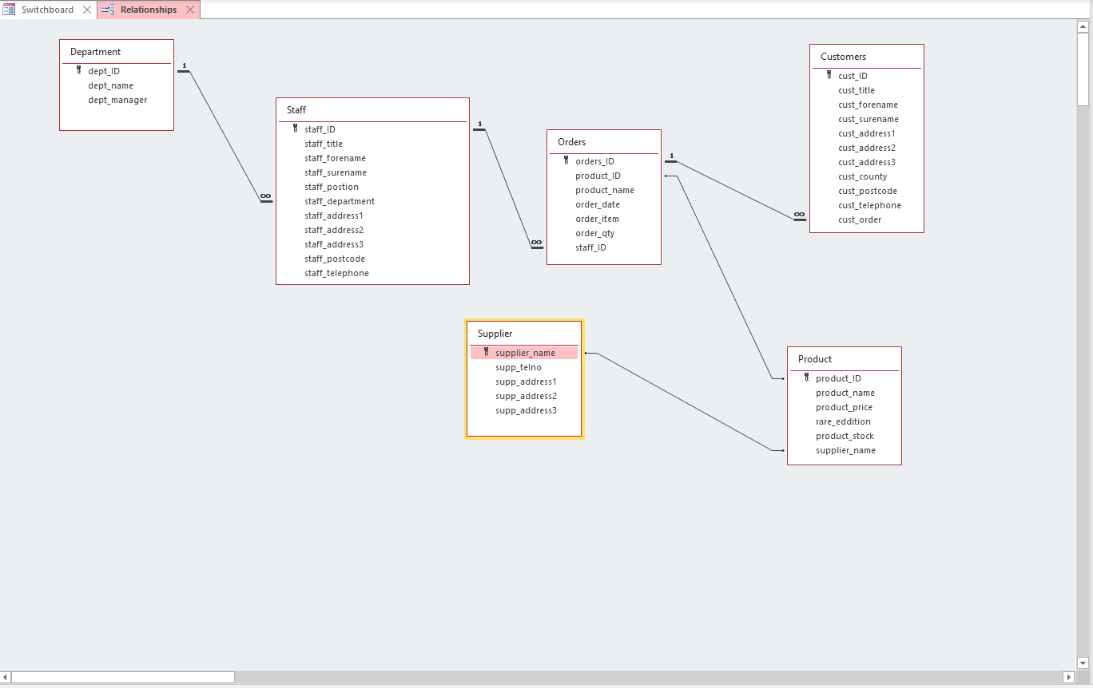

  - Forms Created
This section will of the document will discuss the forms which I created for my database. The forms are the user interface, this allows users the protentional to add and delete records without having to interact will the tables. This is an effective method to stop people from changing information on the tables which I have created. In total I have created a form for each table. These include; Customer, Staff, Department, Product, Supplier and Orders. I also created an extra form based off my menu design this allows the use to move between forms by simply clicking on a button. Each form also includes a close for button which will take them back to my switchboard.
Customers From
This is a screenshot of the customers from, this form can be used to check customer details as well as add new customer to the system, they can also remove customer details if needed. Changes can also be made and saved while using this from.
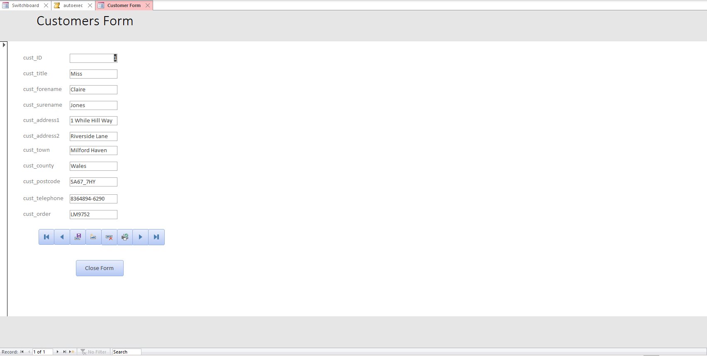
Department
This is the department form, from here new departments can be add or old department can be removed. If a manger retires then the user is able to update the system an add the new manager to the correct department.
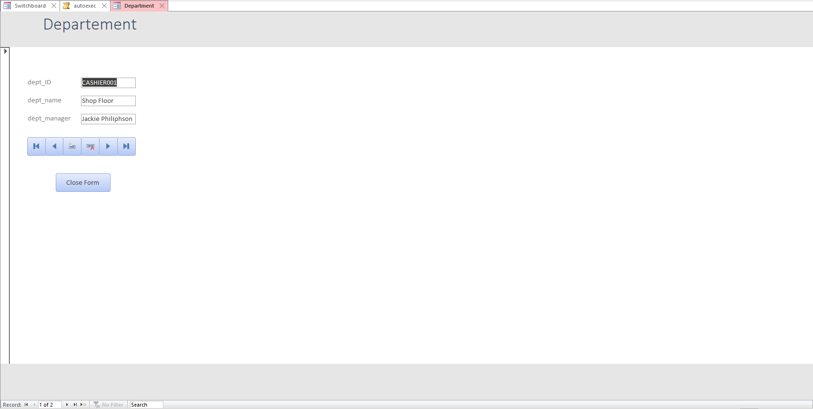
Orders
This form shows the user the orders that the customer have made. This from include the staff member has been liked it as they where the one responsible for the customer order.
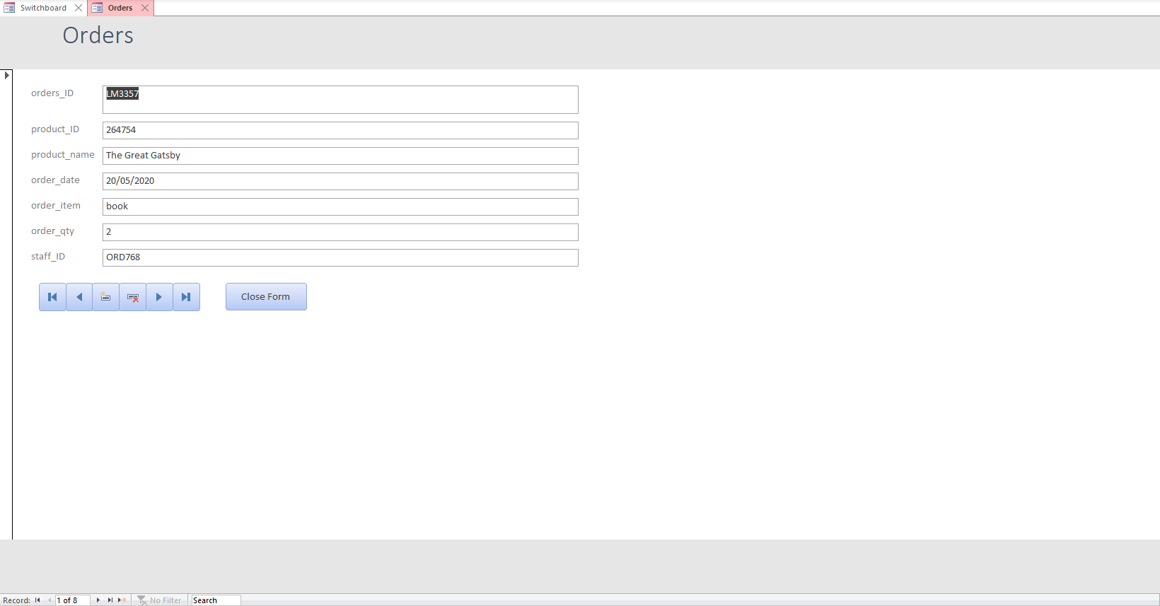
Product
This from has the information about the product which the company sells. This includes the price, product ID and the name of the book it has. It also has the stock levels for the staff to see. The orders table is also displayed on the form so the user can see how many of the book has sold.
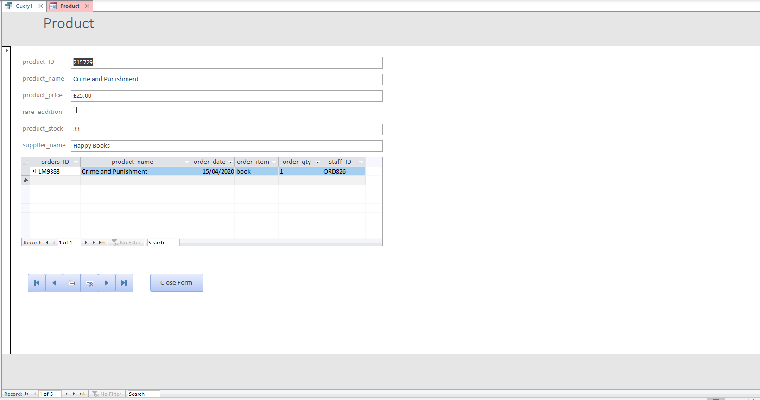
Staff
This form has a list of the staff members within the store. This form is used to add new staff members when new staff are hired, it can also be used to remove staff members which have stop working in the store. The department and the employees ID are also on this form which can be useful when looking for a certain member of staff as they know which manager to refer to.
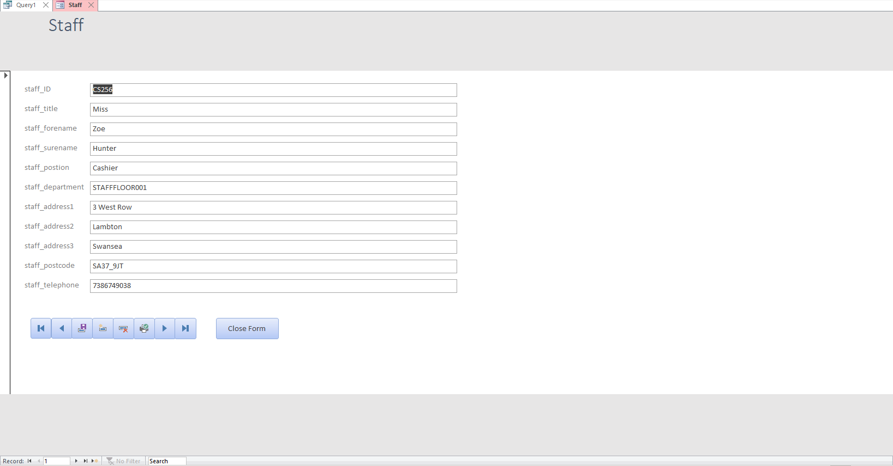
Supplier
The supplier for is used to identify the book supplier. This form includes the contact details which the Book store need in order to order new stock. There us a link to the product table which shows the user what books the supplier sell. It also include the address of the supplier incase a staff member need to go there to pick up some books.
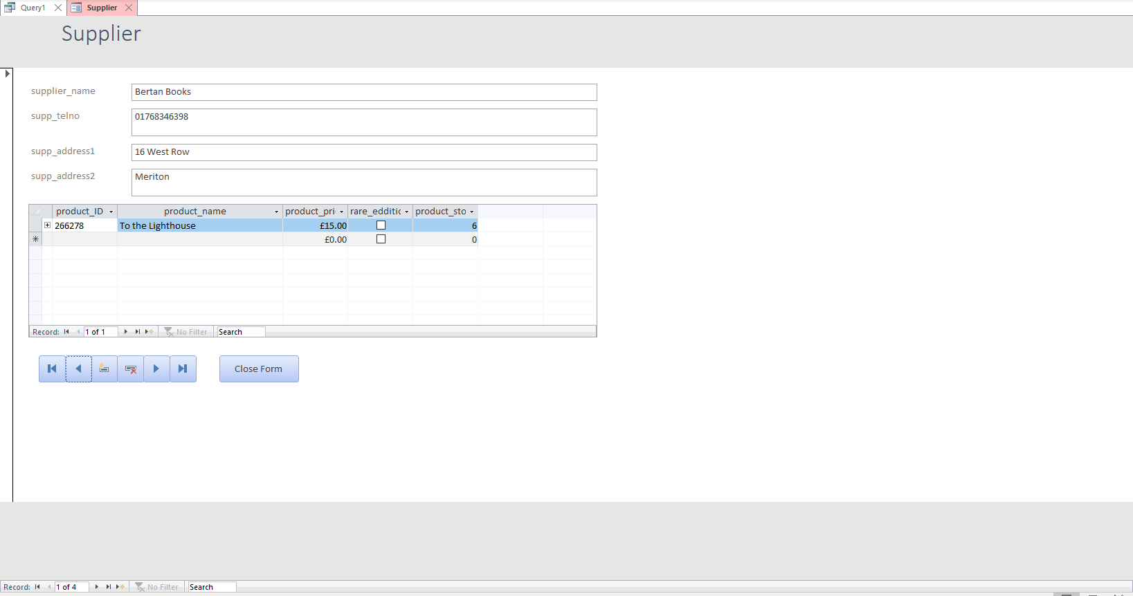
  - Switchboard
The Switchboard of the main menu. This allows the user to navigate through the different, forms in order to access the information they are looking for. Each link takes the user to the appropriate form, I have also added an exit button which automatically closes the program down once clicked. This is a quality of life improve as the user doesn’t have to click on the X at the top right of their screen. Below is a screenshot of the Switchboard.
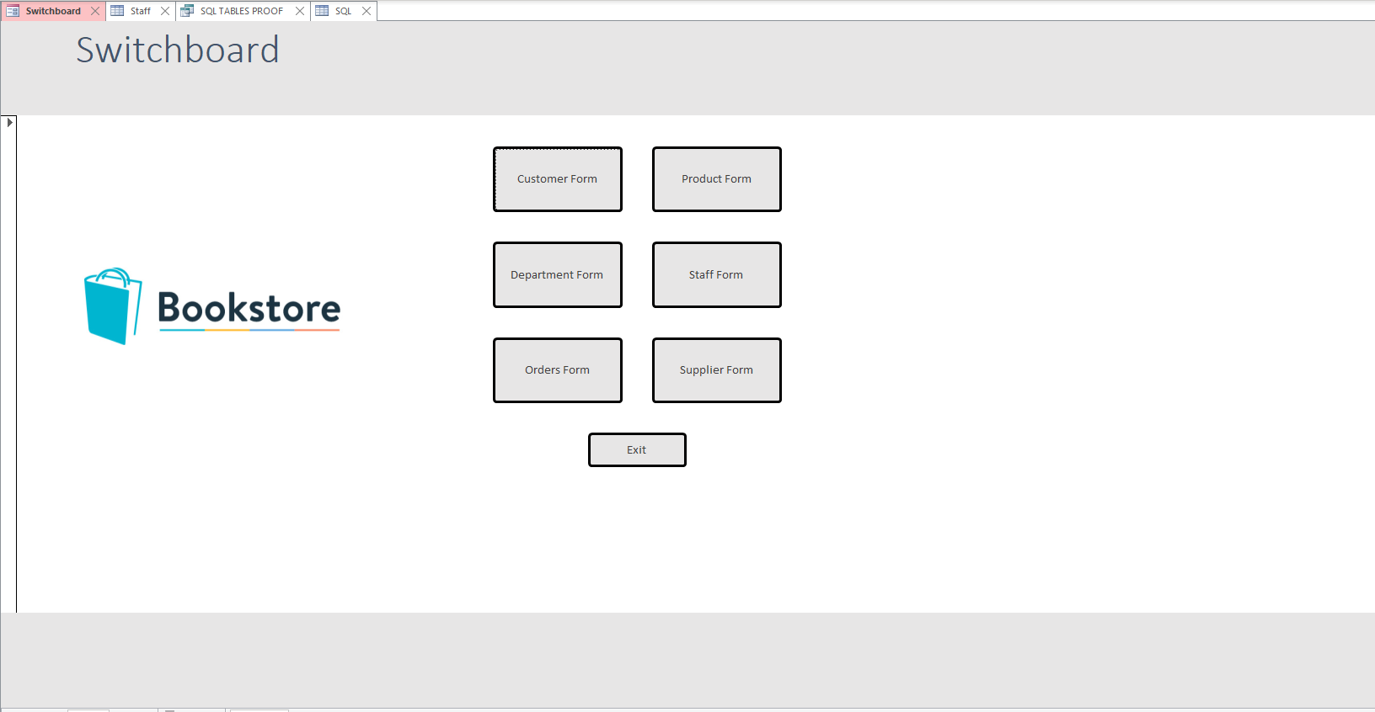
  - Queries Created
I have created queries from all of the test data which I have added to my database. In total I have made 8 queries which do different things, as they all have different information stored within them. I will be turning 7 of these quires into report and I’ll talk about them in more detail in that section of the document. The other query was used to create SQL which is one of the last things that I did.
List of Queries
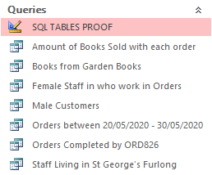
  - Reports Created
I have also created some reports with the data that is on my database. These reports display information about different tables on them. In total I have made a total of 8 reports. This section of the document will talk about these different reports are and the purpose.
Amount of books sold with each other – this is a report which show how popular the different books are, it also show how many books where sold during certain orders. This allow The City Books Store to see their most popular book, as well as encourage them to purchase more of that said book.
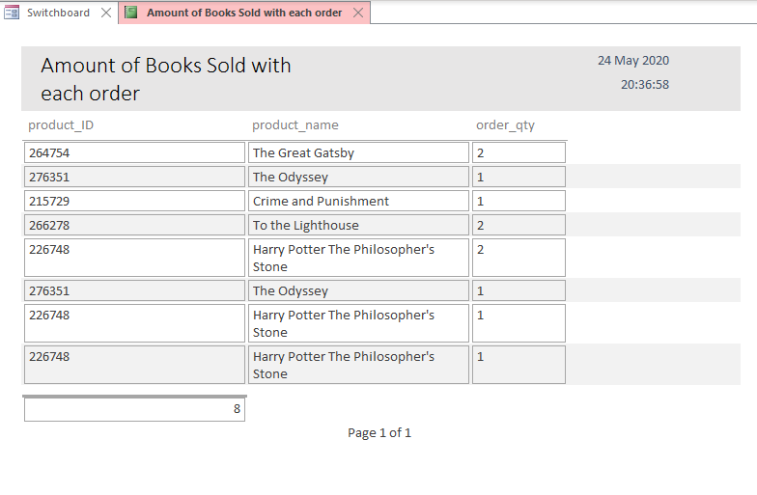
Books from Garden Books – Garden Books is a supplier and I have created a from to allow The City Book Store to see what books this supplier sells. The reason why I have chosen Garden Books as they currently supply the book store with two books. This includes Harry Potter The Philosopher’s Stone and The Great Gatsby.
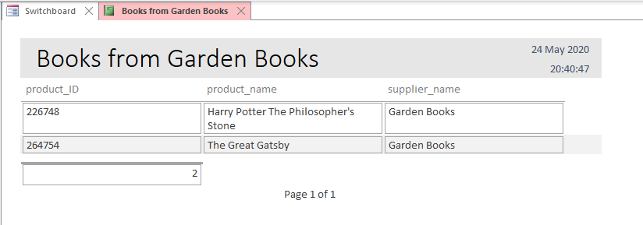
Department Mangers – this report shows the mangers of the different department within the store. This was an important report to have as the user can see the current mangers that work within the store.
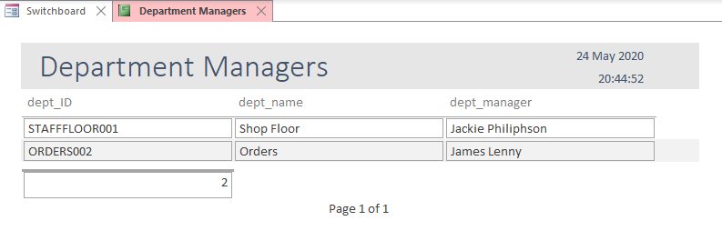
Female Staff in who work in Orders – this is another report which shows the female employees who work in the order department.
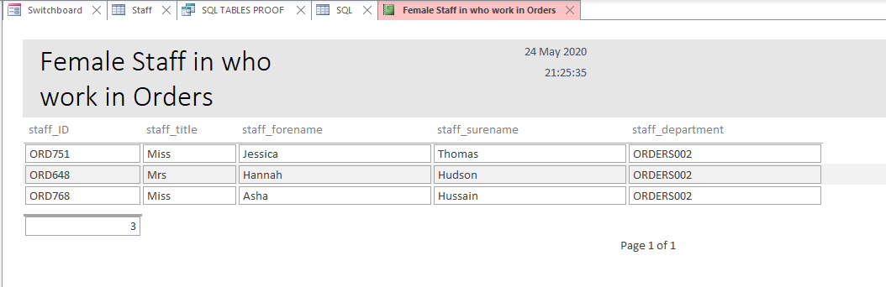
Male Customers – I then created a report showing the male customers. This is a good thing to have as The City Book store could order in books which appeal to a certain demographic, in this case it’s the male customers.
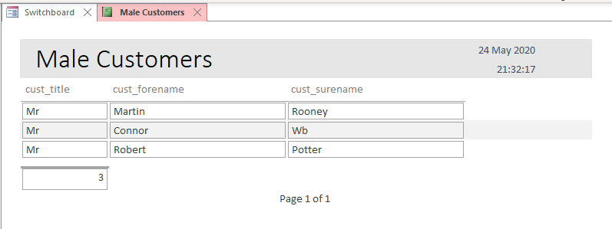
Orders between 20/05/2020 - 30/05/2020 – this report is also a useful as The City Book Store can see the amount of sales they made within that period of time. This can be a crucial for a business as they need to know how many sales, they made in a select period of time.
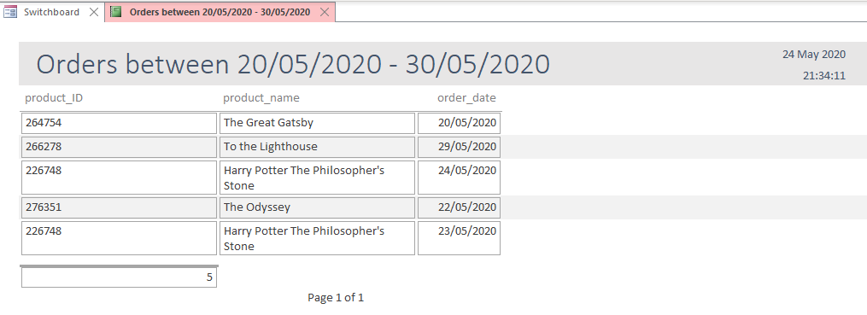
Orders Completed by ORD826 – this is a report about the amount of jobs (orders) that a member of staff has completed. ORD826 refers to Tom Bailey, the report shows how many jobs they have done. This is a useful in case something goes wrong, the business is able to tell which member of staff cause a problem. It also shows if a member of staff is slacking and need to be laid off.
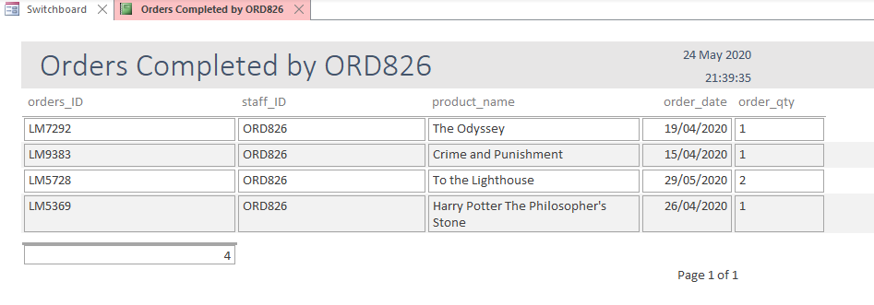
Staff Living in St George’s Furlong – this report shows the staff members who live in the St George’s Furlong area.
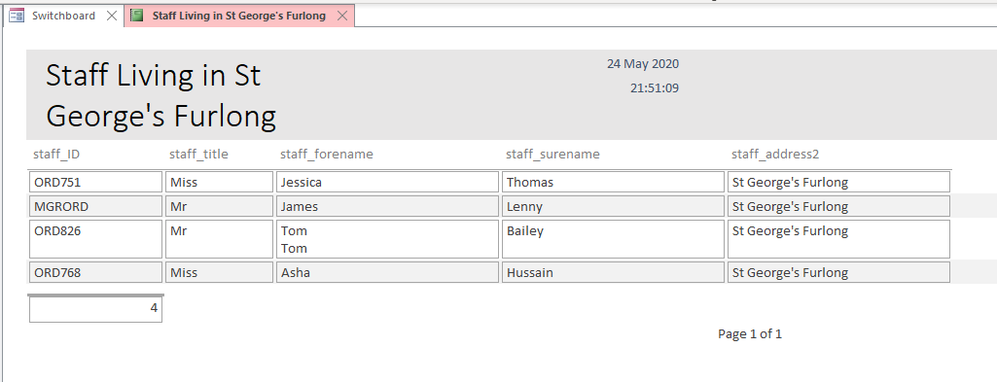

SQL
This section will talk about the SQL that I used to make a table and how I was able to add records to those tables by using SQL. I got the code from w3schools [2].
  - SQL to Make a Table
In order to make a table using SQL, I used code below. This generates 5 columns these include, personID, their last name, their first name, their address and the city they live in. All of these (except for the peronID) has a field limit of 20.
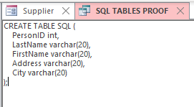
The screenshot below this show what the table actually looks like after using the code to develop the table.
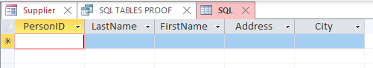
  - Adding Records to tables using SQL
Adding the record is similar to creating the table using SQL. I entered the code which would fill the table with information. The code is shown below.
  - 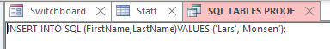
This is the result of that code.
  - 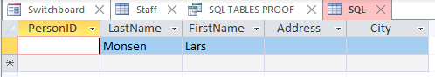
  - Main Menu and form navigation work together correctly.
I have talked about the creation of my main menu and how it works in the Initial Design section of my document. All of the button takes the user to the correct form, once at the form they need to be the user can edit or add information that they need to. However, I haven’t talk about the macro which is used that will automatically excite once the application is opened. Below

Conclusion
What could I improve?
Relationship – there is two relationship that I would change in this database. That would be the one to one on both the product – supplier and the one to one on the product – orders. At the time of making the database I couldn’t think of another way to link these tables with a one to many link. I know that a one to one shouldn’t really be used in a database. But do know this aspect will need to be improved in order to make the database more efficient and better than it currently is.
Conclusion
Apart from issue that I had with the relationship, I think the design process of my database went really well. I included everything which I wanted. When I developing the database I was fairly confident with doing everything as I have made multiple database while studding ICT throughout the years. The only thing which I had issue with was the SQL, I don’t remember using SQL before, if I had it must have been long ago as I forgotten. However, I persevered and found the code I need in order to complete that section. Personally, I believe that I made a good database with a lot of useful features which make it more user friendly and overall improved my database from just normal tables.

References

[1] | J. Taylor, "Bookstore Logo," dribbble, 7 July 2016. [Online]. Available: https://dribbble.com/shots/2822920-Bookstore-Logo. [Accessed 24 May 2020].
[2] | w3schools, "SQL Tutorial," w3schools, [Online]. Available: https://www.w3schools.com/sql/default.asp. [Accessed 24 May 2020].

