

Graduate Diploma in Professional Police Practice

LEVEL 6 - 40 Credits

Workbook title: Competency Based Workbook 1 (DHEP)

(SOUTH WALES POLICE, GWENT POLICE AND UWTSD)

Learner name: Dan Davies

Learner’s University Registration Number: 02132089

FACULTY OF BUSINESS AND MANAGEMENT
PUBLIC SERVICE PROGRAMME

Module title: Policing in the Workplace 3 (DHEP)
Workbook Guidance

Please read these notes carefully; they provide essential information.

What is the workbook for?

The purpose of this workbook is to enable learners to demonstrate and provide evidence of how they meet the learning outcomes set by the College of Policing, for the Graduate Diploma programme. Essentially, you are being asked to outline your experiential learning based upon your theoretical understanding in a range of operational situations.

Area of Professional Practice covered, (called elements in your module descriptor):

- Wellbeing and Resilience
- Communication Skills
- Managing Conflict
- Valuing Difference and Inclusion
- Criminal Justice
- Decision making, discretion
- Conducting Investigations
- Criminal Justice (Managing offenders)
- Problem Solving
- Evidence Based Policing
- Maintaining Professional Standards
- Public Protection.

You may wish to use the same incidents as you’ve outlined in the Occupational Competence Portfolio.

How should the workbook be presented?

Blank electronic copies can be found on Moodle of this workbook. You must submit this document electronically therefore it is important that you save your work regularly and upload the final typed version through Turnitin on Moodle.

Word count policy can be found in chapter 7 of the Academic Quality under section 7.7 (this applies to presenting work above and under the specified word count).
(https://www.uwtsd.ac.uk/media/uwtsd-website/content-assets/documents/academic-office/aqh-chapters/chapters---en/Chapter_07_Assessment_Taught_Programmes_Pages_72-79-UPDATED-05-11-2019.pdf)

Reflective practice is a core aspect for your workbooks and although there is a variety of useful resources on Moodle, there is one book, which is specifically based on reflective practice in policing, here is a link to one chapter from Selina Copley’s Reflective Practice for Policing Students:
https://moodle.uwtsd.ac.uk/pluginfile.php/298870/mod_resource/content/1/Reflective%20Practice%20for%20Policing%20Students%20-%20Selina%20Copley%20Chapter5.pdf

How is the workbook assessed?

Advice and support about the completion of this workbook will be provided by university staff as part of your initial training day. Your tutor constable and in-force training staff will not be involved in assessing or marking your workbook after it has been submitted.

Dates of workbook submission will be made available during the initial training day and posted on Moodle.

Once submitted your workbook will be assessed and marked independently.

Confidentiality

It is important that no individual can be identified either directly or indirectly from the information in the workbook. Therefore, you must:

- adhere to guidance in the Student Handbook about unfair practice and plagiarism.
- not identify individuals including witnesses, victims or offenders by name.
- not write information that enables any individual to be identified indirectly through the description you provide. This includes references to names, colleagues, places (including hospitals, schools, town, villages, streets) specific incidents which were high profile and could be identified due to past publicity, other professionals or any other personal information including medical or other conditions.
- take personal responsibility for adhering to confidentiality rules.
- not include any dates of any incidents or anything that specifically identifies an actual incident.

The content of this workbook should be your own work. Do not allow anyone else to see your work or use your work for their own submissions.

Please be aware that any content that is deemed to be inappropriate, disrespectful, or abusive will not be tolerated. Following review of any content of this nature the information will be shared with the employer of the student responsible.

Should any health and wellbeing concerns be raised because of disclosures made by the student within this workbook, the employer of the student will be informed.

NOTE

Your workbook will be submitted electronically via Turnitin on Moodle. Guidance on this is in the Student Handbook.

Remember that the workbook is YOUR responsibility you must not rely on the assessor or anyone else to pick up any confidentiality breaches as this is your work and you must accept full responsibility for confidentiality. Meeting all the confidentiality requirements is very important.

Dyslexia and other special circumstances

If you have any condition that you feel may affect your ability to deal with any part of the programme, please see the Student Handbook for further guidance. The University has a Student Services Unit that may be able to help but it is the learner’s individual responsibility to contact them.

Guidance:

- Your workbook must contain the items specified in the table below (clearly identified and in the order given).
- You should use this document to insert your text / answer within each section of this workbook.
- You should upload your completed document as a saved pdf file of this workbook; if this is not possible then a Wordbook file is acceptable. Do not send a scanned file from a photocopier, an apple.dot file or a Microsoft publisher file as Turnitin will not be able to assess them, despite you being able to upload them.

Contents

Workbook | Area of Professional Practice | Word count
Task 1 | Wellbeing and Resilience | 1000
Task 2 | Communication Skills, Managing Conflict, Valuing Difference and Inclusion | 2000
Task 3 | Criminal Justice, Valuing difference and inclusion | 2000
Task 4 | Decision making and discretion, Conducting Investigations and Criminal Justice (managing offenders) | 2000
 | Bibliography
Task 5 | Development Plan | Equivalent 1000 words
Confirmation of Confidentiality and Plagiarism
Confirmed by submission through `Turnitin

Task 1

Relevant areas of the National Policing Curriculum:
Understanding the roll of a constable

Guidance:

Focussing on your initial 6 months of learning and since being attested as a Police Constable, discuss and compare the coping strategies you have applied to develop resilience and minimise stress.

1000 words (+/- 10%: include your actual word count at the end of each section)

ANSWER:

Focusing on my first 6 months of training I developed a range of coping mechanisms to build resilience and minimise stress while I was dealing with something completely new to myself. Firstly, I would like to discuss and compare that two key factors which was developing resilience and minimise stress.
Allow me to discuss the definition of resilience – said the dictionary of Cambridgeshire resilience defines itself a number of things such as this allows people to be happy and successful in the things that they are doing which usually consist of something bad happening to them and they find a way to bounce back from that inconvenient situation. This is also the quality behind being able to return quickly under pressure to an earlier good condition after problems. (Dictionary, 2023).
Moving on to the definition of stress I have found that stress can be defined as any change that can cause physical, emotional, or psychological imbalance to the human body and brain, stress is when your body responds to anything that requires attention or action – this is something that everyone human being will be exposed to throughout life. The way to respond to stress is different in every case has everyone has different coping mechanisms in order to overcome the pressure of things that can cause stress on the human body and mental state. (organisation, 2021)
During my 6 months of training, I developed a number of strategies to minimise my stress level and develop resilience in times that were incredibly stressful around exam time and especially when learning something completely new. I developed these coping strategies to ensure that I could make the 6 months of training run as smoothly and as stress free as possible for myself. During the 6 months I developed new coping strategies that I had used previously just as a hobby rather that something to decrease my stress levels and use them to develop resilience for my 6 months of work while in training.

Whilst in training, I made sure that I used the usual things such as sport, physical activities such as rugby, cycling and swimming. However, whilst in training I found that reading and meditation was a big factor of developing my resilience and decreasing my stress levels assisted my training and time at Vantage Point over the 6-month period. I found this through finding that revising for my 1st exam was more stressful than I thought it would be. I found that the build up to the exam quite a stressful period of training as starting the police force was something completely new for me and developing my knowledge and skills in order to make sure that I passed the exam.
Rugby, I found was more of a physical release of emotions that were building up within while training. While training I found that playing rugby nearly 3 times a week was a big help to releasing that physical build up that I had inside me and because that it is a physical sport, I found myself having a far bigger release of energy and all the stress leaving my body while either training or playing. This sport is probably the closest team sport that there is and there are a great bunch of boys at the club that I developed a strong with numerous teammates. I also found that they were a big part of the release of stress that I had during training and being with them week in week out was a big relief for myself and being part of a close team this assisted in making sure that I was okay and that I could enjoy myself in training and let me hair down and completely forget about work while playing and having food with the team on a Saturday evening.
I found Rugby is a very big passion of mine and involves a high level of training commitments as well as making sure that you are available for weekends for the game days. Trying to make myself available for training twice a week during training was hard but something that I needed to make sure I had time for. I have played rugby since a very young age, played at very high level and continue to play at a high level. I found that trying to make training twice a week was hard at times, but this was a relief for my ongoing stress levels even though it was stressful to organise my revision and workload around training and having that time to relax on the weekend while still playing rugby.
I found that (simplysupplements, 2014) states that there a numerous long term health problems that could be brought on be stress which could relate to things such as insomnia and stomach problems. It is suggested that the research had even linked prolonged stress to be the cause of more cancer and diabetes. Due to the research based on this team games such as rugby for example has been shown as a means of reducing stress – this is based on the fact that people play team sports in order to get rid of stress as you are playing with your teammates and friends this allows players to relax around others and also share problems amongst each other. Studies have stated that improvemtns in mood in direct response to physical sport thus suggesting that this is a key element of reducing the levels of stress relief. Rugby due to the fact that this is a contact sport is a combination of outlet of frustrations as well as releasing the feel-good hormones known as endorphins in the body.
I found that cycling helped relieved my psychological health rather than physical, I found that when I was out cycling, I would come across others that were either out running or doing the same as I was, and it was nice to see a friendly face and say hello to someone different every time I went out on my bike. I would often find myself cycling alongside people that I had never met before and eventually developing a group that would go cycling most Sunday afternoons if we could from my hometown which is Barry. If found this relaxing on a Sunday afternoon after playing rugby on the Saturday afternoon and made me feel refreshed in preparation for the Monday morning start back in training school and ready for another week.
As training I got harder and suddenly what we were learning about became a lot more difficult to take in and process and take the time outside of training to learn these for the exams. These were the far more serious crimes such as section 18 assaults, rapes, domestic violence and things like CSE (child sexual exploitation). I found that these were very heavy topics to take in and make sure that I developed the correct knowledge, but in order to cope for these and develop the correct knowledge I found that open water swimming made my relax and feel far more refreshed in order to revise after training school. I found that going open water swimming in the morning, I found that this relaxed me during the mornings and made able to concentrate more during the day whilst in training.

Word Count – 1212

Task 2

Relevant areas of the National Policing Curriculum:
Communication Skills, Managing Conflict, Valuing Difference and Inclusion

You must choose a policing incident involving conflict in which you played a significant role with an offender/service user/victim and reflect on what happened.

Critically assess the incident including social and legislative contexts and any relevant cultural, ethnicity and language issues.

Consider the use of effective communication skills that you used within the incident.

Reflecting upon your incident, critically evaluate any theories or models underpinning the causes of conflict within policing interventions. (Examples would include, Betaris Box, The Drama Triangle).

2000 words (+/- 10%: include your actual word count at the end of each section)

ANSWER:

During my first shift has a response officer I attended an emergency graded call where a male had been detained for shoplifting at a local store. On arrival we have found the male through the on-duty security guard to where he escorted us to the manager’s office where the male was sat with the receipt of the items. The male appeared to be very confused, distressed and unsure to why he had been detained.
On approaching him he became quite agitated that he was going to be arrested and was very unsure to what that meant. He was very irate with officers and staff members as we were dealing with the male. As I was obtaining an account from numerous staff members the male deteriorated therefore, I apprehended the male and told him there would be further arrests if he didn’t calm down before I arrested him for the theft. During this arrest the male become annoyed that he was being arrested for his crimes but the security guard who detained him was not as the male has alleged that he had grabbed him by the neck. The male was provoked by the fact that the security guard was stood there watching him kicking off and kept saying to him that he was going to be arrested for this, he was also saying that he was going to be taken out of the store by the police as well. During this altercation the male that was detained for the suspicion of theft appeared irate when we arrived but while I was the arresting officer, I have then gone over to the male in order to appease the male using the (Betari’s Box – Help children live better, image.) which has assisted myself in appeasing the male as the way I have approached the male and listened to his side of the story has assisted him in remaining calm.

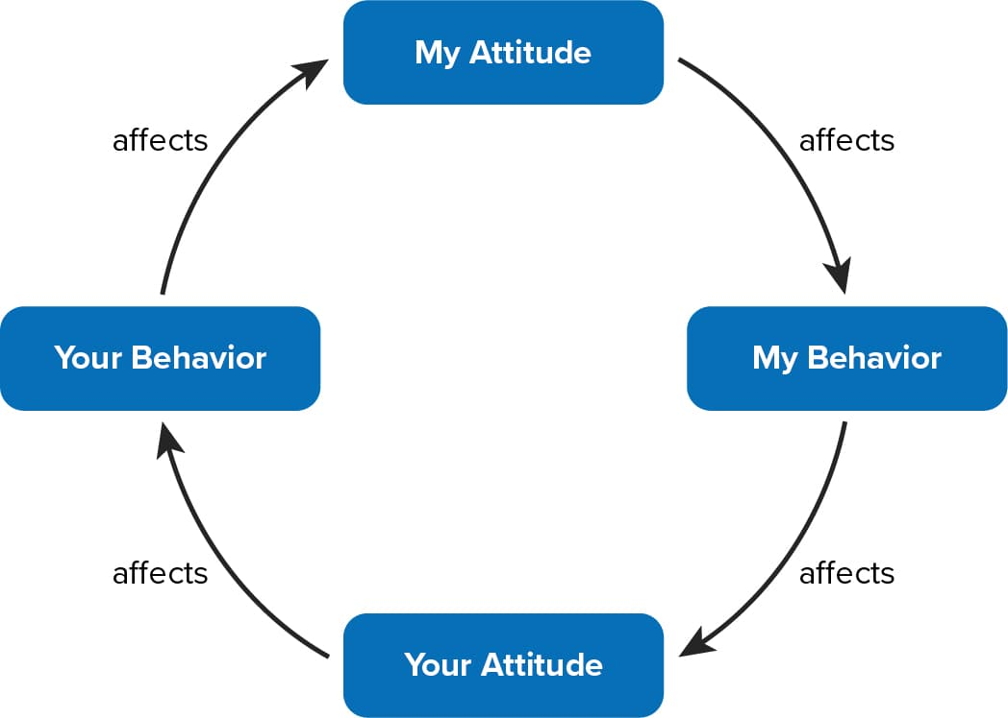

The Betari box has played and essential role in this incident as my attitude had definitely had a positive outcome on the male and how he has then remained unflustered throughout the incident and then after arrest he has remained calm while being conveyed to custody to which he has also become very apologetic about the way he was displaying and acting during his arrest. This model has aided me in making sure that the individual was dealt with accordingly with his allegation and made sure that he remained undisturbed while being in the back of the police car whilst transported to Newport Custody. The Betari box has aided while dealing with the offender as it has played an essential part of dealing with the male and apprehending him when being arrested.

The Thomas Kilmann conflict model was created due to trying to aid the workplace in making sure that the workplace is a better more relaxed approach place when conflict is managed in the correct manner. Thomas-Kilmann conflict model (Thomas & Kilmann 1974) had created a conflict model with 5 different components such as competing which states using this one is primarily when we resort to being more assertive regarding conflict. Avoiding states that we should face problems with a more face on approach and confrontation is best avoided. Thirdly, accommodating this states that downside to this just makes this conflict worse and could potentially lead to further conflict in a worse scenario. Collaborating approach have more of a cooperative dealing this is where both parties may receive help from this solution. Lastly, compromising is the more middle grounding that Thomas has discovered, this is more of an opportunity to be less confrontational but gives the opportunity to become a less of a stand with the person involved.

Whilst dealing with the incident I have directed towards a more collaborating approach as it has given the suspect and I had a better relationship while I was dealing with the male as he was very agitated waiting in the store where the incident had happened while we were obtaining details to what had happened. During the incident the male that had been arrested was very agitated as he was claiming that he was accompanied by his mate in the store when he was detained by security, but he claimed that they had left him go after talking to him. The male was displaying passive resistance on arrival to which he didn’t want to be arrested as his mate has been let off the hook – he was more agitated by the fact that he had been assaulted by the security staff where they have needed to detain him in order to prevent him from leaving the store before we have arrived.
(encyclopedia.com, 2018) states that passive resistance is when a member of the public display’s resistance through nonviolent gestures and arguments against a member of authority. The male in question was swearing and shouting but was willing to come with us after arresting him and putting him in handcuffs he realised that he was in trouble and wasn’t willing to display any further signs of resistance towards us or security staff after we had obtained an account from the staff member regarding what had happened during the store.
Referring back to the Betari Box – my attitude had a positive impact on the male that we were arresting as he was extremely agitated and angry by the fact that the security guard and allegedly assaulted him and he was going to get away with this as neither myself or my colleague were discussing this allegation with the male until after everyone had calmed down and we returned at a later time to the store in order to obtain CCTV, Statements and Exhibits of what was taken along with the total cost of what had been taken during the allegation of theft.

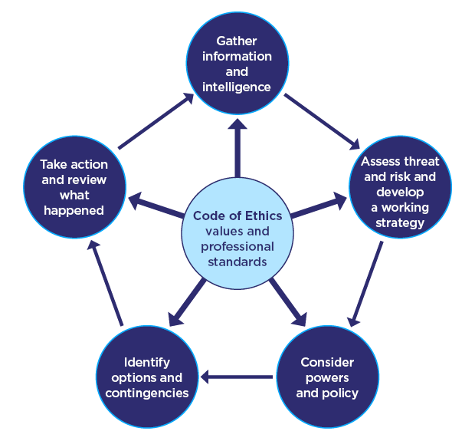

Diagram showing the NDM from the college of policing (policing, 2023).

The NDM is an essential part of policing as this allows us to risk assess everything that is going on and continuing to work alongside the NDM in order to deal with the situations as best we can. The NDM allows officers to risk assess and gather information regarding every incident that we respond to. Assessing the threat and risk and develop a plan is a ongoing thing during the incident from the first call to respond to the end of the incident. Gathering information and intelligence is more based on the fact of what is currently ongoing during the incident. During this incident I have gathered information and intelligent enroute to the emergency for warning markers and previous on the male that had been detained by the security guard. I have then risk assessed the threat, risk and harm to myself and my colleague at the current time and what we needed to do about the situation regarding arresting the male that had been detained based on the information that I had gathered at that time of the incident.
Working along the NDM and the Betari Box I have managed to defuse the male’s anger that he was displaying on arrival. My attitude towards the male and the situation defused the male’s anger quite quickly after speaking to him as a person and not so much as a criminal which appears that’s how everyone had been speaking to him in that sort of manner. The way had reacted the situation – put the males mind at rest and leaving him feel that yes this will get sorted in a correct manner now. Had my attitude been different that day I can honestly believe that the male would of escalated the whole situation and would of started displaying signs of physical resistance towards us and the security guard that was assisting myself keep an eye on the male while we were trying to establish what had happened in the store and what was the time scale of things that had happened. In regard to the way the male had acted during the incident and how he was when we had arrived, he was very different when he was leaving the store with us on his way to the custody suite. The male was like I previously stated was displaying passive resistance and this is why I have then arrested the male to the rear with the handcuffs due to the use of the Betari Box and managing to defuse the situation – I have then managed to explain to the male as long as he carried on in this matter I would take his hands from behind his back and place him in handcuffs to the front for comfort as sitting in a car with your hands behind your back can’t be comfortable. He appreciated this and then said that I was a decent officer and that the way I had dealt with the situation changed the way he reacted with police present. We have then discussed with the male what he was doing in the store and why he hadn’t made any attempt to pay for the items he had taken.
Using my discretion in this incident due to the cost-of-living crisis the male was genuinely trying to bring some food home for his wife and children. The male felt extremely bad about the fact that he had stolen from the store he didn’t mean to and didn’t want too either. The male did have means of paying for the items, but he said that he wanted to try his own luck of trying to leave the store. He didn’t want to get found out by anyone as he was embarrassed by the fact that he didn’t even try and pay for the items and that he admitted to struggling at home in regard to the financial status. This was clearly a concern for the male moving forward so therefore supporting the male we have then placed in a few referrals about the males’ financial issues at home. The male felt extremely disappointed in himself and more to the fact that he was more annoyed in himself – he felt that he had let himself and his family down due to the incident. The male found himself in a very difficult situation and he says that this is why thinks that he reacted the way that he did when police were called and that he was detained by store security staff.
The male wanted to explain to the store staff that they would pay for it and that he didn’t want to cause any animosity during the incident and that he just wanted to remain calm during the incident. The male didn’t want to kick off but after being treated like a criminal by security staff this has agitated the male considerably as he just wanted to have the chance to explain why he had done it – instead of which the male was subjected to considerable force to drag the male to the rear of the store and be questioned about the incident in front of someone that wasn’t even a police officer. The male has then spoken to officers saying that he didn’t want to spoeak to the security staff due to his appalling attitude towards members of the public. During this incident therefore I have approached the male calm and collectively to try and defuse the situation as soon as possible.
Concluding this incident, the Betari Box and the NDM – this is an essential part of our day to day working shifts and life. The Betari Box has been vital during this incident as the male needed a format to concentrate on how he needed be dealt with about the incident which initially he was treated like he should have been.
Word Count - 1984

Task 3

Relevant areas of the National Policing Curriculum:
Criminal Justice, Valuing difference and inclusion

You must choose a policing incident in which you played a significant role with an offender/ service user/victim and reflect on what happened

Critically explore a policing incident that you have attended and examine how you dealt with competing issues such as legalisation, social issues, culture and language.

Consider the victims code of practice and how it was used to support your victim/witness through the criminal justice system.

Your reflection must illustrate your understanding and application of core principles of ethics, equality, diversity and human rights, as well as any relevant Code of Practice considerations.

2000 words (+/- 10%: include your actual word count at the end of each section)

ANSWER:

During my reflection here on a specific incident that I dealt with during the earlier days of my tutorship. On my second day shift accompanied by my tutor we were to attend M&S about a shop lift. Here I would like to analyse and focus on the language barrier that we were faced with when dealing with the certain male.
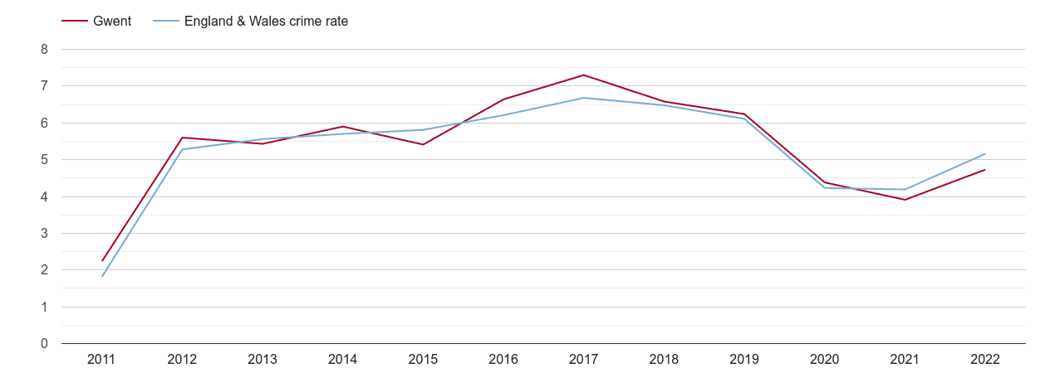
(Plumplot, 2022) this is a graph showing that the levels of shoplifting in the Gwent area is currently on the rise again after dropping over the years that we were in a global pandemic (COVID-19). This showing that Gwent is an area where shoplifting is clearly prolific across the force.
The male was of a Romanian background with very limited use of the English language, this made it difficult for him to understand everything that was going on around him. There were multiple staff members from the store talking to him all at once and then upon our arrival this became far too much for the male as he was very unsure to what had happened and why he had been detained by a member of the store simply for walking out of the store with unpaid items. In this incident I developed a bond with the male on more of a companionate level as the male was confused and was extremely worried about what was going to happen to him after he was taken to the police station. After an amount of time, we grew to understand each other, and the male was a little more aware of what had happened and became very apologetic for his wrongdoing that day. The male become understanding of what he had done during the incident and that he was going to be arrested for the offence. The male regarding the social issues that he was facing which was very poor English and not many people now how he could go about trying to get his name of things and not to charge with the offence.
During the incident I have needed to carry out a developing dynamic assessment of how the male in question was going to understand what we were saying to him and trying to explain to him what was going to happen next. According to ‘communicationtheories.org’ they have said that
“Prime dynamics of culture are the mutual social perceptual set with coordinated, meaning and action, and cultural variance. The differences in communication recital and the diverse forms of communication can create diversity among various cultures. People who live in various cultures and historical epochs communicate differently and have different patterns of thought.”
This suggests that the male that I had dealt with on that day was using his own understanding techniques and was struggling to understand what was needed from him for us. He was struggling to understand what crimes he had committed and what the reason was behind him being arrested. During his time at the police station, he was going to be interviewed to obtain his account and prove or disprove his involvement in the incident. We had clear CCTV footage of the incident. Due to the male’s lack of understanding he had opted to not have a solicitor in the interview. Had this been accepted by myself or the custody sergeant then we would have been breaching PACE during interview. I have then suggested the sergeant that we get one anyway and use a duty solicitor to present with him in interview alongside an interpreter.
During this incident the use of Language line in custody was paramount as this was a great assistance for me and the male that we had currently arrested on suspicion of the theft. We found that he became easier to deal with after he was spoken to by someone of his own nationality and he began to understand why the fact that the police have been called to the store and why he had been subsequently arrested for the offence that he had committed in the store.
Without either of these the interview wouldn’t have been legal, and I believe he would have become more confused and disorientated during the interview process. After using his reaction in the store to the amount of people that were questioning him regarding the incident, I thought that it would be best for us to carry out the interview with all the correct relevant people present in the interview room so that the male could have a fair opportunity to explain his involvement in the incident.
In line with the legislation of theft the male had said multiple times that he was going to pay but only if someone was going to let him drive home with the goods for him to be able to feed his family and return later with a means of paying for the items. He didn’t understand that this was not possible and on multiple occasions I needed to remind the male of the definition for theft and how he had dishonestly appropriated property without any means of paying for the items at that time.
During this process about the male’s human rights were to be allowed a free legal representative for the case that he was involved with. He didn’t understand that this was the case so therefore we have then advised the custody sergeant to allow the male to speak with a Romanian national for him to understand the custody process and what he was going to be interview for.
After this is disclosure had I of interviewed the male, I would have been breaching PACE had I of interviewed the male since he had not understood what was going on in interview. He understood the fact that he had been arrested but in terms of the interview we would have been breeching PACE when questioning him. The custody process is for every foreign national to have access to an interpreter during interview and someone of their nationality to speak to them at the custody desk for them to explain their rights and entitlements.
The male was very confused to the fact that he had been arrested for theft and he wasn’t sure of why police had been arrested him. At first, we were concerned for the male as he didn’t understand that he had committed a crime and he didn’t see that he had done anything wrong. The male needed an appropriate adult in interview as he was a foreign national and an interpreter which was extremely difficult to organise as there wasn’t a Romanian interpreter available for interview so soon so that due to this, we have needed to wait for the interpreter to arrive before we have conducted an interview regarding the matter. Officers have obtained the details of his legal representative that he wanted regarding him being interviewed for the crime that had been committed.
Due to the foreign nationality Romanian, we have then needed an ACRO form to be given when he was released from custody to which initially it had come back that he was wanted for similar offences out in Romania. This was not the case as when I have reviewed the ACRO form that was given I have realised that they have given the wrong photo identification for the male that I had arrested and that it wasn’t the case that he was wanted in Romania. I have then made sure that the male understand that he is going to be released on bail with conditions not to attend Spytty Retail Park or attend M&S in the retail park where the male was detained and later arrested for the offence of theft.
When arrested the male as a suspect and his detention authorised in custody the male has then been submitted for his details to be put through the Criminal Justice system in order for them to understand that this male had previous for theft and that he was a further risk to other stores on the high street upon his release from the custody after interview. The male has needed his interpreter with him at all times when he was being dealt with in custody as he needed someone to translate what was happening to him in regards to the offence but when he was arrested we believed that he had very good understanding of what was happening to him but the after spending time in the police van he has then had time to reflect and told the custody sergeant that he doesn’t understand any English at all. Due to his lack of understanding when he came out of the interview room, he thought that he could leave straight away and that he didn’t realise that he needed to stay even after arrest and interview.
The male was submitted for an ACRO check which initially came back to me that I needed to make arrest enquiries and try and get the male back in as he was wanted in Romania I do not believe that this male was wanted out in Romania as he had been living in East Wales area for quite some time now. The male was then questioned about his knowledge about the allegation that out in Romania he was alleged that he did something very similar but, in this instance, this wasn’t the male that I was working with.

Task 4

Relevant areas of the National Policing Curriculum:
Decision making and discretion, Conducting Investigations and Criminal Justice (Managing offenders)

You must choose a policing incident in which you played a significant role with an offender/service user/victim and reflect on what happened.

Critically assess a policing incident that you have attended, where you played a significant role with an offender/victim and reflect upon what happened.

Reflect upon your use of the National Decision-Making Model and the Code of Ethics and review this affected upon your decision making and use of discretion within the incident.

Critically review your responsibilities regarding the provision of CPIA when conducting this investigation.

2000 words (+/- 10%: include your actual word count at the end of each section)

ANSWER:

As a response officer there are many incidents and crimes that you attend where there can be a certain way of dealing with such things and having different outcomes other than arrest all the time. There is a great variety of ways you can deal with people either through verbal warnings, Postal Charge Recognition or a TOR for all minor traffic offences. There are also things such as an out of court disposal which is a great outcome for first time offenders.
There was a particular incident where I have approached this incident with an open mind and tried to deal with the situation in a different matter than arrest. I have developed a repour with the female and her daughter before going full throttle into what had been reported.
The incident involved a young girl who had been on the phone to her father about some lads who had been potentially giving her drugs and he was concerned that she was developing a bond with the wrong kind of gangs. She had become distant from her mother and grandparents and had started truanting in school which after speaking to her mother was completely out of character for her.

After speaking with mum, she has said that it has become very difficult this school term as this was the first full term her daughter had done outside of the COVID-19 period in school which had a lot of pressure on children this age. She had just begun her GCSE year in school and was finding it difficult to engage with lessons and teachers this term and she didn’t know what to do about it.
The government have said that as there had been an increase in children of this age struggling in school there was still strong bonds between old friends during this period that they weren’t around. (Ford, 2020) has said that “most children and young people up to age 17 still are happy with their relationships with friends, but younger children’s contact with friends varied – only one-third to one half of primary age children had regular contact with friends between April and August. Loneliness was an issue for some older young people”.
Going back to the incident and linking this in with the concern for safety from a family member that I dealt with was that the girl had become distant with her friends as she found it difficult to get back into the same group after such a long period away from her normal friends.
The girl didn’t want to be in that kind of gang or criminality – but her boyfriend at the time was big into all of this kind of stuff and wanted her to be part of it as well. Peer pressure from others can have a negative or positive outcome on certain people but in this case, it was a negative outcome. According to (Johnson, 2021) there are two typed of peer pressure and these said in her report are Explicit pressure and Implicit Pressure and they both have potential negative outcomes on certain age groups.
The first option which is Explicit pressure dictates the use of direct comments towards someone and this will mean that they act in a certain way around certain people – “Ditch them they are weird come hang out with us” this sets a negative picture in a person’s head where they are more likely to act upon that comment.
Secondly, are states that Implicit pressure develops when someone’s behaviour changes to help others or better fit in with the people around them. This influence on others come predominately from popular trends.
In this incident this had been a third-party call from a concerned parent that didn’t live at home with his daughter and wanted to the police to act which wasn’t necessary as this had been documented with school and mum had been in contact with her support worker/social services in order to get her daughter the help that she needed.
I attended the address for a concern for safety about the daughter as there were outcomes in the log that potentially could have been a serious allegations had it not been acted on accordingly. The allegations that had been made by dad were not true and been confirmed my mum that these were not true.
After I have obtained an account from mum we have then set up where her daughter was and when she would be returning home from her boyfriend’s house which wouldn’t be long as she had school the next day and her mum and given her until 22:00 that night to be out with her friends.
We have spoken to mum about dad’s involvement with his daughter and she said he doesn’t know what is going on at home as he is never interested and as she is supporting us being there doing our jobs, on these occasions she didn’t feel that police involvement was necessary. We have spoken to mum and explained to her that due to the nature of the concern and the reports that we have had from her dad that we would need to speak to her in private when she returned. Mum wasn’t happy with this as there wasn’t anything to investigate and it was all being dealt with.
Due the nature of the call and this was getting quite late at night, officer discretion became a big part of this call. I have spoken to the girl about what has been happening in school over the last couple of months and why she thought her dad would want to make these kinds of allegations against her friends and her boyfriend. During my time speaking with the NDM has been an essential part of the whole incident as I have used this to rule out any crimes and risks to the girl at that current time. I have gathered information from the call room regarding the report that we have received from the girls father stating that he believes that his daughter is being used in a sexual nature and that she was being made to misuse drugs with her current boyfriend – in line with the NDM and the fact that the girl was of a young age we believed that she could potentially be in danger to made sure that we went to her mother’s address in order to establish what had gone on. This had been a concerned father reporting on the information that he had received from a third party report which wasn’t true at the time. But due to the threat and risk that she was under in the current log we needed to make sure that she was safe and well therefore we took it upon ourselves to conduct a welfare check on the daughter and take her to her home address – after taking her back home we have then run through the NDM again and assess the current risk to her which was low. Assessed the current situation and give her a PPN and a concern for child report and referrals done.
In addition to this the teenager accepted that she needed support somewhat regarding how she could go about getting back onto the straight and narrow like she was before the pandemic and hadn’t gotten into the wrong kind of crowd. The girl said that she had been drawn into a group of friends with a false sense of security around them and this is where the referrals for the drug helplines came into help for her. We then discussed that she wanted the referrals to be in place so that she could help herself and her boyfriend if he wanted the help as well as it was getting slightly out of control with the drugs going around the group and she was done with the arguments at home with her mother and brother.
In regard to the repour that I had built up with the girl she opened up about her dad and that he very protective over her when he was around and now that he is away from the family she feels now that every little thing is blown out of proportion, and this is where this incident had stemmed from. The girl needed help from us and more of a friendly chat about how to get back into her school with busy exams coming up and discussing that she wanted to become a police officer but was unsure how to go about it – also discussing what she needed to do to obtain a degree in Law as she also had an interest in becoming a lawyer or solicitor.
In terms of referencing the CPIA there wasn’t any criminal proceeding to be recorded in this incident apart from investigate with the family members such as speaking to mum and brother about how things were at home and how things had escalated between them as things hadn’t been right for some time. During this incident the investigation we have needed to rule out any criminal activities before speaking to the mother and daughter separately due to the nature of the call and the fact that daughter was currently at her boyfriend’s house – this is where she had been staying after the argument with her mother at a previous day. During the incident my responsibilities were to make sure that there were no offences disclosed by mum or her daughter when I spoke to her. (Executive, 2015) states that there are a number of specific roles that we as investigating officers are set to cover and this consists of things such as investigator officer, officer in charge of an investigation and disclosure officer. They have said that an officer will primarily be the first point of contact regarding an investigation which in this instance was myself.
In this incident I have then carried out the investigation to establish and obtain an account from both of them and there has been no criminal activities disclosed to us at this point. During the investigation I then contacted her daughter and was planning to attend her boyfriend’s address if she wasn’t willing to cooperate with police in order to rule of the investigation. She has said that she would return home – I needed to attend his address on a separate occasion anyway as there were potential offences that were taking place at his address which needed to be ruled out to whether there was going on.
(Executive, 2015) stating that the role of the investigator is to carry out any outstanding inquiries regarding the incident and discuss everything that needed to be ruled out in regard to the allegations that had been made over the phone which were ruled out and were not the case after it had been investigated correctly.
The nature of the call was out of good intent as the girl’s father was concerned for her but was unaware that something was or had already been done.
After attending the boyfriend’s address he had disclosed that nothing in relation to the allegations had been going on and that they had both recently suddenly dropped in attendance with school studies and were trying to get back on the straight and narrow regarding the school work and truanting, they had developed a bond together and starting dropping out of lessons as it wasn’t the same for either of them before the COVID-19 period began. He was concerned about the same matters as she had due to school and what they both needed to do to get back to normal.
He was concerned that her dad had alleged that was going on – they had been through a lot together and I made sure that nothing was gone on. Dad was concerned as her mother didn’t discuss a lot with him anymore as he has left the family and moved away but didn’t bother with his daughter until something like this is alleged or something happens between him and his daughter. Following the incident, I referred them both to drug help lines as a precautionary due to the allegations, made sure that they were both going to speak to the school liaison officer the following day in school and try and get themselves back into a good working pattern with work.

Task 5
Personal Development Plan (PDP)

As part of your reflective process, please use this table to aid you in identifying the next steps for development.

This is equivalent to 1000 words towards the overall wordcount, please note this is not the actual number of words used in completing the table, the count reflects the thought and research behind it.

Area of Development | How it will be achieved | Who can supply support | Timeline
Conflict | I would like the opportunity one day to carry Taser. Due the high demand I am going to try and put myself forward for anything that involved conflict as I would like to reference this to help myself with the application that I will need to report and register in the station. During the incidents I am right in saying that I saw the male holding the knife walking towards three of my colleagues on a game day in the town. I have found that these incidents can help my matrix to evidence everything. I will try and pick up as much conflict management calls as I can this is also the placements with the Dog section and RPSO to obtain a better range of incidents and authorities. | My Sergeant  Teammates  Colleagues  Family  Friends | End of my 2-year probation
Interviewing | I would like to improve with my interview skills and become faster and more efficient when it comes to being in the interview plan/interview with them. | My Sergeant  Teammates  Colleagues  Family  Friends | By the time I have finished my 10-week matrix without a tutor
Medical Qualification | Before my current job I was a medic in the heath hospital.  - Evidence as many medical emergencies that I go to.  - Make sure that I speak to the correct people to make sure that I get onto the course.  - Make sure that I deal with the people they would want to be dealt with by a doctor or paramedic.  - Evidence what I have done during the medical incidents – keep update with any first aid refreshers. | My Sergeant  Teammates  Colleagues  Family  Friends | By the end of my 2-year probation

Bibliography
The bibliography should only include sources referenced within the workbook using the Harvard referencing system. Information about referencing in written assignments and how to avoid plagiarism can be found on Moodle. It is important that you are aware of the importance of ensuring that the work submitted is your original work.

Effect of pandemic on children's wellbeing revealed in new report - GOV.UK (www.gov.uk)

Positive Peer Pressure: Examples, Effects, and More (healthline.com)

Key requirements of the CPIA - Pre-Trial - Enforcement Guide (England & Wales) (hse.gov.uk)

Passive Resistance | Encyclopedia.com

PRESSED | English meaning - Cambridge Dictionary

Stress (who.int)

Health Benefits of Playing Rugby | Simply Supplements

National decision model | College of Policing

CONFIDENTIALITY and PLAGIARISM – confirmed by submission through Turnitin

Please sign to confirm the work submitted is your own work and has not been copied from another.

Signed: D J G DAVIES

Date: 06/02/2023

