Workshop Skills 1
Learning in the Digital Era (ACCA4025) Workshop Skills – Op Amp Project
James Hunt (2215832)
2022
I have been tasked to build and test a single supply, non-inverting amplifier with a gain of 3.
I began by using the following formular to calculate the gain; Gain = 1 + (RF/R1)
I created the following circuit in Proteus a modelling tool and simulator. My schematic diagram is shown below.
By setting the value of RF to 20k and the value of R1 to 10k I get the following result.
Gain = 1 + (20/10) = 1 +(2) = 3
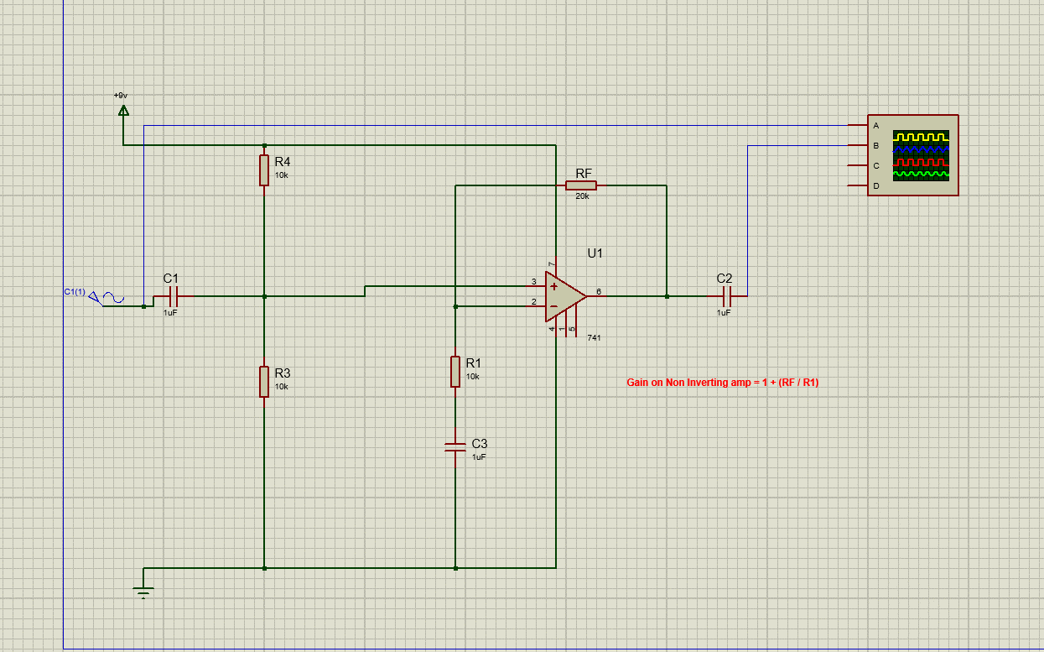
This created the following traces on the simulated scope, where Channel A (yellow) is the input from the simulated Sin wave and Channel B (blue) is the output.
By comparing the two I can confirm that both my circuit works and the gain on the op amp is a gain of 3.
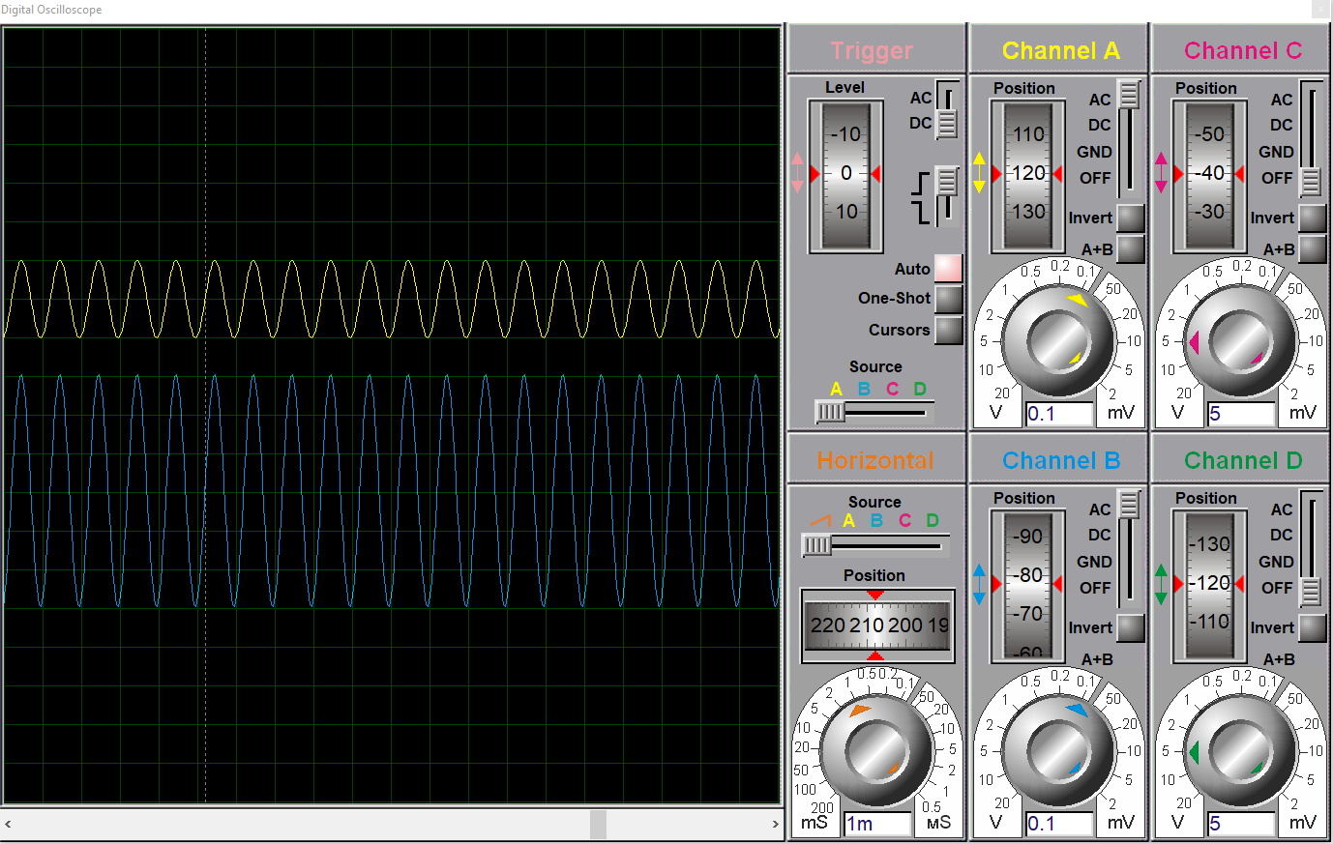

I then modified the circuit to include a signal generator in order to calculate the Gain Bandwidth Product of the simulated 741 op-amp
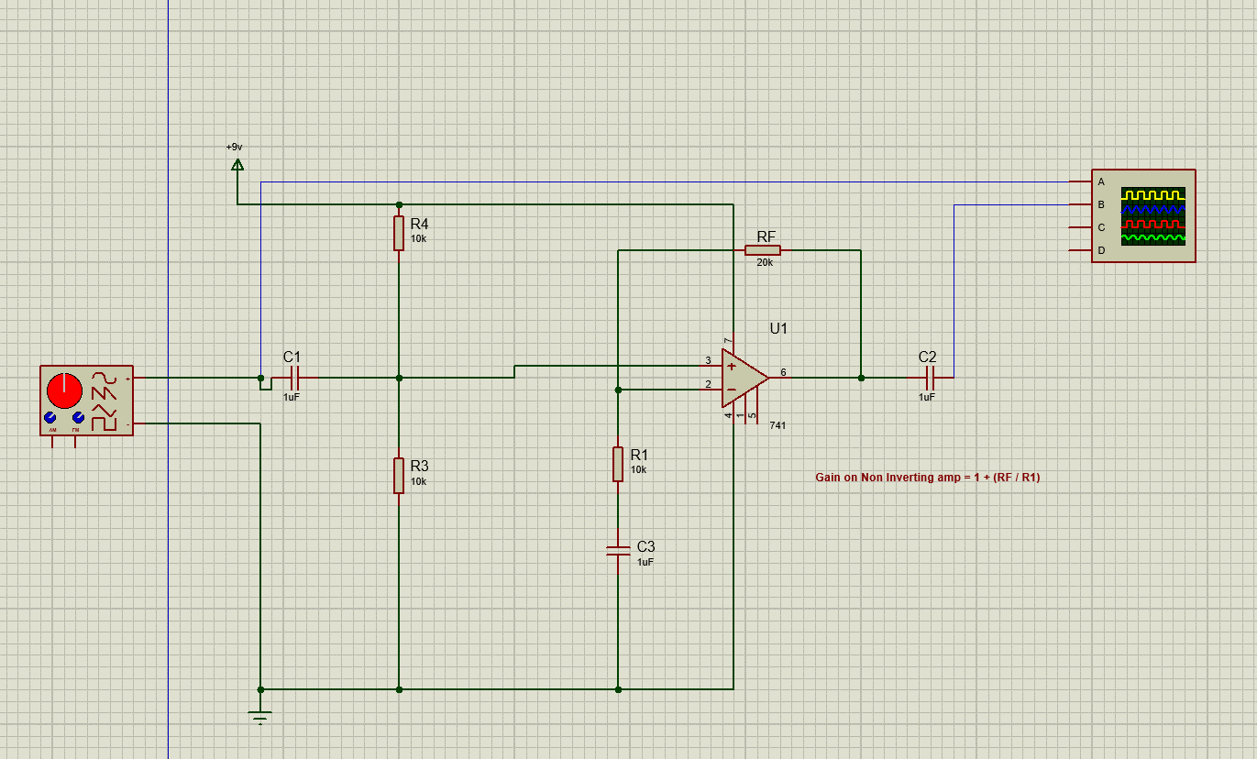
This produced the following results.
Frequency (kHz) | Output (mV)
0.1 | 282.5
0.2 | 300
0.5 | 300
1 | 300
2 | 300
5 | 300
10 | 300
20 | 300
50 | 290
100 | 287.5
200 | 256
250 | 237.5
300 | 218.75
310 | 215.7
320 | 211.75
330 | 207.5
340 | 205.25
350 | 201.25
400 | 183.75
450 | 171.25
500 | 158.75

Expressed as a Graph 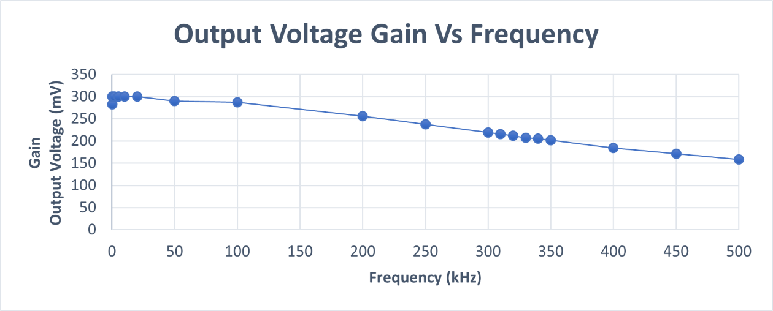

This then allowed me to calculate the Gain Bandwidth Product (GBP) where the GBP is region after the full power bandwidth or the half power point where there is a steady decline in the gain as the frequency increases.
This occurred at approximately 320khz, I can then us the following formula: GBP = Gain x Frequency
GBP = 3 x 320 = 960kHz

Following this simulation of output, I then moved on to recreate my design from Proteus into Easy-PC in order to design a printed circuit board (PCB) for manufacture.
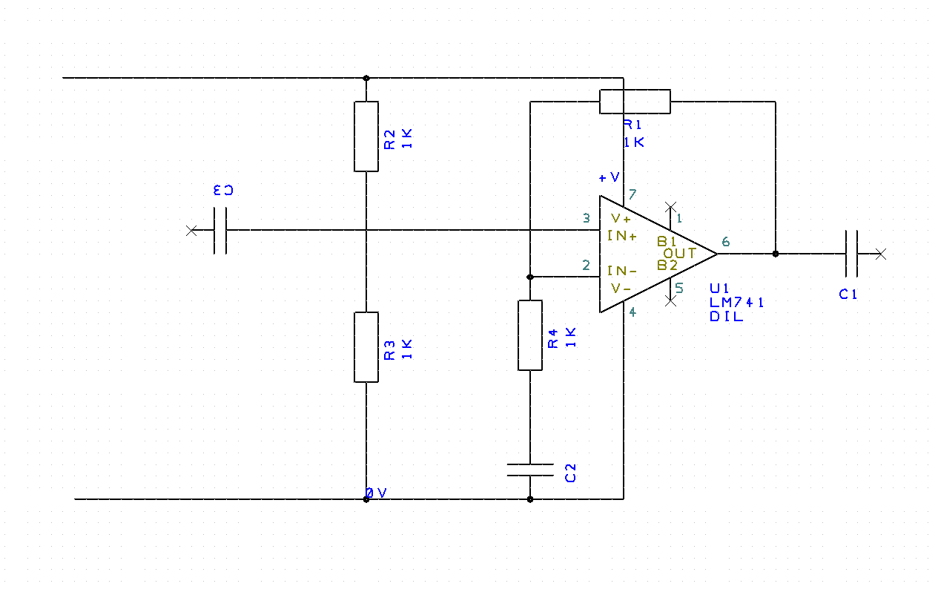
I then added altered the circuit in order to add connectors to the PCB. To avoid accidental polarity reversal, I used the following design.
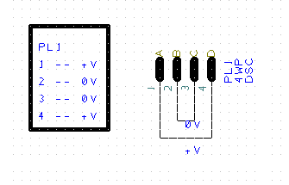
I continued with this logic and added further connections for the Input and Output to produce the following full schematic design.
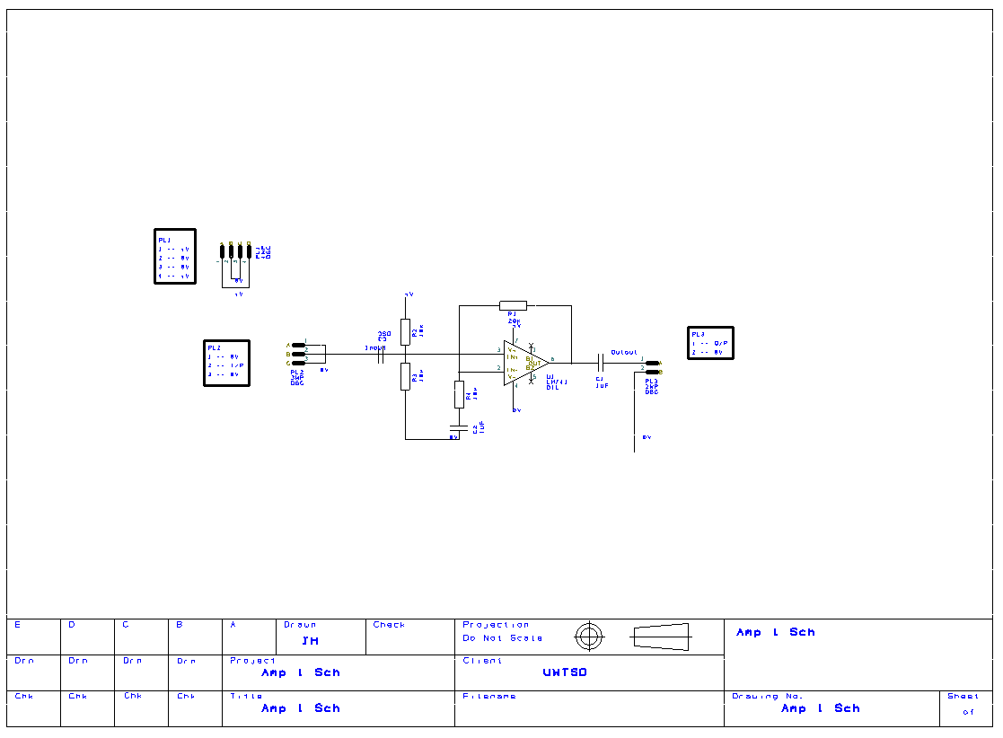
From this design schematic I then used the program to create a first layout of the components on PCB.
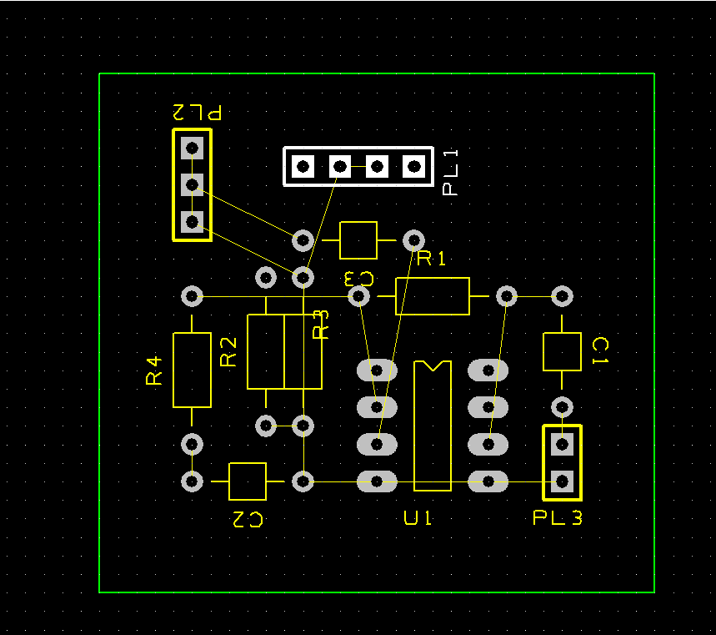

The next step I made was to route the V+ connections by adding a copper shape to the bottom of the board.
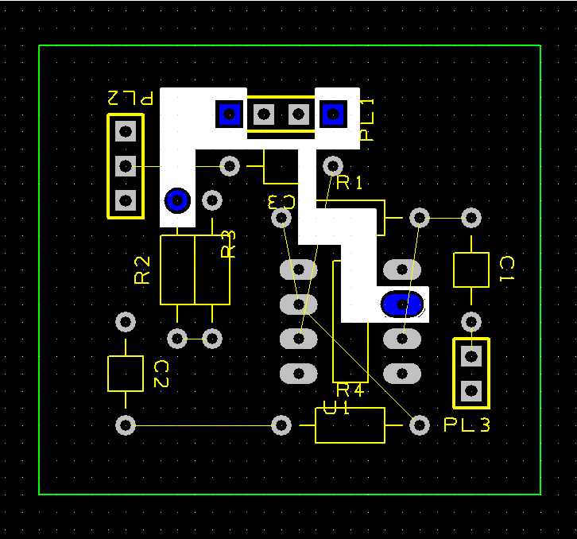

After completing the connections of the V+ net, I then added a second copper shape to bottom of the board to connect the 0V ground connections.
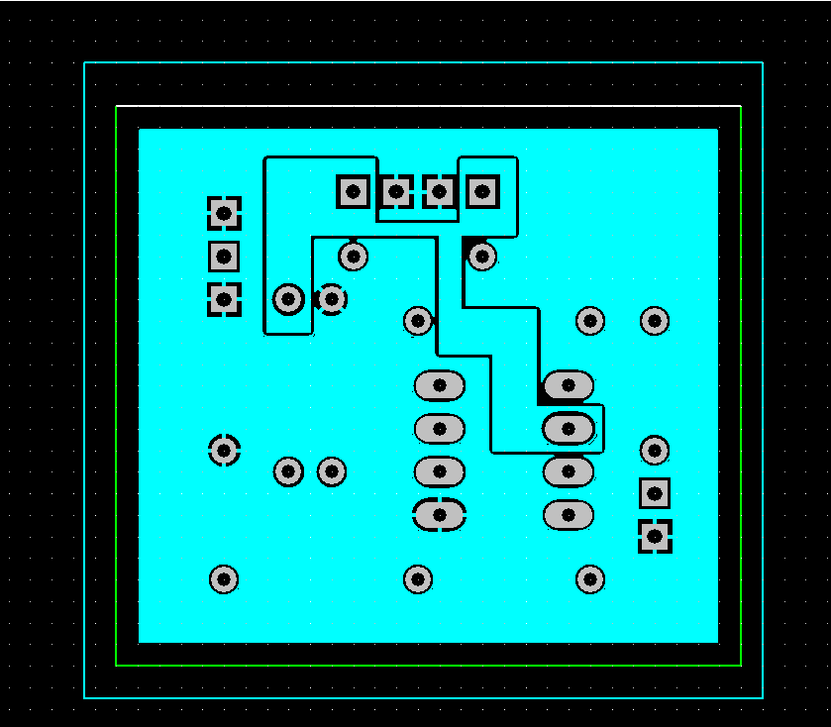

Having made both shapes for copper pours for +V and 0V, I then viewed the top of the board to route the make the connections that the program was unable to optimism and join via the 0V copper pour, or are signal input or output and need to be isolated from the rest of the board.
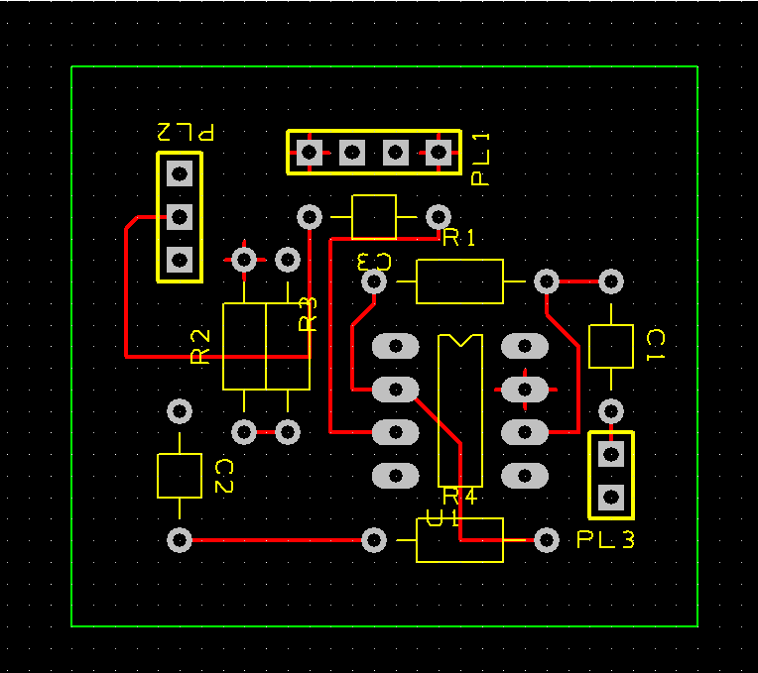
After completing the missing connections, I then ran the built-in design checking tools and with that assistance, I created the following board.
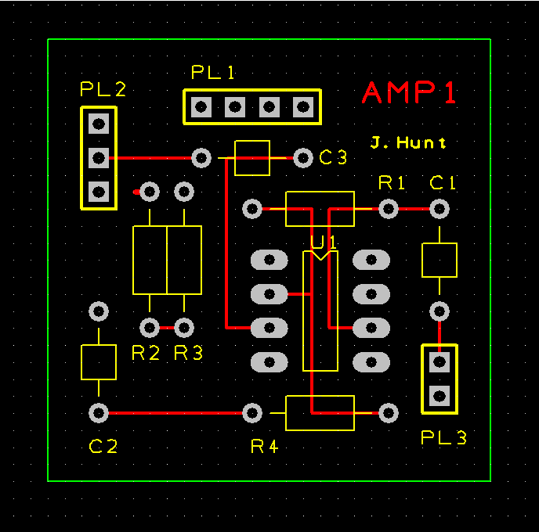
Included on this version, I have added the name of the board on the top copper layer to ensure longevity, as well as cleaning up the routing of the tracks and tidying the placement of name of components and adding my name in the silk screen.
These are the reports back from the design checking tools.
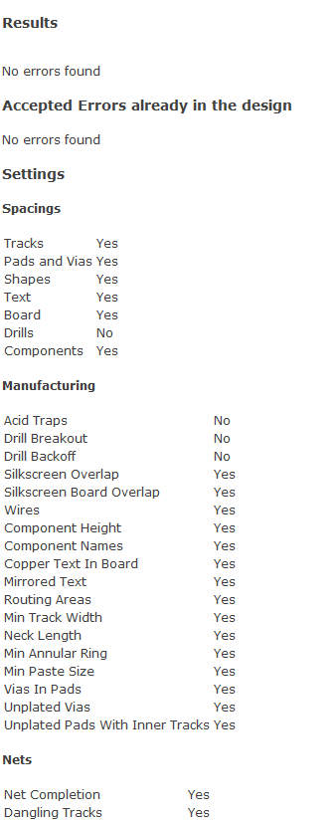
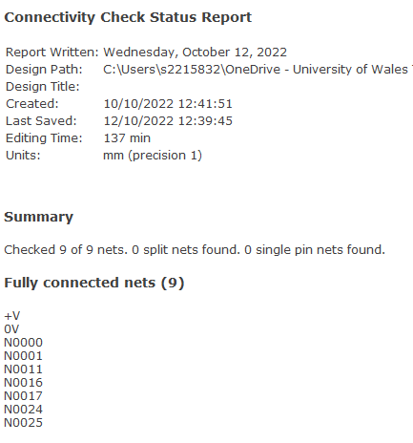

This is a 3d computer generated view of this version of my board.

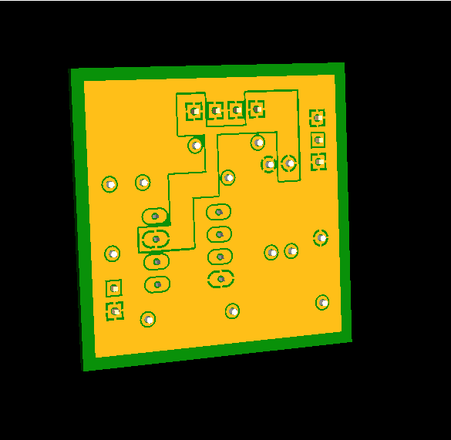
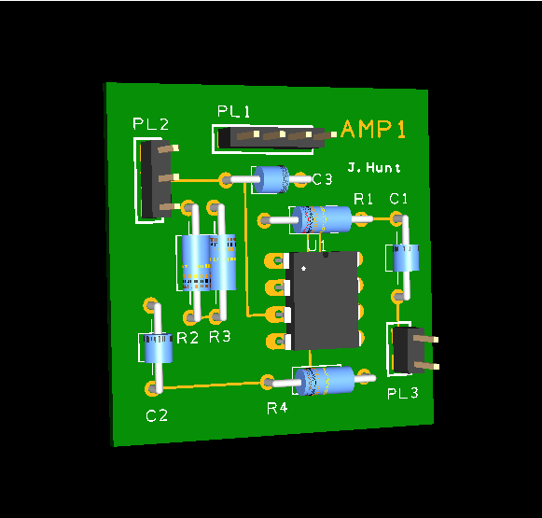

Having completed the layout of the PCB, it has now been sent off to be manufactured and should be available for when I return for the second University of Wales Trinity Saint David block.
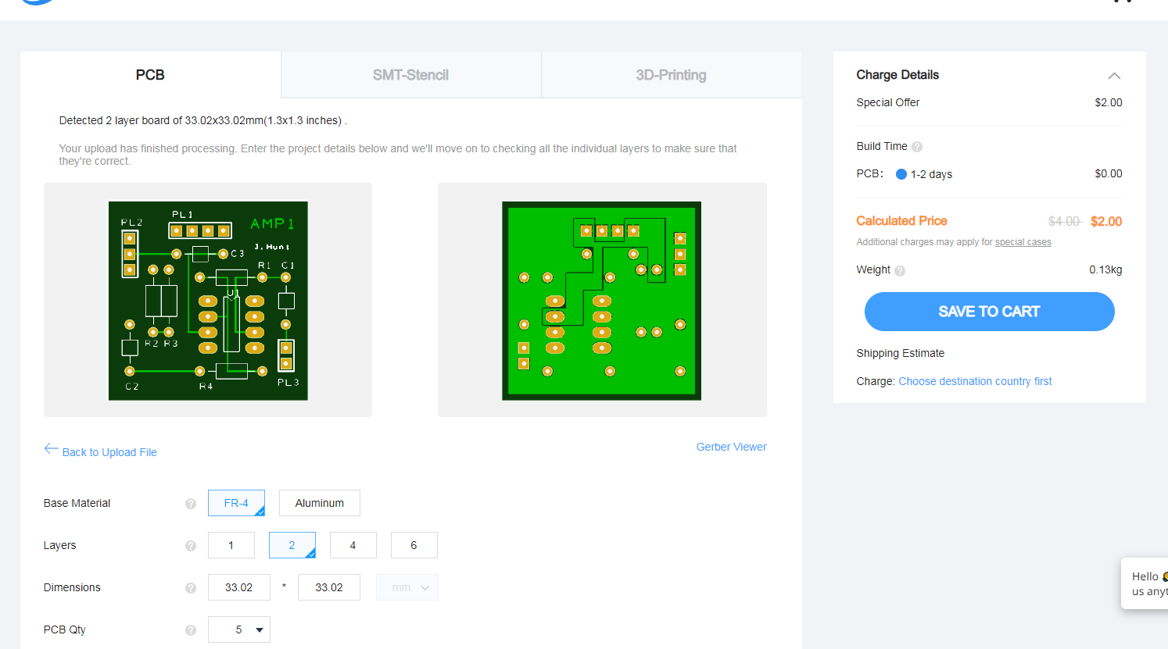
Whilst this is sent off to be printed, I created a breadboarding test setup. My first layout was just using the components and a few flying wires for power and signals.
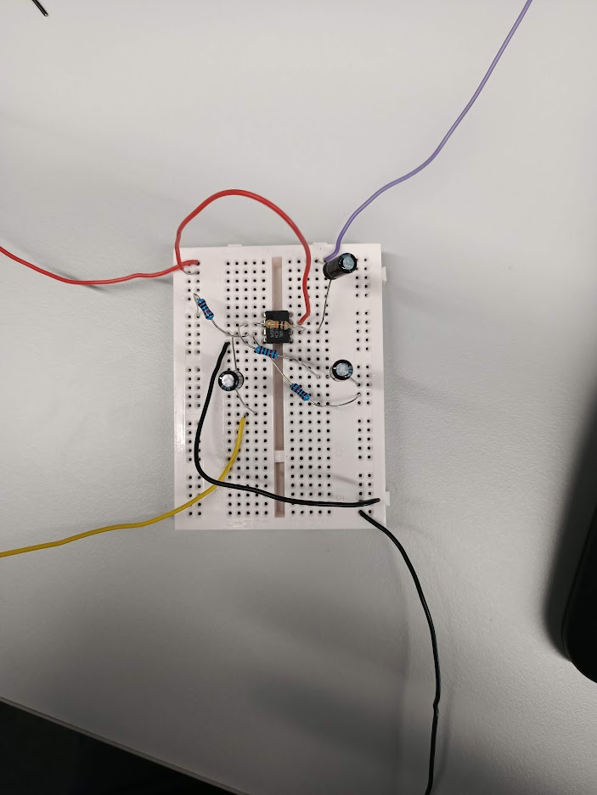
However, this layout has issues with bare wire and crossovers which could create shorts and therefore give incorrect results. To solve this problem, I returned to first modelling the layout in a drag and drop program.
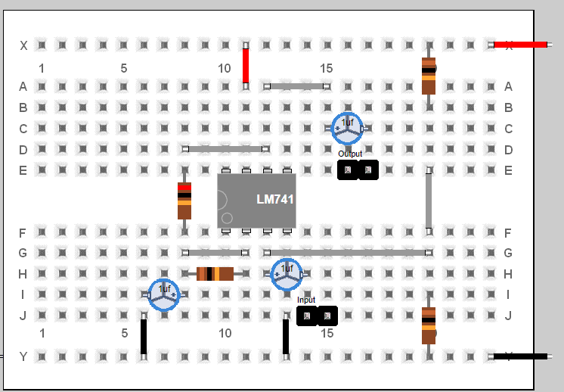
This model follows the correct layout for the components, however to assist with troubleshooting I created the following layout that closely follows the schematic diagram. 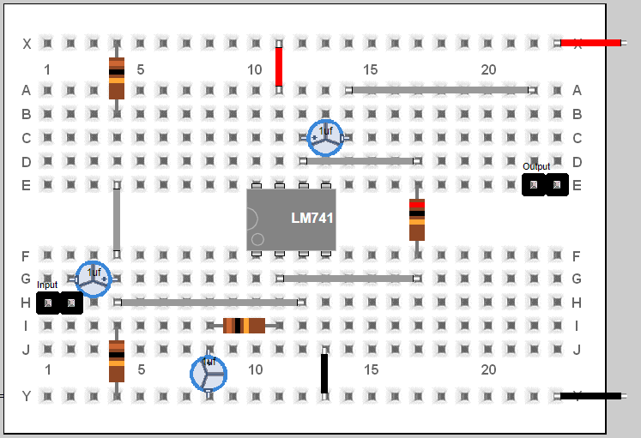

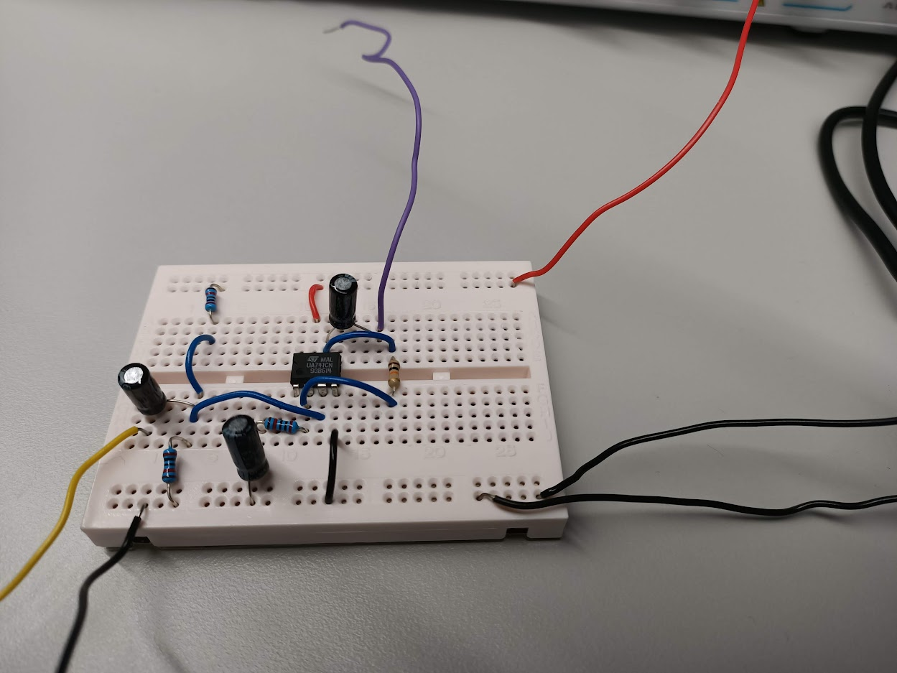
N.B additional 0V for connection for connection to probes. Yellow wire flying wire for signal input and purple for signal output.

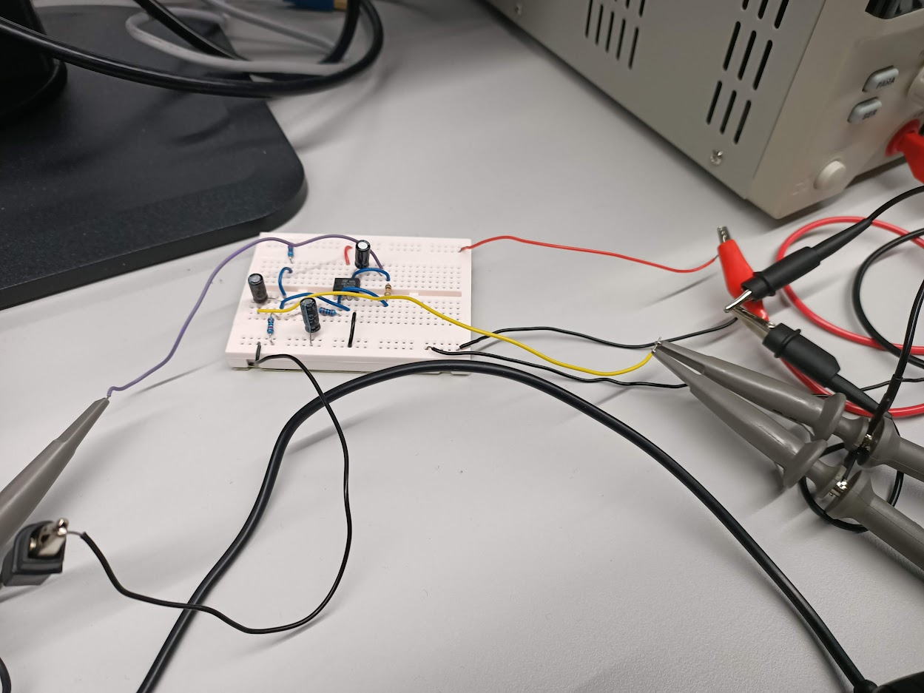
Breadboard circuit now connected to signal generator (probe on yellow wire), oscilloscope (probe on yellow to measure input and on purple for output) and power on red and black.
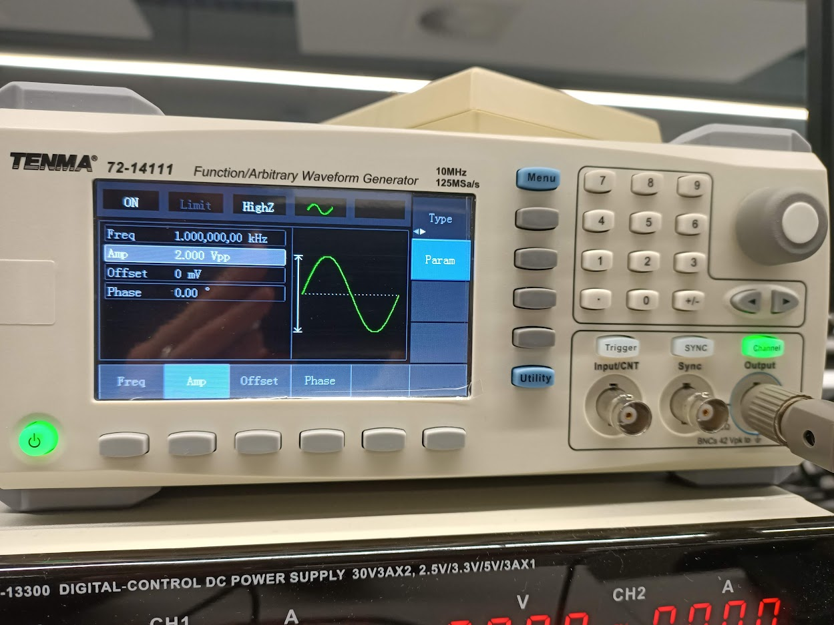
Sine waveform generated that is being feed into the op-amp circuit
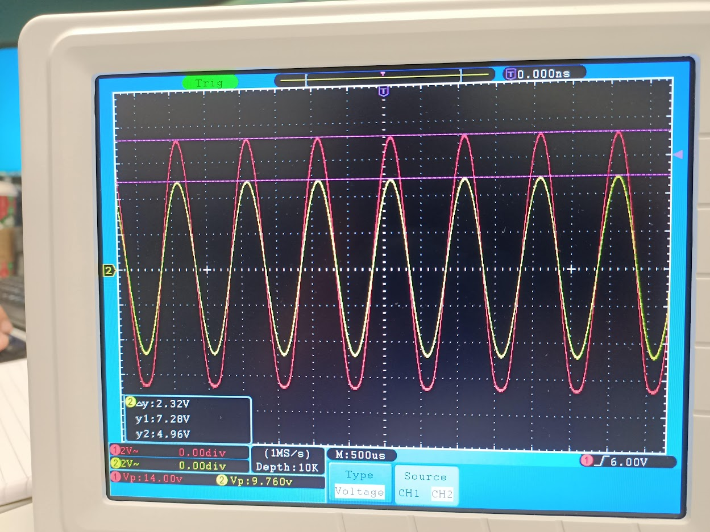

Oscilloscope view of the waveform, yellow trace is the original waveform from the generator. The red trace is the output from the circuit.
However, this is not what I expected as the gain is only 1.5. After troubleshooting I realised the value of the resistors I had been provided had been inverted. I had three 20k and only one 10k resistor.
Therefore, when working out the gain it is; Gain = 1 + (RF/R1) = 1+ (10/20) = 1.5
Comparing this to the output on the oscilloscope this is confirmed by the traces shown and values produced.

Having proved that my breadboard circuit works, I then replaced the resistors to get the gain of 3 required. I did this by swapping components with my fellow students, so for this part of the project we worked collaboratively to produce the following results.
Frequency (kHz) | Output Peak to Peak (mV) | Half wave (mV)
0.1 | 536 | 268
0.2 | 552 | 276
0.5 | 568 | 284
1 | 568 | 284
2 | 568 | 284
5 | 568 | 284
10 | 568 | 284
20 | 568 | 284
50 | 568 | 284
100 | 568 | 284
200 | 536 | 268
250 | 512 | 256
300 | 480 | 240
310 | 472 | 236
320 | 465 | 232.5
350 | 456 | 228
410 | 408 | 204
420 | 408 | 204
425 | 400 | 200
430 | 392 | 196
440 | 392 | 196
400 | 416 | 208
450 | 384 | 192
500 | 384 | 192

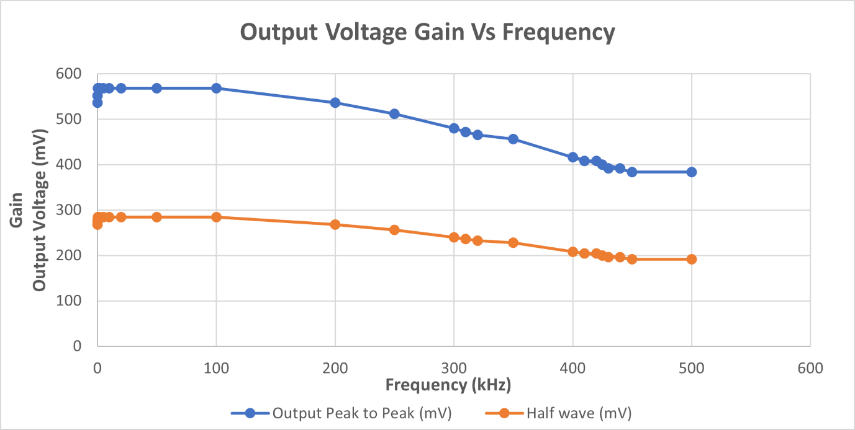

I realised that on the oscilloscope I had been measuring the output as peak to peak, however Proteus defaults to a half wave measurement. I solved this by halving my breadboard results (as shown on above graph). This then allowed for a comparison between a simulated model and the real-world results of a breadboard test.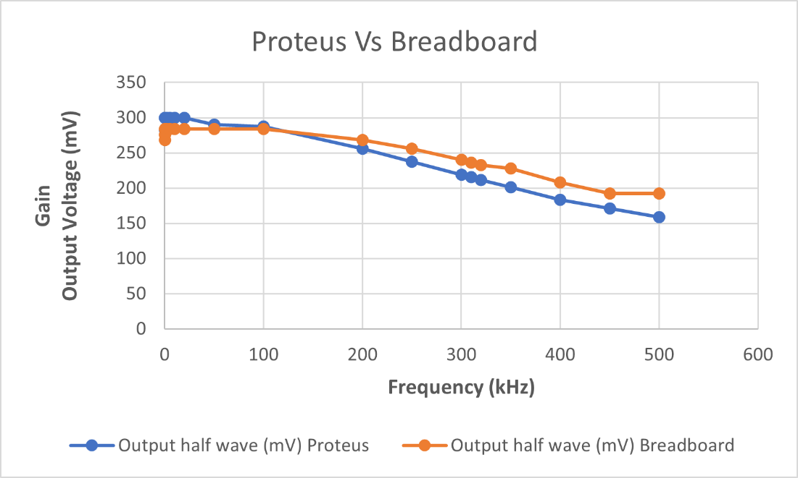

Having completed testing my circuit on a breadboard I then moved on to building up my now manufactured PCB.

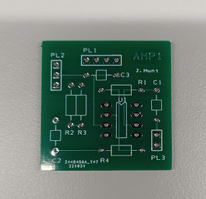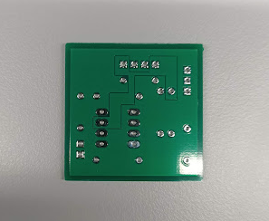

To do this I needed to pick and place all my components, then solder them onto the board.
I started by fitting the vertically small components to allow for easier access to the board. Once this was done I then setup my station to begin work with the needed equipment. 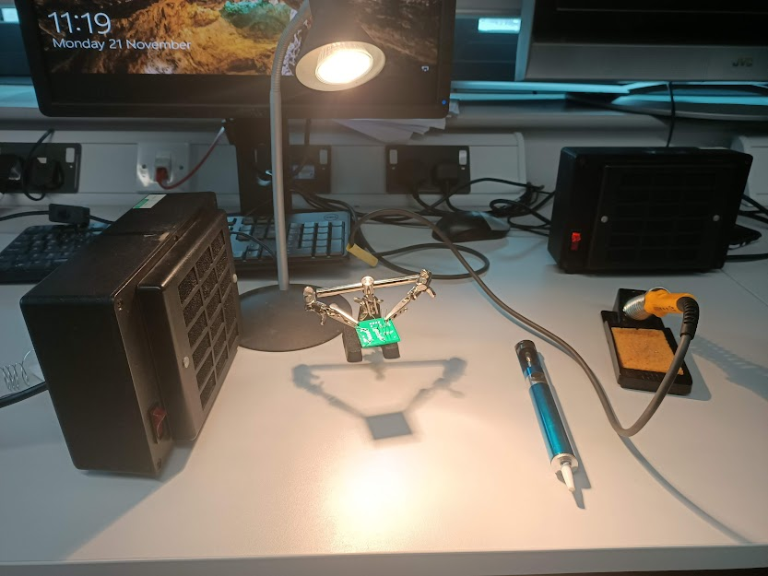

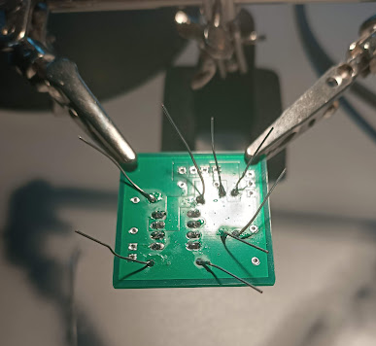
This is my 1st round of soldering with just the 741 chip and resistors in.

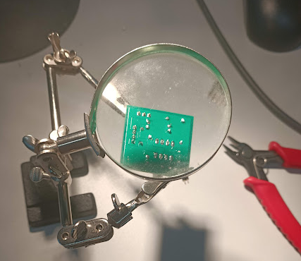
Fully soldered board with all components added and legs trimmed.

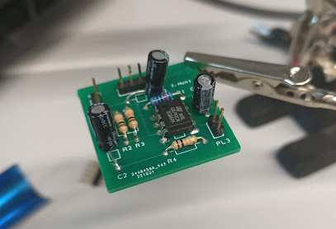
Topside of board with all components and header pins attached for power, signal in and signal out.
I then proceeded to test my board, however I wasn’t receiving a signal. I therefore began to trouble shoot my board.
I began my tracing the signal out route back from the header pins to the op amp chip. I did this by using the probe on the oscilloscope and checking each solder joint between the header pin and the leg on the 741 op amp chip.
By doing this I discovered that there was no signal from the chip. I then used also used a multi meter to trace the power into the 741 chip.

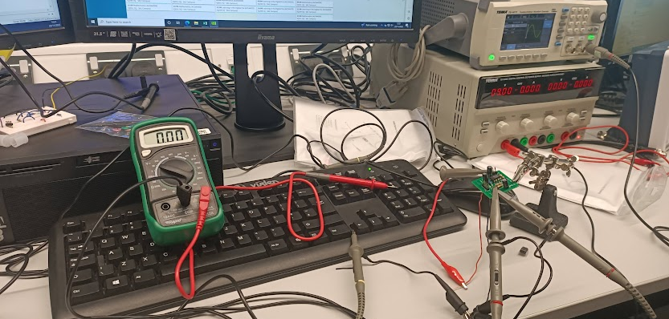

Having traced both the signal out and power into the chip, I then traced the input signal into the 741 chip.

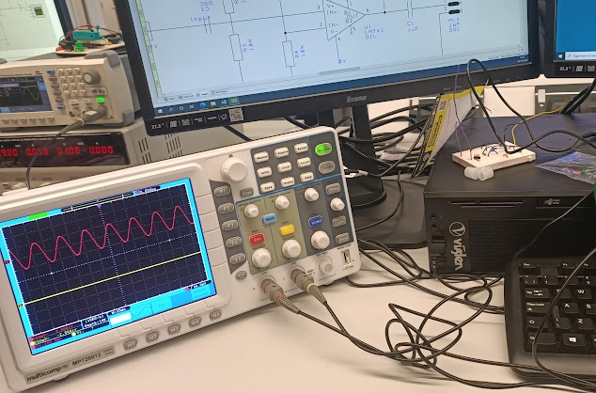
This proved that the signal was being generated correctly by the signal generator (Red trace on the oscilloscope), but still was not being amplified (yellow trace on the oscilloscope).
I therefore concluded there was two possible issues, either the 741 chip was faulty or my pcb design was incorrect.
As I had used the 741 chip successfully in my breadboard setup, I discounted this option for the moment and went back to the circuit diagrams I had created in both Easy Pc and Proteus.
It was then I discovered I had made an error in my circuit diagram on Easy Pc, when transferring the design from Proteus.

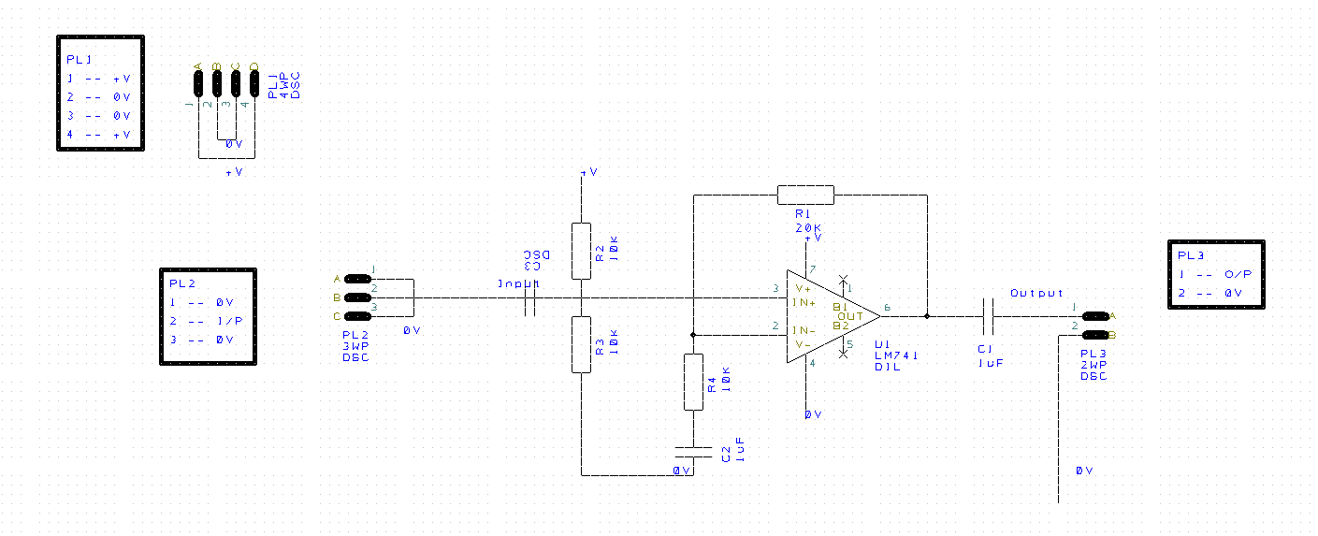
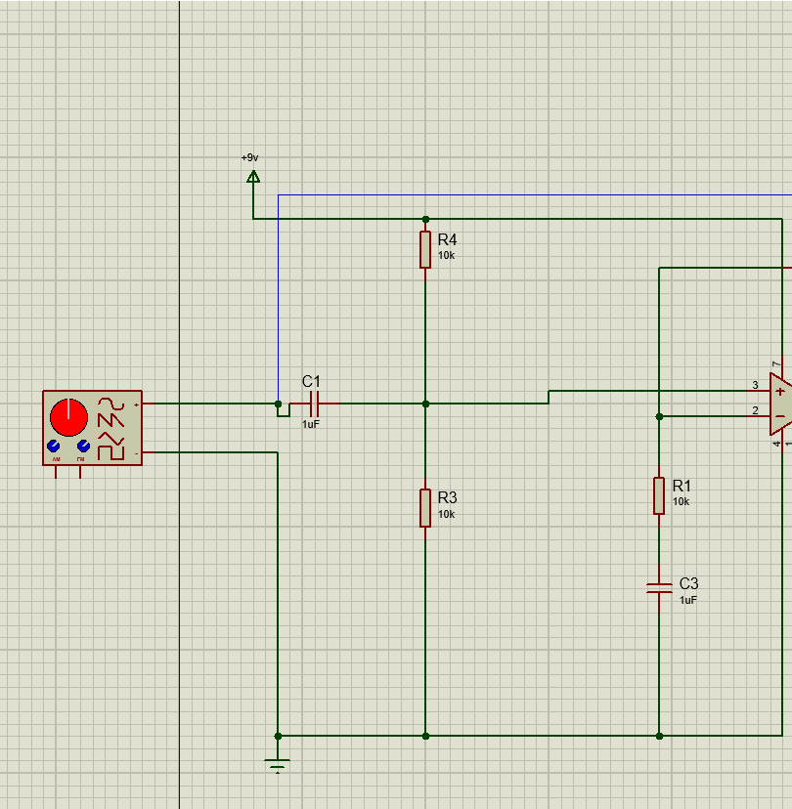

Between the two programmes I had missed adding a joining node in between the two resistors and the signal input (Marked with red circle)
I therefore created a work-a-round using a jumper wire from the bottom of the resistors to pin 3 on the 741 chip.

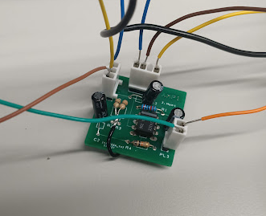
I choose to attach the wire to the resistors on the front on the board as it, allowed me to isolate the resistors and attach them directly to 741. This was in case any of the pads on the rear of the pcb for the resistors where accidently attached to the 0V copper pour.

This proved to work successfully and allowed me to produce the following results.
Frequency (kHz) | Output half wave (mV) PCB
0.1 | 250
0.2 | 270
0.5 | 280
1 | 280
2 | 280
5 | 280
10 | 280
20 | 280
50 | 280
100 | 280
200 | 268
250 | 190
300 | 170
310 | 168
320 | 164
350 | 148
400 | 132
450 | 120
500 | 108

This then allows the following graph to be produced, comparing all three circuits.


