The Native vs. Non-Native Speaker Divide in English: Reconceptualizing the Role of Non-Native English-Speaking Teachers

1 Introduction and the Conceptual Framework of the Native Speaker Fallacy
In contemporary global communication, the English language has undergone a radical and irreversible demographic transformation. With over 1.5 billion English speakers worldwide, empirical data indicates that more than 80 percent of these individuals are non-native speakers (Crystal, 2003, p. 69). Consequently, English has evolved far beyond its historical origins as a national language exclusively owned by Anglophone countries, transitioning into a true English as a Lingua Franca (ELF). Despite this undeniable demographic reality, the binary distinction between native speakers and non-native speakers has remained a foundational, yet contested concept within the realms of second language acquisition research and English language teaching practice. Globally, non-native English-speaking teachers currently make up over 90 percent of the world’s English teaching workforce (Braine, 1999, p. 14). However, their professional legitimacy, pedagogical competence, and linguistic authority have long been marginalized by the pervasive and deeply entrenched ideology of native-speaker hegemony. This essay aims to rigorously delineate the core linguistic, cognitive, and pragmatic differences between native and non-native English speakers. Furthermore, it seeks to deeply examine these differences through the critical lens of scholarly literature on non-native English-speaking teachers, and critique the traditional native and non-native dichotomy from the progressive perspectives of multi-competence, teacher cognition, and English as a Lingua Franca.
To understand the current pedagogical landscape, it is essential to trace the roots of the native speaker construct. The traditional definition of a native speaker rests on four foundational and restrictive criteria: early childhood acquisition from birth, continuous immersive exposure in a predominantly monolingual environment, intuitive and subconscious mastery of the language system, and an elevated social status as the ultimate arbiter of linguistic norms and acceptability (Davies, 2003, p. 12). This idealized, monolingual model originally emerged from the traditions of twentieth-century structural linguistics and generative grammar. Most notably, it is rooted in Chomsky’s (1965, p. 3) influential conceptualization of linguistic competence, which famously defined the subject of linguistic theory as the innate grammatical knowledge of an ideal speaker-listener, in a completely homogeneous speech-community. Within this paradigm, the non-native speaker’s developing language system, historically termed interlanguage (Selinker, 1972, p. 212), was framed almost exclusively as an incomplete and deficient approximation of the native speaker’s target model, rather than being recognized as a legitimate, rule-governed linguistic system in its own right.
However, the unprecedented globalization of English has fundamentally undermined the empirical and conceptual validity of this traditional definition. First, monolingual native speakers now represent a minority of the world’s English users. García (2009, p. 63) argue that the vast majority of the world’s English users operate in inherently multilingual and multicultural contexts, constantly negotiating meaning across diverse linguistic codes and cultural frameworks in their daily communication. Second, within English as a Lingua Franca interactions, over 80 percent of all English communication occurs entirely between non-native speakers. This statistical reality signifies that the localized linguistic norms, idioms, and cultural references of native speakers are no longer the sole, or even the primary, standard for successful international communication (Seidlhofer, 2001, p. 152). Addressing this theoretical imbalance, Cook’s (1999, p. 185) pioneering theory of multi-competence delivered a seminal challenge to the native and non-native binary. Multi-competence argues that non-native speakers are categorically not failed native speakers. Instead, they possess an integrated, holistic, and highly complex multilingual linguistic system that simply cannot and should not be evaluated against monolingual native speaker standards. This theoretical shift is increasingly mirrored in practical English language teaching pedagogy. For instance, Harmer (2007, p. 19) explicitly notes that teaching English in the modern era requires a profound acknowledgement of English as a Lingua Franca, moving away from strict adherence to Inner Circle norms.

2 Linguistic and Cognitive Processing Divergences in Second Language Acquisition
While the conceptual validity and pedagogical supremacy of the native and non-native binary are increasingly and legitimate contested, objective second language acquisition research acknowledges that there are observable, systematic differences between native and non-native speakers. These distinctions do not denote superiority, but rather different linguistic aspects, which manifest across four key dimensions: phonology, syntax, lexical semantics, and pragmatics.
The most widely documented and perceptually obvious difference between native and non-native speakers lies in phonological attainment. This phenomenon is closely tied to the Critical Period Hypothesis, a biological framework suggesting a specific window of neurological receptivity for language learning. Johnson and Newport’s (1989, p. 90) landmark study provided robust empirical evidence that second language learners who began acquiring English before puberty showed native-like performance on grammaticality judgement tasks, while those who started learning after puberty exhibited a linear, age-related decline in performance. Phonology demonstrates an even more pronounced critical period effect. Because of neurological lateralization, the vast majority of post-puberty learners fail to achieve entirely native-like accuracy in vowel production, word stress, rhythm, and intonation patterns (Brown, 2007, p. 61). Translating this into classroom practice, Scrivener (2005, p. 291) observes that incorrect word stress is one of the most frequent causes of communication breakdown for non-native speakers, whereas native speakers possess an intuitive, natural mastery of English stress patterns. Crucially, however, the Critical Period Hypothesis is not an impenetrable biological wall. Birdsong’s (2005, p. 100) subsequent research demonstrates that approximately 10% of adult second language learners can indeed attain native-like phonological and syntactic competence. This indicates that the critical period is a sensitive period rather than an absolute barrier, and that individual psychological factors such as intense motivation, high-quality learning contexts, and innate language aptitude play a massively significant role in ultimate phonological attainment.
Beyond pronunciation, the cognitive mechanisms underlying syntactic processing strongly differentiate the two groups. Native speakers process syntactic structures automatically, effortlessly, and implicitly. In contrast, non-native speakers’ syntactic processing, especially among late learners, is heavily dependent on explicit declarative rule knowledge and lexical-semantic information, rather than pure, automated syntactic structure (Clahsen and Felser, 2006, p. 12). For example, when processing highly complex syntactic structures such as relative clauses, subject-verb agreement across long distances, and intricate tense-aspect marking, non-native speakers typically exhibit slower reaction times, higher error rates, and greater susceptibility to distraction from semantic context. This cognitive reality aligns perfectly with Krashen’s (1982, p. 86) Monitor Model, which posits that non-native language production is heavily regulated by a conscious mental monitor that checks spoken or written output against explicitly learned grammatical rules, whereas native speaker production is automatic, spontaneous, and unmonitored. Scrivener (2005, p. 214) reinforces this theoretical point in everyday pedagogical practice, noting that long, teacher-centered grammar lectures rarely lead to improved spontaneous production.
The third major dimension of difference is lexical semantics competence. Native speakers possess a remarkably rich, deeply interconnected mental lexicon. They possess an intuitive, effortless mastery of collocations, idiomatic language, phrasal verbs, register variation, and subtle semantic nuances. Non-native speakers, by contrast, often possess a less proficient lexical understanding. They frequently focus primarily on core dictionary definitions while lacking profound proficiency in the contextualized, culturally embedded use of words (Lewis, 1993, pp. 108-109). Harmer (2007, p. 74) forcefully emphasizes that the core of vocabulary teaching is not memorizing isolated word meanings, but understanding the collocational relationships between words, which is precisely the cognitive area where non-native speakers face the greatest difficulty. Additionally, native speakers have an innate, socially conditioned sense of register variation. Non-native speakers, however, frequently produce register mismatches, such as deploying overly formal, outdated vocabulary in casual conversation or using colloquial slang inappropriately in formal academic writing.
Finally, linguistic proficiency alone does not guarantee successful communication. Even non-native speakers with near-native grammatical and lexical competence can frequently experience severe communicative failure due to cross-cultural pragmatic inadequacy. Thomas (1983, p. 99) defines this phenomenon as sociopragmatic failure. This occurs when speakers unconsciously transfer pragmatic norms, politeness strategies, and conversational norms from their first language into English. As a result, they may critically misjudge the social conventions and power dynamics of specific speech acts, such as requests, refusals, apologies, and compliments, sounding rude, overly direct, or inappropriately subservient. Native speakers acquire pragmatic competence naturally and implicitly through lifelong socialization in Anglophone cultural contexts, developing a highly context-sensitive understanding of how language functions in complex social interactions. Harmer (2007, pp. 27-29) highlights that effective, modern language teaching must systematically address not just linguistic form and accuracy, but the functional and pragmatic meaning of language in highly specific social contexts.

3 The Psychological Foundation of Teacher Cognition and Pedagogical Strengths
Borg (2003, p. 81) extensively reviews how what teachers think, know, and believe directly dictates their classroom actions. A fundamental principle of teacher cognition research is that teachers’ beliefs are profoundly shaped by their own prior experiences as learners, a phenomenon Lortie (1975, pp. 61-62) famously termed the apprenticeship of observation. For native English-speaking teachers, this apprenticeship occurred entirely within a monolingual, subconscious acquisition framework. They never explicitly learned English grammar or phonology; they simply absorbed it from their environment. Conversely, the teacher cognition of non-native English-speaking teachers is deeply rooted in thousands of hours of explicit second language learning, testing, and cognitive restructuring (Borg, 2003, p. 86). Their pedagogical beliefs are informed by their personal triumphs over the very linguistic hurdles their students currently face. This shared cognitive history endows the non-native educator with a psychological architecture uniquely suited for explicit language instruction, enabling them to deconstruct complex language systems into comprehensible pedagogical sequences.
Non-native teachers possess unique, distinctive, and effective pedagogical strengths that stem directly from their identity as successful non-native speakers and their lived, arduous experience of language acquisition. Medgyes (1994, pp. 47-48), widely recognized as the foundational scholar in this field, argues that the difference between native and non-native teachers is absolutely not a matter of competence versus incompetence. Rather, it is a matter of complementary strengths and limitations in the language classroom. First and foremost, non-native educators possess an unparalleled, empathetic understanding of learning processes, psychological hurdles, and specific learner difficulties. Consequently, they can accurately predict common errors, pinpoint their precise linguistic origins, and expertly design highly targeted remedial activities (Medgyes, 1994, pp. 52-54). Brown (2007, pp. 263-264) notes that understanding a student’s interlanguage requires analyzing the systematicity of their errors. Having made similar errors themselves during their learning journey, non-native teachers can accurately distinguish between natural developmental errors, first language transfer errors, and deeply fossilized errors. Native speakers, conversely, often struggle profoundly to understand the cognitive source of errors that simply never occur in native language development.
Secondly, non-native teachers invariably possess vastly superior metalinguistic awareness and explicit grammatical knowledge. This makes them highly effective and confident at explaining complex, abstract linguistic rules to learners. Native speakers’ grammatical competence is implicit and intuitive; they can instantly judge the grammaticality of a sentence, but often cannot articulate the underlying structural rules (Cook, 1999, p. 186). Non-native teachers, by contrast, have learned English grammar through years of academic study. Therefore, they can present rules in a structured and accessible way. Furthermore, they are adept at designing guided discovery activities that lead learners to inductively grasp grammatical patterns. Their own learning experience enables them to design cognitive tasks that perfectly align with the developmental pathways of learners, skillfully avoiding the frustrating taken-for-granted explanations that often characterize native grammar instruction.
Thirdly, non-native teachers serve as incredibly powerful, living role models for learners. Their presence in the classroom reduces foreign language anxiety and enhances learner self-efficacy. Krashen’s (1982, p. 31) Affective Filter Hypothesis posits that high anxiety, low self-esteem, and low motivation create a mental block that actively prevents language acquisition. Learner anxiety very often stems from the belief that native-like proficiency is the only acceptable marker of success. Non-native teachers, existing as highly successful learners themselves, tangibly demonstrate that fluent, effective, and professional English use is entirely achievable without being born a native speaker. This validates learners’ own developing multilingual identities and drastically reduces the immense psychological pressure to mimic native speakers perfectly.
An extraordinary extension of the non-native teacher’s ability to utilize their linguistic background is the modern pedagogical paradigm of Translanguaging. Moving far beyond the traditional concepts of code-switching, Translanguaging, as comprehensively theorized by García and Li Wei (2014, p. 14), proposes that bilingual individuals do not possess two strictly compartmentalized language systems in their brains. Rather, they possess one integrated, expansive linguistic repertoire from which they strategically select features to communicate effectively and make sense of their complex bilingual worlds. For the teacher who shares the students’ mother tongue, Translanguaging is not a sign of linguistic deficit or confusion, but rather a highly sophisticated cognitive and pedagogical tool. It dismantles the oppressive, monolingual English-only classroom policies that have historically silenced learners and restricted their cognitive expression. By actively encouraging students to utilize their entire linguistic repertoire, teachers foster an environment where complex academic concepts can be negotiated in the native language before being produced in English. Harmer (2007, pp. 133-134) explicitly acknowledges the value of the mother tongue in the classroom, noting that it can be used efficiently for explaining complex instructions, discussing learning methodologies, and fostering a supportive classroom climate. This profound pedagogical strategy actively validates the students’ cultural identities and accelerates cognitive processing, creating a bridge rather than a barrier to English acquisition. This approach completely aligns with Baker and Wright’s (2017, p. 296) foundational premise that bilingualism offers significant cognitive advantages, such as divergent thinking and increased metalinguistic awareness, which are fully activated only when both languages are permitted to interact organically in the learning environment.

4 Ideological Hegemony and Systemic Challenges Facing NNESTs
Despite possessing these immense, evidence-based pedagogical strengths, the primary challenges facing non-native English-speaking teachers stem absolutely not from their teaching competence, but from the pervasive ideology of native speaker hegemony in global language education. Non-native educators face widespread, institutionalized hiring discrimination. Mahboob (2003, p. 1) reveals that a shocking number of language schools and educational institutions worldwide explicitly list native speaker status as a mandatory hiring requirement. This occurs even when non-native candidates possess significantly higher academic qualifications, far more extensive teaching experience, and superior pedagogical training compared to their native-speaker counterparts. This blatant discrimination is deeply rooted in Phillipson’s (1992, pp. 193-194) critical theory of linguistic imperialism. This Western-centric ideology frames white, monolingual native speakers from Anglophone countries as the sole legitimate owners and guardians of the English language, simultaneously reducing highly qualified non-native educators to second-class practitioners.
As a direct result of this systemic prejudice, many non-native teachers unfortunately experience severe internalized self-doubt about their own linguistic competence, particularly concerning their pronunciation and spoken fluency. Scrivener (2005, p. 286) directly and powerfully addresses this unwarranted concern, arguing that teachers absolutely do not need to speak with a perfect Received Pronunciation or General American accent to be competent educators. The primary goal of pronunciation teaching is not to produce flawless mimics of native speech, but rather to equip learners with clearly intelligible pronunciation that enables successful, friction-free global communication. A teacher’s distinct regional or non-native accent is a fully legitimate and valuable model for learners, provided that it does not impede mutual intelligibility. Furthermore, Jenkins (2000, p. 15) points out that in international contexts, striving for a native accent can be an exercise in futility and can even hinder the confidence of learners and teachers alike.
Non-native educators also face ongoing questions regarding the fundamental legitimacy of their linguistic norms, as traditional methodology has long framed native speaker language as the only correct model. However, the exponential rise of research on English as a Lingua Franca definitively demonstrates that in real-world global English communication, mutual intelligibility and pragmatic communicative effectiveness are far more important than rigid adherence to arbitrary native speaker norms. The burden of overcoming these systemic challenges falls not on the teachers themselves to alter their linguistic identities, but on educational institutions to dismantle discriminatory hiring practices and update their pedagogical standards.
5 Reconceptualizing the Paradigm and Conclusion
The fundamental, fatal flaw of the traditional binary is that it stubbornly positions monolingual native speaker competence as the sole, absolute standard for language proficiency. In doing so, it completely ignores the undeniable reality of English as a global lingua franca and actively devalues the rich, complex multilingual competence of non-native speakers. Widdowson (1994, pp. 381-382) argues that native speaker norms are essentially only relevant for communication occurring specifically between native speakers. In interactions occurring between non-native speakers from incredibly diverse linguistic and cultural backgrounds, the primary criterion for successful communication is intelligibility, not adherence to native speaker conventions.
Jenkins’ (2000, pp. 127-131) concept of the Lingua Franca Core provides vital empirical grounding for this massive paradigm shift. The Lingua Franca Core specifically identifies the phonological features that are essential for mutual intelligibility between non-native speakers. Simultaneously, it demonstrates that many features traditionally prioritized in rigid pronunciation teaching actually cause, rather than prevent, communication breakdowns in global interactions. Cook’s (1999, pp. 188-191) multi-competence theory further deconstructs and dismantles the historical binary. It argues forcefully that multilingual speakers possess a single, highly integrated linguistic system in the brain, rather than two entirely separate, isolated monolingual systems. Consequently, multilingual competence is not a broken or deficient version of monolingual native competence. It is a unique, complete, and highly sophisticated form of cognitive and linguistic ability that brings distinct advantages, including enhanced metalinguistic awareness and superior cross-cultural communicative competence. This robust psychological theory provides the ultimate theoretical foundation for the professional legitimacy of non-native teachers: they are emphatically not imperfect native speakers. They are skilled multilingual educators possessing unique pedagogical strengths that monolingual native speakers simply cannot replicate.
In conclusion, this essay has systematically examined the conceptual debates, the objective linguistic and cognitive differences, and the far-reaching pedagogical implications of the native and non-native speaker divide in English. The core findings demonstrate that the traditional binary is deeply rooted in an idealized, structurally flawed monolingual model that is outdated in the modern context of global English. Non-native speakers are legitimate, capable multilingual language users operating with complete, deeply integrated linguistic systems. While there are indeed systematic, empirically observable differences in the domains of phonology, syntax, lexical semantics, and pragmatics, these differences stem entirely from divergent acquisition pathways and unique cognitive processing styles, absolutely not from an inherent hierarchy of linguistic ability. The identity of the non-native educator is definitely not a pedagogical weakness. Rather, it is a rich source of unique, evidence-based strengths. These strengths include empathetic understanding of learning challenges, the effective, strategic use of translanguaging in the classroom, superior metalinguistic awareness driven by complex teacher cognition, and the unparalleled ability to serve as powerful, relatable role models for learners.
The primary, systemic barriers currently facing non-native teachers are not linguistic or pedagogical in nature, but ideological. The pervasive native speaker hegemony continues to unjustly marginalize highly qualified multilingual educators within global language teaching. For the future of educational practice, this critical analysis demands a break from native speaker-centrism. The focus must shift towards cultivating highly adaptable learners who can use English effectively, intelligently in diverse global contexts. The field must focus on real experiences and pedagogical expertise of multilingual speakers, striving tirelessly to build a significantly more inclusive, equitable, scientifically grounded, and practically relevant model of English language education for the all educators.

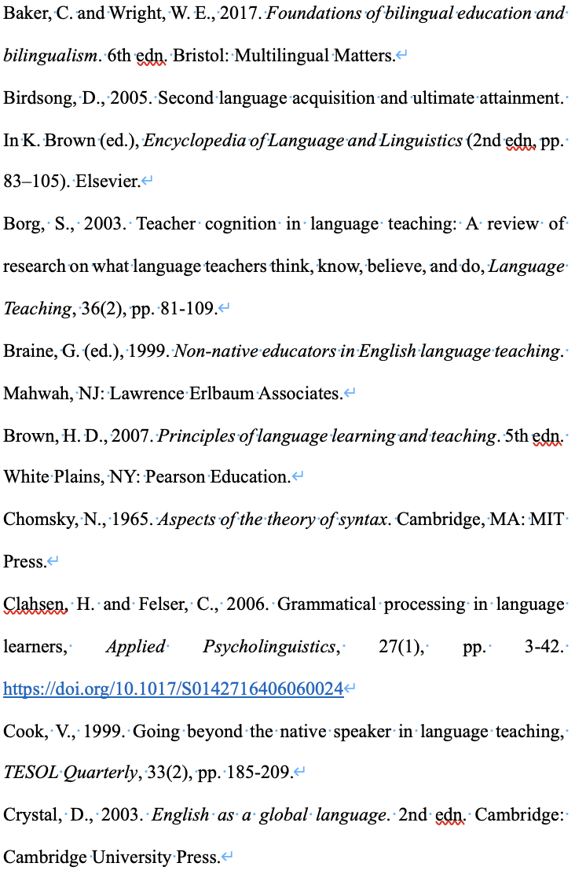
References


