PROBLEM SOLVING TOOLS AND TECHINQUES USED IN HEALTH AND SOCIAL CARE SETTINGS

OLIVETTE MILDRED COLE
STUDENT 2022097

LECTURER: AFZAL MUNNA
BMSW4004
AUGUST 2021

1.Introduction- An overview or problem in healthcare | 3
1.1 Problem in healthcare Diagram | 4
2. Problem definition of problem statement-In the Elderly community | 5
2.1 Fishbone diagram | 5
2.2 Discussion the root of the problem | 6.7
3. Analysis- Analyse the decision-making process | 8
3.1 SWOT Analysis personal and professional development plan | 9
4. Recommendation/Alternative solutions- propose solutions to the problem | 10.11.12
4.1 PMI | 13.14
4.2 How to implement CGA | 15
4.3 Monitoring and review techniques | 16
5. Conclusions | 17
6. References | 18.19.20

CONTENTS PAGE

1.Introduction- an overview of problems in healthcare
Healthcare systems have been facing several problems over the last years. Some of the key challenges are:
- to manage the accumulation of physical and mental care issues caused by the Covid-19 pandemic, and to build a healthcare system that can deal with the impurities that the pandemic has unveiled.
- an ageing population, an issue almost all healthcare systems in the world are struggling to deal with. Thanks to medical progresses life expectancy has increased, however per capita expenses begin to rise at the age of 50 and increase from age 70: it has been estimated that hospital costs are every high for Elderly 80+ patient are about threefold more than the 70year olds, almost According to the hospital-based retrospective study it is nine times higher than a 50-year-old. (Kelly et al. 2015). The Nuffield Trust (2014) calculates that, given the numbers of ageing and growing population, we will need thousands of hospital beds in the next years - the number of staff still must meet this demand. Elderly community is the regular main occupier of public services; therefore, a modern hospital must deliver services arranged around their needs (Royal College of Physicians 2013), preserving quality and dignity in their care: in this essay I am going to delve into this topic.
- recruitment and retention of properly skilled staff, particularly nurses, paramedics, and some medical specialists. This is directly affecting trusts’ capacity to deliver safe and sustainable care; moreover, recruitment of overseas staff has recently been made more difficult by the recent happenings: Brexit has created incertitude for EU staff, with the rights of EEA personnel working in the NHS unclear, and the tougher language tests introduced in 2016 for EEA nurses together with the augmented immigration costs for employers have made overseas hiring more complicated (Gaze 2017).
- long-term conditions, i.e., persistent diseases as diabetes, high blood pressure, prolonged obstructive pulmonary illness, and arthritis. They are more common among older people and more deprived groups, and their treatment absorbs around 70% of total healthcare costs (Department of Health 2012). According to Barnett and team (2012), the management of multi-morbidity will become more important than of single conditions.
- healthcare costs. Medical progresses are having a huge positive impact on people’s lives: organ transplants are saving thousands of lives, IVF treatment is making conception possible for many couples, and tumours, cerebrovascular accidents and heart attacks are now curable. Nonetheless, medical advancements put extra costs on the NHS, and some people also must deal with impairments due to illnesses like stroke or cancer requiring long-term care and expenses.
- lifestyle factors like overweight, alcohol consumption and smoking. They are all dangerous and while smoking rates have declined over the last period, the problems caused by from overweight and alcohol consumption are rising; obesity can lead to heart disease, diabetes, and cancer, while alcohol abuse causes untreatable liver disease.

1.1 problems in healthcare

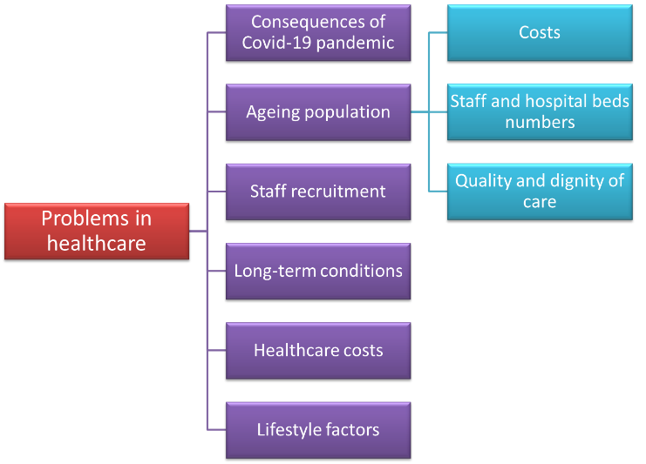

2. Problem definition or problem statement- in the Elderly community
Among, define and discuss one problem above in the workplace also including its scope. Am going to focus on the issues involving quality and dignity of care for elderly people in hospitals. The picture about elderly patients admitted to hospitals is one of insufficient or variable care, but the service provided must meet the levels that older patients and their relatives are entitled to receive. Several examples of failure are documented, and healthcare staff must not assume that these failings are just ‘outliers’ and could never happen in their workplace. In 2012 Ham stated, ‘These malfunctions bring up important issues around all medical services at the hospital they should have act out faster or extra firmly towards this so that they could avoid disappointments occurring again’.

2.1 This fishbone diagram below synthetizes the roots of the problem I am going to discuss.
I have used this fishbone diagram to help me identify the possible causes of a problem. It will be allowing to truly diagnose the problem rather than focusing on symptoms.

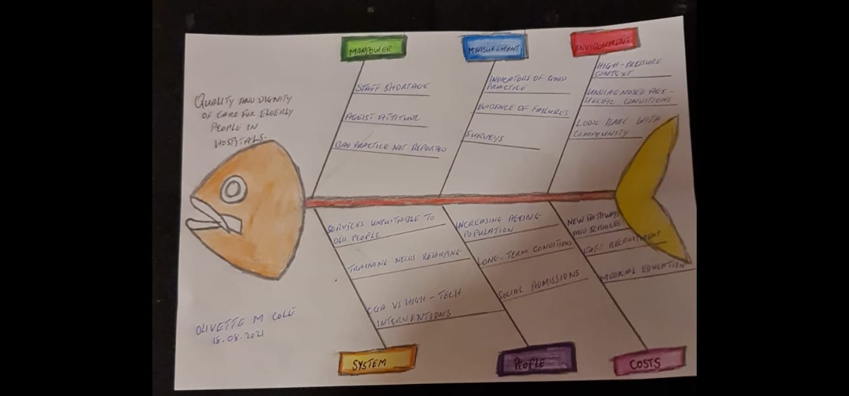

2.2 Discussion – the roots of the problem
According to the NHS Constitution (2010), health service must be comprehensive, accessible to everyone and meeting the demands and choices of the population. The Equality Act (Carruthers and Ormond Royd 2009) outlaws age-based discrimination in public services declaring some ‘age-related, intolerance will not be accepted in a decent culture which values all its partners’. The NHS Functioning agenda that is designed for 2012–2013 (2011) sets the upkeep of elderly cognitively impaired people as a priority, saying ‘approximately bit of the NHS is deteriorating to deliver to Elderly also vulnerable patients with dignified, sympathetic attention to suggestion a better standard in areas such as nutrition, continency. Several indicators of good or unsatisfactory practice are available. The Basic rights Act, Mental Capacity Act, Lack of Freedom Safeguards, in addition frail people protection guidelines provide legal defence for elderly patients; the General Organisation for Health and Clinical Quality (GOCQ) delivers guidelines for circumstances which often found in elderly people such as cognitive impairment, delirium, falls, bone fragility, incontinence, and malnutrition. However, the Governmental Investigation the Rights of Elderly Person’s Well-being and Community Upkeep (Hansard 2008) still described prejudicial approaches and errors in communication and confidentiality, stating ‘although there is much outstanding care in complete culture transformation is needed’. This reflects data by the NHS Watchdog (2011), the Elderly Association (2011), the Excellence care Instruction with the Nutrition Examinations (2011), data about discrimination in healthcare workplace Policy on Aging (2009) and about cognitively impaired inpatients’ care (Alzheimer Society 2009 and RC Psych 2011). Additional indicators of problems in basic management of elderly hospitalized people are given in national audits on continence (RCP 2010), falls (RCP 2011), fractures (HQIP 2011), nutrition (Age UK 2011) and dementia care in hospitals (RC Psych 2011) and by surveys on how terminal illnesses (Department of Health 2011) or hospital discharge (Anon 2010) are experienced. Other reports on the possible roots of poor care (Tadd et al. 2011) and on the baffling experience about dealing with many different services (Glasby et al. 2011) have given important information. Hansard’s ‘entire culture change’ still must happen and healthcare staff may not be giving the right consideration to elderly patients’ priorities, focusing instead on different elements of care.
Rather than oversimplified and sensationalized analysis, an impartial approach is mandatory as successful solutions go beyond the mere blaming of healthcare providers. While there can be extreme episodes of deliberate negligence, several elements often work together so that properly caring personnel supply inadequate care (City University London 2010). These factors can be shortfalls in skills and training, or issues due to system pressures, limited resources, staff numbers and motivation and the physical environment on hospital wards (Firth-Cozens and Cornwell, 2009). Satisfaction with NHS services is usually high in elderly persons (Care Quality Commission 2010), however increasing evidence suggests that this picture may be incomplete. In 2011, 20% of the hospitals examined by the CQC showed ‘basic failings’ on dignity and nutrition (Care Quality Commission 2011), and almost one in five of the nine thousand remonstrances gathered by the NHS Ombudsman were about the care of vulnerable elderly patients (Organisation of Governmental and Health Service Ombudsman 2011). The percentage of inpatients over 65 in 2009–10 that deemed their care as poor of fair is only 5% (Care Quality Commission 2011), while 83% deemed the quality as positive; still 5% means about 250.000 elderly patients unsatisfied. Also, some patients do not make official complaints and frail elderly people are less likely to carry out surveys - some of the complaints may rise from caregivers instead. They should be investigated promptly and honestly, and it must be made sure both that medical staff don’t go through unfair accusations and that complainants’ concerns are addressed. The Francis report (2011) has defined areas for recommendations (such as hiring, instruction, and management of personnel), the roles of professional associations in setting the suitability to practice and an increased attention on quality. The King’s Fund (2011) numbered 21 UK reports (issued 1997-2010) about quality of care for elders and cognitively impaired people, and unless their recommendations are consistently implemented care quality is not going to change. Healthcare staff must move from simple ‘awareness’ to coordinated action aiming at a durable change, not just ticked-off by clinicians but truly experienced by patients and carers. Clinical staff bring credibility and influence care quality; this has been anticipated in Ham’s observation scheduled the forthcoming NHS (2012): ‘so many opportunities on behalf of the health occupation demonstrate a degree of communal management that in the previous takes tough toward assemble … demonstrate that community with direction are ready to step on protection.

3. Analysis- analyse the decision-making process
The proposed solutions are not mutually exclusive, however the last one seems to be the most appropriate and immediately effective
The first proposed solution (service reshaping and admission avoidance) is theoretically very effective over the long term and has the advantage of avoiding long hospital stays with risk of complications but needs systems and pathways to be changed; also, it is expensive and may need other services to be cut down. However, it can make the ‘culture change’ discussed above possible.

In the same way, the second solution (staff recruitment) can be effective particularly in making proportionate decisions, if the staff is properly trained; however it needs the whole staff to change the way they carry out a clinical reasoning, which will take long time, and, as already noticed, recruitment of staff (particularly overseas) has recently been made more difficult, moreover posing a further financial burden on already stretched budgets. Nevertheless, reshaping medical education to meet older people’s needs can contribute to the ‘culture change’ over the long term.

The third solution can provide a more dignified care for elderly people by seeing the patient as an individual with specific needs and preferences and is easy to implement. Complaints and feedback
should shape services basing on the necessities of patients and carers and inform governance and training. However, when it comes to make medical decisions, it is not sure whether the care provided is going to be better in terms of clinical efficacy. This solution is particularly cost-effective as a small change in routine practice can lead to a great result.

The last solution seems to be the most promising. The efficacy of CGA has already been proven by literature, and despite needing some time to be carried out – time that needs to be taken away from other duties – it provides a complete picture of the affected role functional and mindset, and it is not expensive and relatively easy so that almost any staff member can perform it. By highlighting the areas of vulnerability that are specific for every patient and that need to be addressed, it provides the basis for a personalized treatment and discharge plan soon in the period of the hospital stay provided the staff is proactive enough and can prevent complications due to hospital stay.

STRENGTHS  - Multitasking  - Talking openly with employee  - Quality service provider  - Skilled staff  - Working under pressure  - Friendly staff  - Good communication skill  - 24/7 service provided | WEAKNESSES  - Lack of staff motivation and commitment  - Putting your company at risk
OPPORTUNITIES  - Economic support | THREATS  - Economic change  - Rise of digital divide  - Lack of funding
3.1SWOT
SWOT ANALYSIS 2
Personal and professional development plan
STRENGTHS  - Multitasking  - Talking openly with employee  - Quality service provider  - Skilled staff  - Working under pressure  - Friendly staff  - Good communication skill  - 24/7 service provided  - Reliable service  - More training to develop  - Emprove staff  - More capability to meet the need of people  - Increase affordability  - Improve the relevance of online content  - Adult scoial care support grantes | WEAKNESSES
OPPORTUNITIES | THREATS

4. Recommendations/Alternative Solutions- the possible solutions
So how can healthcare staff make sure that high-level, dignified and patient-centred care becomes the standard for old patients in hospitals? In the mind map below, I have summarized the possible solutions I am going to discuss.

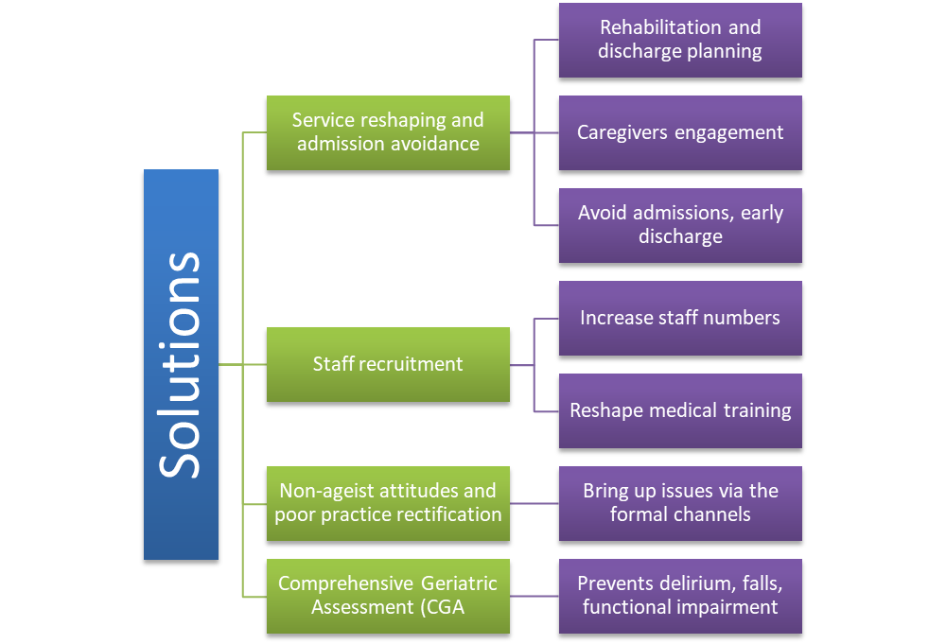

First, the clinical training and priorities must acknowledge the effect of population ageing on the way healthcare services are provided. As Rockwood said (2006), ‘imagine creating facilities for society with different personalities, although society that has several issues wrong with them, they turn up, the responsibility not with the organization nonetheless with the service, however frequently many patients are called with unsuitable problem’. (Stephen Dorrell MP), Chairperson and Governmental Well-being Excellent Group, reiterated the concept, stating (Dorrell et al 2011) ‘nearly the highest complications in care are out-dated establishments and constructions are starting to deliver care to a fairly diverse sort of society… Organisations intended to delicacy infrequent incidents usually healthy individuals second-hand and transport maintenance for society with complex and extended situations. The result is frequently passed from silo to silo’. Healthcare systems developed in a time when most individuals died within the middle age of single diseases. Today, the prevalent duty of healthcare is the care of elderly patients with long-term diseases that frequently come with vulnerability (clinical or social) and cognitive or physical disability that are precipitated by an acute illness. The features of these patients have not really been studied during the medical training, having focused instead on organ-specific analyses. Nevertheless, aside from few areas like obstetrics or paediatrics, all other specialties have now to deal with this kind of patients. This new situation calls for a change in the direction of a new paradigm, with rehabilitation and discharge plans being central. Strict connections with outpatient services and caregiver’s engagement should not be seen as something futile compared with the sides of care (i.e., diagnosis and therapy) typically considered by clinicians as their main duty (Oliver, 2008). While acute assessment and treatment should never be refused to elderly people, pathways should be reshaped in cooperation through main, emotional wellbeing as well as community services toward guarantee any patient stays in hospital only when truly needed. The rates of readmissions, bed usage and delayed discharge for elderly patients are greatly variable among localities (Department of Health 2011). Interest is growing in proactively managing chronically ill patients, avoiding admissions, enabling timely discharge with better community follow up (The Kings Fund 2011).
Second, the number of geriatricians and staff trained in dealing with older people should be expanded. At the same time, medical training must be reshaped so that healthcare providers have the knowledge needed to look after this group of patients – most patients who come to hospital. So far, age-associated conditions are given less priority in training and worse care than diseases of midlife (Centre for Policy on Ageing 2009), and illnesses that are frequent throughout age groups obtain worse care in elders compared to the younger population. Age, life expectation and comorbidities remain reasonably important to several decisions, but systematized differences are often discretionary and might mirror the sometimes ageist priorities or stereotyped assumptions of staff (Oliver 2008).
Third, healthcare staff must show the right behaviours and attitudes and see the patient as a person with necessities, choices, and an individual history; they should provide elderly patients with communication and possibility to choose identical to younger people, engaging caregivers as partners. Old age, physical impairment or dementia must not legitimate a lack of respect due to elders or a worse care. Staff members must also rectify poor practice when noticed. As an example, they should not stand by when they see an old patient shouting out for aid or pretend, they have not noted relatives who might be urging for information; they should challenge staff whose attitude towards elderly people is ageist or unethical. A little endeavour might lead to a huge change and might avoid complaints. In a complex place like a hospital, personnel may think they are unable to change ‘essential’ care, however they do have the duty to bring up issues that undermine patient care through the formal channels. The General Medical Council is unequivocal about this aspect of professionalism (2012).
Finally, healthcare personnel need to consider that hospital-based comprehensive geriatric assessment (CGA) is way more beneficial to patients than most ‘high-tech’ interventions, particularly in terms of decreased mortality and increased functional autonomy (Ellis et al. 2011). According to Oliver (2008), people that are bedridden, with functional or cognitive disability, or with a specific inability to cope at their places are not ‘uncommon’: these features are entirely typical of the frail elderly patients - one of the most numerous patient category in hospitals. These situations can frequently be improved by proper diagnosis and therapy; nevertheless, they are usually marked as ‘social admissions ‘and afterwards, with capacity to improve being still present, patients are ‘medically discharged ‘or too soon labelled as ‘for nursing home ‘. If CGA is properly carried out at the time of admission and if the staff are proactive during the hospital stay, elderly patients can be prevented from becoming bedbound, functionally, or cognitively impaired; this can help speed up their discharge and, at the same time, decrease the possibility of going through undignified care (RCP 2011). Conditions like delirium, incontinence, malnutrition, or falls are not merely due to staff not caring enough for patients; they are not unavoidable and can be prevented or limited by proper assessment, diagnosis, investigation of underlying causes and treatment plan.

4.1 I performed an analysis to identify the most suitable solution to the problem using the PMI tool.
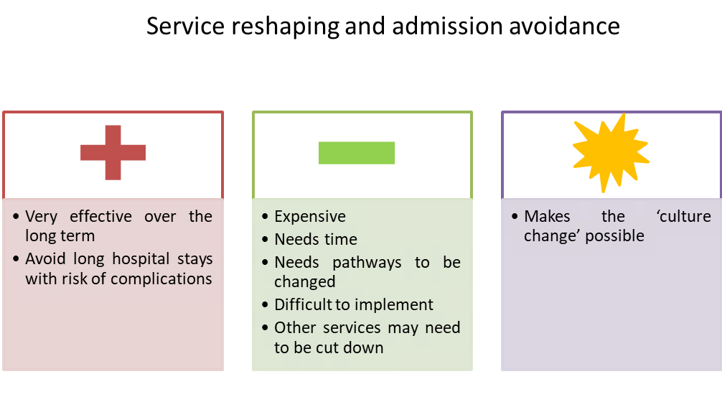
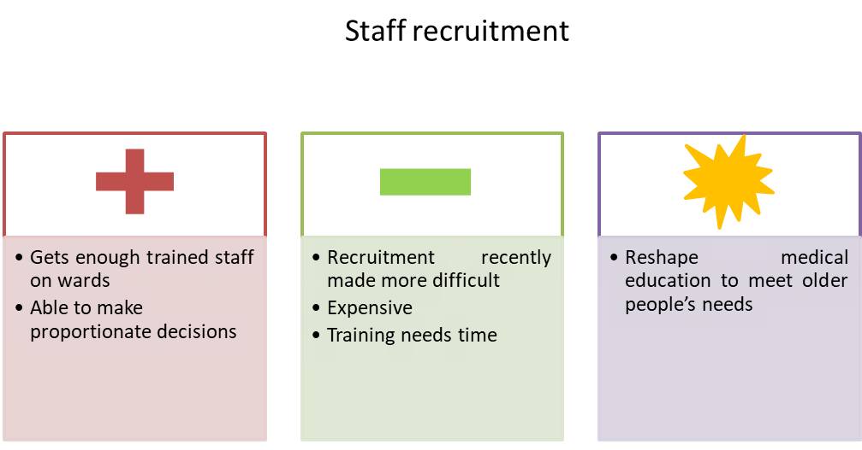
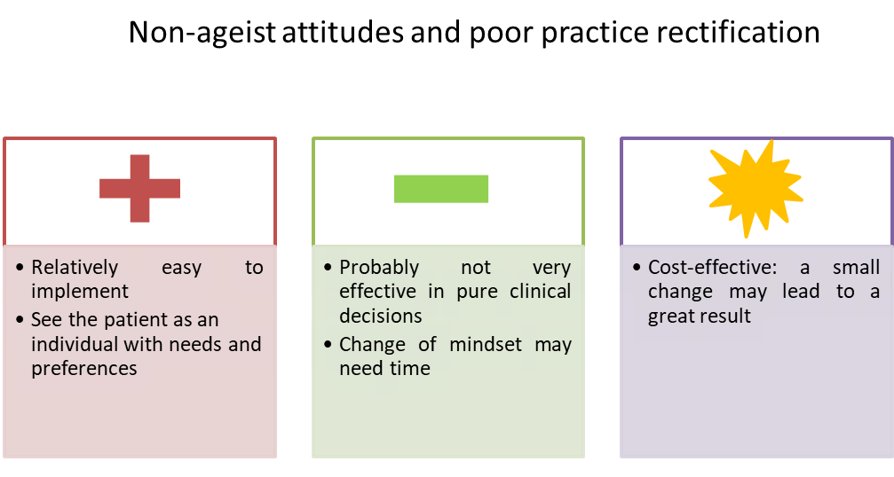
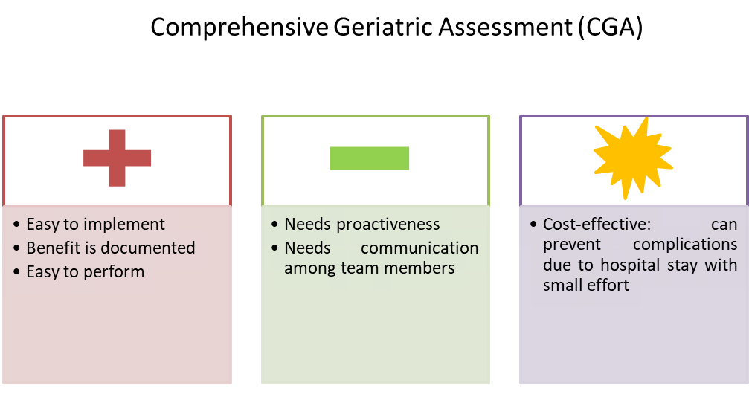

How to implement CGA
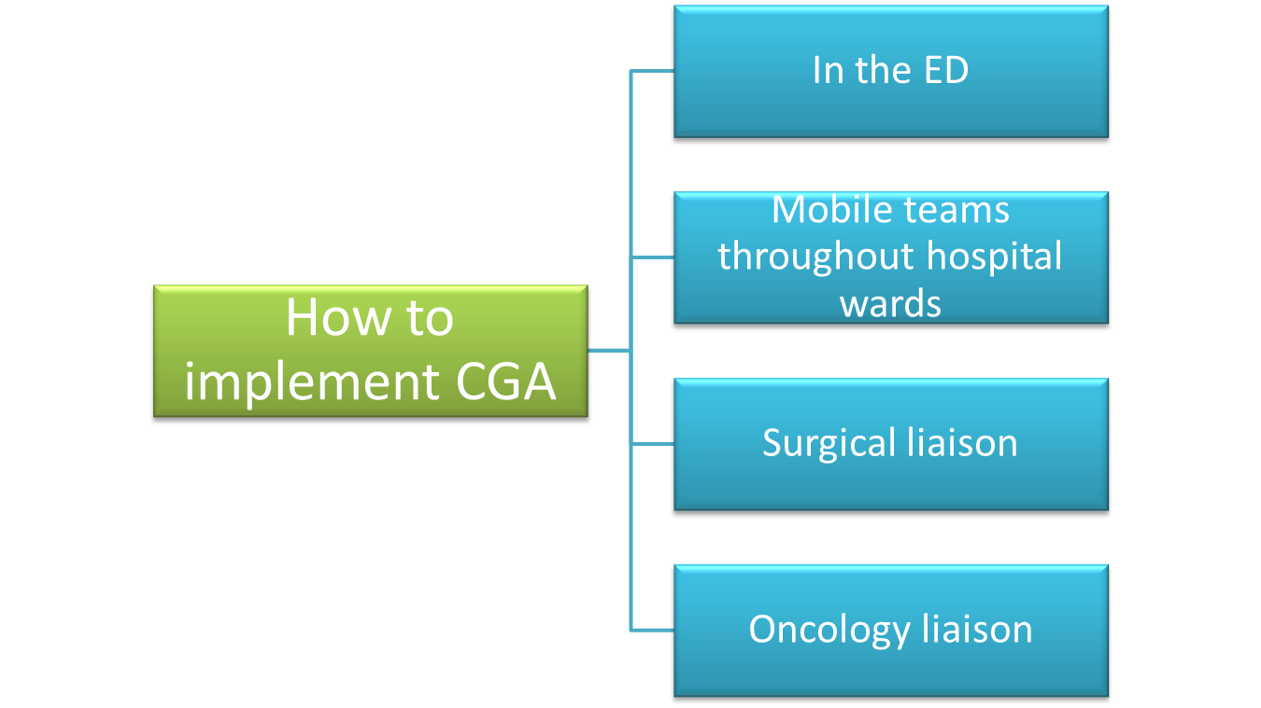

Despite the great potential of the CGA, in the wider hospital setting outside of some specialised medical areas it is less accessible and understood. Nevertheless, it must be delivered to any patient potentially taking advantage from it, therefore new ways of provision in contexts that so far have not been explored are needed. Performing CGA at the onset of an acute illness, i.e., in the Emergency Department, has the potential to decrease the number of admissions to acute units and ITU, while increasing consultations for Palliative Care and slowing the decrease in functional status. This goal can be reached by deploying specially trained nurses (such as Advanced Nurse Practitioners) in the Emergency Department to detect and evaluate elderly patients, with the help of the hospital’s Geriatric Team if needed, and incorporating this service in the ED, with or without an allocated physical setting for ED-attending patients requiring a CGA. These front door services can be completed by ‘Geriatric Consultation Services’, with floating teams that assess patients throughout the different wards. CGA can be embedded into surgical care by the implementation of definite pre-intervention guidelines; moreover, surgical patients may be admitted in an ACE (Acute Care for Elders) unit so that the Geriatric Team can be constantly present; vice versa, a multidisciplinary geriatric consultation team should be present at least in normal working hours for elderly patients in surgical wards. This may bring to a decrease in physical and cognitive impairment, falls and pressure wounds. In an oncology service, the delivery of CGA by geriatrician liaison can help modifying chemotherapy schemes for better tolerance and provide tailored community follow-up.

Monitoring and review techniques
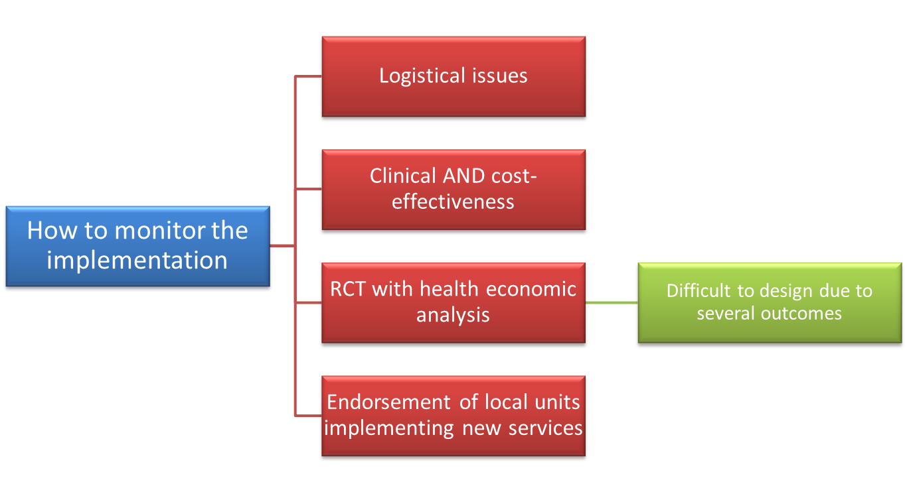
The logistical issues related to CGA implementation in new contexts (such as Emergency Departments, surgical or cancer units) must not be underestimated. Moreover, given the scarcity of evidence about the efficacy of liaison services, additional developing and assessment are needed prior to widespread implementation. For example, some approaches may well be proven as effective but are expensive therefore evaluation of clinical effectiveness must go together with cost-effectiveness. CGA-based interventions are complex, as encompassing several elements of assessment to ease clinical decision-making. The gold standard for cost-efficiency studies is a Randomized Control Trial (RCT) with health-economical investigation (Petrou and Gray 2011), however, to make such a RCT possible many replications of modelling, development implementation and assessment are needed before a new service can be tested versus the ‘classical’ model. Another challenge in assessing CGA services in acute hospitals is making sure that a wide series of appropriate outcomes are considered; they can be of clinical relevance (i.e., functional condition, length of stay), relevant for patients or carers (i.e., self-reported outcomes, caregiver stress), important to providers and managers (i.e., resource utilization, cost-efficacy). Therefore, the project of evaluation studies must find a balance between immediate against long-term outcomes, and between managerial (e.g., length of stay and readmission percentages) and individual outcomes (e.g., health status). Nevertheless, benchmarking demonstrates that there is keenness to establishing new services (NHS Benchmarking Network 2017); this can bring to new ways of CGA provision, running beforehand the evidence of cost-efficacy. The implication is that new local services must be endorsed to be able to evaluate their effect and adjust services consequently.

Conclusions
Among the problems that healthcare systems are facing, one of the most compelling is quality and dignity in care for elderly patients in hospitals. Indicators exist about the standards that elderly people are entitled to expect (such as guidelines and safeguarding policies), however the service provided does not always meet these levels, therefore possible ameliorative solutions need to be sought for, considering that several factors are involved. The possible not mutually exclusive solutions explored in this report are: a change towards a bio-psycho-social model, cantered on rehabilitation and discharge planning, linked with local services and engaging caregivers; to increase the number of geriatricians and to properly train non-geriatric staff to face the particular features of elderly patients; the staff’s appropriate and non-ageist behaviour; the opportunity to rectify poor practice and to bring up issues that put patient care at risk; to put in place early actions to avoid admissions and to enable elderly patients to be discharged earlier and with community follow up; to enhance the hospital-based comprehensive geriatric assessment (CGA). This last solution seems the most promising on a medium-term basis as it is relatively easy to perform and provides the basis for a personalized treatment and discharge plan. To implement these different systems are being put in place, such as deploying trained nurses in the ED to assess elderly patients, or geriatric liaison services in the surgical or oncological area. However, liaison services can be expensive and there still is lack of evidence about their efficacy, therefore clinical effectiveness must be evaluated together with cost-effectiveness, and given the complexity of CGA interventions, evaluation studies must find a balance between the different outcomes.

REFERENCES

- Age UK. Malnutrition in hospital: still hungry to be heard. London: Age UK, 2011. http://www.ageuk.org.uk/get-involved/campaign/malnutrition-in-hospital-hungry-to-be-heard
- Alzheimer’s Society. Counting the cost: caring for people with dementia on hospital wards. London, Alzheimer’s Society, 2009
- Anon. Too many problems when patients leave hospital. London, Which? Magazine 2010. http://conversation.which.co.uk/consumerrights/too-many-problems-when-patients-leave-hospital
- Barnett K, Mercer SW, Norbury M, Watt G, Wyke S and Guthrie B. Epidemiology of multi- morbidity and implications for health care, research and medical education: a cross- sectional study. The Lancet online, 2012
- Care Quality Commission. Dignity and nutrition inspection report. London, CQC, 2011
- Care Quality Commission. Inpatient survey 2010. London, CQC, 2010. http://www.cqc.org.uk/public/reports-surveys-and-reviews/surveys/ inpatient-survey-2010
- Carruthers I, Ormondroyd J, Achieving age equality in health and social care. Report to the secretary of state for health. London: Department of Health; 2009
- Centre for Policy on Ageing. Ageism and age discrimination in health and social care in the United Kingdom. London: CPA, 2009. http://www.cpa.org.uk/agediscrimination/age_discrimination.html
- City University London. Everybody matters. Sustaining dignity in care. London, City University, 2010
- Department of Health 2012. Long-term conditions compendium of Information: 3rd edition
- Department of Health, Right Care Team. NHS Atlas of Variation 2011, Version 2.0. London, Department of Health, 2011. http://www.right care.nhs.uk/index.php/atlas/atlas-of-variation-2011
- Department of Health. The NHS constitution. London: Department of Health; 2010
- Department of Health. The operating framework for the NHS in England 2012–13. London: Department of Health; 2011
- Department of Health. VOICES: re-design and testing to inform a national end of life care strategy. London, Department of Health, 2011. http://www.dh.gov.uk/en/Publicationsandstatistics/Publications/PublicationsPolicyAndGuidance/DH_128787
- Dorrell S, Milburn A, Kerr D, Moyer B. Passing judgement on Lansley’s vision. Health Service J 2011;121:14–7

- Firth-Cozens J, Cornwell J. The point of care. Enabling compassionate care in acute hospital settings. London, Kings Fund, 2009
- Francis R. The Mid-Staffordshire NHS Foundation Trust Public Enquiry 2011 www.midstaffspublicinquiry.com/news/2011/12/transcript-thursday-1-december-2011
- Glasby J, Littlechild R, Ellins J et al. Understanding and improving transitions of older people. A user and carer centred approach. London, Service Delivery and Organisation programme, 2011. http://www.sdo.nihr.ac.uk/files/project/SDO_PRO_08-1809-228_V10.pdf
- General Medical Council. Raising concerns and acting on patient safety. London, GMC, 2012.
- Hansard, 2008. Report of the all parliamentary enquiry into the human rights of older people in health and social care. London, Hansard 2008
- Ham C. The NHS in 2012. BMJ 2011;343:d8259
- HQIP. National Hip Fracture Database. Annual Report 2011. London, NHFD, 2011. http://www.nhfd.co.uk/003/hipfractureR.nsf/NHFDNationalReport2011_Final.pdf
- Kings Fund. The care of older People. Sir Roger Bannister Summit at Leeds Castle, November 2011. London, Kings Fund, 2011. http://www.kingsfund.org.uk/events/hidden_events/sir_roger_bannister.html.
- National Confidential Enquiry into Patient Outcomes and Deaths. An age old problem. A review of the care received by elderly patients undergoing surgery. London, NCEPOD, 2010. http://www.ncepod.org.uk/2010report3/downloads/EESE_fullReport.pdf
- Nursing Standard (in conjunction with the Patients’ Association) C.A.R.E. campaign. London: Nursing Standard, 2011
- Oliver D. ‘Acopia’ and ‘social admission’ are not diagnoses. Why older people deserve better. J Royal Soc Med 2008;101:168–74
- Parliamentary and Health Service Ombudsman. Care and compassion. Report of the ombudsman on ten investigations into NHS care of older people. London, Office of Parliamentary and Health Service Ombudsman, 2011
- Rockwood K. What would make a definition of frailty successful? Age Ageing 2006;34:33–4.
- Royal College of Physicians. Evidence to NHS Confederation and Age UK commission in improving dignity in care for older people. London, RCP, 2011. http://www.rcplondon.ac.uk/sites/default/files/rcp_reponse_to_dignity_in_care_consultation_september_2011.pdf
- Royal College of Physicians. Falling standards, broken promises. Report of the fourth national audit on falls and bone health services. London, RCP, 2011. http://www.rcplondon.ac.uk/sites/default/files/national_report.pdf
- Royal College of Physicians. National audit of continence care. London, RCP, 2010. http://www.rcplondon.ac.uk/resources/national-audit-continence-care
- Royal College of Psychiatrists. National audit of dementia care in general hospitals. London: RC Psych, 2011. http://www.rcpsych.ac.uk/pdf/The%20Interim%20Report.pdf
- Tadd W, Hillman A, Calnan S et al. Dignity in practice: an exploration of the care of older adults in acute NHS trusts. London, National Institute for Health Research, 2011
- The Kings Fund. The management of long-term conditions. London, Kings Fund, 2010. http://www.kingsfund.org.uk/current_projects/gp_inquiry/dimensions_of_care/the_management_of_1.html.
- The Kings Fund; Nuffield Trust. Integrated care for patients and populations. Improving outcomes by working together. London, Kings Fund, 2011. www.kingsfund.org.uk/document.rm?id=9405.
- www.nuffieldtrust.org.uk/news-item/new-analysis-reveals-scale-of-future-pressure-on-hospital-beds (Nuffield Trust, 2014)

