

ECAD6004
Enterprise and Creative Teaching and Learning

BA PRIMARY EDUCATION
with Qualified Teacher Status

Faculty of Education and Communities

Level 6

2017-2018

1501575

Student Self Evaluation Form

This section repeats in brief the common assessment criteria detailed on previous pages. The extent to which these are demonstrated by you determines your mark. Using these criteria, tick the box that best indicates the level of achievement you feel you have achieved with regard to each of them.

Common Assessment Criteria Applied | Level of Achievement
Common Assessment Criteria Applied | REFER |  | 3rd | 2:2 | 2:1 | 1st | 1st
 | OUTRIGHT FAIL | UNSATISFACTORY | SATISFACTORY | GOOD | VERY GOOD | EXCELLENT | EXCEPTIONAL
1. Subject Knowledge and Understanding (which includes using research-informed literature and knowledge and understanding of the subject) | 0-29% | 30-39% | 40-49% | 50-59% | 60-69% | 70-79% | 80-100%
2. Intellectual Skills (Analysis) | 0-29% | 30-39% | 40-49% | 50-59% | 60-69% | 70-79% | 80-100%
3. Pedagogic and Professional Applications  (Practical Application and Deployment) | 0-29% | 30-39% | 40-49% | 50-59% | 60-69% | 70-79% | 80-100%
4. Key Transferable Skills | 0-29% | 30-39% | 40-49% | 50-59% | 60-69% | 70-79% | 80-100%
PLEASE COMMENT ON AREAS IN WHICH YOU FEEL THAT YOU HAVE PERFORMED WELL | PLEASE COMMENT ON AREAS you feel that you need TO DEVELOP
I carried out a lot of research to ensure I could put forward methods for progression which are already tried and tested. | I need to develop my ability to write academically when referring to myself.

Student’s Name | Georgia Davies | Date | 14.12.17
Student’s Signature | G.L.Davies
Critically evaluate your creativity and enterprise dispositions in terms of the EntreComp frame work and how you might develop these to the next level and demonstrate progression.

Introduction
Throughout this assignment, I will critically evaluate my own creativity and enterprise dispositions, using the EntreComp framework (Bacigalupo et al., 2016) as a launch pad to select and underpin skills which need to be improved and further developed. I will suggest and present ways in which these skills may be developed to the next level whilst demonstrating progression.

The Oxford Dictionary (2017) defines disposition as ‘a persons inherent qualities of mind and character’. Thus, I will be discussing my own qualities in terms of the aspects of creativity and enterprise chosen.

Individual enterprise is almost always seen positively as relating to individual creativity and pursuit of opportunity, innovation and development backed up by the individual’s determination to succeed (Lowe and Marriott, 2006). In addition to this DBIS (2014) define enterprise as the quality that gives an individual a positive outlook, an ability to see the glass as half full rather than half empty, and claim that it is a valuable attribute for the whole of life

Maley and Bolitho (2015) state that although creativity is a term in such common use, it proves difficult to define. However, Maley (2003) and Robinson (2011) offer definitions for creativity. Maley (2003) describes creativity as a compromise of core ideas such as ‘making something new’, ‘evoking pleasurable surprise’ or ‘finding new connections’. Robinson’s (2011) definition however, is more concise as he claims that creativity is the imaginative processes with outcomes that are original and of value. Both definitions make reference to new or original outcomes, however, the first definition focuses on making connections instead of just the final outcome.

Creativity has increasingly become a focus in the curriculum (Wilson, 2010) and with the implementation of Successful Futures on the horizon, Donaldson (2015) reinforces the importance of creativity in the pedagogy and application of the curriculum. As well as Donaldson (2015), Duffy (2000), Craft (2000) and Cropley (2001) believe that creativity has a fundamental role in the primary curriculum. Therefore, it is important that I as a future classroom practitioner, assess and develop my personal creativity to ensure I make an effective classroom practitioner. Craft (2003) points out the limitations of incorporating creativity in education, claiming that the curriculum does not allow for the best use of creativity. Thus, this is a limitation that may be banished when Donaldson’s Successful Futures (2015) is rolled in as it has been developed with creativity in mind.

Together with creativity, DBIS (2014) claims that the best schools foster and encourage the enterprising attitudes that many children bring with them when entering primary school. However, HMIE (2008) found that not all schools are successfully implementing enterprise in education and therefore suggest that schools develop their use of effective enterprise activities.

Entrecomp Framework
The EntreComp framework (Bacigalupo et al., 2016) presents the EntreComp Progression Model which shows the boundaries of individual and collective entrepreneurial competences. These competences can be developed and expanded in order to help individuals to greater the impact through creating endeavors. The model does not lay down a direct sequence of steps that each individual should comply too. Instead it aims to provide a comprehensive tool that can be adapted to each individual with a range of different needs.

The framework enables citizens to nurture their personal development, however it has not yet been adapted to or tested in real settings (Bacigalupo et al., 2016). Therefore, it is not yet known how effective this will be in a real-life context. In addition to this, the framework is built on a broad understanding of ‘entrepreneurship’ (Bacigalupo et al., 2016) and therefore not all categories coincide with education.

The Progression Model consists of 3 competence areas, 15 competences, an 8-level progression model and a comprehensive list of 442 learning outcomes (Bacigalupo et al., 2016). For the purpose of this assignment, I have selected 3 competences, one from each competence area. The chosen competences I have selected are ones which I believe have an impact on how well I teach. Therefore, I want to progress and develop my proficiency in the chosen areas as Grigg (2015) found that outstanding teachers are keen to improve and progress.

Creativity
I have identified creativity as an area of development and highlight the importance of creativity in education. Adair (2009) claims that in any profession or in personal life, creativity can lead you into new paths to enrich your life or career, as well as providing individuals with a competitive advantage. Therefore, creativity is an important aspect to focus on and develop.

The EntreComp Framework (Bacigalupo et al., 2016) defines creativity using the following statements. The ability to ‘develop several ideas and opportunities to create value, including better solutions to existing and new challenges’, the ability to ‘explore and experiment with innovative approaches’ and the ability ‘to combine knowledge and resources to achieve valuable effects’.

Within the creativity strand of the framework, there are five separate threads. Although I am stronger in some areas than others, overall I identified myself to be at the Intermediate level of proficiency and therefore there is plenty of room for improvement.

One thread within creativity is to ‘be curious and open’ (Bacigalupo et al., 2016). This is an important quality to have as Wilson (2010) states that creative teachers demonstrate curiosity. The intermediate level of proficiency states ‘I can experiment with my skills and competences in situations that are new to me’ as well as ‘I can actively search for new solutions that meet my needs’ (Bacigalupo et al., 2016). Appendix A shows evidence of a time where I have demonstrated the ability to experiment with skills in situations that are new to me. In addition to this Appendix B shows evidence of a time where I have searched for new solutions. Zwozdiak-Myers (2012) found that no two classes will respond in the same way. Therefore, being creative and open is a vital aspect to being an effective practitioner.

Kaufman, Plucker and Baer (2008) highlight that creativity has many facets and can be understood and assessed in many different ways. Therefore, it is important to explore other ways of measuring creativity rather than solely using the EntreComp framework (Bacigalupo et al., 2016). Wilson (2010) presents the model of creative practice, which focuses on a creative state of mind using four core features (see Figure 1). One feature of this model is ‘curiosity’. Therefore, in order to ensure I have a creative state of mind, I need to focus on the development of curiosity.
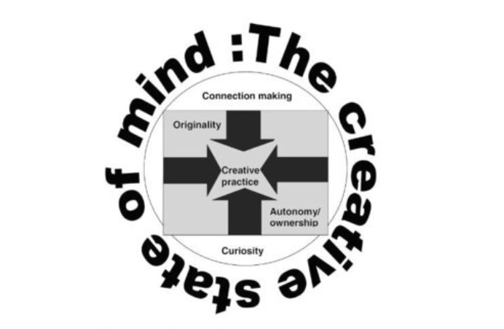

Fig. 1

In order to move to the next level of proficiency, the EntreComp framework (Bacigalupo et al., 2016) states that ‘I can combine my understanding of different contexts to transfer knowledge, ideas and solutions across different areas’. Zwozdiak-Myers (2012) declare that an excellent practitioner can draw on knowledge of past experiences and transfer them in a clear and convincing way. Hence, it is important that I progress to the next level in order to become an excellent classroom practitioner.

Although the EntreComp framework (Bacigalupo et al., 2016) presents a model to assess personal creativity, it does not offer guidance or suggestions of how to progress. Helmholtz (1826) with elaboration by Wallas (1926) created a four stage act for creative endeavors.

The first stage of ‘preparation’ is based on the fact that in order to be creative, an individual must learn the basic background knowledge and skills of a creative endeavour (Helmholtz, 1826). For a teacher this would require researching into the lesson you are planning to ensure you have a secure understanding ready to plan.

The second stage of ‘incubation’, focuses on the experiences and training that contributes to a persons imagination and what they have to work with (Helmholtz, 1826). This stage would involve a teacher focusing on past experience of which lessons went well and which didn’t.

‘Illumination’ – the third stage is described as the moment of recognition of a creative concept (Helmholtz, 1826). This stage often moves the individual’s mind-set from relaxation to excitement. For a teacher, this would be the moment when an idea comes to mind which the teacher thinks would work really effectively and would be beneficial for the children’s learning.

The final stage is Verification. This is the stage in which the individual validates and evaluates their creative insight (Helmholtz, 1826). This stage would be when a teacher is required to reflect on how the lesson went, as well as what could be done to improve.

By using this model, it will ensure that I am using my understanding of different contexts, as well as ensuring I transfer my knowledge and ideas from previous and current situations to create and derive opportunities for creative endeavours. Thus, it will allow me to progress to the advance level of proficiency in terms of being ‘curious and open’ (Bacigalupo et al., 2016) within the creativity strand.

Motivation and Perseverance 682
The EntreComp Framework (Bacigalupo et al., 2016) describes Motivation and Perseverance using the following statements. The ability to ‘be determined to turn ideas into action and satisfy your need to achieve’, the ability to ‘be prepared to be patient and keep trying to achieve your long-term individual or group aims’ and the ability to ‘be resilient under pressure, adversity, and temporary failure’.

Taking these descriptors into consideration, I have identified motivation and perseverance as an area for development. Although I feel more than capable when turning ideas into actions, I have identified the ability to ‘be resilient under pressure, adversity and temporary failure’ (Bacigalupo et al., 2016) as an area of development.

Even though I have managed up until now when under pressure, it has become apparent then when facing temporary failure, it causes a knock in confidence and a period of upset and stress which wastes time. Craft, Jeffery and Leibling (2001) found that the fear of failure limits willingness to even make an attempt. Therefore, it is important that I focuses on the ability to deal with failure to ensure that I do not let the fear of failure limit my experiences.

Like Creativity, the motivation and perseverance strand is broken down into five different threads. Focusing on the ‘Be resilient’ and ‘Don’t give up thread’ I would place myself at the Intermediate level. The framework states that in order to be at an intermediate level in terms of ‘don’t give up’, the individual must be able to maintain effort and interest despite knock backs. Appendix C shows a situation in which I was able to do this. Day et al (2006) points out that resilience is indispensable to high quality teaching. Therefore these qualities are important for becoming a more effective practitioner.

In order to move forward, it is important that I develop the ability to overcome failure rather than letting it set me back as Grigg (2015) states that mature and reflective practitioners see failure as the chance to reflect and move forward. Bain et al. (1999) put forward the following framework which can be used when reflecting:

‘Level 1: reporting the event as it occurred;
Level 2: responding to the event in a spontaneous and emotional manner;
Level 3: relating to the event in terms of past experience and knowledge;
Level 4: reasoning about the event in terms of alternatives, examining assumptions, and conceptualising characteristics of the occurrence;
Level 5: reconstructing the event in terms of theories that can be applied to a broader range of experiences.’

Similarly, Dewey (1933) designed a model for reflection which focuses on solving the problem within the situation which will then improve the effectiveness of teaching. Dewey (1933) along with the likes of Schon (1987) and Kolb (1984) consider reflection as the best way to overcome failure. Consequently, building resilience and the ability to manage failure.

In future, I will use the frameworks mention to reflect when an event hasn’t gone as well as planned. By using these frameworks, it will provide me with the opportunity to focuses on why it went wrong rather than becoming disheartened. This should result in a deeper understanding of the failure and this should lead to a growth in resilience. Boud (1999) however, cautions the use of frameworks for reflection as they do not take into the uniqueness of each individual. As mentioned previously I tend to get upset prior to failure. Korthagen and Vasalos (2005) emphasises the importance of identifying feelings and emotions surrounding failure as these feelings can result in better reflection and future practice. Therefore, I will ensure I incorporate my feelings into each reflection as this is something unique to me and therefore I will avoid the concern raised by Boud (1999).

The framework will prevent me from wasting time prior to failure as I will instead follow a structure to see what went wrong which will allow me to avoid the same failure again. This will divert the attention from the failure itself and allow me to progress to the next level of competence in terms of motivation and perseverance which is to ‘devise strategies to overcome standard adverse circumstances’ (Bacigalupo et al., 2016).

Planning and Management
The EntreComp Framework (Bacigalupo et al., 2016) describes Planning and management using the following statements. The ability to ‘set long-, medium- and short-term goals’, the ability to ‘define priorities and action plans’ and the ability to ‘adapt to unforeseen changes’. Grigg (2015) highlights the importance of planning, stating that it is the platform to all good teaching.

‘Defining priorities and action plans’ (Bacigalupo et al., 2016) is a strong area of mine as it is something I am required to do regularly when on placement (See appendix D). In order to further my ability to prioritise, Foster (2000) suggests recording priorities using a simple A, B, C system as follows: A = immediate attention B = attention in the near future C = non-essential or non-urgent items. As I do not yet use a specific structure when defining my priorities, I will consider using this system to continue to progress, even in my stronger areas.

In addition to this, one thread of planning and management is to ‘plan and organise’ (Bacigalupo et al., 2016). This is also a strong area of mine in terms of planning and management (See appendix E). Wragg (1993) found that the best teachers are usually well organised. Therefore, this is a good trait to have and I will continue to develop my organisational skills.

However, another thread focuses on setting long, medium and short-term goals. Although I am able to set short term goals (see appendix F), I struggle with setting effective long term goals and this prevents me from progressing to the next level of proficiency. The advance level would require me to ‘be able to define long-term goals arriving from the vision from my value creating activity’ (Bacigalupo et al., 2016).

Smale and Fowlie (2009) suggest creating a personal development plan to set and achieve long term goals. Leonard (1996) found that goals are most likely to be effective if they are specific, appropriately difficult, targeted and remembered. These factors will therefore be considered when creating a personal development plan to ensure goals are as beneficial as possible.

Setting goals is pointless unless the goals are actively reviewed and progress is regularly monitored (Smale and Fowlie, 2009). Therefore, in order to ensure that I make the most out of goal setting, I will aim to review goals monthly to ensure they are still relevant and achievable.

Cottrell (2015), Grigg (2015) and Gudger (2014) agree that the most effective goals need to be SMART. SMART stands for specific, measurable, attainable, realistic and timely. With this in mind, as well as the suggestions from Smale and Fowlie (2009), I will begin to set long-term goals using a personal development plan and sticking to the SMART goal guideline.

Conclusion
In conclusion, I have identified areas for further development and outlined ways in which I will ensure progression in weaker areas. However, in order to see if I have progressed in terms of the highlighted proficiency, I will revisit the EntreComp framework once I have put into place all suggestions I have put forward for my personal progression. If I fail to make progression after the implementation of all frameworks and models mentioned then I will continue to research for different models and suggestions to help me progress, as Grigg (2015) claims that outstanding teachers continue to assess and research throughout their career.

Reference List
Adair, J. (2009) Effective Leadership: How to Be a Successful Leader. (3rd ed) London: Pan Books.

Bacigalupo, M. Kampylis, P., Punie, Y and Van den Brande, G. (2016) EntreComp: The Entrepreneurship Competence Framework. Luxembourg: Publication Office of the European Union.

Bain, J., Ballantyne, R., Packer, J. and Mills, C. (1999) ‘Using journal writing to enhance student teachers’ reflectivity during field experience placement’, Teachers and Teaching: Theory and Practice, 5, 1, pp.51–73.

Boud, D. (1999) ‘Peer Learning and Assessment’, Assessment & Evaluation in Higher Education, 24, 4, pp.413-426.

Cottrell, S. (2015) Skills for Success: Personal Development and Employability. (3rd Ed) Hampshire: Palgrave Macmillan.

Craft, A (2003). ‘The Limits to Creativity in Education: Dilemmas for the Educator’, British Journal of Educational Studies. 51, 2, June, pp.113-127.

Craft, A. (2000) Creativity Across the Primary Curriculum. Oxon: Routledge.

Craft, Jeffery and Leibling (2001) Creativity in education

Cropley, A. (2001) Creativity in Education and Learning. London: Kogan Page.

Day, C., Kington, A., Stobart, G. and Sammons, P. (2006) ‘The personal and professional selves of teachers: stable and unstable identities’, British Educational Research Journal, 32, 4, pp.601-616.

Department for Business, Innovation and Skills. (2014) Enterprise For All. London: DBIS.

Dewey, J. (1933) How We Think: A Restatment of the Relation of Reflective Thinking to the Education Process. Boston: DC Health and Company.

Donaldson, G. (2015) Successful Futures. Cardiff: Crown.

Duffy, B. (2000) Supporting Creativity in the Primary Classroom. Buckingham: Open University Press.

Foster, M. (2000) Get Everything Done and Still Have Time to Play. London: Help Yourself.

Grigg, R. (2015) Becoming an outstanding primary school teacher. (2nd ed) London and New York: Routledge.

Gudger, J. (2014) SMART Goals: The Ultimate Goal Setting Guide.

Helmholtz, H. (1826) Genius - The natural history of creativity. Cambridge: Cambridge University Press.

HM Inspectorate of Education. (2008) Improving Enterprise in Education. Livingston: HMIE.

Kaufman, J., Plucker, J., and Baer, J. (2008) Essentials of Creativity Assessment. New Jersey: Wiley & Sons.

Kolb, D. (1984) Experiental Learning: Experience as the Source of learning and Development. New Jersey: Prentice Hall.

Korthagen, F. and Vasalos, A. (2005). ‘Levels in reflection: core reflection as a means to enhance professional growth’, Teachers and Teaching: Theory and Practice, 11, 1, pp.47-71.

Leonard, D. (1996) The Impact of Learning Goals on Self-directed Change in Educational and Management Development. Case Western Reserve University: UMI.

Lowe, R. & Marriott, S. (2006) Enterprise: Entrepreneurship and Innovation. Oxford: Butterworth Heineman.

Maley, A. (2003) Creative approaches to writing materials - Developing Materials for Language Teaching. London: Continuum.

Maley, A. and Bolitho, R. (2015) ‘Creativity’, ELT Journal, 69, 4, October, pp.434-436.

Oxford English Dictionary (2017). ‘Enterprise’ Available at: https://en.oxforddictionaries.com/definition/enterprise [Accessed: 7th December 2017].

Robinson, K. (2011) Out of Our Minds – Learning to be Creative. Newark: John Wiley & Sons.

Schon, D. (1987) Educating the Relfective Practitioner. San Francisco: Jossey-Bass.

Smale, B and Fowlie, J. (2009) How to Succeed at University. London: Sage.

Wallas, G. (1926). The Art of Thought. New York: Harcourt Brace.

Wilson, A. (2010) Creativity in Primary Education. Exeter: Learning Matters Ltd.

Wragg, T. (1993) Primary Teaching Skills. London: Routledge.

Zwozdiak-Myers, P. (2012) The Teacher’s Reflective Practice Handbook. Oxon: Routledge.

Appendix A
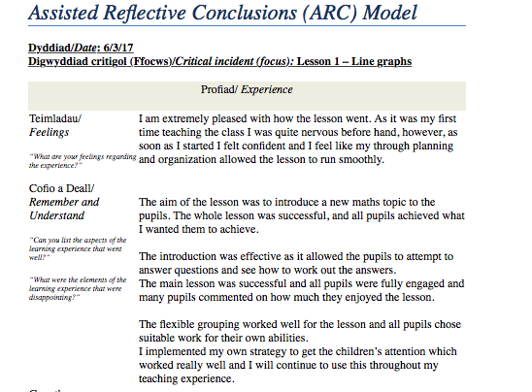
Experimenting with new strategy with a new class

Appendix B – Searching for solutions
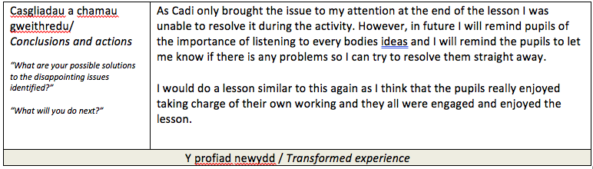
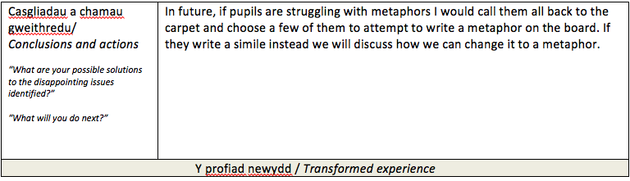
Putting forward possible solutions in situations where problems occurred
Appendix C – Motivated despite knockbacks
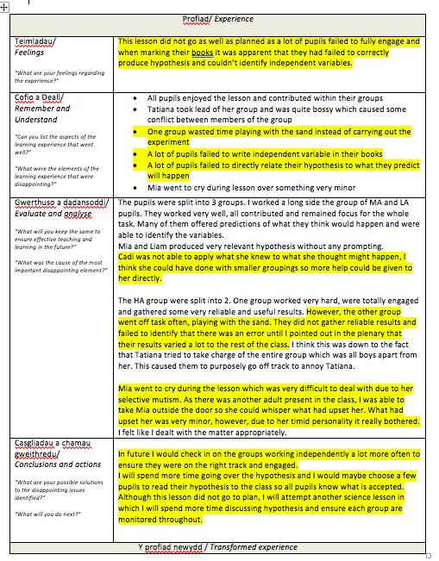

Evidence of motivation for furture lessons despite the lesson not going to plan.
Highlighted areas show what went wrong during the lesson.
Appendix D – Action Plan

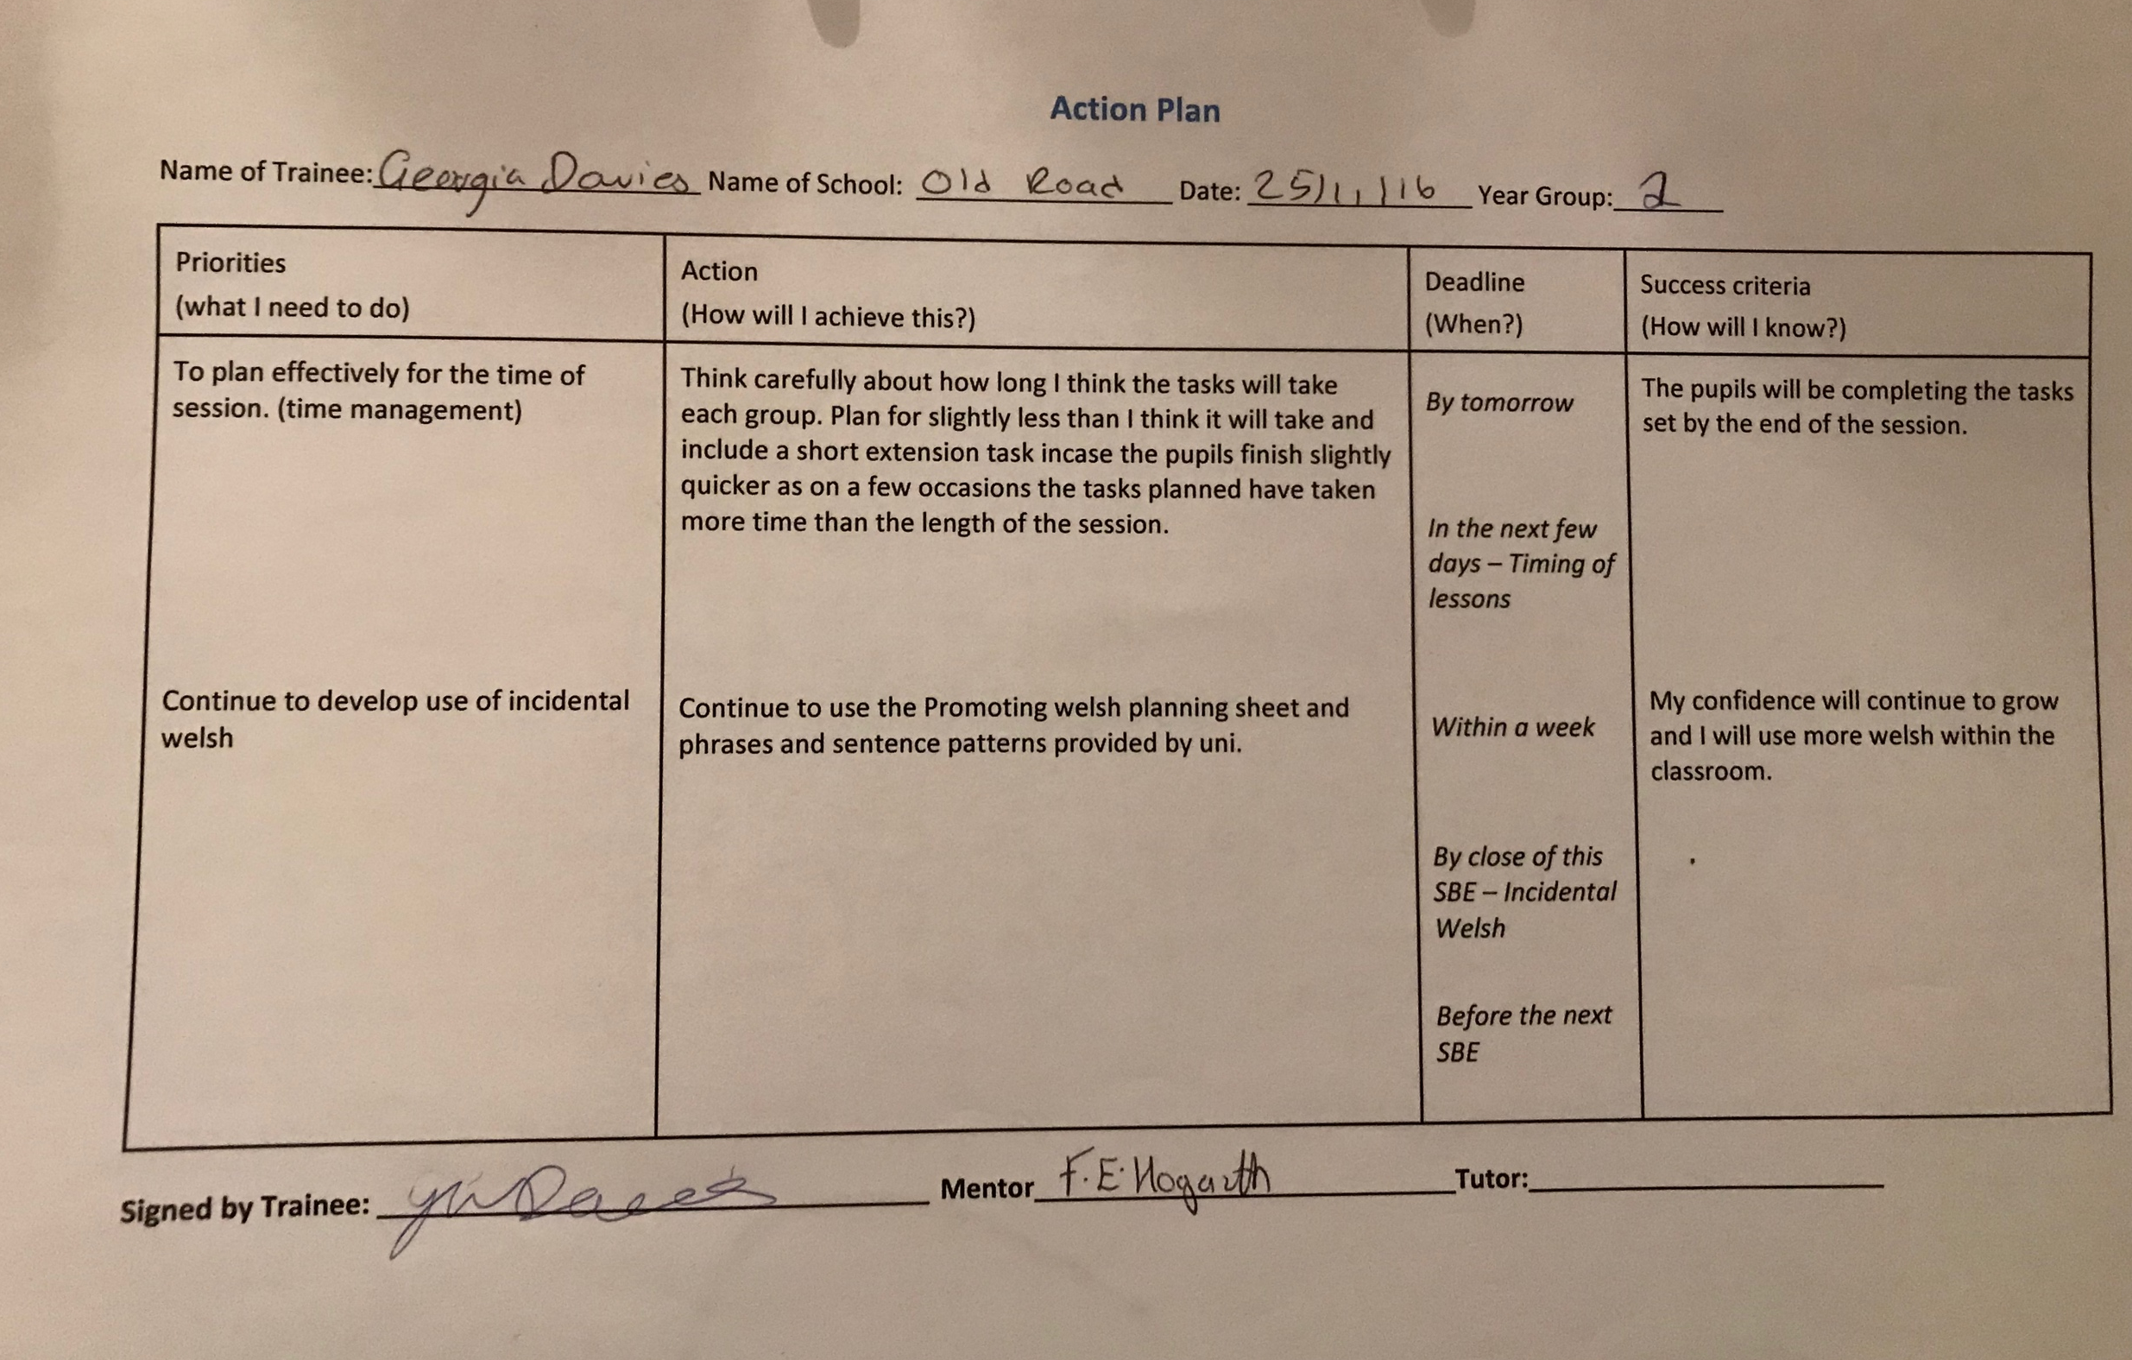
Appendix E – Planning and Organisation
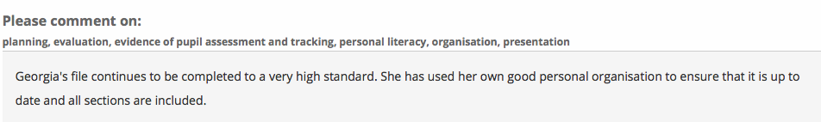
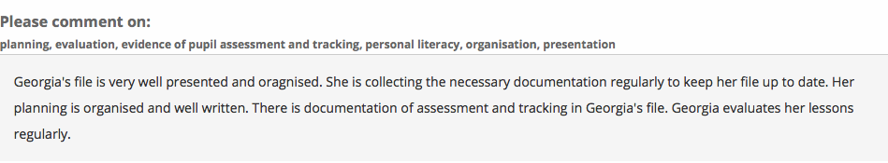
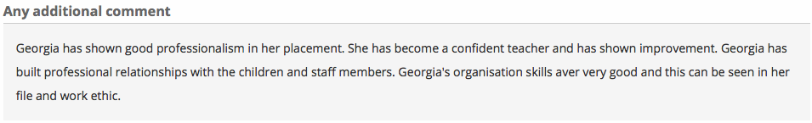
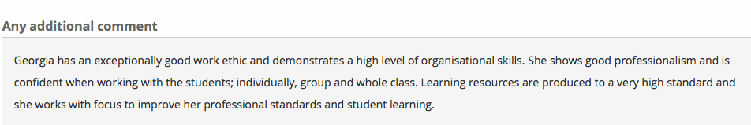
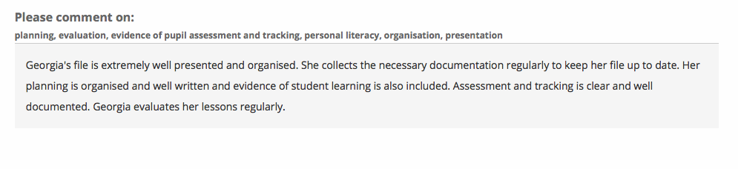

Appendix F – Setting short term goals

Examples of short term goals set in end of week reviews and action plans.


