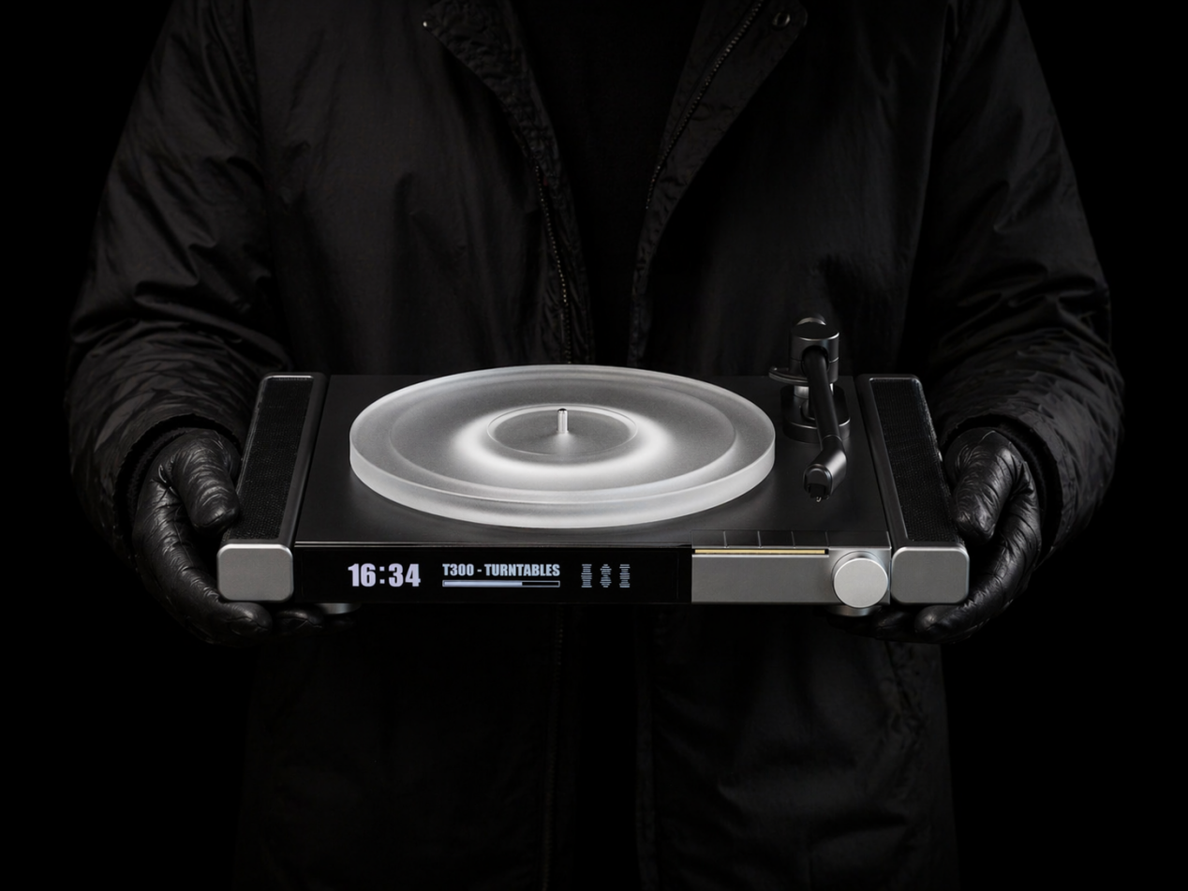

This product visualisation of the vinyl turntable represents the first-stage design outcome within the iterative design research process.

The overall design principle of the product is based on the existing form and functions of current vinyl turntables, without introducing excessive creative intervention or speculative future exploration. Only the appearance, functions, and materials incorporate more design language drawn from contemporary technology products. The core innovation lies in its modular design, which allows users to add and replace product functions according to their own preferences. The specific design content can be divided into two parts: fixed modules and interchangeable modules. The fixed module is the central vinyl turntable section, which serves as the core module for maintaining the traditional vinyl playback function, as well as the functional carrier and power source for all interchangeable modules. The interchangeable modules include the speaker module, digital screen module, ambient lighting module, and physical control module, which can be freely combined and customised in appearance according to users’ needs. The rendered images do not present the ambient lighting module, because it was designed as an integrated replacement component for the digital screen and physical control modules.

This design proposal does not attempt to present the final design form of a future localised vinyl turntable. Rather, it is a preliminary exploration based on the logic of existing products, intended to collect users’ preferences and feedback data regarding the product. The findings gathered from this design stage will provide a data foundation and reference for the second design iteration.

