The impact of current challenges facing hotels in their employee turnover in the UK

Student name: Miglena Kirova (2026402)
Module: Personnel Resourcing & Development (BMIH5005)
Lecturer: Emma Roberts

Introduction
The essay explains the management changes and how PESTLE impacts successful employee engagement and retention. Furthermore, this essay has explored the causes of employee turnover and how technology, BREXIT, COVID-19, robotics, and recruitment impact the employee lifecycle in the UK. PESTLE analysis is defined as a basis for analysing the primary external elements (political, economic, sociological, technological, legal, and environmental) that impact an organisation (CIPD, 2020).
According to (Armstrong & Taylor, 2020) Human Resource Management (HRM) is about how organisations employ, manage and develop people within their structure. HRM is brought by the way of the HR plan, which manages inside the foundation and determined by HR construction. This essay discusses the role of HR within different organisations and how could HR differ within these organisations.

Main body
PESTLE analysis is defined as a basis for analysing the primary external elements (political, economic, sociological, technological, legal, and environmental) that impact an organisation (CIPD, 2020).
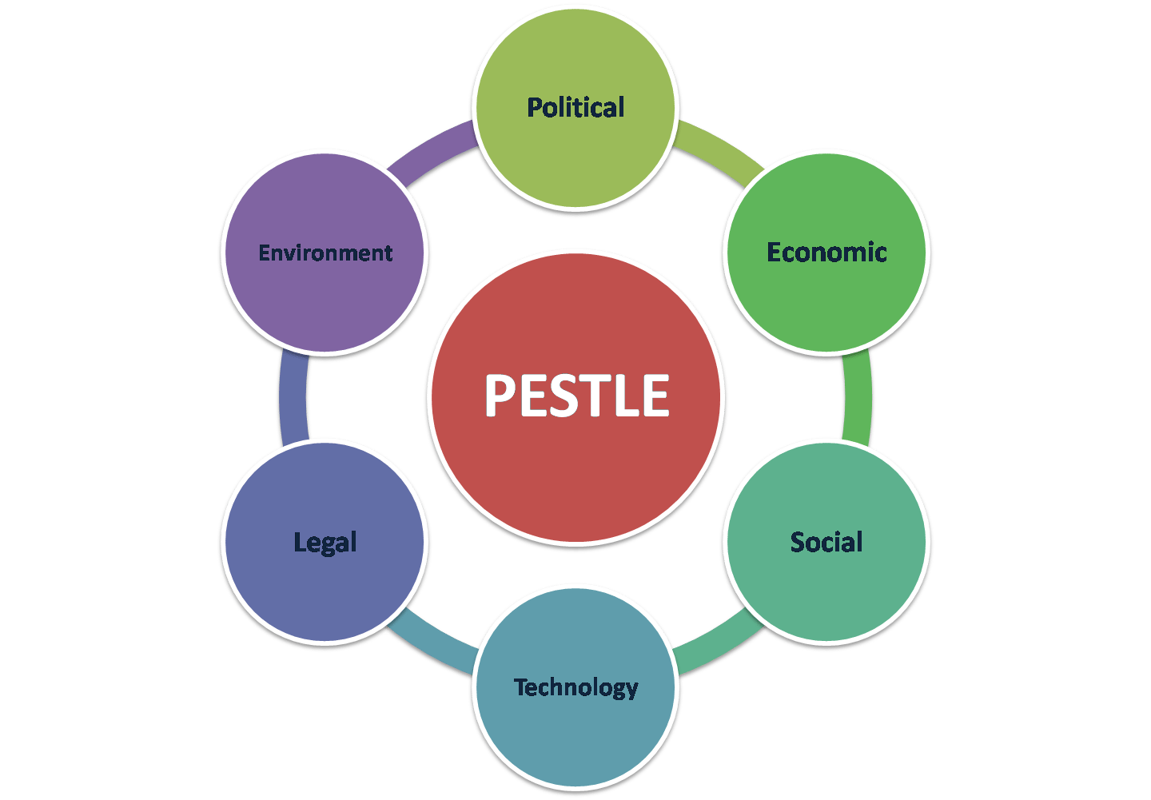
Figure 1 (Sobyia, no date)
Political variables determine how much a government may influence the economy. The business climate can be strongly influenced by tax legislation, tax policy, and other political concerns. (PESTLE ANALYSIS, 2022).
However, (Rahman, 2021) expressed that a part of the cordiality area is the lodging business. Accordingly, political factors influencing the traveler and neighbourliness enterprises will likewise impact the inn business. For instance, assuming the public authority of the United Kingdom carries out visa limitations, the inn business will languish immediately since requests over housing from guests will be negligible
The economic factors are stands for the success of an industry and have immediate and long-haul suggestions for a company. Economic factors include inflation, economic development trends, interest rates, and foreign exchange rates (pestle analysis, 2022). Furthermore, any significant economic shift has a significant impact on the hotel business. Recessions, inflation, and other economic downturns significantly impact people’s capacity to acquire luxury hotels. However, they additionally increment for minimal expense inns, thusly extending a few fragments of the area. Developing countries must focus on expanding their budget hotel business to attract more foreign visitors and boost their economies (Farooq, 2022).
Social elements are cultural norms and expectations, health consciousness, population growth rates, etc. Social elements are very essential for the business that target individual clients. They also showcase the local contractors and their eagerness to work under conditions (Pathak, 2020).
As explained by (FRUE, 2019) employees may keep in touch with HR by signing up for messaging applications such as WhatsApp and participating in workgroup talks. If it cannot call workers or communicate with them over the phone, HR can rapidly send emails or SMS messages using technology. HR may post a job ad quickly and select through applications using the dataset. Alternatively, they can search forums, blogs, and social platforms for recruits.
Furthermore, laws are intended to protect a country’s people from injustice and disorder. Firms are considered legal entities, and to maintain that position, firms must follow specific state-mandated requirements. As businesses are governed by and for people, different standards are in place to guarantee that no one uses them for personal advantage (Papia, 2022).
However, (Shaw, 2022) stated that every country has major environmental challenges since an economy cannot progress without industry. Every year the tourist business in the UK generates roughly 127 billion pounds. The government, commercial enterprises, and other charitable groups have taken initiatives to reuse and minimise plastic waste.
Human Resource Management (HRM) is about how organisations employ, manage and develop people within their structure. HRM is brought by the way of the HR plan, which manages inside the foundation and determined by HR construction (Armstrong & Taylor, 2020, p. 24). The major responsibility of HRM Is to manage an employee’s professional career. Recruitment, career development, and performance management are some of their tasks (PENINSULA, 2021).
According to (Armstrong, 2018, p. 8), ‘’Performance management is the continuous process of improving performance by setting individual and team goals which are aligned to the strategic goals of the organization, planning performance to achieve the goals, reviewing assessing progress, and developing the knowledge, skills, and abilities of people’’. Planning, monitoring, and reviewing performance are part of performance management system activities.
HRM plays an important role in Employee Life Cycle. An HR model that recognises the numerous stages a worker passes through in a organisation is known as the employee lifecycle. Keeping track of an organisation’s employee lifecycle is critical since it gives employees a consistent set of actions to follow throughout their tenure with the firm and helps managers to analyse data (Kakade, 2017-2022). Employees spend a few years or a lifetime with a firm, and it is HR’s role to keep track of them and make their journey happy and favorable. Furthermore, Employee lifecycles are usually separated into five segments, recruitment, onboarding, career development, employee retention, recognition, and offboarding (Saini, 2022).
Attraction refers to a company’s plan for attracting new employees. A business must comprehend how it will attract genius. A firm must first develop goals for what it wants to be renowned for and how it will separate itself from rivals before it can comprehend how to recruit talent. Corporate attractiveness is influenced by brand awareness, company culture, and company perks and advantages. The marketing team can play a significant role in assisting with the attraction phase of the employee cycle. When speaking with candidates about their company, HR should emphasise these points. Likes on social media can be used to track attraction (Pierce, no date). Recruiting is a massive undertaking, and HR plays an important role in making sure the right candidates are hired. When recruiting for new roles, HR must identify the organisation’s essentials and ensure that those essentials are addressed. The incorrect applicant might devastate a company’s operations.
Furthermore, employee onboarding involves the procedure of integrating a new hire into a workplace mission and giving them the resources and knowledge, they must become professional workers (Verma, 2022). Furthermore, onboarding and orientation are frequently confused. While orientation is required for deskwork and other routine duties, onboarding is a vast process that involves management and other employees. Onboarding is all too frequently reduced to presenting a stack of documents to a new employee and having a supervisor accompany them around the premises, making impromptu introductions. As regards filling new roles, HR must first evaluate the essentials of the organisation and establish that they are addressed. The wrong candidate may wreak havoc on a company’s operation (SHRM, 2022). Moreover, after workers have established themselves in the organisation, they seek obstacles to last their training and growth. This inspires them and boosts their commitment and production. Employees who do not advance are more likely to search for work elsewhere, harming the bottom line and generating inconvenience when they depart. Obtaining feedback more regularly, in addition to special occasions, to indicate that the acting is based on employee insight to assist with the development of the workforce (Fjell, 2021).
Another tread of the lifecycle model is employee retention. The company should focus on retain top personnel and guarantee that they are satisfied and confront in their responsibilities within the team. Improving retention is a substantial method to lessen this risk while also boosting durability and enjoyment in the team’s professional advancement. (SpriggHR, 2020). The last stage of the employee lifecycle is offboarding. Employees eventually decide to leave, for example, the employee may relocate or seek career opportunities that they cannot find at the company, they may retire, start their own business, or be lured away by a competitor (Personio, 2022). Employee turnover is unavoidable. A good offboarding program can help HR escape average mistakes in the worker leaving operation and make the transfer smoother for the two parties (Lucid Content Team, 2022).
(Harrison, 2014) stated that firms must drive the emergence of new thought, tap into critical employee thinking and skills, and enable team synergy to improve their current company to build a successful plan for a strategic employee lifecycle.
Economic growth is also increasing the need for businesses to adapt rapidly and easily to change the markets. The ability of businesses and managers to adapt and include their employees in the process may significantly influence their capacity to attain corporate goals. While the strategy and objectives underpinning change initiatives can vary from one company to another, to expand and thrive, all firms must learn to manage change effectively (Harrison, 2014).
According to (CERIDIAN, 2021) employee turnover is difficult to track. The average employee turnover in the UK is around 15% per year. Employee turnover does not always indicate that the association is a horrible position to work. This is due to a variety of circumstances, some of which are beyond the control of business owners. There are several reasons why employees wish to quit the hotel sector. A good shift is one in which everything goes well, and customers depart pleased and satisfied. When communication breaks down, the result can be a poisonous work atmosphere. Staff may feel undervalued and dissatisfied with the company if they are not recognised. However, (Kysilka & Csaba, 2013) stated that turnover is split into two groups (involuntary and voluntary). Involuntary turnover takes place when an employee is fired or terminated. Voluntary turnover happens when the worker departs voluntarily, and it can be triggered by a variety of circumstances (poor job feedback, job unhappiness, higher level of job stress, etc).
The hotel sector has recently experienced some significant changes as a result of COVID-19 and Brexit. According to data, every ten workers has left the business for various reasons, including estimating their occupation stability ensue isolation and being hesitant to back to working days longer than eight hours. (Blythe, 2021).
With the impact of Brexit on the British tourism sector well known and increasing on employment numbers, according to Harry Murray MBE, more must be done to recruit new talent from within the UK. (HOSPITALITY & CATERING NEWS, 2018).
Moreover, due to tougher migration laws, hotel staff have resigned and returned to their homelands. The hospitality sector is facing a manpower shortage at a moment when firms are striving to recover a portion of the funds, they have forfeited in the prior year (Radley, 2022).
(Office for National Statistics, 2021) noted that approximately, 1,650,000 workers in the hotel sector were on leave when firms ceased operations between 2020 and 2021. This amount decreased by the end of May 2021, accounting for 25 percent of all furloughed workers. After those constraints were loosened, business growth increased to £ 6.9 billion.
There will always be employees that want to quit the job. Workers may change jobs, create their own business, or discover vocations that they are more interested in. Employee turnover is impossible to avoid. The firm, on the other hand, may reduce the problem by providing a work atmosphere that encourages people to stay (Kappel, 2017).
Conclusion
This essay explained that Human Resource Management is an important tool for the employee, managing and developing people within their structure. HRM plays an important role in Employee Lifecycle. Furthermore, the essay explained the definition of PESTLE and how PESTLE impacts successful employee engagement and retention. Moreover, the essay discussed the causes of employee turnover.

References
Armstrong, M.( 2018) Armstrong's Handbook of Performance Management. 6th ed. London, United Kingdom: Kogan Page.
Armstrong, M. & Taylor, S.( 2020) Armstrong's Handbook of Human Resource Management Practice. 15th ed. London, United Kingdom; New York, NY: Kogan Page..
Blythe, T.(2021) Employee Retention | Strategies in the Hospitality Industry. [Online]
Available at: https://www.highspeedtraining.co.uk/hub/employee-retention-in-hospitality/
[Accessed 25 05 2022].
CERIDIAN, (2021) Here's what your turnover and retention rates should look like. [Online]
Available at: https://www.ceridian.com/uk/blog/turnover-and-retention-rates-benchmark
[Accessed 25 05 2022].
CIPD, (2020) PESTLE analysis. [Online]
Available at: https://www.cipd.asia/knowledge/factsheets/pestle-analysis
[Accessed 15 05 2022].
Farooq, U.( 2022) ﻿​​﻿​​PESTLE Analysis of the Hotel Industry | Marketing Tutor. [Online]
Available at: https://www.marketingtutor.net/pestle-analysis-of-the-hotel-industry/
[Accessed 26 05 2022].
Fjell, S.(2021) The 7 Stages of the Employee Life Cycle and Why They Matter. [Online]
Available at: https://www.questback.com/blog/the-7-stages-of-the-employee-life-cycle-and-why-they-matter/
[Accessed 19 05 2022].
FRUE, K.(2019) PESTLE Analysis for Human Resources: How PESTLE Affects HR. [Online]
Available at: https://pestleanalysis.com/pestle-analysis-for-human-resources-how-pestle-affects-hr/
[Accessed 25 05 2022].
Harrison, C.(2014) Fostering the Strategic Employee Lifecycle. Training, 51(2), pp. 12-13.
HOSPITALITY & CATERING NEWS (2018) The impact of Brexit on the British hospitality industry - Hospitality & Catering News. [Online]
Available at: https://www.hospitalityandcateringnews.com/2018/05/impact-brexit-british-hospitality-industry/
[Accessed 29 05 2022].
Kakade, S.(2017-2022) What is an Employee Life Cycle? - Definition from WhatIs.com. [Online]
Available at: https://www.techtarget.com/searchhrsoftware/definition/employee-life-cycle
[Accessed 19 05 2022].
Kappel, M.(2017) ﻿﻿​﻿​﻿5 Ways To Reduce Employee Turnover. [Online]
Available at: https://www.forbes.com/sites/mikekappel/2017/08/09/5-ways-to-reduce-employee-turnover/
[Accessed 01 06 2022].
Kysilka, D. P. & Csaba, N. P.(2013) EMPLOYEE TURNOVER IN THE HOSPITALITY INDUSTRY. Tibiscus University in Timisoara, Faculty of Economics, Volume 19, pp. 378-379.
Lucid Content Team (2022) The Offboarding Process: How to Transition Employees Smoothly. [Online]
Available at: https://www.lucidchart.com/blog/what-is-offboarding-in-human-resources
[Accessed 21 05 2022].
Lucid Content Team (2022) What does HR actually do? 11 key responsibilities. [Online]
Available at: https://www.lucidchart.com/blog/what-does-hr-do
[Accessed 18 05 2022].
Office for National Statistics( 2021) Coronavirus and its impact on UK hospitality - Office for National Statistics. [Online]
Available at: https://www.ons.gov.uk/businessindustryandtrade/business/activitysizeandlocation/articles/coronavirusanditsimpactonukhospitality/january2020tojune2021
[Accessed 27 05 2022].
Papia, F. A.(2022) Legal Factors in PESTLE Affecting Businesses. [Online]
Available at: https://www.thestrategywatch.com/legal-factors-pestle-analysis/
[Accessed 25 05 2022].
Pathak, R.( 2020) What is PESTLE Analysis? Factors, Advantages and Disadvantages of PESTLE Analysis. [Online]
Available at: https://www.analyticssteps.com/blogs/what-pestle-analysis
[Accessed 25 05 2022].
PENINSULA (2021) HR roles and responsibilities. [Online]
Available at: https://www.peninsulagrouplimited.com/topic/hr-policies-documentation/role-of-human-resources/
[Accessed 17 05 2022].
Personio (2022) The employee Life Cyce: Success in 6 Stages. [Online]
Available at: https://www.personio.com/hr-lexicon/employee-life-cycle-model-uk/
[Accessed 19 05 2022].
pestle analysis( 2022) What is PESTLE Analysis? An Important Business Analysis Tool. [Online]
Available at: https://pestleanalysis.com/what-is-pestle-analysis/
[Accessed 24 05 2022].
PESTLE ANALYSIS (2022) What is PESTLE Analysis? An Important Business Analysis Tool. [Online]
Available at: https://pestleanalysis.com/what-is-pestle-analysis/
[Accessed 15 05 2022].
Pierce, T.( no date) Employee Lifecycle: The Stages & Why You Need to Know | Eddy. [Online]
Available at: https://eddy.com/hr-encyclopedia/employee-lifecycle/
[Accessed 19 05 2022].
Radley, M.(2022) The impact of Brexit on the UK hospitality industry and what businesses can do. [Online]
Available at: https://trailapp.com/blog/impact-brexit-hospitality
[Accessed 30 05 2022].
Rahman, M.(2021) PESTEL analysis of the hotel industry. [Online]
Available at: https://howandwhat.net/pestel-analysis-hotel-industry/
[Accessed 26 05 2022].
Saini, S.( 2022) What is Employee Lifecycle? Management, Process & Stages - HR-One. [Online]
Available at: https://hrone.cloud/employee-lifecycle
[Accessed 18 05 2022].
Shaw, A. A.( 2022) PESTLE Analysis of UK | The United Kingdom Pestel Analysis. [Online]
Available at: https://www.marketingtutor.net/pestle-analysis-of-uk/
[Accessed 25 05 2022].
SHRM (2022) Understanding Employee Onboarding. [Online]
Available at: https://www.shrm.org/ResourcesAndTools/tools-and-samples/toolkits/Pages/understanding-employee-onboarding.aspx
[Accessed 19 05 2022].
Sobyia (no date) Pestle Analysis Examples to Unlock Business Growth. [Online]
Available at: https://www.advergize.com/insights/pestle-analysis-examples-to-unlock-business-growth/
[Accessed 22 05 2022].
SpriggHR (2020) The 6 Stages of the Employee Life Cycle. [Online]
Available at: https://sprigghr.com/blog/360-degree-continuous-feedback/the-6-stages-of-the-employee-life-cycle/
[Accessed 19 05 2022].
Verma, S. (2022) Employee Life Cycle: A Complete Guide | TechFunnel. [Online]
Available at: https://www.techfunnel.com/hr-tech/employee-life-cycle/
[Accessed 18 05 2022].

