Jerssica Da Silva (1809931)
University of wales trinity saint david
Problem solving & decision making

Module: Problem Solving and Decision Making - BMSK4004
Lecturer: Afzal Munna

Table of contents

Introduction
2
3
3
3
4
5-6
6
6

7
7
7
8
9
9-10
10
10-11
12

12-13
13
14
14
14
14
14-15
16
17
Chosen Problem
- Definition of mismanagement

- Definition of Communication
PDCA Cycle
Disadvantages of mismanagement
Why this problem happens?
How to solve mismanagement
Three actions (CAPA)
Fishbone Theory
- definition
- vantages
- disadvantages
-diagram
Typology of managerial roles
My experience at workplace
Problem Solving definition
7 Steps for problem solving
Decision Making
Types of decision
Ingredients of a good decision making
Proposed Solutions
- Solution 1
- Solution 2
Evaluation
Implementation Plan
Conclusion
Reference
Introduction

This assignment is a report about a chosen problem from my workplace: ‘mismanagement due to lack of communication’, its definition can be found on the first page of this report as well as its disadvantages, the reason why this problem happen inside the organisations and how to overcome it. A PDCA cycle explanation and diagram is a support for these findings.
Once the problem was reported, the aim is finding the causes in order to propose a better solution as possible, for that one of the most commons theories of cause-effect was used it is called Fishbone as well as the three actions strategies. A typology of the managerial roles by Ichak Adizes is there to illustrate what makes a good leader.
My experience with this problem at workplace is reported in detail. Also, the definition of problem solving as well as some tools and techniques to solve problems is included to help on the decision-making process. Analysing the three types of decision and identifying which one is more suitable for each case is crucial for propose a solution and implement it. After the implementation, the monitoring and reviewing steps of the implementation plan is what assure its effectiveness.

Chosen problem
The problem chosen to be reported in this assignment is: mismanagement due to lack of communication. Among other situations related to this problem, I will keep the focus in one of the problems coming from mismanagement, which is the lack of materials required to deliver a good job. I am choosing this problem as the subject of my assignment due to the fact that I think that is the main problem that happen in my company and it does not affect only me but also my colleagues and somehow the corporation as well.
Definition of Mismanagement
According to Merriam-Webster, it refers to the act of performing a wrong or/and poor management (Dictionary, 1828). Organisations must have someone in its leadership; thus, this person should possess a high developed management skill in order to deliver a good work. However, when the manager lacks in this skill, many problems can come from it and this lack is called: mismanagement.
Definition of communication
According to Collins English Dictionary, communication is the act of exchanging information, ideas and/or thoughts. It is essential in every single interpersonal relationship. Communication is the first tool to problem solving (Collins, 2001). A poor communication can generate many conflicts and put the organisation’s interests in risk.
Therefore, ‘mismanagement due to lack of communication’ means that the management team is lacking on exchanging information, ideas, feedbacks between themselves as well as with the team as one. Unfortunately, this problem happens more usually than it should in the organisations, most of the time due to lack of training, knowledge and planning, among other reasons. In this specific case reported below, I believe it is for lack of knowledge and planning.

PDCA Cycle
The PDCA Cycle, or Deming wheel/cycle, follow the Kolb’s Experimental / Leaning Model, as it is a cycle where you need to learn (plan), do ( what would be a kind of test in a small scale, experimenting whether the plan works), check (monitoring whether the plan is viable) and finally act (once the plan is viable is time to act putting it in practice).
I would say that PDCA created by William Deming in 1950’s (Team, 2019), is the best model to apply on the organization’s planning, due to the fact of in this model the main thing is repeat the process until get the best outcomes possible, each iteration is unique, thus the outputs are also different.
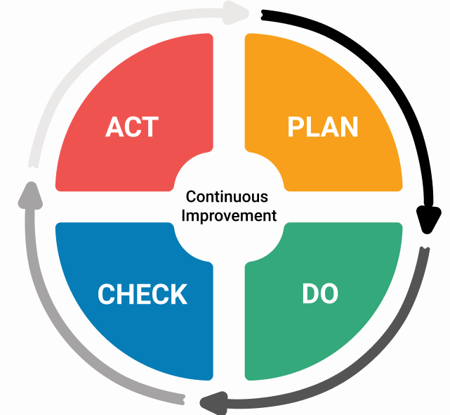 (Kabanize, 2019)
Disadvantages of mismanagement:
An ineffective management reverberates thorough the organisations and have a huge impact on its morale and credibility. It decreases the employees’ motivation leading to less productive and poor performance at workplace due to the fact of their effort hardly will be recognised and rewarded. The main duty of a leader towards their subordinates is motivate and support his/her team when and in what their need as in the end of the day the employees are the face of an organization, thus the way they work, their behaviour and acts reflect directly on the organisation’s image. When employees work under an ineffective or demotivating manager unlikely, they will deliver a good job what can jeopardize the success of the operations causing serious damages to the company.
A manager or any member of management team, should be a true leader to reach good outcomes. Leaders must believe in something to have fallowers, in this case the team members who would do give their very best to help his leader to reach the best output on every single operations, instead if you have a manager who lacks on leadership skills rarely the team member will feel de motivation to work in an effective way and help to keep the organisation’s morale and reputation. Mismanagement also can increase the turnover what is can be a big cost to the corporation as it requires a massive investment recruiting and training new staff who may as well be is unlikely to stay if they are being under the same poor management team (Godin, 2008).
Main disadvantages of mismanagement:
- Poor performance on the employees’ duties;
- Turnover increasement;
- Jeopardize the organization’s reputation;
- Jeopardize the organization’s operations;
- Unnecessary investments in hiring and training new staff;

Mismanagement

Why do the problems happen inside organisations?
People, this is the answer, especially the ones who is part of management. Many times, problems could have been avoided if people had the ability of do not create them. I mean, if a manager had the basic training, and knowledge and possesses soft skills required for management (and for life), so many problems just would not exist. However, plenty of them is out there in the market completely lacking in skills, training and any qualifications to be there, then they create unnecessary problems which even themselves are unable to identify, and it is the last thing that any organization needs.
Wherefore, before search for solutions we need to name, I mean, clearly identify the problem. Once the problem is defined then we need to research and come up with few viable solutions and pick up the most suitable one. For each problem will be a range of different solutions.
Personally, I believe that in leadership must have at least the main basics social skills, besides of technical knowledge, such as; communication, critical thinking, decision making and problem solving. I always, make a distinction between a boss and a leader: a boss is the one who thinks he is the pinnacle inside the corporation and does not matter what or how, he is the one who knows and decides everything, even if he is completely wrong, most of the times this type of managers use of misfeasance towards his employees.
In the other hand a leader, usually does not think he needs to be right every single time, he hears other’s opinions and accept it when he sees that is better than his own. A leader possesses the basic soft skills and work on its improvements as well is aware of his own strengths and weaknesses and work for the best interest of the team as one instead of work on his own interests.

How to solve mismanagement:

First of all, in order to overcome this issue inside the company, the management team needs to recognise that this problem is there. It is necessary to find out what and where is the root of the problem by which the management team is delivering a poor performance. The best way to start is gathering all the members of the management in a meeting and have a brainstorm. All of them should give a feedback, opinion and ideas of why they think this is happening. The diagram below was based in the problem that is mentioned in this reported, the aim here is to find the cause(s), effects and the problem as well as create plans of actions that could be taken depending on the situation.
Three actions strategies to handle one problem (CAPA + Containment Action):
Preventive Action: help to avoid the problems before they come up.
Corrective Action: once the problem is detected, find a solution to eliminate it.
Containment Action: when is not possible to eliminate the problem, one action is taken avoiding that the problem from spreading.
This is a sample of the three actions based on my workplace problem:
Containment Action: Try to reduce the consume of the products in the less dirty areas until the next delivery arrives.
Preventive action: Create an inventory and check the stock of materials regularly

Causes:
mismanagement
Effect:
Low cleaning standards
Corrective Action:
Have a 2nd supplier as a backup
Problem:
Lack of materials

The three actions diagram is a way to solve one specific problem, however if we are looking for a way to resolve mismanagement for good the wee need to go beyond. Many reasons could be the causes for mismanagement such as lack of knowledge, lack of training and the most important the lack of skills, especially communication skills. Maybe there is a lack of communication between employees and managers, and between managers and suppliers. A deeper analysis should be done in order to find a solution that will solve the problem indeed, the most used analysis in these cases is the Fishbone.
Fishbone theory definition
Ishikawa analysis, or most known as Fishbone analysis was developed by Kaoru Ishikawa in 1960’s and is commonly used in a brainstorm session in a group. It has this name as the structure drawn is a fishbone shape, it is a cause and effect analysis, which means that we need to go thru the identify what is the effect and then discuss about the possible causes that is leading into it. The aim is identifying the root of the problem.
It is an important tool to use when a problem needs to be solved since to build a fishbone the group need to think about all the possible causes of a certain problem. In a brainstorm session, many ideas and opinions may come out, what can be very helpful to look the problem in its depth and come up with suitable solutions.
Vantages and Advantages
Vantages
- It promotes a brainstorm what usually involves everybody, therefore making the team working together;
- The group must think and put on the diagram all the possible causes for a certain problem, allowing themselves to analysis all the angles before deciding;
- Makes each one of the members become committed with the outcomes;
- Can be used as a tool to control the quality of a product or a service;

Disadvantages
- If the members are not aware or does not have the perception of the problem, they will face difficulties or misunderstandings in finding the causes;

- It requires a favourable organizational structure to be successfully applied as it deals with a methodology different from the traditional one.

- Preferentially, it should be developed by people who is familiar with PDCA as it need to follow the ‘Plan, Do, Check and Action’ process;

- It does not show whether the problem is serious or not.

Fishbone analysis diagram

People Materials

Poor cleaning standards

Machine Supplier

People  1. Cleaners  2. Supervisors  3. Assist. Managers  4. Managers | Materials  1. Cleaning chemicals  2. cloths  3. gloves  4. hand soap  5. toilet rolls | Machine  1. Floor cleaning machine (swingo)  2. Vacuum  3. Pressure water  4. Carpet cleaning machine | Supplier  1. chemicals suppliers  2. yearly vacuum inspection  3. periodic swingos’ inspection and replacement.

One of the techniques used to help the fishbone diagram development is the called 5 whys (Seiter, 2018), it works by asking Why five times during the brainstorm to finally get into the root of the problem. These two theories combined is one of the most effective tools to problem solving. After brainstormed, now we need to draw our fishbone (Firican, 2013). Before drawing my fishbone, I will give an example of the 5 Whys on my problem.
Why the cleaning standards are low? Because there is a lack of materials.
Why is the lack of materials? Because the delivery is delayed.
Why is the delivery delayed? Because the order was made later then it should.
Why the order was made late? Because the Assistant Manager did not know the orders process.
Why the Assistant Manager did not know the orders process? Because there is a lack of communication what is generating mismanagement.
After the 5 whys, we came to the final root of the problem. In this case we found out that it was mismanagement due to lack of communication. Now that we have the CAPA and 5 Whys, we can easily draw our fishbone diagram.

Typology of managerial roles according to Ichak Adizes

In 1985 Ichak Adizes (Adizes, 1985), developed his typology of managerial roles in the company which he named PAEI:
P- The Producer: this person put up and runs the system of production; is aware about the goals and is more capable than anyone else to the outcomes’ achievements.
A- Administrator: he or she is efficient, is a manager who engineers, coordinates, support and directs the performance the task that was assigned. He managers projects and the team successfully.
E- Entrepreneur: is a manager who thinks ahead, is creative and is always search for ways to innovate the company, aiming the organization’s development and profit making.
I- Integrator: is concerned with his workforce, facilitating the system of working and finding ways that his employees can work as a team.

One of my experiences with mismanagement in my workplace
I work for a large cleaning company and in our daily life at work, we need a range of cleaning products, such as gloves, hand soap, shower gel, vacuum and its accessories, etc as well as machines. All the products that an industrial cleaning company should provide. The company that I work for, was hired by one of the largest Business Park in the UK and the standards required in this Park are quite high, thus we always need to have all the materials enough to clean properly avoiding complains.
The Assistant Managers which are on charge of the materials’ orders were supposed to make it to be delivered once per month or every 2 weeks, but it should be enough to cover the demand of every single day. Well, it seems to be only in theory as in the practice is not what happen. They make the order when the products are almost done, and it takes around two weeks to be delivered once the order is submitted. Therefore, we always have the same issue- lack of basics material to work. Sometimes they blame the supplier, sometimes the blame the manager justifying that he took more time than usual to approve the order and sometimes they blame us (cleaners) saying that we are spending too much chemicals. Also, the machines maintenance and pieces replacement should be done regularly. However, this does not happen so often as it should, many times when a vacuum is broken, they do not have any spare to replace while the storage is full of broken vacuums waiting to be repaired.
The biggest issue I have seen by now was when we were lacking even in toilet roll. In the shed, we did not have hands soap and any kind of chemicals besides ‘Fairy’ (which is not to clean toilet, it is a washing up). Thus, we needed reduce the number of toilet paper that we put in each floor, putting less on the floors with smaller companies and filling up with more on the busier floors. Also, we gave our very best to clean with the limited sources that we have and use the same mop for more days than we should, what made our standards decrease for that period.
Is true that we made it in a way which we did not receive much complains, especially because the Business Centre was aware of the problem, thus they could not blame the employees’ work as we did not have what we needed to deliver a good job and keep high standards. However, for us is very bad when such situations happen as later, we need to work double or more to put our job within the standards we are required to have.

Problem Solving

Problem Solving is the process of go into the details of a problem in order to reach a solution for it. This ability is directly linked with other skills such as critical thinking, communication and decision making, once that to find a solution and implement it you need to explore all the possible causes of the problem by communicating with everyone involved in finding its solution as well as find the causes requires that the group think critically about everything that happen to contribute to the problem, even small details. Usually, after a brainstorm the group come up with more than one solution and in order to solve the problem is necessary make a decision about which one seems to be the best to be implemented (Dictionary, 2019).

Seven steps to Problem Solving
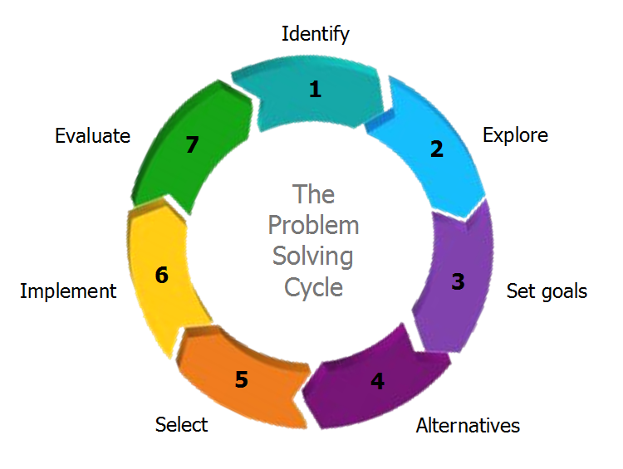 (Petrick, 2013)

Using the ‘Seven Steps Model’ to analyse the problem at my workplace:

Step 1: Identify the problem- in this step is necessary define the problem clearly not leaving room for any ambiguity. The problem here is mismanagement, mainly about the lack of cleaning products which is the main tool in our job, and it is been a recurring problem. This problem affects every employee and compromises the quality of our work.
Step 2: Explore- Identify the causes – in this step everyone who is part of the brainstorm should come up with some possible causes of the problem, even small details can make a huge difference. As I am not officially a member of the management team, I do not really know whether the justifications they give us about this problem is true, however based on the information I have I can say that this problem have been happening for these reasons:
- They relay in one supplier only;
- They do not make standards order, what make them ‘waste’ time every other week checking all the items in stock to order more; time that could be invested to solve other problems;
- They work with a very tight number of products; I think they should order more than they do to avoid any problems in case the delivery do not come on time.
- They always want to work under the badged they have available, saving money but making we lack in materials very often; I know that because I use to help them in the office and I know they always make order less the badged at hand.
Step 3: Set Goals- clarify your objectives- setting goals clearly is necessary as well as plan to reach them, the SMART technique is one of the bests tools to set goals.
S. M. A. R. T
TIME- BOUND
REALIST
ACHIEVABLE
SPECIFIC
MEASURABLE

In this case, the objective is that the management take care of the products order arrive on time, if they could solve this problem it will make a huge impact in our job, especially in the effort we do and in the quality of our work. Very often, we do not have chemicals required for a high standards of cleaning and I hate when I cannot go home knowing that my job is properly done, but at the same time I am not a magician and is impossible to deliver a good job without the tool, and later when the products arrive (and very quick is gone) they want us to put the standards up again within hours. When I think about our lives at workplace without this problem, I could see it much easier as we would have all the tools available to accomplish our daily tasks in the best way possible, avoiding complains and the big effort we need to do working hard to put the standards up again when the chemicals arrive. Would be much better to have a stable working quality in an everyday basis.
Step 4: List workable solutions- Once the problem and its causes were identified, it is now time to find solutions to solve it. A range of workable solutions should be put on the table, therefore in case one does not work than we have a backup plan. Have four or five solutions if possible, would be the best for this type of problem.
Step 5: Evaluate all the options- have a definition for each one of the proposed solutions. Now that we do have many options to solve our problem and an evaluation of each one, we should look back into the problem we are solving and think about the outcomes we are expecting from this solution. This step requires a high developed critical thinking skill in order to analyse all the pros and cons of each solution and finally come into a common sense of which would be the most suitable for this case.
Step 6: Making a decision- once that multiples solutions were created, now it is time to decide which one is most suitable for the problem. Pick up the most workable solution and table the other ones, but not dispose them; instead keep them handy. We never know if/when we will need them.
Step 7: Implementation of the chosen solution- implement the plan and fallow its progress; finally determine a time bound to review if this plan is working or not. If the plan implemented is working, then great keep working on its improvement, otherwise then it is time to implement the next viable plan.

Decision Making

Decision making is about coming into a decision about what action should be taken, usually it means choose between two or more options, the aim is deciding which option is more viable in each case. It is part of the problem-solving process. A professional who possesses this skill is valuable as sometimes making a good decision can be a hard job and when the decision made was not viable it can bring costs to the organisation (Adair, 2007).
Types of decision

There are many types of decisions that can be made to solve a problem, in this report I will highlight the three main types of decision, which are: Routine Decision, Adaptative Decision and Innovative Decision.
Routine Decision: This is how the decisions that are made in order find a solution for a clearly defined and common problem and when procedures, rules and policies previously established can be used to help us to solve them. Example: lack of cartridge in the printer.
Adaptative Decision: This type of decision is made when the problem and the other possible solutions somehow are not usual neither fully understood. Example: changing schedules, leadership or methods of work at workplace.
Innovative Decision: this is the given designation for the decisions that are made are completely new and unclear and is necessary a solution elaborated by using a lot of creativity. Example: developing new ways, products or ideas in order to overcome the competition and/or attract new clients.

Factors affecting decision making
Many factors can affect decision making such as:
- Technical and practical knowledge;
- Creative and Critical Thinking;
- Budget;
- Deadline;
- Conflict of interests;
- Agreements among the team members involved;
- Personal Problems;
- Skills;
- Organisation’s policies.

Ingredients of a good decision making

In order to assure a good decision making is needed to fallow a systematic process, all the steps should be taken. It is similar to problem solving process and requires around five steps:
1. Involve- the whole team in the decision-making process listen each one’s ideas and thoughts;
2. Delegate- tasks to each one of the members, such as research, with everyone’s cooperation the process can be done quicker, and nobody will be overwhelmed;
3. Brainstorm- brainstorm allow that each member come with ideas and opinions what brings more options to the table
4. Creativity- creative ideas means innovation what is good to make a decision to solve a problem and helps the organisation grow and be authentic.
5. Be objective- personal matters or conflicts should be set aside. In a decision-making process the goal should be the solution that meets the best interests of all involved.

Proposed solutions to solve mismanagement due to lack of communication

1. Have meetings more often and ask for feedback from the superiors as well as from the subordinates.
2. Establish some relationship among the team members and management team outside the office.

Evaluating and analysing the proposed solutions

Solution 1.
Regular meetings are essential in every organisation, communication is the key to avoid or/and solve problems. Also, the problems can be put on the table and be discussed it will help to come with more ideas and solutions to solve the problem as well as establish a better relationship among the team members. Be aware of our weaknesses and strengths is a valuable ability in order to find ways to improve our weaknesses, feedback from colleagues is one of the best ways to help us to identify what needs to be fixed. Hearing from others’ experiences is good to make us think about what can be changed in ourselves in order to have a personal and professional grow. Receiving feedback from the subordinates is so important as from the superiors once that the subordinates are the ones who execute the plan/job so they should have the practical knowledge, while the superiors should have the technical knowledge on how things should have been done.

Solution 2.
Establish a relationship outside the workplace can be a good idea when the matter is lack of communication. Is much easier to communicate with people when you feel that they are willing to hear your thoughts and ideas. A health relationship among team members outside the office allow people know each other in a different perspective. Usually at workplace a boss/manager must have a serious posture what can scare an employee who needs to say something, in the other hand in an environment with less pressure this boss likely will have friendly behaviour. I believe that this kind practice helps to build trust and loyalty.
Implementation Plan
Once that one solution was chosen, is time to implement it. Is needed to create an implementation plan and fallow some steps that will help to turn the strategic plan into actions that will lead to the goal’s achievement:
- Organizational Planning
- Strategic management process
- Change management
- Differentiated planning
Key components of a successful implementation plan:
- Define goals/objectives
- Schedule milestones
- Allocate resources
- Designate team member responsibilities
- Define metrics for success
- Define how you will adapt
- Evaluate success
In the implementation process should be tracked by using some of the learning styles and corrected if needed. If the chosen solutions do not solve the problem, then is time to try another solution.

Conclusion

Sometimes, manage a team can not to be easy, especially when dealing with people that think in a different way, problems and conflicts are normal to merge at work environment, leadership skill is crucial for a manager have a good performance and reach good outcomes. Communication is the key for a good interpersonal relationship, people need to communicate between each other in order to do not give room to any misunderstandings. In communication, listening is so important as speak, therefore they can understand other’s ideas and opinions. Problems are unavoidable, especially at workplace, the most important of all is to identify them by using the correct tools and techniques as a support to making decisions and solving problems.

References

References
Adair, J., 2007. Decision Making & Problem Solving Strategies. London: Kogan Page.
Adizes, I., 1985. How to solve the mismanagement crises. California: Adizes Institute Publications.
Collins, 2001. Collins English Dictionary. 1st ed. Glasgow: Omnia Books Limited.
Cottrell, S., 2008. The study skills handbook. 3rd ed. New York: Palgrave MacMillan.
Dictionary, 1828. Merriam Webster. [Online]
Available at: https://www.merriam-webster.com/dictionary/mismanage
[Accessed 20 07 2019].
Dictionary, B., 2019. Business Dictionary. [Online]
Available at: http://www.businessdictionary.com/definition/problem-solving.html
[Accessed 29 07 2019].
Firican, G., 2013. Lightsondata. [Online]
Available at: http://www.lightsondata.com/how-to-fishbone-diagram-data-quality-root-causes/
[Accessed 25 07 2019].
Godin, S., 2008. Tribes- We need you to lead us. London: Piatkus.
Kabanize, 2019. Kabanize. [Online]
Available at: https://kanbanize.com/lean-management/improvement/what-is-pdca-cycle/
[Accessed 21 07 2019].
Petrick, K., 2013. Ansus Consulting. [Online]
Available at: https://ansusconsultingblog.wordpress.com/2013/05/18/the-problem-solving-cycle-an-effective-step-by-step-approach-to-find-viable-solutions/
[Accessed 20 07 2019].
Seiter, C., 2018. Open Buffer. [Online]
Available at: https://open.buffer.com/5-whys-process/
[Accessed 25 07 2019].
Team, L. C., 2019. Lucidchart. [Online]
Available at: https://www.lucidchart.com/blog/plan-do-check-act-cycle
[Accessed 24 07 2019].

