DEVELOPMENT OF AN EXPLAINABLE MACHINE LEARNING FRAMEWORK FOR DETECTING STATE-SPONSORED ADVANCED PERSISTENT THREATS IN NETWORK TRAFFIC

ACKNOWLEDGEMENT
I deeply appreciate the help I received in the completion of this dissertation. I would be especially indebted to my supervisor for guiding me in my research and writing, for his constructive inputs as well as giving me constant encouragement. In addition, I'd like to express my gratitude to everyone else who provided the necessary resources and learning environment for me to undertake this study at my university and amongst my academic staff. I would like to thank all my friends and colleagues who supported, encouraged and helped me during the project. Last but not least, I would like to express my gratitude to all my family members for their unending patience, encouragement and understanding which, without them, the completion of this dissertation would have been difficult.

ABSTRACT
Advanced Persistent Threats (APTs) are sophisticated and persistent cyber-attacks which can adapt their behaviour and mimic legitimate network activities to evade conventional intrusion detection. This dissertation aims to create a helpful and explainable framework using machine learning techniques for detection of APT activity on the state sponsored machines by analyzing network traffic. The work covers analysing characteristics of the network traffic when operating malicious actions, evaluating machine learning classification methods, and the addition of Explainable Artificial Intelligence (XAI) to enhance the explanation of model results. The UNSW-NB15 network traffic dataset was used and a quantitative experimental methodology was adopted. The data preparation techniques included data-quality checking, categorical encoding, normalisation, ratio computations (packets/bytes and packets/sec/bytes, etc.) and log transformations. Four models, namely, Logistic Regression, Random Forest, Multi-Layer Perceptron (MLP) and XGBoost were developed and tested based on the criteria of accuracy, precision, recall, F1-score, ROC-AUC, PR-AUC and false-positive rate.
The results indicate that the overall best classification performance was achieved by using the Random Forest and XGBoost models. Random Forest achieved an accuracy of 0.812531 and F1-score of 0.798993, while XGBoost achieved an accuracy of 0.812211 and F1-score of 0.798511. The performance of both models in discriminating normal and malicious traffic is good, with around 0.962 ROC-AUC value. SHAP and LIME were then used to give local and global explanations of the model predictions such as explanations for correctly and incorrectly classified traffic. Acknowledgements, SYN-ACK, incoming packet, and packet related encap were among the important characteristic features of networks used. The approach translates to a predictive detection framework with interpretable explanations which helps security analysts know the “why” of the suspicious network traffic. Overall, the research proves the usefulness of the combined use of machine learning and XAI as part of a single approach to anti-APT based on processing network traffic.
Table of Contents
Chapter 1: Introduction 8
1.1 Research Background 8
1.2 Problem Statement 8
1.3 Research Aim and Objectives 9
1.4 Research Questions 9
1.5 Research Significance 10
1.6 Research Rationale 10
Chapter 2: Literature Review 12
2.1 Introduction 12
2.2 State-Sponsored Advanced Persistent Threats 12
2.2.1 Definition and Characteristics of APTs 12
2.2.2 State-Sponsored APT Campaigns 13
2.2.3 APT Attack Lifecycle 14
2.3 Network Traffic-Based APT Detection 14
2.3.1 Network Traffic as a Detection Source 14
2.3.2 Traditional Intrusion Detection Approaches 15
2.3.3 Challenges in APT Network Detection 16
2.4 Machine Learning for Network Intrusion and APT Detection 16
2.4.1 Supervised Machine Learning 16
2.4.2 Unsupervised and Semi-Supervised Learning 18
2.4.3 Deep Learning for Network-Based Detection 18
2.4.4 Comparative Evaluation of ML Approaches 19
2.5 Explainable Artificial Intelligence for Cybersecurity 20
2.5.1 Concept of Explainable AI 20
2.5.2 XAI Techniques 21
2.5.3 XAI in Cybersecurity 22
2.5.4 Limitations of XAI 22
2.6 Explainable ML Frameworks for APT Detection: Critical Synthesis 22
2.7 Research Gap 24
2.8 Conceptual Framework for the Proposed Research 25
2.9 Chapter Summary 26
Chapter 3: Methodology 27
3.1 Introduction 27
3.2 Research Design and Approach 27
3.3 Dataset Description and Collection 28
3.4 Data Pre-processing 28
3.5 Feature Engineering and Selection 29
3.6 Machine Learning Model Development 30
3.7 Model Evaluation and Explainable AI 31
3.8 Ethical Considerations 32
3.9 Chapter Summary 33
Chapter 4: Results and Discussion 34
4.1 Introduction 34
4.2 Result Analysis 34
4.3 Key Findings 57
4.4 Discussion 59
4.5 Summary 60
Chapter 5: Conclusion and Recommendations 62
5.1 Conclusion 62
5.2 Summary of Achievements 62
5.3 Research Recommendation 63
5.4 Achievements of Objectives 63
5.5 Future Work 64
References 65

List of Figures
Figure 4.2.1: UNSW-NB15 Training and Testing Dataset Structure and Sample Records 31
Figure 4.2.2: Summary of Dataset Dimensions, Variable Types, Missing Values and Duplicate Records 32
Figure 4.2.3: Binary Class Distribution of Normal and Attack Network Traffic 32
Figure 4.2.4: Data Cleaning and Row Retention Summary for Training and Testing Datasets 33
Figure 4.2.5: Distribution of Network Traffic Across Attack Categories in the Training Dataset 34
Figure 4.2.6: Protocol Distribution of Network Traffic in the Training Dataset 34
Figure 4.2.7: Service Distribution of Network Traffic in the Training Dataset 35
Figure 4.2.8: Correlation Matrix of Numerical Network-Traffic Features 36
Figure 4.2.9: Engineered Network-Traffic Features for Malicious Behaviour Detection 37
Figure 4.2.10: Preprocessed Feature Matrix After Numerical Scaling and Categorical Encoding 38
Figure 4.2.11: Top 15 Network-Traffic Features Ranked by Mutual Information and Random Forest Importance 38
Figure 4.2.12: Class Balance of Normal and Attack Network Traffic After Data Preparation 39
Figure 4.2.13: Random Forest Confusion Matrix for Network Traffic Classification 39
Figure 4.2.14: MLP Confusion Matrix for Network Traffic Classification 40
Figure 4.2.15: XGBoost Confusion Matrix for Network Traffic Classification 40
Figure 4.2.16: XGBoost Feature Importance for Malicious Network Traffic Detection 41
Figure 4.2.17: Comparative Performance Metrics of Machine-Learning Models 41
Figure 4.2.18: Comparative Performance of Machine-Learning Models Across Evaluation Metrics 42
Figure 4.2.19: ROC Curve Comparison of Machine-Learning Models 43
Figure 4.2.20: Precision-Recall Curve Comparison of Machine-Learning Models 44
Figure 4.2.21: Threshold-Based Precision, Recall, F1-Score and False Positive Rate Analysis 45
Figure 4.2.22: SHAP Global Feature Importance for Explainable Network-Traffic Classification 46
Figure 4.2.23: SHAP Beeswarm Plot Showing Feature Contributions to Model Predictions 47
Figure 4.2.24: Local SHAP Explanation for a Malicious Network-Traffic Prediction 48
Figure 4.2.25: Local SHAP Explanation for a Normal Network-Traffic Prediction 49
Figure 4.2.26: LIME Explanation for a Correctly Classified Malicious Network-Traffic Instance 50
Figure 4.2.27: LIME Explanation for a Correctly Classified Normal Network-Traffic Instance 51
Figure 4.2.28: LIME Explanation for a False-Positive Network-Traffic Prediction 51
Figure 4.2.29: LIME Explanation for a False-Negative Network-Traffic Prediction 52
Figure 4.2.30: Representative False-Positive and False-Negative Network-Traffic Cases 52
Figure 4.2.31: Attack-Category Detection Performance Based on F1-Score 53
Figure 4.2.32: Model Robustness Across Different Random Seeds 54

Chapter 1: Introduction

1.1 Research Background
The digital networks, digital cloud services and connected information systems that are in rapid expansion have put more and more organisations under the pressure of exposure to sophisticated cyber threats. APTs are especially difficult among the attacks listed – they are built to gain access without detection and then gradually undertake malicious activities for a prolonged period of time. APT attacks can be much more extensive than typical attacks and may include reconnaissance, initial access, persistence, privilege escalation, lateral movement, C&C, collection and exfiltration of information. Multi-stage and adaptive, their individual activities can mimic legitimate network activity, which can make detection hard using individual indicators. The dissertation, the question of how to "explain" network traffic to detect state-sponsored APT-related behaviour, using machine learning, is therefore addressed (Konyeha et al. 2025). Another security threat is APT attacks with foreign governmental assistance; they can have extensive resources, technical skill and may have long timelines associated with them, such as cyber espionage, intelligence collection, strategic information sabotage, and information stealing.
These can use legitimate credentials, trusted services, encrypted communication and legitimate system functionality to minimise indicators. This means that signature- and rule-based intrusion detection techniques are ineffective if an attacker changes their tools, techniques or modus operandi. One source of evidence for the detection of suspicious activities is network traffic. Communication protocols, services, connection durations, numbers of packets exchanged, bytes transmitted, transmission rates, and sources/destinations are examples of network-flow information. These attributes can depict unusual patterns of communication associated with reconnaissance, lateral movement, C2 communication and data exfiltration even if the content of communications is not present. This is no trivial problem when faced with a large-scale network environment, data volume, class imbalance, encrypted traffic, low-and-slow attacks and changing attack behaviours (James, 2026). One solution to tackle some of these challenges would be machine learning (ML), as it can detect patterns in network traffic that don't fit standard rules, thus avoiding flakiness and bugs.

1.2 Problem Statement
State-sponsored APTs are a challenge due to their persistence and are sometimes hard to distinguish from legitimate networks. Old methods of detection often fail if attackers alter their strategies or use legitimate credentials or methods of communication via trusted services. Therefore, relying on a set of preestablished APT signatures or rules will likely not be enough to detect the evolution of APT behaviour. Using machine-learning methods to try to find patterns in network traffic has potential benefits, the use of complex predictive models poses an additional worry. The model delivers a prediction but fails to elucidate the reasoning; the security analyst could struggle to understand and/or believe the warning. Malicious-traffic detection, coupled with decision explainability of machine learning, thus requires consideration (Jadala, 2026). The main research problem presented in this dissertation is then the challenge of building an approach that can aid in the identification of state-sponsored APT-related behaviour from network traffic and make understandable explanations of the factors associated with machine learning predictions.

1.3 Research Aim and Objectives
Research Aim
This research aims to design an explanation-providing machine learning framework, which detects malicious activity in network traffic in order to reveal the presence of State-Sponsored Advanced Persistent Threats.
Research Objectives
- To study network traffic characteristics of malicious activities related to APTs originating from state actors.
- To study how to classify normal and malicious network traffic using machine learning.
- To assess the effectiveness of machine-learning methods to detect APTs using network traffic.
- To explore the ability of SHAP and LIME to explain machine-learning predictions in network-traffic classification.

1.4 Research Questions
RQ1: What is the network-traffic characteristics that denote state-sponsored APT-related malfunctions?
RQ2: How effectively can machine-learning models distinguish between normal and malicious network traffic?
RQ3: What is the best machine-learning method to use when detecting APTs through network traffic?
RQ4: What approaches can be taken to improve the explainability of machine learning predictions of APT detection with the help of SHAP and LIME?

1.5 Research Significance
The study is important because advanced cyber-attacks are increasingly using a combination of attack signatures and behaviour, meaning that the detection methods they want to use need to be able to detect those behavioural patterns. Knowing what sorts of network traffic match nefarious activity can help guide the creation of smarter techniques for handling network security. The study also has significance as it takes explainability into account along with detection. Machine learning predictions can be tough to interpret, especially model-based and highly complex. Incorporating explainability can provide some clues to the relationship between automated predictions and network characteristics impacting those predictions. It is significant for cybersecurity environments where analysts need to investigate the alerts to make educated security choices (Cheng, 2026). Research-wise, it is a contribution to explainable machine learning in cybersecurity, another emerging field. It explicitly takes into account the relationship between this APT detection data, network traffic and XAI, which highlights the need to consider both automated detection and human interpretation of the model's decision.

1.6 Research Rationale
The motivation behind this research is the ongoing challenge of successful identification of more complex APTs through traditional cybersecurity methods. APTs can take place through several stages of operations and include robust adaptation tactics and communication strategies which are similar to normal network operations. There is a wealth of behavioural info readily available on the network, as different phases of malicious activity may yield observable communication patterns. Machine learning is one option that could be used to uncover complex relationships among these network traits, and while being able to detect them is good, it is not enough to meet the needs of cybersecurity analysts. It is quite important to comprehend why a system thinks traffic is suspicious when evaluating potential threats. Explicable AI is a relevant insight into enhancing transparency and facilitating human interpretation will then be evident (Petrova, 2026). The rationale for the research, therefore, is that understanding the reasoning behind automated predictions of cybersecurity, in addition to identifying suspicious behaviour, is an important thing to consider when determining what good detection of cybersecurity entails. This enables an investigation into a network-traffic-based explainable machine-learning model for APT detection by state parties.

Chapter 2: Literature Review

2.1 Introduction
In this literature review, the literature that pertains to the development of an explainable framework of machine learning in identifying state-sponsored Advanced Persistent Threats (APTs) based on network traffic is analyzed. It defines the connection between advanced, intractable cyber threats, machine learning monitoring (ML) and explainable artificial intelligence (XAI). State-sponsored APTs are difficult since attackers may be hidden over a long time and might upgrade their methods to avoid the use of traditional checks. These Network behaviour analyses can consequently be used to demonstrate suspicious communication, lateral movement and command-and-control operation as well as ML has the potential to detect the formation of network behaviour patterns that are less specific than fixed rules. Nevertheless, proper detection cannot be applied on its own, when the security analysts fail to comprehend the model decisions. XAI has the capability to enhance transparency, which in turn promotes an analyst opinion through an interpretive layer. The literature review discusses the APT characteristics, network traffic analysis, traditional detection and ML-based methods critically based on their strengths and weaknesses. It then determines the research gap and gets a justification to come up with an explainable framework.

2.2 State-Sponsored Advanced Persistent Threats

2.2.1 Definition and Characteristics of APTs
Advanced Persistent Threats (APTs) are premeditated cyber intrusions that are intended to acquire and sustain unauthorized access without being observed. In contrast to traditional malware, which usually aims at disrupting systems, monetizing them or spreading, the work of APTs is usually directed, persistent and designed (Haque et al. 2026). They are characterised by stealth, long access, multi-stage behaviour, adaptive methods as well as conscious disguise of malicious behaviour. Long dwell-times and persistence enable attackers to continue with access, whereas lateral movement and information gathering when a credential is compromised allows attackers to reconnoiter and collect information. Their actions may be similar to legitimate activity. This multi-stage behaviour of campaigns allows malicious behaviour to seem regular when focused on individual network events. The inference is, therefore, that the detection of the APTs needs to be done with reference to patterns among the activities, as opposed to depending on an indicator or malware signature.
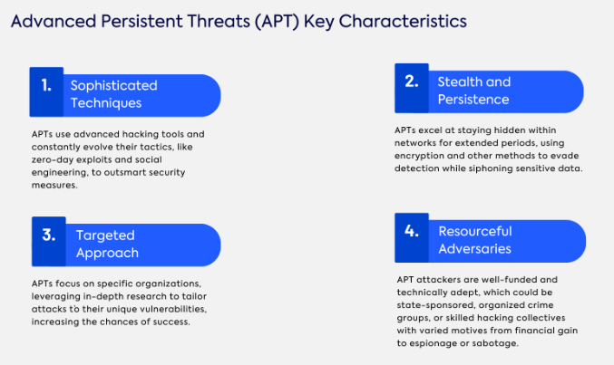
Figure 2.2.1.1: “Understanding Advanced Persistent Threats”
(Source: Haque et al. 2026)

2.2.2 State-Sponsored APT Campaigns
The actors supported or directed by national governments are linked with state-sponsored APT campaigns. They could have the following objectives: cyber espionage, intelligence gathering, strategic information theft and sabotage. Intensive resources, professional skills can be allocated to such campaigns, which allows attackers to evolve practices and stay in place (Thi et al. 2023). It is not easy to detect since actors might have access to compromised legitimate accounts, trusted services, encrypted communications and living-off-the-land techniques to minimize indicators. Previous indicators are not reliable since operations can be customized to reach specific targets. Such features render state-sponsored APTs a challenge to the use of traditional monitoring systems. Their long term campaigns are thus able to defy the traditional alarms and go undetected in the normal organisational routine over months. State-sponsored actors have been recorded maintaining continuous and unnoticed access by legitimate credentials and advanced tradecraft by CISA.

2.2.3 APT Attack Lifecycle
APT activities are carried out in a flowing manner, though the order differs. The process of reconnaissance is to collect target data, then create initial access using phishing, vulnerabilities or compromised credentials (Mutalib et al. 2024). Execution lets malicious code run, and persistence keeps the malicious code running. Privilege escalation aims to get more permissions than subsequently lateral movement. Communication with the compromised infrastructure, collection and exfiltration are made possible with the help of command and control (C2). These stages are mapped in MITRE ATT&CK as tactics. All of the stages yield indicators, such as unusual connection patterns, remote-service activity, repeated C2 communication and abnormal transfers. Hence the detection based on a single signature is not entirely sufficient since attackers can manipulate tools, infrastructure and communications patterns but still keep sequences. Reconnaissance can also create a scan or discovery traffic, initial access might create odd inbound traffic, and lateral movement may create odd internal traffic. Periodic relationships may be reflected by C2 activity, and exfiltration can cause abnormal outbound volumes or destinations.

2.3 Network Traffic-Based APT Detection

2.3.1 Network Traffic as a Detection Source
Network traffic can be used to show evidence of suspicious behavior since malicious activity needs hosts to communicate with external infrastructure. It can be analyzed at packet level or at flow level where consolidated connections are aggregated using IP addresses, ports, protocols, number of packets, size of packets, duration and frequency. These properties can inform a violation of the usual communication patterns even before accessing payloads. Lateral movement, reconnaissance, C2 communication and ex Filtration can be detected by network based monitoring. Flow-level analysis lessens the instance of checking each packet. Nonetheless, feature quality and baselines and distinguishing between malicious and legitimate traffic make it effective (Areghan and Ndibe, 2024). Packet analysis is more detailed in terms of protocols, whereas flow analysis is more scalable to using constant-time monitoring. NIST identifies network-based and network-behaviour analysis as valuable methods of IDPS.
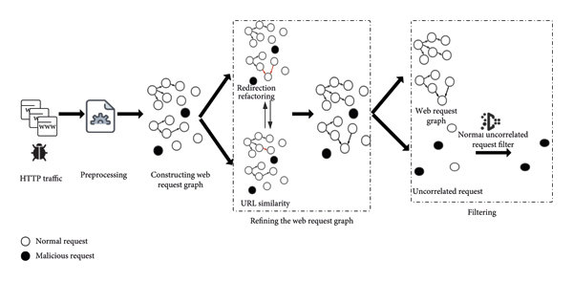
Figure 2.3.1.1: “The overview of HTTP-based APT malware traffic detection based on URL correlation”
(Source: Areghan and Ndibe, 2024)
Temporal evidence that can aid identification of coordinated APT activity may be gained from network traffic. Frequent connections and unusual communications frequencies, as well as unusual destinations and changes in traffic flows might be signs of stages of an intrusion. This can aid in detection as individual events in a network can seem natural on their own, but when combined with these indicators, can paint a picture of a malicious event.

2.3.2 Traditional Intrusion Detection Approaches
Conventional intrusion detection methods vary about the threat identification parameters. The signature-based intrusion detection systems (IDS) compare traffic with the identified signatures and identify known dangers. Rule-based detection is based on known circumstances to indicate events though it needs to be maintained. Detection models based on anomalies normalize normal behaviour and detect anomalies, which contributes to invisible threats. Behaviour-based strategies focus on the behavioural patterns of actions and communications rather than on indicators that are known (Ehsan and Altaf, 2026). Nevertheless, there are limitations of these methods against APTs. Zero-day attacks can have no signature and polymorphic malware can change characteristics. APT actors can impersonate genuine traffic and vary tactics. There can therefore be a challenge with dynamism of multi-stage behaviours using the static mechanisms. This restricts real-life flexibility. NIST gives a difference between signature and anomaly techniques, and their contrasting detection principles.
Signatures and rules are still very useful, as they can quickly identify previously known threats. But relying on a set of predefined indicators introduces problems if the attacker changes the infrastructure, communication or the overall nature of the malware. Some of the limitations can be overcome using anomaly or behaviour-based methods, but may lead to false alarms and necessitate correct baselines.

2.3.3 Challenges in APT Network Detection
There are a number of problems with the use of network traffic in the detection of APT. Payloads may be hidden using encryption, requiring models to do so based on metadata and behaviour. Enterprise traffic on a large scale has issues of scaling since it requires systems to handle a large number of connections. The imbalance between classes can make the models pick the legitimate traffic due to the odd occurrence of malicious events. Attacks that seem like valid activities flood out analysts. Attacks that are low-and-slow are challenging since acts can be maintained beneath thresholds. The concept drift happens when the behaviour of the network and methods of the attackers vary. Without modification, historical models can become ineffective. Such restrictions are inter-reliant, posing greater uncertainty and complicating the practical detection of advanced, dynamic attacks (Pham et al. 2024). These difficulties strengthen the necessity of dynamic analytical methods that can be used to detect behavioural patterns other than fixed signatures.
The other difficulty is in decoding or decrypting partial or encrypted traffic. While it is possible for metadata to be available, it may not be as clear evidence as to what attackers were doing. Individual activities within a setting may be distributed over many hosts and long periods, association of a single activity may be hard. Multivariate traffic attributes and situational signals must be used to usefully detect.

2.4 Machine Learning for Network Intrusion and APT Detection

2.4.1 Supervised Machine Learning
The supervised machine learning involves labelled traffic learning to discern the differences between benign and malicious behaviour. Random Forest is able to effectively utilize numerous decision trees and can effectively cope with noisy and high dimensional network features, whereas Decision Trees offer comparatively clear cut rules of classification. Support VectorMachine (SVM) has the capability to distinguish between classes in high dimensional feature space, but the performance varies with the parameter choice (Caldeira et al. 2026). XGBoost implements serial-optimised trees and in most cases is able to predict well. The complexity of traffic patterns can be represented by the Nonlinear Networks relating with neural networks. These approaches are automated classification, and can perform well on detection when the training data is sufficient to cover the attack classes.
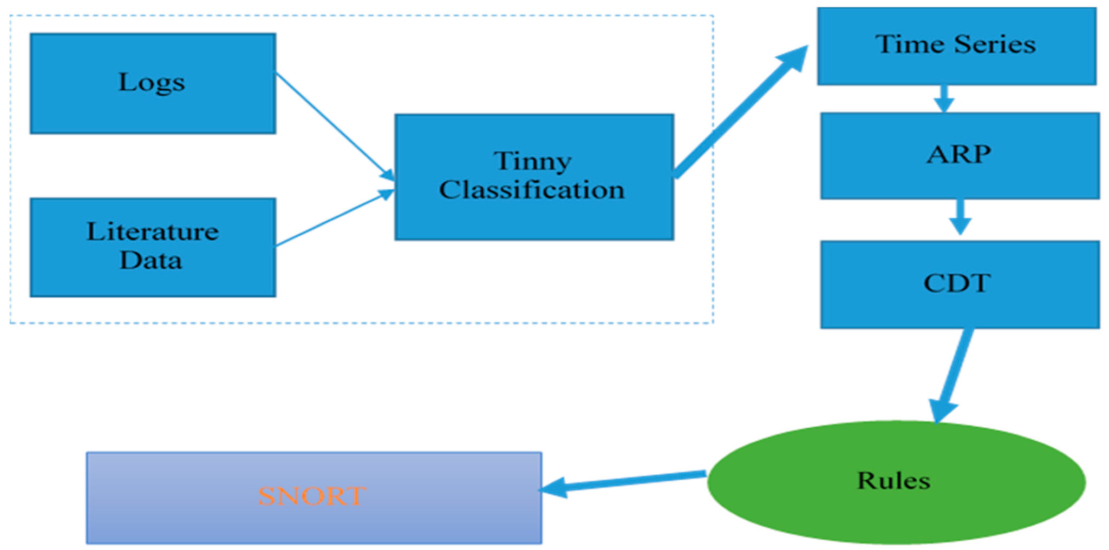
Figure 2.4.1.1: “Machine Learning for APT Detection”
(Source: Caldeira et al. 2026)
Supervised learning is very applicable in scenarios where datasets include labels for both normal and attack traffic that can be trusted. Measures like preciseness, recall, F1 value and Area Under ROC Curve can introduce a consistent metric for the evaluation of the performance of the model. However, supervised models require representative training data, with unseen behaviors possibly not able to be classified accurately.

2.4.2 Unsupervised and Semi-Supervised Learning
The unsupervised and semi-supervised techniques minimize reliance on full labelled attack data. Sorting by similarity can reveal abnormal patterns of communication, and clustering can also reveal anomalies that are not typically found as an observation, whereas isolation forest isolates and marks observations that are not normal data (Trillo et al. 2025). One-Class SVM trains normal activity and Tag icons of anomalies. Autoencoders are capable of learning small representations and detect traffic at a high revival error. These methods apply to APT detection since the new attacks might lack labelled examples. They can be used to discover unknown behaviours because of their flexibility. The anomaly-based techniques can however give a false positive when normal activities are abnormal. Unsupervised methods tend to tackle novelty more effectively, but may be more difficult to tune and interpret, whilst supervised models tend to be more effective at providing higher quality classification in cases where there are good labels available (Alqahtani, 2023). Semi-supervised techniques provide a tradeoff between scarce labelled data and larger volumes of unlabelled traffic.
These are useful if labeled examples are not available, or emerging behaviors are to be explored. In supervised learning, a pattern can be set from traffic data, and are not necessarily labeled as an attack each time. Combining a small labelled training set with a collection may be possible through semi-supervised learning that can potentially give a better practical coverage reduction with annotation demand.

2.4.3 Deep Learning for Network-Based Detection
Deep learning is an extension of ML, where hierarchical representations of high-scale datasets are learned. The convolutional neural networks (CNNs) are able to detect localities within the representations of traffic, whereas the LSTM and the GRU networks generate the sequential data and allow remembering tourist relationships among network events by the time. Autoencoders help in representation learning and finding anomalies, and the hybrid architectures may combine space and time features (Guttikonda, 2025). An LSTM-based model is especially applicable to APTs due to the continuous occurrence of attacks in a sequence as opposed to isolated incidents. However, discriminative deep models are very much trained by using a large amount of training data and computing resources. They can be overfitting in case of limited and/or non-representative datasets, and their internal representations are very complex and thus less interpretative. It means that deep learning may enhance detection abilities, yet poses a strong challenge of explainability, which substantiates the argument in favor of the use of XAI in network security systems.
The complex relationships between network properties can be analysed using deep learning, and could aid in identifying the presence of subtle patterns related to extended attacks. Sequential architectures are particularly important when events happen over the passage of time. However, the need for computational requirements and the complexity and lack of transparency of the models can limit their use in operations, especially as analysts require easy to understand reasoning for decisions about security.

2.4.4 Comparative Evaluation of ML Approaches
APT detection is complementary to ML approaches. Random Forest is a powerful classifier, although it might not generalise well to new behaviours. SVM is a good algorithm in high-dimensional spaces and it is also sensitive towards parameter selection. XGBoost has good prediction capabilities but poor transparency (Ajax, 2026). Autoencoders encourage anomaly detection without a large number of attack examples, but may produce a false positive. LSTM is highly appropriate in capturing temporal behaviour, and appropriate for multi-stage APT activity, but would need more calculational resources.
Approach | Strength | Limitation | APT relevance
Random Forest | Robust | Novelty limitations | High
SVM | High-dimensional data | Parameter sensitivity | Medium–High
XGBoost | Strong prediction | Low transparency | High
Autoencoder | Anomaly detection | False positives | High
LSTM | Temporal modelling | High cost | High
Therefore, predictive accuracy does not give enough information but explainable reasons are necessary to officials of security organizations.
The comparison highlights that both strategies focus on various areas of network security. Tree based models can yield models with high classification results and for the detection of unforeseen behaviour, anomaly detection can be utilized, and for the representation of temporal dependencies, sequence models can be used. Detection performance, required resources, generalisation, false alarms and clear prediction explanation, therefore, should be taken into account on an operational level in evaluation.

2.5 Explainable Artificial Intelligence for Cybersecurity

2.5.1 Concept of Explainable AI
Explainable Artificial Intelligence (XAI) is a concept of explaining all the decisions made by machine learning in a way accessible to humans. This is significant since these complex models may be a black box which gives predicted results without necessarily indicating the way the results have been achieved. When using a model to classify network traffic into something that is malicious in the context of cybersecurity, an analyst must understand what characteristics were used to reach that conclusion (Basnet et al. 2025). The two are model performance and interpretability: a very good model can have limited operational value without being able to examine the result or trust the predictions. XAI can reveal strong features, the decision patterns and prediction reasons and facilitate human supervision. In the detection of APT, explainability is significant as alerts can trigger investigation, containment or escalation. Open-minded thinking can enhance the analyst's confidence and can assist in differentiating threats that are not meaningful and false positives.
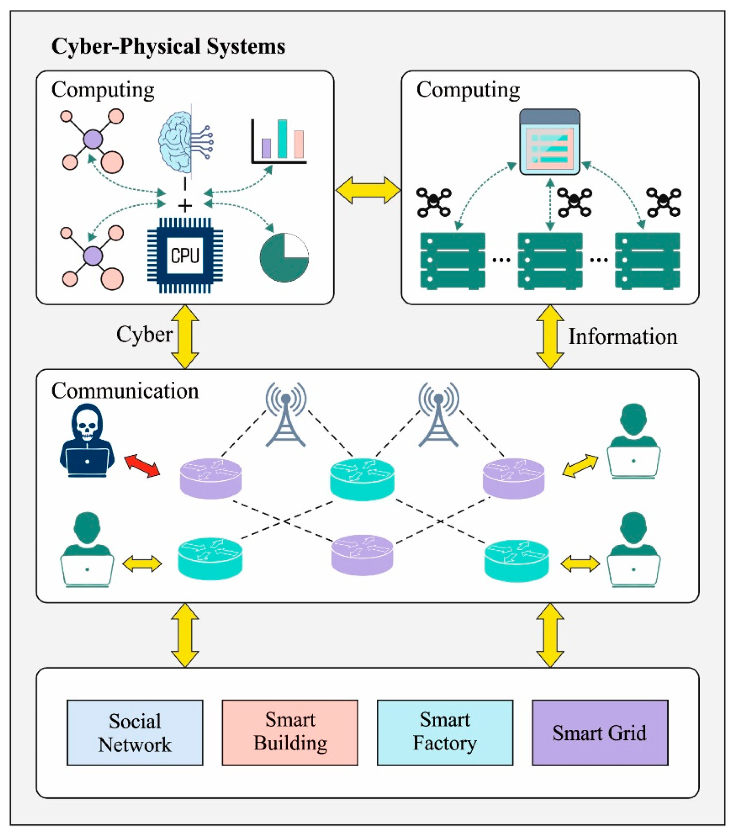
Figure 2.5.1.1: “Explainable Artificial Intelligence Enabled Intrusion Detection Technique for Secure Cyber-Physical Systems”
(Source: Basnet et al. 2025)

2.5.2 XAI Techniques
Network-traffic predictions can be predicted by several XAI methods. SHAP is a method of estimating the value of contribution of features, so that the behaviour of a model can be understood globally and the behaviour of any single prediction explained locally. It is appropriate in the tabular flow data since analysts are able to analyze the effects of features like connection duration, number of packets or destination features on classification. LIME defines individual predictions based on approximating a complicated model locally to a more straightforward interpretable model (Kabir et al. 2026). It is handy in its flexibility, and can be subject to different explanations, depending on the sampling. Importance of features prioritizes the variables based on total impact and is simple to explain, but does not give the reason as to why a specific instance of traffic was labelled as malicious. Partial Dependence techniques show the importance of the predicted values on the values of features, which would be useful in interpreting features relationships. There is no best technique; and choice should depend upon model type, data structure, stability and needs of analysts. In the case of network-flow classification, SHAP would be especially useful as it can generate both per-example alert explanations and high-level understanding of how the model behaves (Samuel, 2026).

2.5.3 XAI in Cybersecurity
Explanation techniques of XAI can enable ML-based cybersecurity alerts to be more action-oriented, by explaining why certain network traffic is considered as malicious. Through explanations, important features that could influence the classification of network traffic as being malicious can be determined, such as abnormal connection rates, flows duration, destinations, or volumes. For example, local explanations can facilitate the investigation of single alerts, whereas global explanations can provide insights into characteristics that recur in detected threats (Rehman et al. 2026). The use of explanations may enable analysts to prioritize their work by differentiating between cases of strong behavioral evidence and weak anomalies. XAI can potentially facilitate incident response through the association of predictions with observable characteristics of the network.

2.5.4 Limitations of XAI
There are some problems with XAI as well. The explanations might not represent the actual decision-making process of the algorithm completely. This raises the problem of fidelity. Sometimes the techniques used increase computation costs, and sometimes the local explanations vary from one run to another. It may happen that although the explanation is technically correct, it may be too hard for humans to understand. Bad explanations could even mislead people.

2.6 Explainable ML Frameworks for APT Detection: Critical Synthesis
From the current literature, it is evident that effective detection of APTs needs to follow a chain approach rather than relying on one method of analysis. Network traffic serves as the first data source that includes flow properties, communication properties and behavior in time (Obioha Val et al. 2025). Feature engineering helps to convert network traffic into features useful for machine learning algorithms. The detection model will classify the traffic as either normal or malicious in nature. After this, XAI can be used to explain the classification. Network Traffic → Feature Engineering → ML Detection → APT Classification → XAI Explanation → Security Analyst Decision.
But current methodologies have their own drawbacks. Supervised learning can provide a great detection capability, but requires representative labeled datasets and can be vulnerable to new attack examples. On the other hand, unsupervised methods provide a greater level of novelty detection but also have some false positives. Deep learning is good for identifying complicated and sequential patterns, but generally requires many resources and cannot provide any intrinsic interpretability (Goodluck, 2026). XAI can overcome this shortcoming by highlighting the influence of certain features and providing explanations for each prediction, but at the cost of computation increase and lack of comprehension of explanations by an analyst.
Another issue to mention is scalability. Methods tested on benchmark datasets may show different behavior in high-throughput operational networks, where various devices generate dynamic traffic (Pokorny, 2026). The same applies to the focus of evaluations that is usually on such measures as accuracy, precision, recall, and F1-score, whereas real-world application requires low levels of false positives, efficiency, and explainable results.
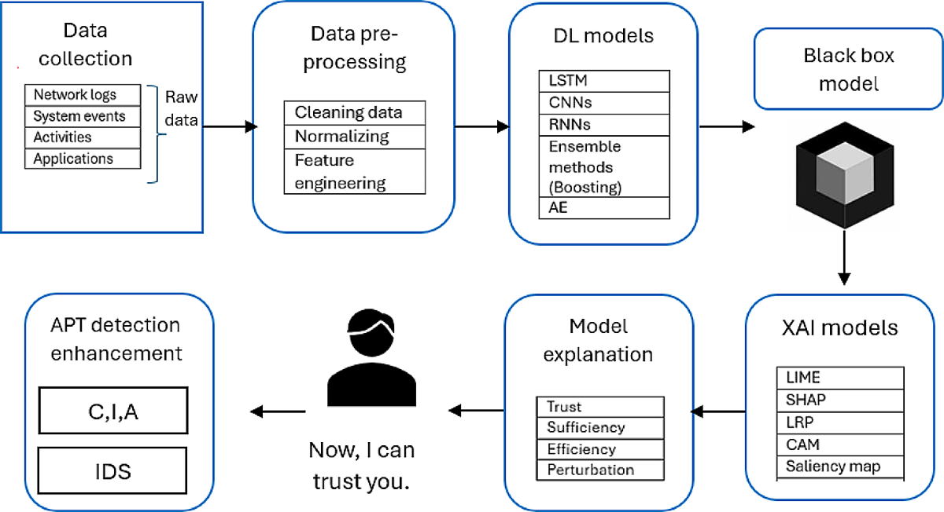
Figure 2.6.1: “Explainable deep learning approach for advanced persistent threats (APTs) detection in cybersecurity”
(Source: Pokorny, 2026)
The key trade-off here is the one between the complexity of the model on one hand, and the transparency of the model on the other hand. A complex model will do a better job in detecting the behavior of APTs, but the simpler models tend to be more transparent in their operation. This means that the literature favors the combination of behavioral network analysis, machine learning classification, and explainable ML.

2.7 Research Gap
Four major gaps come out of the review of the literature. First, there is a gap related to the detection ability. Even though many IDS based on ML show high results in terms of accuracy and other performance indicators while working with the benchmark datasets, they may face difficulties detecting the APT behaviors that were not seen before. The static nature of training data cannot cover continuously evolving attacker tactics.
Second, there is an explainability gap. High-performing machine learning and deep learning models act like black boxes and do not provide sufficient explanations why some network flows are malicious.
The third gap identified is the operational gap associated with focusing on quantitatively measuring performance using metrics such as accuracy, precision, recall, and F1-score. While these metrics are important, they are not enough in evaluating the effectiveness of the explainability in being actionable, alert prioritization, and security investigation (Lu et al. 2025).
Fourthly, there is an integration gap due to the fact that detection, behavioral analysis, and XAI approaches are investigated separately from each other without being integrated into a network traffic-based framework for detecting APTs. Therefore, there is a need for a unified solution that involves effective machine learning-based detection, explainable ML models, and analyst-friendly solutions. This study aims to bridge these gaps by investigating an explainable ML approach for processing network traffic data to detect APT behavior and provide explanations.

2.8 Conceptual Framework for the Proposed Research
The framework proposed has an integrated pipeline of analysis:
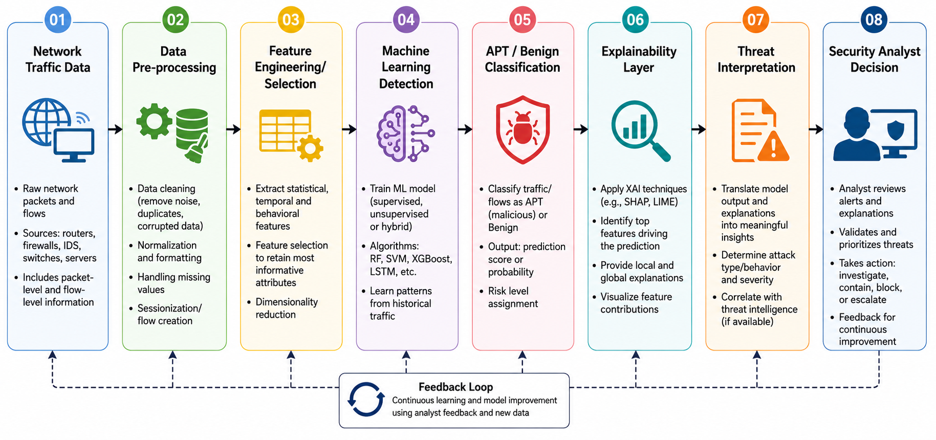
Figure 2.8.1: “Conceptual Framework”
(Source: Self-Developed)
The traffic of the network constitutes the raw data, whereas pre-processing eliminates the inconsistencies and ensures that the data is ready for analysis. The process of feature engineering discovers meaningful features within the network. The machine learning model will detect and classify the abnormal activity. The XAI component, which can make use of approaches like SHAP or LIME, helps understand what causes the predictions made by the machine learning model. Threat interpretation translates the output of the model into useful security information.

2.9 Chapter Summary
The literature reveals that ML could help in improving the APT detection capabilities; however, certain difficulties arise when dealing with new types of attacks, false positive rates, scalability, and explainability issues. XAI is helpful to enhance the explainability and make it easier for analysts to use it. The integration of explainability in APT detection is not common.

Chapter 3: Methodology

3.1 Introduction
This chapter introduces the methodology employed and describes the development of an explainable machine-learning framework for the detection of network traffic-based state-sponsored Advanced Persistent Threats (APTs). The methodology will offer a systematic way to prepare unprocessed network-traffic data into a suitable representation for machine learning analysis and to finally describe the results of the analysis. The study is focused on melding analytics for predictive detection and analytics for explainability, as it is not enough to know that something is malicious; security analysts also need to know why it is malicious. The overall methodology is the same as presented in Chapter 2: Network traffic is prepared, features are developed relevant to this traffic, machine learning models classify network traffic, and XAI techniques explain the predictions of the machine learning models. This is similar to the gap found in the literature focusing on the integration of detection, behavioural analysis and explainability in a single framework.

3.2 Research Design and Approach
The research approach is followed, and the problem is quantitative-based and employs an experimental method and supervised machine learning. A quantitative design is suitable for this study due to the use of measurable variables and statistical measurements for evaluating network traffic throughout the study. The element of the experiment is the creation of several classifiers with identical data sets and conditions, followed by the evaluation of the results obtained. A supervised-learning approach is used to take advantage of the labelled network observations contained in the dataset. The primary classification problem will be to mark normal or passing traffic vs. malicious traffic. This binary formulation directly helps to fulfil another research goal of detecting potentially harmful traffic while keeping original attack-category information for future analysis.
The first step in the process will be examining the dataset to determine the structure of the data, the classes and types of variables. Data quality will then be investigated before numerical and categorical transformation (Shonubi and Adelere, 2025). The original traffic variables will be used to form ‘behavioural’ representations through feature engineering. The feature matrix that will be created will be applied to develop and compare the Logistic Regression, Random Forest, MLP and XGBoost Models. Logistic Regression will serve as a baseline model, and Random Forest and XGBoost will be used to represent tree-based ensemble methods. Another comparison will be done by MLP, using a neural network. Model predictions will be evaluated quantitatively after prediction, followed by SHAP and LIME analyses.

3.3 Dataset Description and Collection
Using the UNSW-NB15, this study will largely rely on the network-traffic data for its study. The dataset consists of normal network activities and synthetic attacks behaviors to be used for network intrusion research. It contains a combination of numerical and categorical network-flow characteristics, so it can be used for supervised categorisation. The provided data consists of a total of 175,341 training data points and 82,332 testing data points, and a total of 36 columns. There are 32 numerical and 4 categorical variables: proto, service, state and attack_cat. The protocol is the communication protocol, service is the network service, state is the state of the connection, and attack category is the type of network activity.
The types of attacks in the research data are Normal, Exploits, Fuzzers, Reconnaissance, DoS, Generic, Backdoor, Analysis, Shellcode and Worms. These categories will be reclassified into a binary class target for the principal detection experiment, with normal observations being benign traffic and attack observations being malicious traffic (Walsh et al. 2024). The dataset includes various protocols and services such as TCP, UDP, ARP and other protocols, and services like HTTP, DNS, SMTP, FTP, SSH, POP3, SSL, DHCP and SNMP. This diversity can be beneficial because it is not always possible to associate malicious behaviour with one protocol/service. Or combinations of particular sets of communication features will have greater potential to indicate abnormal behaviour. Network traffic is especially important for the detection of APTs — these can be identified as suspicious traffic by looking at the flow characteristics, such as duration of the flow, number of packets, number of bytes, protocols and how often they are used. Network-based analysis can additionally aid in the detection of reconnaissance, lateral movement and command and control (CnC).

3.4 Data Pre-processing
The data pre-processing will be done before model development to make sure the records of data in the network are homogeneous and appropriate for the machine-learning algorithms. First, missing values, duplicate records, variable values as numbers, variable types and class labels are covered. The reported summary of data for the supplied data indicates no missing data for either training or testing sets. Infinite numerical values are also checked for and treated in such a way that inappropriate values can not be used in the modelling process. There are two types of variables: numerical and categorical, which need different preprocessing. Numerical variables will continue to be quantitative and will undergo transformation to this type if necessary (Anjum et al. 2022). The categorical variables like proto, etc., service, and state will be translated with one-hot (binary) encoding. Allows to represent each category numerically without man-made ranking among any of the protocols/services and the connection states.
Additionally, if and when appropriate, numerical normalisation will be applied, especially for algorithms that are sensitive to the magnitude of the feature. With the MLP and Logistic Regression models, this can be transferable as features like byte counts and connection durations may be on very different numerical scales. After preprocessing and encoding, the result is a feature set (data structure) in the tree model representation format with 96,822 observations and 198 features, while the 43 numerical features are presented in the feature matrix in the preprocessed feature structure. Class distribution has also been evaluated to eliminate predominance of one class and make it more representative of the classes. These prepared data have 48,894 normal observations, which correspond to 50.5% of the total data; the remaining 47,928 (49.5% of the total data) are attack observations (Ashraf et al. 2026). The imbalance ratio is 1.02, which represents a very close class balance of the classification data.
Moreover, with the preprocessing stage the dataset after transformation will be of the same kind in the training and testing stages to lessen the chances of influence in the classification process, caused by various data representations. Of the biggest importance is the categorical encoding because many machine learning algorithms are unable to understand how a protocol, service or state of connection is defined in plain text. OneHotEncoding transforms such categories into indicators without creating an artificial ordering of the categories. Other data versions besides Logarithmic are used in Logistic Regression and MLP as well since those models could be sensitive to the differences in the numerical value range of data otherwise. The resulting balanced data set is then used to inform the development of appropriate comparative models and subsequent XAI analysis.

3.5 Feature Engineering and Selection
More variables will be designed for the network by feature engineering. Network-flow variables may characterise various aspects of a flow, while their interaction features could be more indicative of suspicious network behaviour. The methodology thus takes into account duration, packets, bytes, timing and communication rates in building up other features. Time, destination bytes, and other variables that are highly skewed will be transformed (logarithmic). The relationship of the source and destination traffic will be represented in terms of ratio-based characteristics such as packet ratio and byte ratio.
Mutual Information (MI) and Random Forest importance will be used for feature selection. The difference between MI and the importance of the features provided by the Random Forest model is that the former is a measure of the relationship between a predictor and the classification target, whereas the latter is a model-dependent measure of the usefulness of features (Rani et al. 2024). The strongest identified features include num_dlload, with MI 0.263404 and Random Forest importance 0.075570; num_tcprtt, with MI 0.314305 and importance 0.072672; num_synack, with MI 0.311897 and importance 0.065018; num_ackdat, with MI 0.308845 and importance 0.062054; and num_packet_ratio, with MI 0.323444 and importance 0.045113. Variables with a high ranking are: num_byte_ratio, num_packets_per_second, num_log_dur, num_rate, num_sinpkt, num_sload, num_log_dbytes, num_dinpkt, num_dmean and num_sjit.
The engineered variables are additional behavioural characteristics which can only be easily obtained from aggregated raw network flow characteristics. For instance, packet/byte ratio expresses the various communication patterns among sources and destination packets, and packets/second and bytes/second give information on traffic intensity. Logarithmic transformations are effective in minimizing the effect of extremely large values on the observation and in making the highly skewed variables in the network appear to be approximately normally distributed. Both the importance from MI and from Random Forest constitute a complementary and different perspective in the identification of variables of interest. The selection process is used to preserve descriptive content and to remove redundant dimensions. The features selected are later used to generate the model input representation for training, a comparison, and explaining the model.

3.6 Machine Learning Model Development
The classification task will be performed using 4 machine learning techniques, namely Logistic Regression, Random Forest, MLP and XGBoost. The model from Logistic Regression will serve as a baseline model for comparison to see if any of the more complicated algorithms show a significant improvement. An ensemble tree-based classifier, Random Forest, will be used. It can simulate non-linear relationships between network-traffic variables and can be used for heterogeneous network-structured data (Henry et al. 2025). XGBoost will then give us a gradient-boosting approach, and MLP will explore the performance of the neural network to learn nonlinear relationships in the prepared feature space. These approaches are chosen based on the literature; in particular, Random Forest and XGBoost are seen as useful approaches for complex network classification, and neural methods can capture more complex patterns.
The models will be successfully trained with the prepared training data, and testing observations will be kept apart for the final evaluation. Normal and malicious traffic will be represented by class labels. Probability scores will also be maintained as these will enable the threshold for classification to be modified in later analysis. The comparative approach is crucial as it is not possible to assume a single algorithm as being optimal in terms of detection and false-positive control and interpretability (Buchta et al. 2024). Comparing the different models allows for more evidence for selecting the right model in the proposed framework.
The four algorithms also include methodological diversity, since they are all different ways to learn relationships in the prepared network-traffic data. Logistic Regression lays a fairly simple benchmark so the performance of more sophisticated models can be evaluated relative to this one. Random Forest can utilize the interaction between several traffic characteristics by the ensemble of decision trees, whereas XGBoost uses sequential boosting to enhance the classification accuracy. The MLP gives a neural network point of view and can model the relationships between the features of the data space that are not linear. The maintenance of probability outputs is a key aspect because the following threshold analysis involves the study of the impact of varying the classification boundary on the detection of malicious traffic, as well as on missed attack and false security alerts.

3.7 Model Evaluation and Explainable AI
The accuracy, precision, recall, F1-score, ROC-AUC and PR-AUC will be used to evaluate model performance, alongside the false-positive rate (FPR). These measures are used in addition to accuracy and are essential as they give a more comprehensive picture than accuracy alone; while intrusion detection must have high recall, it must also minimise false alerts. Recent studies also emphasise the need for a fusion of detection performance and XAI to further promote transparency and analyst confidence. Random Forest achieves 0.812531 accuracy, 0.671328 precision, 0.959588 recall, 0.798993 F1-score, 0.962324 ROC-AUC and 0.946519 PR-AUC. XGBoost records 0.812211 accuracy, 0.671180 precision, 0.958499 recall, 0.798511 F1-score, 0.962298 ROC-AUC and 0.947203 PR-AUC. The accuracy of MLP is 0.779452, and the F1 score is 0.762155, whilst the accuracy and the F1 score of Logistic Regression are the lowest, at 0.740000 and 0.580000 respectively.
Threshold analysis will be employed to strike a balance between detection and false alarms. For XGBoost, a 0.5 threshold produces 0.958499 recall and 0.272762 FPR (Yoon et al. 2025). At 0.7, precision rises to 0.840313, recall becomes 0.860804, and FPR decreases to 0.094938. At 0.8, precision reaches 0.903611, and FPR falls to 0.049826. SHAP will show features that are important for the predictions and understand single predictions; LIME will look at the local prediction behaviour. There are some important SHAP variables, such as num_ackdat, num_synack, num_dinpkt and num_dpkts. A study of false positive/falsenegative predictions will also be done to gain insight into model limitations. Robustness will be assessed using seeds 0, 21 and 42, producing F1-scores of 0.792273, 0.792207 and 0.789511, respectively.
In the evaluation stage the effectiveness of the prediction, in addition to its practical characteristics, is taken into account. High-recall is significant as failures to detect malicious traffic could result in the continued use perhaps of malicious traffic which can be detrimental, whereas false-positive rate can cause an excess of security alerts. This trade-off was clearly visible in the XGBoost threshold analysis, in which a higher threshold led to the decrease of the number of false positive values while concomitantly decreasing the value of the recall. These quantitative measures are followed by an explainability stage that analyzes the rationale given for specific predictions. SHAP provides information on influential features, both in the global sense and in the local sense; LIME does not provide the latter. Reliability testing also investigates how consistently observed performance performs if it is expected to happen across different seeds of a random experiment.

3.8 Ethical Considerations
The study is based on an existing benchmark dataset, with the intensive examination being the characteristics of mobile network traffic but not personally identifying each user. No effort is made to name individual members of the dataset or to name individual organisations. The focus is on the technical performance of explanations for machine-learning models and their model predictions. Ethics are at play when it comes to automated security classification too. False positive and false negative predictions can undermine a model prediction, which does not guarantee that the prediction is accurate (Liya and Lee, 2025). Whilst important factors such as investigations, escalations and containment may be invoked, human decisions are still relevant in the human review process. The outputs that will be produced by XAI will therefore be considered as supporting explanations for attacker behaviour and not as definitive explanations.

3.9 Chapter Summary
In this chapter, the methodology in designing the explainable machine-learning framework has been developed. The methodology for the research will be the UNSW-NB15 dataset and then employ the quantitative and experimental supervised learning approach. Data preprocessing will start by tackling data quality, base categorical encoding, numerical preprocessing and class balance before creating behavioural features. This will involve creating Logistic Regression, Random Forest, MLP and XGBoost and then comparing their performance with respect to various evaluation measures. Threshold analysis will consider the effect of detection ability as a function of false-positive rates, and testing will be done on various seeds to consider model robustness. The explainability layer for the framework will be offered by SHAP and LIME. The obtainable features for any traffic, such as traffic patterns, and their roles in making influence and ways to understand individual misclassification and true classification examples will be explored.

Chapter 4: Results and Discussion

4.1 Introduction
The results achieved after developing and testing the proposed explainable machine-learning-based malicious network traffic detection for Advanced Persistent Threats (APTs) are presented and analysed in this chapter. The analysis processes are described as follows: Data preparation; Feature analysis (Intermediate step); Machine-learning classification; Threshold evaluation (For the equation); Explainable artificial intelligence (XAI); Prediction error & Model robustness (For intermediate results). They report the results obtained in the analyzed network-traffic (NW) dataset, which included a set of normal and malicious observations classified using Logistic Regression, Random Forest, MLP and XGBoost classifiers. A range of the following metrics are used to evaluate the performance of a model: accuracy, precision, recall, F1 score, ROC-AUC, PR-AUC and false-positive rate. The measures offer a complete framework to analyse the performance of all models in detecting malicious traffic and the reduction of false alarms. The chapter also reviews what is most important for making good predictions in the models. Both global and local interpretations of selected models' decisions are given through SHAP and LIME explanations.

4.2 Result Analysis
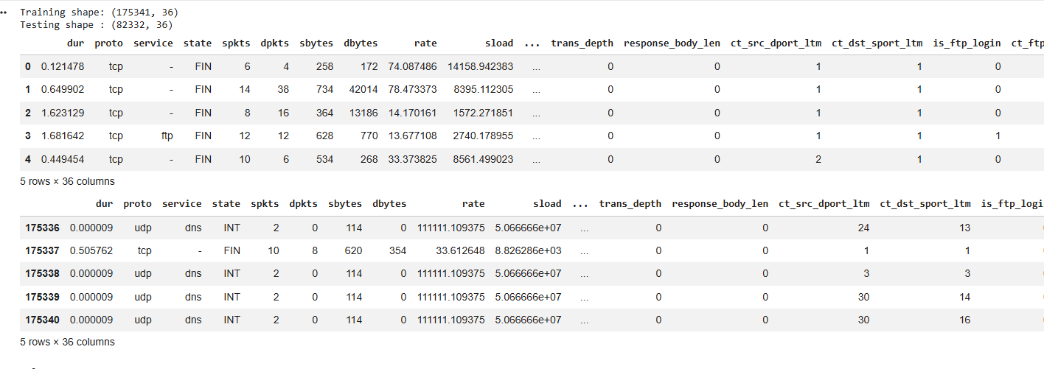

Figure 4.2.1: UNSW-NB15 Training and Testing Dataset Structure and Sample Records
The figure shows a Training dataset with 175,341 rows (plots) and a Testing dataset with 82,332 rows (plots), both with 36 columns (variables). Sample records illustrate various types of network-traffic attributes such as duration, protocol, service, state, number of packets, bytes, rates and connection-related features to be used for further analysis.
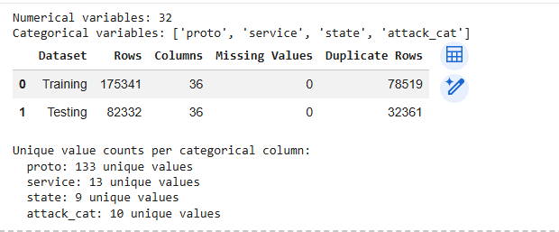

Figure 4.2.2: Summary of Dataset Dimensions, Variable Types, Missing Values and Duplicate Records
The figure shows the characteristics of the data; there are 32 numerical variables and four categorical variables: proto, service, state, and attack_cat. The final datasets for both data types have zero missing values. There are 78,519 duplicate records in the training set, and 32,361 duplicates in the testing set. There are 133, 13, 9 and 10 different categorical values for each of the categories.
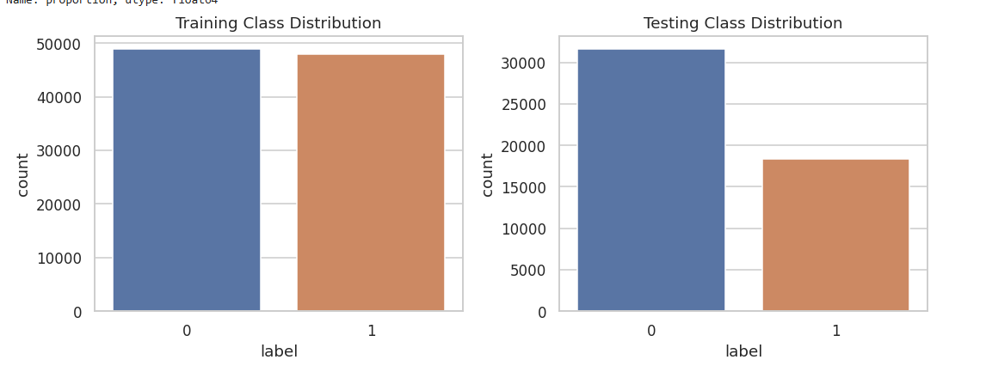

Figure 4.2.3: Binary Class Distribution of Normal and Attack Network Traffic
The figure plots the normal/attack traffic distinction with both binary labels for the training/testing set. Both classes have relatively equal training size, while a higher number of normal observations than attacks are clearly present in the training data (Sanni and Oyetoro, 2026). The training size is roughly equal between both classes, while there is a visible difference in the number of normal observations versus attacks in the testing set.
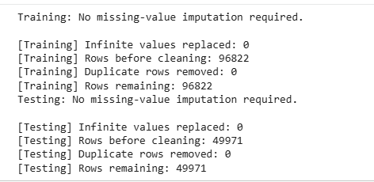

Figure 4.2.4: Data Cleaning and Row Retention Summary for Training and Testing Datasets
The figure shows the results of the data cleaning for both datasets. There have been no missing values and no infinite values in the data, and no imputation has been required. The number of training records after cleaning has been 96,822, and the testing records after cleaning have been 49,971. No duplicate rows have been eliminated in this cleaning step, so the observations that passed the required pre-processing test (s) have been retained.
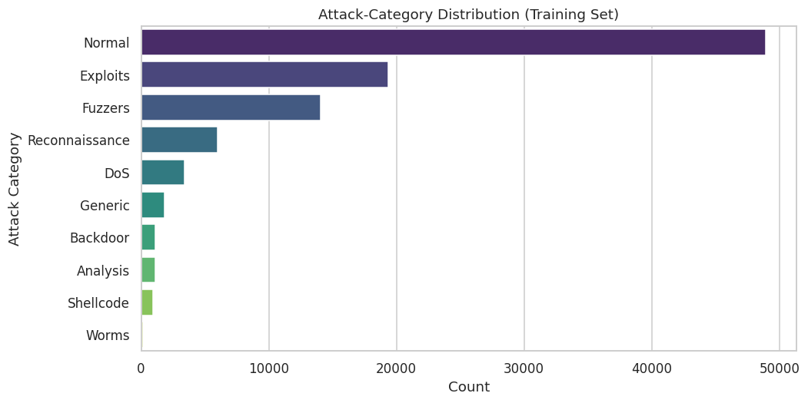

Figure 4.2.5: Distribution of Network Traffic Across Attack Categories in the Training Dataset
The following figure shows the percentage distribution of network traffic per category. The single biggest class of traffic is Normal traffic, followed by Exploits and Fuzzers. The proportion of reconnaissance and DoS is less frequent; Generic, Backdoor, Analysis, Shellcode and Worms are less frequent. The distribution shows significant differences between the different attacks in the training data.
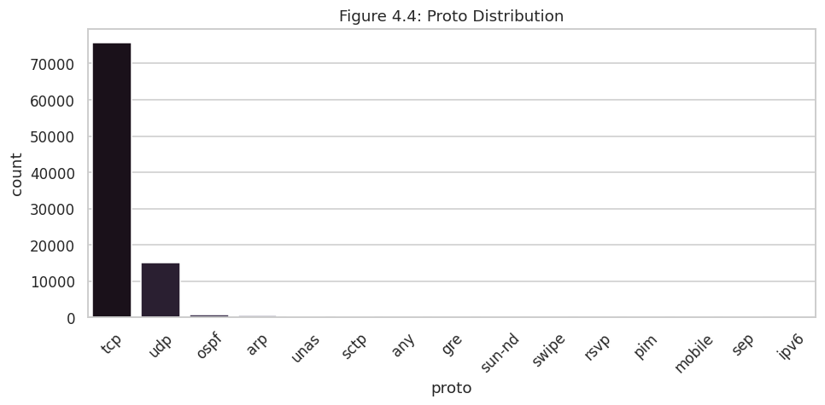

Figure 4.2.6: Protocol Distribution of Network Traffic in the Training Dataset
The figure displays the distribution of different network protocols in the training dataset. In addition, TCP is definitely more prevalent than UDP, and others like OSPF, ARP, SCTP, GRE, and others are fairly occasional (Sarwar et al. 2025). The distribution shows that network traffic is concentrated around certain protocols, with only a minority of protocols being used with much less frequency, thus providing information about behaviour for the classification.
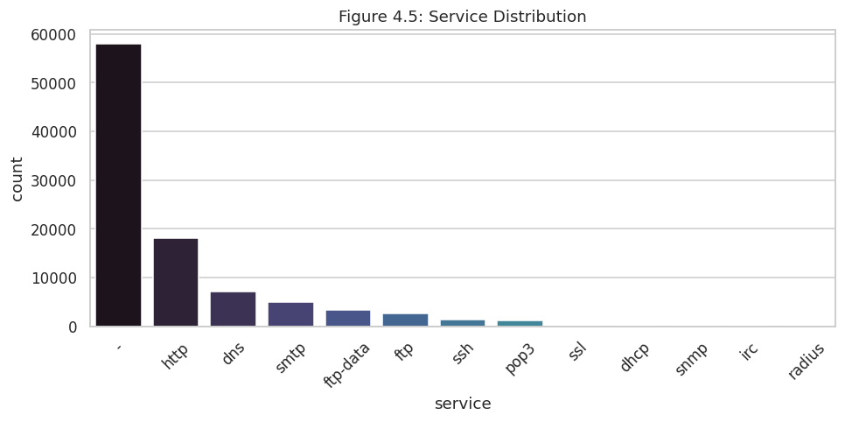

Figure 4.2.7: Service Distribution of Network Traffic in the Training Dataset
As indicated in the figure, the majority of traffic in the training set in this case comes with an unknown service category, followed by HTTP and DNS traffic. Other protocols like SMTP, FTP, SSH, POP3 and SSL are less common, and DHCP, SNMP, IRC, Radius use negligible numbers. This shows that there is a high degree of service spatial variation.
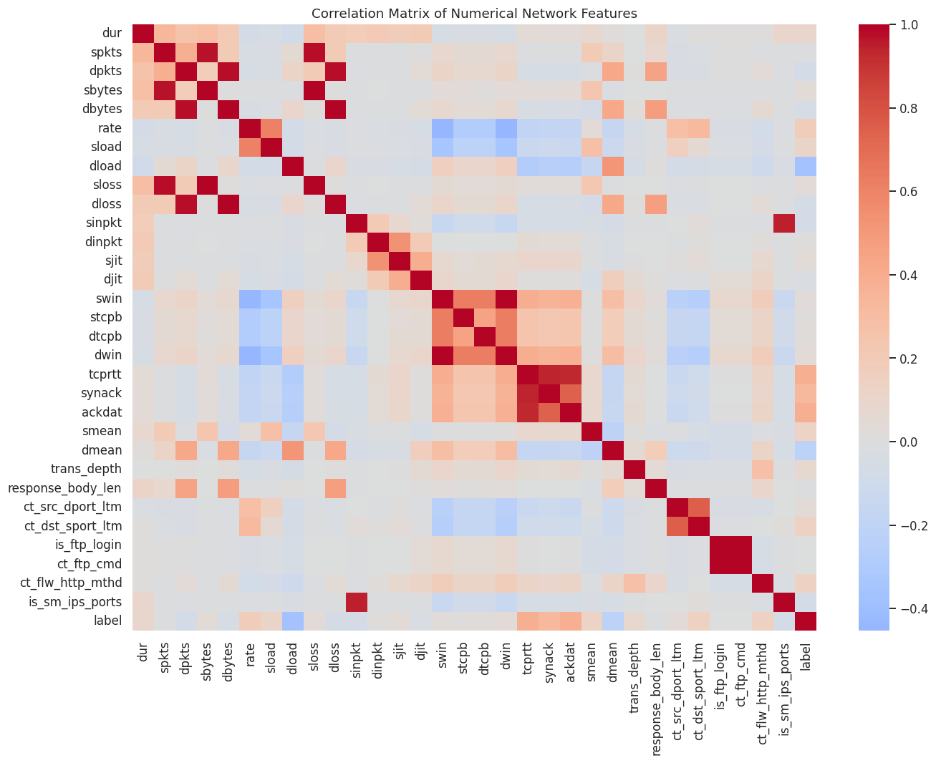

Figure 4.2.8: Correlation Matrix of Numerical Network-Traffic Features
The correlation matrix shows how these numeric features for network traffic are related to each other. Several of the packet-, byte-, and duration-related features have strong positive relationships, and some have negative relationships. The matrix assists in feature dependency detection, feature engineering, and selection prior to developing the machine-learning models.
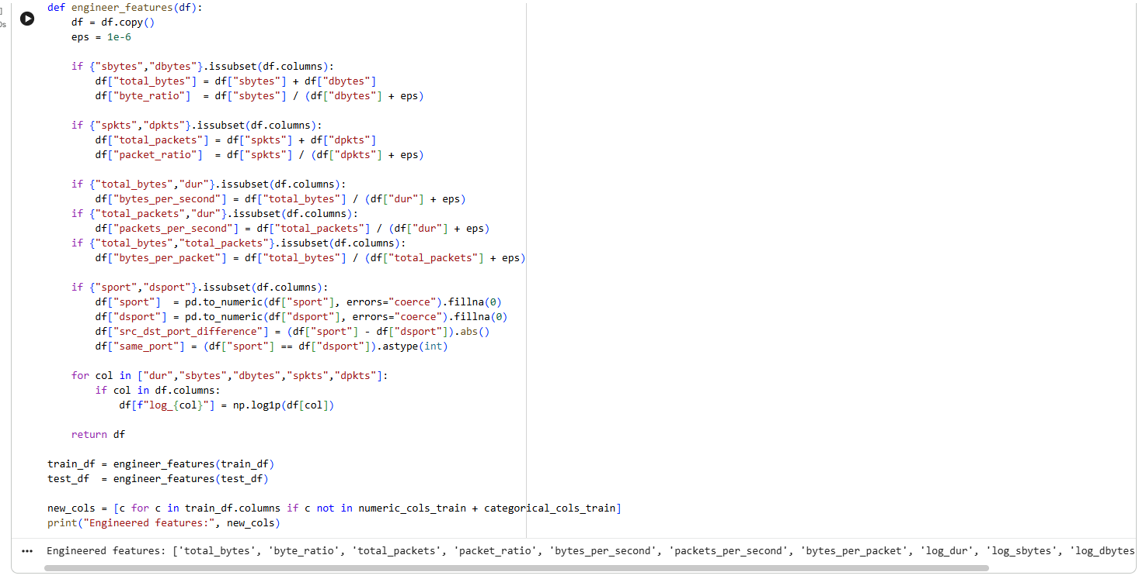

Figure 4.2.9: Engineered Network-Traffic Features for Malicious Behaviour Detection
This figure shows engineered network-traffic features derived from the original set of data. They include byte ratios, packet ratios, packets per second, bytes per second, bytes per packet and logarithmic transformations. These computed metrics are better at characterising traffic behavior and offer some extra value in identifying legitimate and illegitimate traffic.
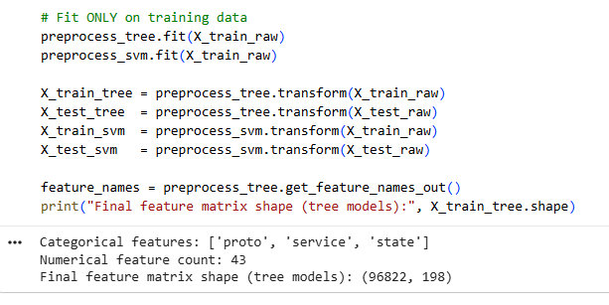

Figure 4.2.10: Preprocessed Feature Matrix After Numerical Scaling and Categorical Encoding
The last feature matrix that has been obtained after preprocessing. As a result, there have been three categorical variables that have been encoded—protocol, service and state—and 43 numerical features have been retained (Zubair et al. 2023). Categorical encoding has resulted in a tree-model matrix with 198 features in 96,822 observations.
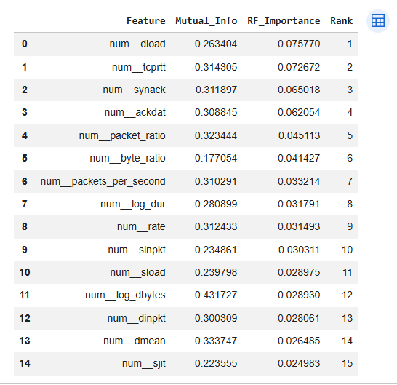

Figure 4.2.11: Top 15 Network-Traffic Features Ranked by Mutual Information and Random Forest Importance
The figure shows ratings of the 15 most important network-traffic features based on the two methods, mutual information and Random Forest importance. There is a strong emphasis on marked features such as load, TCP time, SYN-ACK and ACK data, packet ratio and byte ratio. These variables are extremely helpful to look for patterns when dealing with malicious network traffic.
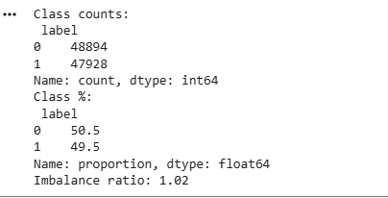

Figure 4.2.12: Class Balance of Normal and Attack Network Traffic After Data Preparation
The figure shows that the prepared dataset is quite balanced between the two classes. Normal traffic = 50.5% Attack traffic = 49.5%. The unbalance ratio is only 1.02, and a large unbalance ratio would affect the binary classification results more because of significant class imbalance.
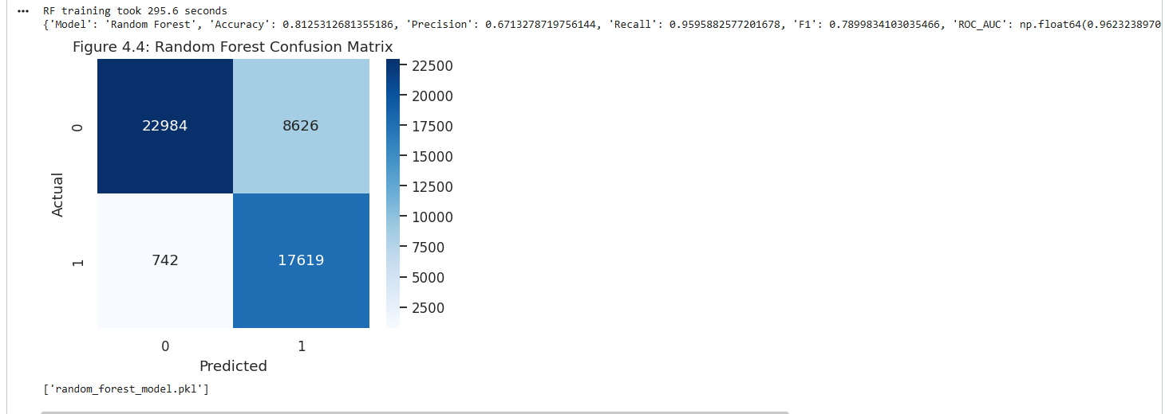

Figure 4.2.13: Random Forest Confusion Matrix for Network Traffic Classification
The Random Forest confusion matrix shows 22,984 correctly classified normal instances and 17,619 correctly classified attacks. 8626 false positives, 742 false negatives. The model is therefore able to correctly classify the majority of malicious traffic, while misclassifying some of the legitimate traffic as malicious.
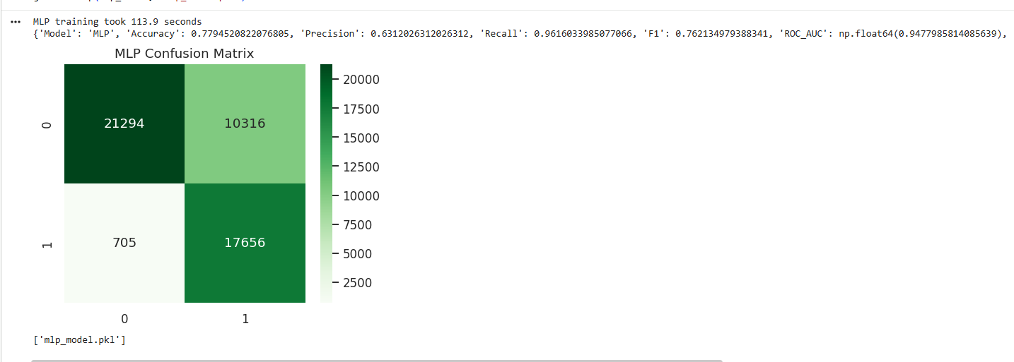

Figure 4.2.14: MLP Confusion Matrix for Network Traffic Classification
The results of the confusion matrix for the MLP are 17656 attacks correctly classified and 21294 normal observations correctly classified. It results in 10,316 false positives and 705 false negatives. The outcomes show extremely high levels of malicious-traffic recall, yet with the magnitude of false positives, the overall level of classification precision is diminished.
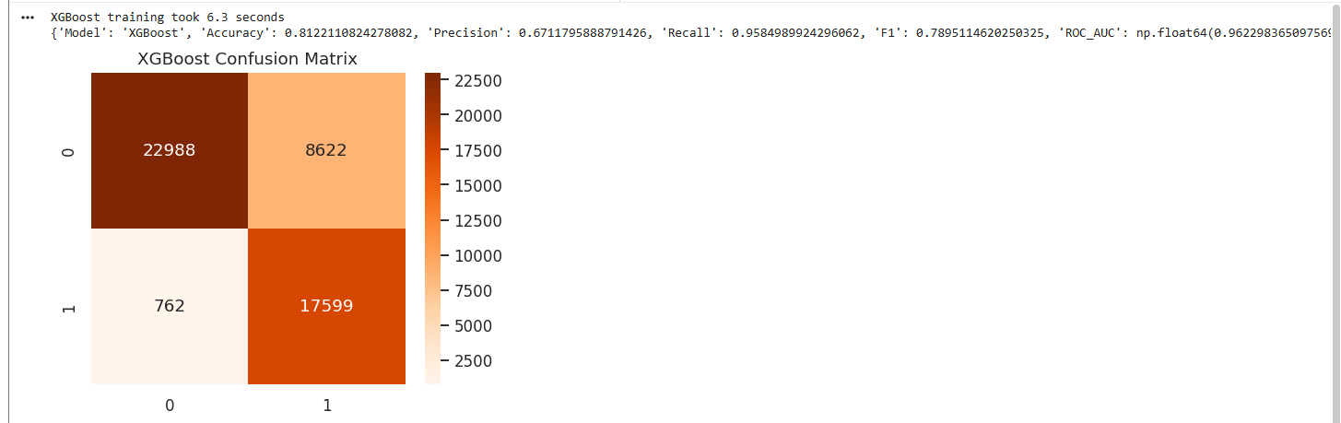

Figure 4.2.15: XGBoost Confusion Matrix for Network Traffic Classification
The XGBoost confusion matrix indicates that 22988 are correct normal and 17599 are correct attacks. Number of False Positives: 8,622, False Negatives: 762. Overall, good performance of XGBoost over malicious-traffic detection with relatively high low false positives compared to MLP.
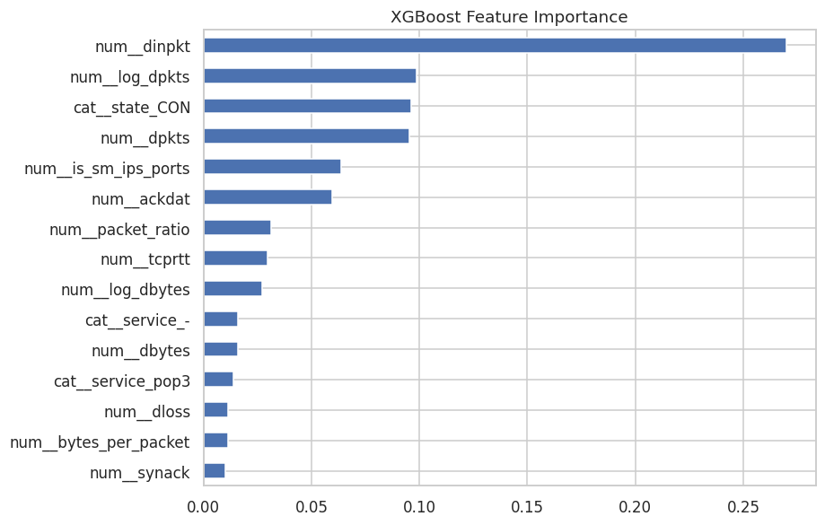

Figure 4.2.16: XGBoost Feature Importance for Malicious Network Traffic Detection
The figure identifies the features contributing most strongly to XGBoost classification. num_dinpkt has the highest importance, followed by num_log_dpkts, categorical state, destination packets and Internet service-port features (Brandão and Silva, 2025). The results show that unwanted traffic detection is significantly influenced by the behaviour of these packets and characteristics of the connections between them.
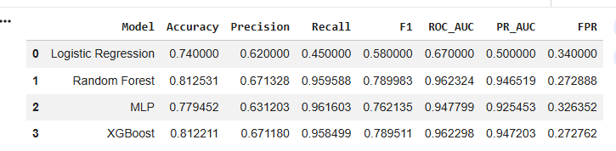

Figure 4.2.17: Comparative Performance Metrics of Machine-Learning Models
The following table shows how Logistic Regression, Random Forest, MLP, and XGBoost differ in terms of accuracy, precision, recall, F1 score, ROC AUC, PR AUC, and false positive rate. XGBoost is, by far, the most accurate model and the latter model, Random Forest, has a higher F1 measure. For MLP, recall is very high, with a higher number of possible “false positives”.
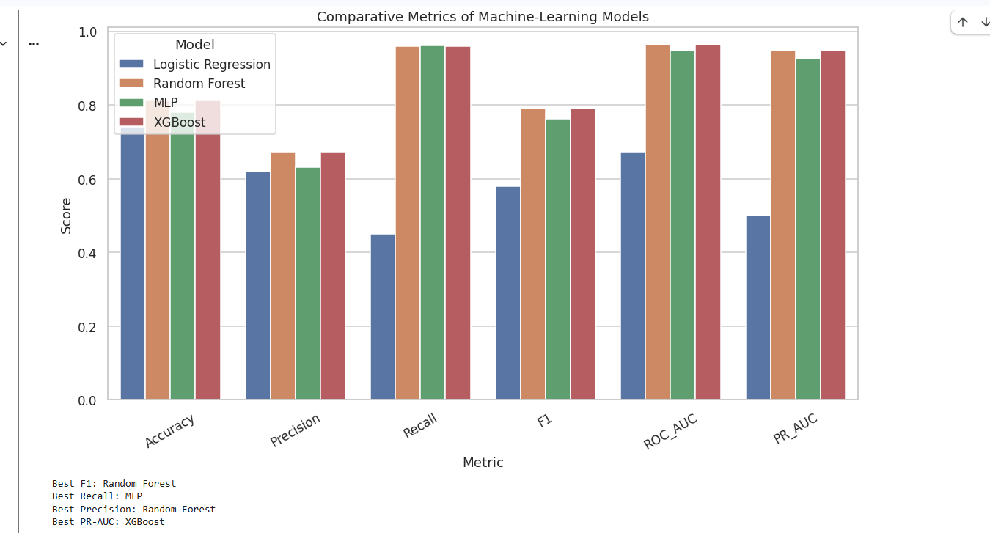

Figure 4.2.18: Comparative Performance of Machine-Learning Models Across Evaluation Metrics
The six performance measures are presented graphically for the models. In comparison with the other three methods, Logistic Regression is always at the bottom, whereas Random Forest, MLP and XGBoost get better results. Random Forest performs the best score on F1, MLP performs well on recall, while XGBoost does well overall.
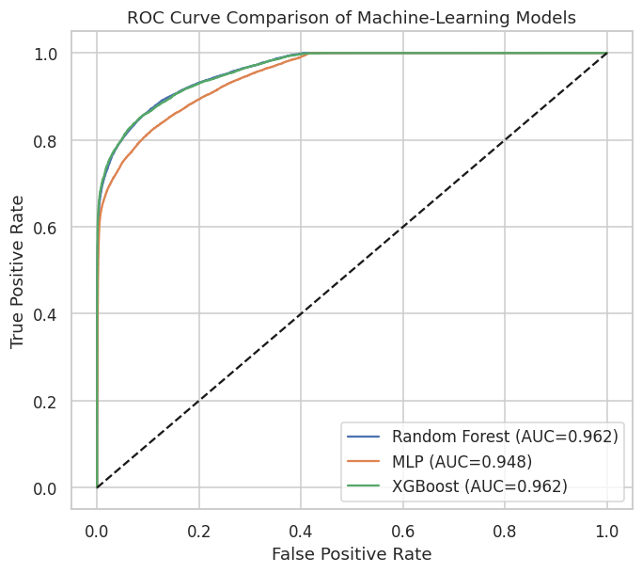

Figure 4.2.19: ROC Curve Comparison of Machine-Learning Models
The ROC curves demonstrate strong discrimination between normal and malicious traffic for all three advanced models. Random Forest model reaches the ROC-AUC of nearly 0.962 while MLP model reaches the ROC-AUC of 0.948. The curves stay significantly further away from the diagonal line, demonstrating successful classification performance.
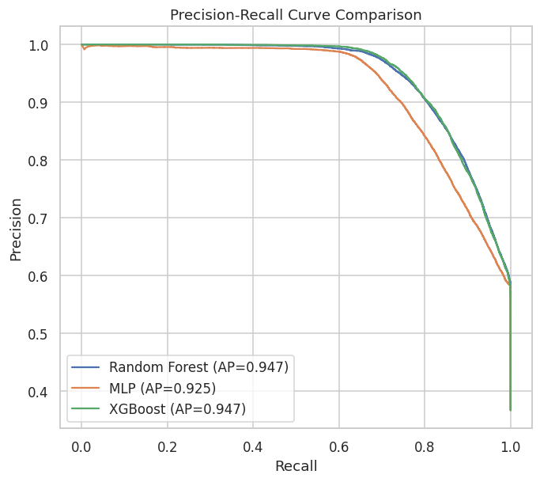

Figure 4.2.20: Precision-Recall Curve Comparison of Machine-Learning Models
The precision-recall curves reveal good performance in a wide range of recall levels. Random Forest and XGBoost achieve average precision of ~0.947, MLP achieve 0.925. The findings show RANDOMFOREST and XGBoost are more effective at detecting malicious network traffic in terms of precision-recall.
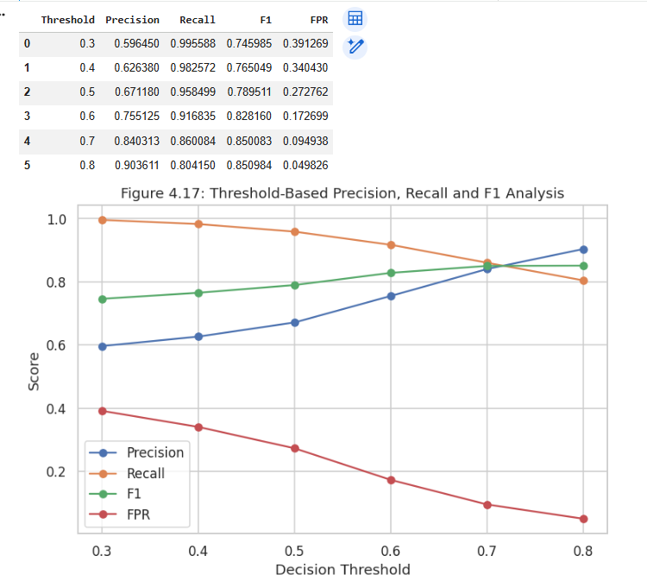

Figure 4.2.21: Threshold-Based Precision, Recall, F1-Score and False Positive Rate Analysis
This web page displays the results of a decision threshold sensitivity test of the model. The higher the threshold, the more precise it is, and the lower the number of false positives; however, less have been returned (Mohamed, 2025). The values of F1-score are near to 0.8, indicating a balance between the identification of attacks and the number of misalarms.
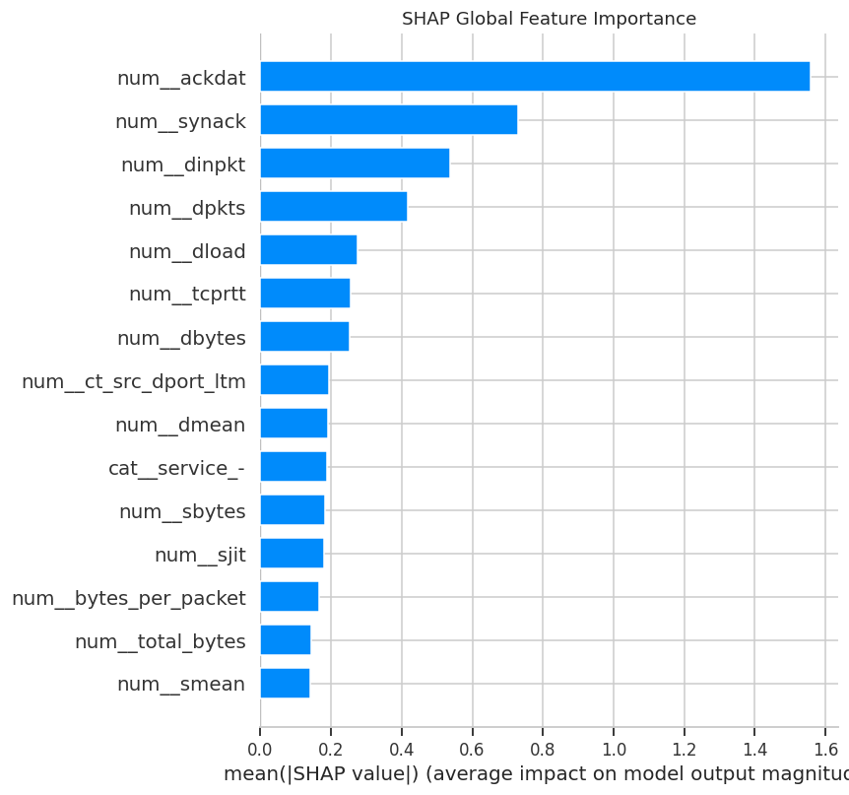

Figure 4.2.22: SHAP Global Feature Importance for Explainable Network-Traffic Classification
The most influential factors in the model are indicated by the average values of the SHAP results: num_ackdat is the most influential feature, followed by num_synack and num_dinpkt. The results suggest that Network traffic type classification depends heavily on the network traffic characteristics such as acknowledgement, packet characteristics and connection characteristics.
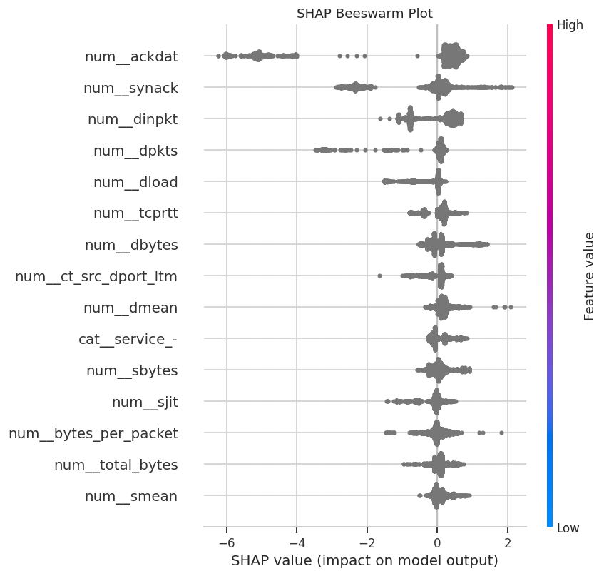

Figure 4.2.23: SHAP Beeswarm Plot Showing Feature Contributions to Model Predictions
The beeswarm graph displays the range of model predictions over observations as a function of the individual feature values. Large differences in SHAP value are observed for the features: num_ackdat, num_synack, num_dpnkts. Some and num_dpkts. Some of the features (num_ackdat, num_synack, num_dinpkt, num_dpkts) have large variations in the SHAP values. This shows that the values of these can have a large influence on the direction of prediction offered by the model.
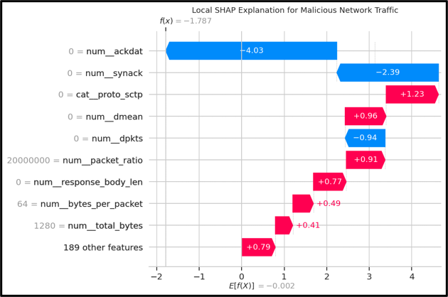

Figure 4.2.24: Local SHAP Explanation for a Malicious Network-Traffic Prediction
The factors that are contributing to one prediction of the malicious behavior are highlighted in the local SHAP explanation: num_ackdat, num_synack provide negative contribution; protocol, mean-duration and packet-ratio provide positive contribution (Williams and Bannett, 2024). The composite feature set pushes the prediction away from the correct class towards the malicious one. The joint feature effects help to push the prediction away from the correct class towards the malicious one.
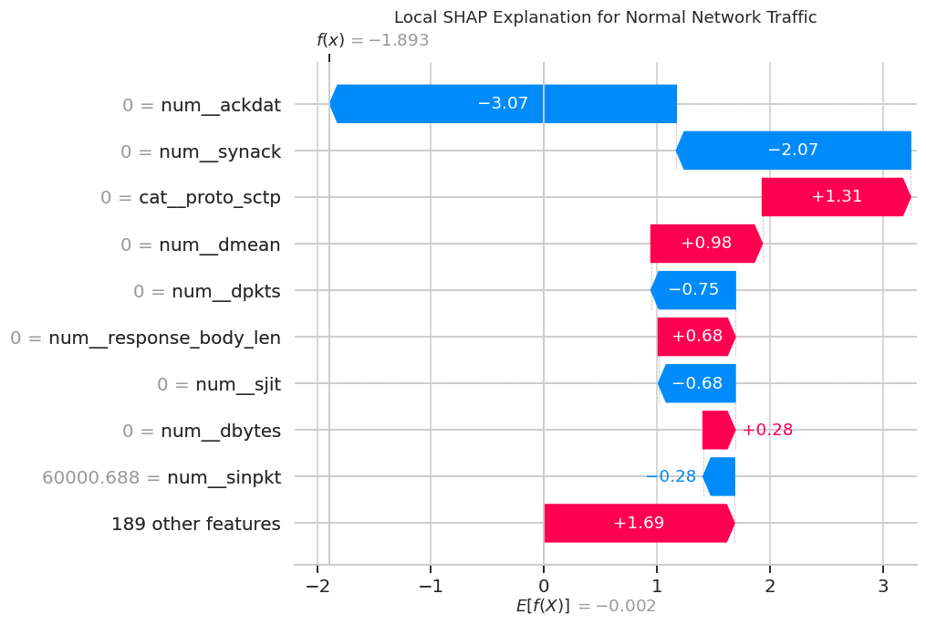

Figure 4.2.25: Local SHAP Explanation for a Normal Network-Traffic Prediction
All features with very significant negative contributions for the correctly classified normal traffic instance are num_ackdat, num_synack, and all features related to protocol and duration are significant positive contributions. Overall, the combined effects show how individual features affect classification and result in the final output for the model.
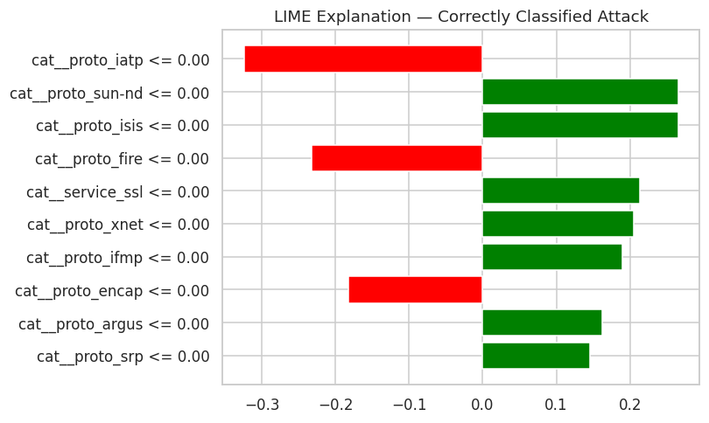

Figure 4.2.26: LIME Explanation for a Correctly Classified Malicious Network-Traffic Instance
The LIME explanation focuses on attributes of the protocol that depend on a correctly classified malicious sample and are categorical. There are a number of conditions in the protocol that make a positive contribution to the prediction, and some make a negative contribution. This illustrates the local interpretation of the model's decision in the case of one observation in the network traffic.
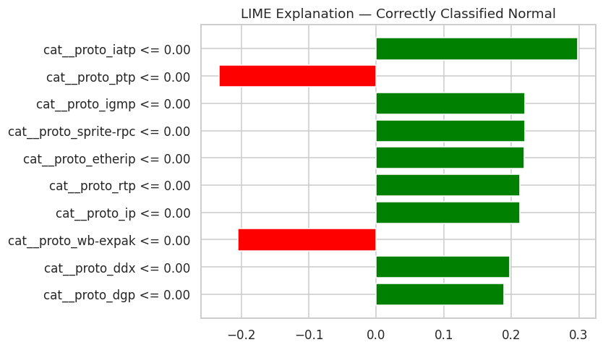

Figure 4.2.27: LIME Explanation for a Correctly Classified Normal Network-Traffic Instance
The LIME explanation displays all the categorical features that affect a correctly classified normal instance. There are a couple of categories of protocol that have positive contributions for the prediction, and cat__proto_ptp and cat__proto_wb-expak have negative contributions for the prediction. This is a representation of the local rationale for the model's classification as ‘Normal Traffic'.
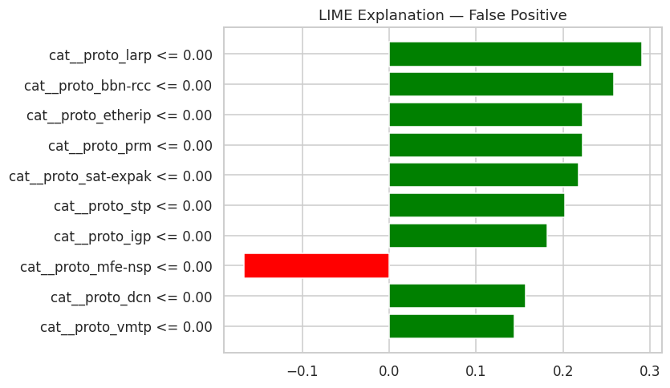

Figure 4.2.28: LIME Explanation for a False-Positive Network-Traffic Prediction
In the figure, normal traffic got mistakenly classified as malicious traffic, resulting in a false-positive prediction (Haghighi, 2026). There are some protocol and service features that have positive contributions for the prediction, and the cat__proto_mfe-nsp feature has a negative contribution. This is an example of how certain characteristics of the network might generate false security alerts.
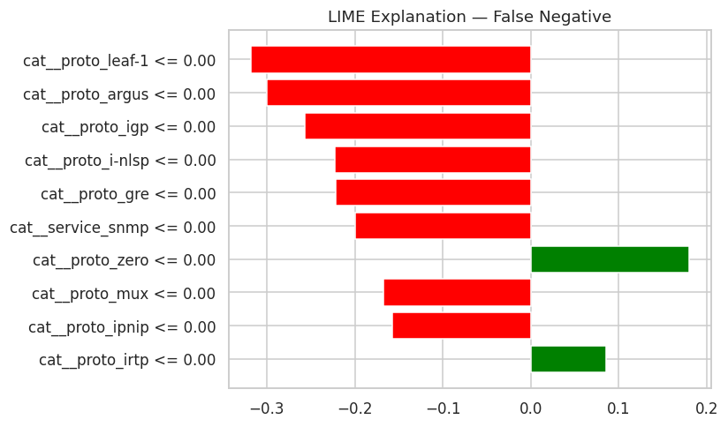

Figure 4.2.29: LIME Explanation for a False-Negative Network-Traffic Prediction
The figure refers to a false-negative situation, in which the malware has been labelled as usual traffic. There are some protocol and service characteristics that negatively impact upon the prediction, and just a handful of characteristics that positively influence it. This illustrates the difficulty in differentiating some of the malicious traffic from the legitimate use of a network.
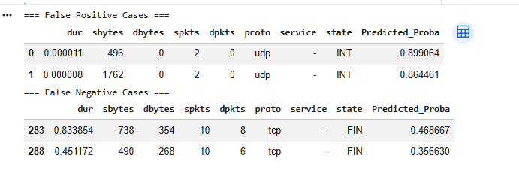

Figure 4.2.30: Representative False-Positive and False-Negative Network-Traffic Cases
The figure provides representative examples of incorrect classifications. In false-positives the UDP traffic has high UDP attack probability and false negatives are the cases of TCP traffic with low predicted UDP attack probability. The examples show classification errors caused by certain traffic characteristics.
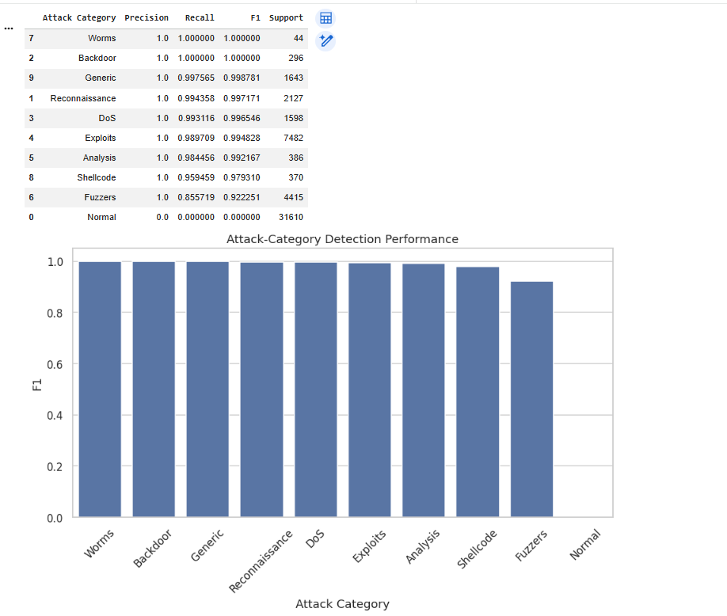

Figure 4.2.31: Attack-Category Detection Performance Based on F1-Score
The figure illustrates the comparison of F1 scores for different attack categories. Worms, Backdoor, Generic, Reconnaissance and DoS rank at very high performance and Exploits, Analysis, Shellcode and Fuzzers are also in the strong performance. The Normal category has 0 F1 because it is not considered as an Attack Category.
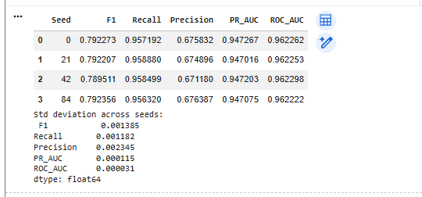

Figure 4.2.32: Model Robustness Across Different Random Seeds
This figure compares an eight model that has been evaluated with 4 random seeds. The F1 scores are within range roughly 0.789-0.793 and the ROC-AUC scores are around 0.962 (Tian et al. 2025). Small standard deviations suggest model performance has not been significantly different for different random seeds.

4.3 Key Findings
The outcomes show that the proposed explainable machine-learning structure succeeded in classifying malicious network traffic patterns and interpreting the information that it produces from binary classification. The results specifically answer the research question that targeted an explanation-based machine learning for modeling malicious activity of state sponsored Advanced Persistent Threats (APTs). A network-traffic analysis, comparative machine learning classification and model effectiveness and SHAP/LIME-based explainability are done to address the four research objectives. The UNSW-NB15 dataset was used, and the original network-flow variables were converted to a 'prepared' feature matrix consisting of 96,822 observations and 198 features, both classes (the normal network flow and attack) being nearly equal in size (50.5% and 49.5%, respectively).
Table 4.3.1: Key Findings in Relation to Research Objectives
Research objective | Key finding | Evidence from results
RO1: To study network traffic characteristics of malicious activities related to APTs originating from state actors | Packet, acknowledgement, connection and traffic-ratio characteristics were particularly informative for distinguishing malicious behaviour. | SHAP identified num_ackdat, num_synack and num_dinpkt as highly influential features.
RO2: To study how to classify normal and malicious network traffic using machine learning | All four models were capable of binary classification, but performance varied considerably between algorithms. | RF and XGBoost produced accuracy of approximately 81.2%, while MLP achieved 77.95% and Logistic Regression 74.00%.
RO3: To assess the effectiveness of machine-learning methods to detect APTs using network traffic | The ensemble models provided the strongest combination of classification performance and discrimination. | RF achieved 0.812531 accuracy, 0.798993 F1 and 0.962324 ROC-AUC; XGBoost achieved 0.812211 accuracy, 0.798511 F1 and 0.962298 ROC-AUC.
RO4: To explore the ability of SHAP and LIME to explain machine-learning predictions | SHAP provided global and local explanations, while LIME illustrated the contribution of categorical traffic characteristics to individual decisions. | Explanations were produced for correct malicious/normal classifications as well as false-positive and false-negative cases.
Another result relates to a trade-off function between detection and false alarms. Through a threshold analysis using the XGBoost model, the new threshold is determined to be 0.8, where the precision increases from 0.671 to 0.904 along with a reduction in its FPR from approximately 0.273 to 0.050 whereas its recall value decreases from 0.958 to 0.861. This shows that performance of the model could not be judged solely based on the accuracy. The robustness analysis also revealed relatively consistent F1 values (~0.790 to 0.792) for various random seed numbers. In general, the results are aligned with the core assumption of the framework of detecting and explaining work side by side, rather than a distinction between classification as one operation and others as the other.

4.4 Discussion
The results contribute to the research goal of creating a transparent machine-learning process for detecting malicious network-traffic generated by state-sponsored APTs and contain empirical evidence. These results show that network-flow information can be useful for recognition of normal and malicious traffic in a behavioural manner. The feature analysis highlighted certain characteristics of packets, acknowledgements and connections of interest with a specific reference to the first research objective. Based on SHAP results, it can be seen that num_ackdat, num_synack and num_dinpkt are among the top features which means that the model's decisions were not largely based on a typical attack signature but were communication-oriented.
The second and third objectives are addressed with the comparative modelling results. When it comes to accuracy, the best that Random Forest produced is 81.253%, and the best it produced for F1 score is 79.899%. XGBoost produced a very close result to that of Random Forest in terms of accuracy (81.221%) and F1 score (79.851%). For both models, there was a strong separation between the classes (normal and malicious) in the tested dataset with ROC-AUC of around 0.962. Despite having a high recall the accuracy and F1-score of Logistic Regression remained the lowest amongst the two ensemble models and MLP.
Table 4.4.1: Discussion of Results Against Research Questions
Research question | Result | Discussion
RQ1: What network-traffic characteristics denote state-sponsored APT-related malfunctions? | Packet and connection-related variables were highly influential. | The results suggest that behavioural traffic characteristics can provide useful indicators of malicious activity.
RQ2: How effectively can ML models distinguish normal and malicious traffic? | RF and XGBoost achieved approximately 81.2% accuracy and 0.80 F1. | ML successfully differentiated the two classes, although false positives remained significant.
RQ3: What is the best machine-learning method to use when detecting APTs through network traffic? | RF and XGBoost produced closely comparable results. | The results do not indicate that performance should be judged using one metric alone; accuracy, F1, ROC-AUC, recall and FPR provide complementary evidence.
RQ4: How can SHAP and LIME improve explainability? | Both methods explained individual predictions and influential traffic characteristics. | XAI adds an interpretive layer to classification, supporting investigation of correct and incorrect predictions.
The threshold operation results further illustrate the inherent role of tradeoff between detection and false alarms in the operation. At a 0.5 XGBoost threshold, recall was 0.958499 but FPR was 0.272762. At 0.8, precision increased to 0.903611 and FPR decreased to 0.049826, while recall decreased to 0.860804. Selection of the threshold should be based on operational needs of the detection environment but not necessarily based on maximising the single metric.
The overview of the empirical results includes the COSMOS analyses SHAP, LIME and EXCEL. Combining SHAP with LIME, SHAP was used to provide importance of individual features world-wide across the dataset, and LIME was adapted to discuss individual features in categorical protocol and service characteristics affecting specific predictions. Importantly, the explanations were also given for false-positive and false-negative cases, demonstrating that XAI can be used to comprehend the reasons behind an alert being triggered by seemingly legitimate traffic and how certain malicious traffic bypasses the detection system. In this way, the results validate the integration proposed in the dissertation: Network traffic → Feature Engineering → ML detection → APT classification → XAI explanation.

4.5 Summary
This chapter introduced and discussed the results obtained from the suggested explainable machine-learning framework for the detection of APT malicious network traffic. The findings revealed that network-flow features, such as packet, ACK and connection-related features, played an important role in the decision of classification. Both Random Forest and XGBoost achieved similar results with a comparably high accuracy of ~ 81.2% and F1 score of ~ 0.80 and ROC-AUC score of ~ 0.962. Threshold analysis showed that there was an interesting trade-off between the recall and the precision in addition to the false-positive rate. The SHAP and LIME analyses also showed that machine-learning-based predictions potentially could be complemented by global and local explanations, including explanations of the wrong predictions. Lastly, robustness tests showed that the results were reasonably consistent with respect to the random seeds. On the basis of the above study results, the research objectives were met collectively, where malicious traffic detection, comparative machine-learning evaluation and explainability was combined in a single framework.

Chapter 5: Conclusion and Recommendations

5.1 Conclusion
The dissertation delved into the construction, assessment, and application of an explainable machine learning paradigm for the identification of Advanced Persistent Threats (APTs) related malicious network traffic. The study focused on the problem of distinguishing advanced threats, which can mimic the behaviour of networks and therefore make use of conventional detection strategies difficult. The researchers utilized the UNSW-NB15 dataset to compile the network-traffic data, create behavioural features and evaluate four machine-learning models before using Shapley and LIME to offer explanations for predictions. It has been found that the overall classification performance of the working models is highest for Random Forest and XGBoost. Random Forest achieved an accuracy of 0.812531 and an F1-score of 0.798993, while XGBoost achieved an accuracy of 0.812211 and an F1-score of 0.798511. The two models both produced an ROC-AUC of ~0.962. The results also indicated that classification has been greatly affected by the attributes of packets, acknowledgements and connections. The study shows that, overall, explainability support, when coupled with machine-learning detection, is useful for malicious network behavior identification and can give analysts some information regarding model decisions.

5.2 Summary of Achievements
The research accomplished a few important items. The first has been a systematic preparation of the UNSW-NB15 dataset, which involved data-quality assessment and data preprocessing, categorical encoding, and feature engineering. Several new behavioural metrics have been designed to better describe the behaviour of networks, such as packet ratio, bytes ratio, packets per second, bytes per second, and bytes per packet or even a logarithmic representation. Second, Logistic Regression, Random Forest, MLP and XGBoost have been trained and tested with the following parameters: accuracy, precision, Recall, F1-Score, ROC-AUC, PR-AUC and false-positive rate. Overall, Random Forest outperformed all other models by a large margin, and XGBoost exhibited very competitive performance on the F1 score. Thirdly, SHAP and LIME have been able to offer global and local explanations, including detailed explanations of the true and false predictions. SHAP highlighted salient features of the network, including (not exhaustively) ack and packet. Last but not least, there has been relative stability in the performance of the models when they have been tested for robustness with various random seeds. The overall results give a comprehensive set of data for the proposed approach and assessment.

5.3 Research Recommendation
Following the findings, some recommendations can be made regarding the development and implementation of machine-learning cybersecurity detection systems. One way forward is pairing explainability with predictive machine learning (PML) in organisations. SHAP and LIME can also be used to give supporting information about the characteristics of the network that lead to a certain prediction so that it can aid in the human review. First, the study shows that the features num_ackdat, num_synack and num_dinpkt can significantly affect the classification. Secondly, other performance measures should also be taken into account for modelling, other than accuracy (Kolhar, 2027). In cybersecurity, the false positive rate and the F1 score are notable in particular, as these metrics can cause problems in the operation due to a false alarm or by missing the traffic of the attacker. Threshold analysis shows that shifts in the decision threshold result in consequential changes in the detection/false alarm trade-off. For instance, the false positive rate follows a decreasing trend, and the precision rate follows an increasing trend as the threshold for XGBoost is increased, while the recall decreases.
Third, supervision should be a key element in the detection process. Some network behaviours are still likely to be misclassified, even in the study, due to false-positive and false-negative cases. XAI explanations should therefore be understood and presented as evidence of attackers' behaviour, not as final explanations. Analysts need to take the interpretation into account with all SIRs and make decisions regarding investigation, escalation, and containment. Next, organisations should routinely test the performance of their models, as network configurations and attack patterns shift. Training on a set of benchmark data is not enough to ensure models have been replicated at high-throughput operational networks (Carter and Foster, 2025). With regular monitoring, changes in traffic patterns and performance degradation can be identified. Finally, supervised classification could be paired with other detection methods as needed in future applications.

5.4 Achievements of Objectives
This intensive approach of data preparation, feature engineering, model formulation, model performance evaluation and explainability analysis enabled it to carry out the research aims. Data-quality checks, data preprocessing, categorical encoding, and behavioural features have been used to satisfy the objective of preparing network-traffic data. This resulting feature representation has been an adequate basis on which to distinguish between normal and malicious traffic. The aim of comparing machine-learning approaches has been accomplished with Logistic Regression, Random Forest, MLP and XGBoost. The evaluation has shown that the best among the tested methods have been both Random Forest and XGBoost, whereas Logistic Regression performed the poorest as the basic model. The goal of insight into influential network features has been tackled by applying feature-importance and SHAP analyses. A few features involved in acknowledgements, packets and connections have been deemed important contributors to classification. Finally, the Explainability objective has been addressed by using SHAP and LIME that could offer both global and local interpretations of the model and/or observe both correct and incorrect predictions.

5.5 Future Work
The proposed framework should be extended by utilising more comprehensive, broader, and recent network traffic databases. While the UNSW-NB15 offers a useful starting point, the reality is that attacks can vary in attack techniques and traffic patterns, as well as varying technologies. Multiple testing of the framework across various datasets would thus create more generalisation, providing greater evidence of generalisation. Future research might also be interested in temporal and sequential models, as APT activity may follow a series of stages over time. A combination of supervised learning and anomaly detection could be considered to increase the accuracy of detecting new behaviours. Some studies suggest temporal approaches could prove more useful for multi-stage APT activity, but there are still issues regarding computational complexity and explaining the attacks (Mansur, 2025). Additional research is also needed to contrast more XAI methods and evaluate their impact on professional security analysts.

References
Ajax, R., 2026. Machine Learning Models for Early Detection of Advanced Persistent Threats Against Government Networks.
Alqahtani, A.H., 2023. The detection of advanced persistent threats in software defined networks using machine learning (Doctoral dissertation, University of Sheffield).
Anjum, M.M., Iqbal, S. and Hamelin, B., 2022, April. ANUBIS: a provenance graph-based framework for advanced persistent threat detection. In Proceedings of the 37th ACM/SIGAPP Symposium on Applied Computing (pp. 1684-1693).
Areghan, E. and Ndibe, O.S., 2024. Explainable AI for autonomous threat detection in critical infrastructure systems. Journal of Computational Analysis and Applications, 33(8), pp.6841-6857.
Ashraf, S., Choi, C. and Bilal, A., 2026. CTDMF-SC: cybersecurity threat detection and mitigation framework for smart cities: S. Ashraf et al. International Journal of Information Security, 25(2), p.54.
Basnet, A.S., Ghanem, M.C., Dunsin, D., Kheddar, H. and Sowinski-Mydlarz, W., 2025. Advanced persistent threats (apt) attribution using deep reinforcement learning. Digital Threats: Research and Practice, 6(3), pp.1-23.
Brandão, P. and Silva, C., 2025. Unveiling the Shadows—A Framework for APT’s Defense AI and Game Theory Strategy. Algorithms, 18(7), p.404.
Buchta, R., Gkoktsis, G., Heine, F. and Kleiner, C., 2024. Advanced persistent threat attack detection systems: A review of approaches, challenges, and trends. Digital Threats: Research and Practice, 5(4), pp.1-37.
Caldeira, I.D.B., Choren, R. and Salles, R., 2026. Explainable AI in Sovereign Network Defense: A Systematic Review of Trustworthy Mechanisms for ISD-WAN Architectures. IEEE Access.
Carter, J.M. and Foster, W.H., 2025. Adaptive Zero-Trust Cybersecurity Governance and AI-Augmented Intrusion Detection for Resilient US Energy, Transportation, and Water Infrastructure Systems.
Cheng, L., 2026. Zero Trust Architecture Effectiveness Against State-Sponsored Cloud Attacks. ScienceOpen Preprints.
Ehsan, U. and Altaf, M.A., 2026. EXPLAINABLE AI-BASED INTRUSION DETECTION FRAMEWORK FOR CRITICAL INFRASTRUCTURE PROTECTION IN PAKISTAN’S DIGITAL ECOSYSTEM. Spectrum of Engineering Sciences, 4(5), pp.608-620.
Goodluck, E., 2026. Graph Neural Networks for Detecting Sophisticated Cyber Attack Campaigns Against National Assets.
Guttikonda, B., 2025. Adaptive Detection of Advanced Persistent Threats (APT) in Multi-Layered Network Environments (Doctoral dissertation, Dublin, National College of Ireland).
Haghighi, H., 2026. Artificial Intelligence and Machine Learning for Cybersecurity in IoT and Industrial IoT: A Systematic Literature Review. Available at SSRN 6641986.
Haque, B.M., Rahman, M.A., Rubel, M.S.K.C. and Hossan, M.I., 2026. Explainable AI-Driven Cyber Risk Analytics and Model Reliability Assessment for Intelligent Governance of US Critical Infrastructure: An XGBoost and SHAP-Based Intrusion Detection Framework. arXiv preprint arXiv:2606.05710.
Henry, U.I., Aimufua, G.I., Bassey, S.I. and Musa, U., 2025. Artificial Intelligence-Driven Cybersecurity: A Review of Modern Techniques and Future Directions.
Jadala, S.K., 2026. Cyber Resilience Against AI-Augmented Advanced Persistent Threats: An Adaptive Detection, Containment, and Recovery Framework for Critical Systems. International Journal of Applied Data Science & Modern Computing, 9(2), pp.15-61.
James, K., 2026. An Adaptive Zero Trust Architecture for Critical Infrastructure Protection Using Federated Deep Learning and AI-Driven Threat Intelligence for Secure Network Modernization.
Kabir, M.H., Siddike, M.A.M., RAZIB, M. and Uddin, M.R., 2026. A National-Scale AI-Driven Cyber Defense Framework for Protecting US Critical Infrastructure Against Nation-State Attacks. Journal of Computer Science and Technology Studies, 8(6), pp.94-107.
Kolhar, A., 2027. Deep Learning for Cybersecurity AI-Driven Intrusion Detection and Prevention Systems. In Securing Smart Cities With Quantum-Enhanced Deep Learning (pp. 91-124). IGI Global Scientific Publishing.
Konyeha, S., Konyeha, C.C., Mintah, E., Ukpebor, O., Sokoya, O. and Jessa, T., 2025. AI-Driven Threat Detection and Response: Toward Autonomous Cyber Defense Systems.
Liya, B. and Lee, A., 2025. AI-Powered Threat Detection: Enhancing Cyber Defense Through Predictive Analytics.
Lu, W., Traoré, I., Woungang, I., Brown, E., Brocardo, M.L., Yu, Q. and Soh, O.L., 2025. Xapt: explainable anomaly-driven prediction of threat stages in apt campaigns. IEEE Access, 13, pp.199737-199756.
Mansur, M.A., 2025. National security and cyber defense in the rise of artificial super intelligence. European Scientific Journal, 21(10), p.116.
Mohamed, N., 2025. Artificial intelligence and machine learning in cybersecurity: a deep dive into state-of-the-art techniques and future paradigms. Knowledge and Information Systems, 67(8), pp.6969-7055.
Mutalib, N.H.A., Sabri, A.Q.M., Wahab, A.W.A., Abdullah, E.R.M.F. and AlDahoul, N., 2024. Explainable deep learning approach for advanced persistent threats (APTs) detection in cybersecurity: a review. Artificial Intelligence Review, 57(11), p.297.
Obioha Val, O., Olaniyi, O.O., Gbadebo, M.O., Balogun, A.Y. and Olisa, A.O., 2025. Cyber espionage in the age of artificial intelligence: A comparative study of state-sponsored campaign. Oluwaseun Oladeji and Gbadebo, Michael Olayinka and Balogun, Adebayo Yusuf and Olisa, Anthony Obulor, Cyber Espionage in the Age of Artificial Intelligence: A Comparative Study of State-Sponsored Campaign(January 22, 2025).
Petrova, E., 2026. A NIST-Aligned Adaptive Threat Detection and Autonomous Incident Response Framework for Large-Scale IoT Ecosystems in the United States.
Pham, V.H., Nghi Hoang, K., Ngo Duc Hoang, S. and Huynh Thai, T., 2024. Xfedhunter: An Explainable Federated Learning Framework for Advanced Persistent Threat Detection in Sdn. Phan The and Ngo Duc Hoang, Son and Huynh Thai, Thi, Xfedhunter: An Explainable Federated Learning Framework for Advanced Persistent Threat Detection in Sdn.
Pokorny, L., 2026. Adversarial Deep Reinforcement Learning in Cyberspace: Characterizing AI-Enabled Threat Patterns to Inform Defensive Strategies for US Critical Infrastructure and Financial Systems.
Rani, N., Saha, B. and Shukla, S.K., 2024. A comprehensive survey of advanced persistent threat attribution: Taxonomy, methods, challenges and open research problems. arXiv preprint arXiv:2409.11415.
Rehman, M., Sufyan, A., Younis, S. and Ishfaq, K., 2026. A MACHINE LEARNING AND RULE-BASED HYBRID APPROACH FOR ADVANCED PERSISTENT THREAT DETECTION. Spectrum of Engineering Sciences, 4(5), pp.1068-1080.
Samuel, K., 2026. Behavioral Analytics and Explainable AI for Identifying Insider Threats in Government Agencies.
Sanni, B. and Oyetoro, A., 2026. Dynamic Threat Hunting Using Deep Reinforcement Learning within NIST-Governed Security Operations Centers (SOCs).
Sarwar, J., Kumar, V., Afrin, S. and Gupta, A.B., 2025. Intelligent Cybersecurity Systems to Safeguard US National Interests Using AI and Machine Learning. Research Journal of Engineering and Medical Science, 1(2), pp.1-13.
Shonubi, J.A. and Adelere, M.A., 2025. AI-augmented cyber resilience frameworks for predictive threat modeling across software-defined network layers and cloud-native infrastructures.
Thi, H.T., Son, N.D.H., Duy, P.T., Khoa, N.H., Ngo-Khanh, K. and Pham, V.H., 2023. XFedHunter: an explainable federated learning framework for advanced persistent threat detection in SDN. arXiv preprint arXiv:2309.08485.
Tian, L., Zhang, X., Kim, M.M.H., Biggs, J. and Rizoiu, M.A., 2025, November. X-troll: explainable detection of state-sponsored information operations agents. In Proceedings of the 34th ACM International Conference on Information and Knowledge Management (pp. 2874-2884).
Trillo, J.R., González-López, F., Morente-Molinera, J.A., Magán-Carrión, R. and García-Sánchez, P., 2025. Evaluation of explainable, interpretable and non-interpretable algorithms for cyber threat detection. Electronics, 14(15), p.3073.
Walsh, M., Worrell, C. and Scanlon, T., 2024. Toward the Use of Artificial Intelligence (AI) for Advanced Persistent Threat Detection. SEI/CMU Technical Report.
Williams, B. and Bannett, M., 2024. AI-Enhanced Cybersecurity for Protecting National Defense Systems. Baltic Journal of Multidisciplinary Research, 1(4), pp.147-154.
Yoon, S.S., Yang, H.S. and Euom, I.C., 2025, October. CrossGuard: A Cross-Modal Deep Learning Framework for Semantic-Structural Threat Detection utilizing Provenance Graph. In Proceedings of the 7th Joint Workshop on CPS&IoT Security and Privacy (pp. 34-48).
Zubair, K.M., Akash, T.R. and Chowdhury, S.A., 2023. Autonomous threat intelligence aggregation and decision infrastructure for national cyber defense. Frontiers in Computer Science and Artificial Intelligence, 2(2), pp.26-51.

