

Student Name: Momoh Kargbo

Student ID: 2007682

Moodle Academic and Employability Skills

Certhe HSC Term1

Group 3

Course Code: BMSW4001-LON

Module Lecturer Barbara Chinyan

Topic Academic Report

Table of Contents
1. Introduction 2
2. Reflection Model 2
3. Academic And Employability Skills 2
4. Time Management 2
5. Conclusion 5
6. Reflection 6
7. Online Learning Experience 9
8. Conclusion 11
9. Reference List 12

1. Introduction
This report is about my academic and employability skills which I learn through my course. The report will be based on three topics which are Time management / Organising study’, ‘Reflection’ and ‘Online Learning Experience’. This report will reflect on my learning of different module of reflection, illustrating their usefulness in line with my adult learning experience to inform my future practice.

2. Reflection Model
I will be using the Eisenhower and Gibbs models of reflection on the topics of ‘Time management / Organising study’, ‘Reflection’ and ‘Online Learning Experience’ as an academic report to reflect on my learning in this module; illustrating their usefulness in line with my adult learning experience to inform my future practice

3. Academic And Employability Skills
Employability skills can be defined as the transferable skills needed by an individual to make them employable along with good technical understanding and subject knowledge, the employer often outlines a set of skills that they want from an employee ( T Reid 2018). graduate form part of process educating generic employability skills, and are important because of the labour market is intense and competitive.

4. Time Management
Time management is defined as; the process of planning and exercising conscious control of time spent on specific activities, especially to increase effectiveness, efficiency, and productivity. ( Roe, 2007)Time management has different methods.

The "Eisenhower Method" stems from a quote attributed to Dwight D. Eisenhower: "I have two kinds of problems, the urgent and the important. The urgent are not important, and the important are never urgent."[12] Note that Eisenhower does not claim this insight for his own, but attributes it to an (unnamed) "former college president."[13]

In a 1954 speech to the Second Assembly of the World Council of Churches, former U.S. President Dwight D. Eisenhower, who was quoting Dr J. Roscoe Miller, president of Northwestern University, said: "I have two kinds of problems: the urgent and the important. The urgent are not important, and the important are never urgent." This "Eisenhower Principle" is said to be how he organized his workload and priorities.
Eisenhower recognized that great time management means being effective as well as efficient. In other words, we must spend our time on important things and not just the urgent ones. To do this, and to minimize the stress of having too many tight deadlines, we need to understand this distinction:
- Important activities have an outcome that leads to us achieving our goals, whether these are professional or personal.
- Urgent activities demand immediate attention and are usually associated with achieving someone else's goals. They are often the ones we concentrate on and they demand attention because the consequences of not dealing with them are immediate.

When we know which activities are important and which are urgent, we can overcome the natural tendency to focus on unimportant urgent activities, so that we can clear enough time to do what's essential for our success. This is the way we move from "firefighting" into a position where we can grow our businesses on our careers.

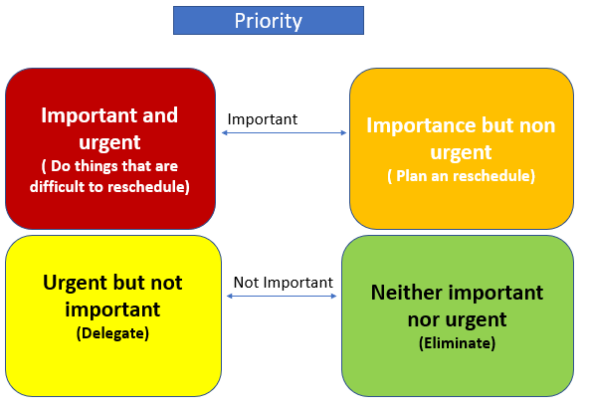

Time management is a somewhat ambiguous term. Time itself cannot be /manage/ but an individual can manage him/herself and the way that she deals with time(Claessens, Eerde, Rutte&Roe,2007, Cannon,1986) Time management refers to strategies which support successful executing of behaviour required to effectively achieve goals, Thus, time management aims to maximize individual behaviour

Before I start this course I could not prioritise things that need to be done now, from things that need to be done later, like when I was doing my last course I will have several tasks be completed in a day like have an assignment, meet my friend for a drink, plus I have to pick my daughter to come over for the weekend, and also don’t want to miss the Saturday football match on television

I could not arrange my time properly, but having learned about the Eisenhower method I now knew that I can do course my work on Saturday morning, record my favourite my football match for later, and pick my daughter spend the Saturday with her, after dropping my daughter back on Saturday night, I could meet my friend for a drink, and I can come home and watch the recorded match on television later.

My supervisor has spoken to me about coming to work on time, as I always come to work late, having learned about Eisenhower theory about time management I now know about important coming to work on time and know-how to deal with the things that are important to things that are not important. I now need to prioritise the urgent things, which need to done now that are urgent, not urgent that I need to schedule for later,

5. Conclusion
In learning about the Eisenhower method has helped me to organise my life with things that are urgent and non-urgent with things that are important unimportant I will now be able to act on things that are important now in future, This method has helped me to organise my life and prioritise important things to unimportant things.

6. Reflection
Gibbs' Reflective Cycle was developed by Graham Gibbs in 1988 to give structure to learning from experiences. It offers a framework for examining experiences, and given its cyclic nature lends itself particularly well to repeated experiences, allowing you to learn and plan from things that either went well or didn’t go well. It covers 6 stages:
- Description of the experience
- Feelings and thoughts about the experience
- Evaluation of the experience, both good and bad
- Analysis to make sense of the situation
- Conclusion about what you learned and what you could have done differently
- Action plan for how you would deal with similar situations in the future, or general changes you might find appropriate.

Below is further information on:
- The model – each stage is given a fuller description, guiding questions to ask yourself and an example of how this might look in a reflection
- Different depths of reflection – and example of reflecting more briefly using this model
This is just one model of reflection. Test it out and see how it works for you. If you find that only a few of the questions are helpful for you, focus on those. However, by thinking about each stage you are more likely to engage critically with your learning experience. Reflective learning is more than just reflection; it is a process where past events are recalled to recapture the experience and then examined it to consider why the observed outcomes occurred and assess personal permanence or reactions to identify how these may be improved in the future (Schon, 1991).

Having learned about reflection I start to put it in a deferent category in my life, I reflect in my place of work and could be explained in the following category

Organisation perspective
Working in an organisation where employer put a lot of pressure on the employee this tends to make employee make mistake and service user tend to rebel and it creates a problem between service user and organisation, say if I going to service user room at 7 am to get him or her ready for a bath, as I have a schedule to keep, and I need to get him or her ready for breakfast in canteen at 8 am, and service user is not ready to bath and just want to stay in room and he or she is refusing to leave the room, and am in under pressure from manager because others service user need to take bath and the organisation under pressure as we are short of staff.
The organisation is under pressure they do not give the service user they want maybe due to budget cut ,and I am getting a lot of pressure from my manager as I can get the service user ready on time.
In conclusion, looking at all aspect of it, what plan should I put place? I should get the service user that refusing to bath earlier than the usual time, to get everyone ready on time in other get everyone ready for breakfast on time, as we are short staff. Or if it possible to take breakfast to them, that will save time and keep resident happy.

Action plan
I also need to have a more empowering relationship with the service user. That way it will keep them happy and I will be able to keep my schedule

Academic Perspective

In an academic perspective, A module I love so much I always attend class, I do all my quizzes, I answer the question in class, and I complete all class exercise but I got a very low mark, why did I get a low mark? Maybe the lecturer doesn’t like me, am angry and frustrated after putting all this work, the lecturer left feedback of my work. but there are good and bad side of it .

Good side – I passed with a low mark
Bad feedback say I could do more, I did not reference some of my work and I did not submit on time.
Conclusion If I do my work on time and reference my work, I will get more mark ACTION PLAN: To submit my work on time and reference my work. I need to give my work at the highest standard.

In 1984, David A. Kolb, published a groundbreaking book entitled Experiential Learning: Experience as the source of learning and development (Englewood Cliffs, Prentice Hall, 1984). This book essentially exposed the principle that a person would learn through discovery and experience.

• Kolb, 1984, p.38) David A. Kolb based his book, Experiential Learning: Experience as the Source of Learning and Development, on the works of John Dewey, Jean Piaget, Carl Jung, Kurt Lewin, and William James. He believes that the centre of learning is the learner's subjective experience. Learning Cycle. The learning cycle is divided into two aspects: Knowing; Concrete Experience (CE)

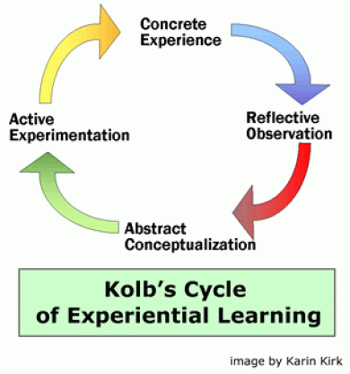

A quote from Mr Gibbs himself: It is not sufficient simply to have the experience to learn without reflecting upon this experience it may quickly be forgotten or it learning potential lost from the feeling and thought emerging from this reflection that generalisation that allows a new situation to be tackled effectively (Gibbs1988)

In conclusion to Evaluation of the experience both good and bad. Analysis to make sense of the situation. This is concluded in what I learned and what I could do differently, draw up an action plan on how I deal with a similar situation in the future.

7. Online Learning Experience
Online learning can be defined as an appropriate mix of e-learning and traditional classroom learning that improves the learning experience of students (Lam, Hung, Chan, Zhang, Yan, & Woo, 2011; Lam, Hung, Chan, Yan, & Woo, 2011). It is one of the latest education trends emerging in open and distance learning institutes as well as conventional universities, continuing education institutions and corporate training (Yau, Lam, & Cheung, 2009), with its evident advantages of flexibility, richness, resource-sharing, and cost-effectiveness (Zhang, 2011). Shankar and Malthouse (2006) point out that the rapid changes in media are affecting one’s perception, such that two-way communication with the capability of personalization and information control (Vlašić & Kesić, 2007), which allows real-time interaction without the time and geographical constraints, turns out to be the most appropriate online learning means in this trend. In the 21st century, online learning is regarded as one of the main media to deliver training and education resources, with the benefits in terms of cost-effectiveness, accessibility and up-to-date information (Anderson, 2011). A study from the US by Allen and Seaman (2007) reveal online learning has been growing continuously with an increase in student access and demand for online learning. Online platform acts as the mean for providing learning in the virtual environment. Researchers advocate 3
The world has responded swiftly to the coronavirus outbreak, and so too have universities and students. When we asked current international students if they are taking any classes online due to COVID-19, 85.1% of them answered ‘yes.’ For those taking classes online, the future looks less clear: 39% thought the shift was short-term, almost 25% thought it would be long-term, and 36% do not know.

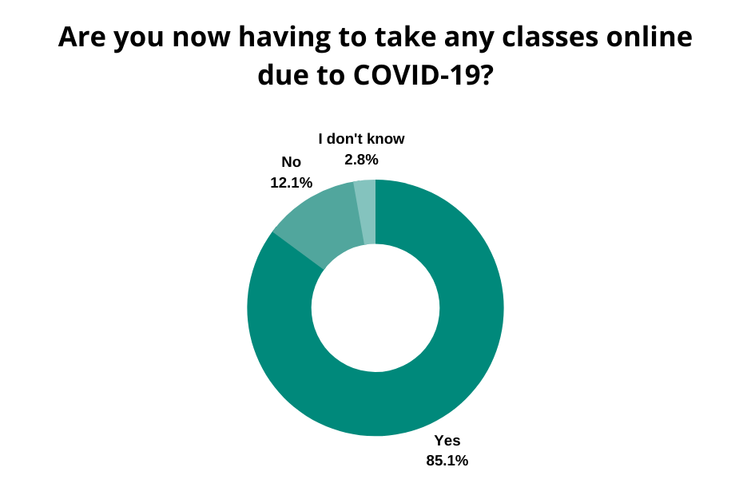

E‐learning is not just a technology change. It is part of a redefinition of how we as a species transmit knowledge, skills, and values to younger generations of workers and students. This book makes a few predictions of how e‐learning and the functions it serves will continue to develop. Learners will have access to millions or billions of knowledge modules. Some will be Web pages with simple text and graphics. Others may include multimedia simulations. In many fields, e‐learning has become the default way to conduct training or to provide education. There are four secrets of e‐learning. The first secret is to teach what learners need to learn in the way they most naturally learn. The second secret is to define clear learning objectives. The third secret builds on the first two. It is to focus on the right objectives. The final secret is in the power of testing.

For me as an online student of health and social care at university of wales trinity saint David London online classes a convenience, it allows me to stay at home with my family and it also saves me time and money. for me online learning experience has more advantages than a disadvantage, if I was to attend class at university, I would have to buy my monthly travel card which will cost £120 plus It will take me 2 hours travel time to and from university, the time I would use to travel I could use that time to do my research or assignment. The disadvantage is I would not meet my lecturer and coursemate in person

8. Conclusion

Online learning is the future, I believe university and colleges will find a way to save cost by investing in online learning because it is cheaper for the university as it will reduce the budget on building management and utility cost. For a student perspective, it will save me time and money, I could use that travel time to do other academic stuff like assignment and research. For the cost I could save £120 a month, the money I could use to cover other expenses, So online learning is a good thing for both the student and university.

9. Reference List

Allen, I.E., Seaman, J.: Online Nation: Five Years of Growth in Online Learning. The Sloan Consortium, Massachusetts (2007)Google Scholar
Anderson, T. (ed.): The Theory and Practice of Online Learning, 2nd edn. Athabasca University Press, Athabasca (2011)Google Scholar
Clark, C.R., Mayer, E.R.: E-learning and the Science of Instruction: Proven Guidelines for Consumers and Designers of Multimedia Learning, 3rd edn. Pfeiffer, San Francisco (2011)CrossRefGoogle Scholar
Coates, D., Humphreys, R.: Evaluation of Computer-Assisted Instruction in Principles of Economics. Educational Technology & Society 4(2), 133–144 (2001)Google Scholar
Huang, R.H., Zheng, L.Q.: Can Using Hand-held Devices Improve the Instructional Quality in Blended Learning Context? A Case Study of the “Introduction to Educational Technology” Course Workshop Proceedings of ICHL 2011: Blended Learning – Maximization of Teaching and Learning Effectiveness, pp. 41–51 (2011)Google Sch
https://institutions.educations.com/insights/demand-for-online-studies-skyrockets-but-here-are-students-biggest-concernshttps://onlinelibrary.wiley.com/doi/10.1002/9781118256039.ch11www.simplypsychology.org
https://www.mindtools.com/pages/article/newHTE_91.hthttp://www.successinlifee.com/home/priotize-your-task-

with-eisenhower-matrix/;https://onlinelibrary.wiley.com/doi/abs/10.1002/j.2168-9830.2009.tb01025.x

