2213369 ECEY5005/C word count:

Awe and Wonder- Science, Mathematics and the outdoors
Part 1
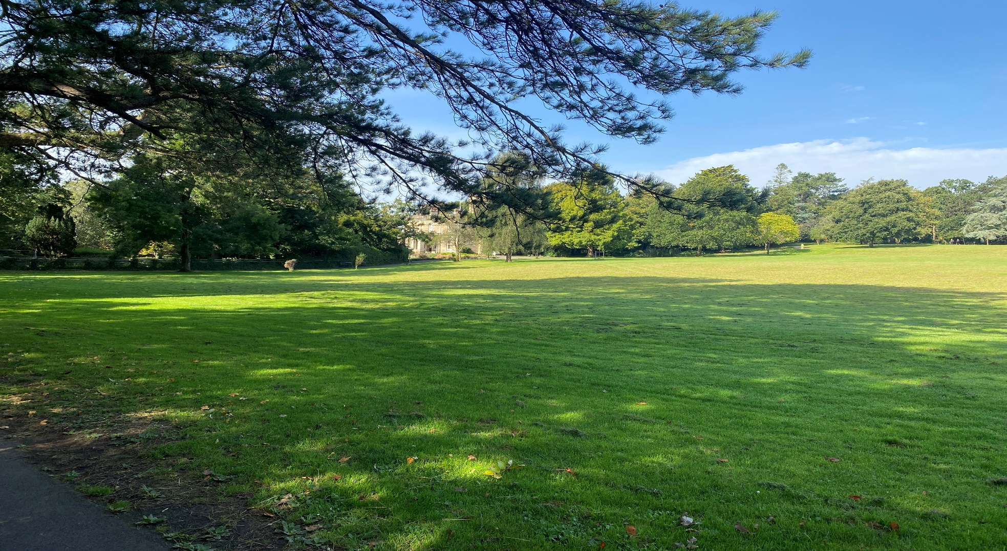
Part 2
Today myself Miss Jones and my year 1 class visited Park Howard to see how the world works in different ways, by allowing the children to explore and investigate the natural world around them. This involved Science and Mathematics by looking more deeply into living and non-living life cycles.
Promptly at 9am class 1 were leaving the school to head to Park Howard. Firstly we made sure that all children had their high visibility jackets on and did a head count to ensure we had everyone before leaving. Before heading off the children decided to hold hands, so that they could stay close together whilst walking to Park Howard. As we got closer to the park the children noticed a main road. One of the children shouted out ‘We need to look both ways to make sure it’s clear before we cross’.
As soon as we arrived at our destination all the children were full of excitement to get stuck into our adventure. Firstly we did another head count and then stood at the front gates taking in the amazing views of the large beautiful grass, trees and house in the distance. The outdoors is one of the best places to engage in play, so firstly we allowed the children to run onto the grass and have a little explore before we got onto our investigating.
Park Howard is a large area where there can be so much choice for an enabling environment. Within the Welsh curriculum there are six areas of learning and I believe Park Howard can support all of these areas. Firstly health and well-being which with it being outdoors and in a large area it can contribute to physical well-being for the children as they will be able to run, roll, skip and jump along the grass and banks. With it also being in nature, this can have a positive effect on their health and bodies. Humanities as this area gives the learners the opportunities to discuss and explore with others what’s around them and reflect upon their actions and those of others. Expressive arts is something children do everyday without even thinking of it. It’s within play when they use their imagination to be creative with various loose parts like taking along musical instruments and things for drawing or painting. Languages, literacy and communication is something this area can be used for with many things like storytelling sat on the grass or tree stump with a door, story trails through the trees. This will get the children’s imagination running wild and they will want to ask questions about the door on the tree stump or a question about the story. Mathematics and numeracy within this area can be counting how many conkers we find on a walk around the park, or the number of trees or wildlife we spot. Then finally science and technology where it brings us to our task at hand which is Living and non- living life cycles.
We wanted the children to become aware and know the differences between living and non-living things. From the school, I brought tick charts with lists of living and non-living life cycles, magnifying glasses and some other materials like plastic containers, some spoons and paintbrushes in case they didn’t want to us their hands for the little crawly things and a book with lots of different living and non- living life cycles in to see if they could spot any within it. The children would then be able to use what they choose on the walk within the grass, bushes and flower beds. Before this adventure out of school, I had come to the area to explore and think about ideas beforehand. Park Howard is filled with lots of space, both grass and concreate as well as a park area, a walking area with beautiful flower beds, a closed in pond and an ancient house in the centre. It screams curiosity and adventure for all children.
We were a total of 9 children and 3 adults on our adventure. We spilt into 3 small groups of 3 children and 1 adult for each group. This was to be able to work closely with each pupil to grasp their full attention and potential within this activity. To start the activity off we got into our groups, picked up a magnifying glass, our tick charts and pencils and whatever else the children wanted to take. Then off each group went in different directions throughout the park. I then asked my group ‘which direction are we going in compared to Miss James’s group? To which one child exclaimed ‘forward! and Miss James’s group is going downwards’. Well spotted I replied. Then we continued on our walk making sure that every steep we took our eyes were peeled to see if we could spot any living or non-living things. I took a step back from the children to observe and support their curiosity. As I watched and listened closely, I could hear the children engaging in discussions about the living mini beasts they had found on the ground and then someone had spotted the ancient house within the distance and shouted ‘Look! I can see a house which is non-living’. I went towards them and said ‘Show and tell me what you have found?’ There were all excited to show me they had found centipede and a worm. They all took it in turns to look at them closely with the magnifying glass before ticking on our chats what we had found. We then made sure the mini beasts were put back where they got them and then continued with our walk. The walk is something that broadened their knowledge of living and non-living life cycles. The environment provided a rich experience of science about the characteristics of both living and non-living life cycles, from mini beasts, trees, tree stumps, the park and the house. This provided the children to be able to be respectful of living thing, explore closely as well as freely without too much teacher interaction.

Part 3 RISK BENEFIT ASSESSMENT

Location / Activity: | Park Howard/ Living and non- living life cycle | Date:
Assessor: |  | Review date:

The boxes in the table below will expand as you type into them; pre-entered text is simply for illustration. You should delete irrelevant items and replace with text relevant to your circumstances.
Your overall risk rating – Low, medium or high – is based on your judgement about whether the BENEFITS of the activity or opportunity outweigh the RISKS.

Experience exploring outdoor space in photograph | How will young people BENEFIT from this activity? | Hazards and associated risks | Who is at risk? | PRECAUTIONS in place to reduce the risk of injury | Overall risk after precautions  RATING: L/M/H
Uneven ground
Stranger danger
Traffic coming from and back to school

Part 4
According to (Williams, 2016) adult practitioners influence the type of experience in supporting children’s play. The adults ultimate goal in supporting this is to ensure that a subtle and sophisticated approach to enhance child- initiated play. As stated by (Bento and Dias, 2017) adults must ensure they are not dominating but rather taking on a supportive role and approach. Sustained shared thinking drives from scaffolding and the role of the adult is to engage in the child’s play and to be able to work with the child to develop and extend their thinking and learning.
We can determine that according to (Media (2000), n.d.) the key aspects in an adult role is be able to develop a stimulating environment, for children with access to natural loose parts. Within the outdoors adults need to be able to identify the unique qualities around them to introduce Mathematics. This could be from collecting natural objects such as twigs, stones or leaves. They could also investigate by measuring the area around them using movement such as strides or hunting for mini-beasts. Children can learn Mathematics through all of their senses including touch, smell, sound and taste. This could be exploring empty or full containers with wet sand or branches. Children could investigate by looking at seeds or measuring the heights of tall sunflowers as well as collecting natural objects like stones or flowers. The adults needs to be fully engaged and It’s important to use specific vocabulary with open ended questions about Mathematical learning within the outdoors.
The Foundation Phase Framework Curriculum for Wales (n.d.) focuses on children being able to enquire and investigate the outdoors in a safe and systematic way. They need to be given the experience to help expand their curiosity about the world they live in and the world around them. This will then ensure they are equipped about living things, people and places. All children should be motivated to be able to enjoy by exploring and experimenting as well as asking questions to find out the answers. In turn this will stimulate them to care, have responsibility, concern and respect for all the living things and the environment. Children can explore Science within the outdoors by drawing living things, exploring the natural world around them, collecting rocks or shells and try and sort by difference and naming animals and plants.
As stated within the Curriculum for funded non-maintained nursery settings (n.d.) adults need to be able to create a safe environment that supports all children to be able to express their feelings and behaviors in constructive way. It’s important that all adults are able to promote a happy advance towards learning. They state that all the involvement that’s offered within the Early years should always aim to be a hands on approach, offering challenges, risk and every opportunity to have a fulfilled learning journey. The experiences need to be holistic and rooted in real-life surroundings to be able to allow all children to have deep levels of participation throughout their learning.
Furthermore (Williams, 2016) found that the findings and discussions that took place in 9 early years settings within North Wales with a total of 37 practitioners was that there was not much literature to indicate that practitioners had the experience of evaluating learning in the outdoors. It is determined that assessing children in the outdoors is not used to it’s full potential, there are lack of resources as well as amount of staff and child staff ratio. Is it said that these practitioners need training for planning for learning and assessment on outdoor learning. It was also said that in Scandinavian countries such as Finland and Denmark that the children there had a higher level of cognitive and physical development along with shared thinking as a result of using the outdoors for learning more often.
Similarly (Estyn, 2011) has said that practitioners are more confident planning outdoor learning and overcoming obstacles such as having limited amount of space or an area that is difficult to adapt. The practitioners said that children benefit with high levels of engagement and enjoyment as well as a positive outlook on behavior and physical fitness.

