Module Name: Learning in the Digital Era
Module Code: ACCA 4025

Student Name: Susan Henry
Student ID: 2517524
Group: 3

Lecturer’s Name: Dr Fahad Ahmed
Video Link:
https://youtu.be/Hkm5n9lx4cs

UNIVERSITY OF WALES TRINITY SAINT DAVID
LONDON CAMPUS
Assignment 2
Learning in the Digital Era

Table of Contents
Introduction 2
Introduction 2
Contents 4
Main Body 5
Gibbs Reflective Cycle 6
Gibbs Reflective Cycle (cont) 7
Task One 8
Self-evaluation 10
Traits gained from Self-evaluation 11
Personal Development plan using SMART goals 12
Personal Development plan 13
Personal Development Plan (cont.) 14
Unit 4 Choose Topic Reflexivity 15
Unit 4 Chosen Topic Reflexivity 16
Conclusion 17
References 18

Introduction
This assignment will inform on my self-development journey and the requirements needed to academically succeed. It requires continuous reflection [3], self-awareness [3] and purposeful actions using structured models such as the Gibbs Reflective cycle [1]. I can identify my strengths and weaknesses, analyse my experiences critically to create an action plan for improvement. Reflexivity enhances this process further by empowering my ability to explore my assumptions, perspectives and behaviours that influencing mu learning. [2]. This provides me with the framework for developing my self-awareness, adaptability and solidify my commitment to lifelong learning [3].

Slide 1

Introduction

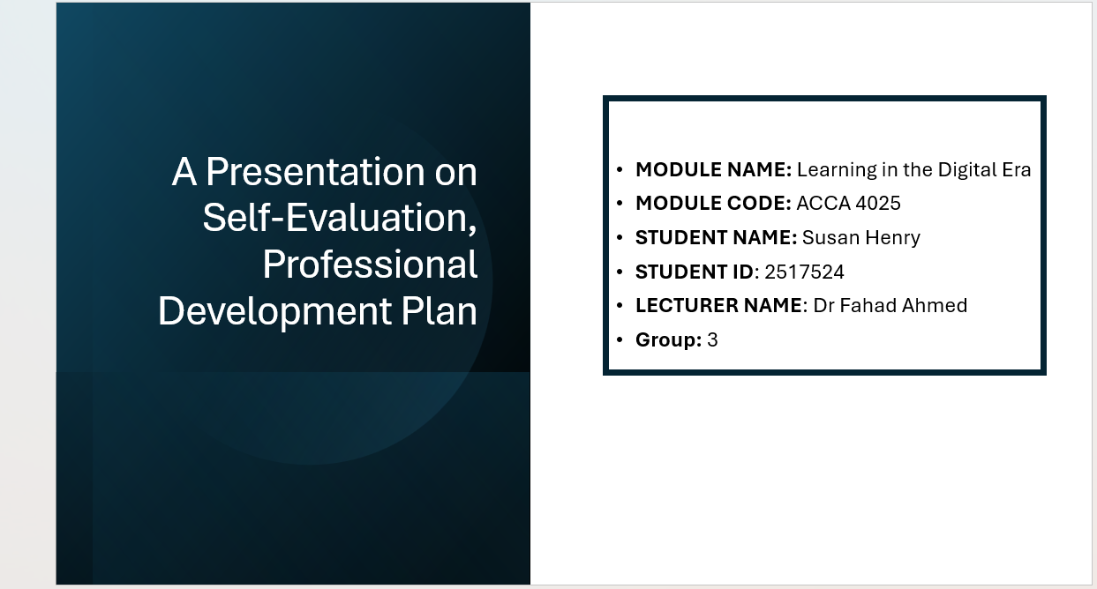

Slide 2
Introduction
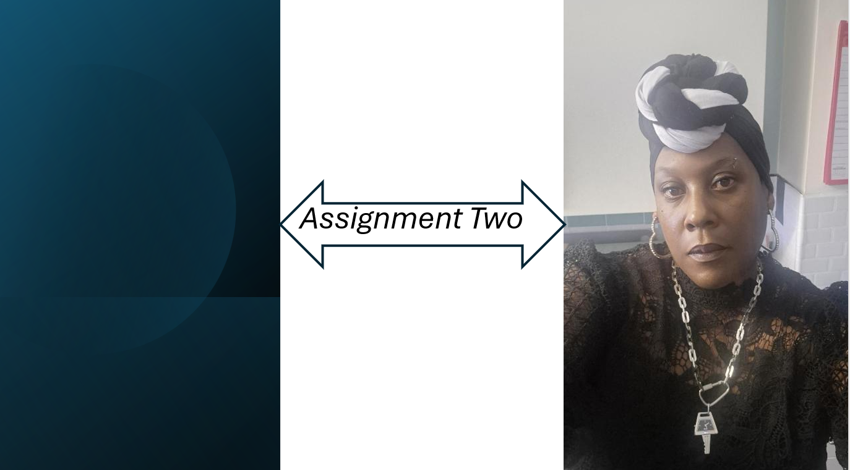

Slide 3

Contents
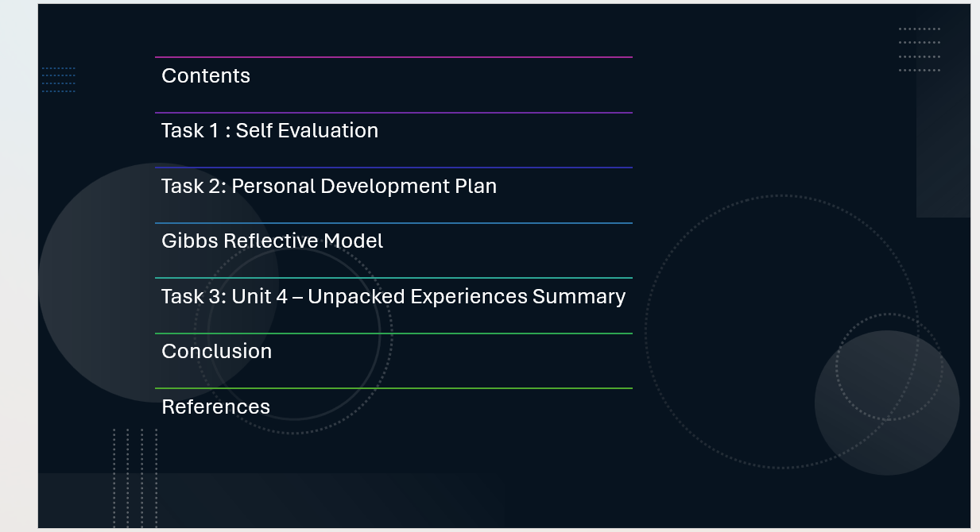

Slide 4

Main Body

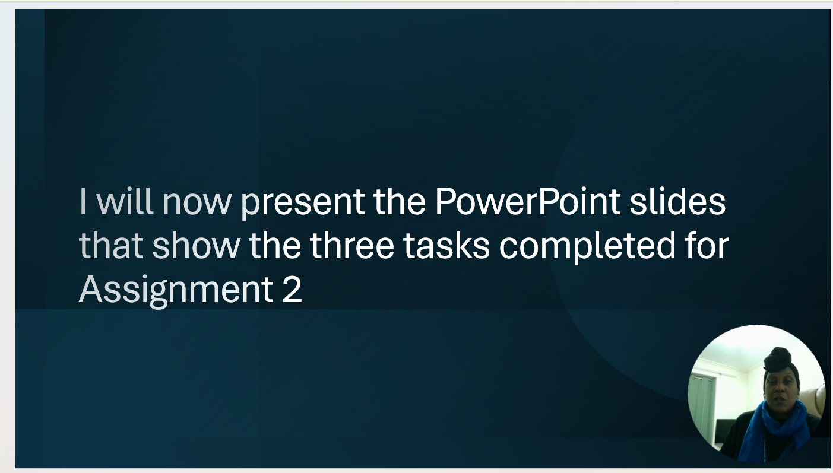

Slide 5

Gibbs Reflective Cycle
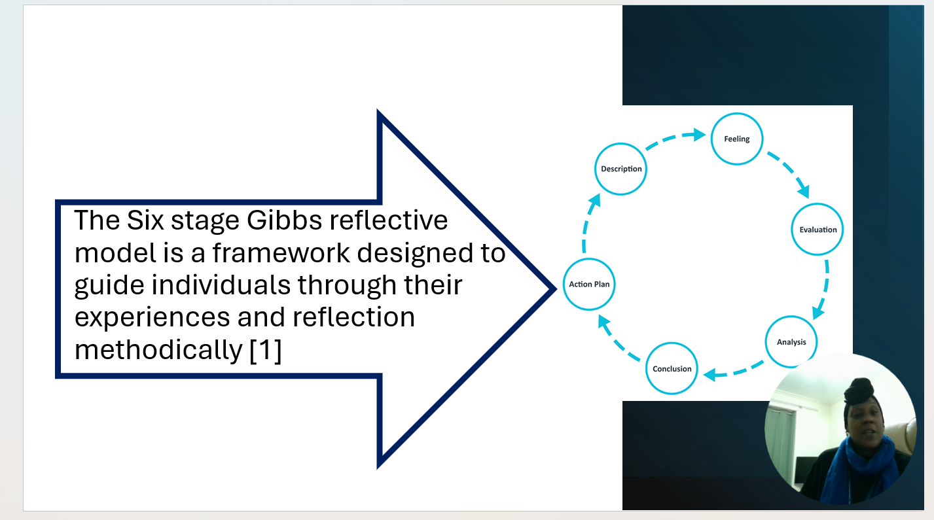

Slide 6

Gibbs Reflective Cycle (cont)
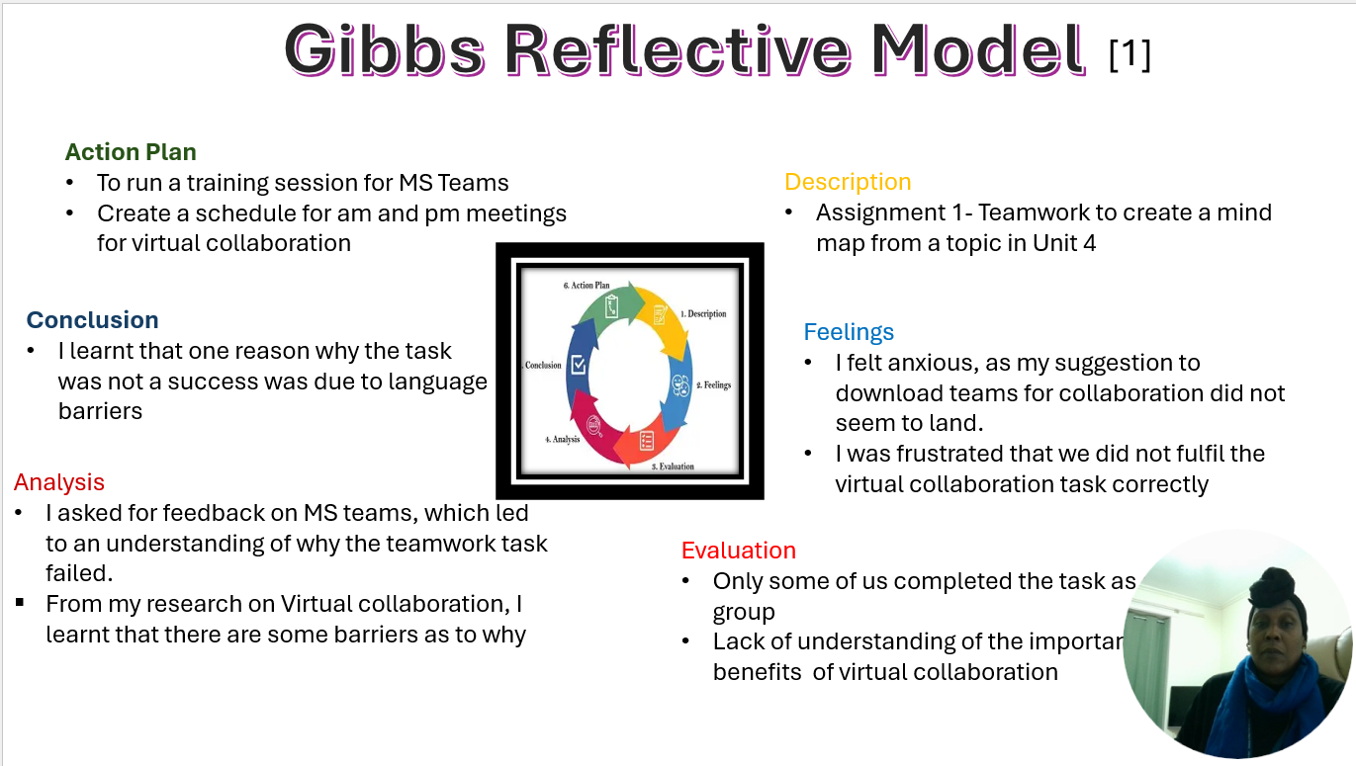
The Gibbs Reflective Cycle was developed by Graham Gibbs in 1988, created to analyse experiences and identify areas for improvement. By completing each of the six stages, I can explore my own actions critically, recognising my strengths and weaknesses, which supports my self-development [1]. It encourages reflexivity allowing me to delve deeper into how my own behaviours and perspectives and consider how they influence outcomes [2]. I am well informed on how the Gibbs’ model helps me to transmute my reflection into purposeful actions, strengthening my commitment to continuous growth and lifelong learning [1], [2], [3].

Slide 7

Task One

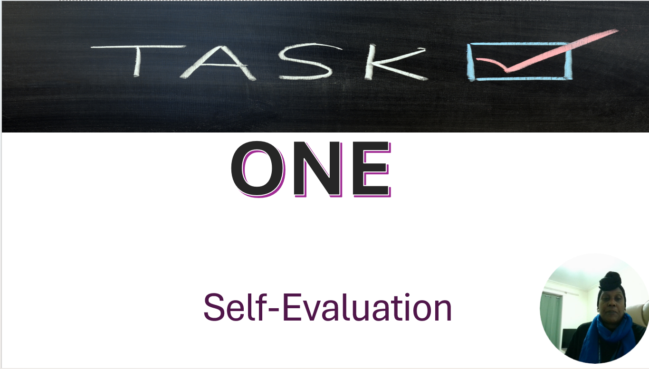

Slide 8

Self-evaluation
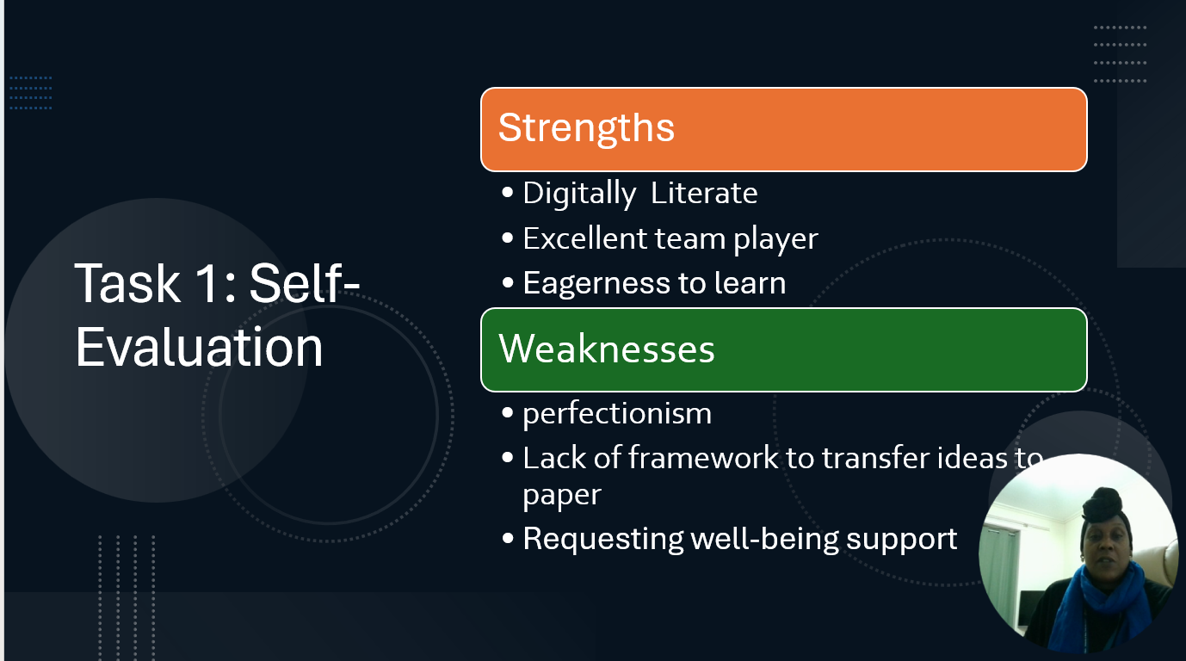
My Self-evaluation of strengths and weaknesses are depicted from completing my Learning in the Digital Era assignments. Although I am an excellent team player, I failed in getting the other student to engage in using Microsoft teams. As a leader I have taken what I have learnt from this and schedule some workshops for training. Using virtual collaboration software is imperative to our academic success.

Slide 9

Traits gained from Self-evaluation
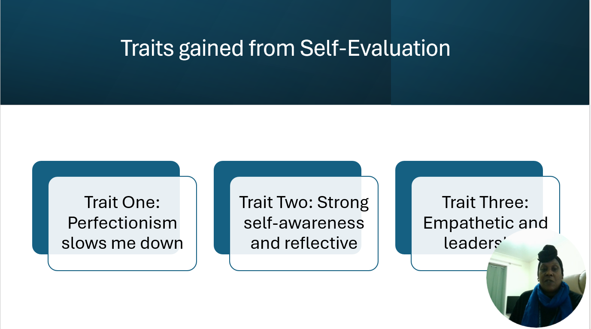
From my self-evaluation I was able to gain my traits, positive and negative. Perfectionism making the top of my list and sometimes the most detrimental to my progress. I am learning to move on to the next task/section, rather than remaining in stuck mode and using up valuable time.

Slide 10

Personal Development plan using SMART goals
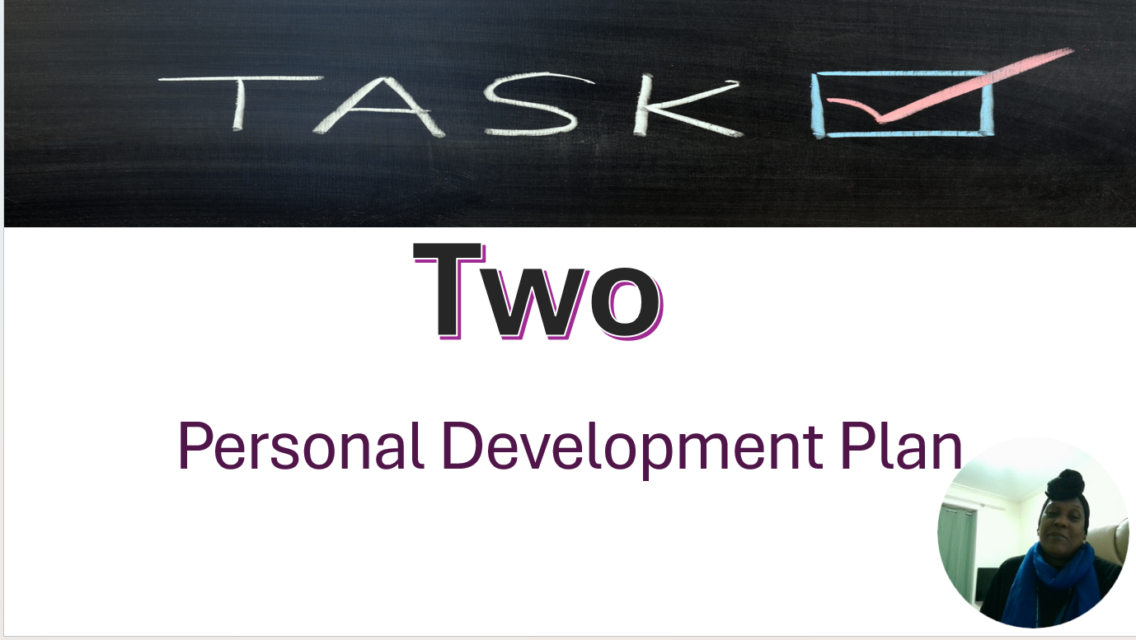

Slide 11

Personal Development plan
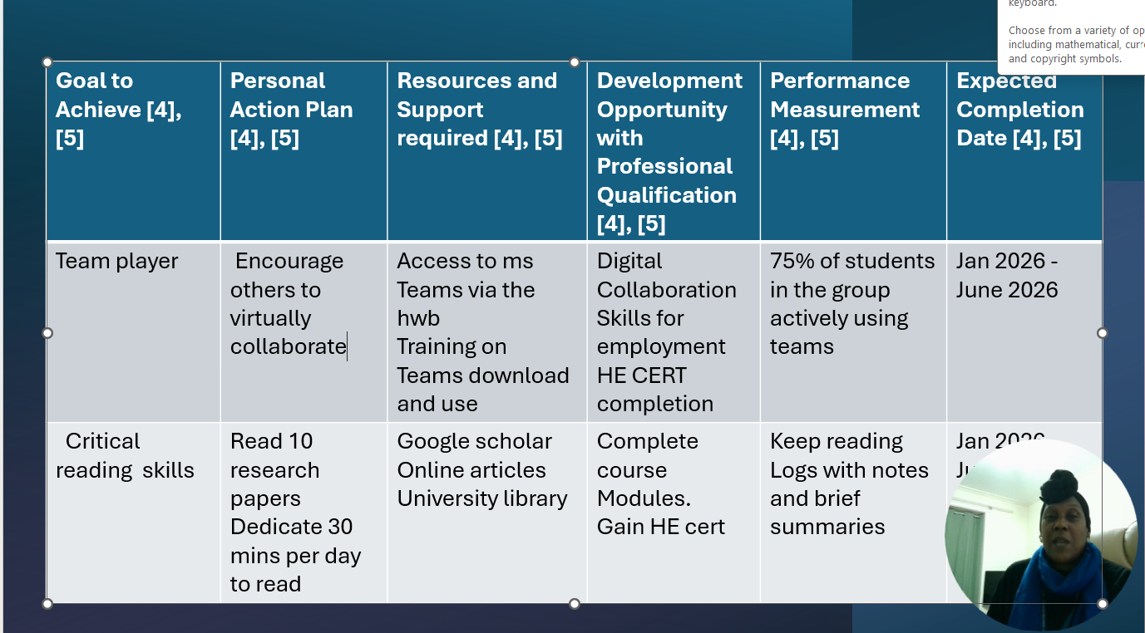

Slide 12

Personal Development Plan (cont.)

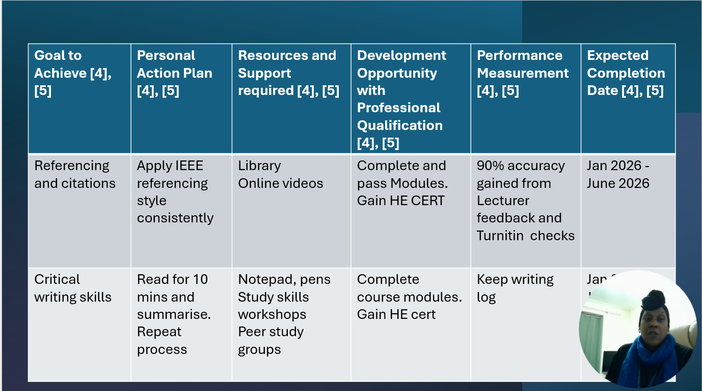
My SMART goals were originally completed on a self-development form, enabling me to start to gather my thoughts on my development needs. I have chosen 4 goals to focus on, and I am looking forward to seeing if my development plan will stay on track and whether I may have to update them before the stated time span [4], [5].

Slide 13

Unit 4 Choose Topic Reflexivity
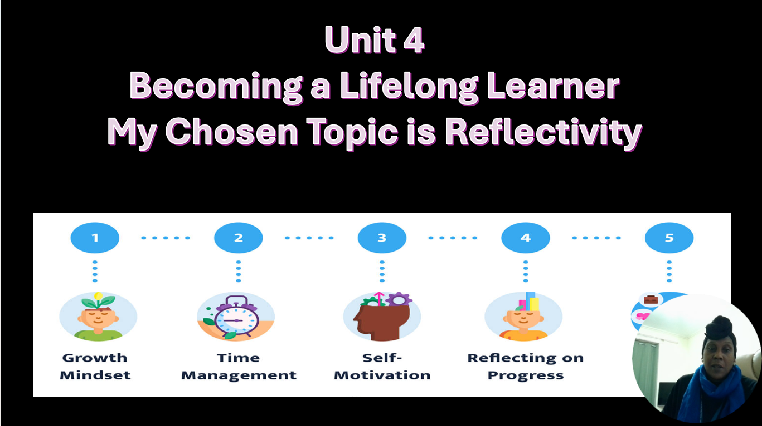

Slide 14

Unit 4 Chosen Topic Reflexivity
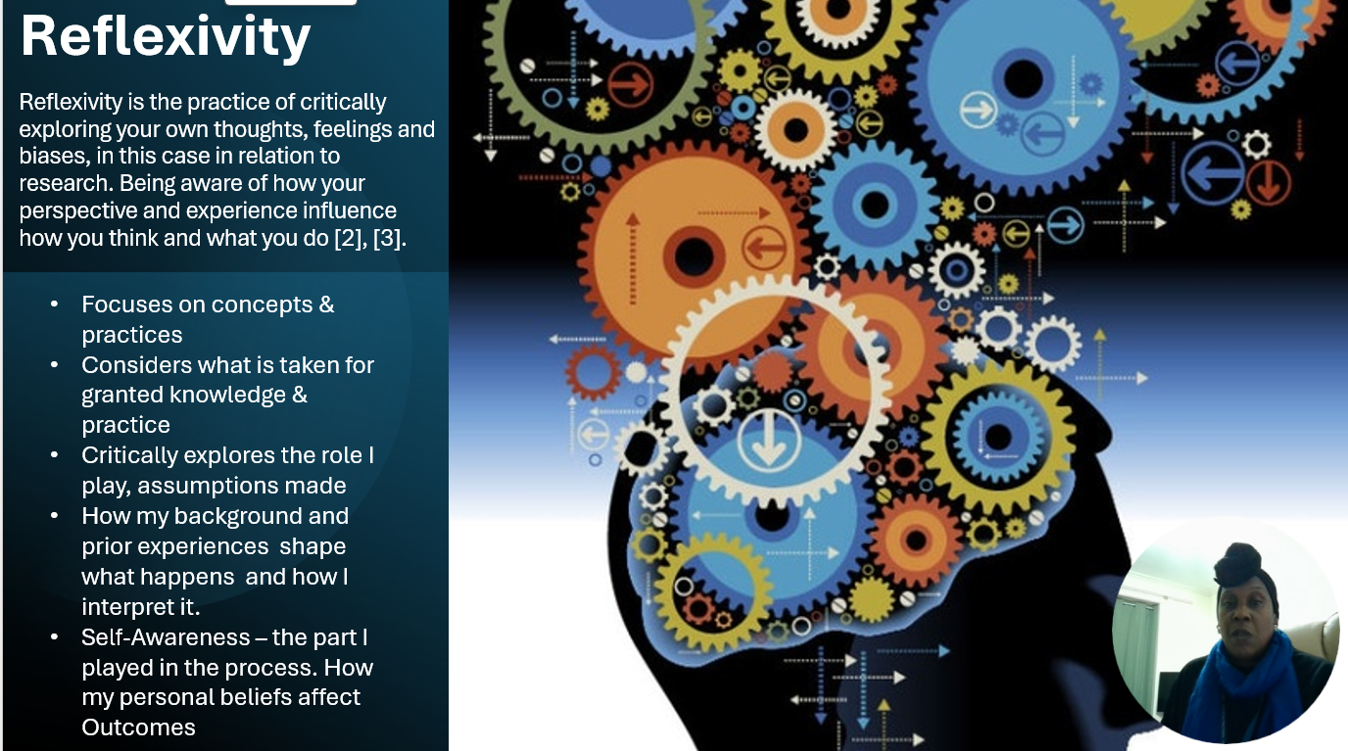
Reflexivity is not the same as reflection, which is a lot of people’s perception. Reflexivity delves deeper into concepts and practices. Questioning your own part in the process, which may be affected by cultural beliefs or backgrounds. These along with prior experiences in life can determine your perspective, behaviours and attitude. In my own reflexivity I have understand how my own experience a child affects my resilience and in the past my confidence [2], [3].

Slide 15

Conclusion
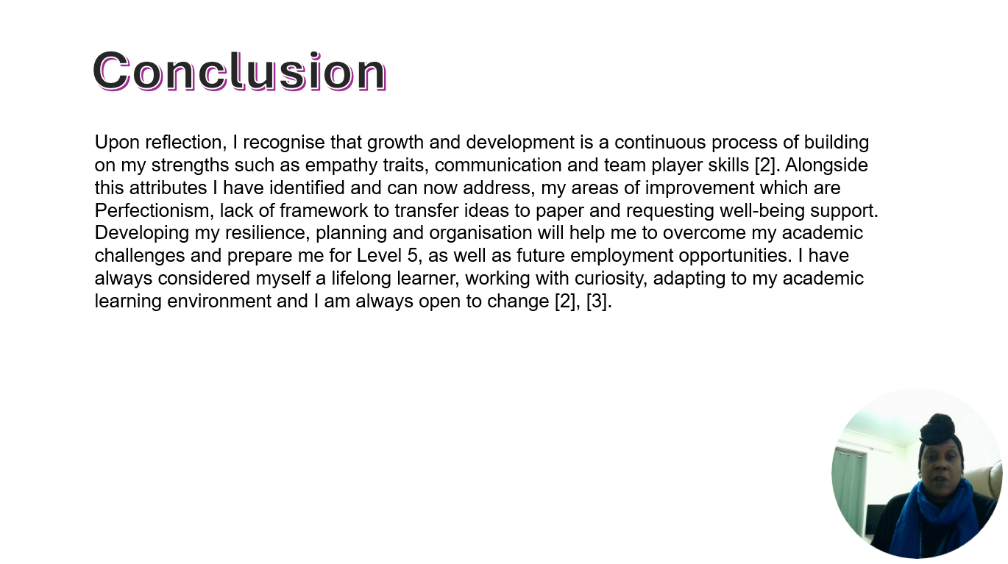

Conclusion (Full version)
Upon reflection, I recognise that growth and development is a continuous process of building on my strengths such as empathy traits, communication and team player skills [2]. Alongside these attributes I have identified and can now address, my areas of improvement which are Perfectionism, lack of framework to transfer ideas to paper and requesting well-being support. Developing my resilience, planning and organisation will help me to overcome my academic challenges and prepare me for Level 5, as well as future employment opportunities. I have always considered myself a lifelong learner, working with curiosity, adapting to my academic learning environment and I am always open to change [2], [3]. I embrace feedback from my lecturer and peers and apply my reflections to new scenarios. My self-development plan is not a fixed strategy but a framework that will evolve as I improve and grow. I am determined to continue learning and improving with purposefulness and reflexivity by acknowledging my personal influence [2], [3]. Reducing my hidden biases in thoughts and research, will also have a positive impact on my critical thinking and writing [2], [3]. Using SMART goals [2], [3]. and Gibbs reflective model [1] throughout my learning experience to ensure I continue to improve, develop and master my academic skills. In turn this will increase the likeliness of me succeeding academically and professionally.

References
[1] G. Gibbs, "Learning by Doing: A guide to teaching and learning methods," 2024, Available at: https://reflection.ed.ac.uk/reflectors-toolkit/reflecting-on-experience/gibbs-reflective-cycle.
[2] L. Mortari, "Reflectivity in research practice: “An overview of different perspectives," vol. 14, no. 5, pp.1609406915618045, 2015
[3] D. Boud, D. Keogh, R, Walker, D “Reflection: Turning experience into learning,” Routledge, 2013.
References
[4] M. Les MacLeod EdD, "Making SMART goals smarter," Physician Exec. vol. 38, no. 2, pp.68, 2012,
[5] C. Swann, et al., "The (over) use of SMART goals for physical activity promotion: A narrative review and critique," vol. 17, no. 2, pp.211–226, 2023,

