TITLE: IN THE 21ST CENTURY, WHY ARE BRANDS SUCH AS COCA-COLA ALIGNING THEMSELVES TO “WORTHY” CAUSES?

HANNAH REES

P150941

Submitted in partial fulfilment of the requirements for the degree of BA (Hons) University Of Wales Trinity Saint David. Swansea

Word Count: 5579

Wednesday 11th December 2019
TABLE OF CONTENTS
Sections |  |  | Page No.
List of Illustrations |  |  | 3
Summary of Topic |  |  | 3
Chapter 1: Introduction |  |  | 4
Chapter 2: Coca-Cola Background |  |  | 5
Introduction |  |  | 5
History |  |  | 5
Advertising: I’d Like to Buy the World a Coke |  |  | 6
Coca- Cola Truck |  |  | 8
Brand Personality and Long-Term Business |  |  | 9
Chapter 3: How ‘innocent’ is Coca-Cola? |  |  | 10
Introduction |  |  | 10
The Innocent Chain Of Good |  |  | 11
Dealing with Declining Volumes |  |  | 13
Share a Coke Campaign |  |  | 14
Environmental Responsibility |  |  | 15
Drinking the world Dry |  |  | 15
Packaging Pollution |  |  | 17
Chapter 4: Poverty and Equality |  |  | 18
The Global Fight Against Obesity |  |  | 18
The Mexicans Dying For a Fizzy Drink |  |  | 19
Poverty, and Healthcare within Africa |  |  | 21
Chapter 5: Conclusion |  |  | 22
Bibliography |  |  | 24
LIST OF ILLUSTRATIONS

Figure 1: I’d Like to Buy the World a Coke
Figure 2: Coca-Cola :The Holidays Are Coming
Figure 3: Guardian Graph: Plastic Waste Comparison
Figure 4: The Innocent Chain Of Good
Figure 5: Share a Coke Campaign
Figure 6: Drinking the World Dry
Figure 7: Plastic Pollution Coalition Figure 8: Drink Up Campaign
Figure 9: BBC: Sales of Soft Drinks in Mexico

SUMMARY OF TOPIC:
This dissertation is a study to discuss the brand Coca-Cola and its alignment with ‘worthy-causes’ throughout the years. I will examine how the company cleverly do this within their marketing strategies and whether the controversy is justified. Furthermore, I will look into the; background of Coca-Cola, their advertising approaches, how “innocent” the company really is, and their attempt to silence their critics with their connections with environmental responsibility, obesity and poverty across the globe. By doing so, I will consider whether the actions of Coca-Cola is done so selfishly or as an act of good will. These messages have been portrayed in a variety of different ways, which raises the question if Coca-Cola manipulates its audience perception of the brand.
Chapter 1: Introduction
In this dissertation, I will focus on Coca-Cola (who are one of the most successful and largest brands in the beverage industry) and the worthy causes that they align themselves to by relating it back to their marketing and advertising strategies.
As stated by Barker;
“advertising is at the core of contemporary culture and at the heart of debates about postmodernism, globalisation and consumer culture, visual-based advertising [is] at the centre of an increasingly world-wide consumer culture, to create added brands or commodity-signs” (Barker 2004:3).

To further analyse that statement, I will be examining the relationships between visual advertisements as well as scenarios that are cleverly produced in order to gain the consumers attention by creating personal connections. John Hegarty, advertising executive and a founder of Bartle Bogle Hegarty advertising agency claims that, “as humans we respond more to emotions than we do logic” (Hegarty 2014:37) which suggests why Coca-Cola are so successful through their use of propaganda advertising which has an impact on consumers. Furthermore, I will look into why the company uses these techniques and how these visual elements benefit the company as a whole. The Advertising Standards Authority (ASA) are the organisation responsible for regulating adverts which determine whether they are likely to cause widespread offence. This will also be considered as Coca-Cola shrewdly camouflage their actions in terms of; Environmental Responsibility, Packaging Pollution and global poverty and healthcare behind positive advertisements.

Chapter 2: Coca-Cola Background
Introduction
Coca-Cola is one of the most successful and largest brands within the beverage industry, according to ‘Retail Detail,’ an all-news retail related publisher. (Retail Detail 2019). Interbrand, the authority on brand names and their value, lists Coca-Cola as the world’s third most valuable brand, following behind Google and Apple (Interbrand 2019). Every day, since 1866, millions of people across the world reach for a bottle of Coca-Cola. The company has produced over five-hundred brands in more than two-hundred countries. Overall, its total assets total up to 90 billion dollars, which is significantly greater than Pepsi and Nike combined (Interbrand 2019).

History
According to Richard Stockton, a science and technology writer for ‘all that’s interesting’ (an online media company that focuses on producing and curating viral-oriented content)
John S. Pemberton (the founder of Coca-Cola) was taken off the battlefield during the American Civil War in 1865 due to a wound to the chest. This then led him to become dependent on morphine which is how he developed an interest towards pharmaceutical attributes. During this time, he began experimenting with coca, kola nut and cocaethylene which is structurally similar to cocaine. However, this was later removed from the product due to legislation. (War History Online 2019) The addictive effect it has on consumers, along-side caffeine and high sugar levels could be one of the many reasons why Coca-Cola are as successful as they are today. However, as a result of its overall negative effects and adverse historic background, Coca-Cola has had to defend their brand by aligning themselves with worthy causes and cleverly advertising an extremely positive outlook.

Advertising: I’d like to buy the world a Coke
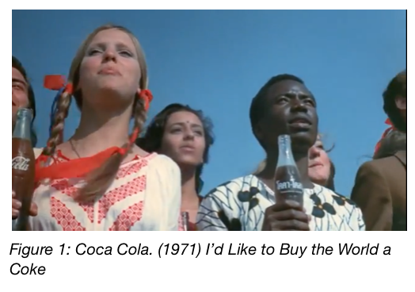
Over the course of Coca-Cola’s history, it has been responsible for several memorable advertising campaigns. One of the most iconic advertisements from the company is ‘Hilltop’ which was aired in 1971. This ad contains a diverse group of people; including all shapes, colours and ethnicity, gathering on a hilltop and singing together. It features the song, ‘I’d like to Teach the World to Sing’ which became instantly synonymous with Coke, and altered it to “I’d like to Buy the World a Coke” (Washington Post 2016) During an interview with the Washington Post in 2016 Backer, the creative director and representative for the global advertising agency at that time, states that this advertisement is “generally considered the World’s most popular commercial” (Backer 2016)
In an interview, Backer discusses this further and states that;

“In that moment [I] saw a bottle of Coke in a totally different and brand new light … [I] started to see the bottle of Coke as more than just a drink that claimed to refresh more than a hundred million people around the globe each day.” Backer began to see the familiar words, ‘Let’s have a Coke,’ as more than an invitation for a refreshment. These were actually a camouflaged attempt to an indirect sentence which was ‘to keep each other company. Backer knew these statements would be successful across the globe which is what lead to the basic idea of not seeing Coke as how it was originally. but instead as a very small common place between everyone globally. This was known as a universal formula that acted as a juxtaposition.” (Washington Post,2016).

In agreement with this statement, Jeff Chang an author for Slate Magazine claims that this was Coca-Cola’s opportunity to globally publicise their product in a positive manner, by advertising during a “season of racial division, imperialist deception, capitalist malaise and national despair” (Slate Magazine,2015). This was an advantage for Coca-Cola as they saw an opportunity and took it to create a more positive atmosphere around the globe by bringing everyone, no matter what ethnicity together. This advertisement was exaggerated by including all faiths, ethnicities and genders to force consumers to believe that by buying a coke you are buying the world shelter and peace. In addition to this, the Hilltop advertisement was among the first shot in full colour. (Slate 2015) This perhaps suggested a potential multicultural future beyond whiteness, which gave false hope to the consumers. A Forbes Article in relation to Coca-Cola’s advertising efforts suggests that; despite Coca-Cola’s refuge in the soft drink industry and large global reach, the company has continuously improved its marketing pay out each year. (Forbes 2016) Coca-Cola believes that they are able to expand their global market reach through experimenting with marketing, aiming to create an emotional connection with consumers. For Coca-Cola, positive customer perception is vital as it faces headwind in the carbonated soft drinks category due to the unhealthy reputation it has. However, it’s approach to brand building and focusing on happiness and positive connotations has given them an advantage in comparison to their competitors such as Pepsi. (Forbes 2016)

Advertising: Coca- Cola Truck
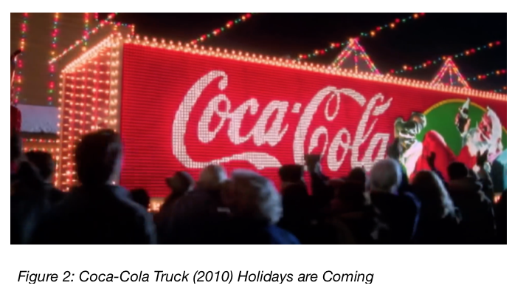
A legendary myth that is known across the globe is Father Christmas. Santa Claus has had a long history within Christmas traditions, and has a positive influence over individuals. In contemporary culture he is considered as a jolly, white-bearded man, wearing a red coat with a white fur collar, red hat and trousers with a leather black belt and boots. The Coca-Cola Company began their Christmas advertisements featuring Santa Claus in the 1920s (Trident 2017). In most recent years, they have dressed one of their lorries and turned it into a Christmas Grotto complete with fairy lights, a Christmas tree and a festive fireplace. This is the perfect example of customer engagement by creating a feeling of nostalgia for potential consumers. The brand has cleverly introduced this within their brand aesthetic as it is an effective approach that produces profits. This concept consists of a tour of various cities across the UK delivering Coca Cola products with a Christmas theme. Although Coca-Cola deem this marketing strategy to be extremely positive and cheerful, there is constant controversy around the ethics of their product which seems to be even more obvious during the Christmas Season (Trident 2017). According to Jordan Foster, an author at Trident, health campaigners based in Liverpool have cancelled a visit from the famous truck due to the obesity crisis the city is experiencing. This marketing technique contributes towards the belief that Coca-Cola devote a lump sum of money to advertising their products in a contentious manner, however, they do so and keep their reputation intact by using Santa Claus’ as a worthy cause. After the launch of the ‘Holidays are Coming’ advertisement, GreenPeace created their own version of the Coca-Cola advertisement which involved a reflection of the Christmas truck with the strap line, “Don’t let Coke choke our oceans” clearly emphasising the realistic amount of plastic the company produces which often end up in landfill or the ocean. (Trident 2017) Overall, Coca-Cola has cleverly designed a particular strategy which results in a raise of sales around Christmas, whilst also achieving a “good act” persona. However, companies such as GreenPeace take this opportunity to highlight other issues aligned with Coca-Cola such as plastic pollution caused by the company. The controversy behind this makes us question the brands ethics and their principles.

Brand Personality and Long-Term Business
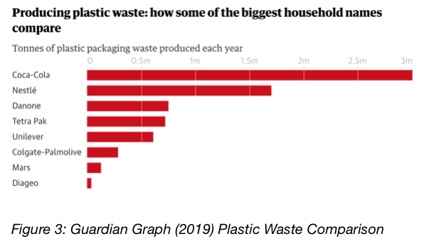
Despite contradicting attitudes towards Coca-Cola, the brand is portrayed as the perfect combination of sincerity and excitement, exaggerating joy and honesty through its social media campaigns and advertisements. (Fabrik 2017) Brand personalities are important for consumers to connect with a brand they can identify with and reflects their personality. In turn, this increases sales for the company. Coca-Cola focus primarily on their branding and packaging which ensures that the brand is universal and is understood across all cultures and languages. (IFP 2017) Indeed, the company has developed a fairly positive reputation to naive eyes, however, they have also proven disloyal to consumers by hiding several less attractive aspects of the brand. One of these involves the packaging used in Coca-Cola’s products. This has a significant environmental impact as they produce 1.3m tonnes of plastic packaging a year. (Sandra Laville, 2019) According to Coca-Cola, their mission over the next ten years is to, “Refresh the world” and “to create value and make a difference.” They also state that they would like to be a “responsible Citizen that makes a difference by helping build and support sustainable communities.” (Coca-Cola Company, 2018) However, the graph above suggests otherwise and proves that Coca-Cola are not fulfilling their promises. In relation to plastic waste, Coca-Cola are producing 1.3m tonnes more each year in comparison in brands such as Nestle (BBC News,2019). According to Nathan Buehler, a reporter for Investopedia, Coca-Cola’s key challenges are to set several sustainable goals by 2020 which included reducing carbon emissions, recycling 75% of the bottles and improving water efficiency (Investopedia,2019). However, this could not potentially be met in the light of the company due to their past reputation of misleading the public. A lawsuit filed in the U.S District Court of Northern California in 2017 alleges that Coca-Cola “engaged in a pattern of deception to mislead and confuse” the public and public health agencies regarding “an attempt to distract consumers attention through the forms of advertisement from their product’s negative attributes” (Healthline,2017).

Chapter 3- How ‘Innocent’ is Coca-Cola?
Introduction
Robert Foley brought to the attention that “brands need to establish a culture of caring and giving in order to give consumers a comfortable feeling which gives them the confidence to express themselves.” (Keith 2014:34) This can be seen in the marketing attempts of Coca-Cola as they make the audience feel special in their own individual way. In Keller and Davey’s opinion, brand awareness is a “way to ensure potential customers, and to see it as the foundation of their equity model” (Kevin Lane Keller,2001). Again, Coca-Cola cleverly interpret this into their marketing and advertising campaigns by ensuring that the audience develop into customers of Coca-Cola through an emotional strategy. These statements have been statistically proven to be true by ‘Causely’ as studies demonstrate that “charitable donations and corporate sponsorships have a positive impact on increased sales, consumer loyalty, and enhanced brand awareness” (Causely,2019).

The Innocent Chain Of Good
Since 2013, Coca-Cola have taken full control of the Innocent drink brand which is considered a healthier alternative in comparison to Coca-Cola (The Journal,2015).
This could be seen as another way Coca-Cola align themselves with a worthy cause due to the fact that Innocent have a connection with their own charity called, “The Innocent Foundation” which allows them to work alongside several different charities across the globe (Innocent Foundaiton, 2019). Since the birth of the brand, charitable given has fundamentally been a part of the business as they aim to prevent deaths and illnesses in children caused by hunger.
An assessment run by the Foundation has proven that roughly “70% of children treated are cured, but only 1 in 5 children affected are able to access the treatment they need” (Innocent Foundation,2019). Innocent claim that “all of their partners have the same core principles and are working together to help communities on a sustainable path to better their lives” (Innocent Foundation, 2014). Richard Reed, co-founder of Innocent states;

According to the Innocent drink CEO’s, the brand “has blossomed since the deal with Coca-Cola four years ago and additionally have been extremely supportive of their mission” (Innocent, 2019). The brands aim was to provide more healthy and natural products to a greater audience, which Coca-Cola have done, and helped protected the brand values in the process” (Innocent, 2019). This resulted in an expansion and a successful relationship between the two companies as Coca-Cola fully supported them by contributing to brand values and giving to charity; culminating a positive aesthetic for Coca-Cola. However, the Innocent team did specifically call attention to the fact that it was completed their ‘Innocent’ way by a “home-grown innocent team” in the “same unique Innocent way” (Innocent Drinks,2019). This was a more excelling path for Coke again as the audience were guaranteed a healthy and nutritious drink, which was still aligned with Coca-Cola. In addition to this, Coca-Cola claim to aim their concerns on an “environmental footprint, to support any active qualities, and to ensure a safe work environment.” (Innocent Drink, 2019) Not only did Coca-Cola promise this, but they also assured an “enhance economic development of the communities where [they] operated.” (Innocent Drink, 2019)
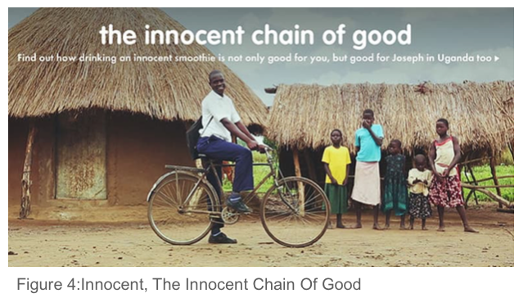
The Art of Conversation 2019 study found that from 300 comments on Innocent's blog to date reveals that; 80% are negative, 10% are positive, combined with 10% neutral responses (Art of Conversation,2016). This is clearly a narrative with a clever concept, as the company combines their positive attributes with a larger, successful corporation with a higher estimated value, which will result in more profit for Innocent and an admirative focus on Coca-Cola. This can also be seen with Body Shop joining L’Oreal, for example. This is a form of merger, more specifically a Product-extension merger. This is where two companies are selling different but related products in the same market (Investopedia 2019). According to Francois Mallette and John Goddard, two authors for Harvard Business Review, “The current cohort of acquisitions goes well beyond the typical defensive, synergy-driven, horizontal integration that marked previous M&A spurts. This tells us businesses aren’t acquiring other businesses simply to expand what they’re already doing. They’re doing it because, strategically, they have to if they want to survive over the medium to long term.” (Harvard Business Review,2019) Therefore, this could be the reason as to why Coca-Cola merged with Innocent as they adopt Innocent’s overall brand values, which involves healthier attributes in comparison to their own, whilst masking their own flaws by covering them with a positively portrayed business. This can be further supported through the advertising campaign which was created in 2014 just after Coca-Cola took over called “The Chain Of Good” (Eat-Marketing, 2014). This emphasises that fact that Innocent smoothies are full of goodness, but also contribute a percentage of profits go towards charities. Figure 4 demonstrates a television advertisement that exaggerates how one man’s Innocent smoothie purchase reaches all the way to Uganda and how a family can benefit from it. This could be; funding education, to purchasing food. This is evidently an extremely powerful message with a great feel good factor, exactly what Coke wanted (Eat- Marketing,2014).

Dealing with Declining Volumes

Elwood Watson, Ph.D. a Professor of History, African American Studies and Gender Studies at East Tennessee State University states that millennials in particular are leading the way in making health-promoting diet and lifestyle choices a priority. As reported by Nielsen, a New York-based international marketing research company, “today’s younger consumers are the most willing to take initiative on behalf of their well-being, and they are prepared to pay premium prices if necessary to achieve their goals” (Nielsan,2019). Due to these factors, beverage volumes have been decreasing over the years which has forced brands such as Coca-Cola and Pepsi to turn to healthier alternatives as they offer them a convenience in terms of marketing (Business Insider, 2018). One of these being water, where they have taken a major push into the growing UK bottled water market under its Glacéau brand (Marketing week,2014).
The New York Professor and long-time food industry activist Marion Nestle claims that;
It is evident that the beverage industry has compensated for a fair amount of television advertisements, bulletin board advertisements, and marketing campaigns. “However, it has also worked to block adverse measure in relation to legislation, influence policy, maintain its popularity among poor and young people, minorities, and undermining public health” (Nestle, 2015).

Within Nestle’s book she studies the marketing around soda drinks and how cleverly they market the brand to manipulate the audience where their persuasive “advertisements are designed to sell happiness. Yet they are not promoting a drink, but on an emotional level, consumers attach to it” (Washington Post, 2015).

Share a Coke Campaign
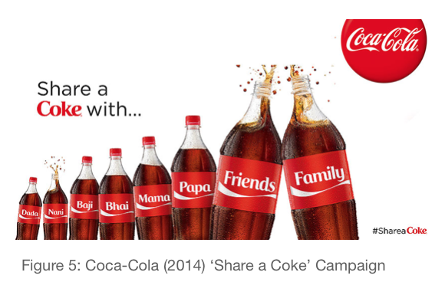
An excellent example to further support Nestle’s opinions is the ‘Share a Coke’ Campaign which was introduced in 2014 where it swapped its iconic logo and replaced it with 250 of the most popular names (Investopedia,2019). This gave the company an opportunity to give consumers a far more personal experience with the brand, as it encouraged them to find bottles with the names they connected with, and to express their individual stories, which in turn, resulted in consumers sharing their experience on social media platforms with the hashtag, ‘shareacoke.’ Furthermore, this resulted in Coke expanding the campaign by increasing the original 250 names to an outstanding 1000 (Tarver,2019). This strategy proved to be extremely beneficial to Coke as they gained an upturn in consumption by 7% amongst young adults. In addition to this, roughly 76,000 virtual Coke cans were shared widely online (Akshay Heble,2019) which resulted in a positive outlook for the brand. Overall, this clearly displays the cleverly designed marketing skills Coca-Cola embed in their advertisements by aligning themselves with consumers in an emotional approach, has lead them to gain an audience advantage as well as profit increase. Therefore, aligning themselves with the consumers has proved to be extremely rewarding.

Environmental Responsibility

As Coca-Cola has grown into a successful brand throughout the years, it has not only altered the current beverage market, but also the environment. Although;

“figures show this growth as a positive, it neglects to factor in environmental effects associated with global growth, such as resource depletion, pollution, and waste. As Coca-Cola has conquered the global beverage market, it must now reassess and take responsibility over its environmental impact of waste management in both water resources and packaging to continue its success into the future” according to Gelsey Hess, Professor at Philadelphia University.

Drinking the World Dry
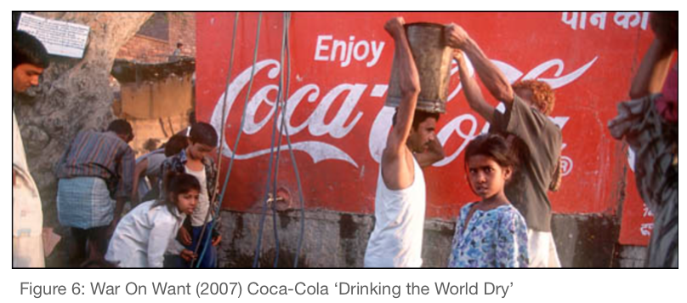
Dr. Asaad Ali Karam,2013 professor at University of Duhok, constructed a case study based on the cultural impact on a brand, particularly the issues around Coca-Cola and India, involving an ongoing drought which has threatened groundwater supplies. Although Coca-Cola is one of the most recognisable brands in the world, these factors aren’t highlighted within their high ethical standards as it is considered a negative aspect. Coca-Cola has been accused of “dehydrating communities through water resources to feed its own plants, drying up farmers' wells and destroying local agriculture.” (War on Want, 2007) In addition to this, the company has breached workers' rights in other countries such as Colombia and Turkey. This is due to the fact that without water it would have no business at all as the process of making relies on access to vast supplies of water (Earth Talk,2019).In an article written in 2004, entitled, “Hills are Alive with Sound of Drilling: Malvern Water Facing Coca-Cola Threat,” it mentions the fear of the company’s proposal to drill for water in the Malvern Hills. “If Coca-Cola were to expand its water-bottling operation, it would remove an additional 20 million litres of water a year from the hills and would require the installation of a 1.7 mile pipeline to retrieve the water” (Hills are Alive with Sound of Drilling). Taking these factors in to consideration and combining them only further suggests Coca-Cola’s attempts to sustain the clear image it desires through the form of cleverly designed, and high budgeted marketing campaigns.

Packaging Pollution
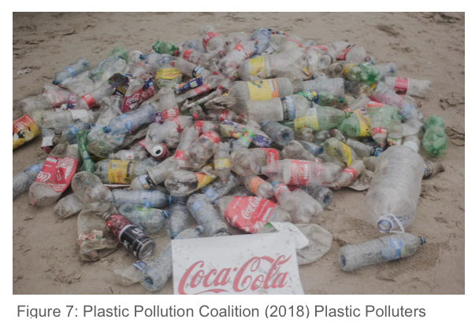
Plastic is commonly described as a durable substance which is incredibly versatile and it is found everywhere in everyday life. The ‘Break Free from Plastic’ organisation have collated hard data, to narrow down the top ten brands responsible for polluting the planet with plastic, where Coca-Cola are at the top of the list with Nestle and Pepsi following closely behind (Break free from Plastic, 2019). “Although there is a lot of controversy based around Coca-Cola as a company, they have begun to address another environmental side effect, which is waste management." An article entitled, The Coca-Cola Company Rolls Out new PlantBottle Packaging discusses the company’s goal of reducing their carbon footprint by tackling packaging. Plant Bottle Packaging is made from at least 30% plant material and is 100% recyclable (The Coca-Cola Company,2019). The plant material is derived from a sugar cane-based ethanol, which is cultivated from an area in Brazil known for its environmental sensitivity (The Coca-Cola Company). This life cycle analysis of the bottle, as well as its origins and manufacturing prove that the bottle is becoming more eco-friendly. They demonstrate that the packaging addresses two factors which are the problem of emissions, along with waste management. “While Plant Bottling Packaging is estimated to eliminate 3 million gallons of gasoline used to produce plastic bottles, it also promotes recycling and a cradle to cradle scenario of the product” (The Coca-Cola Company). Through these actions, we can see that Coca-Cola is beginning to recognise the global environmental impacts of their actions and turning it around for the better. However, these initiatives could possibly be another form of questionable behaviour in order for the company to appear favourable to the public eye.

Chapter 4: Poverty and Equality

The Global Fight Against Obesity

Within the 21st Century the obesity epidemic has been identified as one of the most critical global public health problems. (Int J Health Science, 2007). This is a topic that cannot be ignored as there were “1.9 billion adults overweight or obese globally in 2016, in addition to 340 million obese children. This worked out as nearly 39% of the adult population being overweight (World Health Organisation,2018). One of the many factors contributing to global obesity are things such as lifestyle, level of physical activity and eating and drinking habits. As an example, mood research shows that food can act as a “repair mechanism” which can influence your emotions giving you a feel-good feeling (Mind,2017). According to researchers, another main influence are food and beverage marketers creating on-going marketing and sales techniques such as psychological pricing and discounts which undermine healthier choices (Gertner,2016).
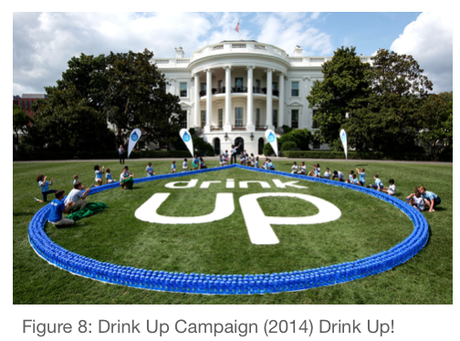
Although the beverage industry is not entirely accountable for its attempts to encourage consumers to purchase more, the public have harshly criticised the soft drink marketers in belief that it plays a big role in sustaining obesity as they are filled with sugar. “Carbonated soft drinks along with tobacco are amongst the few examples of products for which entire industries have been held accountable for their impact on global public health” (Forbes, 2015). An increased public awareness of all of the discussed topics combined has resulted in a decrease of Coca-Cola sales by more than 25% over the past two decades, and under intense pressure Coca-Cola have integrated wellness and the fight against obesity as part of their core mission where they state; “Our products can be part of an active, healthy lifestyle that includes a balanced diet and regular activity” (Coca-Cola Hellenic Bottling Company, 2019). To further support this statement, an interview with Coke’s President - Sandy Douglas confirms that even he limits how many bottles he drinks due to its amount of calories (Iuf,2014). Disregarding Coke’s attempts to fight obesity, only further suggests that the company’s only mission is to compose a positive image for the brand. A prominent figure constantly in the public eye, who the global community has a great deal of respect for is Michelle Obama. The First Lady launched a “Drink up” campaign in 2014, held at the White House which was an effort to encourage and promote healthy choices that focused on water rather than sugary soft drinks. However, Time magazine noted that “many were critical of the fact that instead of vilifying soda companies like Coca-Cola and Pepsi she partnered with them, which seemed contradictory given the direct link from sugary drinks to obesity” (Time,2014). However, what the audience did not realise was that, “every participating company has agreed to only encourage people to drink water — not focus on what people shouldn’t drink” according to Lawrence Soler, president of the Partnership for a Healthier America (ThinkProgress,2013). Once again, Coca-Cola were seen to be aligning themselves to healthy choices in order to portray themselves as superior by collaborating with individuals such as the President of America’s wife.

The Mexicans ‘Dying’ For a Fizzy Drink

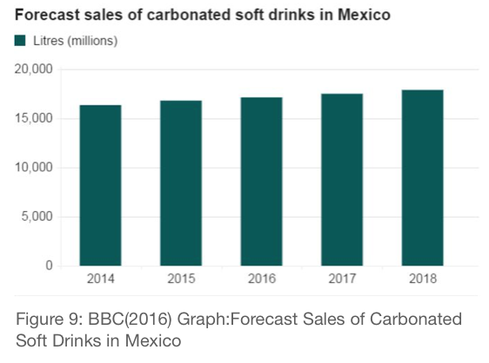
In San Cristobal; one of Mexican’s most rainiest regions, running water is only accessibly once in every two days due to the growing costs. Once this eventually happens, the water is so heavily chlorinated, it is undrinkable. Maria Del Carmen, one of the residents in the area states that, “some neighbourhoods have running water just a few times a week” (Independent, 2018). As a more accessible alternative, residents have been drinking Coca-Cola as it is produced by a local bottling plant. According to the Mexican government, Mexico was the “world’s top per capita consumer of soda in the world, [taking in] 176 litres per person in 2012” (NPR, 2017). As the Coca-Cola consumption has risen in Mexico, so has Type 2 diabetes, and this is continuing to become an issue as it is becoming the leading cause of death within the country, and also the main cost to the health system according to Dr. Carlos Aguilar Salinas, the Vice Head of the Endocrine Department at Mexico’s National Institute of Medical Sciences and Nutrition in Mexico City. Martin Lopez, a local activist who has been involved in the organisation of protests against Coca-Cola emphasises that “ [Coca-Cola] take our pure water, they dye it and they trick you on TV saying that it’s the spark of life, and just take out money and leave” (Independent, 2018). Despite these negative factors, Jose Ramon Martinez (Corporate affairs director for Coca-Cola) claims that the company are beneficial to the country as they are an economic force in San Cristobal by contributing 200 million dollars to the state economy (Independent,2018). However, Laura Mebert a social scientist at Kettering University says that "Coca-Cola pays [little] amount for its water privileges [totalling to roughly] 10 cents per gallons.”(Independent, 2018) This illustrates how little the company actually contributes towards the city, and really it is just a facade. Yet, Martinez rejects all criticism regarding the negative impact on public health and that, “Mexicans may have a genetic proclivity towards diabetes.” (Independent, 2018) However, a graph sourced by the BBC shows otherwise. The sales of carbonated soft drinks within Mexico have only increased throughout the years alongside the increase of diabetes. Nonetheless, if the diabetic gene is common with Latino roots, Coca-Cola have the capability to do everything in their power to help prevent this rather than promote and encourage it. In this aspect, the company seem to be irresponsible, proving that it is a profit driven brand with little or no emotional connection with their consumers.

Poverty and Healthcare within Africa

Bartow Elmore, a professor of U.S. history at the University of Alabama and the author of ‘Citizen Coke: The Making of Coca-Cola Capitalism’ claims that Coca-Cola is responsible for today’s twenty-first Century capitalism, as the history of the company suggests that they need a majority of public resources such as water supplies in order to keep running. He also suggests that, “what make Coke great, was not really what it did, but what it didn’t do” (Elmore,2014). This could be due to the fact that the company used independent businesses as well as local governments in order to fund majority of the production and distribution costs. This can be seen in the developing world of Africa; particularly Sub-Saharan Africa. Coca-Cola is the largest supplier of soft drinks to African markets which is the reason behind Coke’s strategies, as they give local distributors an incentive to keep them selling Coke bottles (New York Times, 1998). Bribery is the key element used within the country as Meshack Malindi, a distributor based in Africa, says, “if he can beat all his rivals to double-digit sales growth, he will win a trip to the soccer World Cup in France this summer” (New York Times,1998). It is clear in this scenario that the main aim is to increase the amount of consumption, which in turn will increase the profits and sales of the company. This has proven to be successful as there are “78 million servings of Coca-Cola consumed in sub-Saharan Africa and sold by 900,000 retail partners” (Janet M. Wojcicki,PhD) which is extremely high given the extensive poverty in this part of the world. However, this is a scenario that is causing trouble for healthcare within the area as “poor oral hygiene is the leading cause of school absenteeism” according to an African Report written by (CNBCAfrica,2017). This is causing the younger market within the country to perform poorly academically and as the oral health along with educational solutions are so low, there is a high chance that it can lead to further oral problems in the future. (CNBCAfrica,2017). It is evident that the company continue malnutrition in this areas but instead of recommending public health measures to prevent tooth decay caused by the soft drink, they hope to include vitamins and minerals into the drink to further increase production (The Atlantic, 2010).
In 2010, The Bill Gates foundation “partnered with Coca-Cola in Uganda to boost the distribution of mango and passion fruit juice as a way to stimulate production of local [fruit juices] to meet Coke’s demand for increased fruit to stimulate sales” (Coca-Cola Economy,2016). This proved to be a successful outcome for Coca-Cola as TechnoServe partnered and set a “goal to double the average income of 50,000 small-scale mango and passion fruit farmers in Uganda and Kenya, and helped them connect into the Coca-Cola supply chain, which they did”(Coca-Cola Economy,2016) As sales in America are rapidly declining, the brand have managed to find a way to protect overall sales by encouraging consumption in the impoverished and malnourished countries such as Africa. However, all the residents need are a secure local food system, access to safe water and primary health care services, not more Coca-Cola.

Conclusion
It is evident that the marketing strategy of Coca-Cola is a long-term, forward-looking approach which involves meticulous planning with the fundamental goal of achieving an overall competitive advantage. The cleverly designed goals help benefit the business by protecting it from negative attributes such as the ones discussed in this essay. There are several advantages that come with aligning themselves with worthy causes such as; building a stronger customer relationship and personal connection with consumers in order to gain profits and sales, increasing the organisations brand value and overall aesthetic. This is an advantage in terms of global competition as they aim to establish its name in several regions. Sub Branding is also a primary activity within Coca-Cola as they create alternative soft drinks such as ‘Diet Coca-Cola’ and ‘Coca-Cola Zero’ which claim to have zero sugar yet it still helps promote the entire brand. Controversy arises when the audience create their own personal meaning of the brand and therefore interpret the message totally parallel to the company’s intention. Each case study that has been focused on is individually contrasting as each campaign, advertisement or marketing strategy varies therefore it is ambiguous to pin-point a specific reason as to why Coca-Cola align themselves with these worthy causes. This could be discussed in even further detail, however what we have come to terms with is that the brand’s advertising and marketing strategy is done with careful consideration and care in order to protect the company’s brand values and aesthetic by portraying a positive outlook, whilst still aiming to get the desired profit and increase global connections.
Bibliography

Books
Barker C. (2004) The SAGE Dictionary of Cultural Studies. London: SAGE Publications Ltd.

Gertner, David, Rifkin, Laura (2017) Coca‐Cola and the Fight against the Global Obesity Epidemic. Wiley Periodicals, Inc.

Hegarty J. (2014) Hegarty on Creativity: There Are No Rules. 1st Ed. n.d. Thames & Hudson Ltd

Marion Nestle (2015) Soda Politics Taking on Big Soda (And Winning) OUP USA; 1st edition edition (12 Nov. 2015)

Journals

Bartow Elmore (2017) How Coca-Cola built a sugary empire, by outsourcing as much as possible.

Denton, D Keith. (2014) Journal of Strategic Innovation and Sustainability; West Palm Beach

Gelsey Hess (2019) Environmental History Journal: The History Of Globalalised Western Diet

Gertner, D., Gertner, A., Araujo, D. V., Bahia, L.,& Bouzas,I. (2016). Calories and cents: Customer value and the fight against obesity. Social Marketing Quarterly

Pediatrics- Janet M. Wojcicki, PhD, MPH and Melvin B. Heyman, MD, MPH (2010) Malnutrition and the Role of the Soft Drink Industry in Improving Child Health in Sub-Saharan Africa.

Online Articles
BBC NEWS (March 2019) ‘Coca-Cola reveals how much plastic it uses’ [ONLINE] Available at: https://www.bbc.co.uk/news/newsbeat-47569233 [Accessed: 17 November 2019]
Building Customer-Based Brand Equity: A Blueprint for Creating Strong Brands [ONLINE] Available at: http://anandahussein.lecture.ub.ac.id/files/2015/09/article-4.pdf Kevin Lane Keller [Accessed 5 December 2019]

Business Insider (May 2018) ‘ People are drinking less Pepsi and Coke than ever — and it reveals the power of the ‘biggest marketing trick of the century’ https://www.businessinsider.com/pepsi-coke-decline-while-bottled-water-grows-2018-5?r=US&IR=T [Accessed 20 November 2019]
Retail Detail (2019) ‘Coca-Cola is the worlds biggest brand’ [ONLINE] Available at: https://www.retaildetail.eu/en/news/food/coca-cola-worlds-biggest-brand-unilever-strongest-manufacturer [Accessed: 21 November 2019].

Campaign Live (2011) Coca-Cola rolls out PlantBottle packaging in UK https://www.campaignlive.co.uk/article/coca-cola-rolls-plantbottle-packaging-uk/1090840 [Accessed: 21 November 2019]

CNBC Africa (2017) Yes, poor oral hygiene has a huge impact on Africa [ONLINE] Available at: https://www.cnbcafrica.com/zdnl-mc/2017/04/13/oral-hygiene-impact-africa/ [Accessed: 20 October 2019].

Forbes (September 26, 2016) ‘ Coca-Cola’s Advertising And Marketing Efforts Are Helping It To Stay On Top’ [ONLINE] Available at: https://www.forbes.com/sites/greatspeculations/2016/09/26/coca-colas-advertising-and-marketing-efforts-are-helping-it-to-stay-on-top/#12312c1728d7 [Accessed: 18 November 2019]

Free Library (2004) ‘The Hills are living with the sound of Drilling’ https://www.thefreelibrary.com/Hills+are+alive+with+sound+of+drilling.-a0125208949 [Accessed: 19 November 2019]

Healthline (January 2017) ‘Lawsuit: Coca-Cola Uses False Advertising to Sell Unhealthy Drinks’
[ONLINE] Available at: https://www.healthline.com/health-news/coca-cola-false-advertising-unhealthy-drinks#1 [Accessed: 18 November 2019]

Huffington Post (January 2017) ‘Younger Consumers Are More Health Conscious Than Previous Generations’ [ONLINE] Available at: https://www.huffingtonpost.ca/timi-gustafson/younger-consumers-are-mor_b_14290774.html?guce_referrer=aHR0cHM6Ly93d3cuZ29vZ2xlLmNvLnVrLw&guce_referrer_sig=AQAAABTGapD56UAQRhOoTYuJIrQS74uyZt7GTjZKtTGe_p52CJcd1t1YsRcnSuUB9E2O74uFT_mqpmu75VDaOQPC1avQwXJrAgfZYhtgJ8_xrfc7oUlnsTmt4O3zznQy4eUwRnV2-fRZ15m96nRK9mzYPTvKLKRmgMwpseYfwL1VpW5T&guccounter=2 [Accessed 19 November 2019]

Independent (2018) ‘Coca-Cola could be causing a diabetes epidemic in this town’ Available at: https://www.independent.co.uk/life-style/health-and-families/features/mexico-coca-cola-health-diabetes-obesity-water-shortage-protest-a8449861.html [Accessed: 23 November 2019]

New York Times (1998) Putting Africa On Coke's Map; Pushing Soft Drinks on a Continent That Has Seen Hard, Hard Times [ONLINE] Available at: https://www.nytimes.com/1998/05/26/business/putting-africa-coke-s-map-pushing-soft-drinks-continent-that-has-seen-hard-hard.html [Accessed 14 October 2019].

NPR (2017) ‘How Diabetes Got To Be The No. 1 Killer In Mexico’ [ONLINE] Available at:
https://www.npr.org/sections/goatsandsoda/2017/04/05/522038318/how-diabetes-got-to-be-the-no-1-killer-in-mexico [Accessed: 30 October 2019].

The Journal (May 3rd 2015) ‘Two years after being sold to Coke, has this company kept its innocence?’ [ONLINE] Available at: https://www.thejournal.ie/innocent-drinks-coca-cola-2073030-May2015/ [Accessed: 20 November 2019]

ThinkProgress (2013) ‘Michelle Obama Wants Americans To Drink More Water, But Still Won’t Go After Big Soda Companies’ Available at: https://thinkprogress.org/michelle-obama-wants-americans-to-drink-more-water-but-still-wont-go-after-big-soda-companies-cc1cc52c908/ [Accessed:22 November 2019].

War History Online (Apr 14, 2019 Jay Hemmings) Coca-Cola: Morphine Replacement And a By Product of the American Civil War [ONLINE] Available at: https://www.warhistoryonline.com/war-articles/civil-war-responsible-coca-cola.html [Accessed: 18 November 2019].

Washington Post ‘I’d like to buy the world a Coke’: The story behind the world’s most famous ad, in memoriam its creator ( May 17,2016) [ONLINE] Available at https://www.washingtonpost.com/news/morning-mix/wp/2016/05/17/id-like-to-buy-the-world-a-coke-the-story-behind-the-worlds-most-famous-ad-whose-creator-has-died-at-89/ [Accessed: 18 November 2019].

Websites
All that is interesting (2019) The secret History of Coca-Cola [ONLINE] Available at: https://allthatsinteresting.com/coca-cola-history [Accessed: 18 November 2019].

A Replication and Extension of a Known Empirical Generalisation [ONLINE] Available at: https://www.marketingscience.info/wp-content/uploads/staff/2015/08/BrandAdvertising.pdf [Accessed: 18 November]

Causely (2019) Why Charitable Giving is Surprisingly beneficial to you business [ONLINE] Available at: https://www.causely.com/blog/why-charitable-giving-is-suprisingly-beneficial-to-your-business [Accessed 19 November 2019]

Digital Vidya- Akshay Heble(2019) Case Study On Coca Cola ‘Share A Coke’ Campaign [ONLINE] Available at: https://www.digitalvidya.com/blog/case-study-on-coca-colas-share-a-coke-campaign/ [Accessed 20 November]

Eat Marketing (2014) The Innocent Campaign 2014 does a chain of good [ONLINE] Available at: https://eat-marketing.co.uk/the-innocent-campaign-2014-does-a-chain-of-good/ [Accessed 19 November 2019]

Fabrik (2017) Brand Personality Examples [ONLINE] Available at: https://fabrikbrands.com/what-your-brand-personality-says-about-you/ [Accessed 21 November 2019].

Health and Wellness (2019) [ONLINE] Available at: https://coca-colahellenic.com/en/sustainability/health-wellness/ [Accessed: 22 November 2019].

History (2010) Santa Claus [ONLINE] Available at: https://www.history.com/topics/christmas/santa-claus [Accessed: 20 November 2019].

Inisights for Professionals (IFP) (2019) Coca-Cola’s Most Powerful Lessons in Branding [ONLINE] Available at: https://www.insightsforprofessionals.com/marketing/leadership/coca-colas-4-most-powerful-lessons-in-branding [Accessed: 20 November 2019]

Innocent Drink (2019) ‘Innocent and Coca-Cola agree deal for further investment’ [ONLINE] Available at: https://www.innocentdrinks.co.uk/us/press/release/130222-innocent-and-coca-cola-agree-deal-for-further-investment [Accessed 19 November 2019]

Innocent Foundation(2014-2019) Imagine a world where no one goes hungry [ONLINE] Available at: https://www.innocentfoundation.org [Accessed 19 November 2019]
Interbrand (2019) Coca Cola Brand Strength [ONLINE] Available at: https://www.interbrand.com/best-brands/best-global-brands/2019/ranking/cocacola/ [Accessed: 16 November 2019].
hg
Investopedia (2019) How Coca-Cola Makes Money [ONLINE] Available at: https://www.investopedia.com/articles/markets/112515/how-does-cocacola-actually-make-money.asp [Accessed: 21 November 2019]

Investopedia (2019) What makes share a coke so successful [ONLINE] Available at: https://www.investopedia.com/articles/markets/100715/what-makes-share-coke-campaign-so-successful.asp [Accessed 21 November 2019]

IJHS (2007) Is Diabetes Becoming the Biggest Epidemic of the Twenty-First Century? [ONLINE] Available at: https://www.ncbi.nlm.nih.gov/pmc/articles/PMC3068646/ [Accessed: 19 November 2019].

Iuf (2014) Coke Confronts Its Big Fat Problem [ONLINE] Available at: http://www.iuf.org/ccww/?q=node/626 [Accessed 23 November 2019].

Mind (2017) Food and Mood [ONLINE] Available at: https://www.mind.org.uk/media/34727115/food-and-mood-2017-pdf-version.pdf [Accessed: 22 November 2019].

Marketing Science (2015) Brand and Advertising Awareness: [ONLINE] Available at: https://www.marketingscience.info/wp-content/uploads/staff/2015/08/BrandAdvertising.pdf [Accessed: November 5 2019].

Research Gate (2013) Cultural Impact on Brand: A Case Study on Coca Cola’s Cultural Issues in India’ [ONLINE] https://www.researchgate.net/publication/291346589_Cultural_Impact_on_Brand_A_Case_Study_on_Coca_Cola's_Cultural_Issues_in_India

The Atlantic (2010) Soft Drinks: A Weapon Against Malnutrition in Africa? [ONLINE] Available at: https://www.theatlantic.com/health/archive/2010/11/soft-drinks-a-weapon-against-malnutrition-in-africa/66775/ [Accessed: 29 October 2019].

Trident (2017) Coca-Cola - A brand that delights at Christmas [ONLINE] Available at: https://www.wearetrident.co.uk/coca-cola-delights-christmas/ [Accessed: 20 November 2019].

War on Want (2007) COCA-COLA: DRINKING THE WORLD DRY [ONLINE] https://waronwant.org/media/coca-cola-drinking-world-dry

World Health Organisation(2018) Obesity and Overweight [ONLINE] Available at: https://www.who.int/en/news-room/fact-sheets/detail/obesity-and-overweight [Accessed: 20 November 2019].

Images
Figure 1 : Coca Cola. (1971) I’d Like to Buy the World a Coke. [Online Video]. 1971. Available from: https://slate.com/culture/2015/05/coca-colas-its-the-real-thing-ad-how-the-mccann-erickson-ad-changed-american-advertising-and-america.html [Accessed: 18 November 2019].

Figure 2: Coca Cola. (2010) Official Holidays are Coming Coca-Cola Christmas Advert 2016 [Online Video] Available from: https://www.youtube.com/watch?v=owVXyuR8JOE [Accessed: 18 November 2019].

Figure 3: The Guardian (2019) Coca-Cola admits it produces 3m tonnes of plastic packaging a year [Article Screen-Grab] https://www.theguardian.com/business/2019/mar/14/coca-cola-admits-it-produces-3m-tonnes-of-plastic-packaging-a-year [Accessed: 20 November 2019)

Figure 4: Innocent (2014) The Innocent Chain of Good [Online Video] https://www.youtube.com/watch?v=LeXgxN24loc [Accessed: 21 November 2019]

Figure 5: Coca-Cola (2014) ‘Share a Coke’ Campaign [Campaign Advertisement] https://www.digitalvidya.com/blog/case-study-on-coca-colas-share-a-coke-campaign/ [Accesse 19 November 2019]

Figure 6: War On Want (2007) Coca-Cola ‘Drinking the World Dry’ [Online Screen-Grab] 2007. https://waronwant.org/media/coca-cola-drinking-world-dry [Accessed: 21 November 2019]

Figure 7: Plastic Pollution Coalition (2018) ‘Coca-Cola, PepsiCo, and Nestlé found to be worst plastic polluters worldwide in global cleanups and brand audits’ [Online ScreenGrab]
https://www.plasticpollutioncoalition.org/blog/2018/10/9/coca-cola-pepsico-and-nestl-found-to-be-worst-plastic-polluters-worldwide-in-global-cleanups-and-brand-audits [Accessed: 21 November 2019].

Figure 8: Drink Up Campaign (2014) Drink Up! First Lady, Michelle Obama [Online Screengrab] https://obamawhitehouse.archives.gov/photos-and-video/video/2014/07/22/drink-first-lady-michelle-obama [Accessed: 10 November 2019].

Figure 9: BBC (2016) Forecast Sales of Carbonated Soft Drinks in Mexico [Online] https://www.bbc.co.uk/news/magazine-35461270 [Accessed 12 November 2019].

Reports

Greenpeace Philippines (2017). Branded, Vol. II Identifying the World’s Top Corporate Plastic Polluters [ REPORT NO. 02- 01]

Keller, K. L. and Davey, K.K. (2001). Building Customer-Based Brand Equity: A Blueprint for Creating Strong Brands [REPORT NO. 01-107]

Pan American Health Organisation (2012) Health in the Americas. Country Volume [REPORT no.441]

