

MSc Computer Networks and Cyber Security

Security Analysis Techniques
and Procedures - ACCA 7030

by
Helen Frey | 1252724

Lecturer: Associate Professor Carlene Campbell

Table of Contents

Abstract 7
TASK ONE: Penetration Testing on a Live Website 8
1. Introduction 8
2. Literature Review 8
2.1 Black Box Penetration Testing 8
2.2 Pentest Standards Organization 8
2.3 Shodan 8
2.4 Nmap 9
2.5 OWASP ZAP 9
3. Defining Scope 9
4. Contingency Planning 9
5. Start and End Dates 9
6. Penetration Test 10
6.1 Reconnaissance & Footprinting 10
6.2 Using IP Address to Gain Access to Website 11
6.2.1 Error Codes 12
6.2.2 Network Attributes 12
6.2.3 Defacing/Altering the Website 13
6.2.4 Changing Attributes 15
6.2.5 Cookie Poisoning 15
6.3 Shodan 16
6.4 Scanning with Nmap 20
6.4.1 Nmap scanning for open ports 20
6.4.2 Nmap Banner Grab 21
6.4.3 Nmap Vulnerability Scan 22
6.4.4 Nmap Sitemap Generator 23
7. OWASP ZAP 24
8. Wafw00f 28
9. Results 28
10. Conclusion 29
Appendix 1: Rules/Guidelines and Test Exclusions 30
Appendix 2: Results of NMAP Vulnerability Scan 31
Appendix 3: List of Vulnerabilities and Solutions 32
Appendix 4: Report to Healios-Pharma 34
Table of Contents 35
1. Introduction 36
2. Scope 36
3. Tools 37
4. Industry Standards 37
5. Methodology 37
5.1 Scope 37
5.2 Contingency Planning 37
5.3 Start and End Dates 38
5.4 Reconnaissance and Footprinting 38
5.5 Website 38
5.6 Shodan 39
5.7 NMAP 40
5.8 OWASP ZAP 40
5.9 WafW00f 40
6. Recommendations 41
7. Invoice 43
TASK 2: Research into Cybersecurity Incident and Defensive Technique Case Study 44
1. Introduction 44
2. Background 44
3. Assumptions 45
4. Literature Review 45
4.1 Forensic Investigation Process 46
4.2 Pre-Investigative Phase 46
4.2.1 Chain of Custody Form 46
4.2.2 Evidence labels 47
4.2.3 Preservation of Physical Evidence 48
4.2.4 Collection of Evidence 49
4.3 Tools 50
4.3.1 Forensic Tool Kit (FTK) 50
4.3.2 The Sleuth Kit (TSK), incorporating Autopsy 50
4.3.3 Kali GNU/Linux Rolling 50
4.3.4 Oracle Virtual Box VMWare 50
4.4 Data Analysis and Reporting 50
Conclusion 50
Appendix 1: Forensic Report for HPC 51
1. Executive Summary 53
2. Introduction 53
3. Background 53
4. Pre-Investigative Phase 53
5. Investigation 54
5.1 Tools 54
5.1.1 Forensic Tool Kit (FTK) 54
5.1.2 Oracle VirtualBox v6.1.26 54
5.1.3 Kali Linux 2021.3 Debian 64-bit Virtual Machine 54
5.1.4 Recuva version 1.53.1087 54
5.2 Chain of Custody 54
5.3 FTK 55
5.4 Oracle Virtual Box 57
5.5 Kali Linux/Recuva 58
6. Conclusion 61
Appendix 2: Invoice 62
Bibliography 63

Table of Figures
Figure 1: HPC Officials 11
Figure 2: Address Information from Whois 11
Figure 3: Data collected regarding HPC’s registrar and servers 12
Figure 4: Insecure Website 12
Figure 5: Error Codes 13
Figure 6: Network Requests are not blocked 14
Figure 7: Healios Heading Normal 14
Figure 8: Blacking out background 15
Figure 9: Before Colour Change 15
Figure 10: After Colour Change 16
Figure 11: Attributes were changed 16
Figure 12: Cookie Data 17
Figure 13: Shodan result showing ports 80 and 443 open 17
Figure 14: Shodan Result showing port 443 18
Figure 15: SSL Certificate 18
Figure 16: Website vulnerabilities 1 19
Figure 17: Vulnerabilities 2 20
Figure 18: Vulnerabilities 3 21
Figure 19: Nmap showing ports 80 and 443 open 22
Figure 20: Nmap results of Banner Grab 22
Figure 21: Nmap Sitemap Generator Results 24
Figure 22: JQuery Library Vulnerability 25
Figure 23: Passive X-Frame-Options Header 26
Figure 24: No Anti-CSFR Token 26
Figure 25: Cookie Without SameSite Attribute 27
Figure 26: Server Leaks Information 27
Figure 27: X-Content Type-Options Header Missing 28
Figure 28: Suspicious Comments 28
Figure 29: Firewall detection using Wafwoof 29
Figure 30: Evidence Chain of Custody Form [18] 48
Figure 31: Evidence Labels [19] 49
Figure 32: best practice in digital evidence collection - modified to incorporate live volatile data collection [22] 50

List of Tables
Table 1: List of Vulnerabilities and Exploits Possible 23

Abstract
With cyber-attacks getting more media exposure, organizations are becoming more aware of possible security issues that they may be exposed to. Penetration testers are experts that test security features of an organization, albeit less destructively than a real attacker, to discern what vulnerabilities, if any, their systems have that would allow it to be breached by an attacker.
Task One outlines the methods and tests made whilst performing a penetration test on Healios Pharmaceutical Company. There is an accompanying report outlining the vulnerabilities found and the proposed solutions.
Task Two follows a forensic examination to recover a document destroyed by an ex-employee. It sets out the forensic methodology and recovery processes together with the results in a report to Healios Pharmaceutical Company.

TASK ONE: Penetration Testing on a Live Website

Introduction
Organizations are becoming more aware of the cybercrimes perpetrated due to a lack of security practices. Ethical penetration testing can be used by organizations to evaluate their network infrastructure by simulating attacks in the same way an unauthorized attacker (or hacker) would. This penetration test is done using strict guidelines that are agreed by both parties in writing beforehand. Once the weaknesses have been detected security measures can be implemented [1]–[3].
Healios Pharmaceutical Company (HPC) is an organization that is concerned that there may be vulnerabilities within their network and has asked that CEAC Cybersecurity and Forensics Ltd (CCFL) conduct a penetration test on their website and a written report on the results is required. HP has not given CCFL any information regarding the company apart from the name of their website making it a black box penetration test.

Literature Review

2.1 Black Box Penetration Testing
There are various types of penetration testing depending on how much information is given beforehand. In white box testing the full network system and credentials are shared with the tester whereas in black box testing the tester has no information except the name of the organization. This is the most authentic type of test. It is also noteworthy that the organization’s IT department are usually unaware that a test is going to be carried out [2].

2.2 Pentest Standards Organization
In 2009 a group of information security practitioners came together to create a Penetration Testing Execution Standard in the United States. Whilst this is not yet an official standard, it does lay out baseline methods within the industry which will be used as a guide to conduct the penetration test on Healios Pharmacy [3].

2.3 Shodan
Shodan is a search engine for engineers and developers that harvests publicly available information about devices that are directly connected to the Internet rather than the World Wide Web. The queried devices range from desktops to traffic light systems to nuclear power plants [4].

2.4 Nmap
Nmap is the de facto standard tool that scans networks using IP packets to ascertain what devices are connected to any network and can also provide details about the operating systems and services running on the network [3], [5].

2.5 OWASP ZAP
OWASP Zap is an open-source dynamic application security testing tool which is used to find vulnerabilities in web applications [6].

Defining Scope
A written agreement has been entered into outlining the scope of the penetration test and the Rules/Guidelines are set out in Appendix 1.
HPC has asked for a black box penetration test meaning that the usual questions such as ‘are there any devices in place that may impact the test’ have not been asked.

Contingency Planning
The organization’s services must be maintained whilst the penetration test is conducted. Therefore, a contingency plan will be put in place as follows:
- Tests on critical systems will be carried out after regular operating hours
- Backups and restoration points have been carried out before the penetration test [7]

Start and End Dates
HPC has asked that work be carried out over the weekends to ensure that the services remain available should there be any tests carried out on critical systems that may fail [8], [9]. Testing would start in November and be finalised by December 2021.

Penetration Test

6.1 Reconnaissance & Footprinting
The website (https://healios-pharma.com/) was visited to ascertain what information was readily available. The Chairman, the Chief Scientific Officer and the Chief Digital and Technology Officer were found (figure 1).
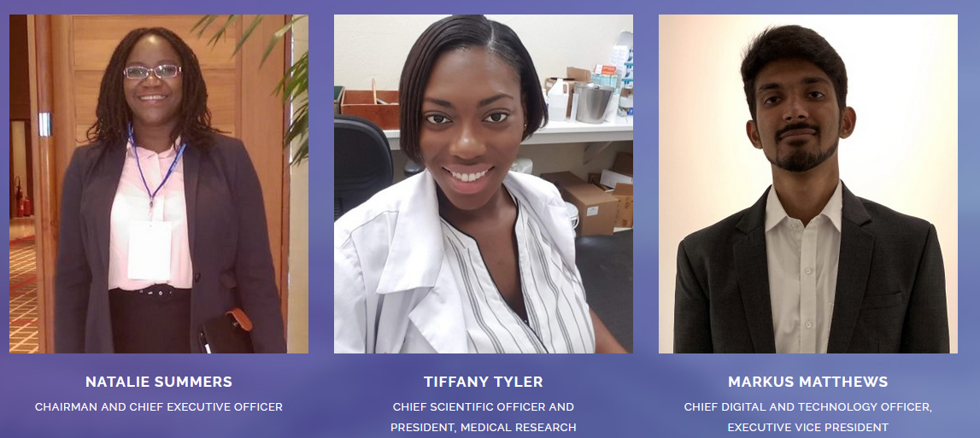
Figure 1: HPC Officials
Searches were carried out for these HPC officials using Facebook Linked-In and Twitter to no avail.
The IP address 13.126.252.213 and the physical location was found using SmartWhois as shown in figure 2.
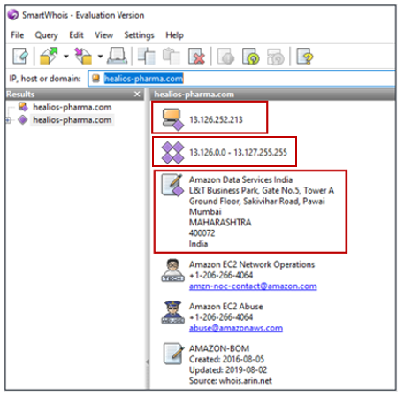
Figure 2: Address Information from Whois
The IP addresses in figure 2 were run through Whois and the Name Servers being used by HPC were found as shown in figure 3 (.org, .co.uk, .com and .net).
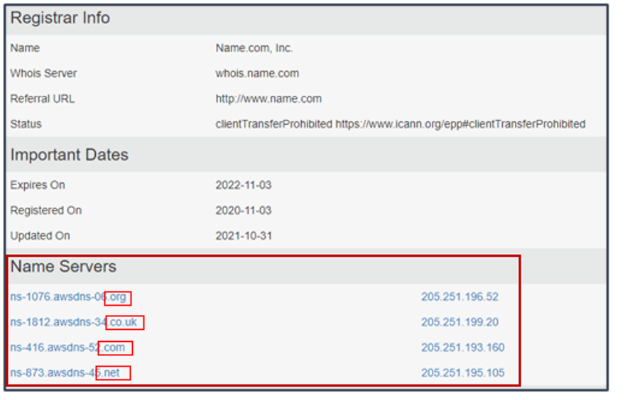
Figure 3: Data collected regarding HPC’s registrar and servers

6.2 Using IP Address to Gain Access to Website
Once the IP address was found, it was used to gain access to the website. This showed that the website is ‘not secure’ as illustrated in figure 4.
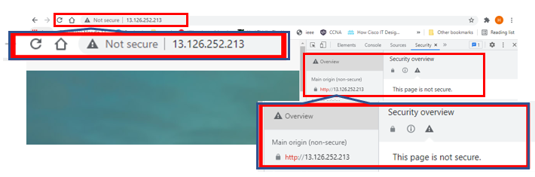
Figure 4: Insecure Website

6.2.1 Error Codes
Looking at the Console area of the HTML, there are 3 error codes where DevTools have failed to load – one for bootstrap.min.css.map, one for assets/js/popper.js.map and content for assets/js/bootstrap.min.js.map (figure 5).
This information allows the attacker to know some of the directories available within the system.
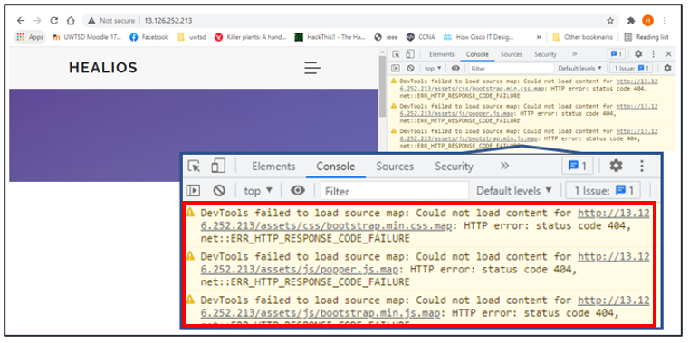
Figure 5: Error Codes

6.2.2 Network Attributes
There are no network access control lists in place as figure 6 demonstrates that the network requests have not been blocked.
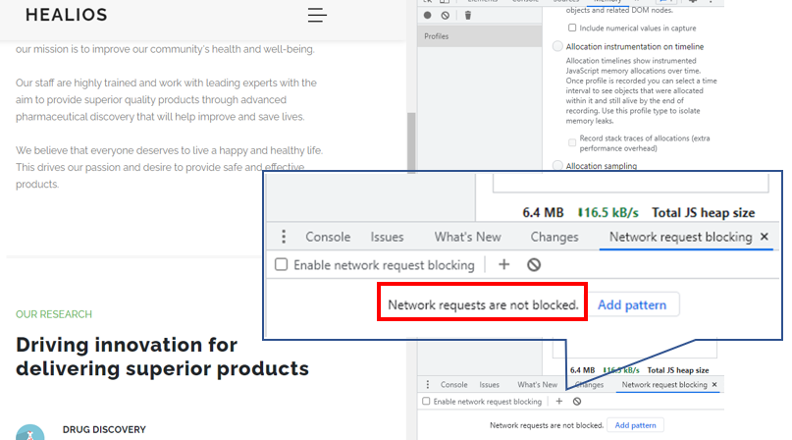
Figure 6: Network Requests are not blocked

6.2.3 Defacing/Altering the Website
The next step was to see whether any of the website features could be changed using the HTML or CSS. Figure 7 shows the HTML code before access.
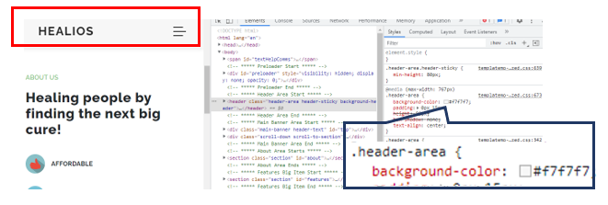
Figure 7: Healios Heading Normal

Figure 8 shows that the background colour of the header has been changed to black, thereby removing the name and defacing the website.
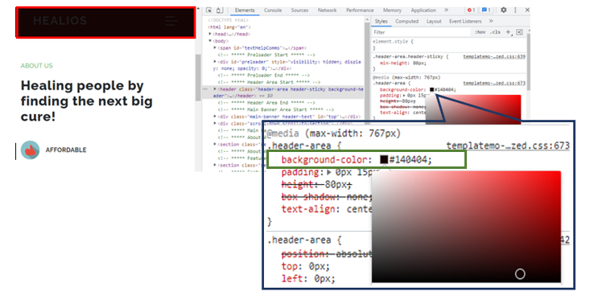
Figure 8: Blacking out background

The next alteration was to change the colour of the font. A contrast colour was used for illustrative purposes. Figure 9 shows the before image and figure 10 the after image.
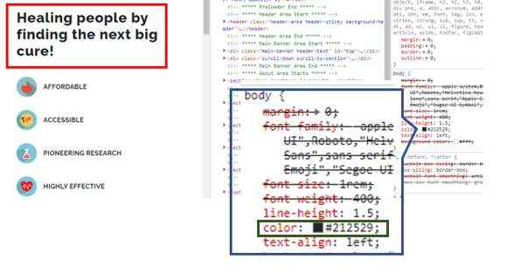
Figure 9: Before Colour Change

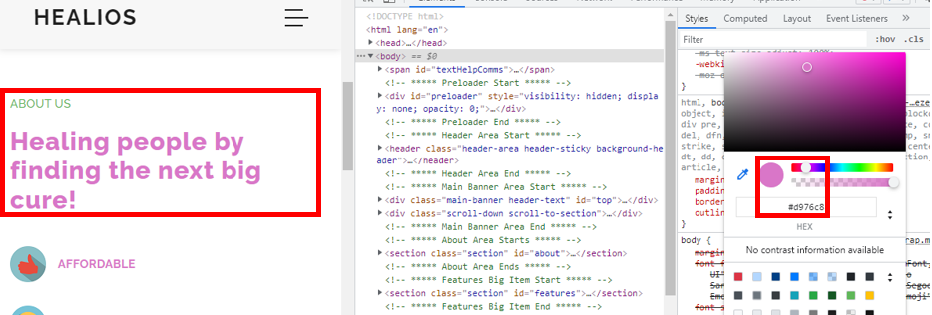
Figure 10: After Colour Change

6.2.4 Changing Attributes
Some attributes were changed to show that it was possible as shown in figure 11.
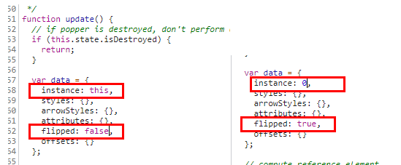
Figure 11: Attributes were changed

6.2.5 Cookie Poisoning
The website is showing the cookie data. Allowing the cookie data to be visible can allow an unauthorized person to manipulate them and gain access to user data stored in cookies. This will allow for a cookie poisoning attack through cross-site scripting. This is done by inserting malicious script in the page so that it sends the session cookies or every visitor to the page to them, thus gaining access to the user data. This can be mitigated by installing an SSL Certificate.
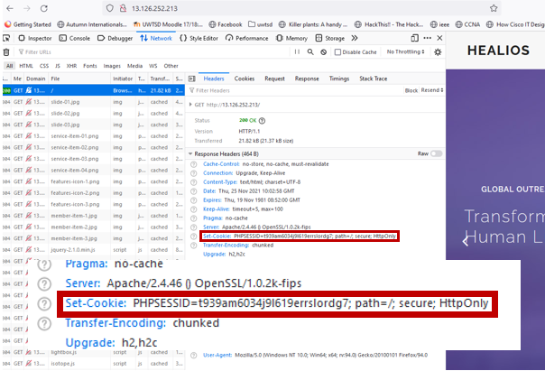
Figure 12: Cookie Data

6.3 Shodan
Shodan was run to ascertain what ports, if any, were open. Port 80 and 443 were open as illustrated in figures 13 and 14. Although open, these port states do not allow incoming traffic unless it is in a specific response to outgoing traffic. They would however be useful for data exfiltration.
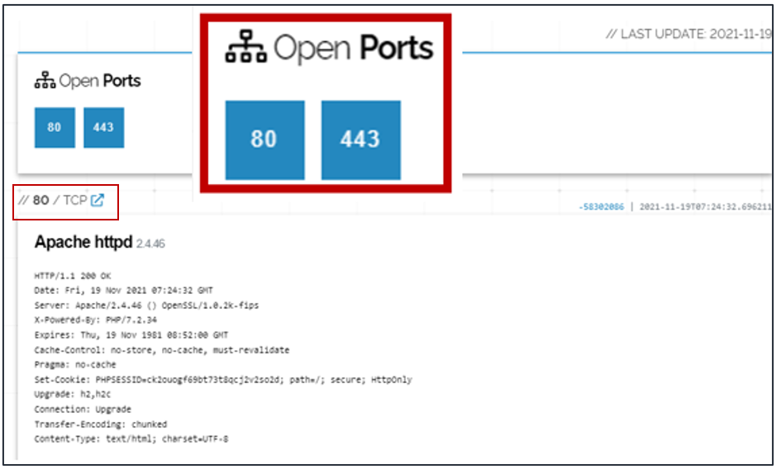
Figure 13: Shodan result showing ports 80 and 443 open

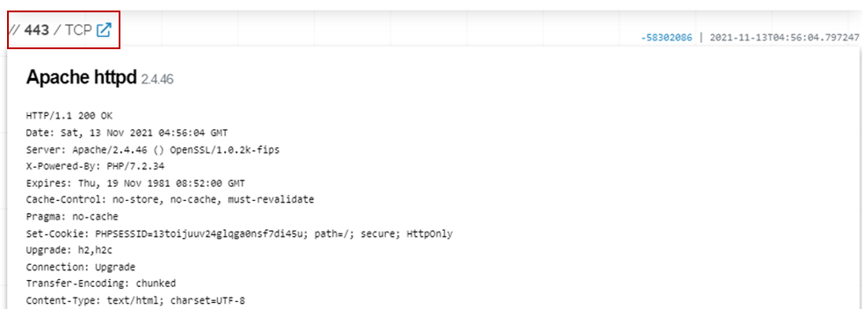
Figure 14: Shodan Result showing port 443

Shodan also investigated the Secure Socket Layer (SSL) as illustrated in Figure 15. This allowed for the encryption method to be found – SHA256. The website uses a public key algorithm of RSA encryption with a 2048-bit RSA public key.
An email address was noted ie. root@ip-172.31.44.145 which could be used to attempt to gain access to the emails using a brute force password cracker.
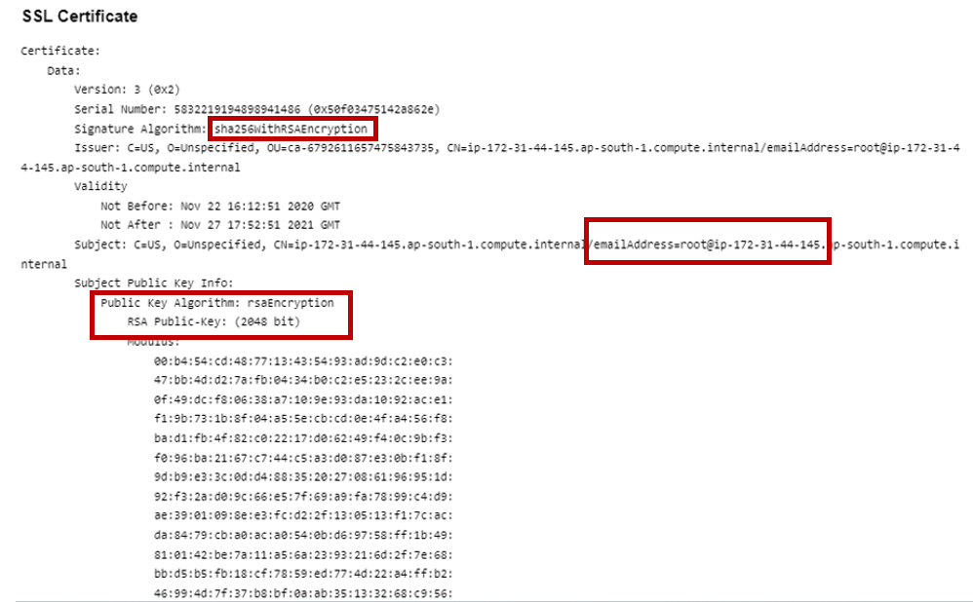
Figure 15: SSL Certificate

Vulnerabilities were found as set out in Figures 16-18 and Appendix 3.
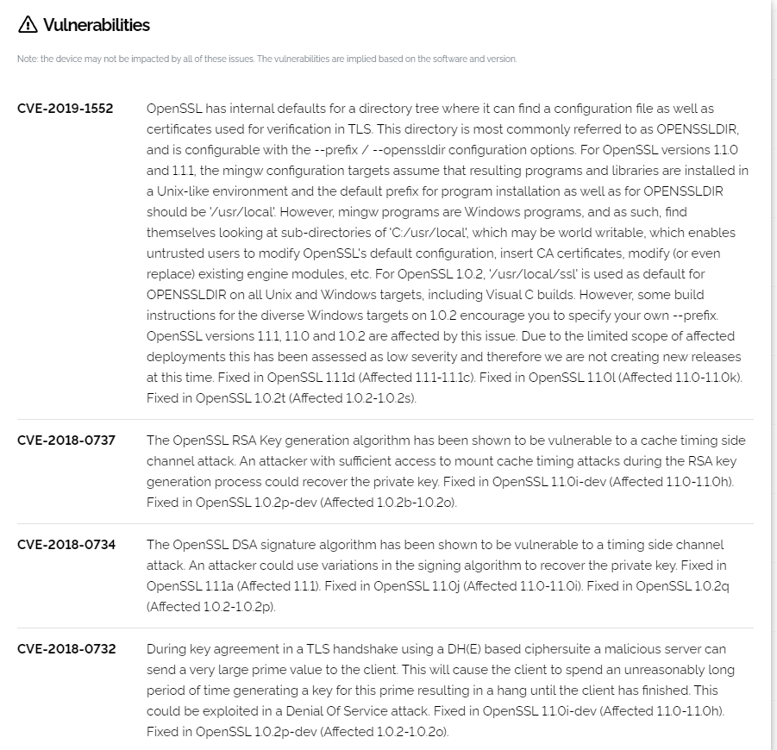
Figure 16: Website vulnerabilities 1
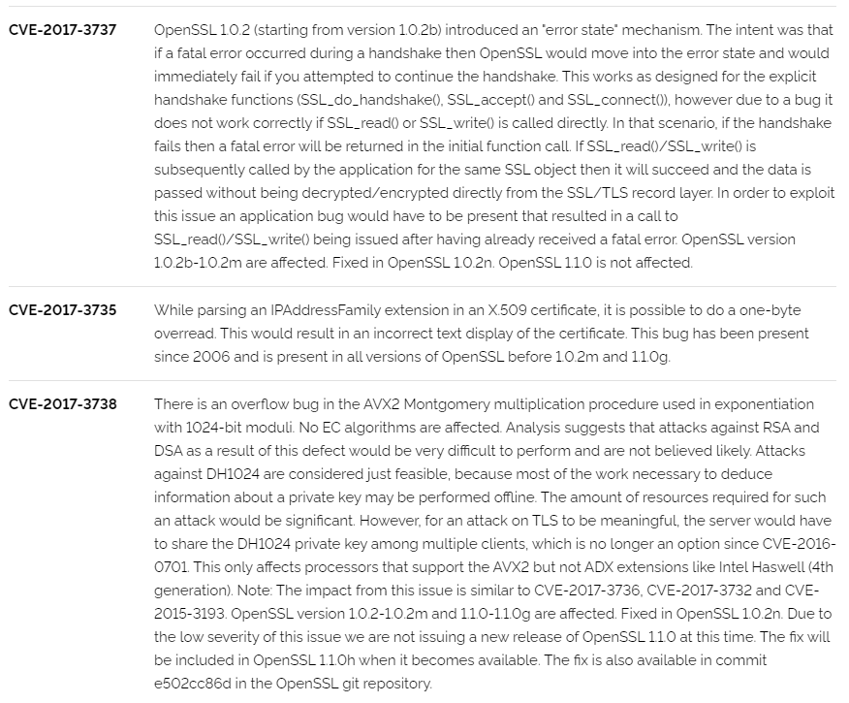
Figure 17: Vulnerabilities 2

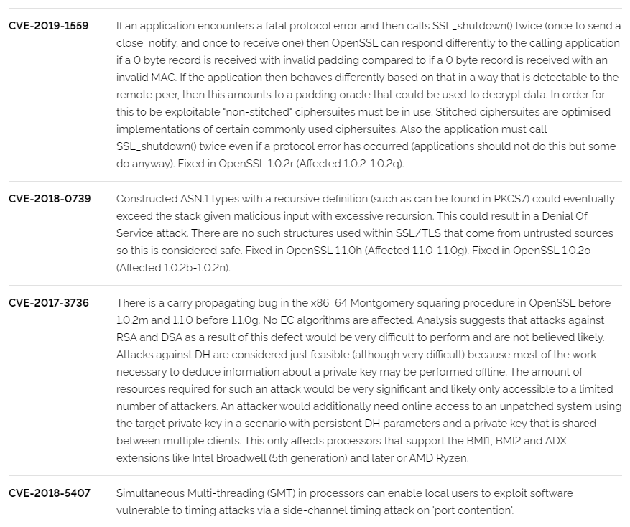
Figure 18: Vulnerabilities 3

6.4 Scanning with Nmap

6.4.1 Nmap scanning for open ports
Nmap was used to see whether this tool could find different ports that were open. However, it too only found ports 80 and 443 as detailed in figure 19.
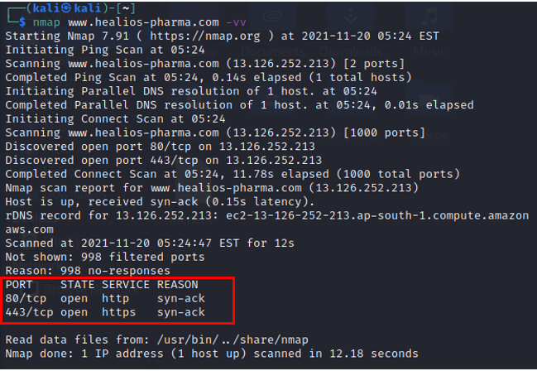
Figure 19: Nmap showing ports 80 and 443 open

6.4.2 Nmap Banner Grab
A banner grabbing scan was made and the results show that Apache 2.4.46 was being used.
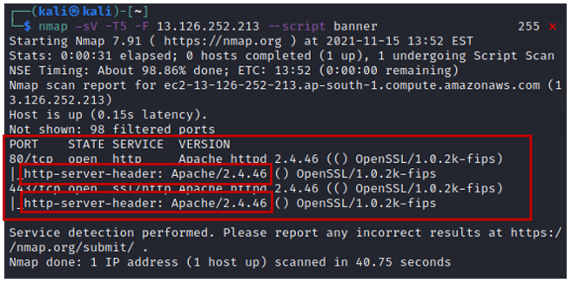
Figure 20: Nmap results of Banner Grab
This website uses Apache 2.4.46 and according to [10]under CVE-2021-40438 states that:
A crafted request uri-path can cause mod_proxy to forward the request to an origin server chosen by the remote user. This issue affects Apache HTTP Server 2.4.48 and earlier [10].
This vulnerability can be exploited remotely, so it would need to be patched.

6.4.3 Nmap Vulnerability Scan
A vulnerability scan was run on Kali against 13.126.252.213 the main vulnerabilities are listed below in Table 1 and in Appendix 3. The majority of these vulnerabilities can be fixed by updating Apache to version 2.4.51.
cpe:/a:apache:http_server:2.4.46:
CVE-2021-39275 7.5 | https://vulners.com/cve/CVE-2021-39275
CVE-2021-26691 7.5 | https://vulners.com/cve/CVE-2021-26691
FDF3DFA1-ED74-5EE2-BF5C-BA752CA34AE8 6.8 https://vulners.com/githubexploit/FDF3DFA1-ED74-5EE2-BF5C-BA752CA34AE8
*EXPLOIT*
CVE-2021-40438 6.8 | https://vulners.com/cve/CVE-2021-40438
CVE-2020-35452 6.8 | https://vulners.com/cve/CVE-2020-35452
CVE-2021-36160 5.0 | https://vulners.com/cve/CVE-2021-36160
CVE-2021-34798 5.0 | https://vulners.com/cve/CVE-2021-34798
CVE-2021-33193 5.0 | https://vulners.com/cve/CVE-2021-33193
CVE-2021-30641 5.0 | https://vulners.com/cve/CVE-2021-30641
CVE-2021-26690 5.0 | https://vulners.com/cve/CVE-2021-26690
CVE-2020-9490 5.0 | https://vulners.com/cve/CVE-2020-9490
CVE-2020-13950 5.0 | https://vulners.com/cve/CVE-2020-13950
CVE-2019-17567 5.0 | https://vulners.com/cve/CVE-2019-17567

Table 1: List of Vulnerabilities and Exploits Possible

6.4.4 Nmap Sitemap Generator
A sitemap scan was run against 13.126.252.213 and the files used, by extensions can be found in figure 21 below.
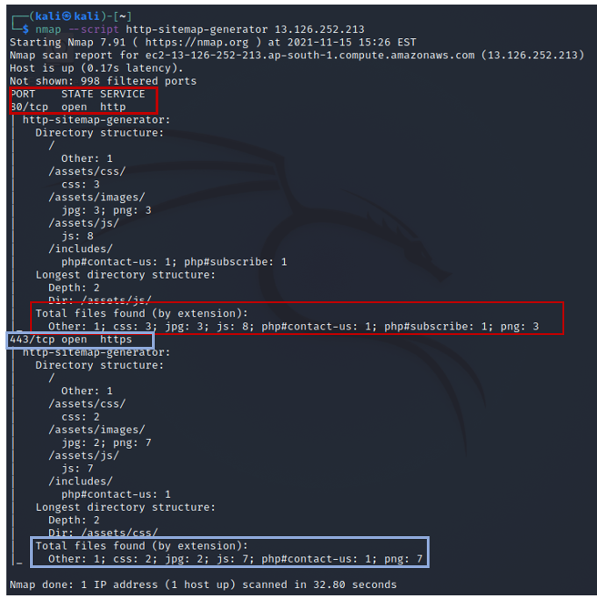
Figure 21: Nmap Sitemap Generator Results

OWASP ZAP
OWASP Zap was used to investigate the website for vulnerabilities. See figures 22-28 below. They were: JQuery Library, Passive X-Frame-Options Header, No Anti-CSFR Token, Cookie Without SameSite Attribute, Server Leaks Information, X-Content Type-Options Header Missing and Suspicious Comments. The explanation and solutions to these vulnerabilities can be found in Appendix 4, chapter 6.
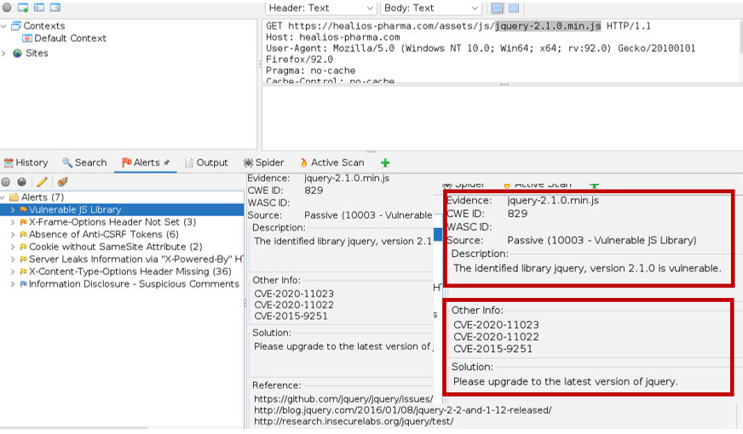
Figure 22: JQuery Library Vulnerability

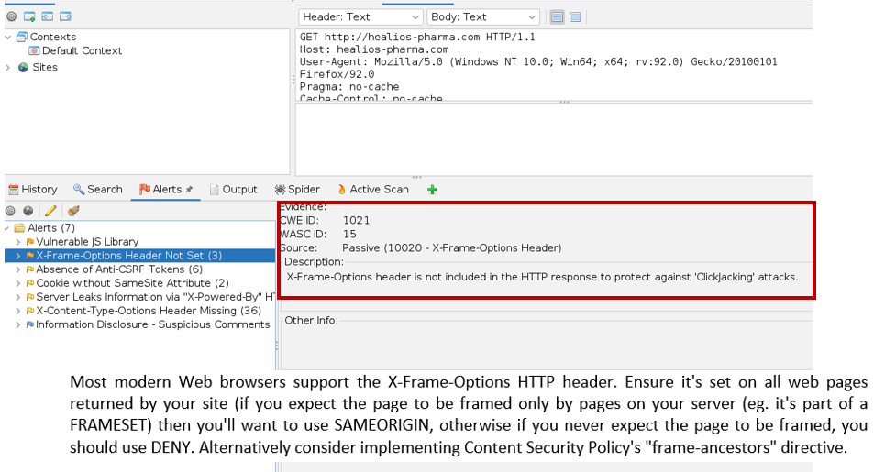
Figure 23: Passive X-Frame-Options Header

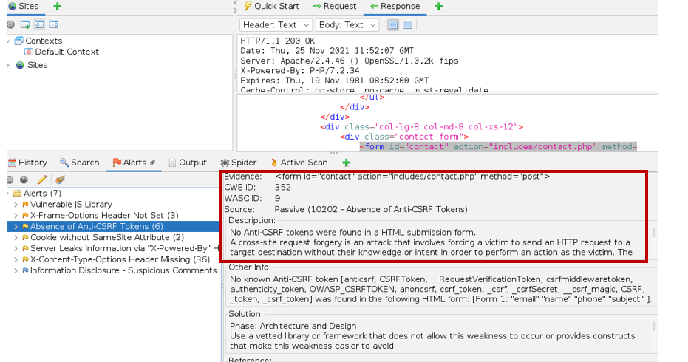
Figure 24: No Anti-CSFR Token

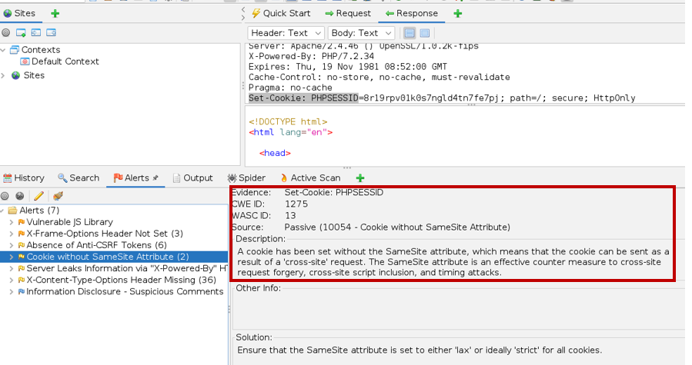
Figure 25: Cookie Without SameSite Attribute

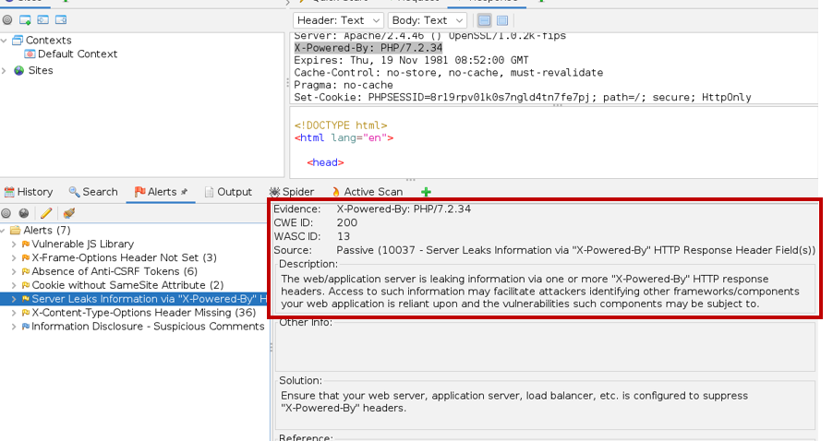
Figure 26: Server Leaks Information

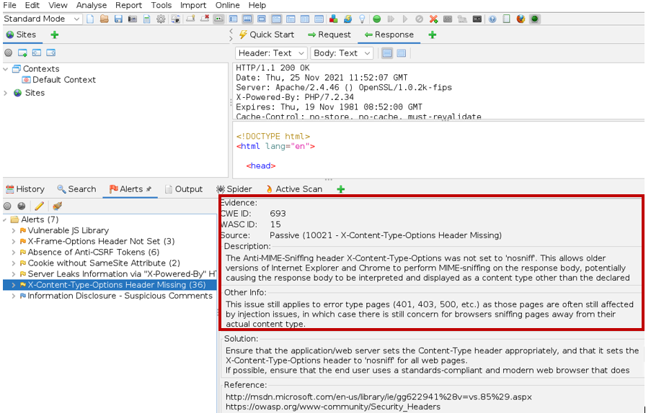
Figure 27: X-Content Type-Options Header Missing

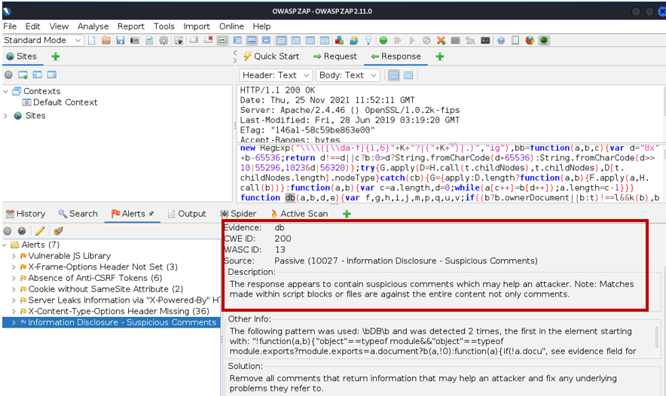
Figure 28: Suspicious Comments

Wafw00f
Wafw00f is a tool that is used to detect whether Web Application Firewalls are in place. Figure 29 shows that there are no Web Application Firewalls detected, and this is therefore a vulnerability that will need to be addressed.
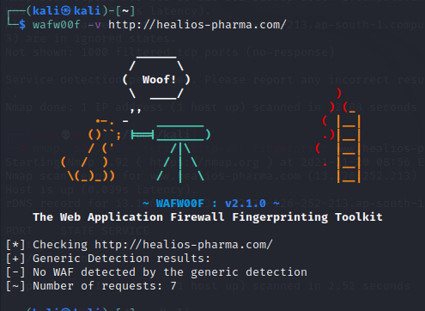
Figure 29: Firewall detection using Wafwoof

Results
- The IP Address, the physical location and the Name Servers were found using SmartWhois (6.1).
- The IP Address was used to gain access to the Website where it was found to be ‘not secure’ (6.2).
- Error codes were found on the website illustrating what directories were available on the system (6.2.1).
- There are no network access control lists in place – the network has not been blocked (6.2.2)
- The website was able to be modified and defaced (although according to the scope this was not allowed so any changes were for illustration purposes and the changes were reversed immediately) (6.2.3).
- Website attributes were also changed (6.2.4).
- Cookie Poisoning (6.2.5) – use an SSL Certificate.
- Shodan demonstrated that Ports 80 and 443 were open (6.3).
- Ports 80 and 443 were found to be open using Nmap although no incoming traffic is usually allowed through these ports – only return traffic (6.4.1).
- A banner scan showed that Apache 2.4.46 was being used (6.4.2).
- A vulnerability scan showed that this version of Apache allowed for many vulnerabilities to be exploited (6.4.3).
- OWASP Zap illustrated many vulnerabilities (7).
- WafWoof was used to determine that no Web Application Firewalls were in place (8).

Conclusion
From the results it can be seen that there are vulnerabilities on the website. A report created for HPC can be found in Appendix 4 which encompasses the vulnerabilities and the steps recommended to mitigate against them.

Appendix 1: Rules/Guidelines and Test Exclusions
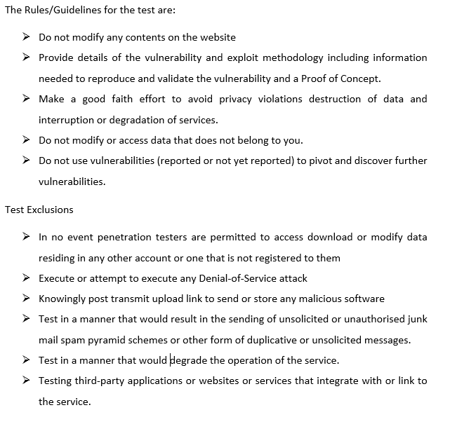

Appendix 2: Results of NMAP Vulnerability Scan
NMAP Vulnerability Scan on 13.126.252.213
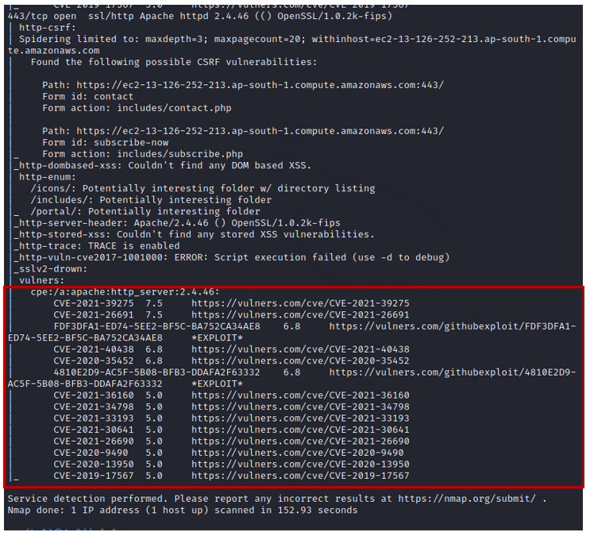

Appendix 3: List of Vulnerabilities and Solutions
Vulnerability | Problem | Solution
CVE-2019-1552 | OpenSSLDIR allows untrusted users to modify Open SSL’s default configuration, insert CA certificates. | Patch using OpenSSL 1.0.2t
CVE-2018-0737 | OpenSSL RSA key generation algorithm is vulnerable to cache timing side channel attack. | Patch using OpenSSL 1.0.2p-dev
CVE-2018-0734 | The OpenSSL DSA signature algorithm is vulnerable to a timing side channel attack. | Patch using OpenSSL 1.0.2q
CVE-2018-0732 | During the TLS handshake a very large prime value can be sent to client allowing for a Denial-of-Service attack. | Patch using OpenSSL 1.0.2p-dev
CVE-2017-3737 | OpenSSL has error state mechanism. Could allow for decrypted text. | Patch using OpenSSL 1.0.2n
CVE2018-5407 | Simultaneous Multi-threading in processors can enable local users to exploit software vulnerable to timing attacks via a side-channel timing attack on port-contention
CVE-2021-39275 | Ap_escape_quotes may write beyond end of buffer when given malicious input. | Patch Apache server
CVE-2021-40438 | A crafted request uri-path can cause mod_proxy to forward the request to an origin server chosen by remote user. | Patch Apache server
CVE-2021-36160 | Can allow mod_proxy_uwsgi to read above allocated memory and crash (Denial-of-Service attack). | Patch Apache server
CVE-2021-34798 | Malformed requested cause server to dereference a NULL pointer. | Patch Apache server
CVE-2021-33193 | A crafted method sent through HTTP/2 will bypass validation – allowing for request splitting or cache poisoning. | Patch Apache server
CVE-2020-9490 | A cache-digest header in HTTP/2 request would crash the server. | Configure HTTP/2 server feature via H2Push off.

Appendix 4: Report to Healios-Pharma

CEAC Cybersecurity and Forensics Limited

Penetration Test
Carried out on Healios Pharmaceutical Company

December 2021

Table of Contents

1. Introduction 37
2. Scope 37
3. Tools 38
4. Industry Standards 38
5. Methodology 38
5.1 Scope 38
5.2 Contingency Planning 38
5.3 Start and End Dates 39
5.4 Reconnaissance and Footprinting 39
5.5 Website 39
5.5 Shodan 40
5.5 NMAP 41
5.6 OWASP ZAP 41
5.7 WafW00f 41
6. Recommendations 42
7. Invoice 44

Introduction
This report will set out the information ascertained in the black-box penetration test (the Test) conducted on Healios Pharmaceutical Company’s (HPC) website at their request. It will document the steps taken and the results together with the recommendations and invoice.

Scope
The scope of the Test was to determine whether HPC’s website was vulnerable to attacks and to expose any weaknesses and document the results. The rules/guidelines and testing exclusions are outlined in figure 1.
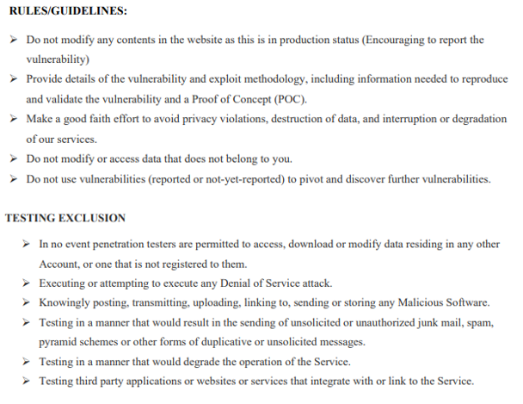
Figure 1: Rules/Guidelines and Testing Exclusions

Tools
The tools used were as follows:
- SmartWhoIs
- Oracle Virtual Box
- Kali-Linux
- Shodan
- Nmap
- Wafw00f

Industry Standards
Best practices were followed using the industry standard best practices that include the General Data Protection Regulations United Kingdom (GDPR-UK), the National Institute of Technology (NIST) and the Pentest Standards Organization.

Methodology
- The scope of the test will be defined.
- Contingency planning will be considered.
- Start and end dates will be determined.
- Reconnaissance and Footprinting will be implemented.
- Testing will be executed.
- A report will be generated.
- Recommendations will be made.

5.1 Scope
The rules/guidelines and testing exclusions were documented between CEAC Cybersecurity and Forensics Limited (CCFL) and Healios Pharmaceutical Company (HPC) and signed by both parties.

5.2 Contingency Planning
Contingency planning was put in place to ensure that the services provided by HPC would not be disrupted in any way by the Test. It was decided that tests on critical systems were to be carried out after regular operating hours and that backup and restoration points were created before the start of the Test.

5.3 Start and End Dates
The Test would commence in November 2021 and be finalised before the end of December 2021.

Reconnaissance and Footprinting
SmartWhoIs was used to discover the Internet Protocol address (IP Address) of Healios-Pharma.com together with the physical location as illustrated in figure 2.
Figure 2: IP Address and Physical Location

5.5 Website
The IP Address was used to gain access directly to the website without going through a Domain Name Server. This showed that the website is unsafe ie. the website can be modified as shown in figure 3.
Figure 3: Website Not Secure
Taking into consideration the testing exclusions, minor alterations were made for illustrative purposes but were immediately returned to the original layout as shown in figure 4 where the heading has been put into black to make it unreadable.
Figure 4: Website Change

Shodan
Shodan was used to test the IP Address to see if any ports were in an ‘open’ state. The results show that both Port 80 and Port 443 were in fact open.
Figure 5: Open Port

NMAP
Nmap was used to create a banner grab that revealed that Apache 2.4.46 was being used (figure 6). This is outdated with many vulnerabilities and should be replaced with version 2.5.51 which has mitigated the vulnerabilities.
Figure 6: NMAP showing Apache version 2.4.46

OWASP ZAP
OWASP ZAP found many vulnerabilities and they are set out together with the solutions in Recommendations below.

5.9 WafW00f
Waffw00f was used to detect the use of Web Application Firewalls. The results, shown in figure 7 illustrate that none were found.
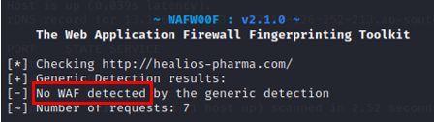
Figure 7: WafW00f detects a lack of Web Application Firewalls

Recommendations
The following vulnerabilities were found, and the following recommendations are advised to ensure that the website is no longer vulnerable to any of these attacks:
Vulnerability Issue | Solution
The website is not secure. | Use HTTPS without a redirect of use HSTS.
No Network Access Control Lists | Create Network Access Control Lists
Cookie Poisoning | Use an SSL Certificate.
Use of Apache 2.4.46 | Update to Apache 2.5.51
No Web Application Firewall | Put a Web Application Firewall in place
The JS Library (JQuery) runs version 2.1.0 which is vulnerable. | Upgrade to the latest version of JQuery.
Passive X-Frame-Options Header. The X-Frame-Options header is not included in the HTTP response to protect against Clickjacking attacks – where the attacker deceives users into clicking malicious links. | Ensure the X-Frame-Options is set on all web pages using SAMEORIGIN or use DENY. Alternatively, implement Content Security Policy’s “frame Ancestors” directive.
Absence of Cross-Site Request Forgery (CSFR) Tokens are a low to medium risk – they are used to prevent Cross-Site Scripting Forgeries. | Phase: Architecture and Design – use a vetted library/framework to mitigate this.
Set-Coookie-PHPSESSID means that there is no SameSite attribute. This can allow for Cross-Site request forgery, cross-site script inclusion and timing attacks. | Ensure that the SameSite attribute is set to lax or strict for all cookies.
X-Powered by PHP/7.2.34 is the web/application server is leaking information via one or more X-Powered-By HTTP response headers which may allow attackers to identify other components of the web application. | Ensure the web, application server etc is configured so that it suppreses X-Powered-By headers.
The Anti-MME Sniffing header was not set to ‘nosniff’ which is vulnerable to Multipurpose Internet Mail Extension sniffing allowing users to upload content to the website. | Set the Content-Type header to ‘nosniff’ for all web pages.
Passive Information Disclosure – return information gives information that may assist an attacker. | Remove all comments that give return information and fix underlying issues relating to them.
Table 1: List of Vulnerabilities and Solutions

Invoice

Invoice
CEAC Cybersecurity and Forensics Ltd

Date: 20 December 2021
Invoice Number: 21-5076
Healios Pharmaceutical Company
L&T Business Park, Gate No 5, Tower A, Ground Floor
Sakivihar Road, Pawari, Mumbai
Maharashtra
400072, India

Description | Price
Standard Penetration Test  on Healios-Pharma.com website | £3,000
 | £3,000
VAT at 20% | £600
TOTAL | £3,600

TASK 2: Research into Cybersecurity Incident and Defensive Technique Case Study
Abstract
Computer forensics is the science of preserving, retrieving, acquiring and present data that has been electronically processed. The purpose is to provide unbiased evidence to form a conclusion without assigning innocence or guilt. This assignment will set out the steps and procedures taken to recover documentation that was destroyed by a former employee of Healios Pharmaceutical Company.

Introduction
Forensic investigators are trained to use specialised tools that can recover data forensically and forensic examiners independently analyse this evidence to provide logical, unbiased data and give an expert evaluation of the history of the artefacts found and from these provide a logical explanation of what took place and when [11]–[13].
The management of digital evidence is crucial as it can be fragile. There are systematic and legal procedures that assist with keeping the integrity of the data intact [11].
CEAC Cybersecurity and Forensics Ltd (CCFL) was engaged by Healios Pharmaceutical Company (HPC) following the destruction of documentation by their employee. The document was crucial to the company, worth approximately $3 million, and had not been ‘backed-up’ since the final version had been created. CCFL’s brief was to recover the deleted file using forensic methodology. This assignment will set out the procedures taken to recover the document.

Background
- CCFL’s policy was that documents would be stored in MS Word or RTF and critical documents were stored as pdf.
- The employee’s actions were discovered one week after they had left the company.

Assumptions
- HPC will want to take their employee to court.
- CCFL is using Windows OS.

Literature Review
Digital forensics is:
The use of scientifically derived and proven methods towards the preservation, collection, validation, identification, analysis, interpretation, documentation and presentation of digital evidence derived from digital sources for the purpose of facilitating or furthering the reconstruction of events found to be criminal or helping to anticipate unauthorized actions shown to be disruptive to planned operations [1].
The goal is to find facts to recreate the truth of an event by examining the tell-tale artifacts left on a digital device when it has been used, whether this is by a document being altered or a website visited [2],[13]. Digital forensics relies on the interpretation of the data and information retrieved by tools and the procedures and principles are basically similar irrespective of the type of investigation performed [1].
However, using tools is not sufficient, there must be an understanding of how data is stored in a computer system to be able to apply the scientific methodology required [3]. All data is stored on media, eg. hard disk drives, external hard drives, USB flash driver etc. as a string of binary digits (bits) with a value of either one or zero and just one number incorrectly recorded can cause files to be corrupted [4].
Data is stored in orderly patterns on sectors of a drive and a map of sectors tell the computer what sectors are free, and which are in use. In Windows the sector map is called a File Allocation Table (FAT). When data needs to be stored, the map is interrogated and the computer then stores the data on a free portion. Once a file has been deleted, the map considers the space free by removing a pointer in the FAT. Until it has been overwritten, this data can be retrieved [5].

4.1 Forensic Investigation Process
According to [6] there are 8 distinct phases to a forensic investigation process:
- Search Authority
- Chain of custody
- Imaging/Hashing Function
- Validated Tools
- Analysis
- Repeatability (Quality Assurance)
- Reporting
- Possible Expert Presentation
These can be categorised in three separate phases, the Pre-Investigation, the Investigation and the Post-Investigation phase.

4.2 Pre-Investigative Phase
The pre-investigative phase involves getting as much information as possible before setting out to the crime scene so that the correct tools are selected. In some cases, for example, Faraday bags may be required to block alteration of wireless devices by blocking remote wiping which is done by preventing signals from being sent or received [7].
Regarding volatile data, ie. data that has been stored temporarily and would be lost should power be removed, a ‘live’ examination is required. This volatile data is usually stored in Random Access Memory (RAM) [15].
Persistent data can be found even when the device has been powered off and is usually held in a memory card or hard drive.
All legal prerequisites, such as search warrants and company security, health and safety procedures should be in place before the examination commences [11], [16].

4.2.1 Chain of Custody Form
A Chain of Custody Form should be created. This is a legal document recording the movement of the ie. it governs the acquisition, testing and storage of the evidence and contains that date, time and location together with the name/job title of the person handling it. This information is imperative to prove the integrity should it be required in a court of law [17].
The form also contains information pertaining to the evidence state for example, if it was switched on/off or in sleep mode etc. An example Chain of Custody Form can be found in figure 30.
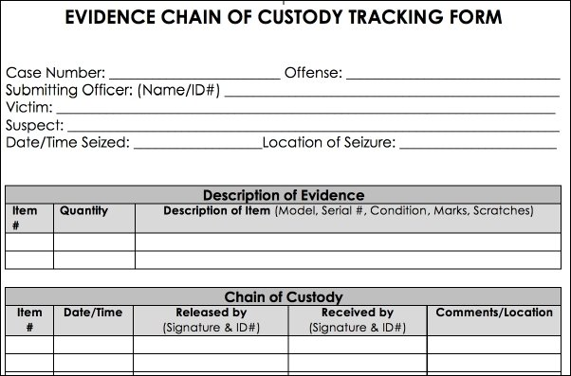
Figure 30: Evidence Chain of Custody Form [18]

4.2.2 Evidence labels
Labels are used to tag individual items and are referenced according to the file and evidence type used by the forensic laboratory.
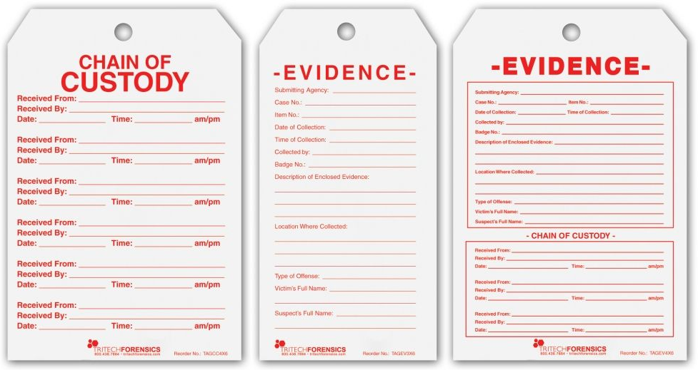
Figure 31: Evidence Labels [19]

4.2.3 Preservation of Physical Evidence
Physical evidence covers a large scope of evidence from computers to cables, removable media etc. The preservation of the integrity of physical evidence is important. Wearing gloves whilst handling the evidence prevents contamination [20], [21].
[22] recommends that the following steps be taken:
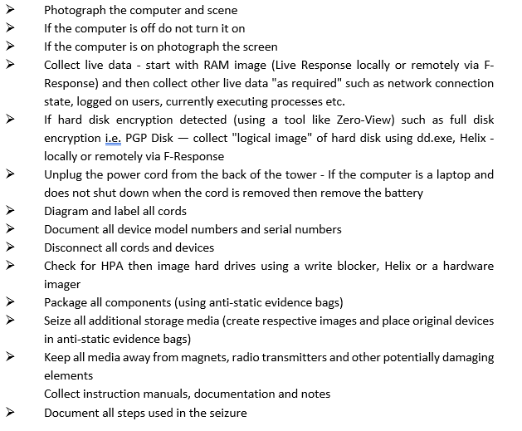
Figure 32: best practice in digital evidence collection - modified to incorporate live volatile data collection [22]

4.2.4 Collection of Evidence
The recovery of data should be conducted by trained personnel and the chain of custody document updated accordingly. The evidence is transported to the forensic laboratory where the extraction/copy of the data is initiated [23].
Forensically sterile equipment is used to create a disk image ie. the digital device is duplicated using a bit-by-bit procedures which is an identical copy of the original, including the partitions and operating systems [20], [22], [23].
A program, using a mathematical algorithm, eg. Hash Calc is used to calculate the checksum of the original disk before the copy and the copy is then verified against the original to ensure that data integrity has been maintained [24].
Write blockers, either hardware or software, are used to ensure that no additional information is added to the disk either before, during or after the copying process.

4.3 Tools
Tools are used to extract the evidence before it can be analysed.

4.3.1 Forensic Tool Kit (FTK)
FTK is software, developed by Access Data specifically for computer forensics and provides investigators which amalgamates many common forensic tools [25].
4.3.2 The Sleuth Kit (TSK), incorporating Autopsy
TSK is open source and supports Linux, Mac and Windows file systems [26].

4.3.3 Kali GNU/Linux Rolling
Kali GNU is an open source set of digital forensic software tools maintained by Offensive Security. This software provides many common tools.

4.3.4 Oracle Virtual Box VMWare
Oracle is an open source virtualisation environment tool providing forensic investigators with a forensically sterile environment.

Data Analysis and Reporting
This section is the investigative and post-investigative phases.
Once the forensic acquisition is completed an analysis of the disk image is initiated.
Following the collect and analysis of all the data/artefacts a report is made based on the findings [22].

Conclusion
Using the forensic methods outlined above, an investigation was made into the documents deleted from HPC’s system. The investigation together with the results can be found in Appendix 1. An invoice for the work can be found in Appendix 2.

Appendix 1: Forensic Report for HPC

CEAC Cybersecurity & Forensics Limited

Digital Forensic Report
for
Healios Pharmaceutical Company

Case Number: 20210579
December 2021

Table of Contents

1. Executive Summary 56
2. Introduction 56
3. Background 56
4. Pre-Investigative Phase 56
5. Investigation 57
5.1 Tools 57
5.1.1 Forensic Tool Kit (FTK) 57
5.1.2 Oracle VirtualBox v6.1.26 57
5.1.3 Kali Linux 2021.3 Debian 64-bit Virtual Machine 57
5.1.4 Recuva version 1.53.1087 57
5.2 Chain of Custody 57
5.3 FTK 58
5.4 Oracle Virtual Box 60
5.5 Kali Linux/Recuva 61
6. Conclusion 64
Invoice 65

Executive Summary
Case number 20210579 is the report for Healios Pharmaceutical Company following the deletion of a document by a company employee that contained a formula worth approximately $3 million. This report documents the steps taken by CEAC Cybersecurity & Forensics Limited to recover the document, which was a success.

Introduction
This report was created for Healios Pharmaceutical Company (HPC) following an incident at their Headquarters when a file was deleted by one of their employees. CEAC Cybersecurity & Forensics Limited (CCFL) were engaged to find and recover the deleted file.

Background
One of HPC’s research scientist that was working on a $3 million formula became a disgruntled employee and left the company. On 1 December 2021, before leaving the company they destroyed the document containing the formula.
Unfortunately, the formula had not been backed up on to the company’s server due to previous technical issues.
The fact that the formula and other critical documentation had been destroyed did not come to light until a week after the employee left the company ie 7 December 2021. HPC’s IT department were unable to resolve the issue and contacted CCFL to investigate the matter and attempt to recover the deleted formula.

Pre-Investigative Phase
A discussion between CCFL and the IT was held to ascertain where the deleted formula was situated. This allowed the investigator to prepare for the search. A contract was entered into allowing CFFL to search the computers to find the deleted documents – no search warrant was required.

Investigation

5.1 Tools

5.1.1 Forensic Tool Kit (FTK)
FTK was created by Access Data. It enables bit-by-bit copies of evidence files to be created allowing the original to remain intact. Bit-by-bit copies were used in conjunction with a write blocker that permits the files to be copied but not altered in any way [27].

5.1.2 Oracle VirtualBox v6.1.26
Oracle virtual machine is cross-platform software that allows virtual machines to be created that run different operating systems on the same computer [28].
This system allows digital forensic examiners to undertake their examination in a sterile environment [29].

5.1.3 Kali Linux 2021.3 Debian 64-bit Virtual Machine
Kali Linux is an open source project maintained by Offensive Security that includes tools aimed at penetration testing and security auditing. Creating a virtual Kali Linux machine allows for non-invasive procedures to be carried out on copies of the evidence [30], [31].

5.1.4 Recuva version 1.53.1087
Recuva is an application created to restore/recover deleted files from hard drives or storage devices [32], [33].

5.2 Chain of Custody
A chain of custody form was created as follows:
Location | Item No. | Date | Description | Investigator
IQ Building,  SA1 8AH | 2021-1301/1 | 28/11/2021 | Dell Optiplex  Serial number: 2548734698 | Mrs Helen Frey

Item Number | Date/Time | Held by | Released to | Comments/location
2021-1301/1 | 07/12/2021  09.45 | Derek Philips | Helen Frey | Swansea  The handover for forensic examination was made. The Dell machine was off at the time of handover.
2021-1301/1 | 07/12/2021  10.30 | Helen Frey |  | Forensic Laboratory  Disk Image created and mounted on Virtual Machine.
2021/1301/1 | 07/12/2021  17.00 | Helen Frey | Laboratory safe | Held in safe whilst work was performed on the copy

5.3 FTK
An image was taken of the original hard drive using FTK as shown in Figures 1-4.
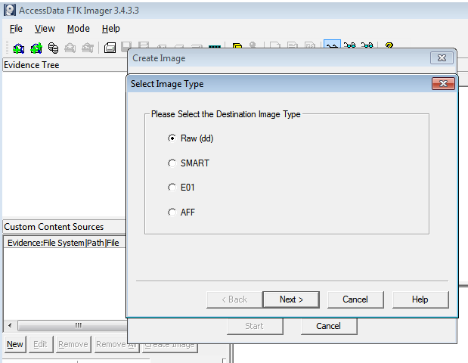
Figure 1: FTK Creation of Bit-by-Bit copy of evidence

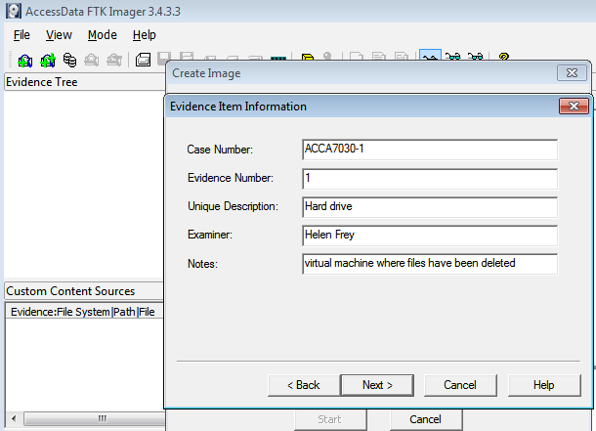
Figure 2: Evidence Item Information
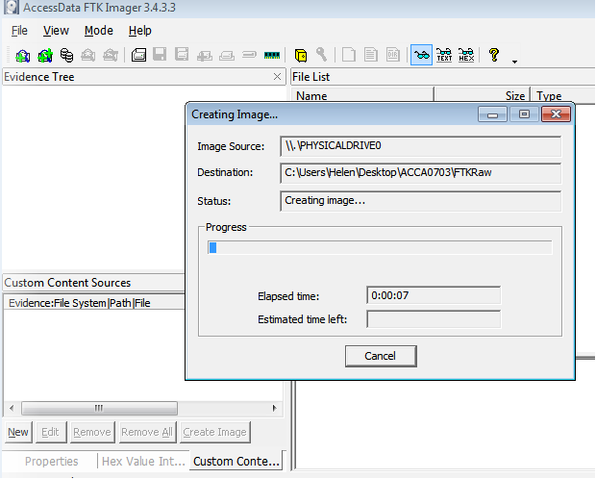
Figure 3: Creation of the Image

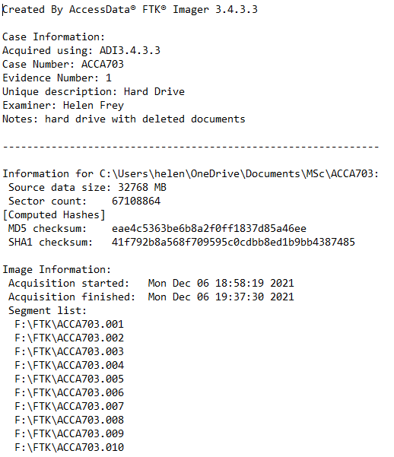
Figure 4: FTK Image

5.4 Oracle Virtual Box
A virtual machine was created in Oracle VM VirtualBox using Kali Linux to enable the evidence to be forensically analysed as shown in Figure 5.
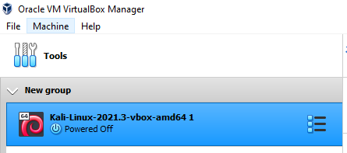
Figure 5: Kali Linux Machine in Oracle VM VirtualBox

5.5 Kali Linux/Recuva
The virtual Kali Linux machine was used to run Recuva. Figures 6-11 show the processes taken to recover the documents.
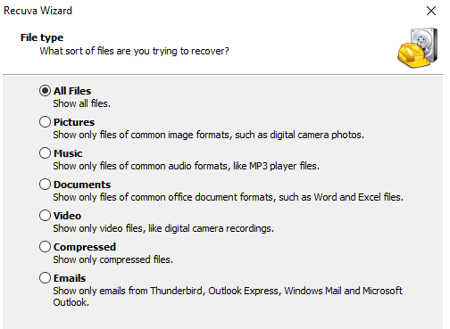
Figure 6: Recuva Set up 1
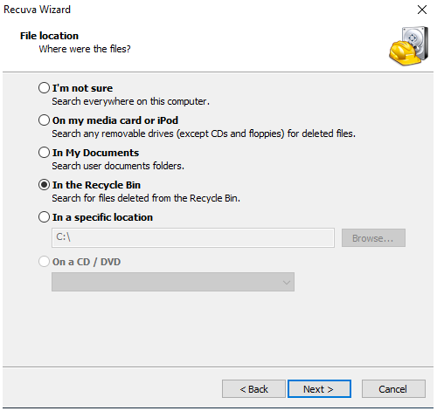
Figure 7: Recuva Set up 2
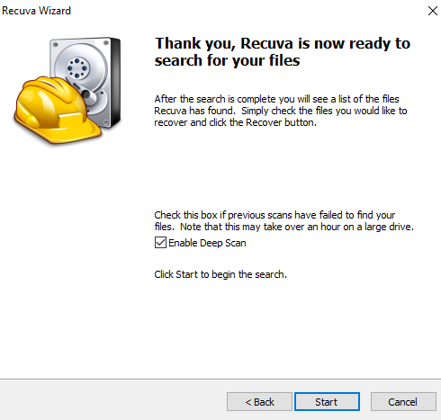
Figure 8: Recuva Set up 3
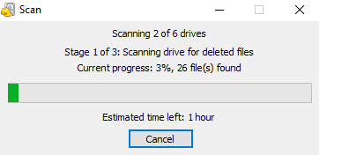
Figure 9: Recuva Running

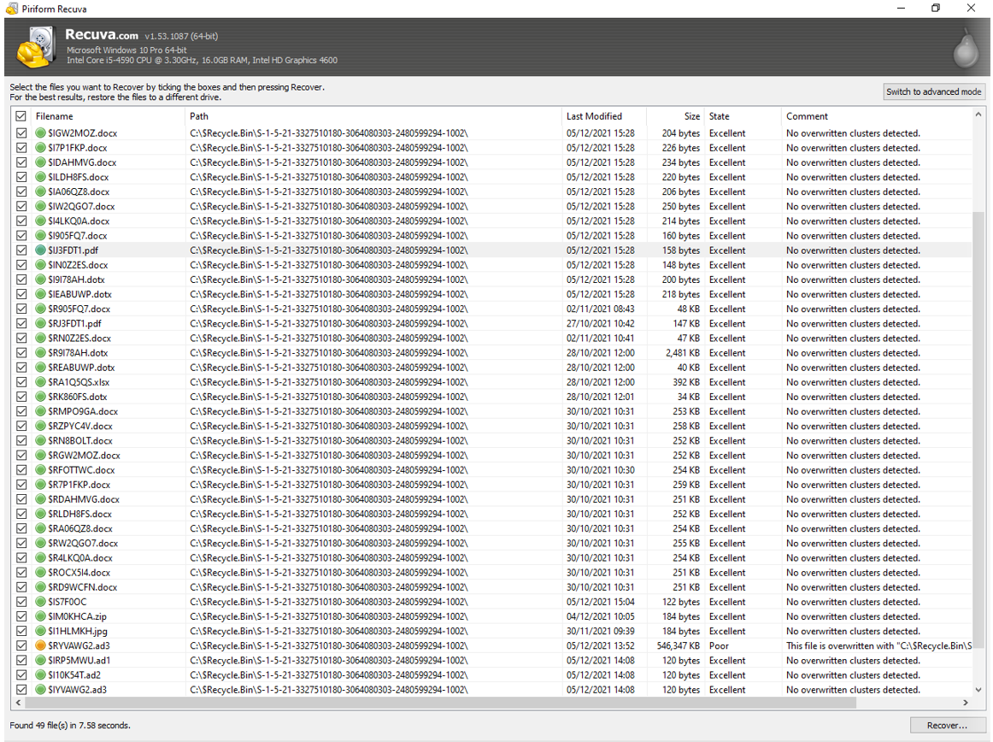
Figure 10: Recuva Results

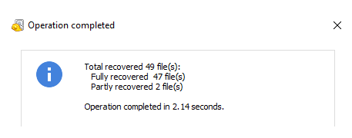
Figure 11: Recovered Documents

Conclusion
A bit-by-bit copy of the evidence was made using a write-blocker to ensure the original remained intact. The copied drive was used to recover files that had been deleted using various tools. The recovered files were returned to Healios Pharmaceutical Company.

Appendix: Invoice
Invoice
CEAC Cybersecurity and Forensics Ltd

Date: 20 December 2021
Invoice Number: 21-5077
Healios Pharmaceutical Company
L&T Business Park, Gate No 5, Tower A, Ground Floor
Sakivihar Road, Pawari, Mumbai
Maharashtra
400072, India

Description | Number of Hours @ £80 | Total
Disk retrieval  Setting up and creating copy disk  Investigation  File retrieval  Written report – standard fee | 1  5.30  2.00  1.30 | £80  £440  £160  £120  £300
 |  | £1,100
VAT at 20% |  | £220
TOTAL |  | £1,320

Bibliography
[1] G. Jayasuryapal, P. M. Pranay, H. Kaur, and Swati, “A Survey on Network Penetration Testing,” Proceedings of 2021 2nd International Conference on Intelligent Engineering and Management, ICIEM 2021, pp. 373–378, Apr. 2021, doi: 10.1109/ICIEM51511.2021.9445321.
[2] “Types of Penetration Testing | Black Box vs White Box vs Grey Box.” https://www.redscan.com/news/types-of-pen-testing-white-box-black-box-and-everything-in-between/ (accessed Nov. 20, 2021).
[3] “The Penetration Testing Execution Standard.” http://www.pentest-standard.org/index.php/Main_Page (accessed Nov. 20, 2021).
[4] Shodan.io, “What is Shodan?”
[5] “Nmap: the Network Mapper - Free Security Scanner.” https://nmap.org/ (accessed Nov. 20, 2021).
[6] “What is Zap security? 8 Common FAQs for OWASP ZAP | The GitHub Blog.” https://github.blog/2020-07-30-maintainer-spotlight-how-to-secure-your-project-with-one-of-the-worlds-top-open-source-tools/ (accessed Nov. 25, 2021).
[7] “What Can Go Wrong On An Internal Penetration Test? » Triaxiom Security.” https://www.triaxiomsecurity.com/what-can-go-wrong-on-an-internal-penetration-test/ (accessed Nov. 11, 2021).
[8] “Pre-engagement - The Penetration Testing Execution Standard.” http://www.pentest-standard.org/index.php/Pre-engagement (accessed Nov. 11, 2021).
[9] “The Penetration Testing Execution Standard.” http://www.pentest-standard.org/index.php/Main_Page (accessed Nov. 11, 2021).
[10] “NVD - CVE-2021-40438.” https://nvd.nist.gov/vuln/detail/CVE-2021-40438 (accessed Nov. 14, 2021).
[11] H. I. Bulbul, H. G. Yavuzcan, and M. Ozel, “Digital forensics: An Analytical Crime Scene Procedure Model (ACSPM),” Forensic Science International, vol. 233, no. 1–3, pp. 244–256, Dec. 2013, doi: 10.1016/J.FORSCIINT.2013.09.007.
[12] Greg. Gogolin, “Digital forensics explained,” p. 176, 2013.
[13] F. Amato, A. Castiglione, G. Cozzolino, and F. Narducci, “A semantic-based methodology for digital forensics analysis,” Journal of Parallel and Distributed Computing, vol. 138, pp. 172–177, Apr. 2020, doi: 10.1016/J.JPDC.2019.12.017.
[14] S. L. Garfinkel, “The Prevalence of Encoded Digital Trace Evidence in the Nonfile Space of Computer Media,,” Journal of Forensic Sciences, vol. 59, no. 5, pp. 1386–1393, Sep. 2014, doi: 10.1111/1556-4029.12528.
[15] D. Liu, “Collecting the Volatile Data from a Router,” Cisco Router and Switch Forensics, pp. 305–389, Jan. 2009, doi: 10.1016/B978-1-59749-418-2.00009-0.
[16] “Volatile Data | Computer & Mobile Phone Forensic Expert Witnesses |.” https://athenaforensics.co.uk/what-is-volatile-data/ (accessed Nov. 25, 2021).
[17] G. Giova, “Improving Chain of Custody in Forensic Investigation of Electronic Digital Systems,” IJCSNS International Journal of Computer Science and Network Security, vol. 11, no. 1, 2011, Accessed: Nov. 26, 2021. [Online]. Available: https://www.researchgate.net/publication/267400650
[18] “image_01_002.jpg (602×397).” https://static.packt-cdn.com/products/9781785882081/graphics/image_01_002.jpg (accessed Nov. 26, 2021).
[19] “Chain_Of_Custody.jpg (1024×566).” https://fingerprintpads.com/images/products/Chain_Of_Custody.jpg (accessed Nov. 26, 2021).
[20] “Computer forensics: Collecting physical evidence - TechRepublic.” https://www.techrepublic.com/blog/it-security/computer-forensics-collecting-physical-evidence/ (accessed Nov. 26, 2021).
[21] “(PDF) DIGITAL FORENSICS: Digital Evidence In Judicial System.” https://www.researchgate.net/publication/332245703_DIGITAL_FORENSICS_Digital_Evidence_In_Judicial_System (accessed Nov. 26, 2021).
[22] “SANS Digital Forensics and Incident Response Blog | Best Practices In Digital Evidence Collection | SANS Institute.” https://www.sans.org/blog/best-practices-in-digital-evidence-collection/ (accessed Nov. 26, 2021).
[23] D. Bem and E. Huebner, “Computer Forensic Analysis in a Virtual Environment,” 2007, Accessed: Nov. 28, 2021. [Online]. Available: www.ijde.org
[24] “Project 3 - CCJS 321 - Digital Forensics in the Criminal Justice System Investigative Conclusion and - StuDocu.” https://www.studocu.com/en-us/document/university-of-maryland-global-campus/digital-forensics-in-the-criminal-justice-system/project-3/7171375 (accessed Nov. 28, 2021).
[25] “Computer forensics: FTK forensic toolkit overview [updated 2019] - Infosec Resources.” https://resources.infosecinstitute.com/topic/computer-forensics-ftk-forensic-toolkit-overview/ (accessed Nov. 28, 2021).
[26] “The Sleuth Kit (TSK) & Autopsy: Open Source Digital Forensics Tools.” https://www.sleuthkit.org/ (accessed Nov. 28, 2021).
[27] “FTK® Forensic Toolkit - Exterro.” https://www.exterro.com/forensic-toolkit (accessed Dec. 07, 2021).
[28] “VirtualBox – Oracle VM VirtualBox.” https://www.virtualbox.org/wiki/VirtualBox (accessed Dec. 07, 2021).
[29] “White Paper / Oracle VM VirtualBox Overview / Version 2.0 Oracle VM VirtualBox Overview,” 2021.
[30] “Kali Linux 2021.3 Release (OpenSSL, Kali-Tools, Kali Live VM Support, Kali NetHunter Smartwatch) | Kali Linux Blog.” https://www.kali.org/blog/kali-linux-2021-3-release/ (accessed Dec. 07, 2021).
[31] “What is Kali Linux? | Kali Linux Documentation.” https://www.kali.org/docs/introduction/what-is-kali-linux/ (accessed Dec. 07, 2021).
[32] “Direct - Piriform Recuva Pro version 1.53.1087 Preactivated -=TeamOS=- | Team OS : Your Only Destination To Custom OS !!” https://teamos-hkrg.com/threads/piriform-recuva-pro-version-1-53-1087-preactivated-teamos.64743/ (accessed Dec. 07, 2021).
[33] “Recuva 1.53.1087 Free Download for Windows 10, 8 and 7 - FileCroco.com.” https://www.filecroco.com/download-recuva/ (accessed Dec. 07, 2021).

marking criteria and Student FEEDBACK

This section details the assessment criteria. The extent to which these are demonstrated by you determines your mark. The marks available for each criterion are shown. Lecturers will use the space provided to comment on the achievement of the task(s), including those areas in which you have performed well and areas that would benefit from development/improvement.

Common Assessment Criteria Applied (Assignment 1) | Marks available | Marks  awarded
1. Engagement with Literature Skills
Extent of research and/or own reading, selection of credible sources, application of appropriate referencing conventions.
You have engaged with the literature using relevant sources and materials. Appropriate referencing convention used. Critical appraisals done. (Grade mark: 93.33%) | 15 | 14
2. Knowledge and Understanding Skills
Extent of knowledge and understanding of concepts and underlying principles associated with the discipline.
You have demonstrated excellent knowledge and understanding. You have explained and analysed the chosen area excellently (Grade mark: 93.33%) | 15 | 14
3. Cognitive and Intellectual Skills
Analysis, evaluation and synthesis; logic, argument and judgement; analytical reflection; organisation of ideas and evidence
You have discussed application of the methods, tools and technique used to carry out all your tests. You have done penetration testing on the live website you have carried out a number of step-by-step tests with a number of penetration testing tools including Nmap, Kali Linux, etc. Screenshots and discussion of these provided. You have done recommendation for the threats discovered. Note if you had use this tool https://tools.kali.org/web-applications/dirbuster you had opportunity to get to the portal and this portal would take you to the backend and you could try to dig it for more information.  Overall, an excellent report. Part 2 is excellently done but could reduce some of the background research. It would be good if you had listed the step you had taken in a similar to fig.32. The first procedure should be:  • All the ceased devices carefully placed in anti-static bags and transported them to a forensics laboratory.  The schedule to execute the potential solution done, cost solutions done, recommended solution given and invoice for the forensics investigation portion. Chain of custody document, sample generated report done (Grade mark: 90.00%) | 40 | 36
4. Practical Application Skills
Deployment of methods, materials, tools and techniques; application of concepts; formulation of innovative and creative solutions to solve problems.
Evidence of practical/hands-on penetration testing done. Screenshots provided and the relevant tools used. (Grade mark: 96.00%) | 25 | 24
5. Transferable Skills for Life and Professional Practice
Attributes in professional practice: individual and collaborative working; deployment of appropriate media; presentation and organisation.
A professional work. However, the organisation is a bit confusing. Next time create the appendix at the end and name each appendix appropriately for each task with the evidence. (Grade mark: 80.00%) | 5 | 4

Assignment Mark (Assessment marks are subject to ratification at the Exam Board. These comments and marks are to give feedback on module work and are for guidance only until they are confirmed. ) | Late Submission Penalties (tick if appropriate) |  | 92%
 | Up to four weeks late |  | 92%
 | First Attempt? |  | 92%

