Student name: Tisha Patel
Student ID number: 2515079
Programme: MSc Public Health and Social Care in Practice
Module: Health Care System, Organization and Leadership
Module code: LCHS7002 Contribution to
Overall Module

Lecturer: Dr Fahad Khan Internal Verifier: Dr Hamdi Hussain
Assignment Title: Case Study Analysis

Report: Comparative report on COVID-19 leadership responses

Title: Comparative Analysis of Leadership and Health System Responses to COVID-19: A Case Study of Spain, South Korea, and Canada

Executive Summary
Based on the public's perceptions that the three nations' faces differed greatly, the governments had to take different approaches to achieve a better result. The study draws on various leadership theories to look at how key leaders guide strategy, communicate, and help users when something happens in a crisis. A response in South Korea was deemed a good one by the people and the findings of studies. Spain delayed vulnerability to the outbreak due to a decentralised system, but it worked better with vaccination. The governance system in Canada is good at working together, but it also has its challenges. The case study shows the value of working together as a team and making quick decisions within our community internationally. It also explains how those in power should be moral and keep the best interests of others in mind. The recommendations proposed highlight that resilient, data-driven, and equitable systems for handling pandemics need to respond effectively.

Table of Contents
1. Introduction 4
2. Epidemiological Overview 5
3. Spain’s Health System Response 8
3.1 Governance and Health System Organisation 8
3.2 Policy and Ethical Response 10
3.3 Evaluation and Outcomes 10
4. South Korea’s Health System Response 11
4.1 Centralised Coordination and Rapid Response 11
4.2 Technological and Public Health Strategies 13
4.3 Lessons and Ethical Considerations 14
5. Canada’s Health System Response 14
5.1 Federal-Provincial Coordination and Policy Evolution 14
5.2 Public Health and Social Impact 15
5.3 Epidemiological Modelling and Preparedness 16
6. Comparative Analysis 18
7. Theoretical Frameworks and Leadership Styles. 20
8. Discussion 20
9. Conclusion and Policy Implications 22
References 23

1. Introduction
In late 2019, the COVID-19 pandemic started worldwide. It rapidly went across entire continents and even ended up overloading hospitals. In March 2020, the World Health Organization declared a pandemic. They tested many countries' governance and economic judgments on their resilience. By 2025, thousands of people will be unwell in America, and over 770 million people will have gone to the doctor, happening accidentally, resulting in half a million deaths (WHO, 2025).
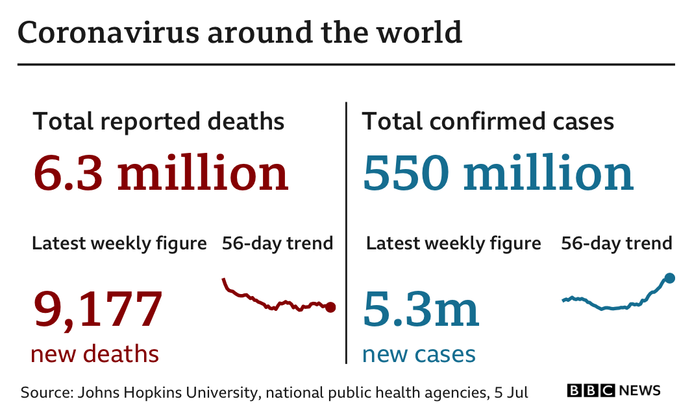
Figure 1: COVID-19 around the world
(Source: JHU, 2025)
This comparative study occurs in Spain, South Korea, and Canada, where there are three country models. In countries like Spain, the process of different regional administrations plays a major role in the end of COVID-19 (Kölling, 2021). South Korea has everything one needs for a perfect pause to this outbreak due to its use of technology (Peña-Ramos et al., 2021). Its government has made travelling to other countries almost impossible (Choi, 2020). They even have a text message that you have tested positive in South Korea. Canada also has a character, different from the Continental European Union (Kim et al., 2020).
This study thoroughly examines how the structure of government functions and ethical decisions have impacted this pandemic. The following analysis looks at the data found in the World Health Organization as well as other sources, to determine how national strategies impacted the environment. The paper's structure is to be organized into four sections. The first two will each cover a different country's health governing method. The third will look into one specific country's method, and the last will sum up the paper's findings, focusing on one specific aspect.

2. Epidemiological Overview
The coronavirus spread all over Spain, South Korea, and Canada due to many factors, and a lot of people did not know what was going on. According to the WHO (2025), Spain had reported over 14.5 million COVID-19 cases and a staggering 124,00 deaths. South Korea reported 34.8 million cases and 35,000 deaths, soon to be California by a multiple. Death ratios are higher in countries like Spain and Canada, but lower in South Korea. South Korea was able to stop the spread by detecting cases early and isolating the people in the infected areas (Choi, 2020; Kim et al., 2020).
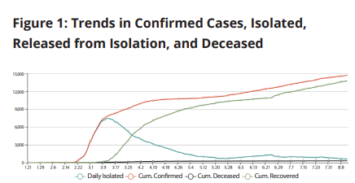
Figure 2: REPUBLIC OF KOREA’S COVID-19 PREPAREDNESS AND RESPONSE
(Source: World Bank, 2025)
In 2020, three countries outside the US experienced a large increase in COVID-19 cases (Worldometer, 2025; and JHU, 2025). America was not the only country with a large outbreak. Both Spain and Italy had as many orbits as America had. All in 2020 and 2023. South Korea was able to flatten the curve of the virus thanks to many strict restrictions (López Casasnovas and Pifarré i Arolas, 2022). As a result, Canada had a slower and more gradual increase in symptoms in the people (You, 2020). This was because of the policy variations that went from province to province (Desson et al., 2020; Detsky and Bogoch, 2020).
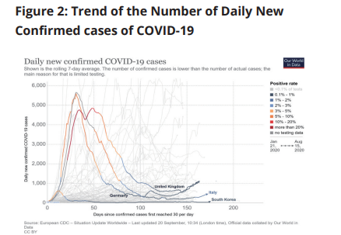
Figure 3: REPUBLIC OF KOREA’S COVID-19 PREPAREDNESS AND RESPONSE
(Source: World Bank, 2025)
Merely another instance showed country-to-country differences. According to WHO (2025), they report that in the middle of 2022, Spain had successfully vaccinated 88 per cent of its eligible population, one of the highest in Europe (Mendoza, 2025). South Korea followed close behind this percentage with a malaria initiative covering 87% of the population by late 2022 (Peña-Ramos et al., 2021)..
This quickly succeeded due to good distribution to the right places and a very high public endorsement of this new, global method (Hong, 2022). Canada's method of not changing where people who wanted to get vaccinated had to go likely delayed things, but eventually, Canadians got vaccinated pretty fast (Trudeau, 2021; Dozois, 2021).
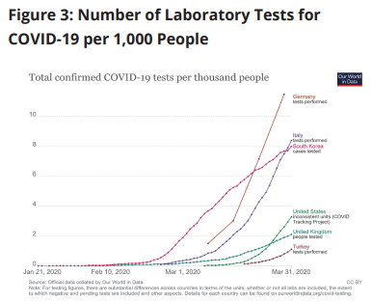
Figure 4: REPUBLIC OF KOREA’S COVID-19 PREPAREDNESS AND RESPONSE
(Source: World Bank, 2025)
Recovery trajectories also differed. The Spanish health system was not doing well even after 2020, especially when patients were getting monumentally ill (Legido-Quigley et al., 2020). Although intensive care is getting better, the services are still not equal throughout all areas (Ruiz-Hornillos et al., 2021). Lots of people in South Korea went to the hospital, but fewer than in other places (Shim et al., 2020).
Socio-demographic factors shaped these outcomes. Spain's ageing demographic, with 20 per cent being 65 and older, is due to high rates of death (Royo, 2020). While some places reduced the spread of COVID, countries like South Korea supported it. Canada has a whole bunch of different races that could have different levels of danger going on, depending on their work and how close they live to each other (Song and Miral, 2023). Despite spikes in coronavirus cases, South Korea experienced less stress on their economic systems than some other countries (Dozois, 2021). Their digital economy kept their country excluded from high unemployment rates, which harmed other countries like Spain. Because of it, they were able to keep their students in college (World Bank, 2024).
Countries differed in how they collected data. South Korea implemented a strategy of trace, test, and treat, which reached a ratio of 80,000 tests per million by June of 2020 (Kim et al., 2020). Her (2020) stated that eventually, efforts in Spain improved due to sustaining a pattern of procuring the right amount (of goods) (Rodriguez-Arrastia et al., 2022).
When the public cooperates, a community will follow the health recommendations. Studies have shown that public trust in healthcare has increased in South Korea, an especially advantageous change, compared only to Canada and Spain (OECD Health Survey, 2024). In Seoul, the communication was simply transparent, so they did not get biased information (Choi, 2020).

3. Spain’s Health System Response

3.1 Governance and Health System Organization
Spain's health system is very decentralized and mirrors the federal nature of its government. Most of the responsibility for health policy and service delivery has been transferred to the 17 autonomous communities, which apply national health directives (Kölling, 2021). Due to devolution, local-tailoring has become as much possible as governance-tension during the COVID-19 crisis.
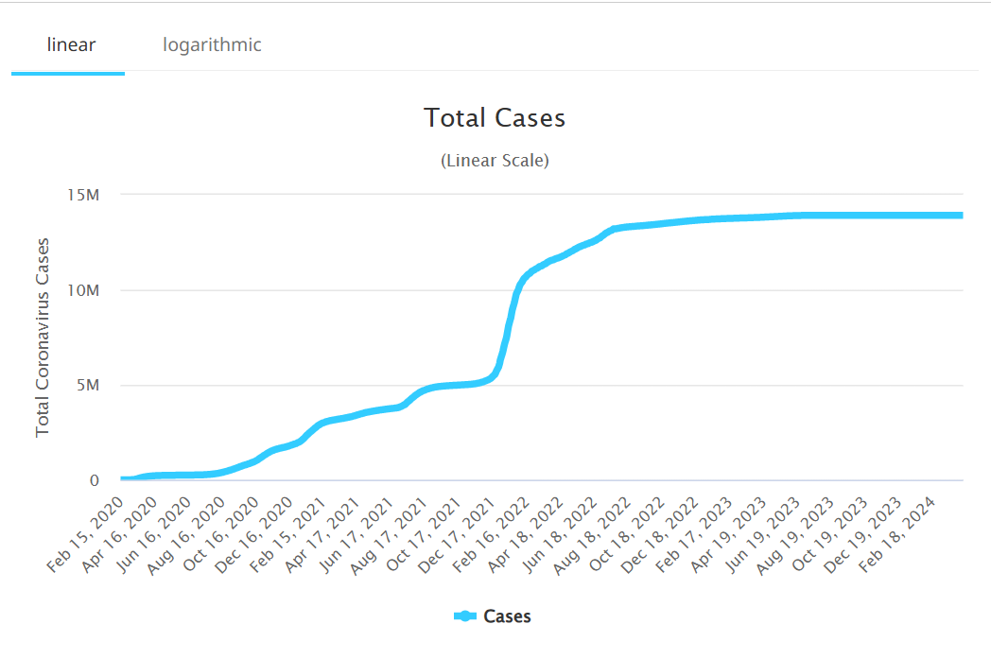
Figure 5: Total coronavirus cases in Spain
(Source: WorldOmeter, 2025)
Spain’s model fosters local desires, according to López Casasnovas and Pifarré i Arolas (2022), while promoting autonomy, the system suffers under the pandemic strain, as rapid decentralized decision-making is not offered on health. In March 2020, the Ministry of Health sought to regain control by declaring a state of emergency to centralized authorities on health procurement and mobility restrictions. According to Kölling (2021), this tension from the federal level resulted in inconsistent messaging, disjointed policy-making, and unequal access to medical resources across territories.
The healthcare capacity has weakened due to decades of austerity, furthering this structural challenge. Hospitals were already down beds, people and emergency preparedness as a result of previous budget cuts (Legido-Quigley et al., 2020). As a result, the initial spike in cases inundated ICUs in Madrid and Catalonia mainly. In spite of this, the strength of the public health system in Spain, supported by community health networks and universal access, has ensured continuity of essential care (López Casasnovas and Pifarré i Arolas, 2022).

3.2 Policy and Ethical Response
Spain’s policy response to COVID-19 included Europe’s strictest lockdown and a large economic aid package. According to Royo (2020), on 14 March 2020, the entire population was asked to stay in their homes under mobility limitations. The government said we have to flatten the curve for COVID, but there were many discussions about individual rights versus the state’s overreaching (BS, 2020; Landauro, 2020). Hospitals faced a lack of resources and made clinicians decide on the basis of the patient’s age, comorbidities and survival probabilities. According to Faggioni et al. (2021), Spain's triage protocols for healthcare resources influenced by utilitarianism ethics that prioritize maximizing life years saved discriminate against the elderly and disabled.
Bioethical committees across Spain have debated these issues, calling for better transparency and patient involvement in all decisions. According to Ruiz-Hornillos et al. (2021), organizations of healthcare ethics committees have pointed out weaknesses in communication and need ethical principles based on solidarity and proportionality. Due to a lack of regulation and resources, a large number of deaths occurred in nursing homes during the first wave of the pandemic. Almost 50% of these deaths were from nursing homes (Legido-Quigley et al., 2020).
The Spanish government later enacted a phased reopening plan dependent on epidemiological indicators to balance health protection and economic recovery (Royo, 2020). During early waves, support for restrictions was high, indicating social cohesion and trust in science institutions (Rodriguez-Arrastia et al., 2022).

3.3 Evaluation and Outcomes
Various evaluations reveal a mixed record of Spain’s handling of the pandemic. The systems of accountability used were lacking, and even further fragmented reporting on data and transparency were reported throughout the region (Peña-Ramos et al., 2021). The way they looked at the pandemic showed more cooperation between governments and stronger health systems. Legido-Quigley et al. (2020) also noted that, although there were early coordination problems, Spain’s health system recovered exceptionally well because of the fast expansion of intensive care units (ICU), rapid digitalization of patient data, and a nationwide vaccination scheme.
About 14 million cumulative cases and 122,000 deaths were recorded in Spain in 2025. (Mendoza, 2025; WHO, 2025). Vaccination coverage above 87% of the population, among the highest in Europe, contributed to significant reductions in severe cases and deaths. The results show a movement from crisis to stabilization, thanks to adaptive governance and ethical lessons learned from past mistakes.
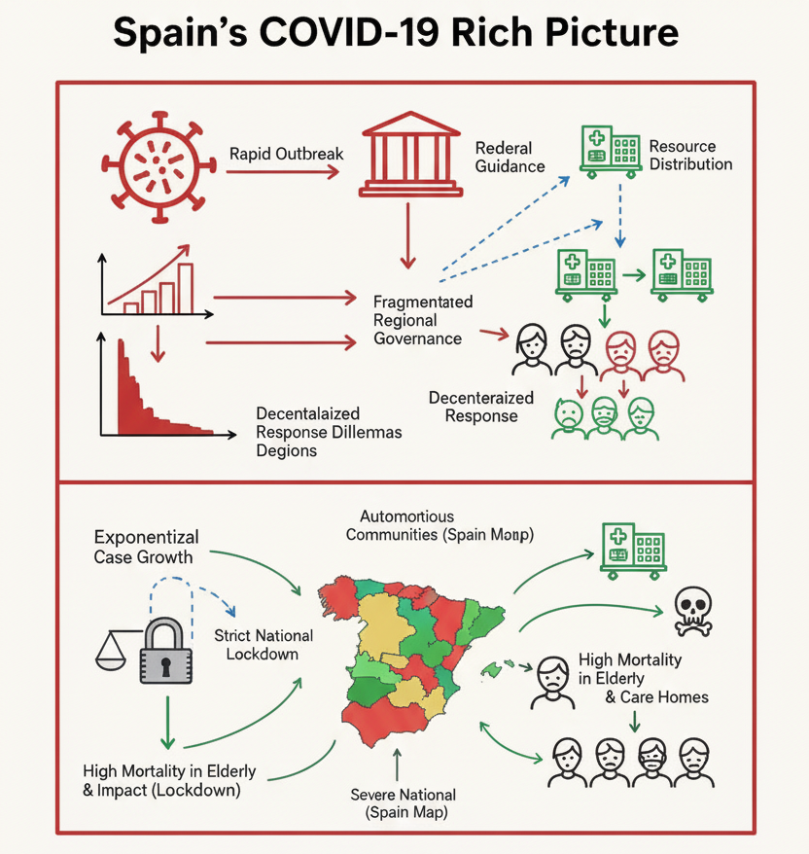
(Source: Author)
Rodriguez-Arrastia et al. (2022) claim that the lesson learned is a shift from reactive to proactive policymaking, which involves strengthened surveillance systems and emergency preparedness, as well as improved crisis communication. In 2021-2022, public health reforms improved coordination at the regional level, enhanced institutional accountability, and engaged citizens in health decisions.
Spain had both a capable and decentralized health governance system to deal with pandemic effects. The crisis revealed gaps in coordination, ethical stress, and capacity shortages, but it also led to institutional reform and public confidence in universal health coverage. As could be seen from the assessment of Peña-Ramos et al. (2021), the Spanish health system comes out stronger and more resilient than ever.

4. South Korea’s Health System Response

4.1 Centralized Coordination and Rapid Response
South Korea's actions against COVID-19 have been viewed as successful in implementation due to planning. At the start of the outbreak, South Korea's government set in place a framework with help from multiple groups. The KCDC and local authorities had a say in quick decisions and had more resources (Choi, 2020; Kim et al., 2020). The government kept people informed about infection rates and whatnot, so they knew what was going on and, more importantly, trusted their government.
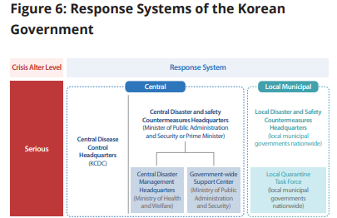
Figure 6: KCDC RESPONSE
(Source: World Bank, 2025)
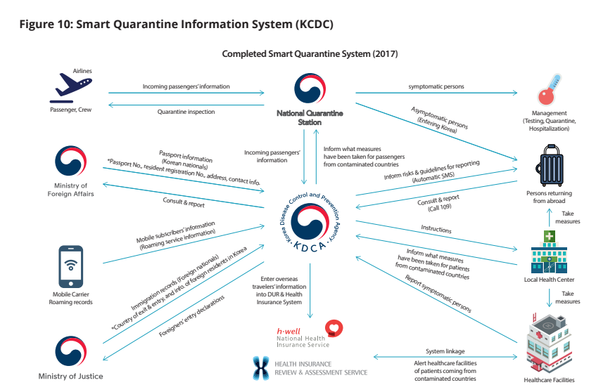
Figure 7: KCDC RESPONSE
(Source: World Bank, 2025)
Major innovations helped to rapidly create and implement test systems. Drive-thru clinics and walk-in center’s allowed high-volume services, minimizing contact to enhance efficiency and ensure safety. The government also gave a lot of importance to identifying clusters early by carrying out aggressive testing programs, with data being combined in real-time predictive models of potential outbreaks, from which to guide measures of containment. The method worked well in stopping the infection from spreading, showing a successful combination of public health efforts and government.
South Korea prevented long lockdowns by using a specific amount of information about a small area. Swift action in South Korea ended in a limited economic disruption while raising public confidence, but it was the opposite for Western nations during the pandemic. It's time to simply acknowledge and avoid carbon emissions (Choi, 2020; Kim et al., 2020).

4.2 Technological and Public Health Strategies
South Korea's handling of a global pandemic relied heavily on improvements in technology. The government used all of the people's information from mobile phones, credit cards, and even CCTV cameras to track down people who came in contact with someone who had the virus. The AI, along with technology, made investigations a whole lot faster and more accurate (Her, 2020; Shim et al., 2020).
Reducing variable factors for doctor decisions. They were able to use the data they had collected on patients and put the high-risk patients in front of hospital flows. Singapore's government-issued isolation accompanied governments' warnings about phone apps used to keep track of and help volunteers track coronavirus at their guests (Shim et al., 2020).
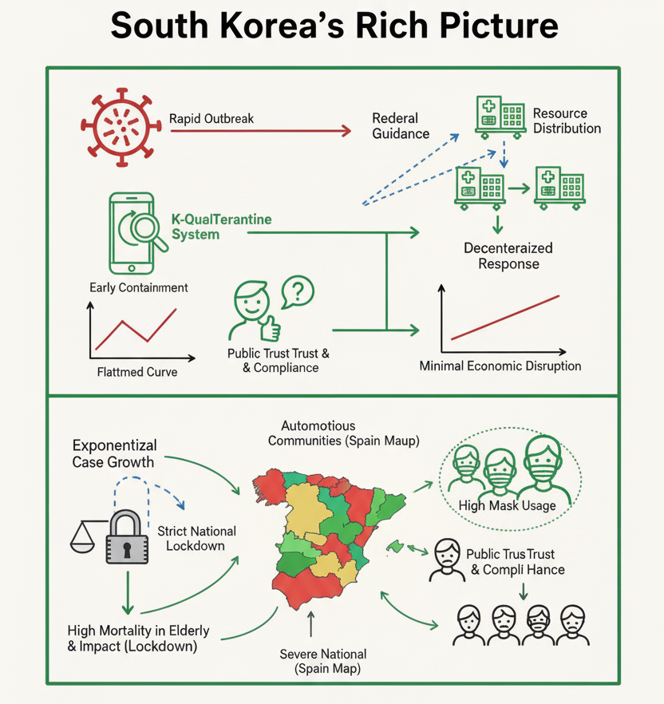
(Source: Author)
Combining normal health tricks with modern high-tech items is the reason fewer infected people are being seen by doctors. Real-time information and digital monitoring allowed South Korea to avoid imposing a total lockdown and instead kept control over infections, instead of the population as a whole doing it (Her, 2020).

4.3 Lessons and Ethical Considerations
South Korea's response to the pandemic shows how citizens can trust in government. Communicating regularly and being honest with the people helped them follow rules, but also created a problem, surveillance, which is wrong to have. Comparisons with Spain's health regulations illustrate the tension between large-scale organizational structures and an individual's personal rights, exposing why Spain's attempt at proper management of the Coronavirus was flawed (Peña-Ramos et al., 2021; Legido-Quigley et al., 2020; Rodriguez-Arrastia et al., 2022). Spain had a lot of controversy in triage and handling resources. Many people passed away, and a lot of stress was created by new cutbacks to the health care system (Faggioni et al., 2021; Ruiz-Hornillos et al., 2021).
South Korea has taken a successful approach to meeting the balance between using technology to protect people and also returning to old ways of keeping the nation safe to protect their rights by combining digital tools to help public health, while ensuring their civil liberties will be respected (You, 2020; Hong, 2022; Song and Miral, 2023). It became clear that centralizing responses, keeping the public informed, and using technology effectively impact disease outcomes. Citizens are having to face this situation and should know the reason behind the government's actions. This will help control and trust between the government and citizens. A crisis will pop up, and one needs to know what to do (Peña-Ramos et al., 2021; López Casasnovas and Pifarré i Arolas, 2022; Royo, 2020).

5. Canada’s Health System Response

5.1 Federal-Provincial Coordination and Policy Evolution
The healthcare reaction of Canada to COVID-19 was strongly influenced by its federal system, delegating much of the control over the health policy to the provinces and territories (Desson et al., 2020; Trudeau, 2021). This complexity of jurisdiction implied that national direction, funding and even the acquisition of vaccines could be offered by the federal government, but the burden of conducting the tests, all the tools to combat the disease, and the management of hospitals were mostly left to provincial governments. This led to an extremely diverse policy environment: some provinces, such as Ontario and Quebec, introduced an early lockdown and a contact tracing program, but initially, some provinces had less strict policies. The communications and distribution of resources were simplified by the mechanisms of the Public Health Agency of Canada (PHAC) and the COVID-19 Vaccine Task Force, which did not interfere with the regional autonomy (Trudeau, 2021; van den Brink, 2025). Nevertheless, such division also brought its own problems, such as the slowness of harmonizing restrictions and population health messaging, which sometimes negated national consistency in their response. During the course of time, the federal guidance was modified to suit the requirements of the regions that had diverse epidemiological characteristics, which depicts an illustrative example of a dynamic, adaptive policymaking within the framework of federal limitations (Desson et al., 2020).
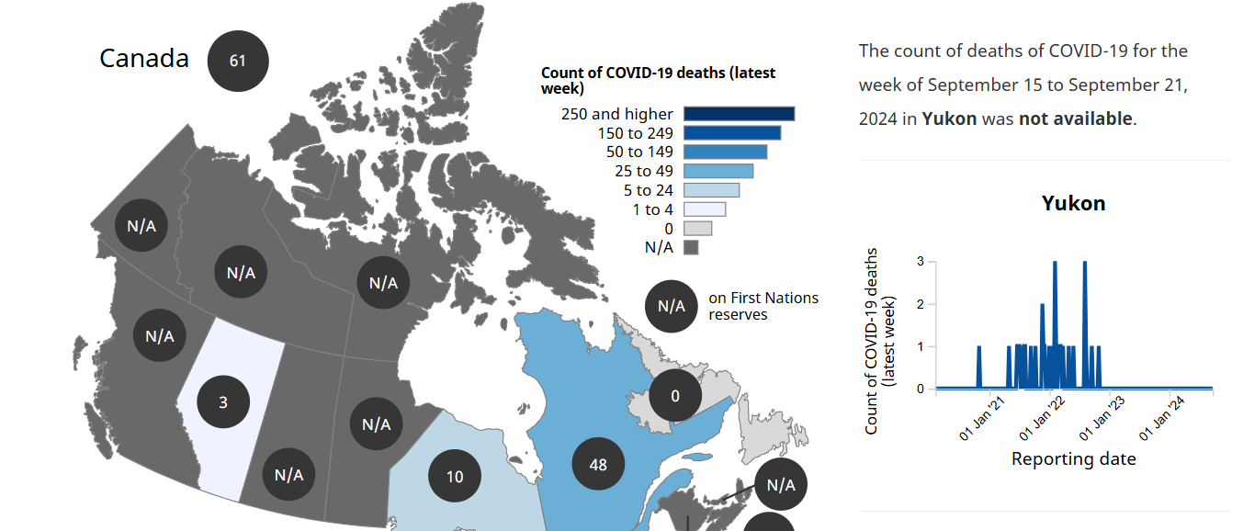
Figure 8: Deaths in Canada over time
(Source: Government of Canada, 2025)

5.2 Public Health and Social Impact
The impact of the pandemic on mental health and the labour market was acute in Canada. According to national surveys, the rate of anxiety and depression was increasing, especially in young adults and those who have already had mental health problems (Dozois, 2021). The isolation of social life, uncertainty, and destabilization of regular services increased the pressure on mental health facilities, which revealed structural failures in the availability of services. At the same time, there were disruptions in the labour market where people lost jobs in service industries and tourism, as well as in hospitality, which was disproportionately experienced by women and younger workers (Lemieux et al., 2020). There were other difficulties encountered by international students and temporary foreign workers, such as precarious employment and restricted access to healthcare benefits (Firang, 2020). These social consequences highlighted the necessity of working together to develop a policy that would entail economic relief, mental health services, and specific protection of vulnerable groups. Another initiative that tried to relieve these effects was provincial programs, including mental health hotlines in Ontario and federal wage subsidy initiatives, but there were still differences in uptake and awareness. The interaction between the socioeconomic well-being and the public health practices thus carried with it a critical issue of concern during the crisis.
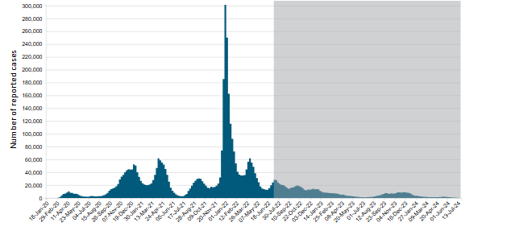
Figure 9: Deaths in Canada over time
(Source: Government of Canada, 2025)

5.3 Epidemiological Modelling and Preparedness
The scientific modelling was critical in the Canadian response to the pandemic. Provisional forecasts of the course of the cases, the requirements of the hospitals, and the level of transmission were used to inform provincial lockdowns as well as federal recommendations of the policy (Tuite et al., 2020; Detsky and Bogoch, 2020). The effectiveness of non-pharmaceutical interventions in Ontario, which is targeted by models calibrated using population statistics and mobility patterns, showed the promise of reducing the time and intensity of the response, including school shutdowns and travel bans. In addition to predictive analytics, proper health communication also played a role in influencing the behavior of the people. The government briefings and online dashboards were used to update on case numbers, hospitalizations and vaccination progress and promoted transparency and compliance. The strategy used in Canada resembled the experience of other well-to-do countries, including Spain, where well-developed epidemiological surveillance supported a responsive reaction, but ethical issues related to the triage and allocation of resources arose in both settings (Pena-Ramos et al., 2021; Faggioni et al., 2021). They were further compared with South Korea and helped understand the significance of early tests, contact tracing using digital tools, and the timely implementation of vaccines in emerging outbreaks (Choi, 2020; Kim et al., 2020). The incorporation of modelling understanding into the policy in Canada facilitated a fairly coordinated reaction, notwithstanding the issues with the federal-provincial government, in that regional disparities in the results indicated the constraints of predictive instruments when local conformity and medical capacity differed.
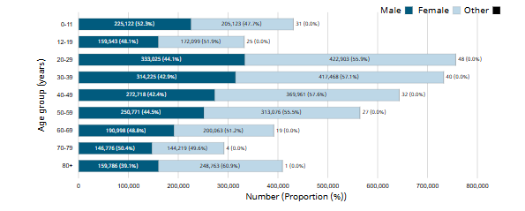
Figure 10: Age and Gender affected by COVID-19 in Canada over time
(Source: Government of Canada, 2025)
To conclude, the COVID-19 response in Canada was influenced by the interactions between federal-provincial coordination, the effect of the pandemic on public health, and evidence-based modelling. Although the federal structure had jurisdictional complications, it enabled interventions which were responsive to local epidemiological conditions. The multidimensionality of pandemic preparedness was emphasized by social and economic issues, especially in mental health and labour markets. Lastly, the scientific basis of policy was offered through the application of epidemiological modelling and open communication based on experience in other countries and supported the value of adaptive and data-driven health governance.
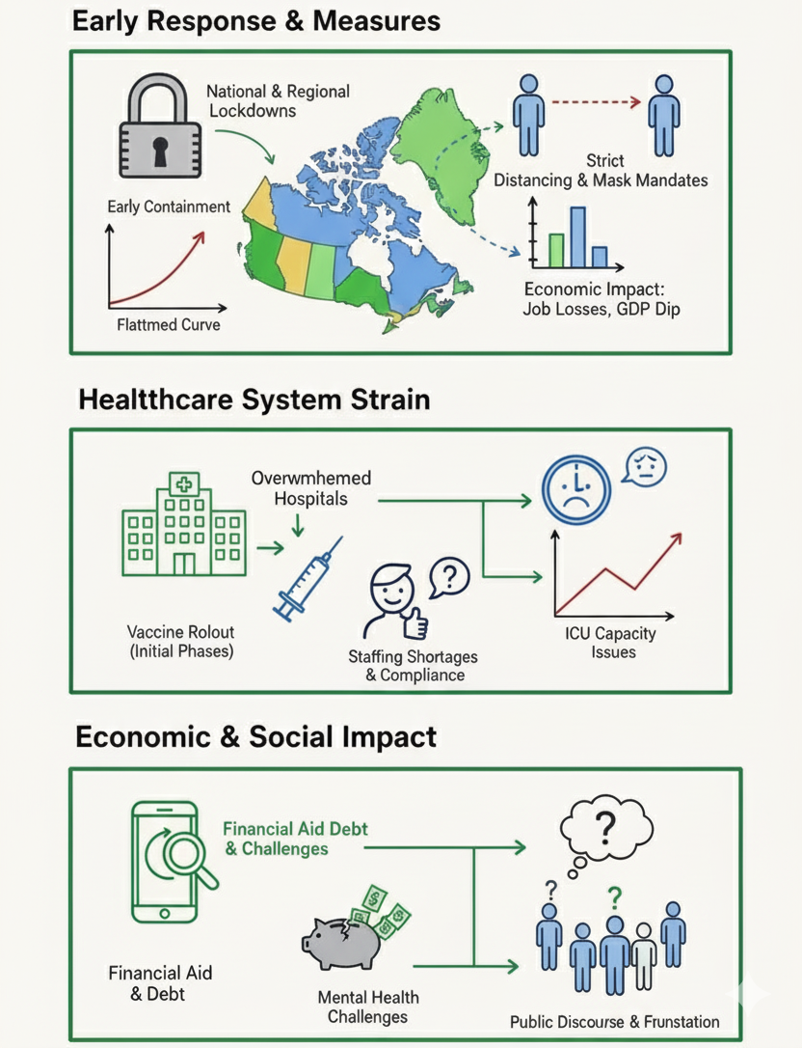
(source: Author)

6. Comparative Analysis
Comparative analysis of Spain, South Korea and Canada shows that governance systems, ethical policies and population outcomes varied in the COVID-19 pandemic, which clearly shows how systemic organization, cultural norms and population health resonance interact.
Policy Coordination and Governance: The reaction of Spain was marked by bureaucratic disintegration and slow integration of policy. The Spanish health system is highly decentralized and puts much power in the provincial autonomous communities, which has led to heterogeneity of pandemic responses and unequal distribution of resources (Legido-Quigley et al., 2020). This complexity of structure was one of the factors that led to a late national response in the early phase of the crisis and hindered effectiveness in containment strategies.
South Korea, on the contrary, utilized the centralized, but technologically advanced, system of governance to enable quick surveillance, contact tracing, and social compliance. The Korean model involved the integration of governmental control over them with legal means of their use of data, which enabled the timely detection and the lockdown of the cases (Hong, 2022).
Canada had an ambivalent experience, as it has a federal-provincial system of governance. Even as the federal agencies offered strategic leadership and shared public health messages, the provinces had a lot of autonomy in enacting local interventions (Desson et al., 2020; Trudeau, 2021). This two-sidedness was about a middle success: successful communication on the national level and citizens willing to comply were observed, still, testing inconsistencies and vaccine implementation, as well as resource allocation, underlined another problem with coordination.
Population Outcomes and Social Impact: The quality of people’s outcomes reflected the effectiveness and ethics of governance. Spain's system fragmentation had an impact on higher morbidity and mortality, which was made worse by lagging public health intervention and non-adherence to containment measures (Legido-Quigley et al., 2020). In South Korea, there are not many infected people, and mortality is not widespread. This owes to an excellent public health infrastructure of the country, along with the great compliance of its people. (Hong, 2022). Canada had moderate outcomes; the high level of public participation and trust in official messaging helped maintain community transmission, but the inequities across the provinces and Indigenous communities in accessing products and services showed systemic inequities (Desson et al., 2020; Trudeau, 2021).
Cultural and Systemic Resilience: The pandemic response was affected by a lot of factors, like cultural context and systemic resilience. Spain has regions that can adapt. Finally, the regional government structure of Spain was a hindrance rather than a help to decision-making. (Legido-Quigley et al., 2020). The way South Korea's centralized approach and tech-driven means worked out, combined with their social cohesion and quality of being adaptive, shows us that such resilience is a factor of design and nature (Hong, 2022).However, it also demonstrated that some aspects of resilience rely on inter-jurisdictional coherence and fair distribution of resources (Desson et al., 2020).

7. Theoretical Frameworks and Leadership Styles.
The type of leadership played a significant role in the way every nation managed COVID-19. According to Lewin, the 1939 model, the autocratic, democratic and laissez-faire styles influence the decision-making and sharing of decisions. Autocratic style enables leaders to be responsive in a crisis at the top. A democratic style encourages collaboration and trust; however, it may slow decision-making. The transformational theory proposed by Bass in 1985 also suggests that an effective leader must have a clear vision, motivation and moral direction, which is essential in making people remain confident in case of a health crisis.
According to the situational model in 1969, leaders are supposed to transform their style to what society requires. These concepts are present in Spain, South Korea and Canada. South Korea exercised robust central authority, which operated in an autocratic and transactional manner with severe contact tracing, monitoring and rapid policy action (Kim et al., 2020). Canada was more democratic and transformational, focusing on open communication, compassion and cooperation with other governments (Desson et al., 2020).
The Spanish authorities alternated between national policies and territorial management, which formed an unequal enforcement (Kolling, 2021). Put collectively, these illustrations reveal that effective pandemic leadership must be characterized by a combination of power and collaboration with compassion (Heifetz, 1994). This type of flexibility not only influences the results but also boosts the sense of moral obligation and civic trust in times of uncertainty in the world.

8. Discussion
The way in which Spain, South Korea, and Canada responded to their respective pandemic’s sheds light on how different aspects of a society intersect to impact public health. A sets of guidelines called frameworks allow one to dream of a different scenario.
According to Peña-Ramos et al. (2021), in Spain, the pandemic revealed serious flaws in the country's system of healthcare. The separation of regions prevented the government from reaching a single conclusion and way of going about things, as the regions have different ideas and methods of implementing them (Legido-Quigley et al., 2020). It was stressed to use ethics frameworks to make public decisions about healthcare during the pandemic, mainly regarding triage, distributing scarce medical resources, and giving everyone an equal chance at medical care (Faggioni, González-Melado and Di Pietro, 2021). The ethical debates are very opinionated. One has to think about the sensing potential (Rodriguez-Arrastia et al., 2022; Royo, 2020). Reports of epidemiological data and constant meetings of government personnel caused problems with trust and compliance during these unclear times in Spain (Ruiz-Hornillos et al., 2021). Spain's past performance has shown that even with technologically advanced resources, it might be nothing without correct steering (López Casasnovas and Pifarré i Arolas, 2022; BS, 2020; Landauro, 2020).
South Korea's resilience stands out interestingly, showing how resistant they are through an already rapidly growing tech industry and high staying power in following governmental rules and regulations. Before the epidemic, the country acted prepared and implemented digital tracking and contact tracing, and this ended up helping them in times of trouble Choi, 2020; Kim et al., 2020; Shim et al., 2020). For the betterment of health as a whole, individual privacy is dependent on the trust in the authorities provided; when one no longer shares trust, societal benefits must be placed higher in consideration. Using tools in conjunction with such clear communication may more efficiently prevent or recover from hardships by keeping everyone in sync (Hong, 2022; Song and Miral, 2023).
Canada has adjusted its policies to suit common practice. Regions received different guiding principles because even though everyone followed the same general plan, everyone also did everything differently in different places (Desson et al., 2020; Trudeau, 2021; Detsky and Bogoch, 2020). Since the situation regarding vulnerable people's treatment showed some confusion, responding to their needs under a single system was pretty difficult (Dozois, 2021; Lemieux et al., 2020). Everything needed to be transparent and follow a consistent message for people to feel safe, but eventually, everyone is going to slip up, whether it be an accident or a serious incident; nobody is perfect, no matter how much they try. Resilience during a crisis depends not only on how well citizens are structured but also on having principles and trust in others (Tuite, Fisman and Greer, 2020; Firang, 2020).

9. Conclusion and Policy Implications
The comparative study of Spain, South Korea and Canada reveals that successful management of a pandemic is dependent on the systems of governance, ethical systems and the involvement of the society. The decentralized system in Spain, where regional coordination was rapid but initially did not allow a quick response at the national level, had a high mortality rate and ethical concerns when allocating resources (Pena-Ramos et al., 2021; Legido-Quigley et al., 2020). The rapid containment, low mortality, and high compliance rates of South Koreans were the result of the centralized, technology-based strategy that allowed the country to prevent the spread of the coronavirus due to the institutional trust and social norms that allow people to remain resilient (Choi, 2020; Hong, 2022). The federal-provincial hybrid model in Canada was not very successful, showing the feasibility and difficulties in balancing the autonomy of the regions and national control and the necessity of equity-oriented ethical governance (Desson et al., 2020; Trudeau, 2021).

References
BS, (2020). COVID-19: Spanish Health Minister warns of serious risk without tough rules. Available at: https://www.business-standard.com/article/current-affairs/covid-19-spanish-health-minister-warns-of-serious-risk-without-tough-rules-120092700088_1.html. [Accessed on: 22.10.2025].
Choi, J.Y., 2020. COVID-19 in South Korea. Postgraduate medical journal, 96(1137), pp.399-402.
Desson, Z., Weller, E., McMeekin, P. and Ammi, M., 2020. An analysis of the policy responses to the COVID-19 pandemic in France, Belgium, and Canada. Health Policy and Technology, 9(4), pp.430-446.
Detsky, A.S. and Bogoch, I.I., 2020. COVID-19 in Canada: experience and response. Jama, 324(8), pp.743-744.
Dozois, D.J., 2021. Anxiety and depression in Canada during the COVID-19 pandemic: A national survey. Canadian Psychology/Psychologie canadienne, 62(1), p.136.
Faggioni, M.P., González-Melado, F.J. and Di Pietro, M.L., 2021. National health system cuts and triage decisions during the COVID-19 pandemic in Italy and Spain: ethical implications. Journal of Medical Ethics, 47(5), pp.300-307.
Firang, D., 2020. The impact of the COVID-19 pandemic on international students in Canada. International Social Work, 63(6), pp.820-824.
Government of Canada (2025). COVID-19 epidemiology update: Current situation. Available at: https://health-infobase.canada.ca/covid-19/current-situation.html. [Accessed on: 22.10.2025].
Her, M., 2020. How is COVID-19 affecting South Korea? What is our current strategy?. Disaster medicine and public health preparedness, 14(5), pp.684-686.
Hong, S.A., 2022. Six pivotal lessons learned in South Korea for a whole-of-government approach to successful COVID-19 vaccine rollout in planetary health. OMICS: A Journal of Integrative Biology, 26(10), pp.567-579.
JHU (2025). Canada. Available at: https://coronavirus.jhu.edu/region/canada. [Accessed on: 22.10.2025].
JHU (2025). South Korea. Available at: https://coronavirus.jhu.edu/region/south-korea. [Accessed on: 22.10.2025].
JHU (2025). Spain. Available at: https://coronavirus.jhu.edu/region/spain. [Accessed on: 22.10.2025].
Kim, J.H., An, J.A.R., Min, P.K., Bitton, A. and Gawande, A.A., 2020. How South Korea responded to the COVID-19 outbreak in Daegu. NEJM Catalyst Innovations in Care Delivery, 1(4).
Kölling, M., 2021. COVID-19 and federalism in Spain. In Federalism and the Response to COVID-19 (pp. 208-216). Routledge India.
Landauro, I. (2020). Drastic steps needed to tackle out-of-control pandemic, Spanish minister says. Available at: https://www.reuters.com/article/health-coronavirus-spain/update-1-drastic-steps-needed-to-tackle-out-of-control-pandemic-spanish-minister-says-idUKL8N2HD2TU/. [Accessed on: 22.10.2025].
Legido-Quigley, H., Mateos-García, J.T., Campos, V.R., Gea-Sánchez, M., Muntaner, C. and McKee, M., 2020. The resilience of the Spanish health system against the COVID-19 pandemic. The Lancet Public Health, 5(5), pp e251-e252.
Lemieux, T., Milligan, K., Schirle, T. and Skuterud, M., 2020. Initial impacts of the COVID-19 pandemic on the Canadian labour market. Canadian Public Policy, 46(S1), pp.S55-S65.
López Casasnovas, G. and Pifarré i Arolas, H., 2022, April. Health care systems: organisation and response to COVID-19 with a focus on Spain. In Forum for Social Economics (Vol. 51, No. 2, pp. 175-191). Routledge.
Mendoza.J., (2025). Cumulative coronavirus cases and deaths in Spain 2020-2025. Available at: https://www.statista.com/statistics/1109308/cumulative-coronavirus-cases-deaths-and-recoveries-in-spain/?srsltid=AfmBOopvnKhaqVrxJbDkNwWAFgssVQ8MrEkp_o1StpPZIdkm2kK61WtO. [Accessed on: 22.10.2025].
Peña-Ramos, J.A., Recuero-López, F., Sánchez-Bayón, A. and Sastre, F.J., 2021. Evaluation of the Spanish health system during the COVID-19 pandemic: accountability and wellbeing results. International journal of environmental research and public health, 18(24), p.12907.
Rodriguez-Arrastia, M., García-Martín, M., Romero-López, A., Ropero-Padilla, C., Ruiz-Gonzalez, C., Roman, P. and Sanchez-Labraca, N., 2022. Evolution of the Public-Health response to the COVID-19 pandemic in Spain: A descriptive qualitative study. International journal of environmental research and public health, 19(7), p.3824.
Royo, S., 2020. Responding to COVID‐19: The case of Spain. European Policy Analysis, 6(2), pp.180-190.
Ruiz-Hornillos, J., Hernández Suárez, P., Marín Martínez, J.M., Miguel Beriain, Í.D., Nieves Vázquez, M.A., Albert, M., Herrera Abián, M., Pacheco-Martínez, P.A., Trasmontes, V. and Guillén-Navarro, E., 2021. Bioethical concerns during the COVID-19 pandemic: what did healthcare ethics committees and institutions state in Spain?. Frontiers in public health, 9, p.737755.
Shim, E., Tariq, A., Choi, W., Lee, Y. and Chowell, G., 2020. Transmission potential and severity of COVID-19 in South Korea. International Journal of Infectious Diseases, 93, pp.339-344.
Song, E.E. and Miral, I., 2023. Personalisation of Executive Power After COVID-19 Onset in South Korea. Korea Observer, 54(4).
Trudeau, J., 2021. Canada's Response to the COVID-19 Crisis. Political Turmoil in a Tumultuous World: Canada Among Nations 2020, p.211.
Tuite, A.R., Fisman, D.N. and Greer, A.L., 2020. Mathematical modelling of COVID-19 transmission and mitigation strategies in the population of Ontario, Canada. Cmaj, 192(19), pp.E497-E505.
Van den Brink, T., 2025. Justin Trudeau and the (Lost) Art of. Assessing Justin Trudeau’s Minority Governments (2019–2025): Navigating Through 697 Promises in Times of Crisis.
WHO (2025). COVID-19 cases in the world. Available at: https://data.who.int/dashboards/covid19/cases. [Accessed on: 22.10.2025].
World Bank (2025). REPUBLIC OF KOREA’S COVID-19 PREPAREDNESS AND RESPONSE. Available at: https://documents1.worldbank.org/curated/en/534981606291035033/pdf/Republic-of-Korea-s-COVID-19-Preparedness-and-Response.pdf. [Accessed on: 22.10.2025].
World0meter (2025). Spain. Available at: https://www.worldometers.info/coronavirus/country/spain/. [Accessed on: 22.10.2025].
World0meter, (2025). Canada Available at: https://www.worldometers.info/coronavirus/country/canada/. [Accessed on: 22.10.2025].
World0meter, (2025). South Korea. Available at: https://www.worldometers.info/coronavirus/country/south-korea/. [Accessed on: 22.10.2025].
You, J., 2020. Lessons from South Korea’s Covid-19 policy response. The American Review of Public Administration, 50(6-7), pp.801-808.

