University of Wales Trinity Saint David
Business and Management

Course Name: The Global Business Environment
Course Code: LCCB4005

Assessment 2- TERM 2

‘’Environmental Analysis of an industry’’

Students Name: Svetlomira Nedyalkova
Students Number: 2010796

Professors Name: Mr. Mushfiqur Rahman

April 2021

Table of Contents
Introduction 3
Critically analyze the changes that the company have made in the last few years to their business model to self-regulate and adapt to some of the concerns raised by the different stakeholders above. 4
Critically explain if these changes have/will give the company some form of competitive advantage position and provide any relevant recommendations to management of this organisation. 7
Conclusion 10
Reference List 11

Introduction
The global business environment is considered to be a comprehensive account of the industrial revolution as it captures the ships in the environment of business globally. It is caused due to the destructive nature of either the consequences of globalisation or rapid advancements in the technology sector that have an economic social and political impact (Akhtar and Sushil, 2018). It considers the factors that are exogenous to the organisation and influence decision making in terms of capability and resource usage. H&M is a renowned Swedish multinational retail company that deals with fast fashion for women, teenagers, children and men. The company was founded by Erling Persson in the year 1947 in Vasteras, Sweden. As of 2019 the company operates in 74 different countries and has more than 5000 stores with various brands and 1,26,000 full-time positions (hmgroup.com, 2021).

Critically analyse the changes that the company have made in the last few years to their business model to self-regulate and adapt to some of the concerns raised by the different stakeholders above.

H&M believes that being a good employer in all the aspects and operating with their partner is a must. The company respects their rights of its employees to establish or join any organisation of their choice and believes in constructive employee and employer relationship. It also ensures that the employee association or trade union representing the company is constructive in nature. H&M is committed to close engagement and open relationship with its various stakeholders. This might include right from providing information that is transparent to aiming to meet the diverse needs of its stakeholders. Throughout the year the company works towards maintaining regular dialogues with the group of stakeholders such as employees, suppliers, NGOs, IGO's, the communities, industry peers, shareholders, as well as policymakers. Thus H&M does this on a very regular basis through meetings active participation and dedicated servers which hold multiple initiatives of stakeholders. The company seeks collaboration with all its stakeholders to enhance the company's performance as a corporate citizen as well as the business of the country (hmgroup.com, 2021).
PESTEL Analysis
Elements | Factors | Influence
Political | Political instability | As a global retail brand operating in a huge number of stores across the world, it becomes necessary to monitor the political risk as it is crucial for the company's growth. The company has franchise outlets in different markets of various countries which have been seen to be politically unstable especially Egypt Lebanon Turkey and the state that offers close monitoring of all the changes. It has ensured contingency plans to deal with this political instability in an advantageous manner such that it is visible for both the company and the stakeholders of it.
Economic | Post Brexit | Irrespective of the negative effects of Brexit it has bought whose currency is across Europe and thus H&M reports that its sales rose by 7% post Brexit in terms of local currency and in 2016 it grew by 10% when converted to Krona; the Swedish currency (statista.com, 2018).
Socio-Culture | Increasing level of transparency | In the present scenario, the demand for levels of transparency is increasing especially in the context of businesses, as customers are now looking forward to investigating their investment in their business. Thus, H&M is adhering to such demands in an increased manner, through brand announcing. In June 2017 the company started rolling out quarterly updates, along with its online CSR reports.
Technological | Increasing influence of media and mobile usage | H&M has continued to implement and develop its application for mobile devices and has recently unveiled the usage of its H&M club function, which allows the customers to collect their reward points, from their instore as well as the online purchase through H&M mobile applications.
Environmental | Demand for sustainable fashion | H&M always ensures that it is 100 per cent circular as well as renewable by 2030. This simply means that all of the H&M products that are produced from older products generated by the company, and are recycled by using durable materials. This is how the company is striving to meet the needs of sustainable fashion (hm.com, 2018).
Legal | Legal disputes | In recent years, H&M has involved itself in various legal disputes that were related to infringement by other clothing retailers. The most prominent dispute was when this retail giant lost its patent dispute against one of the UK manufacturers worth million pounds for infringement coveted technology.
Table 1: PESTEL analysis
SWOT
Strengths
The new strategy of HRM which was announced in 2017 comes as an outcome of the economic revolution, where it is considered to be the role model for leading the change in renewable as well as circular fashion along with circular economy (hm.com, 2018). The company has a very strong presence digitally and it operates in a huge number of markets. H&M can continue to expand its business in booming markets such include Iceland, Georgia, Columbia, Kazakhstan, Turkey, Malaysia, and Singapore.

Weakness
The increased growth of the company online and the emerging markets have become the main competitors of the company. Companies like Zara, Inditex can out space H&M since Inditex, even today remains the largest clothing retailer in the world and has been overpowering H&M in the past few years.
It is also seen that the text is quicker in terms of diversification of brands than H&M in regards to higher prices. This enables the company to already miss out on a very significant portion of the market and receives a unique proposition due to high-priced brands. This is definitely a con in terms of gaining market share.
Opportunities
In the initial months of 2017, the company was able to grow halfway towards the Zara market position which took 7 years for the latter. This help H&M to generate great profit through its operations and became global receptive awesome numerous brands and seek to enter new locations and expand its market reach (statista.com, 2019).
Threats
Since H&M witnessed create profitability in various locations such as India it started to limit and its expansion to only developing countries where the rural areas are still not being built up and have no access to the GDP per capita. This can pose to be a threat since it can have better holds in other European countries.
The chairman of H&M, Stephen Persson, 2017 mention that the company in order to acquire more shapes has provided 40% to its own family and 70% controls to voting rights within the firm. This strategy is only suitable if the company wishes to move towards meeting the needs of shareholders and not stakeholders (hm.com, 2018).
Product Life Cycle
Every phase of the retail industries product history will show a story of the merchandise that is carried out in the company. The individual steps followed by the company such as the product solution of H&M for optimal data compilation, distribution and inventory and tracking. The analysis of these aspects helps the company to know the loopholes and required measures to fix them.
Being one of the renowned international retailer's product solutions have their own issues but the current product life cycle, mainly falls back in terms of cost and time due to which the profits have been declining. The inventory had to be kept up with the demands while it was constantly running low (Bojonca, 2019).

Critically explain if these changes have/will give the company some form of competitive advantage position and provide any relevant recommendations to management of this organisation.

Porter's five forces
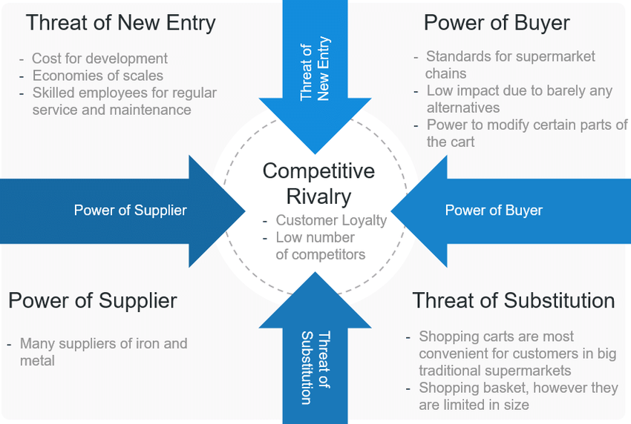
Figure 1: Porter’s Five Forces
Source: Fabian Nguyen, 2018
Porter's five forces are considered as a framework that can be used for evaluating the competition of an organisation or a business. It helps the organisation to derive major forces that can determine its competitive advantage in the industry in terms of profitability and benefits.
The threat of new entrants
The fashion market of the United Kingdom is not saturated and hence there are no many barriers to the entry of new organisations. The low capital that is required to open the new store reduces the barrier of scales economics and high investment hence the threat of new entrants is high for H&M.
Threat of substitutes
In the case of the fashion sector replacing the brands or products is not very difficult and hence the fashion retailers like H&M have to focus on differentiating the products that make them one-of-a-kind brand (Hopkinson et al., 2018). The company can mitigate this by offering continuous change as per the requirements of the customers thus reduce the threat of substitute brands or products. Additionally, the relationship between price and quality has to be improved.
Bargaining power of buyers
This is one of the negative aspects of the non-existential loyalty in the fashion industry where H&M operates. The customers tender to switch to the products that are available for low prices and the positive aspects become irrelevant for the company in such cases. Along with the customer association, it becomes necessary to defend other interest which is not really organised.
Bargaining power of suppliers
The suppliers of the fashion retail industry are considered to be one of the important stakeholders of the company and hence it becomes necessary to maintain healthy relationships with them (hm.com, 2018). Since the quality of the materials and the product depends on the suppliers, it requires a company like H&M to align its strategy with the demands of suppliers and hence they have high bargaining power.
Rivalry among existing fashion companies
The fashion industry of the United Kingdom is booming and there are many National international as well as local competitors who have gained immense visibility in the fashion industry. The opportunities for growth are high but the price variability has a greater influence on the customers. Thus the competition is very high for H&M in the market.
Porters Value chain
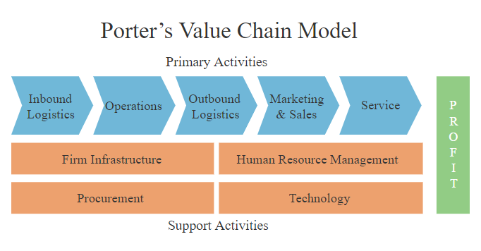
Figure 2: Porter’s Value Chain Model
Source: clustercollaboration.com, 2017
The value chain of the model is connected to two communities ecosystems and people and numerous businesses across the world and hence makes it a part of the global economy (hm.com, 2018). The business of H&M has an environmental social and economic impact that is far-reaching and significant and hence it becomes the responsibility of the organisation to make it a positive one. It also includes creating positive change along the value chain that is right from the farms to the manufacturing in the factories to supplying the products to millions of customers.
Inbound logistics
It is necessary to build strong relationships with the H&M suppliers as they support to perform the business operations. It is necessary to analyse the inbound logistics of the company to understand the challenges it can face in its development phases. This analysis requires the organisation to focus on every aspect of let's process of transforming the raw material into a finished product. The activities include retrieving the raw material storing the supplies and distributing these materials to start the process of production (forbes.com, 2018).
Operations
The importance of evaluating the operational activity arises whenever the material arrives at the inventory of H&M and that it is ready to process this raw material into an end product that can be launched into the market. Some of the activities involved in the operational phase include assembly machine in packing and testing. The maintenance and repair of the equipment fall into this category and this analysis will help the company to improve its productivity and maximize efficiency while ensuring competitive success in the market.
Outbound logistics
Outbound logistics is a set of activities that will deliver the end product to the customers of the company through various intermediaries. The prominent activities in the outbound logistics included warehousing, material handling, order processing, scheduling, transporting the products and delivering them to the end destination (hm.com, 2018). H&M should analyse its outbound logistics to optimise and explore the competitive advantage it has over other businesses in the market.
Marketing and sales
Marketing and sales provide highlights of the company's benefits as well as to the differentiation points through which it can persuade its customers to purchase the products instead of the competitor's. Production of high-quality product and marketing them is equally important as offering affordable cost for unique features. The company should also invest in promoting marketing and selling activities of which products and the sales agents of the company play a very important role here. Some of the prominent activities in sales and marketing include advertising pricing, quoting, building relations, channel selection and so on.
Services
Services include the before the sale and after-sale services that are offered by the company. This plays a very important role in gaining the modern customers now look for after-sales services and is now considered to be the important activity. This is one of the major concerns of the stakeholders.

Conclusion

From the above study of the business environment of H&M, it can be inferred that various external, as well as internal factors, influence its business operations. Furthermore, it can be concluded that there are major concerns of the stakeholders which the company is trying to meet through various strategies. It can also be concluded that the company can face a few threats of new entrants and substitutes but can be tackled through analysis of its business processes especially operations and services.

Reference List:

Akhtar, M. and Sushil, S., 2018. Strategic performance management system in uncertain business environment. Business Process Management Journal.
Bojonca, D., 2019. Corporate sustainability in the fast fashion industry: the case of H&M.
forbes.com, 2018 [Online] Available at: https://www.forbes.com/sites/barrysamaha/2018/03/26/hm-conscious-exclusive-collection-2018-sustainable-fashion-anna-gedda-interview/?sh=566f7f3f74f0 [Accessed 8th March 2021]
hm.com, 2018 [Online] Available at: https://about.hm.com/content/dam/hmgroup/groupsite/documents/masterlanguage/CSR/reports/2018_Sustainability_report/HM_Group_SustainabilityReport_2018_%20FullReport.pdf [Accessed 8th March 2021]
hm.com, 2018 [Online] Available at: https://about.hm.com/content/dam/hmgroup/groupsite/documents/masterlanguage/Annual%20Report/Annual%20Report%202018.pdf [Accessed 8th March 2021]
hm.com, 2019 [Online] Available at: https://about.hm.com/content/dam/hm/about/documents/en/CSR/Others/Stakeholder%20engagement%20overview_en.pdf [Accessed 8th March 2021]
hm.com, 2019 [Online] Available at: https://about.hm.com/content/dam/hmgroup/groupsite/documents/en/hm-way/HM%20Way_en.pdf [Accessed 8th March 2021]
hmgroup.com, 2021 [Online] Available at: https://hmgroup.com/about-us/history/ [Accessed 8th March 2021]
hmgroup.com, 2021 [Online] Available at: https://hmgroup.com/sustainability/circular-and-climate-positive/circularity-and-our-value-chain/value-chain/ [Accessed 8th March 2021]
Hopkinson, P., Zils, M., Hawkins, P. and Roper, S., 2018. Managing a complex global circular economy business model: opportunities and challenges. California Management Review, 60(3), pp.71-94.
statista.com, 2018 [Online] Available at: https://www.statista.com/statistics/540472/hennes-mauritz-global-value-chain-based-on-climate-impact-share/ [Accessed 8th March 2021]
statista.com, 2019 [Online] Available at: https://www.statista.com/statistics/252190/gross-sales-of-the-h-und-m-group-worldwide/ [Accessed 8th March 2021]

